Will the Recession be Short?

Victor A. Canto

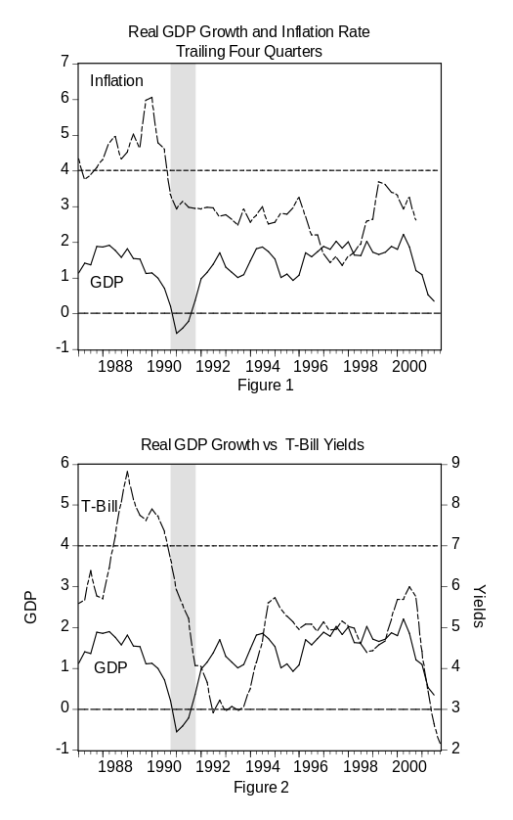
Over the past few weeks we have struggled to find an appropriate parallel to the economic situation in the aftermath of September 11. In a recent paper we argued that the appropriate parallel for the post 9/11 was the Gulf War. In both cases the incident punctuated what we already knew: that the economy was in recession. We also pointed out some interesting similarities. In both cases, Alan Greenspan was chairman of the Fed and George Bush was president. However, there are some major differences this time. The George Bush in the White House now is proposing to lower tax rates. For that reason we believe that the recovery is going to be stronger than that of the previous recession. More on this subject anon.

Looking at Figures 1 and 2 we can see the similarities between the two periods:

- During the months preceding the recession the inflation rate rose prior to the economic slowdown (i.e., we believe the reason for this was that Greenspan had deviated from the price rule). The reason then was obvious: We had oil price increases. Leading up to Desert Storm, oil prices rose to $35 during the third quarter from a $14 range at the end of 1988. Looking at Figure 1, it is easy to see that inflation rose steadily throughout 1999. The Maestro was preoccupied with Y2K and thus abandoned the price rule.

- The incipient inflation and the quick resolution of the Gulf War, combined with non-eventful Y2K turned out to be, meant that Greenspan began to withdraw some of the excess base money he had printed. The central bank began aggressively raising the Fed funds rate. During the 12-month period from February 1988 to February 1989, the Fed funds rate was hiked 10 times. The target rate peaked at 9.75% from its 6.5% level in early 1988. Beginning in May 1999 and ending in May 2000, the Fed again started increasing the Fed funds rates, this time nine times. The target rate peaked at 6.5% in May 2000, up from its 4.75% level of a year earlier.

- Looking at Figure 2, it is fairly apparent that the Fed funds hike preceded the economic slowdown. Thus, if one is willing to assume that the temporal precedence is evidence of a causal relationship, then Alan Greenspan deserves some of the blame for the two recessions that we endured over the past 11 years. We give him a lot of credit for bringing and keeping inflation in the 2% range. However, we need to hold him accountable for departing from the price rule and, thus, doing damage to the economy.

- Notice that in the early Nineties, the U.S. economic recovery coincides with the stabilization of the inflation rate. We interpret this to mean that the Maestro returned to the price rule. Hence, any increases in the Fed funds rate or T-bill yields reflected an increase in real rate of returns and thus signaled an economic recovery. The question is, did the markets anticipate the recovery. To answer this question, we looked at the futures markets for T-bills at the end of September 1990, December 1990 and March 1991. The later date was the quarter right before the recovery started. The information presented in Figure 3 is quite interesting. First, we see a decline in interest rates at the short end of the curve while the long end remains basically unchanged. The decline in the futures’ rates reflected the decline in real rates as well as the economic slowdown. Second, notice that the September futures project no change in the interest rate. We interpreted that to mean that there is no change in the real rate of return and thus we expected the weakened economic conditions to continue through the next two quarters. The December futures implied a revised forecast looking for a slight rise in rates beginning in the third quarter. The futures market was looking for a recovery by the third quarter.

The parallels with the current slowdown fit our story quite well. We know that short rates have been declining during the past few months and so have the expected future short rates. However, looking at Figure 4 it is apparent that the short rates are expected to begin a steady climb right after the first quarter. This is consistent with our views that the rise in the expected real interest rate is signaling an economic recovery.

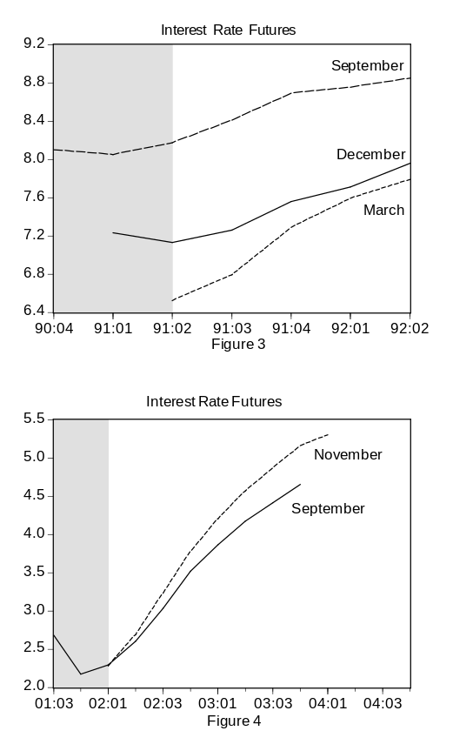
- Our parallel is now complete. There are however some differences between this recession and the previous one. In the earlier recession, George Bush raised taxes, and Clinton followed suit. Thus, we had a sub-par economic recovery. It was not until the Republicans regained Congress that it became clear that the tax hike movement would be derailed. The economy kicked into high gear. In contrast, we now have George Bush advocating lower tax rates. Therefore, we should expect a stronger recovery coming out of this recession. The question is what happens to Congress in the next election. If we continue the pro-growth agenda there is no reason why we could not get back to the virtuous cycle of strong growth in both the real economy and the stock market.

