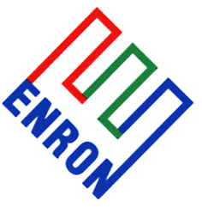 | LME Options – INTERNAL USE |  |  | Fri 26th Jan 2001
Enron Metals Options |  | Jimmy Gordon, Russell Plackett  Mark Shaer | Tel: 44 207 783 2133

Option Vols (last 4 days valuation, 2 daily change | Option Open Interest (calls red line, puts blue blocks)
Aluminium: support $1590, resistance $1635, ma10 $1587, ma30 $1574  Vols trading at 22% for front month with upside well bid by the MMs. Market short vol and hurting. Charts shows nearby bids. | Upside calls in demand on bullish price move. Apr $1650-$1750 calls bought ($45 and $20 prem) by influential player aggravating already short market.
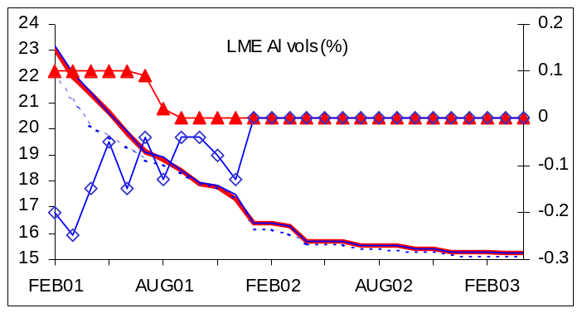 | 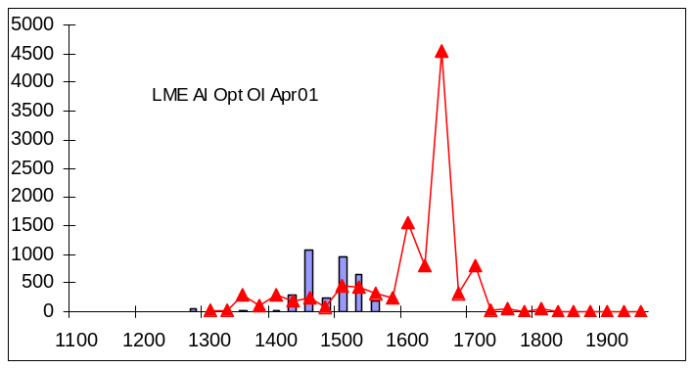
Copper: support $1780, resistance $1825, ma10 $1806, ma30 $1819  Nearby vols steady at 18%, with downsides well bid by physical traders. Flat vol curve indicative of flat copper interest. | $1850 April calls bought by GSF for $40 but generally quiet day. Mkt must break range before any real option related activity seen.
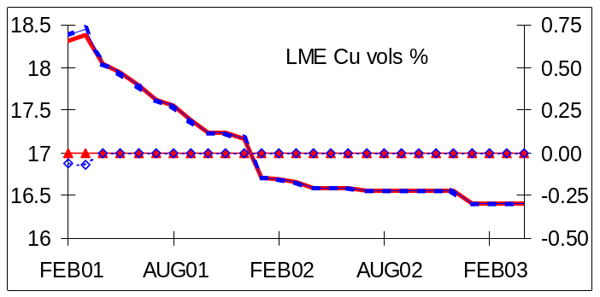 | 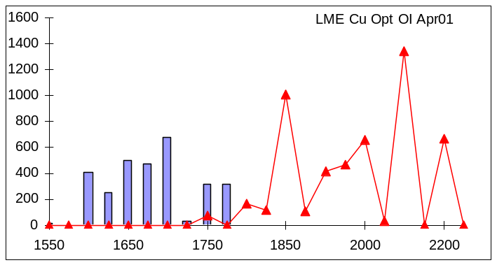
Nickel: support $6700, resistance $7170, ma10 $6794, ma30 $6750  Quiet day vols unchanged and still straddling 30%. Some selling Feb and March vol before weekend as MM minimise theta loss. | Low OI levels highlight the lack of option related activity in this metal
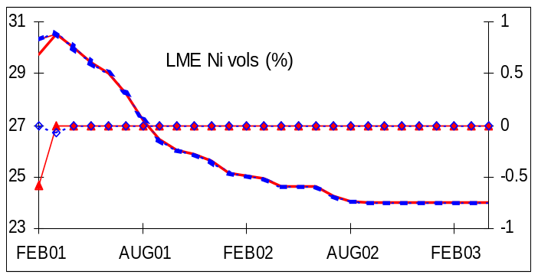 | 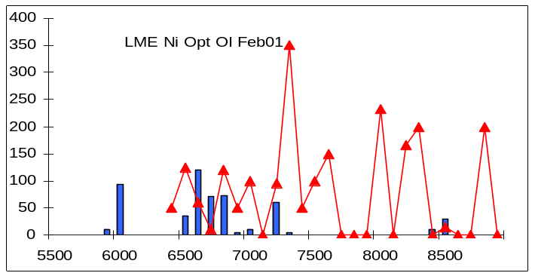
Zinc: support $1050, resistance $1065, ma10 $1054, ma30 $1054  No change on vol strip. Some light selling of nearbys ahead of the weekend. MM long vol and gamma trading is compressing the range. | Apr and June $1050 calls sold for $30-$45 respectively by US banks to earn prem from inactive market. Chinese still sellers of $1000 and $1025 puts, but low open interest overall.
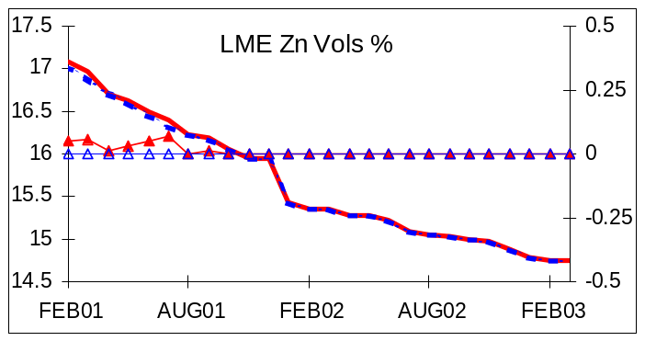 | 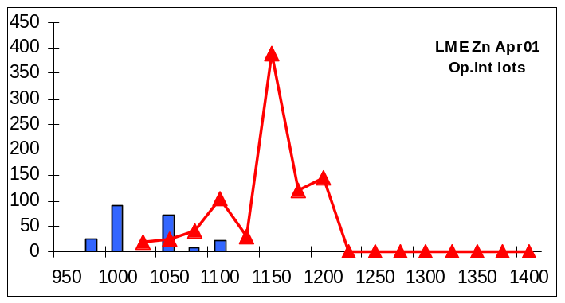

Rohan Ziegelaar (London) | Direct Tel: 44(0)20 7783 2415 | Fax: +44 (0)20 7783 1419 | Rohan.Ziegelaar@enron.com
This material is provided to you for discussion purposes only and is not intended as an offer or solicitation for the purchase or sale of any financial instrument or security, nor does this material constitute investment or trading advice. Enron Metals Limited makes no representation or warranty, express or implied, as to the truth, accuracy or completeness of this material and neither Enron Metals Limited or any of its Affiliates, nor any of Enron Metals Limited’s employees, officers or agents of its Affiliates shall be liable for any matter owing out of or in connection with this material of the use of it. Opinions expressed are the opinions of the author and do not necessarily represent the opinion of Enron Metals Limited or any of its affiliates. Enron Metals limited or its affiliates may hold positions or make markets in financial instruments identical or economically related to transactions discussed herein.

