Request to Extend Price Caps

August 10, 2000

California ISO
Department of Market Analysis
Overview
In its various rulings on price caps, the FERC has indicated that the ISO as a buyer of services in the markets it operates has the right to limit the prices it is willing to pay for those services. We interpret these rulings to mean that this buyer’s right to limit purchase prices exists independently of the FERC-approved price cap authority which FERC has identified as expiring on November 15, 2000, and will therefore continue indefinitely beyond that date without any need for the ISO to request from FERC any extension of authority.
However, if this interpretation is not correct, the ISO will need to request an extension of price cap authority in order to be able to limit the prices it is willing to pay for services purchased through its markets. To this end, this report provides an explanation and summary of the recent performance of the California electricity markets as supporting evidence for the need to extend the ISO’s price cap authority, as a means of mitigating system-wide market power, beyond November 15, 2000 and until the Comprehensive Market Redesign (CMR) currently in progress is implemented. In the coming weeks the ISO CMR team will be working on developing a more comprehensive approach to mitigating system-wide market power that is consistent with other market reforms being developed. It is anticipated that the entire CMR proposal will be filed with FERC in November 2000.

Price Cap History
On January 27, 1999, FERC confirmed the CAISO’s authority to reject bids that exceed price caps in its real-time (imbalance energy) and ancillary service markets, pending the submission, approval and implementation of reforms in the ancillary service markets. FERC further determined that the ISO should have the flexibility necessary to adapt its price caps to conditions in those markets, as they change over time.
In a May 26, 1999 Order, FERC conditionally approved all elements of the ISO’s ancillary service market redesign proposal (Amendment 14). The May 26, 1999 Order also confirmed the ISO’s authority to impose caps on the prices it would pay for Ancillary Services and imbalance energy, but limited the duration of that authority to November 15, 1999.
Many of the Ancillary Service market reforms were implemented in mid-August 1999. Three important components of the reforms, however, were delayed due to software problems. As a result, the ISO did not have the opportunity to confirm the efficacy of the Ancillary Service market reforms to maintain competitive conditions during a summer peak season. In September 1999, the ISO filed Amendment 21 with the FERC requesting a one-year extension of the ISO’s price cap authority for energy and ancillary services from November 15, 1999 to November 15, 2000. On November 12, 1999, FERC issued an order approving the one-year extension.
The recent price spikes in ISO’s real-time and Ancillary Service markets have raised serious concerns that the ISO’s markets are not workably competitive under predictable conditions (when loads are over 38,000MW). Measures required to mitigate the exercise of market power are not yet adequately developed. In fact, the level of price caps that had been raised from $250/MWh to $750/MWh starting October 1, 1999, after implementation of several Ancillary Service market redesign elements, was reduced after the price spikes of May and June 2000. The price caps were reduced to $500/MWh effective July 1, 2000, and subsequently to $250/MWh effective August 7, 2000 (along with a purchase price cap of $100/MWh for replacement Reserve). The ISO Governing Board approved these lower caps through October 15, 2000. The ISO will file for an extension to its current price cap authority in the ISO Real-time Energy and Ancillary Service markets to extend beyond November 15, 2000 until a comprehensive market reform proposal is implemented which will address mitigation measures for global and locational market power.
Based on FERC’s Orders of January 7, 2000, and April 12, 2000, the ISO has undertaken a comprehensive redesign of its markets with primary emphasis on reforming its congestion management process. Included in this Comprehensive Market Redesign (CMR) program are measures to mitigate local market power and additional measures to deal with system-wide (global) market power. System-wide market power mitigation measures may involve replacing price caps with bid caps when markets are not competitive, and offering threshold criteria for identifying and mitigating both local and system-wide market power. However, the time frame for implementation of these reforms is beyond November 15, 2000.
In the following sections, we provide a brief review of the current market structure that will demonstrate the need for the price caps in the interim until comprehensive market reforms are implemented.

Overview of Market Competitiveness
As demonstrated in a recent report, prepared by the ISO Department of Market Analysis for the California Electricity Oversight Board, titled “Report on California Energy Market Issues and Performance: May-June, 2000”, the price spikes observed in May and June 2000 reflect a combination of shortage of supply and inelastic demand. This combination allows practically any supplier with significant capacity to exercise market power and drive up wholesale prices. When workable competition exists, prices should be close to the short-run variable cost of the highest-cost generating unit required to meet the demand. In markets where consumers have the ability to respond to price increases by reducing consumption, prices above competitive levels in times of shortage may be seen as legitimate “scarcity rents” because they reflect the willingness of consumers to pay for electricity. Moreover, where scarcity prices are set by consumer willingness to pay and there are no barriers to the entry of new suppliers, occasional high prices under scarcity conditions are important signals to new generators to enter the market. Where consumer responsiveness and new entry are severely limited, however, as in today’s electricity markets, the ability of suppliers to exercise market power under tight supply conditions cannot be limited by competitive market forces. In this situation effective mitigation of market power must be accomplished through rules, procedures and incentives designed into the structure of the markets themselves, and every effort must be made to facilitate price responsiveness by consumers and removing barriers to the entry of new suppliers. The other critical assurance of a competitive market is consumers capability to hedge the market price volatility through forward contracts.
Recent aggregated bid information released by the PX shows that supply being offered in the PX market is lower in quantity and higher in price than the supply offered under comparable load conditions last year. The decreased supply in the PX is attributed to two key factors. First, a significant amount of thermal capacity divested to merchant generators is being scheduled through bilateral contracts or through regional block forward and spot markets. Of capacity scheduled through these bilateral or forward market contracts, a significantly greater amount appears to have been purchased for out-of-state markets. The result has been an increase in gross exports and a decrease in overall net imports into the California market. In addition, high real time and replacement reserve purchase prices and quantities have created a significant opportunity cost that may have led suppliers to withhold or bid higher prices in the PX Day Ahead market.
Price spikes in the ISO’s real time market during May and June occurred primarily during hours when the ISO needed to increment significant amounts of generation in real time in order to meet demand due to underscheduling of loads and generation in the Day Ahead and Hour Ahead markets. In some hours, as much as 25% of system needs were met in the real-time market. This significant level of under-scheduling is largely attributable to the different market incentives faced by buyers and sellers. Large buyers have tried to “defend” against higher prices in the PX Day Ahead Market by shifting some of their demand to the real-time market and suppliers have offered less supply at higher prices in the Day Ahead market because of opportunities to earn higher replacement reserve payments and real time energy prices. An important objective from a reliability perspective is to limit the amount of transactions in real time. Creating stronger incentives for load and suppliers to bid and schedule in the forward markets will help reliability and promote more competitive markets. One way to do this would be to modify the ISO’s current policy of charging replacement reserve to under-scheduled load and over-scheduled generation, which was originally enacted as an incentive to minimize real-time imbalances. In practice, however, this policy also has made it more profitable for the generators to appear in the real-time market rather than to appear in a forward schedule. .
In assessing market competitiveness it is important to distinguish between high prices caused by market power and scarcity conditions. Not all incidences of price exceeding system marginal cost are evidence of market power, because scarcity rents are legitimate during hours of shortage. Scarcity rents are appropriate when the level of electricity demand is such that there is little, if any, unused capacity available throughout the system. In these instances, prices in the market should be set by the willingness of consumers to forego purchases of electricity, rather than by the bids of generators. These market conditions indicate genuine scarcity of generating capacity, because all available capacity is used and no additional capacity exists to serve any incremental increase in demand. Due to the extremely limited degree of demand elasticity that currently exists in California’s newly deregulated energy market, the ISO’s real time price cap has had to serve as a proxy for consumers’ willingness-to-pay during periods of true scarcity, as well as the limit on market power during periods of high demand.
Our preliminary analysis shows there have been shortages in the California ISO control area for a number of hours, when available capacity was not sufficient to meet the net demand for capacity. There were also other high price hours when we cannot identify any apparent shortage and the high prices are most likely results of market power. The presence of market power can be verified by bids setting market clearing prices significantly over the variable costs of the highest cost supplier in the ISO’s markets. The highest variable cost of in-state generators is approximately $100/MWh and many suppliers have routinely bid a significant part of their capacity at the former $750 price cap level. This shows that during high load periods, many bidders are pivotal, meaning their bids are guaranteed to be selected and thus they can influence the market clearing price through their actions.
The observed market power was the combined effect of the bidding activity of in-state and out-of-state generation resources. The available data and tools do not allow detailed analysis of the market power of out-of-state generation owners. The ISO, however, is not aware of any acute regional shortages in most of the high price hours. The high prices bid by out of state suppliers as well as the high prices quoted to ISO’s out of market calls are indications of market power of out-of-state suppliers.
One means to insure competitive markets was divestiture. The divestiture of generation resources by California IOUs has resulted in a market share of approximately 9% for a few of the large non-utility generation companies. No additional market power mitigation were imposed by the CPUC and FERC at the time of divestiture. Thus, these companies are net sellers who can profit from causing price spikes. While for most hours the ISO markets are sufficiently competitive, at high load conditions, when capacity reserves are low, market suppliers with a capacity share of 9% or less can be pivotal. When net demand for capacity in the ISO control area is more than 91% of available capacity, suppliers can easily bid high prices, and know their bids will be accepted and set the market-clearing price. Thus, prices have hit the price cap during many hours even when there was not a absolute shortage on the system. Insuring new entry and sufficient reserves are the fundamental solutions to this problem.
Another key mitigation mechanism in place at the start of the market was the retail rate freeze combined with the CTC recovery. This provided the UDC’s with a direct incentive to keep wholesale electricity costs low in order to maximize CTC recovery. As the rate freeze is lifted, there needs to be an alternative assignment of the responsibility to keep costs low for the retail customer.

Impediments to Price Responsive Demand
A lack of price responsive retail demand for energy was identified by the ISO Market Surveillance Committee (MSC) as one of the main factors inhibiting the competitiveness of the California market. The retail rate freeze mutes the incentives for loads to reduce demand at times of high system load and high prices.
AB1890 gives the UDCs until March 31, 2002 to recover any stranded costs associated with uneconomic investments and contractual obligations, and thus sets a time limit to the rate freeze. Currently, only SDG&E has already recovered all of its stranded costs and, pursuant to AB 1890, is no longer required to have its rates frozen at 90% of the 1996 levels. PG&E and SCE are also expecting to recover their stranded costs before the March 31, 2002 date for termination of CTC. The CPUC recently issued an opinion regarding policies relating to Post-Transition Ratemaking (PTR) to determine appropriate and consistent ratemaking practices for all three UDCs after the rate freeze. This issue is closely related to a separate CPUC proceeding on the role of the utilities in retail competition. CPUC staff completed a study on this issue in June 2000.
While these longer-term policies are being worked out, several new load responsiveness programs have been developed for summer 2000. The UDC’s under the rate freeze still have the incentive to minimize costs of wholesale procurement. SCE and PG&E have each developed summer 2000 pilot programs for developing demand responsiveness in the PX day-ahead market. In addition, the ISO has developed a summer 2000 trial program for increasing load participation in the ISO ancillary service and supplemental energy markets.
These new programs are relatively small in scale, and represent only the initial steps towards developing price responsive demand which is crucial for competitive market outcomes .
Limited UDC Day-Ahead Demand Responsiveness Programs
On March 16, 2000 the CPUC approved day-ahead price-responsive load programs for SCE and PG&E. Under these programs, when certain market conditions in the day-ahead PX market exist, the utilities offer incentive payments to program participants who are willing to voluntarily curtail their energy usage. Each utility proposed different day-ahead market conditions for triggering the program. Under SCE’s program, incentive payments are offered when the unconstrained PX day-ahead energy price equals or exceeds $250/MWh. PG&E’s program is activated when the constrained PX day-ahead energy price equals or exceeds $250/MWh.
To date, participation in the UDC’s day-ahead demand responsiveness has been moderate. Approximately 40-50 customers have signed up for PG&E’s program with a potential curtailment capability of approximately 100 MW. PG&E indicates that their program has been triggered 11 days in June and July. The highest participation in any single hour was 15 participants and day-ahead curtailment offerings have been as high as 50 MWh in some hours. Most of the program participants are also operating under an existing interruptible tariff. Participation in SCE’s program has also been moderate. To date, approximately 100 customers have signed up but only 49 are currently set up to actively participate. Most of the program participants are also under SCE’s existing interruptible tariff. As of July 28th, SCE had activated their program 15 times and curtailments ranged from 10-30 MWhs with most of this coming from interruptible tariff customers.
Limited Load Participation in the ISO Ancillary Services
There is approximately 75 MW of load capacity contracted under the ISO's Demand Relief Program. To date the ISO has called on program participants to curtail load approximately three times in June for all 15 hours available pursuant to the terms of the program and in July, 2000 the ISO had called on the program three times for a total of 16 hours.
Approximately 230 MW of load capacity has signed Participating Load Agreements with the ISO to be eligible to participate in the ISO's ancillary service and supplemental energy markets. However, most (95%) of this capacity is load that is already operating under existing interruptible tariff rates and subject to CPUC approval to participate in the ISO's ancillary service and supplemental energy market. Both SCE and PG&E filed advice letters with the CPUC requesting authority for their interruptible loads to participate in the ISO markets on June 7th and the ISO submitted comments supporting their filings. Because the CPUC decision is still pending, there has been essentially no new participation by curtailable loads in the ISO markets. The recent reduction in the price cap from $750 to $500 and then $250 could further discourage load participation in these markets.

Need for Forward Contracting and Hedging Products for Ancillary Services and Energy
An important feature of a fully developed commodity market is the ability of buyers and sellers to contract well in advance of the actual “date of delivery”. Such ability provides for greater price discovery and enables both sides of the market to hedge against price volatility in the spot market. Since the UDCs must supply their loads through the PX, the development of the PX block forward markets represent an important step in this direction. However, the effectiveness of these markets are limited due to restrictions on the scope of their use by the UDCs.

CalPX Block Forward Market for Ancillary Services
On February 17, 2000 the California Power Exchange filed with FERC on behalf of its CalPX Trading Services (CTS) a request for authority to conduct a block forward market for ancillary services and for the CalPX to provide scheduling of bilateral ancillary service transactions. FERC conditionally approved this program on April 25, 2000 and CTS implemented trading of ancillary services in its block forward market beginning on May 1, 2000 for June delivery. Forward trades and registered bilateral agreements for ancillary services are scheduled for delivery in the CalPX day ahead market.
To date (July 28, 2000), there has been only a nominal amount of ancillary service capacity traded in the Cal PX BFM. The low volume may be partially due to the newness of the program and the late date in which PG&E and SCE obtained CPUC authority to participate in this market (May 4, 2000).

CalPX Block Forward Market for Energy
In June 1999, the California Power Exchange introduced a new block forward market for energy. The CTS BFM contract was developed based on input from market participants who wanted CalPX to offer a standardized contract on a forward market basis to trade on-peak blocks of power for an entire month at a single price. Offering this type of product provides market participants with a market to hedge against hourly price variation associated with the CalPX day-ahead PX market. The contracts are in multiples of 1 MW or 25 MW blocks for the on-peak time period (6:00 a.m. to 10:00 p.m. Monday through Saturday, excluding certain holidays). These contracts are contracts for differences and are settled against the monthly average PX day ahead zonal price. In November 1999, the CalPX introduced a new quarterly block forward market for energy. Under this new contract, blocks of peak-hour power can be traded for an entire quarter at a single price.
In addition, the CalPX has recently received FERC authority to offer block forward energy products for delivery points outside of California and to offer products tailored to “super peak” and “shoulder peak” periods. As of May 2000, the CalPX has been offering block forward energy products for delivery on Mead, Palo Verde, and COB and is offering “super peak” and “shoulder peak” periods.
Figures 1 and 2 show the monthly volumes that have traded in these markets for summer 2000 as of July 28, 2000.

Figure 1: Monthly Block Forward Market Volumes (SP15)
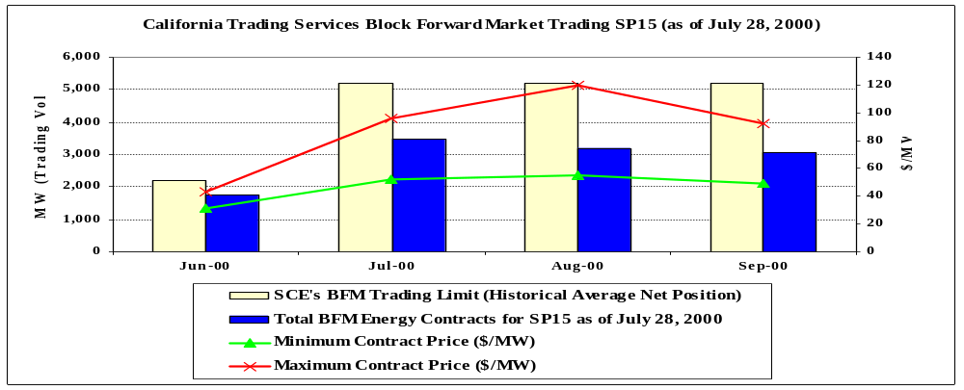

Figure 2: Monthly Block Forward Market Volumes (NP15)
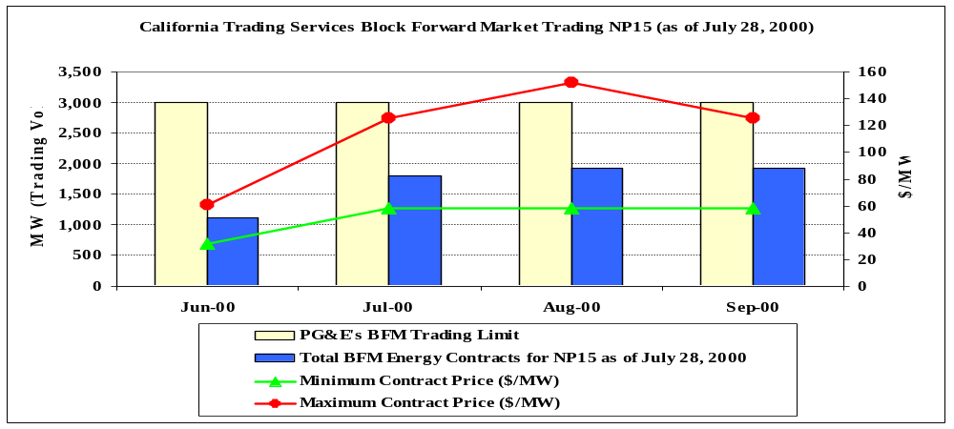

Figure 1 compares BFM trading volume to date to SCE’s CPUC imposed BFM trading limit. To the extent trading volume in SP15 is associated with SCE, this figure indicates that SCE was able to hedge approximately 80% of its trading limit in June 2000 and roughly two-thirds of its trading limit in the remaining months (Jul-Aug). Figure 1 also shows the maximum and minimum trading prices and indicates that with the exception of August, which experienced a maximum contract price of $120/MWh, trading prices were below $100/MWh.
Figure 2 compares BFM trading volume for NP15 to an estimate of PG&E’s trading limit. To the extent that BFM trading volumes for NP15 are associated with PG&E, this figure indicates that relative to their estimated trading limit, PG&E hedged very little in June and have hedged roughly two-thirds of their trading limit for the remaining months. Contract trading prices in NP15 for the months of July-Sep roughly ranged from $60/MW to $150/MW.
On August 3, 2000, the CPUC gave SCE and PG&E authority to enter into long-term bilateral contracts. Such transactions are limited to previously authorized trading limits in the forward market and must expire on or before December 31, 2005. This additional flexibility will further help the UDCs in hedging against price volatility in the spot markets.

Comprehensive Market Redesign to Address Market Power
In compliance with FERC’s directive on the ISO’s Tariff Amendment 23 to avoid a piecemeal approach, the on-going stakeholder process to reform the ISO’s congestion management market includes several elements addressing the identification and mitigation of both local and system-wide market power. The Comprehensive Market Redesign (CMR) program draws on recent FERC orders regarding market power mitigation plans for some other ISOs, and is considering the use of bid caps (rather than price caps) under non-competitive market conditions. The contemplated plan is expected to include threshold criteria for identification of non-competitive market conditions, and clear thresholds for bid caps when they are invoked. The plan will address the type of availability criteria and standards which may be needed.
Thus far the CMR activity has developed options and recommendations for local market power mitigation to address the major flaw in its current congestion management system. The CMR process will formulate options for global market power mitigation and availability standards for stakeholder review and comments in the coming revision of the CMR document it has put out for stakeholder review.

Conclusion and Recommendation
Based on the facts that (1) available supply capacity will be scarce under rather predictable conditions, with loads over 38,000MW and no significant new generation will come on line in the next 2 years to relieve this low level of reserves, (2) current regulatory barriers limit the extent and the pace of development of hedging products, and (3) demand response programs are in their early stages of development, there is a need to have price cap authority beyond November 15, 2000, as an interim measure while the market reforms are being implemented. A longer-term approach for mitigating global market power will be proposed in the ISO’s Comprehensive Market Redesign (CMR) filing that will be filed with FERC in November 2000.

One of these reforms -- the “no pay” reform, under which payments would be withheld for Ancillary Service capacity that was used for the uninstructed generation of Energy -- is expected to be implemented in September 2000. The capability for trades of Ancillary Service capacity between Scheduling Coordinators was implemented in mid-September, 1999. Another key market functionality, the ability of SCs to attach congestion adjustment bids on Inter-SC trades will be implemented September 2000. The automation of instructions to participants in the Imbalance Energy market (Automatic Dispatch System (ADS)) was implemented on June 1, 2000.
See presentation on Price Behavior in Cal-PX Markets: May-June 2000, prepared by PX compliance Unit for the Energy Oversight Board, June 29, 2000, available in archives on PX website (calpx.com)
Net demand is defined as internal load less imports, plus requirements for operating reserves.
DMA noted in their report of June 1999, Annual Report on Market Issues and Performance (p 1-3), the need for alternative market power mechanisms after the freeze ends and there is no stranded cost recovery.
See the Market Surveillance Committee’s “Report on the Redesign of California Real time Energy and Ancillary Services Markets,” October 18, 1999.
Currently, SDG&E can pass through all energy and energy related costs to its bundled-service or default customers (i.e., customers who do not choose a non-utility electricity provider under the Direct Access program). However, for the period July-September 1999, customer rates were capped at 112.5 percent of the frozen electric rate levels (which, combined with the legislated 10 percent rate reduction, translates to 101.25 percent of 1996 levels). Any revenue shortfalls SDG&E might have faced as a result of the cap were recoverable from customers in subsequent months.
CalPX Trading Services” (CTS) is a non-incorporated division of the CalPX for the purpose of separating the block forward market, for financial, administrative, regulatory, and organizational reasons, from the existing markets operated by the CalPX.
In approving PG&E’s request for expanded BFM trading authority, the CPUC did not provide an explicit trading limit and instead authorized PG&E to trade up to their average hourly net position as determined for each quarter. PG&E initially requested its trading limit be raised to 3,000 MW and indicated this level was below its net position during super peak periods. This requested level is used here as an estimate of PG&E’s net position.

