Saturday, January 29th, 6th Annual IDHAFR Party
Hosted by John , Mo & Rob
The later you come the farther you'll have to park. Party usually peaks around 10 and is never quite the same.
1 of the hosts can be relied upon to become extremely festive each year. It is usually the host w/ the fewest invitees. Don’t make me be the one this year.
Bring anyone(s) you would like. We will even have John’s parents there in case we need respectable looking people to handle grumpy neighbors…though we’ve been lucky 5 years in a row. Please do not leave with any of our hats, our beer loving pit bull, or through the yard in your vehicle.

*>>From US Hwy 290 exit Loop 610 East
*>>From North I-45 or North US Hwy 59 exit Loop 610 West
From North Loop 610 exit Ella Blvd (Exit 14), it's between the T.C.Jester and Shepherd/Durham exits
Turn South on Ella and go 0.6 miles to Grovewood (just past Elementary school on left)
Turn left (East) on Grovewood and go 0.01 miles to Clovis
Turn right (South) on Clovis (this is your First right) and go 0.15 miles to Wister
Turn left (East) on Wister (this is your second left) and go 0.05 miles to IDHAFR 3rd house on left; 6422 Wister

*>>If you are South of I-10, get to I-10 however you want
From I-10, inside Loop 610, exit T.C.Jester (Exit 765A),
it's the second exit from the West Loop and is between the Washington/Westcott and Shepherd/Durham exits
Turn North on T.C.Jester and go 0.85 miles to the light at 11th Street
Turn left (West) on 11th at the light and go 0.55 miles to Shirkmere
Turn right (North) on Shirkmere and go 0.15 miles to the Stop sign at Wister
Turn left (West) on Wister and go 0.2 miles to IDHAFR on right; 6422 Wister

6422 Wister Ln
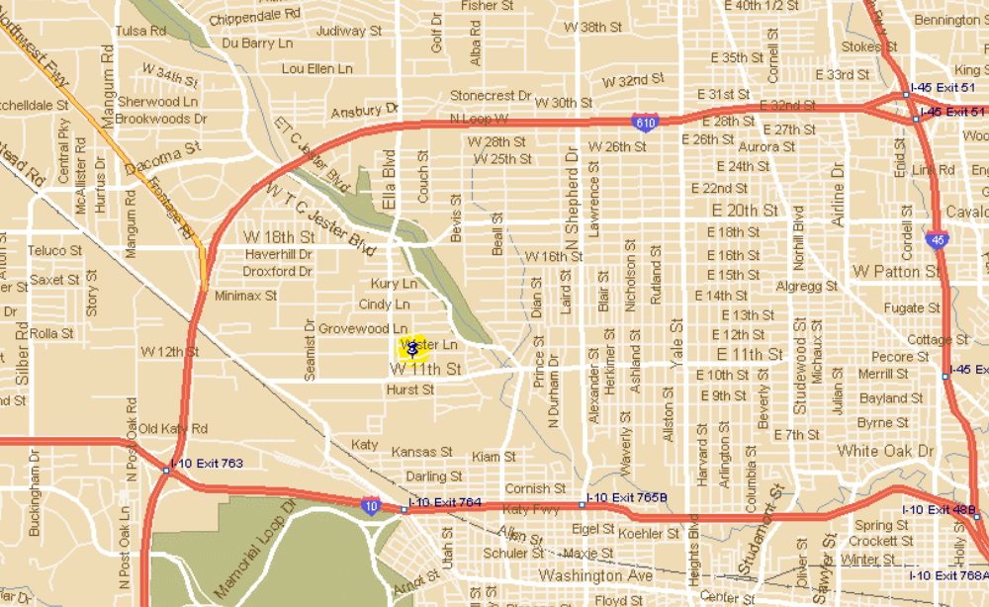713-869-6312.

