HRABAL HOUSEWARMING PARTY
(Or just another excuse to get together…)

Hello all…. just a little note to invite you to break-in our new home. We are finally getting settled in so the time is ripe for a proper party…. and there are actually places for you to sit now… and the floor still works well too…..

The ceremony is set for Saturday, May 12th, starting at around 7:00 P.M. Please feel free to bring whatever you feel is appropriate, I’m really talking beverages here….. and we would prefer if you left the little ones at home…. gives you more time and flexibility to really enjoy yourself.

We are now located in Spring, Texas…. the address is 20130 Forest Drive and the phone number is 281-353-9172 (see map below). RSVP’s regrets only…. Hope all is well and we look forward to seeing you in May. Nicole and Richard Hrabal

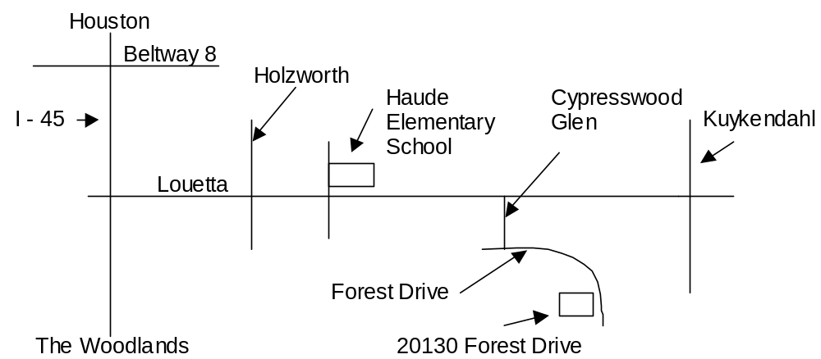
It’s not too far… only 20 something miles from downtown Houston
Take I-45 north, Exit Louetta, two exits past FM 1960
If you hit The Woodlands, you’ve gone too far
Go around over the freeway heading west on Louetta (or left for some of ya’ll)
You will pass a light at Holzworth
You will pass a light at Haude Elementary School
The next major right will lead you into Cypresswood Glen Subdivision
If you hit Kuykendahl, you’ve again, gone too far
In Cypresswood Glen the first stop sign is Forest Drive
Take a left on Forest Drive, we are around the corner on the right.
Take care and drive fast….

