How to identify if your cow has MAD COW disease:

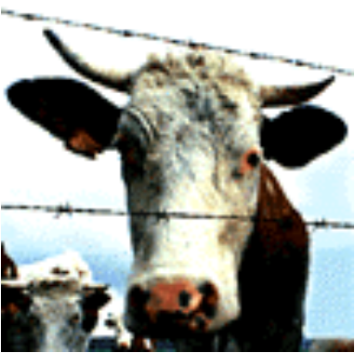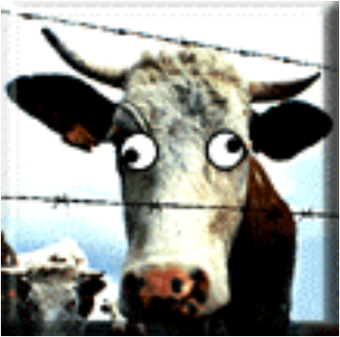

If your cow sounds like this, then If your cow sounds like this, then
fire up the barbecue. May we suggest the fish.

 (Double Click speaker) (Double Click speaker)

