

To: | Steve Young, Fernley Dyson
cc: | David Weekes
From: | Tim Poullain-Patterson | Department: | Trading Support
Subject: | Garcia Munte Exposure | Date: | 22nd February 2000

A. Introduction

This report summarizes the current situation with Garcia Munte (GM). We currently have a credit exposure of $70mm, considerably in excess of the authorized credit limit of $10mm.

B. Term Supply Agreement

On 1st April 1999 Enron signed a 1-year supply agreement for between 138,000-336,000 metric tonnes of Gasoil. This agreement included deferred payment terms of three equal installments over the two months following delivery.

By mid December deliveries under the term agreement had reached the contractual ceiling. However, no one kept track of delivered volumes against contracted volumes. Deliveries continued and were applied against the term agreement with deferred payment terms. From November there was a sharp increase in the number of cargoes sold to GM and from this point our exposure rose rapidly to the current level.

The evolution of our “delivered unpaid” exposure is graphed below and shows is due to rise further as deliveries scheduled for this week are made before cash payments result in the exposure being paid down:
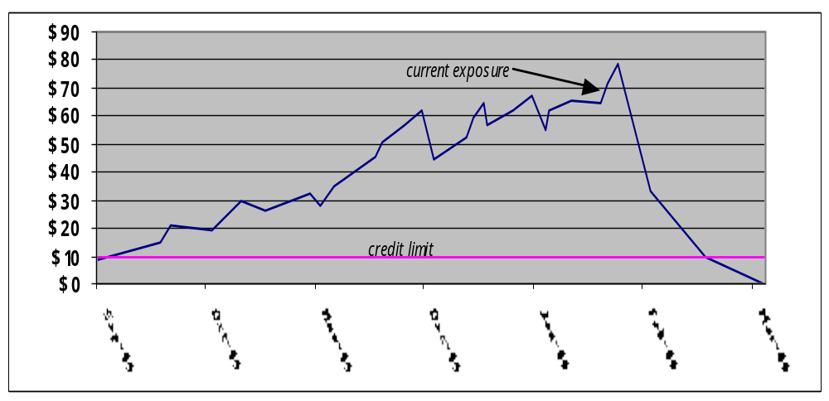

The exposure has been in excess of the authorized credit limit since October. This is partly due to oil prices doubling since the term agreement was negotiated. By late summer, the arithmetic of the contractual volumes, deferred payment terms and rising prices meant that the credit limit of $10mm was no longer sufficient.

C. Control Failures

Since mid-December the delivered volume has risen to nearly double the ceiling provided for in the term agreement (approaching 600,000 metric tonnes), and deliveries in December thro’ February have been running at six times the contractual levels. Deliveries have therefore been made outside a contractual framework and there has been a material increase in activity with GM without the requisite pre-approvals being sought from the oversight groups.

There is usually a time lag of up to a couple of days between a delivery being made and invoices being raised and booked into the accounting systems which in turn feed the Credit Aggregation System (CASS). However, owing to pressures on operators resulting from the significant increase in product flows, this time lag rose in some cases to up to a month.

This resulted in the size of the credit overdraft being difficult to track and invariably understated in the accounting systems. However, at this stage it is not clear what system generated numbers were being used by Credit to track the exposure or the extent to which spreadsheets maintained by Logistics were used for this purpose.

The first responsibility for ensuring that trading operations are managed within authorised credit limits lies with the trader. However, Logistics should ensure that deliveries are allocated to bona fide contracts, and initiate the invoicing process in a timely manner. On both counts there were failings on the part of the Operators.

D. Next Steps

Several steps are being taken to accelerate the reduction of our exposure:

- Identify deliveries that should have been made under a spot sale agreement on the basis that GM sold the product onto third parties on 5–day payment terms. This would require negotiation with GM.

- To date we have had an unblemished payments record with GM, who are aware that we have a serious credit problem that may jeopardize our short term and ongoing relationship(s). They may be willing and able to accelerate payments to ease our internal pressures.

- Withold deliveries scheduled for this week and/or negotiate more favorable payment terms. Alternatively, the product could continue to flow on the basis that GM reassign B/L’s that we have assigned to them, i.e. Enron would retain title until the exposure is managed down.

Despite both Ross Koller (trader) and David Hardy (Credit) being on vacation at the moment, both Graham Cane (logistics) and I have a good relationship with Joe Garcia (the senior GM representative) and feel comfortable negotiating a combination of the above proposals.

E. Open Items

Further work is required to address the weaknesses identified within Credit and Logistics.

There seems to be some confusion as to what the actual credit limit was. There has been some suggestion that the $10mm authorized limit could be flexed to accommodate contractual obligations in the face of a rising oil price environment. This may have encouraged the trader to push the envelope.

It is not clear how credit were tracking the exposure. The exposure in CASS is clearly incorrect and woefully understated. However, it is also not clear what action has been taken in respect to the limit violation currently recorded in CASS.

There needs to be a review of the credit limit with GM, in light of the above as well as the impending start-up of Joint Ventures with GM for which DASH approvals have already been obtained.

A review of large contracts and exposures with other Global counterparties is warranted given that this is the second time in a matter of months that actual exposures have been considerably higher than authorized.

The weaknesses identified within Global Products Logistics also need to be addressed, namely; contract management and tardy initiating of invoicing.

Tim Poullain-Patterson

