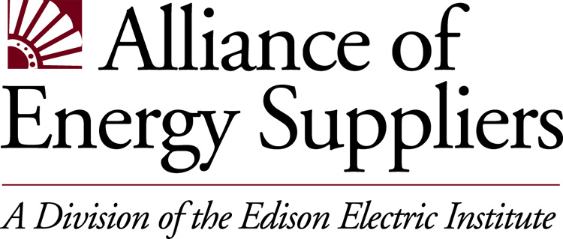

Energy Enterprise Trading and Risk Management:

An Industry Benchmarking Study

Tomorrow’s most successful companies will be organizations which understand their competitive positioning in a rapidly changing energy industry and are poised to make internal changes to grow that competitive edge. The critical first step to ensuring the highest level of performance is to establish a company’s level of performance compared with others. Industry benchmarking.

EEI’s Alliance of Energy Suppliers is offering energy suppliers of wholesale gas and power marketing companies the opportunity to participate in a new industry study of Energy Enterprise Trading and Risk Management. Managed by the consulting firm of Teknecon Energy Risk Advisors, LLC (TERA), this industry-specific study will provide participating companies with detailed analysis of benchmarking results and metrics that will identify best
practices in trading and risk management programs on an enterprise-wide basis. These results can help you retool your trading processes, identify need for change, and ultimately help improve company performance.

Study Objectives
- Identify characteristics of high performing wholesale gas and power trading organizations
- Understand generation asset management opportunities and issues
- Know the business processes and competitive positioning of your company compared with a peer group.
- Use unique analytics to evaluation performance.
- Establish ranges of performance in various metrics for the wholesale gas and power trading/risk management operations.
- Understand emerging marketing opportunities and issues.
- Identify the strategic choices available to your company.

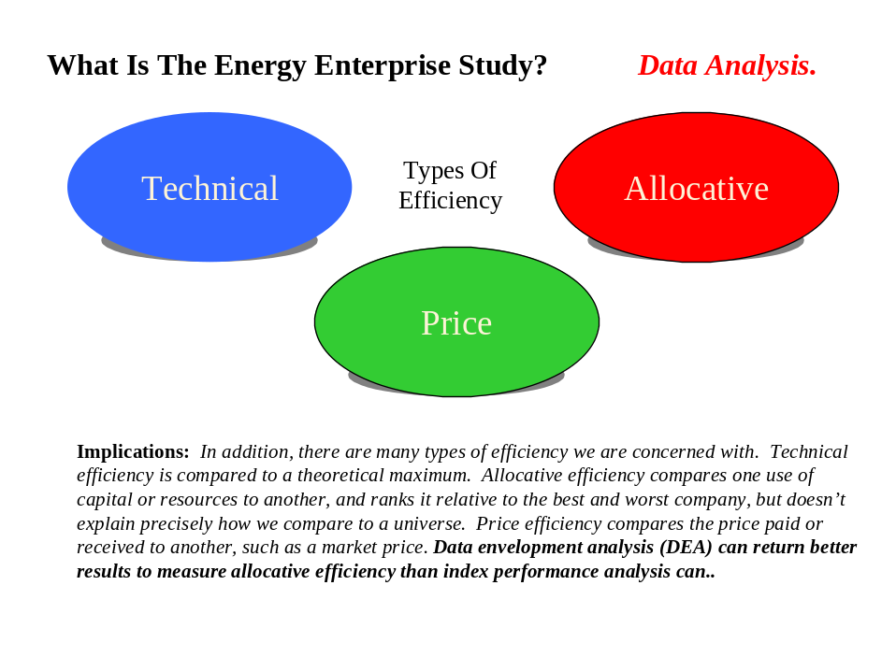Business Operations Benchmarked
Each participating company will be provided a focused perspective on trading and risk management policy and oversight within other energy and financial firms for wholesale operations. Within nine major sections, this project will assess the quantity and quality of corporate policy and resources through the benchmarking process. All aspects of business operations throughout the enterprise are considered.

 Business Model
 Volume  Revenue
 Gross Margin  Expenses
 Net Income  Technology
 Compensation  Human Resources

Specific subject areas to be covered in the Energy Enterprise Trading and Risk Management study include:

Risk Measurement VaR/DeaR Risk Adjusted Performance
Management Reporting Daily P &L Brokerage Commissions
Program Standardization Deal Capture Limits & Position Tracking
Program Evaluation Transaction Settlements Coordinated Cash & Financial
Transaction Documentation Trading Process Flow Liquidity & Cash Flow
Written Confirms Invoicing Forward Risk Coordination

A final report will provide data on more than 700 metrics. Individual companies will be compared to peers, but specific peer characteristics will be anonymous.

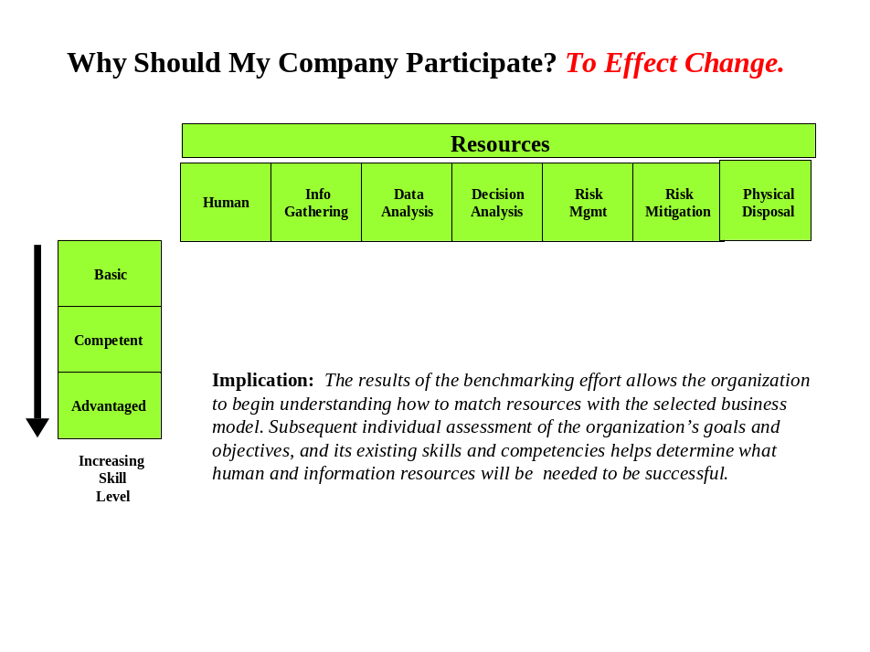Value of Study Participation
The goals of this study are for you to have a comprehensive understanding of the risks in volatile energy markets, and integrated strategies across the entire value chain, building core competencies in trading and risk management throughout the organization.

- Identify new, more effective work process to implement strategic change
- Learn where your company stands in relation to your peers and competitors
- Know what ranges of performance are feasible and realistic
- Obtain first-of-its-kind data --- there are few well-established performance metrics.
- Stay on top of changes in existing and emerging markets and the impacts on your business.
- Learn the characteristics of leading companies in this highly competitive and fast-paced market.

How to Participate
Meetings and teleconferencing can be arranged with interested companies and TERA professionals, as well as Alliance of Energy Suppliers’ staff. In addition, project information is available on the TERA web site at www.survey@teknecon.com

The process for participation will be time-effective and efficient. Background materials and questionnaires will be developed and interviews with relevant staff and senior management conducted. A password-secure web site will be established describing the benchmarking methodology and containing input screens.

The schedule to complete the study is:

 Final date registration date for participation December 1, 2000
 Roundtable Discussion to finalize survey metrics January 10, 2001
 Web-Site Live – easy data input screens in a
Password-protected site (on-line help) February 1, 2001
 Data Collection Complete March 1, 2001
 Preliminary Presentations – initial results and
opportunity to revise data April 1, 2001
 Final Presentations – ½ day with senior
Management June 2001

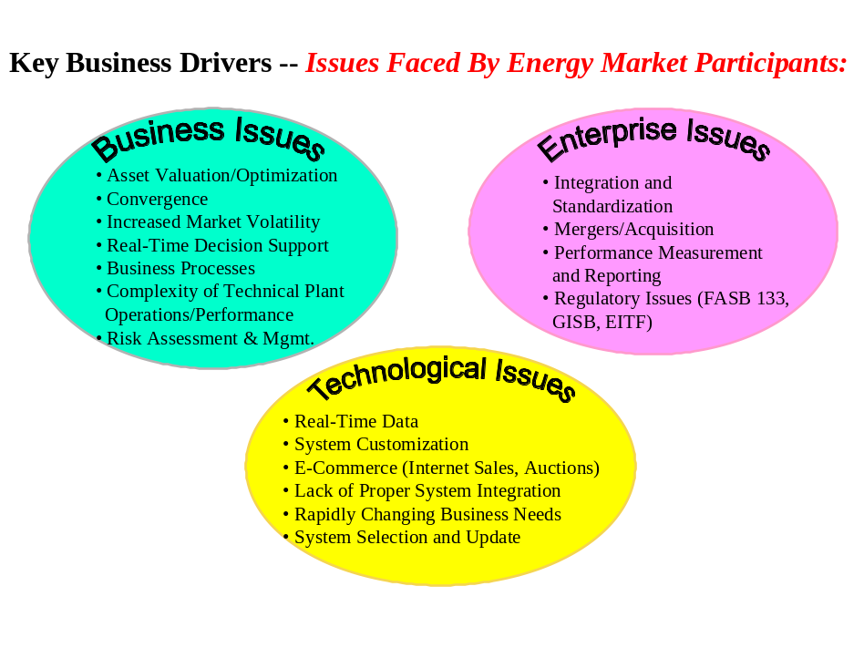
Industry leaders are innovative and opportunistic.

They are taking advantage of industry consolidation, the changing regulatory environment, and pursuing new sources of revenues. And senior management are making risk management programs an integral part of their business model to mitigate negative returns. The Energy Enterprise Trading and Risk Management study will help your company know where it stands, and if necessary, how to be better.



Teknecon Energy Risk Advisors (TERA), LLC is a consulting firm with focus in the oil, natural gas, and electricity industries. TERA’s business reputation is built on a thorough understanding of trading and risk management, and how the marketplace views energy companies through the drivers of shareholder value.

For more information, contact Theresa Sanders at 202-508-5183 – tsanders@eei.org

