Safety-Gated Test-Time Adaptation for Streaming APT Detection
Recovering Rare Reconnaissance-Stage Detection Without Sacrificing Data-Exfiltration Safety
Praxis Research Paper PX-001
Doctor of Engineering in AI/ML
Gary P.
July 2026
Status: Final Positive - Defense Ready

Abstract
Streaming intrusion detectors for advanced persistent threats (APTs) face an operational tension: rare early-stage activity such as Reconnaissance can collapse under source-level shift, but adaptation must not sacrifice high-consequence Data Exfiltration behavior. This paper evaluates a locked, validation-selected, safety-gated test-time adaptation (TTA) policy for an Unraveled APT source-file holdout. The method adapts only BatchNorm behavior of a frozen support-floor MLP over the unlabeled target stream, then uses a selective gate to rescue likely Reconnaissance predictions while protecting Data Exfiltration. On the locked test split, Macro F1 improves from 0.7685 to 0.8658 and Reconnaissance F1 improves from 0.0250 to 0.5050, while Data Exfiltration F1 changes from 0.9157 to 0.9202 and override rate remains 0.0470. A matched-rate frozen confidence-reject baseline leaves Reconnaissance F1 at 0.0000, ruling out a simple uncertainty filtering explanation. The defended claim is bounded to the tested Unraveled feature pipeline and held-out source-file split; DAPT2020 remains a negative external-validity boundary for cross-dataset TTA transfer.
Keywords: advanced persistent threats; intrusion detection; test-time adaptation; BatchNorm adaptation; class imbalance; distribution shift; safety gating; streaming detection

1. Introduction
APT detection is not only a classification problem; it is an operational control problem. A detector that improves rare-stage recall by degrading a high-risk destructive stage is not deployable. PX-001 studies whether no-label deployment-time adaptation can recover weak Reconnaissance detection while preserving Data Exfiltration behavior under a realistic held-out source-file shift.
- A safety-gated selective TTA policy adapts only BatchNorm behavior and leaves learned model weights frozen.
- A locked evaluation protocol separates validation-selected gate thresholds from final test replay.
- The result is a +0.4800 absolute Reconnaissance F1 gain and +0.0974 Macro F1 gain with Data Exfiltration preserved.
- Negative and boundary evidence is retained, including the DAPT2020 TTA transfer failure.

2. Background and Related Work

2.1 APT stage classification and class imbalance
APT campaigns contain stages with uneven support and consequence. Early Reconnaissance is rare and easily missed, while Data Exfiltration is operationally severe. The metric frame therefore emphasizes Macro F1, Reconnaissance F1, and Data Exfiltration F1 rather than accuracy alone.

2.2 Test-time adaptation
TTA updates behavior at deployment using unlabeled target data. BatchNorm-statistic adaptation and entropy-minimization methods show that source-free target adaptation can improve robustness, but security settings require class-aware safety constraints.

2.3 Selective prediction and safety gating
The PX-001 gate is selective but not merely abstention. It arbitrates between a frozen and adapted prediction while enforcing a protected-class rule for Data Exfiltration.

3. Problem Setting and Threat Model
The system under test is a streaming APT stage classifier: a frozen support-floor MLP trained on the Unraveled APT feature pipeline. The target stream is unlabeled during adaptation. The safety envelope has two constraints: Data Exfiltration primacy and bounded intervention. The policy may override only a small fraction of predictions and must not degrade the protected class beyond the registered safety floor.

4. Method
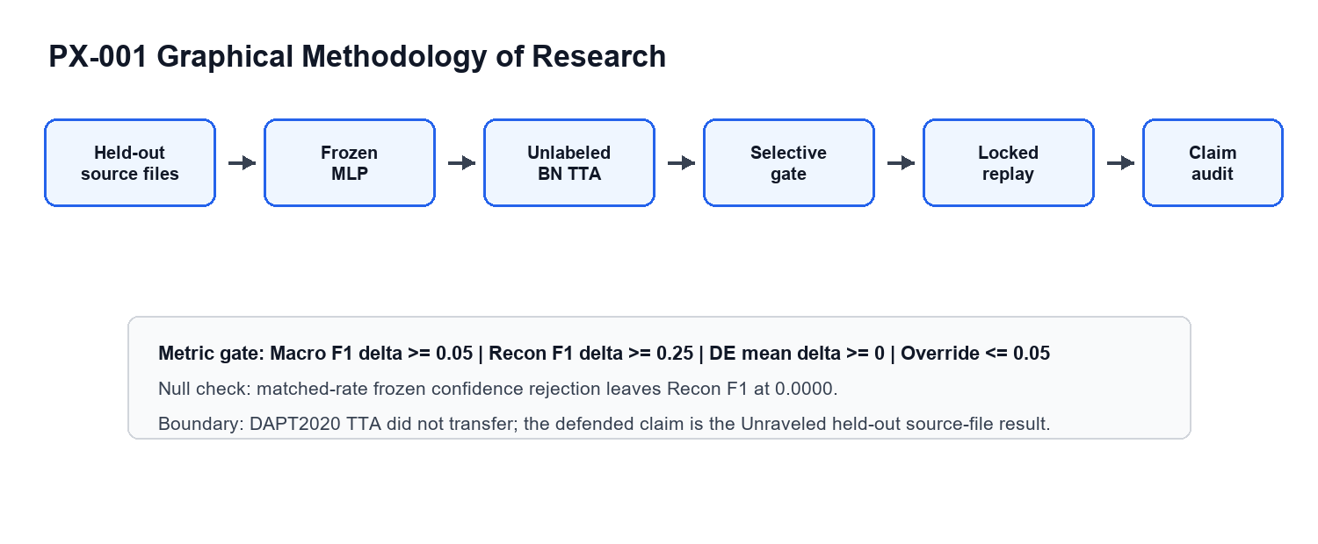
Figure 1. PX-001 GMR and safety-gated TTA workflow.

4.1 Frozen base detector
The base model is a support-floor MLP trained on source data and then frozen. The TTA experiment does not retrain the classifier weights.

4.2 BatchNorm test-time adaptation
Let f_theta(x) be the frozen MLP and BN_phi be the BatchNorm statistics adapted on the unlabeled target stream. The adapted path produces y_tta = argmax f_theta,BN_phi(x), while the frozen path produces y_frozen = argmax f_theta(x).

4.3 Locked safety gate
- Rule 1: preserve confident frozen Data Exfiltration predictions.
- Rule 2: accept the adapted prediction when it rescues Reconnaissance above the registered threshold.
- Rule 3: otherwise accept adaptation only for low-confidence frozen predictions; default to the frozen model.
Final prediction: y_hat = g(x) * y_tta + (1 - g(x)) * y_frozen, where g(x) is the deterministic locked gate. The safety objective is lexicographic: recover Reconnaissance when possible, but do not trade away protected Data Exfiltration behavior.

5. Experimental Setup
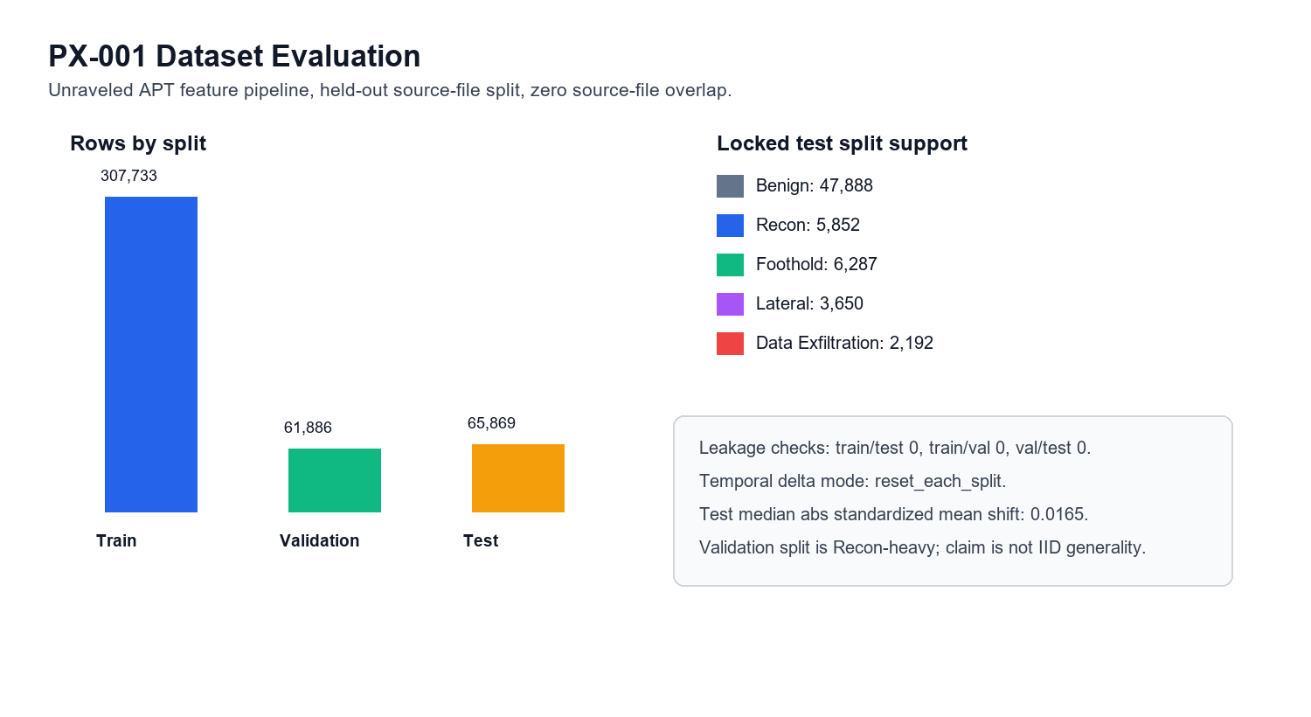
Figure 2. PX-001 dataset split, leakage checks, and feature-shift summary.

5.1 Dataset and split
Split | Rows | Source files | Capture days | Benign | Recon | Foothold | Lateral | DE
Train | 307,733 | 142 | 25 | 268,710 | 5,151 | 15,047 | 15,748 | 3,077
Validation | 61,886 | 6 | 1 | 22,011 | 23,791 | 5,784 | 8,047 | 2,253
Test | 65,869 | 25 | 5 | 47,888 | 5,852 | 6,287 | 3,650 | 2,192

Train/validation/test source-file overlap is 0, and temporal delta state is reset within each split. The validation split is Recon-heavy, so the result is framed as a deployment-shift adaptation result rather than IID generalization.

5.2 Metrics and gates
- Macro F1 delta must be at least +0.05.
- Reconnaissance F1 delta must be at least +0.25.
- Mean Data Exfiltration F1 delta must be nonnegative.
- Override rate must be at most 0.05 in the locked replay.
- Matched-rate frozen confidence rejection must not explain the Reconnaissance gain.

6. Results

6.1 Primary locked replay
Metric | Frozen MLP | Locked selective TTA | Delta
Accuracy | 0.8984 | 0.9243 | +0.0260
Macro F1 | 0.7685 | 0.8658 | +0.0974
Recon F1 | 0.0250 | 0.5050 | +0.4800
Data Exfiltration F1 | 0.9157 | 0.9202 | +0.0045
PR-AUC | 0.8732 | 0.8738 | +0.0006
Override/reject rate | 0.0000 | 0.0470 | +0.0470

All four registered gates pass. The PR-AUC delta is small, so the correct interpretation is an operating-point and safety-gate improvement, not a broad probability-ranking improvement.

6.2 Seven-seed defense replay
Metric | Frozen 7-seed | Selective TTA 7-seed | Interpretation
Macro F1 | 0.7165 | 0.8341 | Positive extension
Recon F1 | 0.0615 | 0.5219 | Rare-stage rescue persists
Changed-from-DE count | 0 | 0 | Protected-class behavior preserved

6.3 Matched confidence-reject null
Control | Reject/override rate | Kept Macro F1 | Kept Recon F1 | Kept DE F1
Frozen confidence reject | 0.0470 | 0.7730 | 0.0000 | 0.9374

The matched-rate confidence-reject control leaves Reconnaissance F1 at 0.0000, so the result is not explained by touching the same percentage of uncertain rows.

7. Claim Boundary and Limitations
- Allowed claim: under the tested Unraveled held-out source-file split, safety-gated no-label TTA recovers rare Reconnaissance detection while preserving Data Exfiltration behavior.
- Not claimed: universal APT detection, universal TTA safety, DAPT2020 TTA transfer, or adversarial target-stream poisoning robustness.
- Known boundary: DAPT2020 detector-recipe transfer is useful appendix evidence, but DAPT2020 TTA feasibility is negative and does not support cross-dataset TTA generality.

8. Discussion
PX-001 is strongest when defended as an engineering design: a safety gate turns a useful but potentially risky adaptation mechanism into a constrained operational control. The result supports adapting at deployment only when protected-class behavior and override rate are explicitly monitored.

9. Conclusion
A locked, validation-selected, safety-gated TTA policy rescued Reconnaissance-stage APT detection and improved Macro F1 while preserving Data Exfiltration behavior. PX-001 is defense-ready as a bounded positive result.

10. Evidence Artifacts
- reports/tta_streaming_apt/PRAXIS06_PAPER_READY_FINAL_REPORT_20260513.md
- reports/tta_streaming_apt/paper_assets_20260509/tables/table1_main_result.csv
- reports/tta_streaming_apt/paper_assets_20260509/tables/table3_split_counts.csv
- reports/tta_streaming_apt/cloud_paper_hardening_20260513/tta_cloud_paper_audit_summary.json
- reports/praxis_defense_validation/PX001_PX050_DEFENSE_VALIDATION_20260710.md
- scripts/run_tta_locked_final.py
- scripts/run_tta_defense_hardening.py

References
Ioffe, S., & Szegedy, C. (2015). Batch normalization: Accelerating deep network training by reducing internal covariate shift. Proceedings of the 32nd International Conference on Machine Learning, 37, 448-456. https://arxiv.org/abs/1502.03167
Schneider, S., Rusak, E., Eck, L., Bringmann, O., Brendel, W., & Bethge, M. (2020). Improving robustness against common corruptions by covariate shift adaptation. Advances in Neural Information Processing Systems, 33.
Sharafaldin, I., Lashkari, A. H., & Ghorbani, A. A. (2018). Toward generating a new intrusion detection dataset and intrusion traffic characterization. Proceedings of the 4th International Conference on Information Systems Security and Privacy, 108-116. https://doi.org/10.5220/0006639801080116
Strom, B. E., Applebaum, A., Miller, D. P., Nickels, K. C., Pennington, A. G., & Thomas, C. B. (2020). MITRE ATT&CK: Design and philosophy. The MITRE Corporation. https://www.mitre.org/news-insights/publication/mitre-attck-design-and-philosophy
Sun, Y., Wang, X., Liu, Z., Miller, J., Efros, A. A., & Hardt, M. (2020). Test-time training with self-supervision for generalization under distribution shifts. Proceedings of the 37th International Conference on Machine Learning.
Wang, D., Shelhamer, E., Liu, S., Olshausen, B., & Darrell, T. (2021). Tent: Fully test-time adaptation by entropy minimization. International Conference on Learning Representations. https://openreview.net/forum?id=uXl3bZLkr3c
Praxis Research. (2026). PX-001/PX-050 defense validation summary [Repository report]. reports/praxis_defense_validation/PX001_PX050_DEFENSE_VALIDATION_20260710.md

Appendix A: Portable Audit Logic
DATA_EXFILTRATION = "Data Exfiltration"
RECONNAISSANCE = "Reconnaissance"

def selective_tta_prediction(frozen_label, frozen_confidence, tta_label, tta_confidence,
uncertainty_threshold=0.50,
recon_rescue_threshold=0.50,
de_keep_threshold=0.00):
if frozen_label == DATA_EXFILTRATION and frozen_confidence >= de_keep_threshold:
return frozen_label
if tta_label == RECONNAISSANCE and tta_confidence >= recon_rescue_threshold:
return tta_label
if frozen_confidence < uncertainty_threshold:
return tta_label
return frozen_label

