Deterministic Tool-Boundary Gates for Agentic Package-Install Hallucination
A Completed Praxis Evaluation of PyPI/NPM Install-Action Verification
Praxis Research Paper PX-050
Doctor of Engineering in AI/ML
Gary P.
July 2026
Status: Lead Final Positive - Defense Ready

Abstract
Agentic coding systems can transform model-generated package hallucinations into install actions. PX-050 evaluates a deterministic package-install gate placed at the observable tool boundary. Across fixed fixtures, live model command strings, parser stress tests, controller/extractor repair, crafted adaptive stress, and a two-model dry-run live-agent tool-call corpus, the hardened verifier produced zero observed invalid allows under the defended corpora while preserving valid install utility. In the final 288-row Qwen/DeepSeek dry-run live-agent corpus, raw/no-gate unsafe rate was 0.9453, controller target recovery was 0.9757, registry-only validation allowed 20 invalid actions, hardened validation allowed 0 invalid actions, and valid allow rate was 1.0000. The defended claim is bounded: the result concerns observable PyPI/NPM install command strings and dry-run tool-call arguments before execution; it does not prove broad agent safety, malicious-existing-package detection, arbitrary shell safety, or post-install runtime protection.
Keywords: package hallucination; slopsquatting; agentic AI; deterministic verifier; tool boundary; software supply chain security

1. Introduction
Package hallucination becomes operationally dangerous when a coding agent turns a fabricated package name or unsafe install string into a tool call. PX-050 tests a deployable control point: before a package manager executes, a deterministic verifier parses and validates the proposed install action.
- The gate is deterministic and external to hidden model reasoning.
- The final evaluation uses two open-weight coding models in a dry-run live-agent harness.
- The hardened policy is compared against raw/no-gate and registry-only baselines.
- Boundary results, including failed raw/strict StarCoder evidence, are preserved instead of removed.

2. Background and Related Work
Prior package hallucination work establishes that code-generating LLMs can recommend package names that do not exist. Slopsquatting converts such names into a supply-chain attack path when attackers register hallucinated names. PX-050 contributes a measured tool-boundary defense rather than another model-only mitigation.

3. Methodology
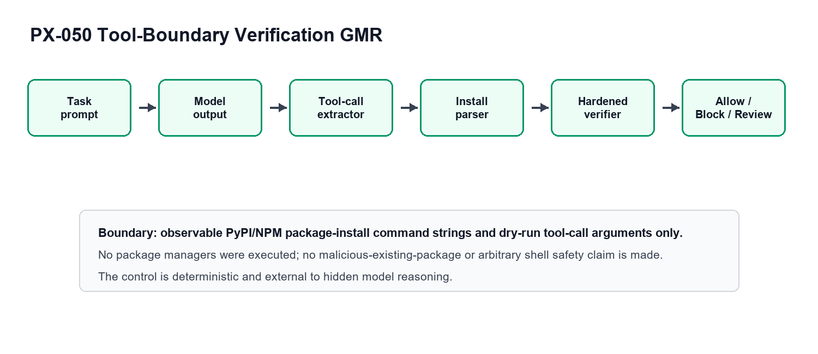
Figure 1. PX-050 package-install tool-boundary GMR.

3.1 System under test
The gate accepts a dry-run model output or tool-call argument, extracts a candidate install command, parses package targets and syntax, checks registry and policy evidence, and returns allow, block, or review. No package manager is executed.

3.2 Verifier formalization
- Let r be a dry-run model output or tool-call argument.
- Let c = extract(r) be the controller-selected install command.
- Let p = parse(c) return ecosystem, package targets, syntax flags, and parse status.
- Let e(p) be registry-existence evidence for target packages.
- Let s(p) be policy-safety evidence, including remote source, shell-chain, malformed, no-target, and unsupported-manager checks.
- The hardened decision h(r) is allow only when parse, target recovery, registry evidence, and policy-safety checks pass; otherwise the action is blocked or reviewed.

3.3 Corpora
Corpus | Rows | Invalid | Valid | Role
Fixed adaptive gate | 138 | - | - | Deterministic baseline fixture
Parser stress | 984 | 600 | 384 | Inert parser mutation robustness
PX-050S held-out controller repair | 440 | 240 | 200 | StarCoder controller/extractor repair
PX-050T crafted adaptive stress | 1,440 | 1,140 | 300 | Adaptive raw-output stress
PX-050U/V final live-agent corpus | 288 | 128 | 160 | Two-model dry-run tool-call evidence

4. Results
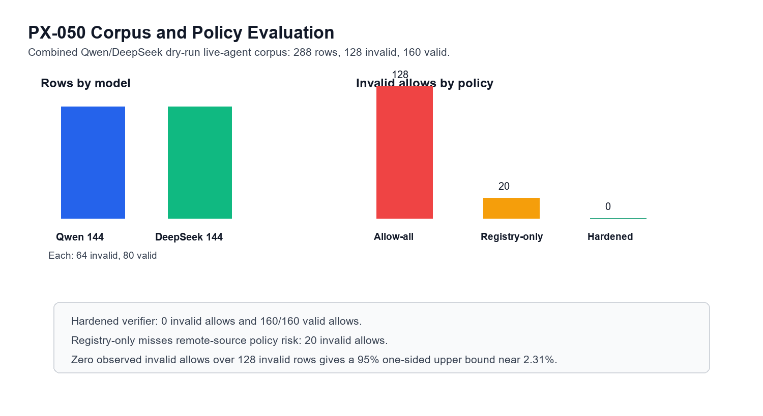
Figure 2. PX-050 corpus and policy evaluation.

4.1 Final two-model dry-run live-agent result
Category | Rows | Invalid | Valid | Registry invalid allows | Hardened invalid allows | Hardened valid allows
Qwen2.5-Coder | 144 | 64 | 80 | 10 | 0 | 80
DeepSeek-Coder | 144 | 64 | 80 | 10 | 0 | 80
Combined | 288 | 128 | 160 | 20 | 0 | 160

Metric | Value
Raw/no-gate unsafe rate | 0.9453
Controller target recovery | 0.9757
Registry-only invalid allow count | 20
Hardened invalid allow count | 0
Valid allow rate | 1.0000
Policy review rate | 0.0243
Provenance alert recall | 1.0000

4.2 Stress and repair results
Run | Rows | Key result | Interpretation
Parser stress | 984 | Hardened escape 0.0000; valid clean allow 1.0000 | Parser robust to inert mutations
PX-050S controller repair | 440 | Invalid allows 0; valid allow 1.0000 | Deployment boundary repair succeeds
PX-050T adaptive stress | 1,440 | Invalid allows 0; valid allow 1.0000 | Crafted strings did not bypass hardened gate
PX-051V policy refresh | 288 | Hardened security 1.0000; utility 1.0000 | Security-utility operating point is deployable
PX-052V provenance refresh | 288 | Alert recall 1.0000; clean FPR 0.0000 | Observable lineage sufficient in this corpus

4.3 Zero-event interpretation
Evidence set | Observed invalid allows | Invalid rows | Exact one-sided 95% upper bound
Two-model live-agent corpus | 0 | 128 | 2.31%
Parser-stress invalid rows | 0 | 600 | 0.50%
Controller adaptive invalid rows | 0 | 1,140 | 0.26%

The defense wording must be zero observed invalid allows. The data do not support saying zero possible escapes.

4.4 Worked examples
Example | Pattern | Hardened decision | Defense interpretation
Valid package | npm install commander / pip install rich | allow | Preserves normal dependency setup
Nonexistent target | pip install praxis_fake_20260705_pkg | block | Blocks slopsquatting-style invalid target
Remote source | npm install https://example.invalid/pkg.tgz | block/review | Shows why registry-only is insufficient
Shell chain | pip install validpkg && curl example.invalid | block/review | Keeps package gate separate from arbitrary shell safety
No target recovered | Explanatory text without parseable install target | review | Avoids unsafe automatic allow

5. Discussion
PX-050 is strongest as a deployable systems result. It does not require the model to be honest or introspectable; it validates the observable effect before execution. The registry-only baseline matters because it shows that existence checks alone miss policy-unsafe install forms, especially remote-source style commands.
- Allowed claim: deterministic validation at the PyPI/NPM package-install tool boundary blocked observed invalid or policy-unsafe install actions in measured dry-run corpora while preserving valid utility.
- Not claimed: malicious-existing-package detection, package-content malware analysis, arbitrary shell safety, hidden chain-of-thought monitoring, post-install runtime safety, or broad agent safety.
- Boundary evidence: raw/strict StarCoder runs failed promotion gates and are retained as evidence that raw text is not the correct deployment boundary.

6. Conclusion
PX-050 is a lead defense-ready positive. It shows that a deterministic tool-boundary verifier can close observed package-install hallucination risk in measured PyPI/NPM dry-run corpora while preserving valid install utility.

7. Evidence Artifacts
- reports/agentic_deployment_defense/px050_final_defense_package_export_20260705/PX050_FINAL_DEFENSE_PACKAGE_EXPORT_20260705.md
- reports/agentic_deployment_defense/px050_live_agent_two_model_determination_20260705/summary.json
- reports/agentic_deployment_defense/px050uv_live_agent_combined_corpus_20260705/combined_live_agent_tool_calls.csv
- reports/agentic_deployment_defense/px051v_live_agent_policy_refresh_20260705/summary.json
- reports/agentic_deployment_defense/px052v_live_agent_provenance_refresh_20260705/summary.json
- reports/praxis_defense_validation/PX001_PX050_DEFENSE_VALIDATION_20260710.md
- scripts/run_d1_live_agent_corpus_refresh.py
- scripts/run_px050_parser_stress_appendix.py
- scripts/run_px050s_controller_adaptive_stress.py

References
Guo, D., Zhu, Q., Yang, D., Xie, Z., Dong, K., Zhang, W., Chen, G., Bi, X., Wu, Y., Li, Y. K., Luo, F., Xiong, Y., & Liang, W. (2024). DeepSeek-Coder: When the large language model meets programming. arXiv. https://arxiv.org/abs/2401.14196
Hui, B., Yang, J., Cui, Z., Yang, J., Liu, D., Zhang, L., Liu, T., Zhang, J., Yu, B., Lu, K., Dang, K., Fan, Y., Zhang, Y., Yang, A., Men, R., Huang, F., Zheng, B., Miao, Y., Quan, S., Feng, Y., Ren, X., Zhou, J., & Lin, J. (2024). Qwen2.5-Coder technical report. arXiv. https://arxiv.org/abs/2409.12186
Lozhkov, A., Li, R., Ben Allal, L., Cassano, F., Lamy-Poirier, J., Tazi, N., Tang, A., Pykhtar, D., Liu, J., Wei, Y., Liu, T., Tian, M., Kocetkov, D., Zucker, A., Belkada, Y., Wang, Z., Liu, Q., Abulkhanov, D., Paul, I., et al. (2024). StarCoder 2 and The Stack v2: The next generation. arXiv. https://arxiv.org/abs/2402.19173
Spracklen, J., Wijewickrama, R., Sakib, A. H. M. N., Maiti, A., Viswanath, B., & Jadliwala, M. (2025). We have a package for you! A comprehensive analysis of package hallucinations by code generating LLMs. 34th USENIX Security Symposium, 3687-3706. https://www.usenix.org/conference/usenixsecurity25/presentation/spracklen
Praxis Research. (2026). PX-001/PX-050 defense validation summary [Repository report]. reports/praxis_defense_validation/PX001_PX050_DEFENSE_VALIDATION_20260710.md

Appendix A: Portable Verifier Pseudocode
def hardened_install_decision(raw_output):
command = extract_install_command(raw_output)
if not command:
return "review"
parsed = parse_install_command(command)
if not parsed.ok or not parsed.packages:
return "review"
if parsed.has_shell_chain or parsed.has_remote_source or parsed.unsafe_syntax:
return "block"
if not all(registry_exists(pkg, parsed.ecosystem) for pkg in parsed.packages):
return "block"
return "allow"

