PX-057

Adaptive Stopping to Prevent
LLM Overthinking
  - A preregistered Gate 2 evaluation of answer stability, uncertainty, and compute-aware early stopping
FINAL PRAXIS PAPER / VALID POSITIVE RESULT
Prepared by Gary Pagan
Final evidence date: July 24, 2026
Experiment stage: Gate 2 complete; H1-H3 passed; H4 transfer pending
CLAIM BOUNDARY
This document reports one frozen 200-item GSM8K sample, Qwen2.5-7B-Instruct, and one eight-round iterative prompting protocol. It does not claim cross-model, cross-domain, or large-scale robustness.

ABSTRACT
Extended test-time reasoning can improve difficult answers, but it can also cause a model to abandon a correct answer. PX-057 tested whether a frozen adaptive stopping rule could preserve accuracy while reducing generated-token use. The experiment evaluated 200 deterministically sampled GSM8K test questions with Qwen2.5-7B-Instruct under eight sequential reconsideration rounds. The primary policy stopped after round 2 when the normalized answer remained stable for two consecutive rounds and both rounds exceeded a mean-token-probability proxy of 0.05; otherwise it continued through round 8. The independent completeness audit verified 200 unique questions, 200 complete traces, 1,600 unique question-round generations, the frozen dataset hash, and the registered model identity. Adaptive accuracy was 91.0%, compared with 61.5% for fixed-long inference and 88.0% for fixed-short inference. The policy saved 66.5% of generated tokens on average (bootstrap 95% CI 63.7%-69.1%), prevented 60 of 67 observed correct-to-wrong events (89.6%; bootstrap 95% CI 82.1%-95.5%), and harmed 1 of 200 questions (0.5%). All preregistered H1-H3 gates passed. However, adaptive stopping tied the answer-stability control, so the confidence condition did not add observable accuracy in this setting. The result supports a bounded deployment proposition for this model, sample, and prompting protocol; cross-model and cross-domain transfer (H4) remains untested.
KEYWORDS
large language models; test-time compute; adaptive stopping; overthinking; GSM8K; reproducible evaluation

1. Executive Finding
PX-057 is a valid positive Gate 2 result. The strongest demonstrated fact is not that all LLM reasoning should stop early; it is that repeatedly prompting this model to reconsider the same GSM8K answer through eight rounds caused substantial correct-to-wrong degradation, and a preregistered early stability gate avoided most of it.
Decision dimension | Observed result | Interpretation
Scientific validity | Independent completeness audit passed | The frozen sample, model identity, traces, generations, and gate outputs were internally consistent.
Primary comparison | 91.0% adaptive vs. 61.5% fixed-long | Adaptive stopping improved accuracy by 29.5 percentage points under the tested iterative protocol.
Efficiency | 66.5% mean generated-token saving | The policy used roughly one-third of the fixed-long generated-token budget.
Safety of stopping | 1/200 early-stop harm | The 0.5% observed harm rate remained below the preregistered 2% ceiling.
Mechanism nuance | Adaptive tied answer stability at 91.0% | The stability signal carried the observed performance; confidence added no measured accuracy benefit.
External validity | H4 pending | No cross-model, non-math, sampling, or prompt-transfer claim is supported yet.

2. Problem and Literature Basis

2.1 Why the experiment was necessary
Test-time scaling research shows that additional inference compute can improve reasoning, but the benefit depends on problem difficulty and allocation strategy. Snell et al. found that compute-optimal allocation can outperform uniform strategies, while Muennighoff et al. showed that forcing additional reasoning can sometimes repair an answer. These findings motivate more compute, but they do not imply that more compute is always beneficial.
The direct foundation for PX-057 is Zhou et al.'s 2026 study, which reports diminishing marginal returns at larger reasoning budgets, correct-to-wrong answer abandonment, and difficulty-dependent optimal reasoning lengths. That work identifies the phenomenon and shows that moderate stopping can reduce cost while maintaining comparable accuracy. PX-057 converts that observation into a deployable control question: can a precommitted, label-free rule stop before a harmful reversal without creating too many premature errors?

2.2 Praxis gap
A practical stopping control must decide from information available at inference time. Gold correctness cannot be used to stop. PX-057 therefore combines two observable signals: normalized answer stability and a confidence proxy derived from generated-token probabilities. It evaluates the policy against fixed-short, fixed-long, stability-only, uncertainty-only, and oracle reference arms.

2.3 Research question
Can a frozen answer-stability-plus-confidence rule reduce generated-token use and prevent correct-to-wrong reversals while preserving accuracy relative to an eight-round fixed-long protocol?

3. Hypotheses and Preregistered Gates
ID | Hypothesis | Frozen pass criterion | Outcome
H1 | Preserve accuracy while saving compute | Accuracy delta vs. fixed-long >= -1 pp and mean saving >= 20% | PASS: +29.5 pp; 66.5%
H2 | Prevent harmful overthinking | Prevent at least 25% of observable events | PASS: 60/67; 89.6%
H3 | Avoid excessive premature errors | Early-stop harm <= 2% of all traces | PASS: 1/200; 0.5%
H4 | Transfer without retuning | H1 and H3 pass in a frozen held-out domain | PENDING: not tested in Gate 2

The preregistration was written before the scientific result. No post-result threshold change is part of this determination. Gate 2 adjudicated H1-H3 only; H4 was explicitly reserved for transfer testing.

4. Method

4.1 Experimental design
The study used a repeated-reconsideration trace design. Each question received an initial deterministic solution followed by seven deterministic prompts to reconsider the previous proposed solution, for a maximum of eight rounds. Each response ended in a numeric final answer that was normalized and compared with the GSM8K gold answer.
Component | Frozen specification
Model | Qwen/Qwen2.5-7B-Instruct
Dataset | OpenAI GSM8K test split; frozen SHA-256 3730d312f6e3440559ace48831e51066acaca737f6eabec99bccb9e4b3c39d14
Sample | 200 unique questions; deterministic seed 57
Generation | Greedy decoding (do_sample=False); max 256 new tokens per round
Trace budget | 8 sequential rounds per question
Primary policy | Minimum round 2; patience 2; confidence threshold 0.05
Compute measure | Cumulative generated tokens; saving = 1 - adaptive tokens / fixed-long tokens
Execution | AWS SageMaker job px057-gate2-full-retry-2026-07-24-14-55-01-066

4.2 Stopping signals
Answer stability was satisfied when the normalized extracted answer was identical across the two most recent rounds. Confidence was computed as exp(mean normalized transition log-probability) over generated tokens, clipped to a numerically safe range. The result is a sequence-level mean-token-probability proxy, not a calibrated probability that the answer is correct.
At each round from round 2 onward, the adaptive rule stopped at the first point where both recent answers were stable and both confidence values were at least 0.05. If no point qualified, it returned the round-8 answer. The policy never observed the gold label.

4.3 Comparison arms
- Fixed-short: return the answer at round 2.
- Fixed-long: return the answer at round 8; the primary preregistered baseline.
- Answer-stability: stop after two identical normalized answers, without confidence.
- Uncertainty-only: stop at the first round at or after round 2 whose confidence proxy reaches 0.05.
- Adaptive: require both two-round answer stability and confidence at or above 0.05.
- Oracle best step: return the first correct eligible answer; descriptive ceiling only and not deployable.

4.4 Outcome definitions
- Overthinking event: at least one correct eligible answer before round 8, followed by an incorrect round-8 answer.
- Prevented overthinking: the adaptive answer is correct on a trace classified as an overthinking event.
- Early-stop harm: round 8 is correct but the adaptive answer is incorrect.
- Generated-token saving: one minus cumulative adaptive generated tokens divided by cumulative round-8 generated tokens.
- Accuracy: exact match between the normalized extracted numeric answer and the GSM8K gold answer.

4.5 Integrity and reproducibility controls
An independent adjudication script compared the cloud artifacts with the frozen configuration. It verified experiment and model identifiers, dataset hash, sample size, round count, 200 unique selected IDs, 200 complete traces, and exactly 1,600 unique and complete question-round pairs. It also recomputed the required gate-decision set and recorded SHA-256 hashes for the four core evidence files.

5. Results
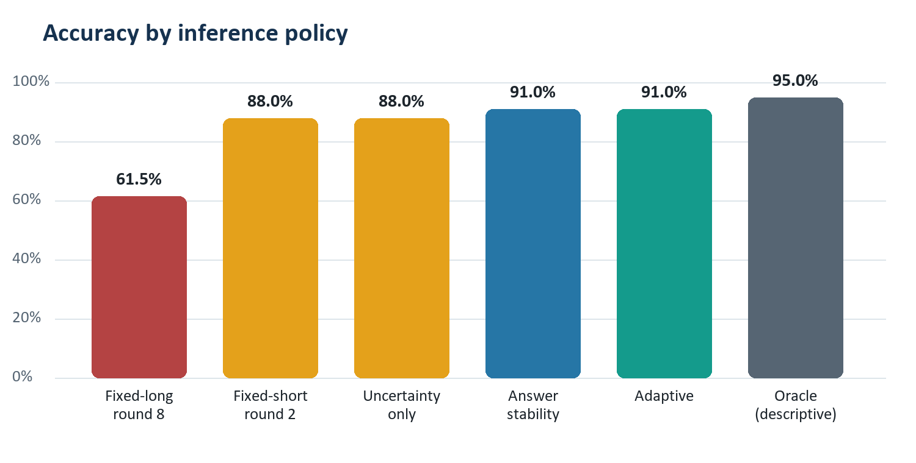
Figure 1. Accuracy for all registered arms. The oracle is descriptive and not deployable.
Arm | Correct / 200 | Accuracy | Difference vs. fixed-long
Fixed-long, round 8 | 123 | 61.5% | Reference
Fixed-short, round 2 | 176 | 88.0% | +26.5 pp
Uncertainty-only | 176 | 88.0% | +26.5 pp
Answer stability | 182 | 91.0% | +29.5 pp
Adaptive | 182 | 91.0% | +29.5 pp
Oracle best step | 190 | 95.0% | +33.5 pp

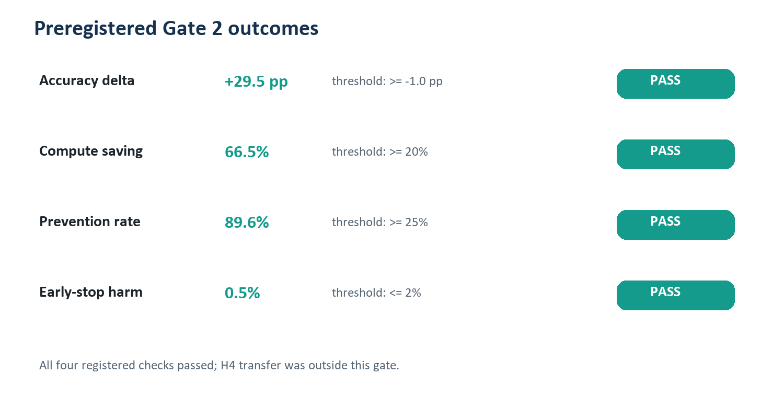
Figure 2. Every Gate 2 threshold passed. H4 was not part of this adjudication.
Metric | Estimate | Uncertainty / count | Registered threshold
Adaptive accuracy delta | +29.5 pp | Descriptive difference | >= -1.0 pp
Mean generated-token saving | 66.5% | Bootstrap 95% CI 63.7%-69.1% | >= 20%
Overthinking prevention | 89.6% | 60/67; bootstrap 95% CI 82.1%-95.5% | >= 25%
Early-stop harm | 0.5% | 1/200 | <= 2%

The adaptive policy returned 182 correct answers. Fixed-long inference returned 123 correct answers, meaning that the repeated reconsideration protocol degraded aggregate performance sharply by round 8. Sixty-seven traces satisfied the preregistered overthinking definition; the adaptive policy retained a correct answer on 60 of them. One trace moved in the opposite direction: fixed-long was correct while the adaptive return was wrong.

6. Interpretation

6.1 What the experiment demonstrates
- Under this frozen iterative prompting protocol, additional reconsideration frequently reduced answer correctness.
- A two-round stability gate was sufficient to avoid most observed correct-to-wrong reversals.
- The registered adaptive policy simultaneously exceeded the accuracy non-inferiority gate, the compute-saving gate, the prevention gate, and the harm ceiling.
- The experiment is reproducible at the artifact level because the sample, configuration, trace corpus, raw outputs, and hashes are preserved.

6.2 What the experiment does not demonstrate
- It does not show that early stopping improves every model, task, prompt, or decoding regime.
- It does not establish performance on the full GSM8K test set; 200 questions were evaluated.
- It does not establish cross-domain or cross-model robustness; H4 remains pending.
- It does not prove that the confidence proxy is calibrated or causally useful.
- It does not compare production latency, energy, or dollar cost directly; generated tokens are the registered compute proxy.

6.3 Why the stability-control tie matters
The adaptive and answer-stability arms both achieved 91.0% accuracy. Therefore, the result supports answer stability as the effective observable signal in this run, but it does not support an incremental accuracy claim for the confidence threshold. A production design should treat the confidence component as unvalidated until an ablation across models and domains shows a consistent benefit, lower harm, or better latency.

6.4 Relationship to the source literature
Zhou et al. identify diminishing returns and correct-answer abandonment at larger reasoning budgets. PX-057 reproduces the core operational concern in a different, deliberately simple protocol and tests a deployable stopping rule. The current result aligns with the source paper's argument that uniform compute allocation is suboptimal, while extending it from description to a preregistered safety-and-efficiency gate. It is not a direct reproduction of the source paper's full model, task, or token-budget matrix.

7. Validity Assessment
Validity dimension | Risk | Assessment and mitigation
Internal | Round-specific prompting may induce degradation | The degradation is real for the frozen protocol, but should not be generalized to natural uninterrupted reasoning. Fixed-short and fixed-long arms make the protocol effect visible.
Construct | Confidence proxy is not calibrated correctness | Reported explicitly as mean-token probability. Stability-only and uncertainty-only ablations separate signal contributions.
Statistical | Single 200-item sample | Bootstrap intervals are reported for saving and prevention. No unregistered significance claim is made.
External | One model and math dataset | Claim is bounded; H4 requires a second open model and non-math corpus without retuning.
Measurement | Numeric extraction can mis-score malformed outputs | Exact extraction and normalization code are frozen; future work should include a blinded manual scorer audit.
Operational | Generated tokens do not equal end-to-end cost | Future replication should record latency, GPU-seconds, energy, and dollar cost alongside tokens.

8. Praxis Contribution and Recommended Next Gate
The Praxis contribution is a verification-gated inference control: stop only when a frozen observable rule qualifies, quantify both prevented degradation and stopping harm, and refuse broad deployment claims until transfer gates pass. This reframes adaptive compute as a safety case rather than only an efficiency optimization.
The next investment should be a frozen H4 replication matrix:
- Retain the current 200-item Qwen/GSM8K result unchanged as the discovery experiment.
- Add at least one second open model with the same six arms and no threshold adjustment after test inspection.
- Add a non-math reasoning corpus with deterministic scoring or blinded adjudication.
- Predefine a validation-only threshold-selection process, then lock thresholds for held-out testing.
- Measure wall-clock latency, GPU-seconds, and cost in addition to generated tokens.
- Require the confidence component to beat or reduce harm relative to stability-only before retaining it in the final production policy.

9. Conclusion
PX-057 passed its preregistered Gate 2 evaluation. On 200 frozen GSM8K questions, Qwen2.5-7B-Instruct achieved 91.0% accuracy with adaptive stopping versus 61.5% after eight forced reconsideration rounds, while saving 66.5% of generated tokens, preventing 60 of 67 observed overthinking events, and producing one early-stop harm. The result is strong enough to justify H4 investment and a bounded Praxis claim. It is not yet sufficient for a general robustness claim. The scientifically defensible conclusion is that answer-stability stopping is promising and operationally testable, while transfer and the incremental value of confidence remain open questions.

Data, Code, and Evidence Availability
Artifact | Repository location / identifier
Preregistration | reports/adaptive_stopping_overthinking/PX057_ADAPTIVE_STOPPING_PREREG_20260723.md
Frozen configuration | configs/px057_adaptive_stopping_gate2_full_20260724.json
Trace collection | scripts/run_px057_trace_collection.py
Policy evaluation | scripts/run_px057_adaptive_stopping_gate.py
Independent adjudication | scripts/adjudicate_px057_adaptive_stopping.py
Verified determination | reports/adaptive_stopping_overthinking/gate2_full_determination_20260724/summary.json
Cloud job | px057-gate2-full-retry-2026-07-24-14-55-01-066
Cloud output | s3://praxis-garypagan-272615233626-us-east-1/experiments/px057-adaptive-stopping/gate2-full-20260724/output/.../model.tar.gz

Core evidence SHA-256 hashes: selected_rows.json 6203c728f838fda9b932f69c83f7c90eb2e04c65045b24071d5347d4aaa6fc7e; reasoning_traces.jsonl d1221cab111650111e2cb8aa0b03a6b3c99b2bc0738c222cd078ab8935ad9b8c; raw_generations.jsonl 5f63edfe41c1b4cd47d3678eba133ae0c139164743265d49cfea70a546088646.

References
Zhou, S., Ling, R., Chen, J., Wang, X., Fan, T., & Wang, H. (2026). When More Thinking Hurts: Overthinking in LLM Test-Time Compute Scaling. Findings of ACL 2026, 23967-23977. DOI: 10.18653/v1/2026.findings-acl.1199. Original publication and PDF
Snell, C., Lee, J., Xu, K., & Kumar, A. (2024). Scaling LLM Test-Time Compute Optimally can be More Effective than Scaling Model Parameters. arXiv:2408.03314
Muennighoff, N., et al. (2025). s1: Simple test-time scaling. arXiv:2501.19393
Cobbe, K., et al. (2021). Training Verifiers to Solve Math Word Problems. arXiv:2110.14168 (GSM8K source)
Qwen Team. (2024). Qwen2.5 Technical Report. arXiv:2412.15115

Appendix A. Verification Record
Check | Result
Experiment Id Matches | PASS
Model Id Matches | PASS
Dataset Sha256 Matches Config | PASS
Summary Sample Size Matches | PASS
Summary Rounds Matches | PASS
Selected Row Count | PASS
Selected Ids Unique | PASS
Trace Count | PASS
Trace Ids Match Selected | PASS
Trace Steps Complete | PASS
Raw Generation Count | PASS
Raw Generation Pairs Unique | PASS
Raw Generation Pairs Complete | PASS
Self Reported Gate Checks Complete | PASS

Appendix B. Registered Claim Statement
Permitted claim: On a frozen 200-item GSM8K sample with Qwen2.5-7B-Instruct and this eight-round iterative prompting protocol, the preregistered adaptive stopping rule preserved or improved accuracy relative to fixed-long inference, reduced generated-token use, prevented most observed correct-to-wrong overthinking events, and stayed below the harm-rate ceiling.
Prohibited overclaim: PX-057 does not yet establish large-scale robustness, general LLM overthinking prevention, cross-domain transfer, cross-model transfer, or superiority of confidence-aware stopping over answer stability alone.

