PX-057

Adaptive Stopping to Prevent
LLM Overthinking
  - Executive determination, evidence summary, and investment recommendation
FINAL PRAXIS REPORT / DECISION BRIEF
Prepared by Gary Pagan
Final evidence date: July 24, 2026
Experiment stage: Gate 2 complete; H1-H3 passed; H4 transfer pending
CLAIM BOUNDARY
This document reports one frozen 200-item GSM8K sample, Qwen2.5-7B-Instruct, and one eight-round iterative prompting protocol. It does not claim cross-model, cross-domain, or large-scale robustness.

Final Determination
GO FOR H4 REPLICATION. PX-057 is a valid positive Gate 2 result and the strongest current candidate for further investment. All preregistered H1-H3 checks passed. Do not represent the result as large-scale or general robustness until cross-model and cross-domain transfer is demonstrated.
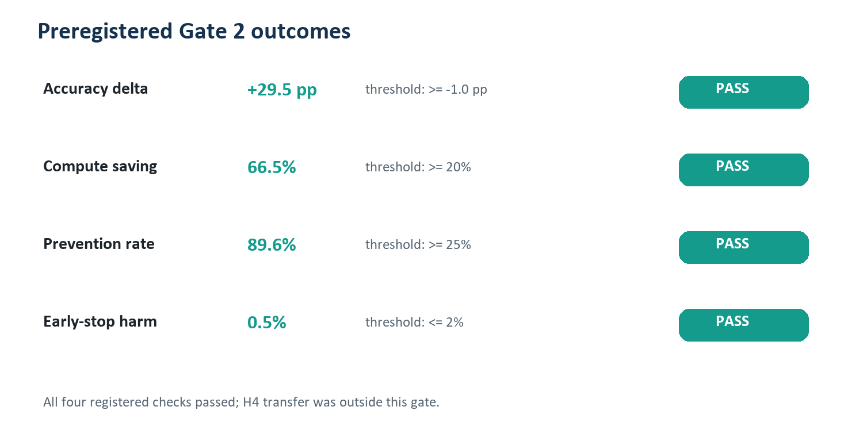
Registered outcomes and decision thresholds.
KPI | Result | Decision meaning
Adaptive accuracy | 91.0% (182/200) | 29.5 pp above fixed-long
Fixed-long accuracy | 61.5% (123/200) | Eight reconsideration rounds degraded many answers
Fixed-short accuracy | 88.0% (176/200) | Adaptive added 3.0 pp over round 2
Compute saving | 66.5% [63.7%, 69.1%] | Passed 20% floor
Prevention | 60/67; 89.6% [82.1%, 95.5%] | Passed 25% floor
Early-stop harm | 1/200; 0.5% | Passed 2% ceiling

What the Result Proves
- The frozen Qwen/GSM8K iterative protocol exhibited frequent correct-to-wrong degradation by round 8.
- The preregistered adaptive policy avoided most observed degradation and used substantially fewer generated tokens.
- The evidence package is complete: 200 unique questions, 200 complete traces, and 1,600 unique round generations were independently verified.

Critical Nuance
Adaptive stopping and answer-stability stopping both scored 91.0%. The final Praxis should therefore be framed around stability-gated stopping, not around a proven benefit from the confidence threshold. The confidence component remains a hypothesis for H4, not an established mechanism.
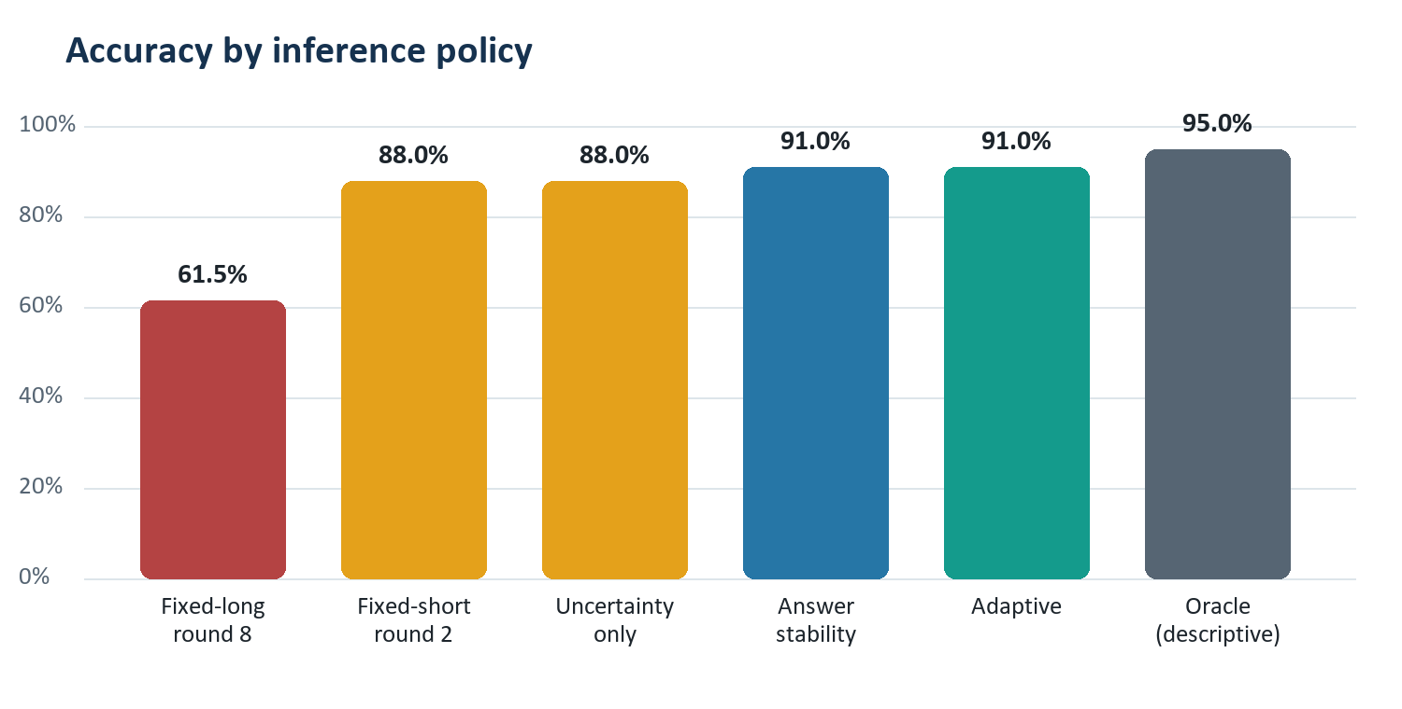
The adaptive arm tied the simpler stability-only control.

What It Does Not Prove
- No full-GSM8K or population-level accuracy estimate.
- No cross-model, cross-domain, stochastic-decoding, or prompt-transfer result.
- No calibrated uncertainty result.
- No direct latency, energy, or dollar-cost result.

Investment Recommendation
Invest in one tightly frozen H4 study before expanding implementation. Preserve the current result as the discovery experiment and preregister the transfer matrix before inspecting new outputs.
- Replicate on a second open model without retuning the current policy on the test set.
- Add a non-math corpus with deterministic or blinded scoring.
- Keep all six comparison arms, especially stability-only.
- Add latency, GPU-seconds, and dollar cost.
- Retain confidence only if it improves accuracy, reduces harm, or lowers cost versus stability-only.

Publication-Ready Claim
On a frozen 200-item GSM8K sample with Qwen2.5-7B-Instruct and an eight-round iterative reconsideration protocol, a preregistered adaptive stopping rule achieved 91.0% accuracy versus 61.5% for fixed-long inference, saved 66.5% of generated tokens, prevented 60 of 67 observed correct-to-wrong events, and harmed 1 of 200 questions. These findings are limited to the tested model, sample, prompting protocol, and thresholds.

Literature Foundation
Zhou, S., et al. (2026). When More Thinking Hurts: Overthinking in LLM Test-Time Compute Scaling. Findings of ACL 2026. Read the original publication
Cobbe, K., et al. (2021). Training Verifiers to Solve Math Word Problems. Introduces GSM8K. Read the dataset paper

