FINAL PRAXIS 003

Safety-Gated Adaptive Investigation Stopping for Agentic Security Triage
Research Report
Gary Pagan
September 8, 2026
Methods, frozen decisions, results and reproducibility

Final Praxis 003 - verified discovery report

Abstract of Praxis
This experiment tested a mechanically reviewed answer-stability stopping policy on 400 generated inert security authorization cases. A pinned Qwen2.5-7B-Instruct model produced eight cumulative-evidence responses per case, yielding 3,200 real inference records. Fixed-short (A0), fixed-long (A1), answer stability (A2), and safety-gated stability (A4) were evaluated on the same recorded traces. Frozen gates covered correctness, cost, correct-to-wrong prevention, early-stop harm and review. The independent determination was Negative. A4 correctness was 34.50%, round saving 23.34%, and token saving 31.03%. Observed A4 harm was 34/400, with a one-sided 95% upper bound of 11.16%; its harm gate failed. There were 100 degradation events affecting 97 cases. These findings apply to this generated authorization-matching benchmark, not independent real incidents or deployed SOC safety.

Chapter 1: Introduction
Security investigations can stop before decisive evidence arrives, or continue after reaching a correct conclusion and change to an incorrect disposition. Comparing only final accuracy or token cost conceals the difference between prevented degradation and harmful premature stopping. This study evaluates those outcomes separately and charges mechanically required review to the same complete denominator.
The research question is whether safety-gated stability stopping can preserve correctness, reduce investigation cost, and prevent degradation while respecting frozen harm and review ceilings. H1 requires non-inferiority to both frozen non-adaptive baselines within two percentage points. H2 requires at least 20% round and token saving. H3 requires at least 25% prevention and 20 observed degradation events. H4 requires observed harm <=2%, one-sided 95% upper bound <=4%, and review <=20%. H5 restricts evidence to the new security-framed task.
The scope is a controlled generated corpus. Eight security contexts share one authorization rule: an executed action is benign when actor, asset and inclusive time interval match the sole signed approval; otherwise it is malicious. This explicit rule supplies reproducible labels and limits task realism. No historical PX-057 performance is imported, no live security system is operated, and no human reviewer supplies hypothetical correct answers.

Chapter 2: Literature Review
REFRAIN establishes adaptive early stopping as a reasoning-efficiency mechanism [1]. MiCP treats multi-turn stopping with coverage control [2]. SIR-Bench evaluates incident-investigation depth and active evidence gathering against incident-derived labels [3]. NVIDIA's vulnerability-analysis implementation already supports early termination after consecutive identical security justifications [4]. Consequently, neither general early stopping nor security-domain stability stopping is claimed as a new algorithm.
This experiment's contribution is the bounded paired evaluation protocol: a fixed staged corpus, shared full traces, explicit harmful-stop and prevented-degradation counters, and a mandatory review denominator. The novelty search was focused, performed before outcomes, and did not establish exhaustive priority. The generated benchmark does not inherit the incident realism or expert annotations of SIR-Bench.

Chapter 3: Methodology

Design and GMR
The graphical methodological representation (GMR) is: freeze corpus and protocol → validate 80 artificial trajectory fixtures → execute two disjoint real-inference infrastructure cases → independently verify the pilot → collect 400 eight-round discovery traces → evaluate all frozen policies → independently recompute metrics and gates → classify and report. Pilot cases are excluded from discovery and cannot tune prompts, policies, corpus or thresholds.
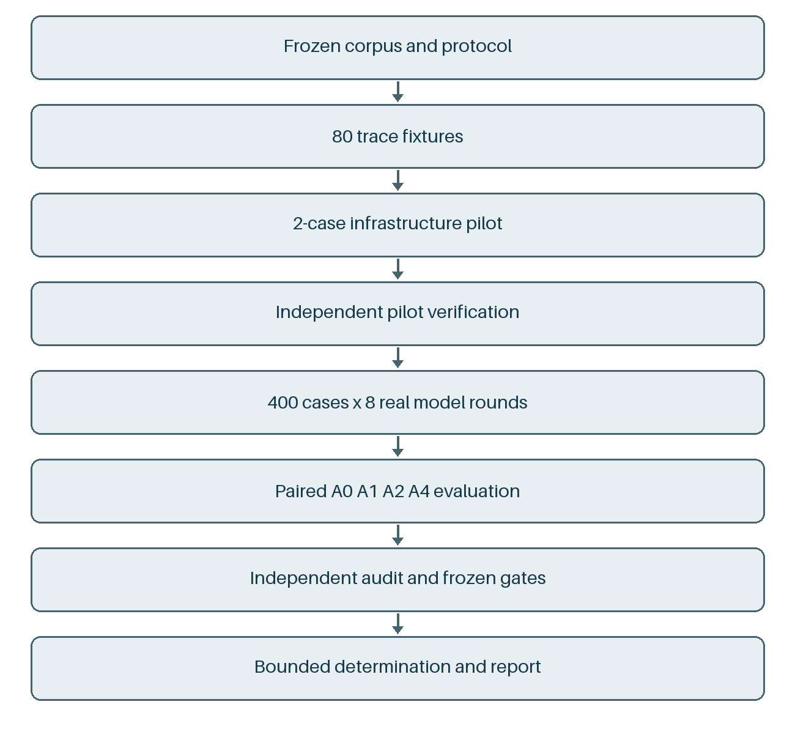
Graphical methodological representation (GMR).
The corpus contains 50 cases in each of eight families and 200 cases per label. Ground truth and evidence order were generated and hashed before inference. Authoritative evidence appears at a predeclared stage among rounds 2, 4, 6 and 8; later weak context cannot change ground truth. Private label records are excluded from prompts. A pre-discovery independent code audit identified that indexed evidence IDs could encode label parity; a dated amendment replaced only the model-visible IDs with opaque SHA-256 projections. The corpus, labels, evidence order, policies and thresholds were preserved, original frozen sources were archived, and a fresh infrastructure pilot was required under the successor seal. Each round includes only evidence exposed so far and prior normalized dispositions. There is no browsing, adaptive evidence acquisition or feedback from correctness.
The model was Qwen/Qwen2.5-7B-Instruct at revision a09a35458c702b33eeacc393d103063234e8bc28, using greedy decoding, seed 20260908, BF16 without quantization, and a 64-token output ceiling. Sixteen independent case traces could run concurrently; each case's rounds were sequential. Actual token counters include prompt and completion tokens. Raw responses, request identities, runtime details, prompt hashes and timestamps were retained. Malformed outputs and refusals count as abstentions and incorrect utility, with no exclusions.
A0 stops at round 2; A1 at round 8; A2 after two identical non-abstaining answers, otherwise round 8. A4 applies the same stability rule but emits REVIEW for protected cases, incomplete frozen evidence coverage, a latest-round disposition flip, or abstention. REVIEW continues investigation; unresolved final review yields zero-utility abstention. Any REVIEW counts toward review rate. The collector still records all eight rounds after a policy would stop, allowing counterfactual comparison without altering evidence or outcomes. Reported savings describe evaluated policy prefixes, not total compute consumed to collect the experiment.
Harm is an incorrect selected endpoint with any later correct response. Prevention is a correct selected endpoint followed by at least one incorrect later response among cases with adjacent correct-to-wrong transitions. The full 400 cases form the harm, correctness and review denominators. The harm upper bound is one-sided exact Clopper-Pearson; prevention intervals are two-sided exact intervals. Paired bootstrap intervals use 10,000 replicates and seed 20260908. Non-inferiority compares against both A0 and A1 using conservative one-sided 97.5% lower bounds. Case-template dependence limits any population interpretation of these intervals.

Chapter 4: Results and Discussion

Verified outcome
The unchanged frozen verifier passed in the cloud for all 400 cases and 3,200 unique round records, reproduced policy decisions and counters, and checked protocol/model identities and file hashes. The final classification is Negative. Fixture and infrastructure-pilot outputs are separate from these scientific records. A strict local replay stopped on a last-place SciPy beta-quantile equality difference. A separately labelled supplemental replay checked all exact integer, boolean, identity and hash conditions and allowed absolute floating-equality deltas only up to 1e-14; the three actual differences were at most 9.72e-17. All threshold inequalities and gate decisions were unchanged. The strict local failure and supplemental receipt are retained in paper/evidence; the frozen cloud PASS is neither overwritten nor represented as a strict local PASS.
Arm | Correctness | Mean rounds | Token saving vs A1 | Early-stop harm | Harm upper 95% | Reviewed | Abstained
A0 | 76/400 (19.00%) | 2.00 | 85.14% | 225 (56.25%) | 60.41% | 0.00% | 72.00%
A1 | 217/400 (54.25%) | 8.00 | 0.00% | 0 (0.00%) | 0.75% | 0.00% | 0.00%
A2 | 226/400 (56.50%) | 5.79 | 36.60% | 37 (9.25%) | 11.99% | 0.00% | 0.00%
A4 | 138/400 (34.50%) | 6.13 | 31.03% | 34 (8.50%) | 11.16% | 100.00% | 34.00%

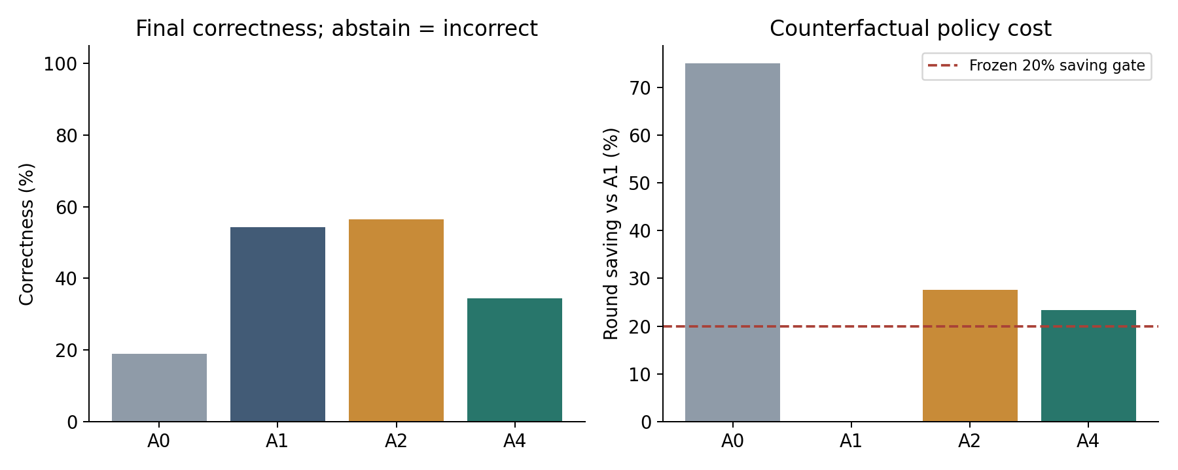
Correctness and counterfactual policy round saving

Research questions and frozen gates
Frozen decision | Result
sample_400 | PASS
H1_noninferiority | FAIL
H2_cost_reduction | PASS
H3_prevention | PASS
H4_harm | FAIL
review_rate | FAIL
phenomenon_20 | PASS
A4_not_equivalent_to_A2 | PASS

The correctness comparisons were:
- A4 minus A0: 15.50 percentage points; lower one-sided 97.5% paired-bootstrap bound 10.00 percentage points.
- A4 minus A1: -19.75 percentage points; lower one-sided 97.5% paired-bootstrap bound -25.00 percentage points.
A4 round saving was 23.34%, with paired 95% interval [21.13%, 25.56%]. Token saving was 31.03%, with paired 95% interval [28.28%, 33.71%]. Prevention affected 39 of 97 eligible cases: 40.21%. The harm safety gate failed. Mandatory failed gates prevent promotion regardless of favorable descriptive metrics; thresholds remain unchanged.
The hypothesis decisions are therefore specific: cost and degradation prevention passed, while correctness non-inferiority, the early-stop harm ceiling and review-rate ceiling failed. The observed phenomenon exceeded its minimum event count. A4 was not equivalent to A2 under the frozen equivalence rule, but that difference is not evidence of a useful safety layer: A4 had lower correctness and greater review burden. A1's zero early-stop harm is structural because the fixed-long endpoint has no later observed round; it does not mean its final classifications were always correct.
All 3,200 model responses used recognized JSON dispositions; 1,552 explicitly abstained. The negative result cannot be attributed to malformed-output parsing. Every case triggered a latest-disposition-flip review before A4 terminated (400/400); the frozen rule counts transitions from abstention into a supported disposition as flips. Additional overlapping triggers included abstention in 288 cases, protected status in 40, and low evidence completeness in 40. Thus the review rule charged useful resolution of uncertainty as well as possible degradation, explaining why every case consumed review. This is a limitation of the frozen policy definition; it was not relaxed after observing results.

Stage and family structure
Round | Correct | Abstain | Prompt + completion tokens
1 | 0/400 | 400/400 | 90,298
2 | 76/400 | 288/400 | 121,380
3 | 57/400 | 288/400 | 140,860
4 | 114/400 | 192/400 | 168,257
5 | 119/400 | 192/400 | 188,077
6 | 167/400 | 96/400 | 216,790
7 | 160/400 | 96/400 | 236,346
8 | 217/400 | 0/400 | 262,887

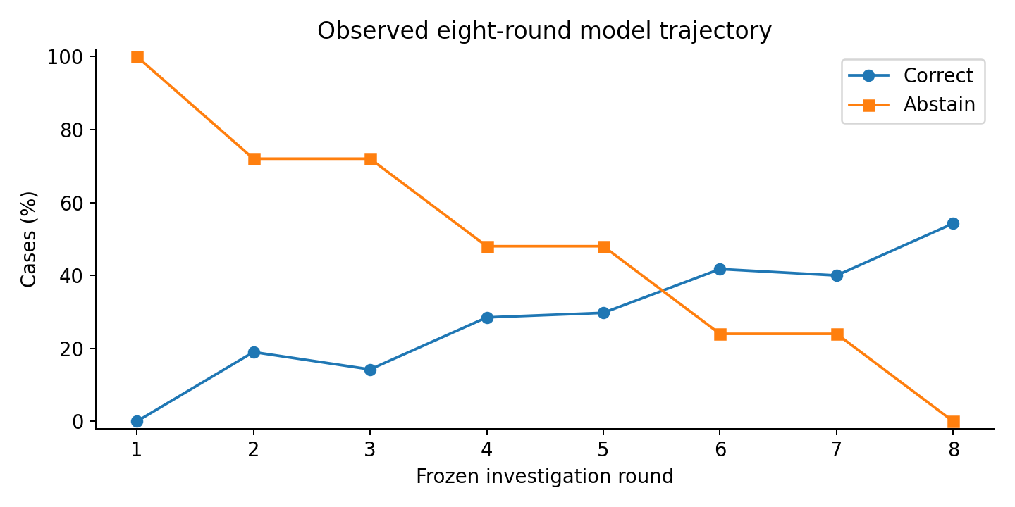
Accuracy and abstention at each frozen evidence round
Case family | Cases | A4 correct
archive | 50 | 18
cloud | 50 | 16
egress | 50 | 20
endpoint | 50 | 15
identity | 50 | 19
mail | 50 | 15
remote_access | 50 | 18
service | 50 | 17

Complete arm-by-family correctness, harm, prevention, review, abstention and round counts are supplied in family_breakdown.csv; stage counts are supplied in round_breakdown.csv. These are descriptive breakdowns without post-hoc selection of favorable families.

Limits of interpretation
The same simple authorization construct underlies all eight family templates. The experiment therefore evaluates handling of a fixed explicit decision rule as evidence accumulates, rather than expert incident reasoning. The 400 generated cases are not 400 independent real incidents. Numeric variation and fixed staged distractors do not establish external validity. Review abstentions receive zero utility; there is no assumed analyst rescue. Full traces support policy-prefix counterfactuals but do not establish that deployed adaptive agents would follow the same trajectory when given control of evidence collection. One pinned model and one frozen seed do not establish model-family generality. Shared-server batching and numerical implementation are retained as runtime provenance, not a claim of hardware-independent bitwise identity.
The safety design has a structural constraint, identified before discovery and preserved: 40 protected and 40 disjoint delayed-evidence cases force at least 20% review, consuming the entire review ceiling before any additional model-driven REVIEW. The 40 protected cases force terminal abstention, placing A4 correctness at a maximum of 90%. If a non-adaptive baseline exceeds 92%, the frozen two-percentage-point non-inferiority criterion cannot pass. Thus a negative finding can reflect this conservative review/utility design as well as model behavior. The study does not generalize that limitation into a claim that all possible safety-gated stopping policies fail, and does not relax the rule after observing outcomes.

Chapter 5: Conclusions and Future Work
The frozen experiment concluded Negative. The relevant scientific answer is determined by the mandatory gates above, including negative findings, rather than by selecting favorable aggregate accuracy or cost numbers. A positive deployment-safety claim is not supported by a generated corpus alone. Any future model replication or external incident-corpus study requires its own prospective freeze and must retain this result unchanged.
Future work can evaluate expert-labelled staged incidents, independently selected evidence schedules, realistic analyst-review costs and a second model. Such work must distinguish an absent degradation phenomenon from a failed stopping policy and compare any more complex safety layer with the already available stability baseline.

References
1. Sun et al. Stop When Enough: Adaptive Early-Stopping for Chain-of-Thought Reasoning. 2025. https://arxiv.org/abs/2510.10103
2. Zhou et al. Adaptive Stopping for Multi-Turn LLM Reasoning. 2026. https://arxiv.org/abs/2604.01413
3. Begimher et al. SIR-Bench: Evaluating Investigation Depth in Security Incident Response Agents. 2026. https://arxiv.org/html/2604.12040v1
4. NVIDIA. Vulnerability analysis blueprint: test-time compute and early stopping. Inspected 2026-09-08. https://github.com/NVIDIA-AI-Blueprints/vulnerability-analysis

Appendix A: Provenance
- Protocol SHA-256: 8e4ff9f6596b1433544eca2031c91c752f5d2d5919644b695dc1fbfc29f02983.
- Corpus SHA-256: d56afea85977d35dcadc53e23540478545f77f0f4bf391821a09ae2f1fd8b2be.
- Raw discovery SHA-256: 13a97bf948a7baf5f55fe7929e0cf4b05fea3fefb2117b08e0795702ba79871c.
- Completion timestamp: 2026-09-08T22:05:53.483485+00:00.
- Raw run directory: final_praxis/003_adaptive_investigation_stopping/artifacts/discovery/qwen_20260908_v2.
- Independent receipt: INDEPENDENT_VERIFICATION.json in that directory.
- The seal includes generator, policies, prompt/collector, evaluator, independent verifier, fixture marker, corpus, preregistration and shared model-adapter/server code.

Appendix B: Reproduction
Run harness/run_traces.py --preflight-only to validate sealed inputs. The separate --pilot run must pass evaluate_policies.py and independent_verify.py before the discovery collector accepts its matching receipt. Discovery uses --base-url http://127.0.0.1:8765 and a new output directory. Analysis and verification run only after RUN_COMPLETE.json is written. paper/build_report.py <run_dir> constructs this document and standalone plots from the verified artifacts. See BUILD_AND_RUN.md for exact commands, retry rules and denominator semantics. Completed raw runs and published reports are never overwritten.

