# **Overview**

**About your team**

Our team consists of 5 people and we divided responsibilities between us.

1. Kuanyshbek Sagyngaliyev (id: 201564; email: 201564@astanait.edu.kz ) is responsible for Java script

2. Kadyrova Nazira (id: 201436; email: 201436@astanait.edu.kz ) is responsible for express node js

3. Kaharman Ayala (id: 201827; email: 201827@astanait.edu.kz ) is responsible for documentation

4. Bulbul Abenova (id: 201284; email: 201284@astanait.edu.kz ) is responsible for html, css

5. Aida Sapenova (id: 201226; email: 201226@astanait.edu.kz ) is responsible for html, css

**Communication strategy**

* Sunday 14.03.2021 the roles of each member of the group were assigned, the style of the site and its features were chosen.
* Monday 15.03.2021 there was an assessment of each other's work and a discussion about where to correct.
* Tuesday 16.02.2021 connecting parts of the site into one, checking for working capacity, adjustments and release of a full-fledged site.

**High-level project scope** – Since this was a task for the final exam, we decided that it would be more correct to use our potential by creating a completely new website from scratch, trusting our tastes and knowledge.

**Target audience/market** – Our site is designed for those people who are interested in football.

# **Project goals and team interests**

The project is a website for users and operators. The task of the site is to display the winner on the page and in the list of game results. The site will show all combinations of combinations that add up to a given score.

**Project goals**

- Using solid knowledge of HTML and CSS, Bootstrap to create a website

- Accurate reproduction of the design in the form of HTML pages;

- Full cross-browser, identical display of all parts of the design in different browsers

- Responsive JS commands

- Creating fully responsive server with express node js

**Team interests**

* Developing HTML, Java.Script and CSS skills
* Adapting and improving teamwork skills
* A clear understanding of the principles of website design
* Understanding of routing a server

# **Phases**

* Phase 1 –Basic website, more specifically for scoring all possible head taps and displaying winners, with HTML
* Phase 2 – adding styles using CSS to improve and simplify the interface
* Phase 3 – writing JS to process commands
* Phase 4 – routing a server via express node js

# **Content structure**

**Site map**

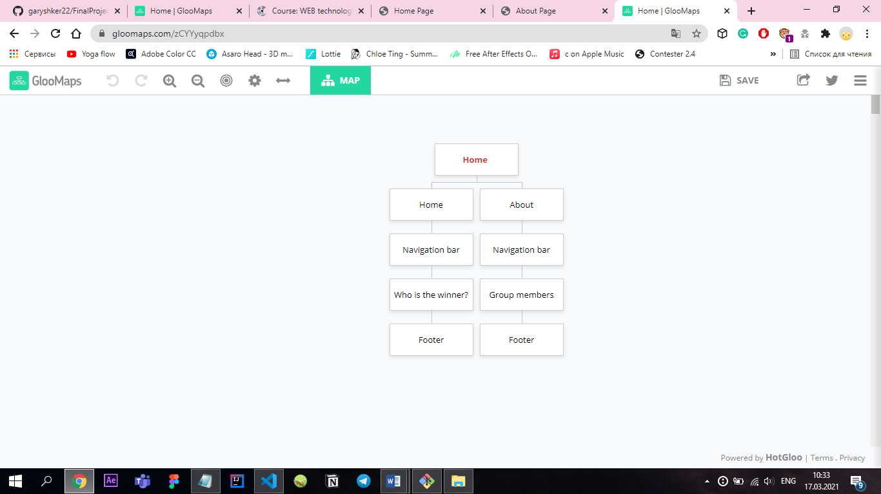

**Content types**

* Index.html has event type content as it displays the winner team.
* About.html is people type content as it shows the group members with their photo and name.

**Design**

It is important to provide design assets and related references

There are many ways to provide design assets, for example:

* Image files



Img1. The photo of our team



Img2. The background of the index page



Img3. The background of the about page

* Sketch files

(logotype of the website)



* Colours: #2c5f2dff #000000 #ffe77aff #007bff
* Typography rules: Montseratt (font family)
* hover states

.cards:hover{

    transform: scale(1.1);

    transition:all 1s;

}

* Animations

#cont .container{

    display: flex;

    flex-wrap:wrap;

    transition:all 1s;

}

* **Grid system**
* .cards {

    margin:auto;

    margin-left: 50px;

    margin-bottom: 50px;

    background-color: #2c5f2dff;

    height: 290px;

    width: 240px;

    color: #ffe77aff;

}

* **Spacing**

<nav class="navbar navbar-expand-md fixed-top justify-content-center ">

<h1 id="title" class = "text-center mb-4">Who is the winner? </h1>

**Functionality**

Site content is dynamic information that is stored as files and a database on the server, fetched using server-side scripts, and rendered on the fly into HTML pages. The language will be used HTML, CSS, Java Script for auxiliary purposes, the use of the express.js . All scripts and site data will be hosted on the hosting provided.

**Hosting**

Hosting for this project is a local host using express node js with gitBash terminal.

* 1. Create app.js file
  2. Create package.json using ‘npm init’ command (in gitBash)
  3. Install the express node ‘node i express’
  4. Develop an express commands to support server work
  5. Run the routing using gitBash ‘nodemon app.js’

**Accessibility**

* Unfortunately, our site is not adapted for people with disabilities. At the same time, we believe that our site is organized simply and easily understood by users. In our website there are no problems with the readability of texts and transitions between pages. Therefore, we believe that we have done a good job of making the website accessible.

**Deadlines:**

* Phase 1 (html, css, js, express js) – 15 March 18:00
* Phase 2 (connecting all the elements and documentation) – 16 March 23:59

# **Summary**

The focus of this project is to develop a fully responsive website using our knowledge form the course “Web technologies”. The target was to create two pages according to the task and provide a good interface with a local routing. We have achieved our goal successfully, although faced some challenges in the form of developing JS command to get combination of possible scores. However, it would be much better if the project time was more extended to fix all the bags and expand other fields to widely show our understanding of the course.