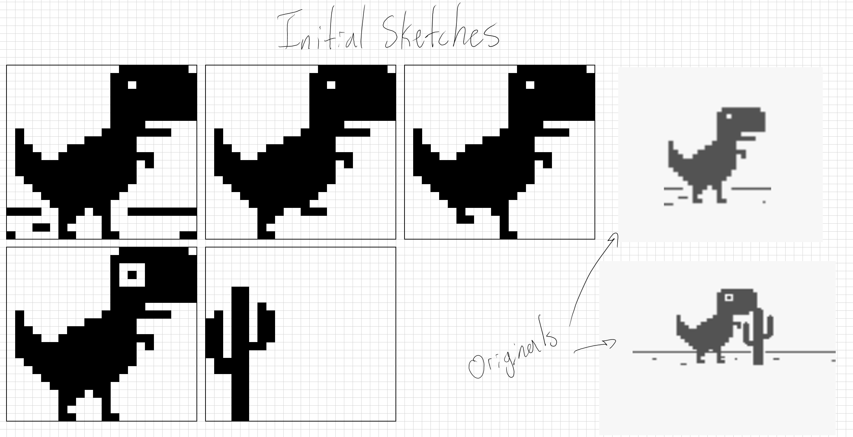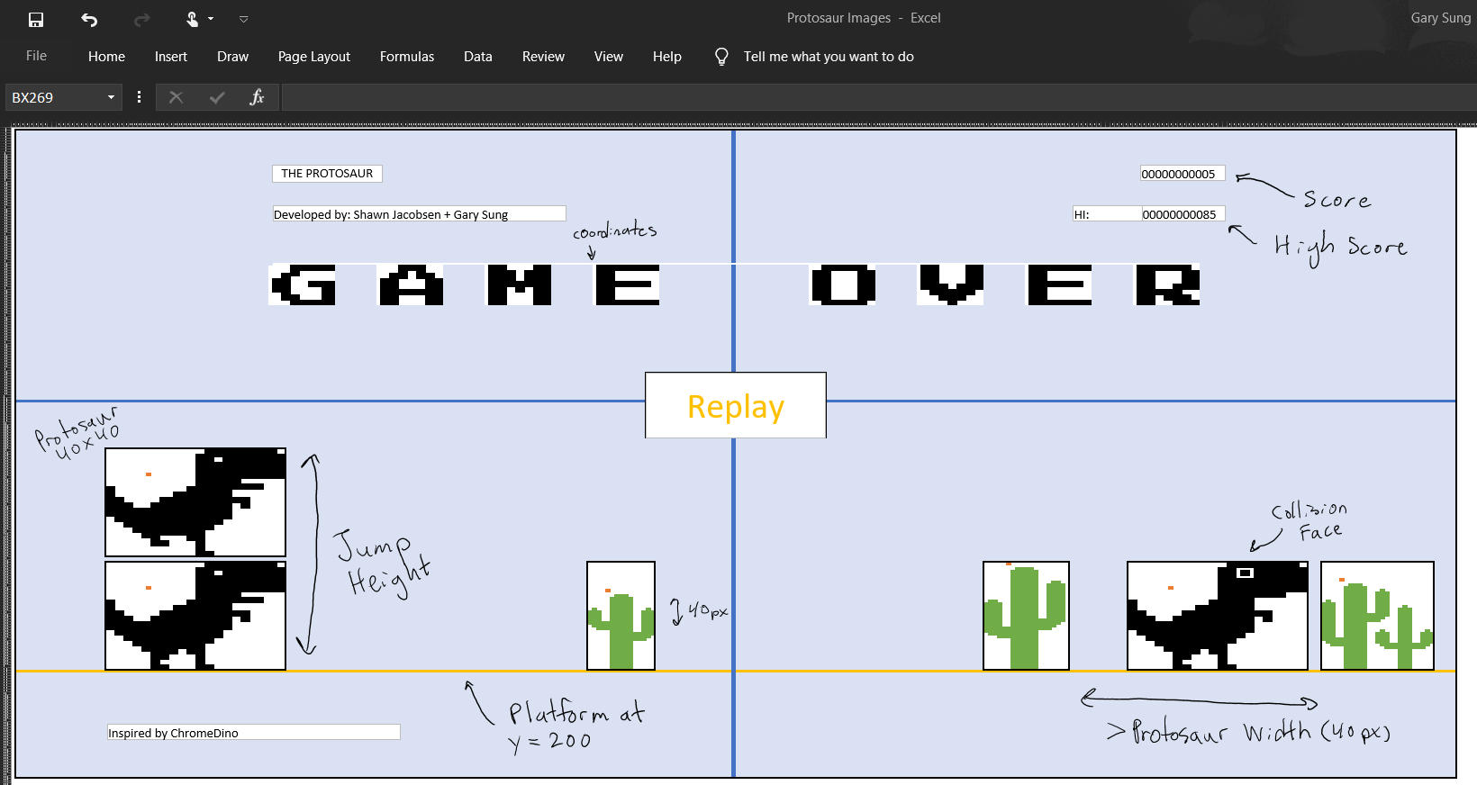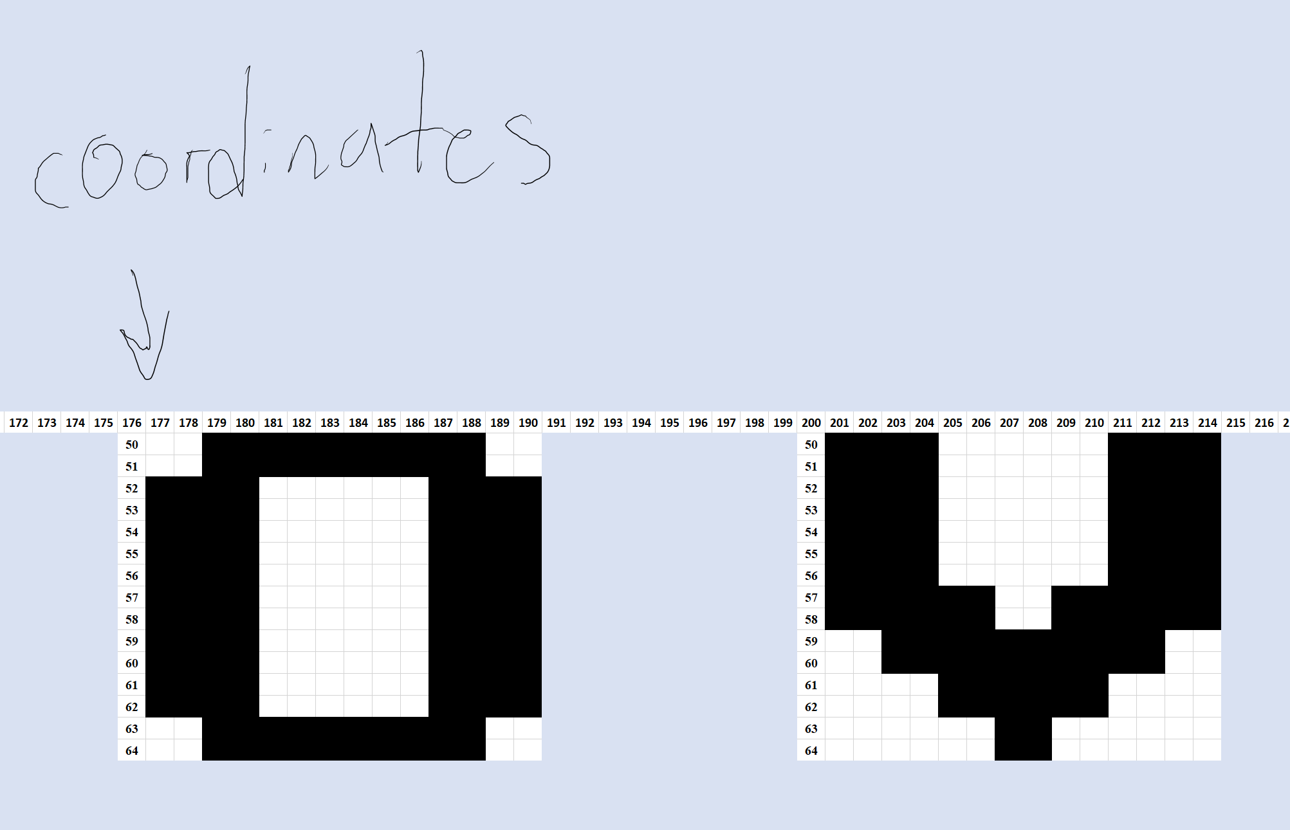

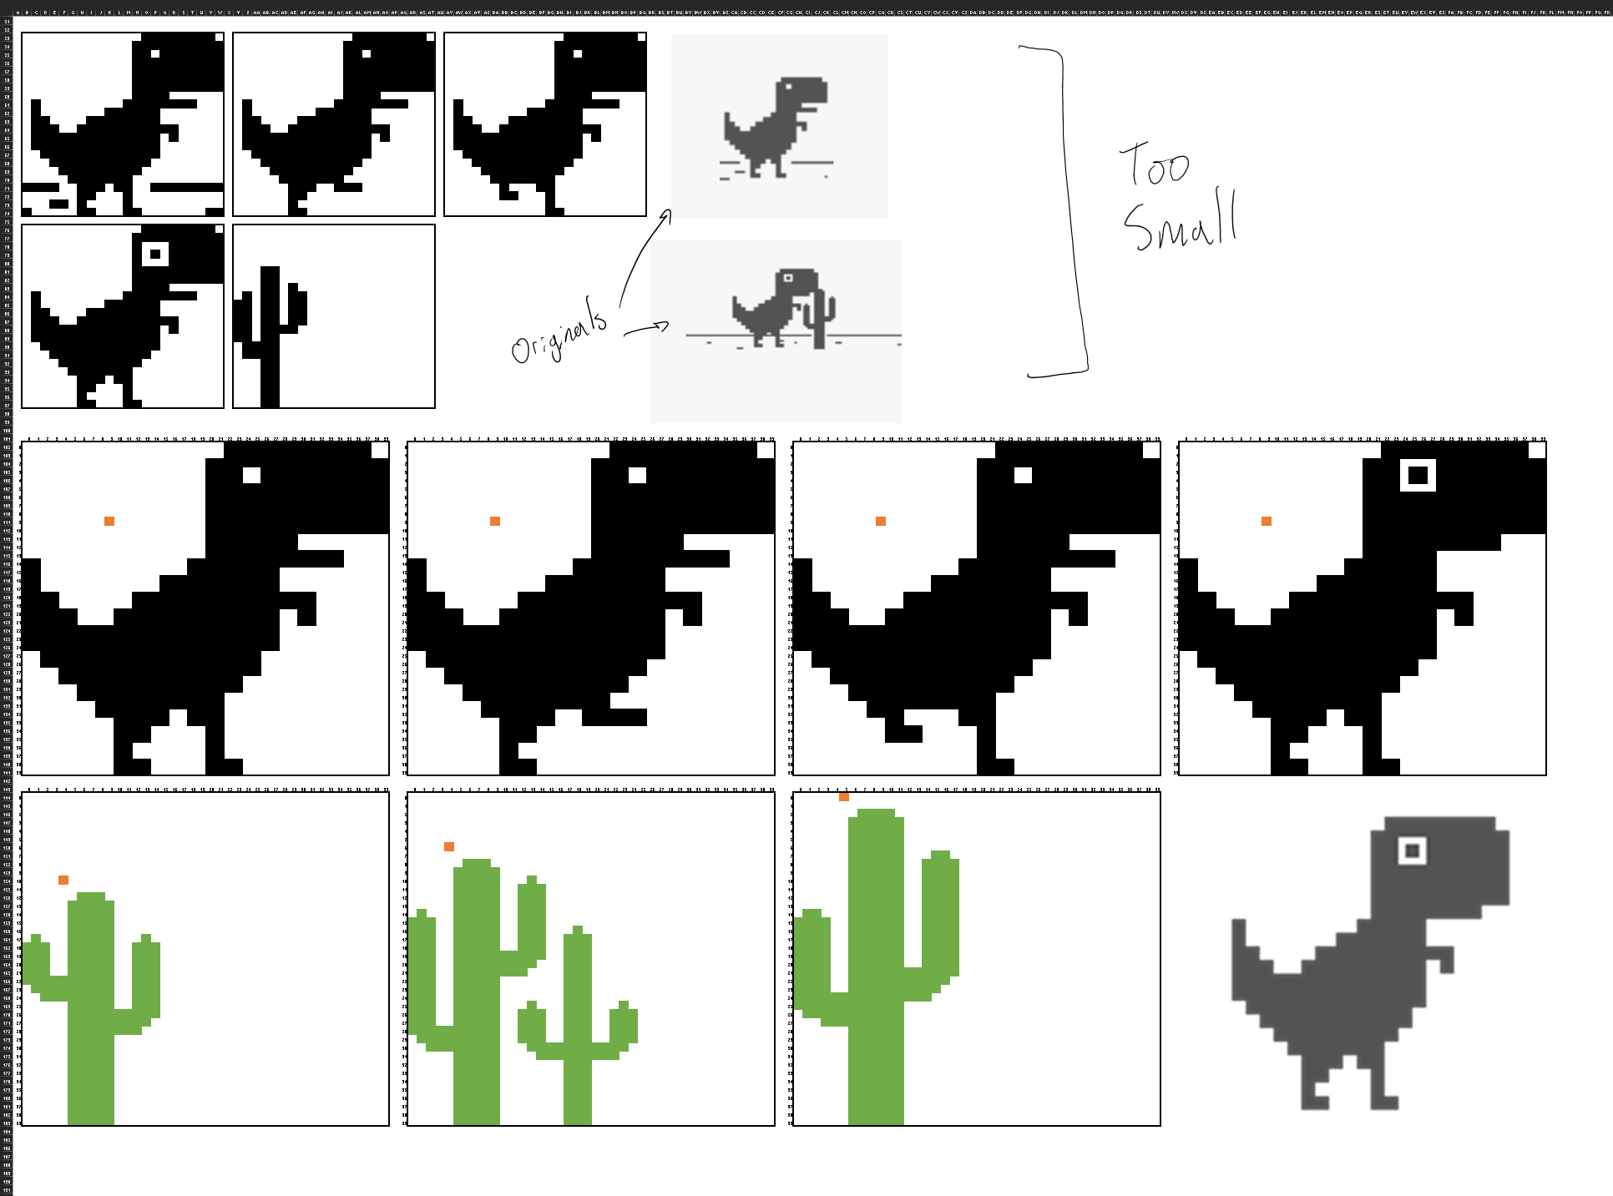

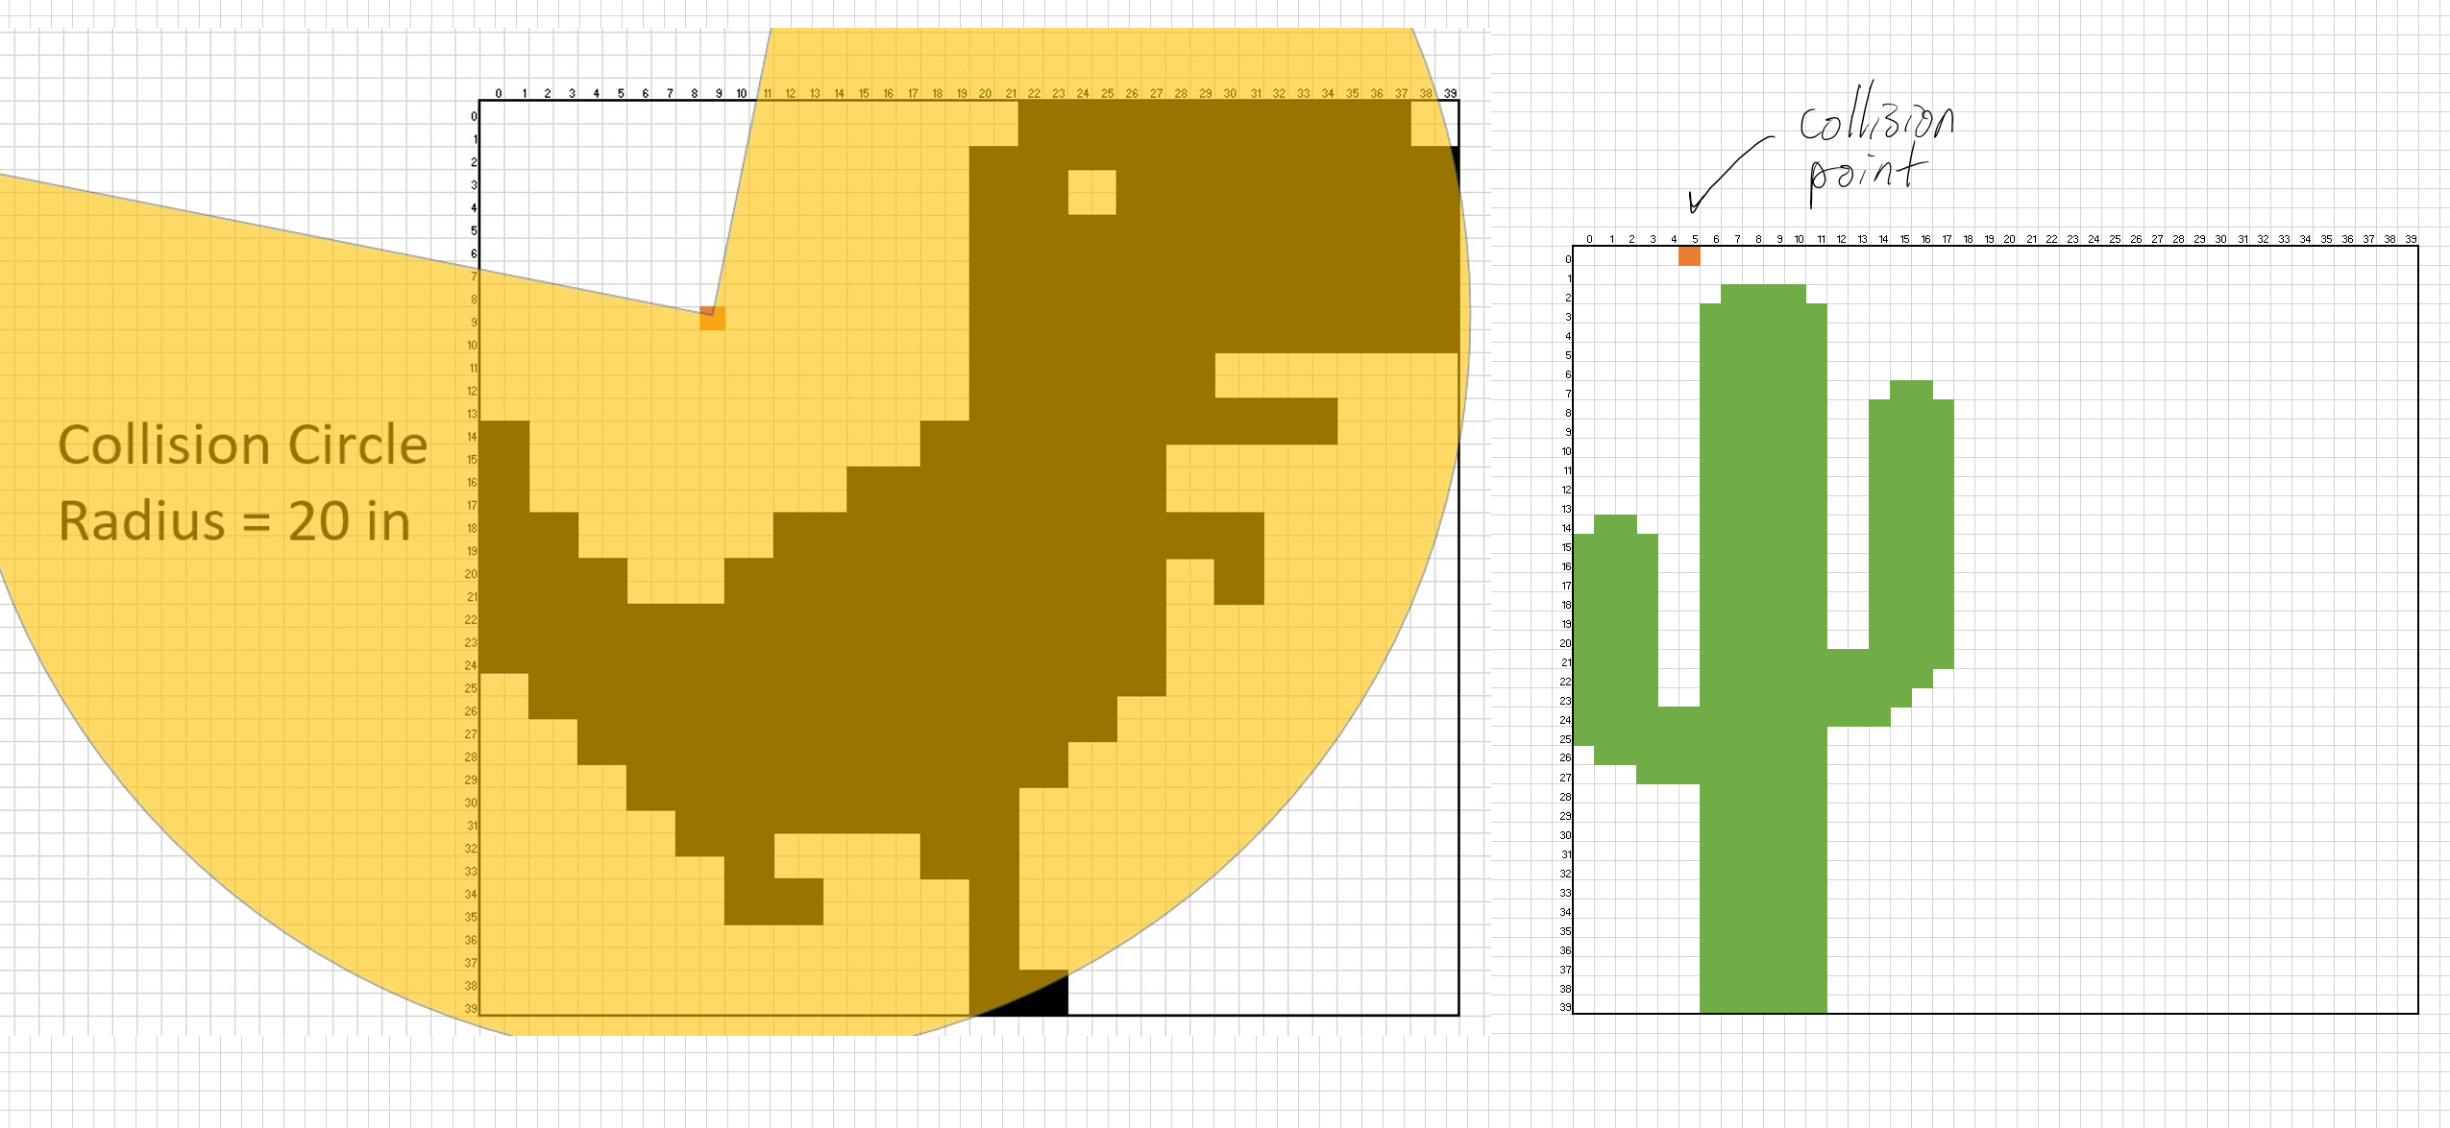

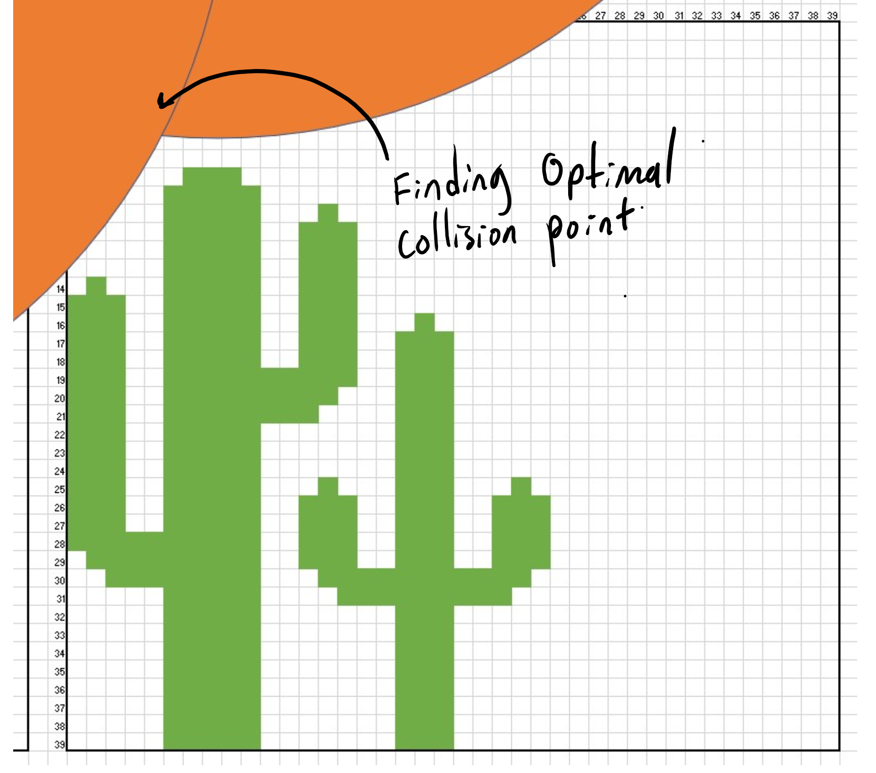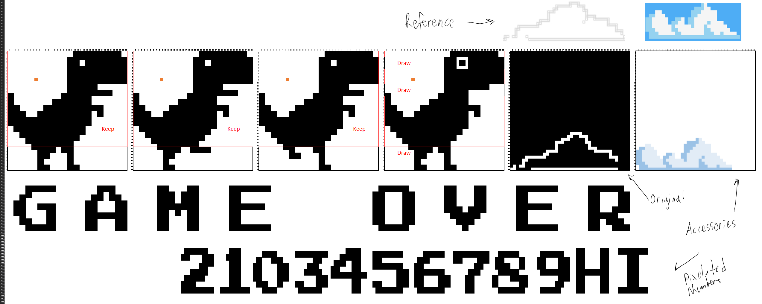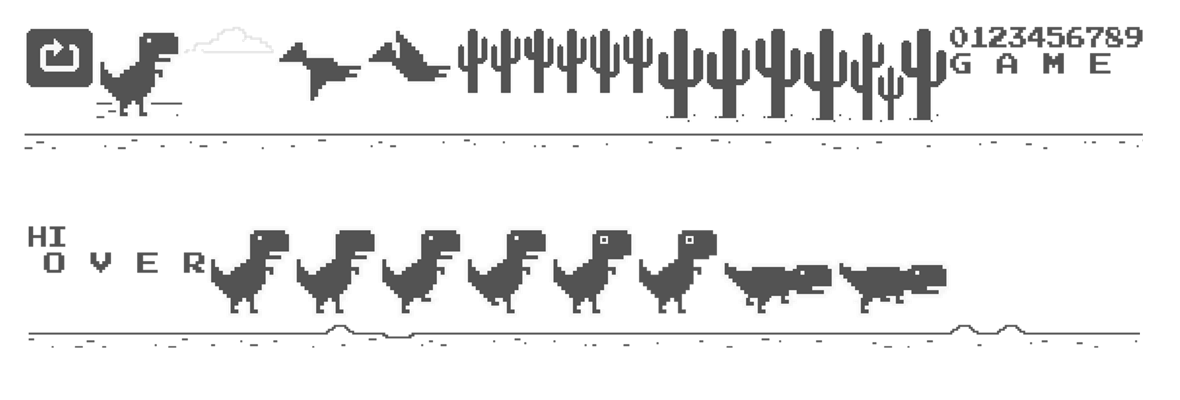

**Algorithm**

1. Include preprocessor directives
2. Define constants
   1. Sleep time
   2. Dino, obstacle, and platform x position
   3. Collision radius between dino and obstacle
   4. Dino and obstacle velocity
   5. Gravity
3. Class definition for Dino and Obstacle
4. Define variables in the main function
5. Create a do while loop with condition true
6. If the Dino is on the ground, set jumping to true
7. Check if the change in time is greater than the sleep constant
8. Determine the front cactus
9. Call the collision function
10. If Dino collided with Cactus,
    1. Change the frame of the Dino to “collision face”
    2. Emit a buzz sound
    3. Draw the Dino, Cactus, replay button, “gameover,” title, score, high score, and credits
    4. Check if the player presses the replay button
    5. Reset the score and Cactus location
11. Increase the Dino y position using the velocity and gravity constants
12. Increase the frame of the Dino
13. Recalculate the position of the Cactus
14. Increase the score and check if it is a high score
15. Check if the Dino is below the platform
16. Clear the screen
17. Draw the platform, Dino, score, and Cactus