Gary Baker

Set Dressing Postmortem

G300 – Sundstrom

Fall 2020

When we started this project, I knew I was going to want an interesting theme. After a while, I came up with the idea of a theater as this was within scope, but it was also interesting. I aimed at going for a theater that had a stage, not just one with a screen, and to make it more interesting, I wanted to make it a murder mystery at the theater to keep players involved because they can only move around in this world.

When I started designing on paper, the whole thing was way too blocky. To break this up, I made the balconies round, added a tilt like you would find in an actual theater, and added rounded sections to the corners of the map. Also, I added rooms that extended of the upstairs of the lobby that naturally went into the halls that lead to the balconies. I think the variance in height is one of the main ways that the grid is broken up in this level. I wanted to make the place feel grand, so I added two large staircases in the main lobby that go to the upper level. Chandeliers and wall mounted lights were used to help with this aesthetic.

I also had to think about the movement of the player. I knew that the player would start in the lobby, but where would they go? I wanted them to ultimately end up near the stage, as that covers most of the level and the props make it one of the more interesting areas. Because of this, I made sure the balconies had a guard that was small enough for the players to jump over. That led to a design that looked like this.

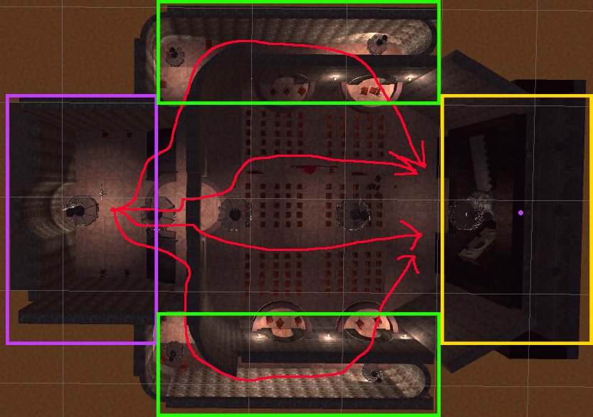There are four major paths the player can take if we include jumping off the balconies. One of the major things I noticed when playtesting with my wife and fellow classmates, is that everyone would immediately go upstairs and into the cramped hallways. This hide away the main part of the level until they eventually made their way to a balcony! To try and direct the player toward the main area first, I lit the parts of the map that lead into the seating area a little more, and made the path upstairs around the entrances into the hallway subtly darker on purpose. All these paths bottleneck towards the stage as well.

When they are in the seating gallery, I wanted them to go towards the stage. I helped direct the player towards this using three different techniques. First, I made the blood make a path towards the front, thus breadcrumbing the player to the stage. Theaters also naturally come with copious amounts of leading lines that will draw the player’s focus towards the stage. Then the stage is also a landmark as it is drastically different than the rest of the area.

Some of the players that played tended to look straight down, and I think the blood helped with that aspect. I think my biggest take away from the design perspective was that newer player handle controls drastically differently than experienced gamers. My wife, who does not play games at all, found the controls to be difficult, and thus she was always looking at the ground. This is were things like breadcrumbing make a huge difference in my level, as it allowed her to make her way towards the stage. This was different than the classmate who played my game because they were comfortable with the controls and took the whole scene in from the upper balcony before making the way around.

From a more technical perspective, I think that some of the hardest parts of this projects were somewhat self-induced from a lack of knowledge. I got the scene to what I thought was a good point when I was level-blocking, but when it came time to render the materials onto the walls and the floor, I quickly became aware of my many shortcomings. Notably, I would place structures with their faces at the exact same level when white-boxing to make seamless transitions in the walls. However, this made some problems within unity as it did not know which face to show, so it would randomly change between the two. I fixed this by moving the pieces by values similar to .0005.

Also, I had some issues with problematic meshes. The material would suddenly rotate by 90 degrees on random faces. I fixed this using the UV mapping editor within Unity.The way to do this was to go into face-selection mode within Probuilder and select the faces that were wrongfully orientated. Then, open the UV editor (shown above) from the Probuilder menu. From there, you can rotate the mapping of the mesh by 90 degrees, thus correcting their shape.

Also, I used a simple, but neat way to implement the blood splatters. First, I made a new Quad (a 3d shape in Unity) and then I would drag the image that I wanted to use as the splatter onto it. Unity A picture containing indoor, ceiling, building, light
would then automatically make a material for it with the image as the albedo. Then I used the same image for all the other material properties, with a copied version of the image as a normal. After tenting it red, it made for a convincing blood splatter from various images of stains. An important thing to note is to make sure that the scale for the height of the quad is low, as the player will be walking on it.

This blood, along with music and post-processing effects like adding warmth and grain really brought the theater into a different atmosphere.