How to configure cis_profile for Foreman Server

Login as admin in Foreman GUI

Click Configure / (Puppet) Classes / Import environments from foreman.example.local.

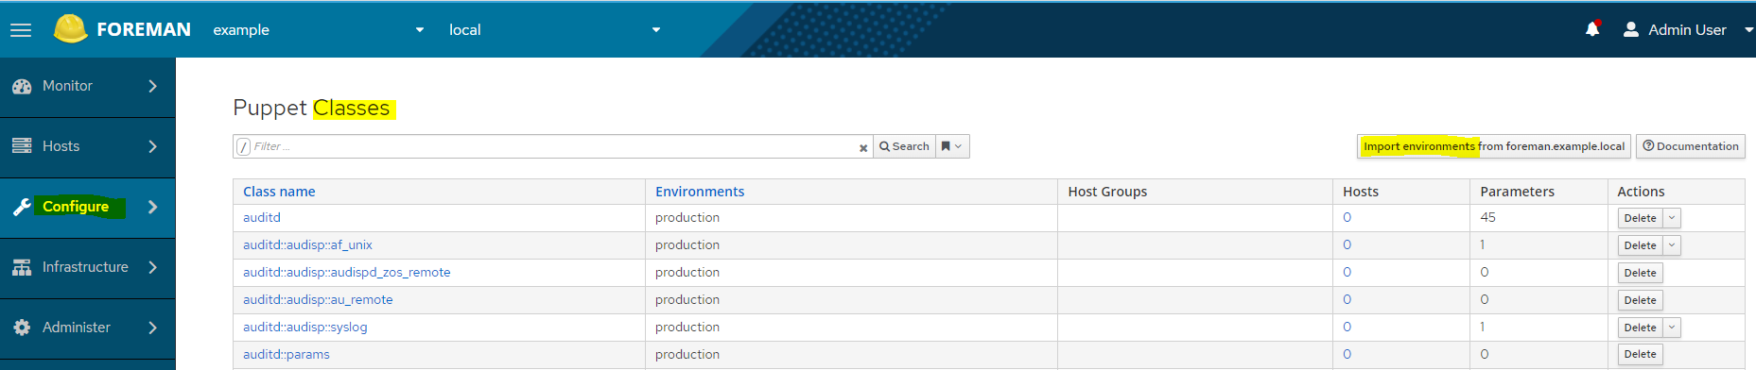

It should detect the ‘production’ environment.

Select (Check the box) the ‘production’ environment and click ‘Update’.

All the puppet modules residing at /etc/puppetlabs/code/environments/production/modules will be imported.

Click Configure / Host Groups and create ‘cis_profile’ Host Group.

Under ‘Host Group’ tab:
Name: cis_profile
Environment: production
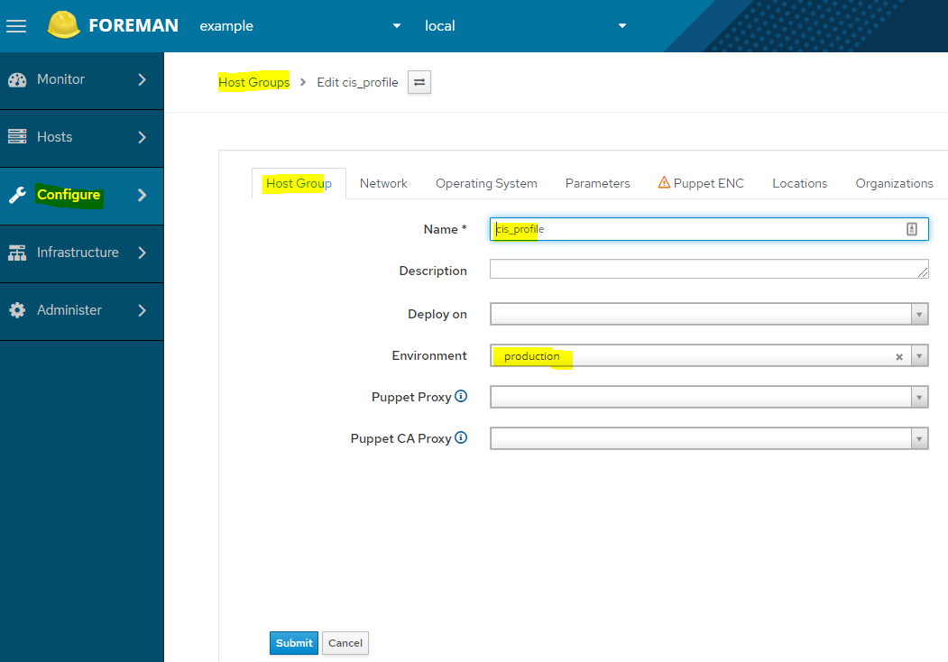

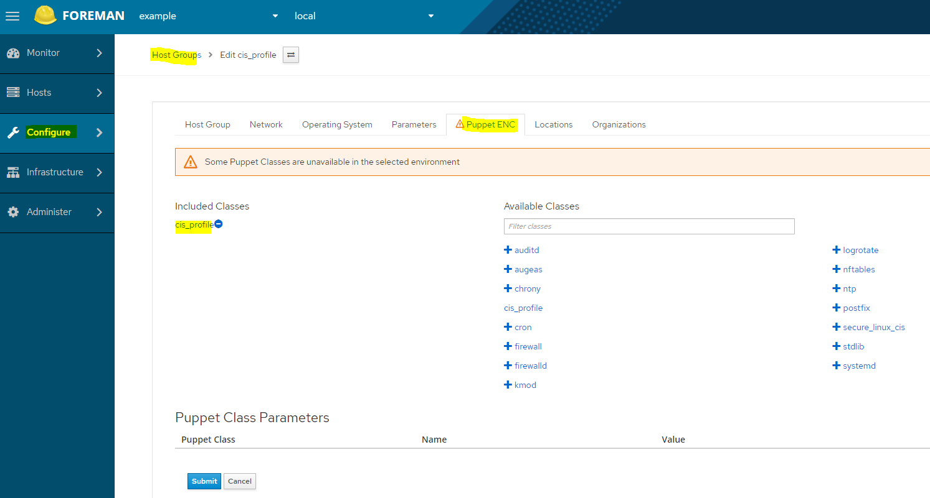
Under ‘Puppet ENC’ tab:

Click the ‘+’ for ‘cis_profile’ to add it to ‘Included Classes’.

Click Hosts / All hosts, select all hosts.
Click ‘Select Action’, select ‘Change Group’

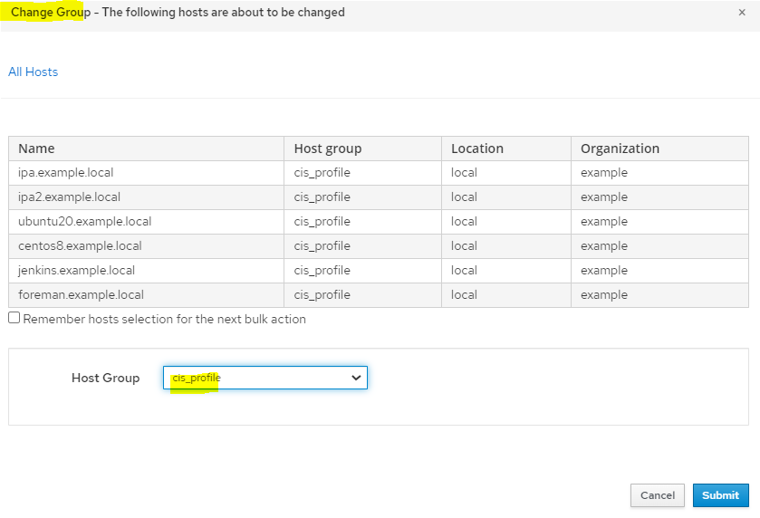

Click ‘Submit’.

Click Configure / Smart Class Parameters, search for ‘enforcement_level’, change its ‘Default Value’ from ‘1’ to ‘2’.
Click ‘Submit’.

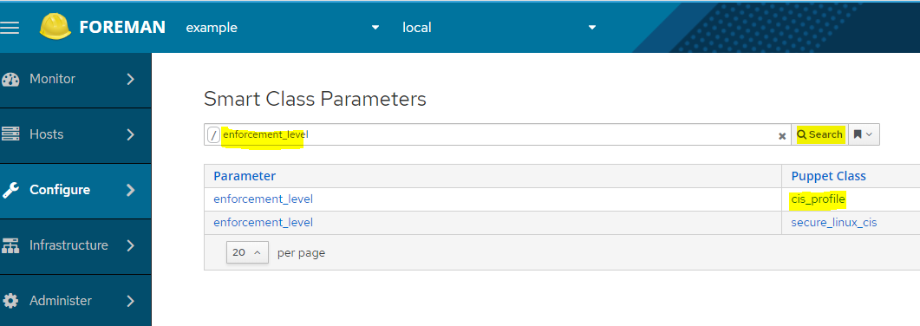

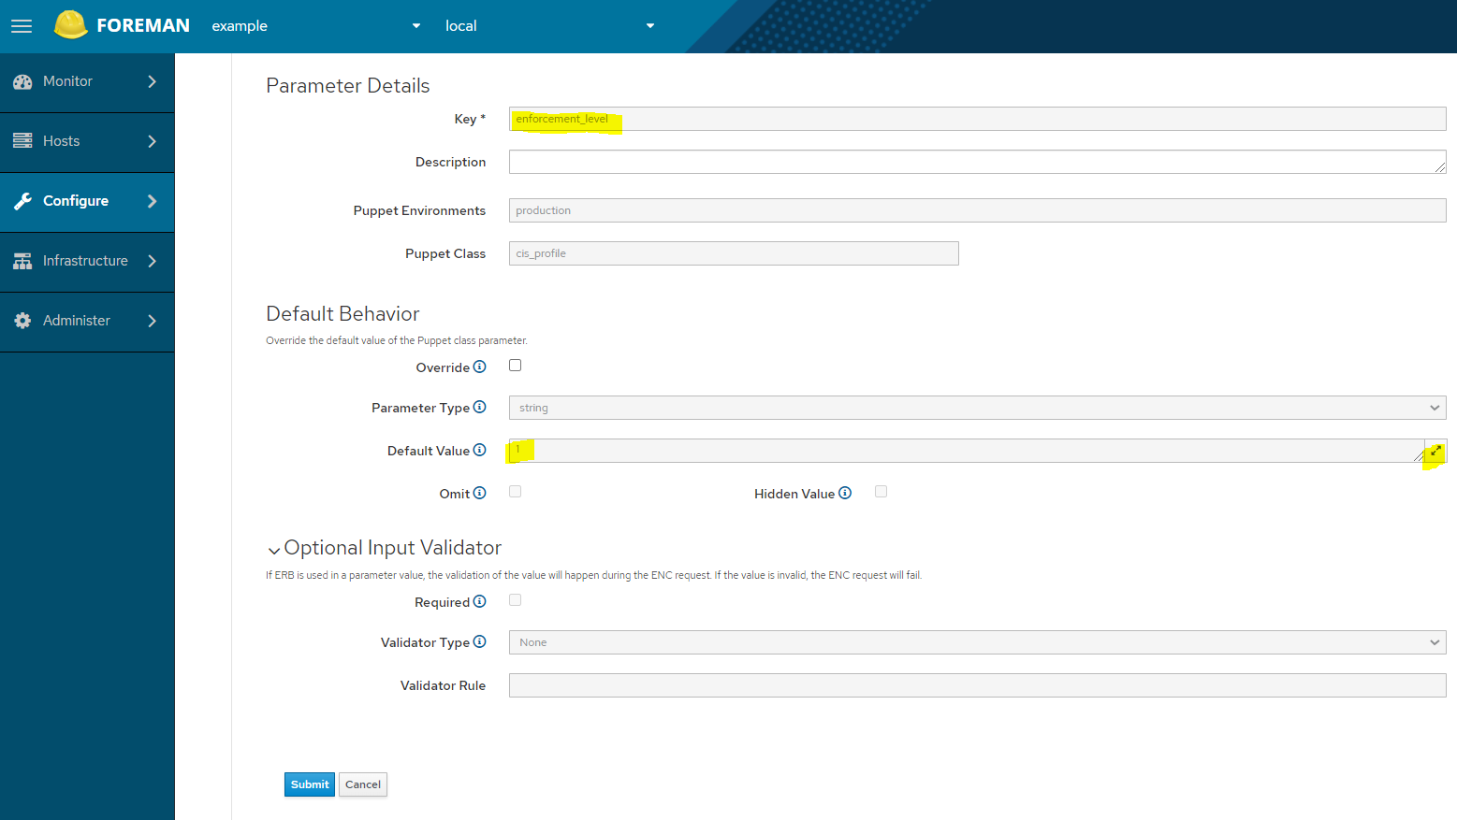

Final screen:

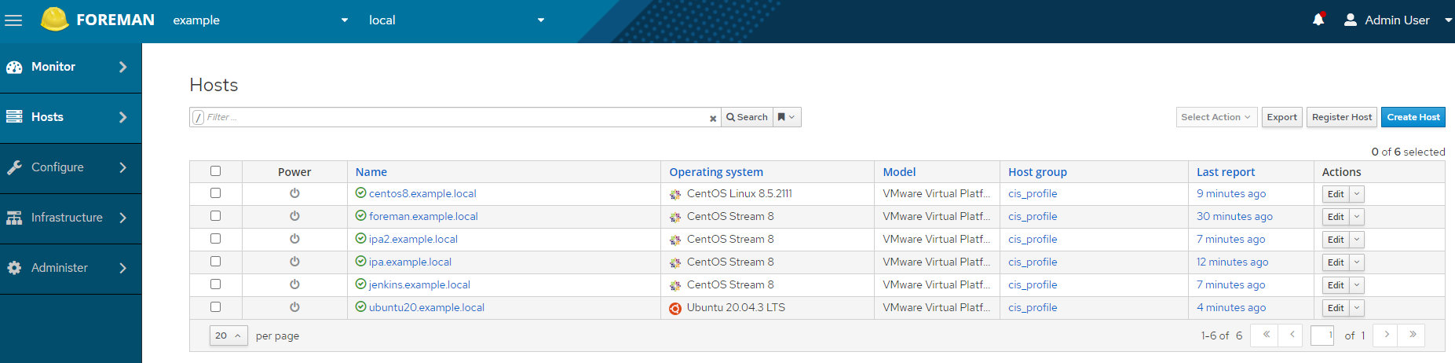

=== End-of-doc ===

