Login as admin to <http://127.0.0.1:8080/jenkins> (Jenkins baseURL) or <http://127.0.0.1/jenkins> (Nginx reverse proxy).

Click ‘**Manage Jenkins**’ / ‘**Manage Nodes and Clouds**’ / ‘**New Node**’

To create Inbound Agent (aka JNLP4 or Java Web Start agent), for example enter:

Node: **jkagent01**

Click ‘**Permanent Agent**’

Click ‘**OK**’

Enter:

# of executors: **2**

Remote root directory: **/home/Jenkins/agent**

Labels: **linux**

Usage: **Only build jobs with label expressions matching this node**

Launch Method: **Launch agent by connecting it to the master**

Click ‘**Save**’

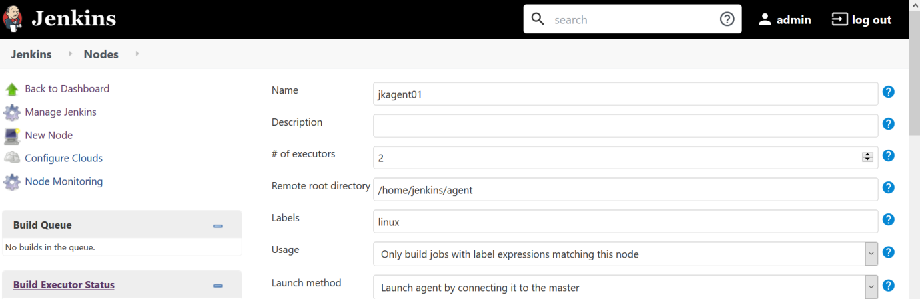

Click the created node ‘**jkagent01**’ to look at its details.

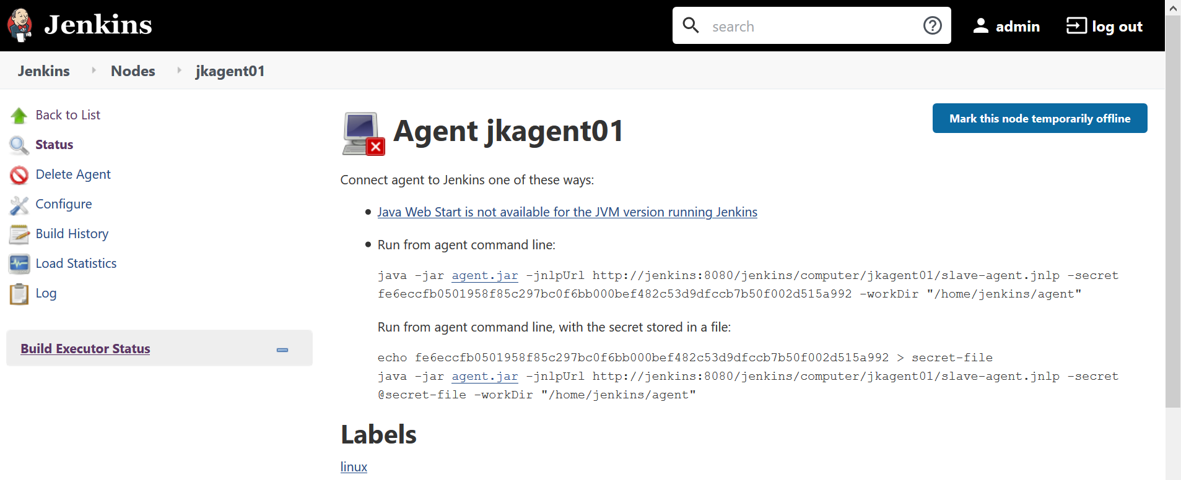

Note down the secret and update it in docker-compose.yaml file.

To re-stop-rm-up jkagent01 container, you may run the following steps:

$ **. ./functions && display_shell_function docker_compose_re_up**

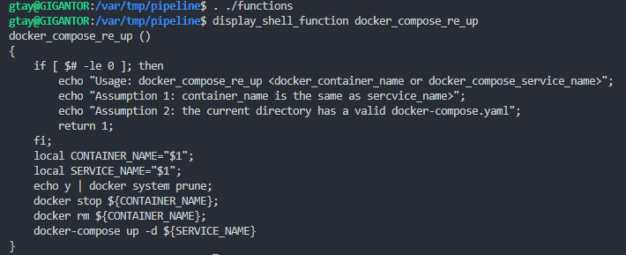

$ **sudo ./fix_jenkins_perms.sh**

$ **docker_compose_re_up jkagent01**

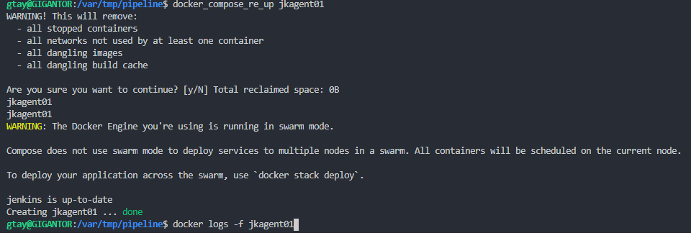

Tail the container log file to check, last message should be ‘INFO: Connected’

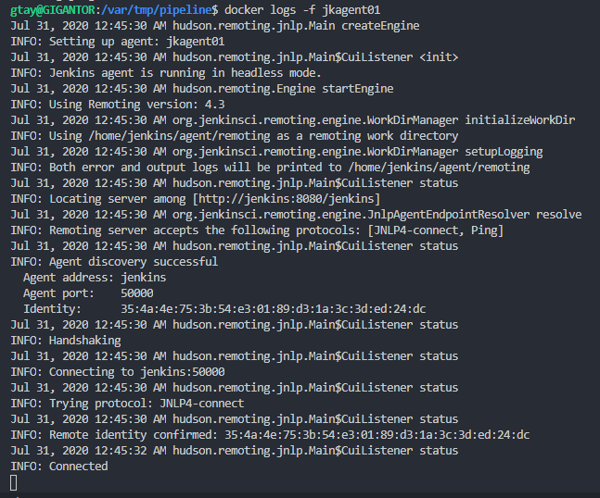

To create SSH Agent, first create a SSH-Key-Pair for example by ‘**ssh-keygen**’ with null passphrase, note down its content of private key, assuming you name the keypair file using **jenkins@jkagent02**,

The private key will be jenkins@jkagent02 and the public ley [Jenkins@jkagent02.pub](mailto:Jenkins@jkagent02.pub)

Copy the private key and public key to Notepad++ just in case to have their line feeds properly adjusted.

Then for example enter:

Node: **jkagent02**

Click ‘**Permanent Agent**’

Click ‘**OK**’

Enter the following parameters as shown:

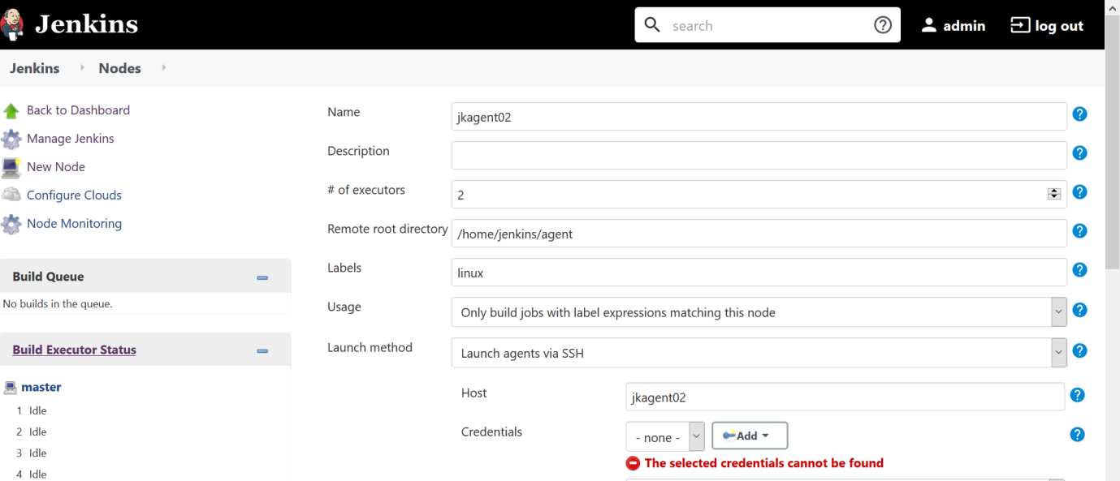

Click ‘**Add**’ / ‘**Jenkins**’ to create SSH Private Key Credentials in Jenkins, enter for example:

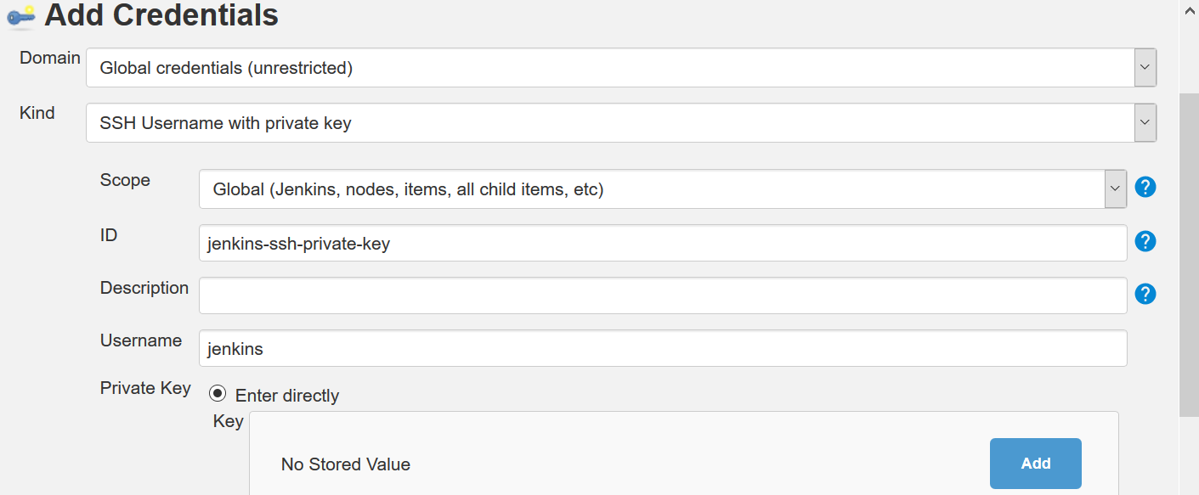

Click ‘**Add**’ again, and paste the content of the SSH private key obtained previously.

Click ‘**Add**’ again, click the drop-down to the right of ‘Credentials’, and select ‘**jenkins**’ (Username in above screen), you may wish to select ‘**Non verifying Verification Strategy**’, i.e. not checking /home/jenkins/.ssh/known_hosts file, click ‘Advanced’ and enter JavaPath found via:

$ docker exec -it jkagent02 bash -c ‘which java’



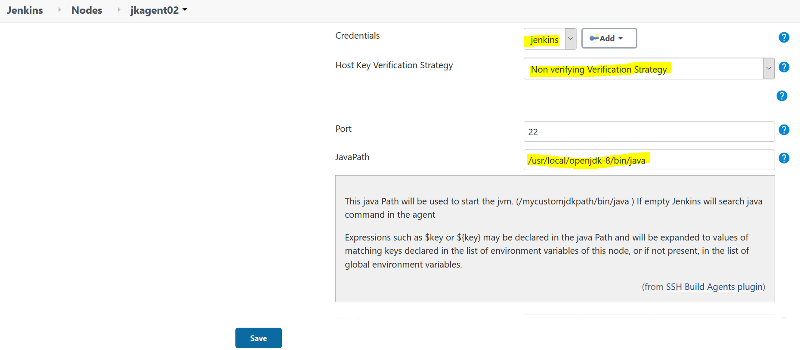

Click ‘**Save**’, you might notice the agent is not up.

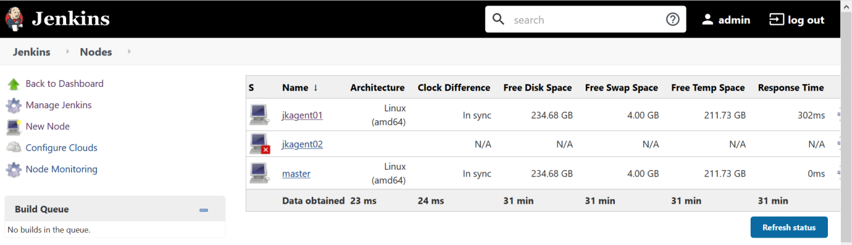

Next copy the public key to the container’s jenkins’ $HOME/.ssh/authorized_keys

$ cat [~/.ssh/jenkins@jkagent02.pub](mailto:~/.ssh/jenkins@jkagent02.pub)

$ **docker cp** [**~/.ssh/jenkins@jkagent02.pub**](mailto:~/.ssh/jenkins@jkagent02.pub) **jkagent02:/home/jenkins/.ssh/authorized_keys**

$ docker exec -it jkagent02 bash -c 'cat /home/jenkins/.ssh/authorized_keys’

Click the ‘**Launch Agent**’. Both agents should be up now.

