alarm.R

garyw

2021-04-30

# # Install packages  
# install.packages(c("bnlearn", "bnviewer"))  
# if (!requireNamespace("BiocManager", quietly = TRUE))  
# install.packages("BiocManager")  
# BiocManager::install()  
# BiocManager::install(c("graph", "Rgraphviz"))  
# install.packages("ggplot2")  
  
# Load packages  
library("bnlearn")  
library("bnviewer")  
library("Rgraphviz")

## Loading required package: graph

## Loading required package: BiocGenerics

## Loading required package: parallel

##   
## Attaching package: 'BiocGenerics'

## The following objects are masked from 'package:parallel':  
##   
## clusterApply, clusterApplyLB, clusterCall, clusterEvalQ,  
## clusterExport, clusterMap, parApply, parCapply, parLapply,  
## parLapplyLB, parRapply, parSapply, parSapplyLB

## The following objects are masked from 'package:bnlearn':  
##   
## path, score

## The following objects are masked from 'package:stats':  
##   
## IQR, mad, sd, var, xtabs

## The following objects are masked from 'package:base':  
##   
## anyDuplicated, append, as.data.frame, basename, cbind, colnames,  
## dirname, do.call, duplicated, eval, evalq, Filter, Find, get, grep,  
## grepl, intersect, is.unsorted, lapply, Map, mapply, match, mget,  
## order, paste, pmax, pmax.int, pmin, pmin.int, Position, rank,  
## rbind, Reduce, rownames, sapply, setdiff, sort, table, tapply,  
## union, unique, unsplit, which.max, which.min

##   
## Attaching package: 'graph'

## The following objects are masked from 'package:bnlearn':  
##   
## degree, nodes, nodes<-

## Loading required package: grid

library("ggplot2")  
  
# setwd('~/Projects/cics490e_research')  
setwd('E:/Projects/cics490e_research')  
  
# Compute f1 score given tp, fp, fn  
f1 <- function(m) {  
 tp <- m$tp  
 fp <- m$fp  
 fn <- m$fn  
  
 return(tp / (tp + (fp + fn) / 2))  
}  
  
# Load Dataset  
data('alarm')  
head(alarm)

## CVP PCWP HIST TPR BP CO HRBP HREK HRSA PAP SAO2 FIO2  
## 1 NORMAL NORMAL FALSE LOW NORMAL HIGH HIGH HIGH HIGH NORMAL NORMAL LOW  
## 2 NORMAL NORMAL FALSE NORMAL LOW LOW HIGH HIGH HIGH NORMAL LOW NORMAL  
## 3 NORMAL HIGH FALSE NORMAL NORMAL HIGH HIGH HIGH HIGH NORMAL LOW NORMAL  
## 4 NORMAL NORMAL FALSE LOW LOW HIGH HIGH HIGH HIGH NORMAL NORMAL NORMAL  
## 5 NORMAL NORMAL FALSE LOW LOW NORMAL HIGH HIGH HIGH NORMAL LOW NORMAL  
## 6 NORMAL NORMAL FALSE LOW NORMAL HIGH HIGH HIGH HIGH NORMAL LOW NORMAL  
## PRSS ECO2 MINV MVS HYP LVF APL ANES PMB INT KINK DISC  
## 1 HIGH ZERO HIGH NORMAL FALSE FALSE FALSE FALSE FALSE NORMAL FALSE TRUE  
## 2 HIGH ZERO ZERO NORMAL FALSE FALSE FALSE FALSE FALSE NORMAL FALSE FALSE  
## 3 NORMAL ZERO ZERO NORMAL FALSE FALSE FALSE FALSE FALSE NORMAL FALSE FALSE  
## 4 HIGH ZERO ZERO NORMAL FALSE FALSE FALSE FALSE FALSE NORMAL FALSE FALSE  
## 5 LOW ZERO ZERO NORMAL FALSE FALSE FALSE FALSE FALSE NORMAL FALSE FALSE  
## 6 HIGH HIGH ZERO NORMAL FALSE FALSE FALSE TRUE FALSE NORMAL FALSE FALSE  
## LVV STKV CCHL ERLO HR ERCA SHNT PVS ACO2 VALV VLNG VTUB  
## 1 NORMAL NORMAL HIGH FALSE HIGH FALSE NORMAL NORMAL NORMAL HIGH LOW ZERO  
## 2 NORMAL LOW HIGH FALSE HIGH FALSE NORMAL LOW LOW ZERO ZERO LOW  
## 3 NORMAL NORMAL HIGH FALSE HIGH FALSE NORMAL LOW LOW ZERO ZERO LOW  
## 4 NORMAL NORMAL HIGH FALSE HIGH FALSE NORMAL NORMAL LOW ZERO ZERO LOW  
## 5 NORMAL NORMAL HIGH FALSE HIGH FALSE NORMAL LOW LOW ZERO ZERO LOW  
## 6 NORMAL NORMAL HIGH FALSE HIGH FALSE NORMAL LOW LOW ZERO ZERO LOW  
## VMCH  
## 1 NORMAL  
## 2 NORMAL  
## 3 NORMAL  
## 4 NORMAL  
## 5 NORMAL  
## 6 NORMAL

# Ground truth network  
modelstring <- paste0("[HIST|LVF][CVP|LVV][PCWP|LVV][HYP][LVV|HYP:LVF][LVF]",  
 "[STKV|HYP:LVF][ERLO][HRBP|ERLO:HR][HREK|ERCA:HR][ERCA][HRSA|ERCA:HR][ANES]",  
 "[APL][TPR|APL][ECO2|ACO2:VLNG][KINK][MINV|INT:VLNG][FIO2][PVS|FIO2:VALV]",  
 "[SAO2|PVS:SHNT][PAP|PMB][PMB][SHNT|INT:PMB][INT][PRSS|INT:KINK:VTUB][DISC]",  
 "[MVS][VMCH|MVS][VTUB|DISC:VMCH][VLNG|INT:KINK:VTUB][VALV|INT:VLNG]",  
 "[ACO2|VALV][CCHL|ACO2:ANES:SAO2:TPR][HR|CCHL][CO|HR:STKV][BP|CO:TPR]")  
dag_true <- model2network(modelstring)  
graphviz.plot(dag_true)

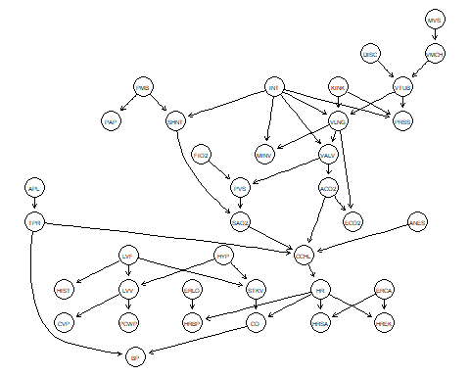

# Given 1 incorrect edge to blacklist  
n <- dim(dag_true$arcs)[1]  
arcs <- dag_true$arcs  
df_b1 <- data.frame(edge=character(), f1=numeric())  
  
for (i in 1:n) {  
 e <- arcs[i,]  
 net <- hc(alarm, blacklist = e)  
  
 df_b1[i,] <- c(paste(e, collapse = ' -> '), f1(compare(dag_true, net)))  
}  
df_b1$f1 = as.numeric(df_b1$f1)  
  
gt_f1 = f1(compare(dag_true, hc(alarm)))  
  
ggplot(df_b1, aes(x=edge, y=f1, group=1)) +  
 scale_x_discrete(limits=df_b1$edge) +  
 scale_y_continuous(breaks = sort(c(seq(min(df_b1$f1), max(df_b1$f1), length.out=5), gt_f1))) +  
 geom_point() +  
 geom_hline(aes(yintercept=gt_f1, color='red')) +  
 geom_text(aes(5,gt_f1,label = 'Without given prior knowledge', vjust = -0.5, color='red')) +  
 theme(axis.text.x = element_text(angle = 90, vjust = 0.5, hjust=1)) +  
 labs(title = "F1 score given 1 incorrect blacklist edge",  
 x='Edge added to the blacklist', y='F1 Score') +  
 theme(legend.position = "none")

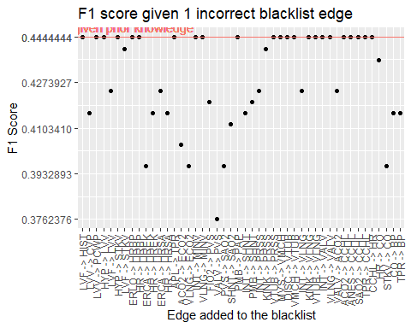

ggsave(  
 'blacklist_1_f1.png',  
 device = 'png',  
 path = 'figures',  
 width = 32,  
 height = 18,  
 units = 'cm'  
)  
  
# Given n random incorrect edge to blacklist  
df_bn <- data.frame(f1=numeric())  
  
for (i in 1:n) {  
 e <- arcs[sample(1:n, i),]  
 net <- hc(alarm, blacklist = e)  
  
 df_bn[i,] <- f1(compare(dag_true, net))  
}  
  
ggplot(df_bn, aes(x=(1:n), y=f1)) +  
 scale_y_continuous(breaks = sort(c(seq(min(df_bn$f1), max(df_bn$f1), length.out=5), gt_f1))) +  
 geom_point() +  
 geom_hline(aes(yintercept=gt_f1, color='red')) +  
 geom_text(aes(5,gt_f1,label = 'Without given prior knowledge', vjust = -0.5, color='red')) +  
 labs(title = "F1 score given n random incorrect blacklist edge",  
 x='Number of edges added to the blacklist', y='F1 Score') +  
 theme(legend.position = "none")

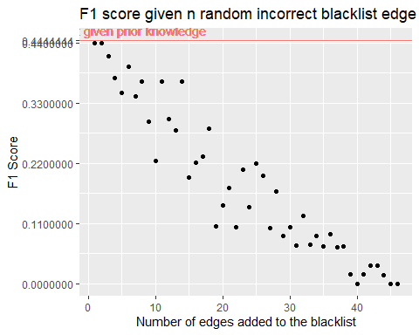

ggsave(  
 'blacklist_n_f1.png',  
 device = 'png',  
 path = 'figures',  
 width = 32,  
 height = 18,  
 units = 'cm'  
)  
  
  
# Given 1 correct edge to the white list  
df_cw1 <- data.frame(edge=character(), f1=numeric())  
  
for (i in 1:n) {  
 e <- arcs[i,]  
 net <- hc(alarm, whitelist = e)  
  
 df_cw1[i,] <- c(paste(e, collapse = ' -> '), f1(compare(dag_true, net)))  
}  
df_cw1$f1 = as.numeric(df_cw1$f1)  
  
ggplot(df_cw1, aes(x=edge, y=f1, group=1)) +  
 scale_x_discrete(limits=df_cw1$edge) +  
 scale_y_continuous(breaks = sort(c(seq(min(df_cw1$f1), max(df_cw1$f1), length.out=5), gt_f1))) +  
 geom_point() +  
 geom_hline(aes(yintercept=gt_f1, color='red')) +  
 geom_text(aes(5,gt_f1,label = 'Without given prior knowledge', vjust = -0.5, color='red')) +  
 theme(axis.text.x = element_text(angle = 90, vjust = 0.5, hjust=1)) +  
 labs(title = "F1 score given 1 correct whitelist edge",  
 x='Edge added to the whitelist', y='F1 Score') +  
 theme(legend.position = "none")

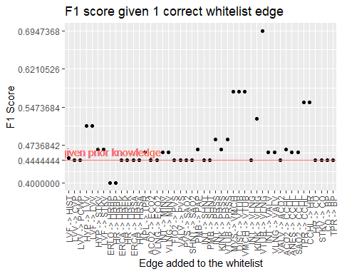

ggsave(  
 'whitelist_c1_f1.png',  
 device = 'png',  
 path = 'figures',  
 width = 32,  
 height = 18,  
 units = 'cm'  
)  
  
  
# Given n random correct edge to the white list  
df_cwn <- data.frame(f1=numeric())  
  
for (i in 1:n) {  
 e <- arcs[sample(1:n, i),]  
 net <- hc(alarm, whitelist = e)  
  
 df_cwn[i,] <- f1(compare(dag_true, net))  
}  
  
ggplot(df_cwn, aes(x=(1:n), y=f1)) +  
 scale_y_continuous(breaks = sort(c(seq(min(df_cwn$f1), max(df_cwn$f1), length.out=5), gt_f1))) +  
 geom_point() +  
 geom_hline(aes(yintercept=gt_f1, color='red')) +  
 geom_text(aes(5,gt_f1,label = 'Without given prior knowledge', vjust = -0.5, color='red')) +  
 labs(title = "F1 score given n random correct whitelist edge",  
 x='Number of edges added to the whitelist', y='F1 Score') +  
 theme(legend.position = "none")

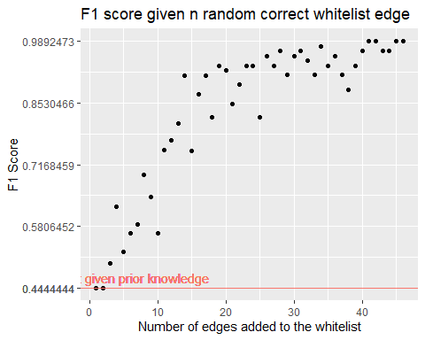

ggsave(  
 'whitelist_cn_f1.png',  
 device = 'png',  
 path = 'figures',  
 width = 32,  
 height = 18,  
 units = 'cm'  
)  
  
  
# Given 20 random incorrect edge to the blacklist and learn the network from different size of data  
df_size_b20 <- data.frame(size=numeric(), f1=numeric())  
  
e <- arcs[sample(1:n, 20),]  
for (i in c(100, 200, 500, 1000, 2000, 5000, 10000, 20000, 50000, 100000)) {  
 sim <- rbn(dag_true, i, alarm, replace.unidentifiable = TRUE)  
  
 net <- hc(sim, blacklist = e)  
  
 df_size_b20[dim(df_size_b20)[1]+1,] <- c(i, f1(compare(dag_true, net)))  
}

## Warning in check.data(x): variable ACO2 has levels that are not observed in the  
## data.

## Warning in check.data(x): variable APL has levels that are not observed in the  
## data.

## Warning in check.data(x): variable VLNG has levels that are not observed in the  
## data.

## Warning in check.data(x): variable VTUB has levels that are not observed in the  
## data.

df_size_b20$size = as.numeric(df_size_b20$size)  
df_size_b20$f1 = as.numeric(df_size_b20$f1)  
  
ggplot(df_size_b20, aes(x=size, y=f1)) +  
 scale_x_continuous(trans='log10') +  
 scale_y_continuous(breaks = sort(c(seq(min(df_size_b20$f1), max(df_size_b20$f1), length.out=5), gt_f1))) +  
 geom_point() +  
 geom_hline(aes(yintercept=gt_f1, color='red')) +  
 geom_text(aes(200,gt_f1,label = 'Without given prior knowledge', vjust = -0.5, color='red')) +  
 labs(title = "F1 score given 20 random incorrect blacklist edge and learn the network from different size of data",  
 x='Size of data the network learned from (log_10)', y='F1 Score') +  
 theme(legend.position = "none")

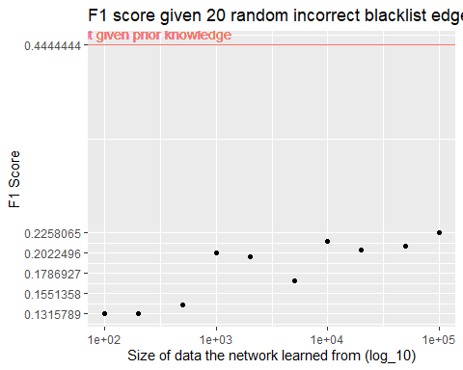

ggsave(  
 'blacklist_size_20_f1.png',  
 device = 'png',  
 path = 'figures',  
 width = 32,  
 height = 18,  
 units = 'cm'  
)  
  
  
  
save.image('data.RData')