Draft for F1000Research / methods submission. Not peer-reviewed. Text and figures may change before posting.
Mermaid flowcharts for perturbation design: diagrams-as-code, curated databases, and the E. coli lac operon as a worked example
A methods-oriented primer for investigators combining large language models, RegulonDB-class resources, and logic-style process charts
Gary Welz
Researcher, New Media Lab, CUNY Graduate Center
Email: gwelz@gc.cuny.edu | ORCID: https://orcid.org/0009-0005-7806-0892
Draft date: April 2026

Recommended hands-on before reading the methods sections
In any contemporary large language model, run the following prompt verbatim:
Use mermaid markdown format to make a flowchart of the Lac Operon and deliver it to me as an html file.
Inspect the returned HTML. Then issue a second prompt for any other biological process you use in the lab or in silico. The remainder of this draft assumes familiarity with how variable, detailed, and revisable such outputs are - and why reconciliation with curated data remains necessary.

Abstract
Planning genetic, pharmacological, or nutritional perturbations is easier when the investigator can state, in advance, which molecular levers are plausible and which readouts would discriminate competing mechanisms. Logic-style flowcharts - authored as diagrams-as-code (here using Mermaid markdown) - provide a lightweight, versionable complement to pathway databases, genome browsers, and machine-learning predictors. This methods paper distills a seminar-tested workflow for a general research audience: we motivate text-based diagrams in wet-lab and computational pipelines; we compare three deliberately different encodings of the classical Escherichia coli lactose (lac) operon - a literature-first logic diagram with explicit Boolean-style gates, a RegulonDB-emphasis regulatory wiring diagram without those gates, and a hybrid diagram that retains interpretive logic while adding database-grounded entities (notably explicit lacI expression); we explain why the full two-input induction condition (inducer present and catabolite repression relieved) appears only in some encodings; and we recommend layered hybridization (regulatory backbone + literature logic + identifier and parts audits) instead of naively merging incompatible ontologies. No bespoke software is required beyond ordinary LLM access, Mermaid rendering, and public databases.

1. Introduction
The lac operon remains the canonical bacterial example of integrating environmental signals, transcription factors, and promoter logic.¹ Contemporary laboratories rarely study it in isolation, but it is ideal as a tutorial system: many curated representations exist, so source choice becomes visible as scientific information rather than as an invisible preprocessing step.
Meanwhile, perturbation-forward workflows - CRISPR screens, chemical genetics, single-cell readouts, virtual-cell-style predictors - benefit from an explicit, criticizable sketch of inputs, branch points, feedback, and candidate measurements before budget is committed. A flowchart is not a mechanistic ODE model and not a trained deep network; it is a hypothesis artifact suitable for group review, supplementary files, and teaching.
Mermaid is a widely supported markdown-adjacent language for flowcharts and related diagrams; source text diffs cleanly in Git and renders in browsers, notebooks, and static site generators.² Modern LLMs can emit fenced mermaid blocks from natural language, which accelerates first drafts but increases the obligation to validate against authoritative resources.

2. Background and rationale
High-dimensional expression or chromatin data and modern predictors answer different questions than a hand-specified logic chart. The chart's job is to make conditional structure discussable: which environmental axes gate which genes, where redundancy may hide causal effects, and which branch-point perturbations would be most informative. It should complement - not replace - controlled experiments and quantitative models.
Mermaid is practical in collaborative research groups for three reasons:
- Text to vector diagram: the same source renders in CI documentation, lab wikis, and supplementary PDF pipelines.
- Collaboration: pull requests on diagram source are interpretable; meeting-driven edits are quick.
- LLM interface: models can propose structure; human authors remain responsible for citations, organism fit, and experimental feasibility.

3. Objectives for the practicing investigator
- State what could change under a planned intervention before locking readouts or model architecture.
- Maintain diagrams-as-code beside literature notes and analysis scripts.
- Combine LLM-assisted layout with RegulonDB-class regulatory facts without collapsing distinct abstraction levels into one unreadable graph.
- Treat disagreement between diagram sources as data - analogous to comparing alignment or quantification pipelines.

4. LLM-first
A well-posed conversational prompt often yields a surprisingly detailed first pass: two-input logic (allolactose / LacI and glucose / cAMP-CRP), default OFF at the operator, graded induction, sometimes a feedback arc as inducer is consumed. Reliability varies by model version and prompt; treat any auto-generated chart as revision zero to be checked against reviews and databases.

5. Three encodings of the same operon
GLMP-style public comparisons (see viewer in Data Availability) contrast multiple evidence mixes for one operon. For methods exposition we isolate three complementary styles; names here are descriptive only.

5.1 Literature-first logic diagram
Built from textbook-style reasoning, this encoding foregrounds explicit AND-style integration and is optimized for pedagogy and perturbation intuition, not for locus tags.
What is typically missing here: there is no first-class node for lacI transcription or for the gene to protein production of the repressor. LacI appears only inside the wording of the first decision node - the repressor is assumed to exist whenever lactose logic is discussed. That is fine for high-level logic, but it hides a real experimental lever (CRISPRi on lacI, titration of repressor copy number, etc.).
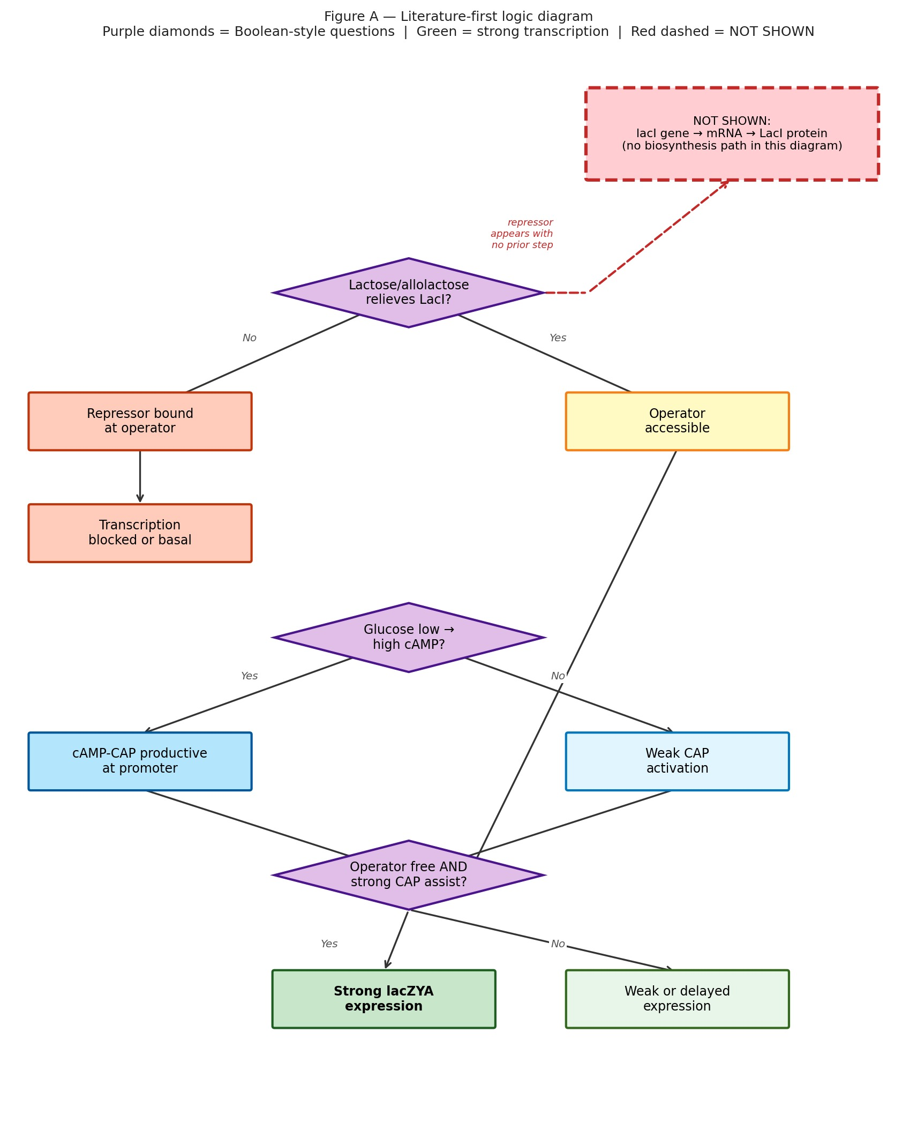
Figure A. Literature-first logic. Purple diamonds = explicit Boolean-style questions. Green = strong transcription outcome. Red dashed box (top right) = what this encoding leaves implicit: no biosynthesis path for LacI protein.
Read Figure A against Figure C: the red dashed annotation has no counterpart in the main flow - the hybrid inserts a real chain of orange nodes for lacI expression before any "repressor off operator?" decision.

5.2 RegulonDB-emphasis regulatory wiring
A chart faithful to how RegulonDB represents E. coli transcriptional regulation centers who regulates whom with signed or labeled edges; it does not encode the full Boolean "both conditions" story as explicit gate nodes.³ Figure B highlights the lacI gene to protein spine (orange) as a first-class entity; there are no purple AND diamonds.
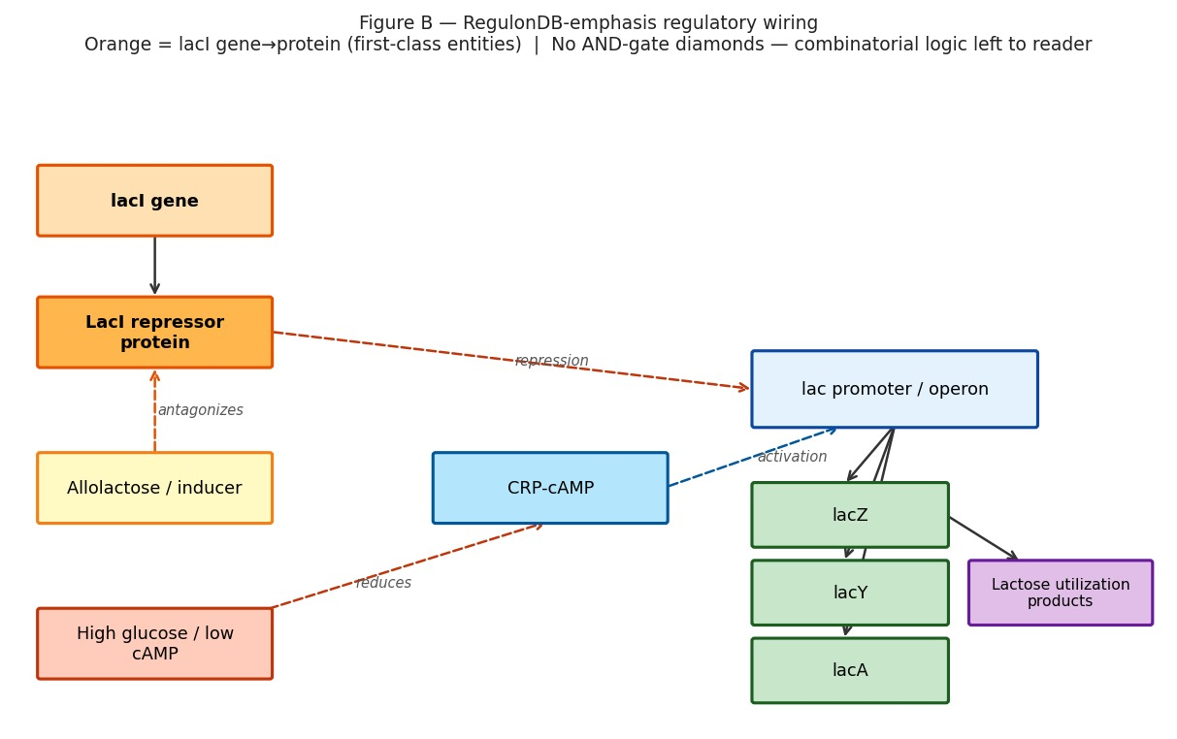
Figure B. Regulatory wiring emphasis. Orange = lacI gene to protein (RegulonDB first-class entities). No AND-gate diamonds; combinatorial logic is left to the reader.

5.3 Hybrid diagram (literature logic + RegulonDB entity completeness)
The hybrid merges interpretive structure from reviews and LLM drafts with database-grounded entities. The key addition is an explicit step for lacI transcription to LacI protein upstream of operator control - a node that matters for perturbations such as tuning repressor dosage via CRISPRi. Boolean-style gates are retained from the literature-first chart.
Exactly one structural addition vs. Figure A: the two orange nodes at the top are the RegulonDB-class spine that Figure A's red annotation warned was missing. Purple diamonds and the green transcription outcome use the same color language as Figure A; only the orange chain is new.
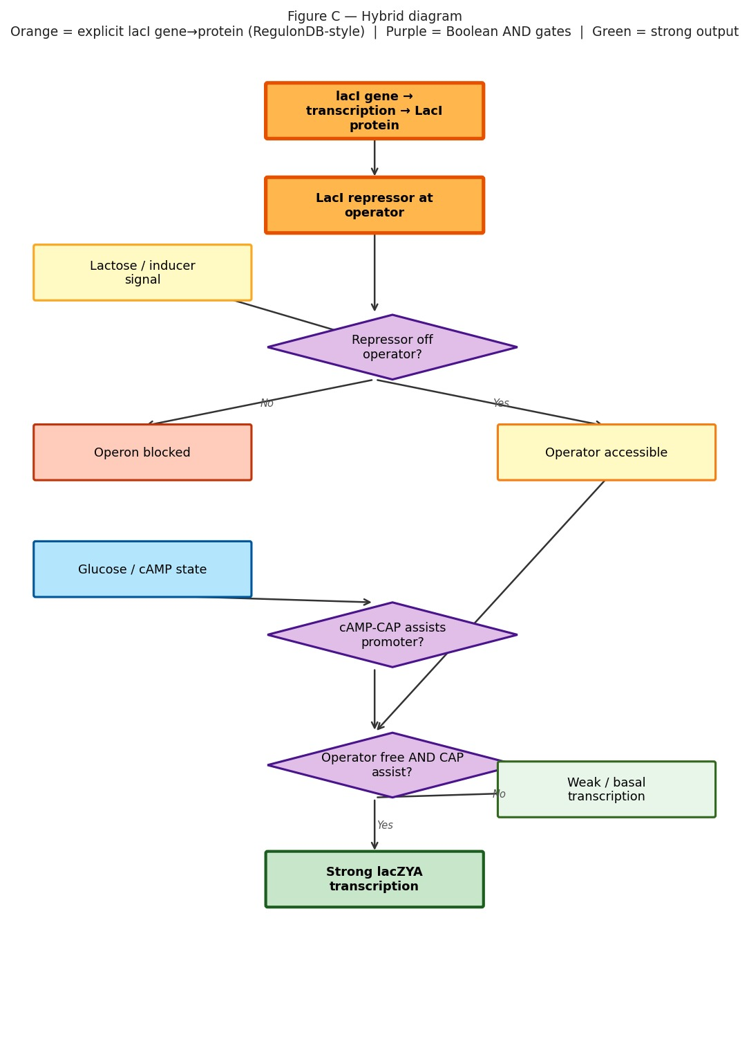
Figure C. Hybrid. Orange = explicit lacI gene to protein (RegulonDB-style completeness). Purple diamonds = Boolean AND gates (same convention as Figure A). Green = strong lacZYA transcription output.

5.4 At-a-glance: literature-first vs. hybrid
Feature | Literature-first (Fig. A) | Hybrid (Fig. C)
lacI gene to LacI protein | Absent (repressor assumed) | Present as two orange nodes
Explicit AND gate | Yes (purple diamond) | Yes (same convention)
Perturbations readable from picture | Nutrients, operator, CAP branch | Those plus lacI expression as its own lever
RegulonDB entity completeness | Not the goal | Explicitly merged

Interactive multi-encoding views are available at the GLMP demo viewer (URL given in Data Availability).

6. Why the two-input induction condition is not automatic in database-native views
Strong induction requires relief of LacI-mediated repression and favorable catabolite control (glucose scarcity to sufficient cAMP for CRP). Textbook diagrams express that as AND logic. Curated regulatory databases excel at listing regulators, targets, and evidence; they do not always export that simultaneous requirement as explicit gate nodes. LLM- or review-driven charts supply that interpretive layer - subject to validation - while RegulonDB-class edges supply who is connected to whom.

7. Layered hybridization (recommended workflow)
- Regulatory backbone: TF to gene resolution from a trusted resource (for E. coli, RegulonDB or equivalent).
- Interpretive overlay: literature or LLM-assisted gates and feedback arcs where they clarify conditionality.
- Parts audit: EcoCyc / BioCyc for enzyme identities and reactions.⁴
- Identifier layer: KEGG or model-organism locus tags attached as node metadata after topology stabilizes.⁵
Naive union of every node type from multiple ontologies typically obscures the very branch logic that makes diagrams useful for perturbation planning.

8. Practical guidance: prompt discipline and operational habits
The same pathway, same organism, and different natural-language instructions yield different Mermaid topologies. Best practice: generate two charts, diff the source, reconcile against one primary review figure or database page, and archive both the Mermaid text and the citation in supplementary material.
More broadly, investigators benefit from routinely pairing literature search, structured databases, and diagram-as-code so that inputs, branch points, and feedback are explicit before large experiments or model training runs. Public GLMP galleries illustrate how source mixtures change charts; they are optional references, not prerequisites.

9. Evidence buckets for perturbation design
- Primary literature and reviews (mechanism, conditions).
- Pathway and interaction databases (Reactome, KEGG, WikiPathways, BioCyc; STRING for functional linkage).⁶⁻⁸
- Gene-centric resources (NCBI Gene, UniProt, Ensembl, GO).
- Regulatory layers (RegulonDB, Abasy-class summaries; refs. 3, 9).
- Perturbation execution (reagents, libraries, chemistry).
- Data archives for realistic readouts (e.g. GEO).¹⁰

10. What logic charts add on top of databases and papers
Typical resources | Logic-style flowchart adds
Gene lists and canonical pathway maps | Explicit branching and AND/OR reasoning under stated conditions
Static lookup-optimized maps | "If this edge is removed, what fails first?"
Perturbation methods | Menu of informative interventions tied to mechanism sketch

11. Synthesis
Databases summarize what is connected; papers record what was measured under stated designs; a logic flowchart helps investigators choose perturbations that disambiguate mechanisms and anticipate qualitative directions before committing full experimental or computational cost.

Acknowledgments and AI Use Disclosure
The author used Claude (Anthropic, claude-sonnet-4-6) to assist with programmatic rendering of Figures A-C via Python/matplotlib and for PDF/DOCX typesetting. All scientific content, diagram structure, biological interpretation, and conclusions are the author's own. The GLMP viewer diagrams referenced in §5 were generated via Cursor IDE using various large language models as described in the Data and Code Availability section.

Data and code availability
Public GLMP process JSON and viewers reside on Google Cloud Storage. The lac operon multi-viewer: https://storage.googleapis.com/regal-scholar-453620-r7-podcast-storage/glmp-v2/viewer_demo/glmp-viewer-demo-v1-v6.html?process=ecoli_lac_operon&version=v1 No new experimental data were generated for this methods draft.
Figures A-C in this submission were rendered programmatically for publication using Python/matplotlib. The GLMP viewer diagrams referenced in §5 were generated via Cursor IDE using various large language models; visual differences between the two sets illustrate the prompt and tool sensitivity discussed in §8.

References
1. Jacob F, Monod J. Genetic regulatory mechanisms in the synthesis of proteins. J Mol Biol. 1961;3(3):318-356.
2. Mermaid documentation. https://mermaid.js.org/ (accessed 2026).
3. Gama-Castro S, et al. RegulonDB: a database of transcriptional regulation in Escherichia coli K-12. Nucleic Acids Res. https://regulondb.ccg.unam.mx/
4. Keseler IM, et al. EcoCyc: enriching the BioCyc collection of databases. Nucleic Acids Res. 2021;49(D1):D608-D612.
5. Kanehisa M, et al. KEGG for taxonomy-based analysis of pathways and genomes. Nucleic Acids Res. 2023;51(D1):D587-D592.
6. Gillespie M, et al. The Reactome Pathway Knowledgebase 2024. Nucleic Acids Res. 2024;52(D1):D672-D678.
7. Martens M, et al. WikiPathways: connecting communities. Nucleic Acids Res. 2021;49(D1):D613-D621.
8. Szklarczyk D, et al. The STRING database in 2025. Nucleic Acids Res. 2025;53(D1):D638-D646.
9. Escorcia-Rodriguez JM, Tauch A, Freyre-Gonzalez JA. Abasy Atlas v2.2. Comput Struct Biotechnol J. 2020;18:1228-1237.
10. Barrett T, et al. NCBI GEO: archive for functional genomics data - updated. Nucleic Acids Res. 2013;41(D1):D991-D995.
Suggested bioRxiv/F1000Research category: Method Article / Systems Biology | Correspondence: gwelz@gc.cuny.edu

