DANNY GARZA

Sebring, FL 33872 ◆ (321) 408-3048 ◆ garzadanny0101@gmail.com
PROFESSIONAL SUMMARY

AI automation and workflow practitioner with independent consulting and project experience since 2023. Build practical systems that turn complex tasks into clear steps, useful tools, and repeatable handoffs.
Work across ChatGPT, OpenAI, Codex, Google Workspace, CRM workflows, webhooks, REST APIs, and Python-supported tracking utilities.
Design structured prompts, agent workflows, knowledge-base organization, and human review points. Translate business goals into process maps, operating procedures, and documentation that non-technical users can follow.
Use AI-assisted development to build websites, applications, and workflow prototypes. GitHub work includes a Node.js opportunity dashboard with API routes, JSON storage, CSV export, and scoring tests.
Bring hands-on service operations experience from supervising event teams, coordinating VIP transportation, adapting staffing, and resolving customer concerns under time pressure.
Continue developing skills through coursework in agentic AI, LangChain, OpenAI APIs, prompt engineering, automation, and business analysis. Focus on work that is understandable, reviewable, and useful.
SKILLS

• AI & Automation: ChatGPT, OpenAI, Codex, structured prompts, agent workflows, LangChain fundamentals |  | • Platforms: GoHighLevel, Google Workspace, CRM pipelines, SMS/email sequences, calendar workflows
• Integrations: REST APIs, webhooks, Google Sheets, Python utilities, JSON, data cleanup |  | • Business Operations: Lead follow-up, missed-call response, appointment reminders, SOPs and handoffs
• Documentation: Intake forms, evidence checklists, issue tracking, reusable templates, process maps |  | • Development: AI-assisted coding, Node.js, JavaScript, HTML/CSS, dashboards, GitHub
• Workflow analysis |  | • Team supervision
• Prompt design |  | • Data organization
• Implementation planning |  | • Customer communication
• Website development |  | • Scoring logic review
• Business research |  | • Event coordination
• Human review checkpoints |  | • Portfolio development
• Task prioritization |  | • Process improvement
• Customer issue resolution |  | • Research synthesis
• Risk identification |  | • Technical documentation
• Exception handling |  | • Clear written communication
• Problem decomposition |  | • Follow-up workflows
• Project organization |  | • Reporting handoffs
• Requirements clarification |  | • Tool evaluation
 | EXPERIENCE

AI Consultant | Agentic AI Operations, 2023 - Current
Freelancer | Contract
• Created intake forms, evidence checklists, process maps, and communication templates for administrative workflows.
• Organized documentation around source records, issue tracking, and repeatable review steps.
• Turned complex administrative tasks into templates and instructions for non-technical users.
• Designed ChatGPT and OpenAI prompt workflows to support research, documentation, and decision-making.
• Reviewed operational information to identify workflow gaps and follow-up needs.
• Built decision-support frameworks using structured prompts, reference material, and human review.
• Developed implementation roadmaps that connect business requirements with practical AI use cases.
• Mapped where AI could support existing workflows and where human judgment was needed.
• Compared emerging tools against the task, user needs, and available resources.
• Created reusable documentation for consistent execution across recurring tasks.
• Adapted templates and workflow instructions as requirements changed.
• Explained technical processes in plain language for users with different experience levels.
• Broke complex problems into smaller steps, alternatives, and reviewable decisions.
• Applied new AI tools through hands-on projects and iterative workflow design.
• Reviewed operating procedures to identify unclear steps and duplicated effort.
• Assessed workflow, communication, and resource-use issues before proposing changes.
AI Workflow Consultant | Custom Frameworks, 02/2023 - Current
Self-employed – Titusville, FL
• Designed multi-step AI orchestration frameworks with task routing, specialist roles, challenger reviews, feedback loops, and organized reference material. Used prompts and runbooks to make complex work easier to follow and review.
• Built Google Sheets and Python-supported tracking utilities for leads, conversation status, bookings, and operating dashboards.
• Produced SOPs, reusable templates, and user-facing documentation for non-technical users.
• Designed service-business workflows for missed calls, lead follow-up, CRM stages, appointment booking, and reporting handoffs.
• Used IDEs and AI coding tools to develop websites, applications, and workflow prototypes, including a Node.js and JavaScript dashboard.
• Built a dashboard prototype with API routes, JSON persistence, CSV export, and a weighted scoring model using estimated or manually entered inputs.
• Added scoring and routing test cases to the dashboard project; documented the limits of its sample data and planned integrations.
• Developed a project-scoped task and result handoff system with persistent state and an MCP interface for AI-assisted workflows.
Valet Supervisor, 03/2020 - 07/2024
Accurate Event Services – Pompano Beach, FL
• Supervised valet and security teams at major events, including the International Polo Club, SunFest, and the South Florida Fair; coordinated vehicle handling, hospitality, and VIP service.
• Adjusted traffic flow, VIP shuttle operations, and staff training for changing crowds, schedules, and safety needs.
• Coordinated staffing schedules and team assignments during peak event periods.
• Monitored team performance and customer concerns to identify service and process improvements.
EDUCATION

Technology Education Coursework — No Degree
Wellington High School - Wellington, FL
WEBSITES, PORTFOLIOS, PROFILES

• https://danny-garza-resume-portfolio.netlify.app/ (Portfolio)
• https://www.linkedin.com/in/garza-danny-0101tm/ (LinkedIn)
• https://www.credential.net/profile/garzadanny0101/wallet (Course Completions)
• https://aimnd01.com (Company)
• https://aisolidknowledge.com (AI Systems Portfolio)
• https://github.com/garzadanny0101-cmyk (Code and Projects)
COURSE COMPLETIONS

• Agentic AI in Action: Hands-On with LangChain, 2026-04-19
• Inside Agentic AI: Foundations and Frontiers, 2026-04-19
• Agentic AI in Action: Tool Use with LangChain, 2026-04-19
• Inside Agentic AI: Core Architecture of Agentic Systems, 2026-04-19
• Using OpenAI APIs: Exploring APIs with the OpenAI Playground, 2026-04-19
• AI in IT Automation: Integrating AI Automation in IT Operations, 2026-04-19
• Using OpenAI APIs: Fine-tuning Models, the Assistants API, & Embeddings, 2026-04-19
• Getting Started with Prompt Engineering, 2026-04-19
• BABOK v3: Introduction to Business Analysis, 2026-04-19
• Exploring Prompt Engineering Techniques, 2026-04-19
• AI-Powered Productivity: Generative AI Bootcamp, 2026-04-19
WORKFLOW APPROACH

Start with the business problem, map the process, and choose tools that fit the task. Build structured prompts, define inputs and outputs, organize reference material, and include human review. Document exceptions and handoffs so the next person can use the workflow. Distinguish a prototype from a deployed system and estimated inputs from observed results.
SELECTED PROJECTS

• Missed-Call Rescue Workflow Prototype: Designed a service-business flow for text-back messages, lead qualification, booking links, CRM updates, and reporting handoff.
• Appointment Follow-Up System: Designed reminder, confirmation, reschedule, and exception paths for appointment operations, with SMS/email sequencing and calendar status rules.
• Opportunity Dashboard Prototype: Built a Node.js and JavaScript application with local API routes, JSON storage, CSV export, and scoring tests, using estimated or manually entered inputs.
• AI Prompt and Runbook Systems: Created reusable prompts and operating instructions for task routing, research, document preparation, output review, and human approval.
TARGET FIT

• AI Automation Specialist
• AI Workflow Builder
• Agentic AI Operations Support
• Operations Analyst
• AI Evaluation Support
• Customer Operations / CRM Support
• Process Documentation Specialist
PROFESSIONAL FOCUS

/s/ Danny Garza
AI Automation | Workflow Design | Operations
Practical AI systems, clear documentation, and hands-on implementation.
Portfolio and GitHub projects (if private, contact info below, and gladly provide access) show the workflows, tools, and deliverables behind the experience listed here.

COURSE COMPLETION
CERTIFICATE PORTFOLIO
Danny Garza
Skillsoft / Metrix Learning Course Completion Certificates
AI • Agentic AI • Automation • Cybersecurity • APIs • Business • Digital Transformation
59 unique course-completion certificates compiled from the supplied certificate archive.

SELECTED COURSE-COMPLETION BADGES
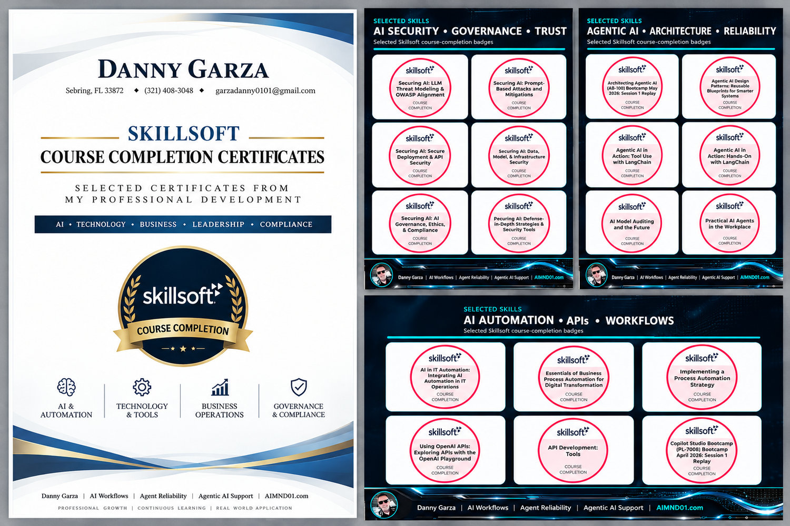



CERTIFICATE INDEX
AI, AGENTIC AI & GENERATIVE SYSTEMS  01. Agentic AI in Action: Hands-On with LangChain | AI, AGENTIC AI & GENERATIVE SYSTEMS  16. Inside Agentic AI: Core Architecture of Agentic Systems
02. Agentic AI in Action: Tool Use with LangChain | 17. Inside Agentic AI: Foundations and Frontiers
03. AI Change Management: Leading the Transformation | 18. Leadercamp on-demand: Artificial Intelligence-Powered Personal Branding
04. AI in IT Automation: Integrating AI Automation in IT Operations | 19. Prompt Engineering Techniques with DeepSeek-R1
05. AI Model Auditing and the Future | 20. Using OpenAI APIs: Exploring APIs with the OpenAI Playground
06. AI-enhanced Sales Strategies | 21. Using OpenAI APIs: Fine-tuning Models, the Assistants API, & Embeddings
07. AI-Powered Productivity: Generative AI (AB-730T00) Bootcamp February 2026: Session 1 Replay | AUTOMATION & DIGITAL TRANSFORMATION  22. Assessing Risks in Digital Transformation Initiatives
08. AI-Powered Productivity: Transform Workflows with Generative AI (AB-730T00) Bootcamp April 2026: Session 1 Replay | 23. Automating workflows with Copilot in Zapier (Email automation)
09. Architecting Agentic AI (AB-100) Bootcamp May 2026: Session 1 Replay | 24. Creating a Digital Change Plan
10. Artificial Intelligence: Types of Artificial Intelligence | 25. Digital Transformation Framework
11. Automating content generation with prompt engineering for ChatGPT (GPT-4) | 26. Essentials of Business Process Automation for Digital Transformation
12. Automating Image Generation with DALL-E Prompt engineering | 27. How to be successful in your Digital Transformation: Practical Tips and Advice: Session Replay
13. Azure AI Jumpstart (AI‑901) Bootcamp May 2026: Session 1 Replay | 28. Implementing a Process Automation Strategy (retired)
14. Build Declarative Agents VS Code (MS-4010) Bootcamp January 2026: Session 1 Replay | 29. Leadercamp on-demand: Digital Transformation Across Industries
15. Generative AI Foundations: Advanced Generative AI Techniques for IT | 30. Psychology of Digital Change Resistance

CERTIFICATE INDEX — CONTINUED
AUTOMATION & DIGITAL TRANSFORMATION  31. The Role of RPA in Business Process Automation for Digital Transformation | APIS, DEVELOPMENT, DATA & TECHNICAL SYSTEMS  46. IoT Technology Fundamentals
CYBERSECURITY, RISK & CLOUD  32. AWS Cloud Practitioner Bootcamp January 2026: Session 1 Replay | 47. JSON Essentials
33. Azure Fundamentals: IoT & AI | BUSINESS, LEADERSHIP, ANALYSIS & SALES  48. Applying Value Stream Mapping in Lean Business
34. Bitcoin Design & Security | 49. Automating data analysis with Microsoft 365 Copilot in Excel
35. Incident Response: Preparing for a Cybersecurity Breach | 50. Automating Transcription with Google AI Speech-to-Text
36. Zero Trust Security Bootcamp February 2026: Session 1 Replay | 51. BABOK(r) v3: Introduction to Business Analysis
APIS, DEVELOPMENT, DATA & TECHNICAL SYSTEMS  37. Advanced Visualizations & Dashboards: Visualization Using Python | 52. COMPLIANCE SHORT: Business Ethics
38. APIs & Output | 53. Financial Integrity
39. Automatic Workload Repository | 54. Leadercamp on-demand: Positive Psychology at Work
40. Bitcoin Technology Fundamentals | 55. Leadership Insights on Problem Solving & Decision Making
41. Blockchain for Supply Chain Insights | 56. Mastering Advanced Questioning Techniques
42. CompTIA A+ Core 1: Motherboards, CPUs, and Expansion Cards | 57. Maximize Your Productivity by Managing Time and Tasks
43. Git & GitHub: Working with Git Repositories | 58. Prospecting: Panning for Sales Gold (retired)
44. Harnessing Blockchain for Business Transformation | 59. Strategies for the Modern Public Relations Professional
45. IDEs

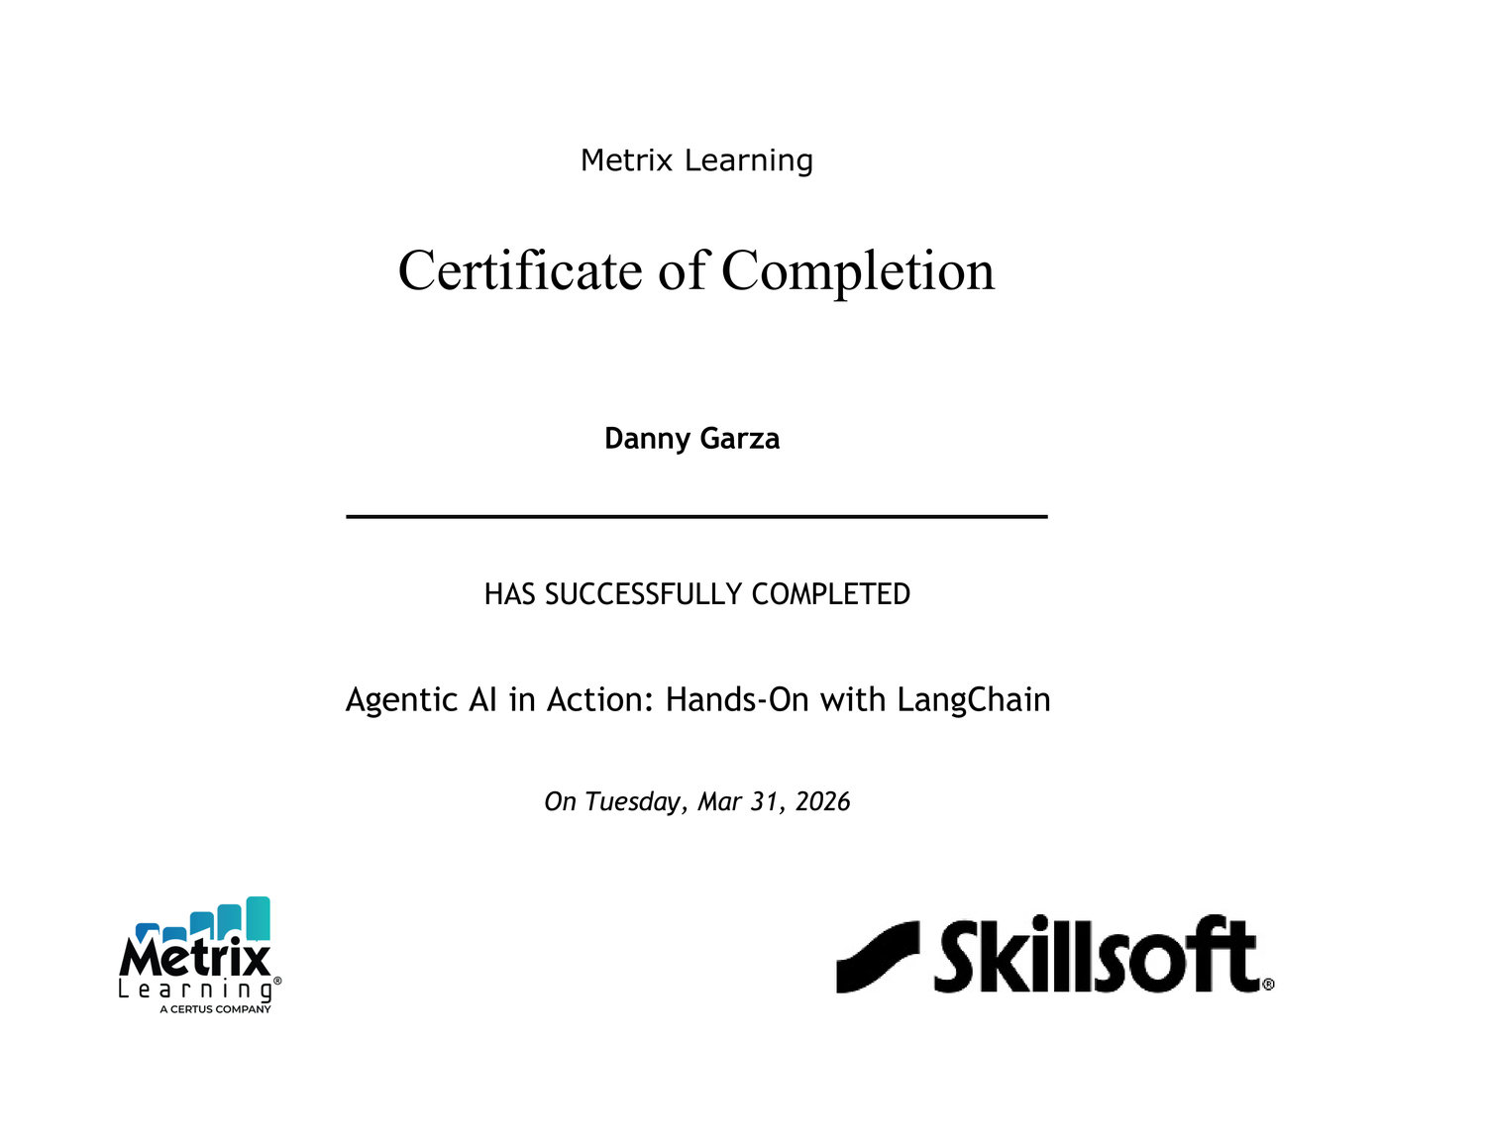

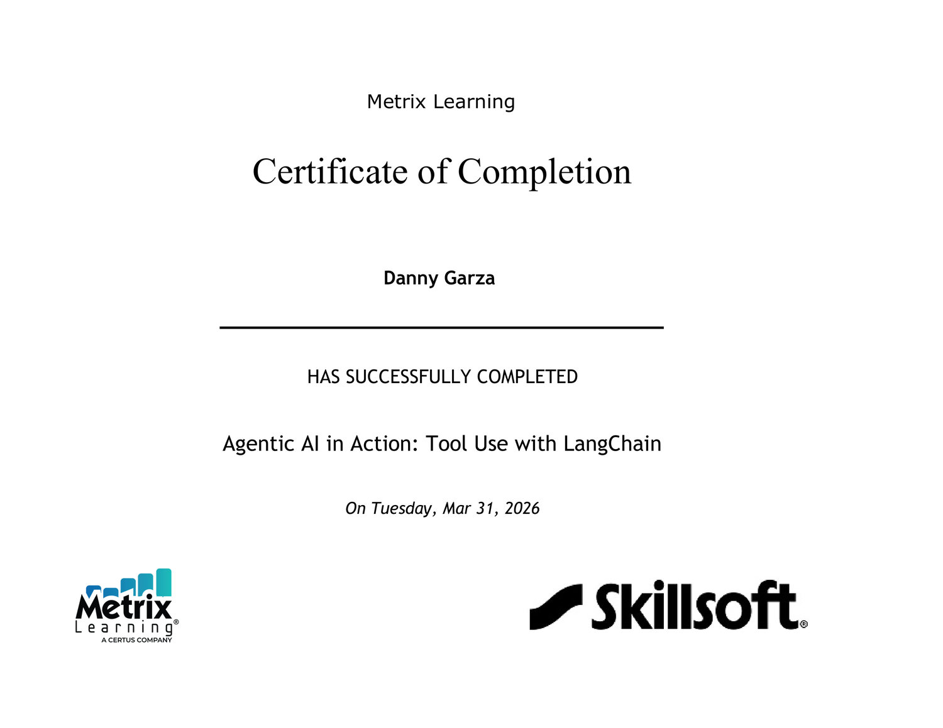

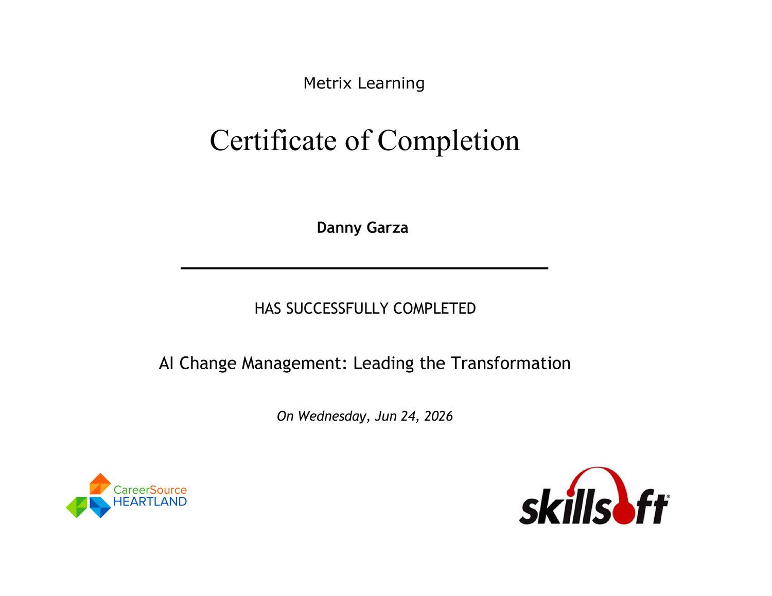

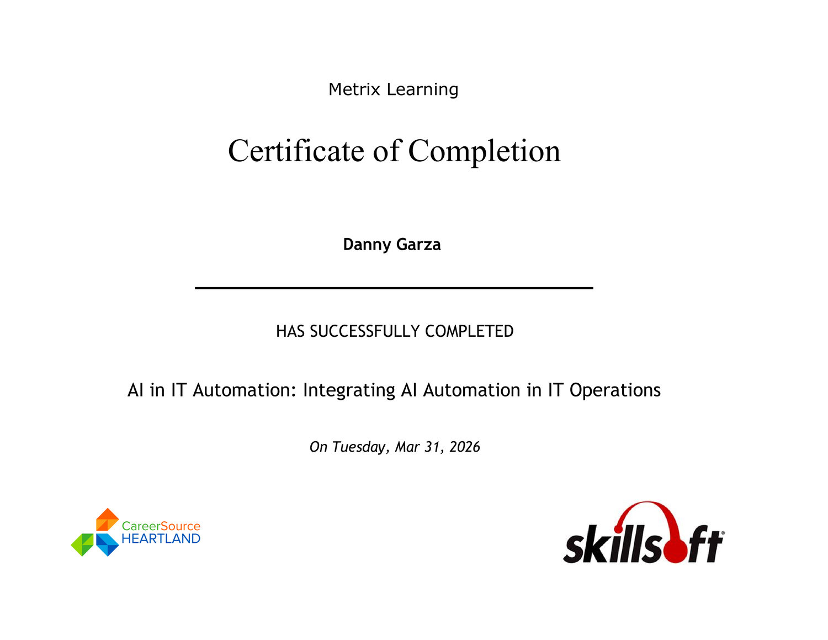

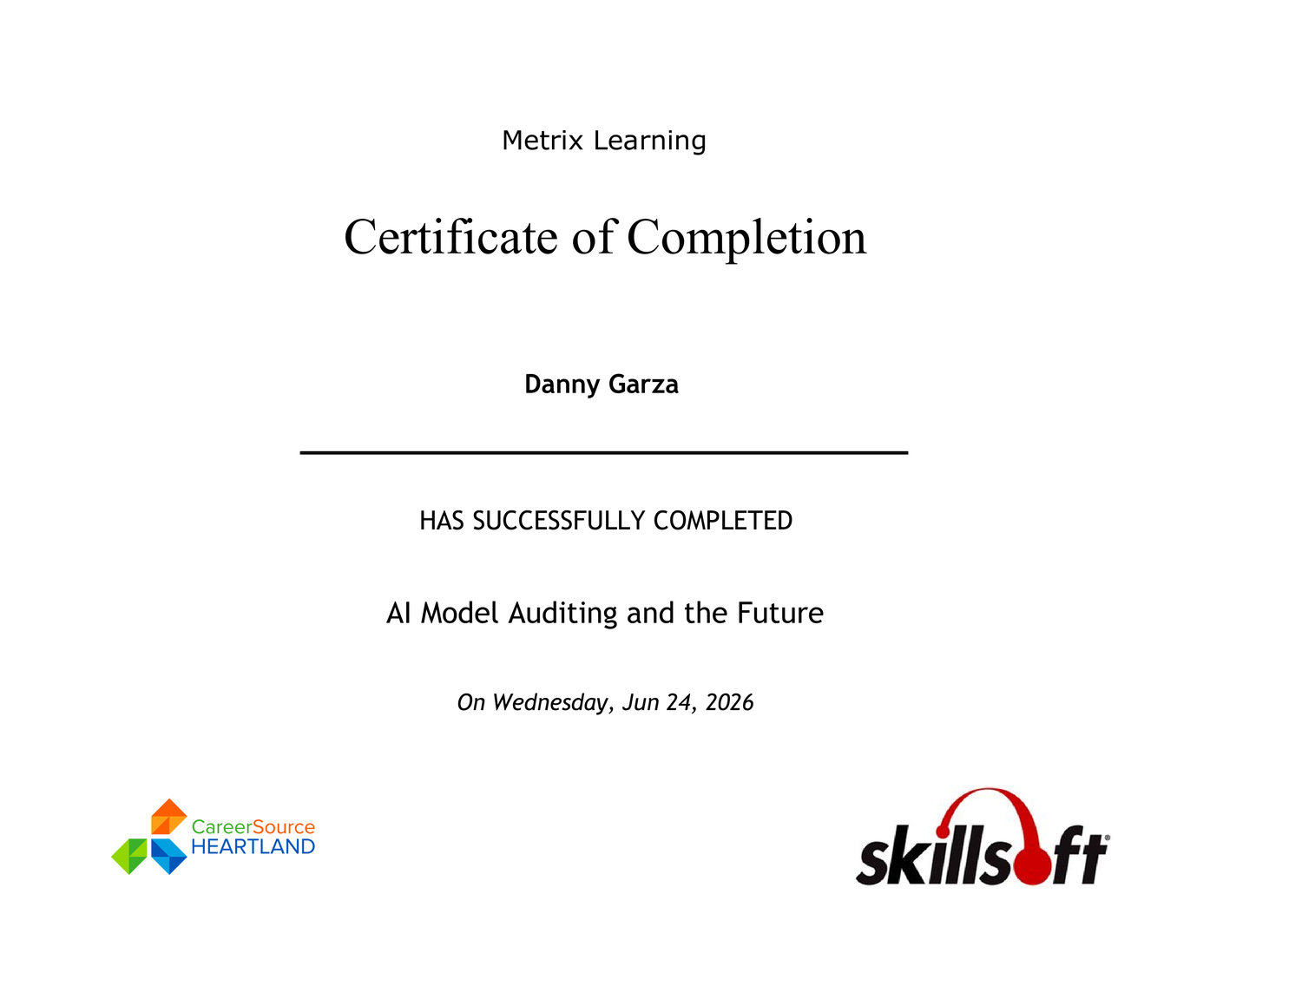

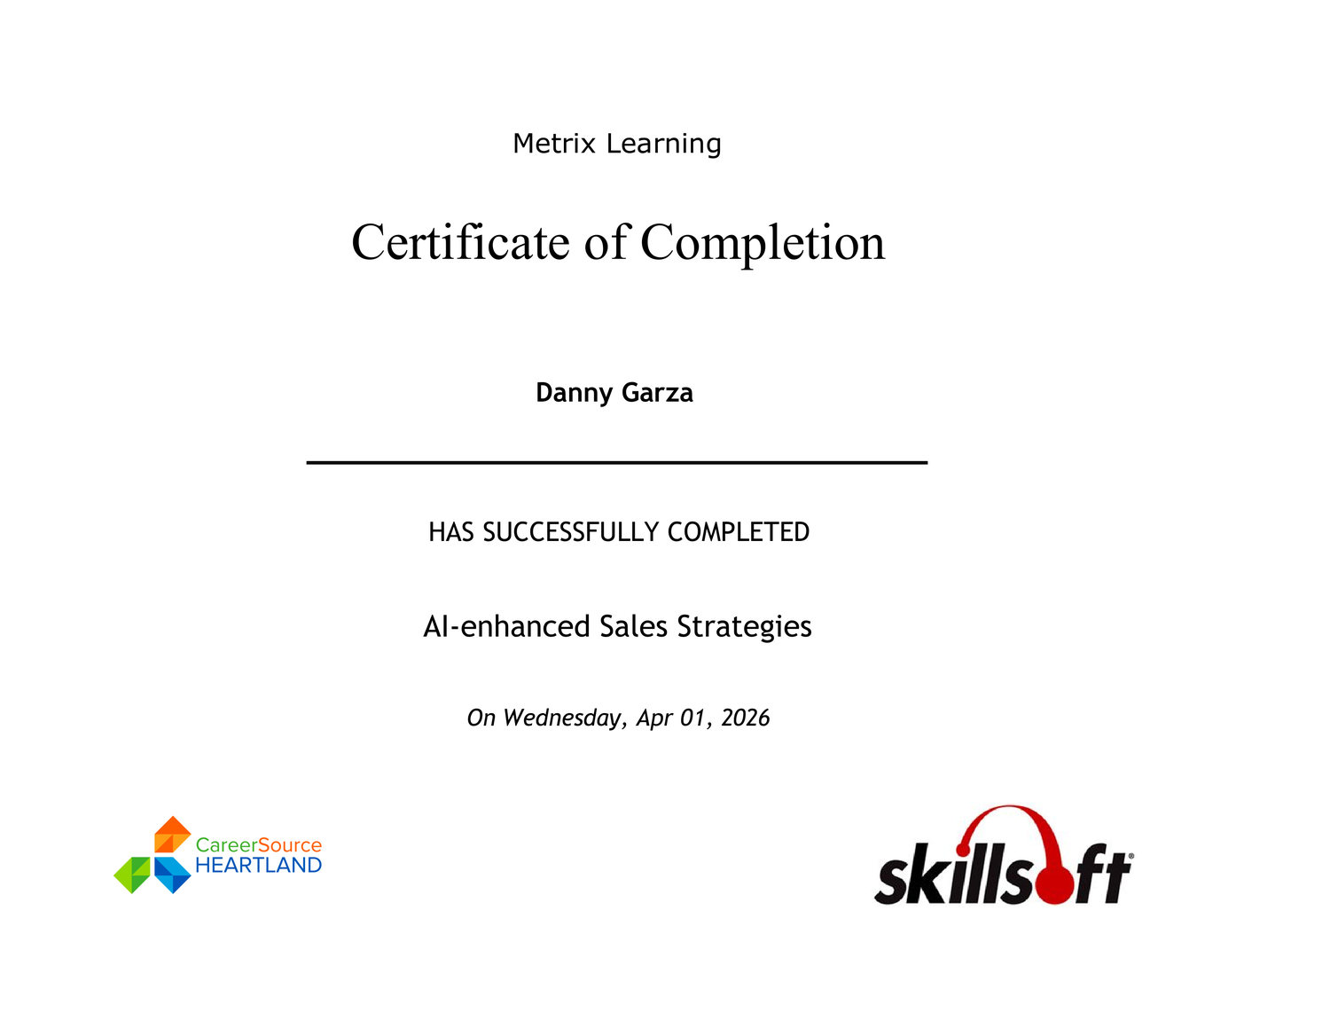

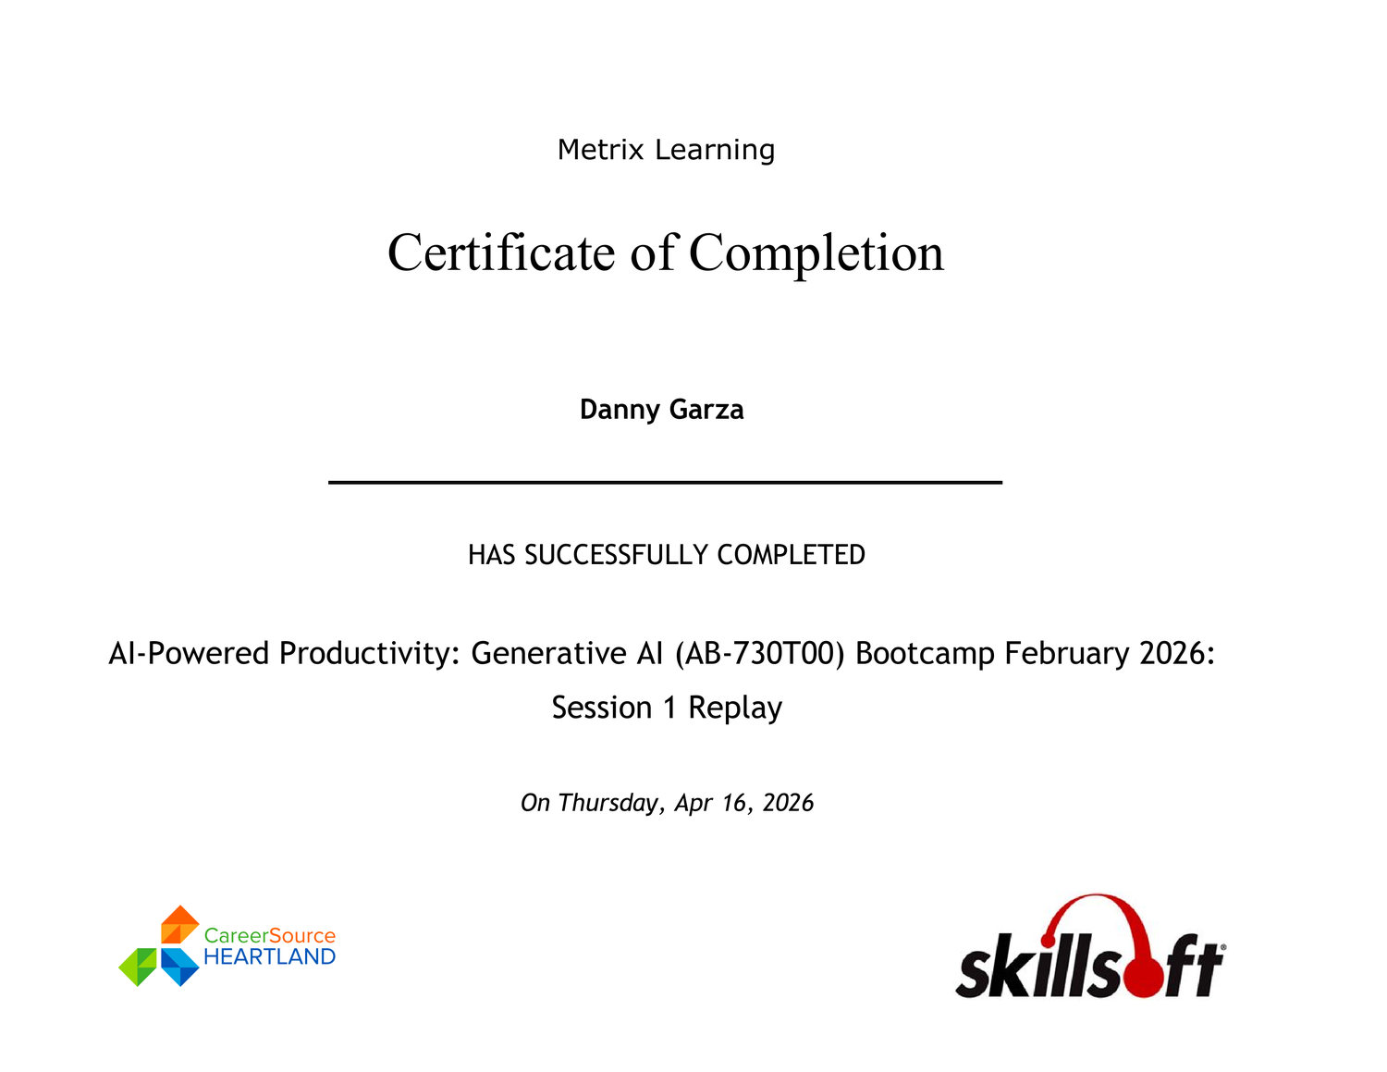

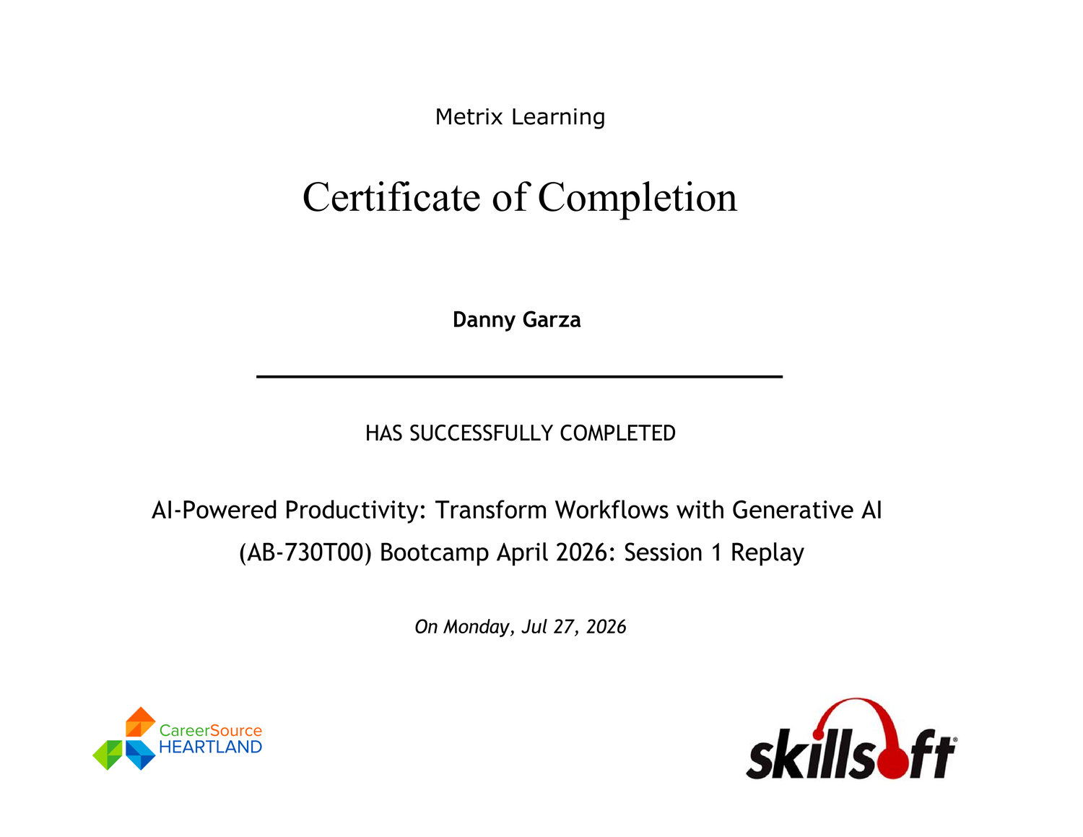

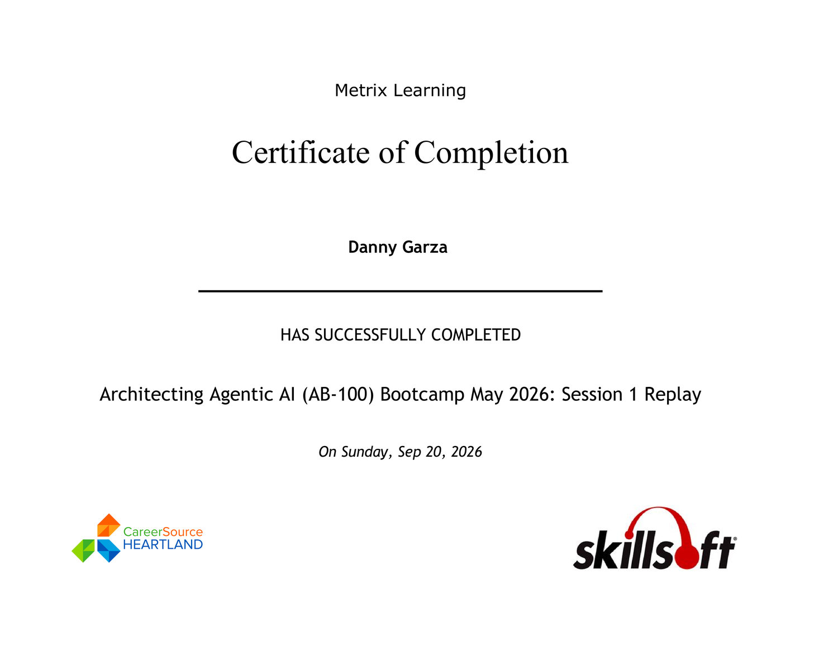

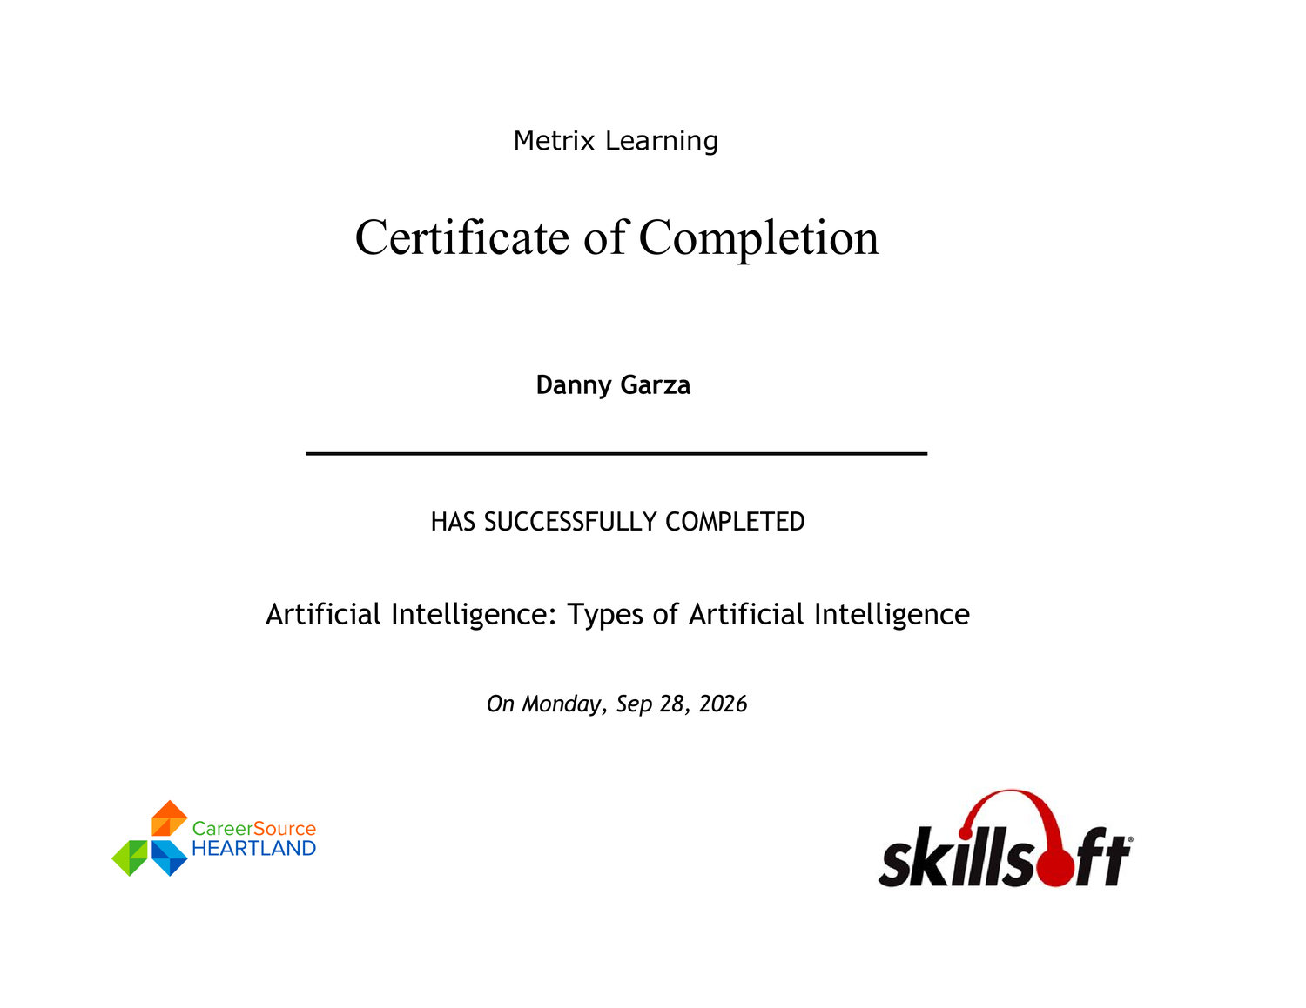

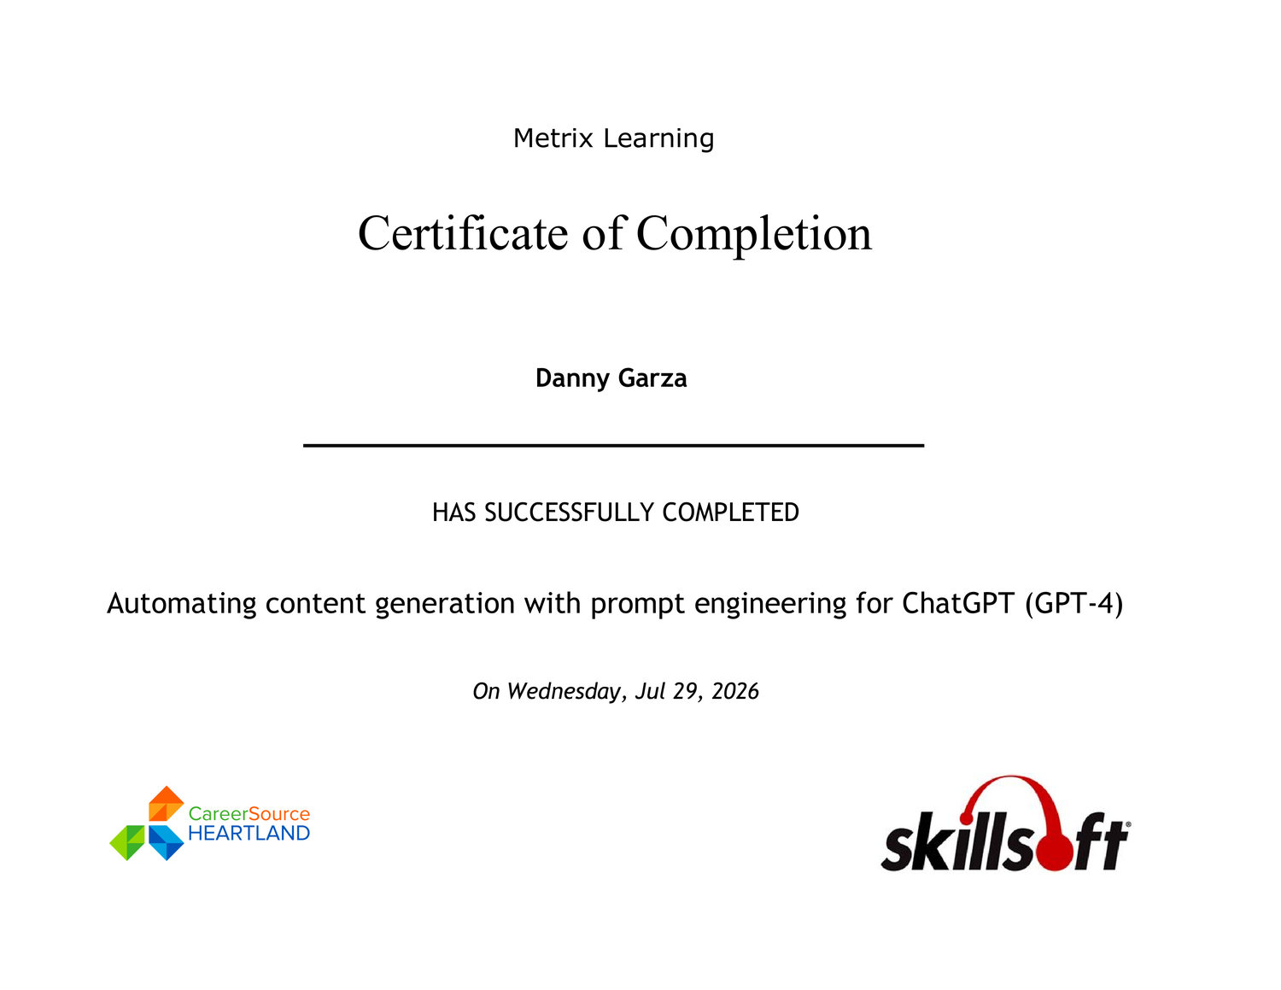

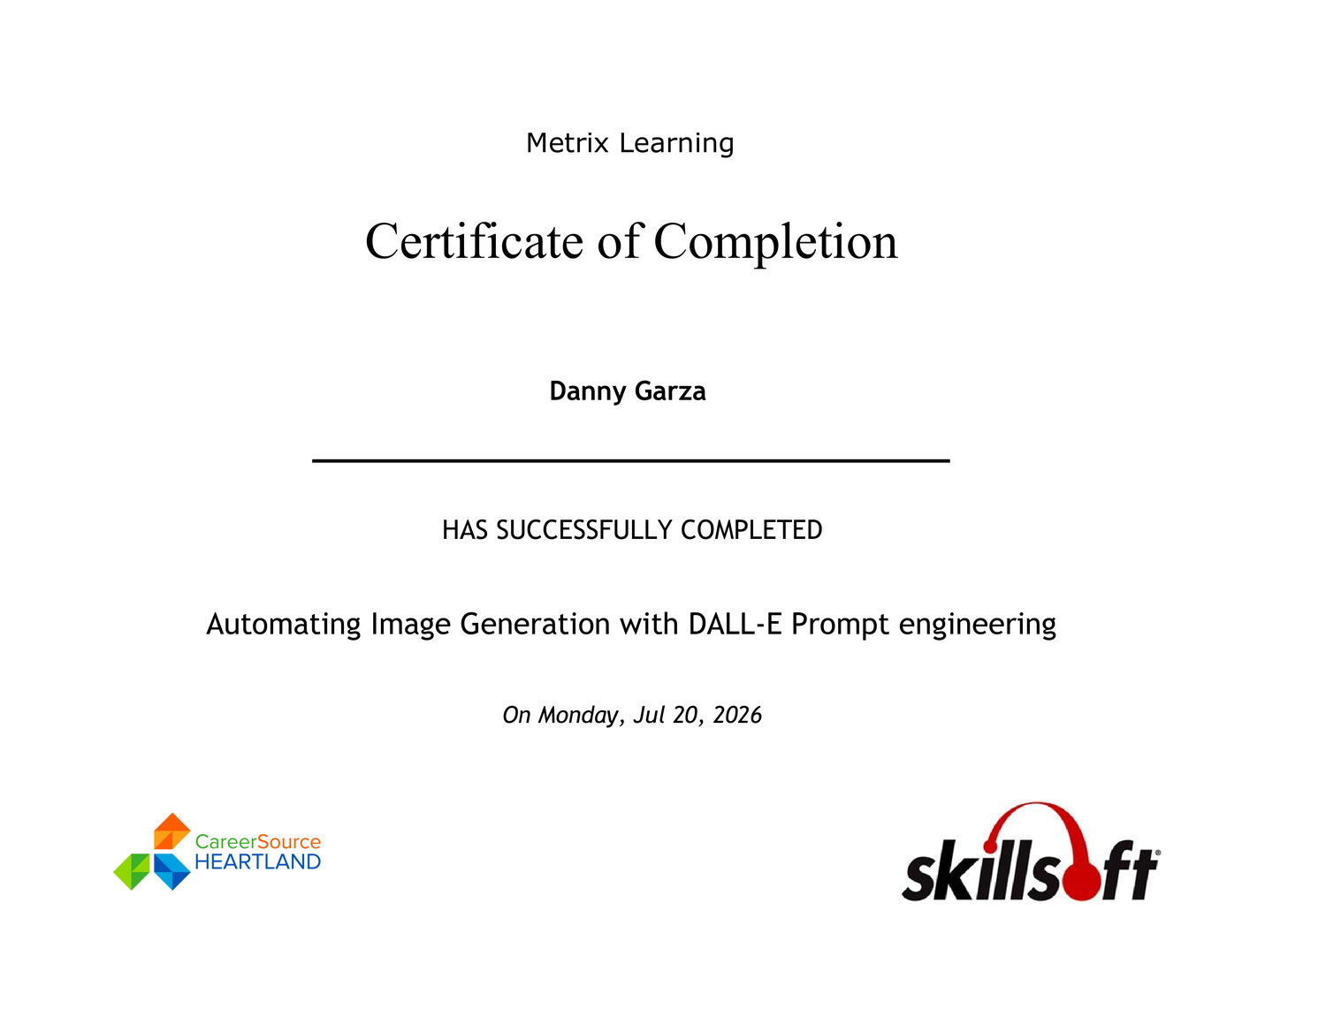

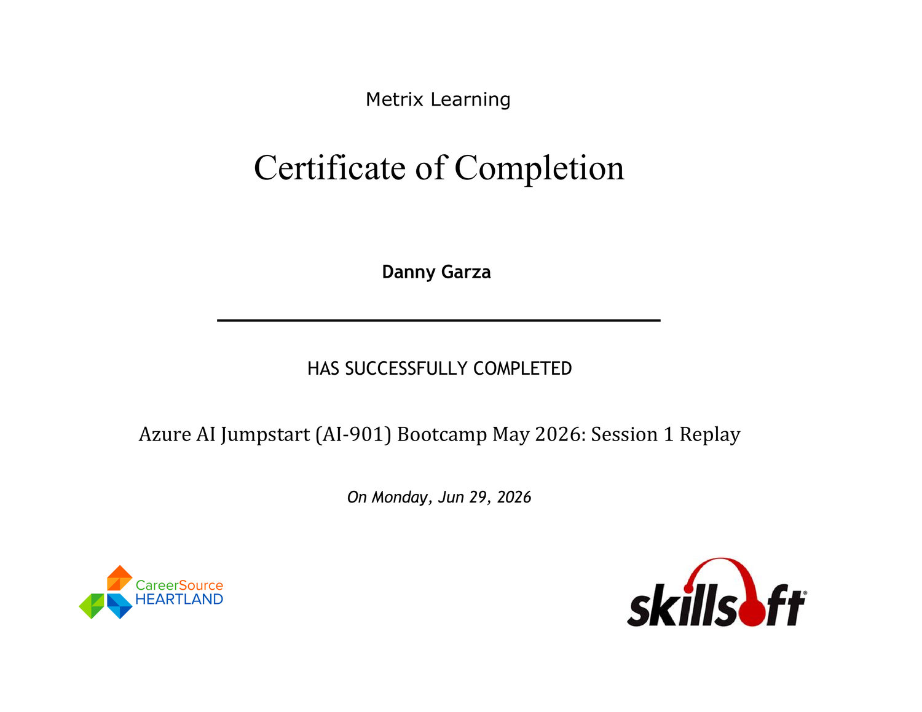

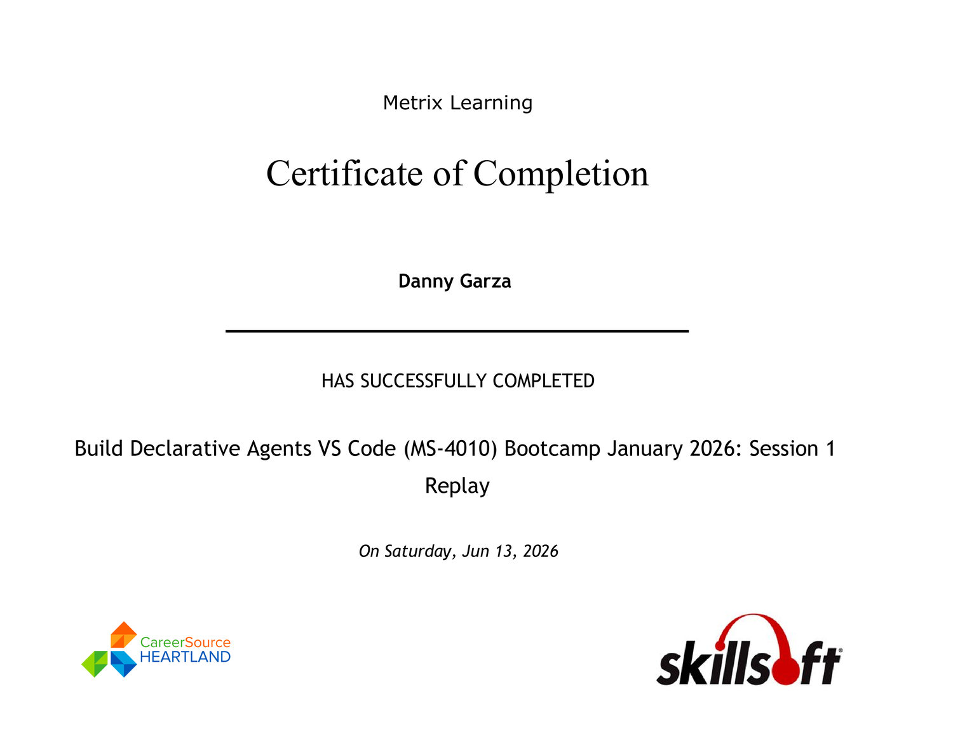

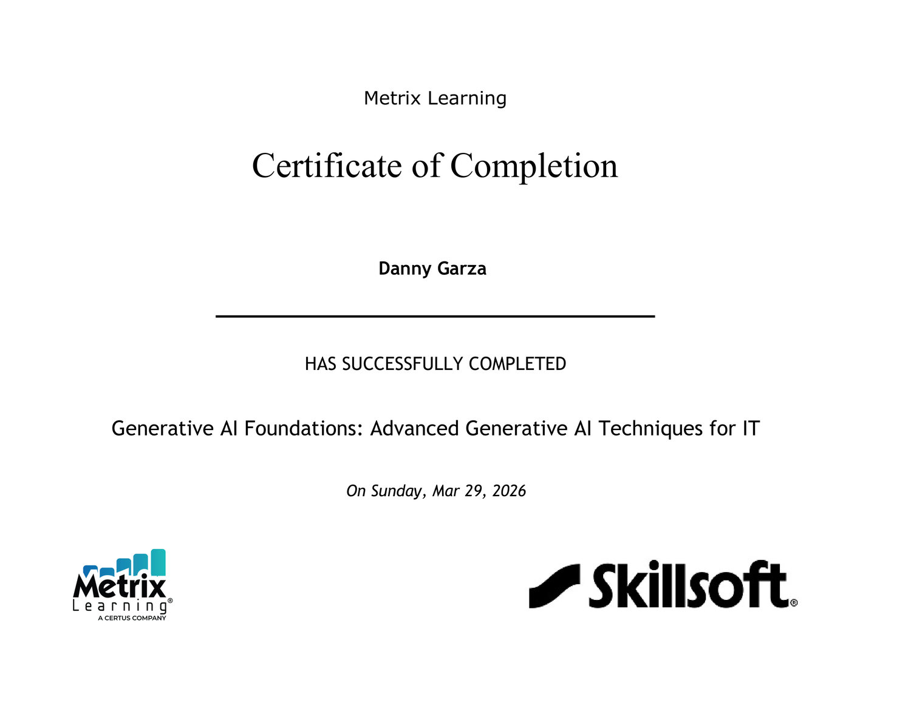

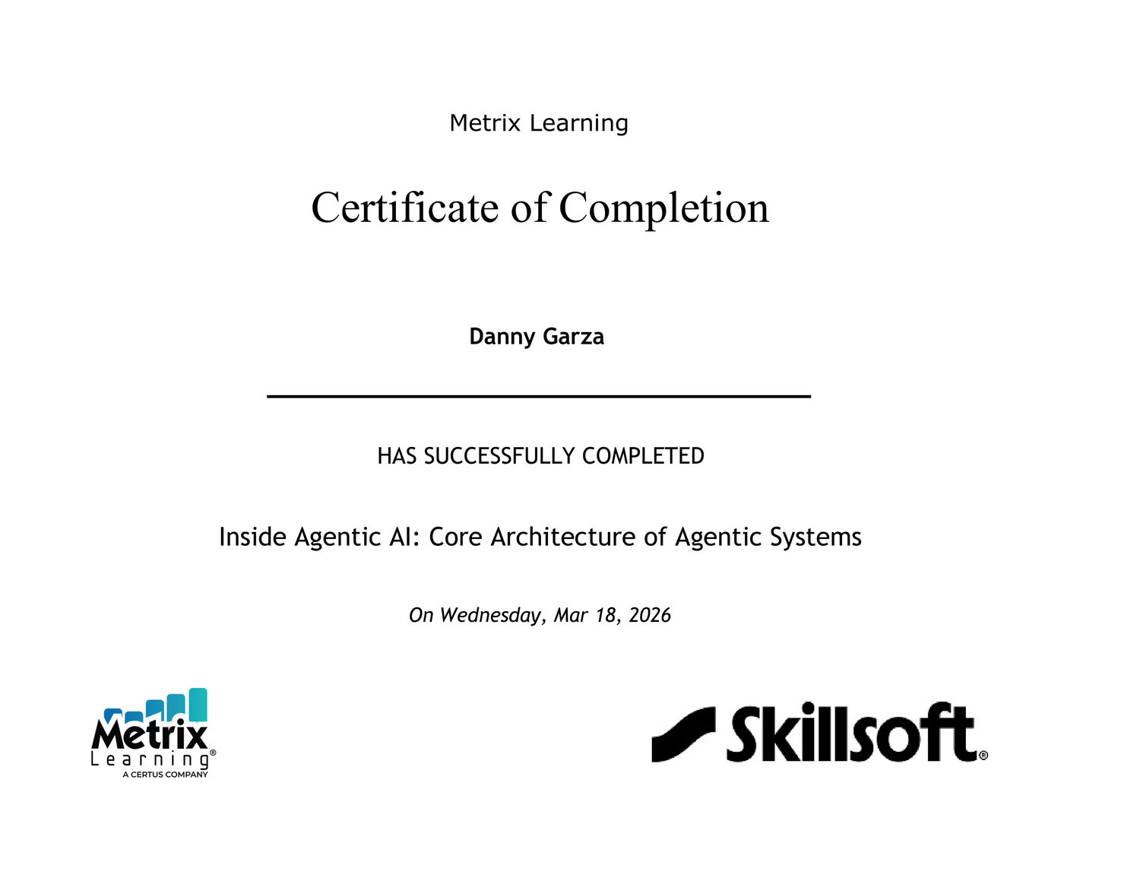

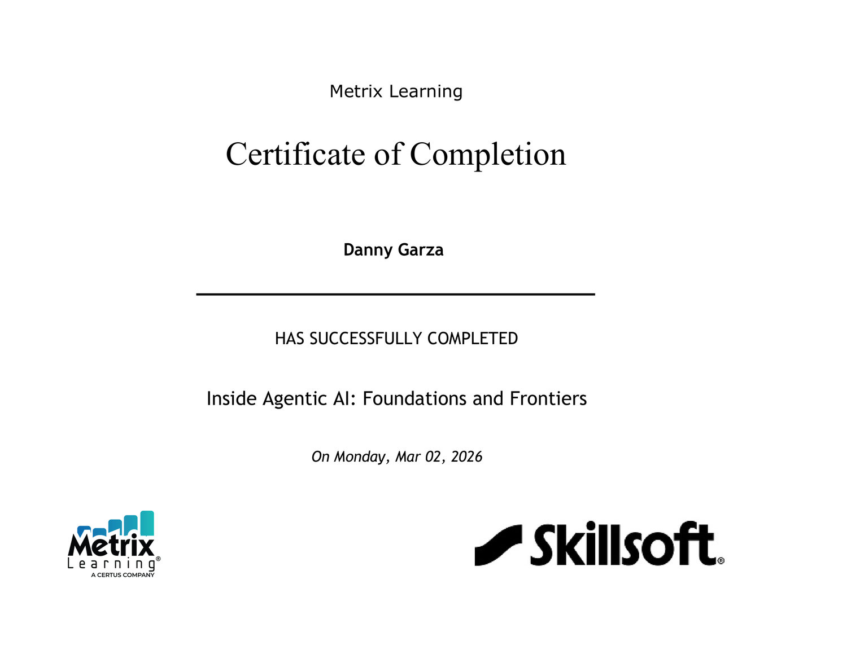

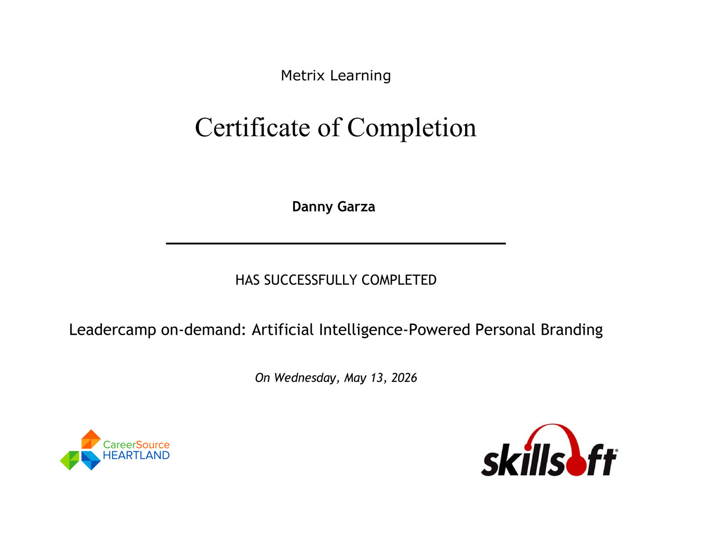

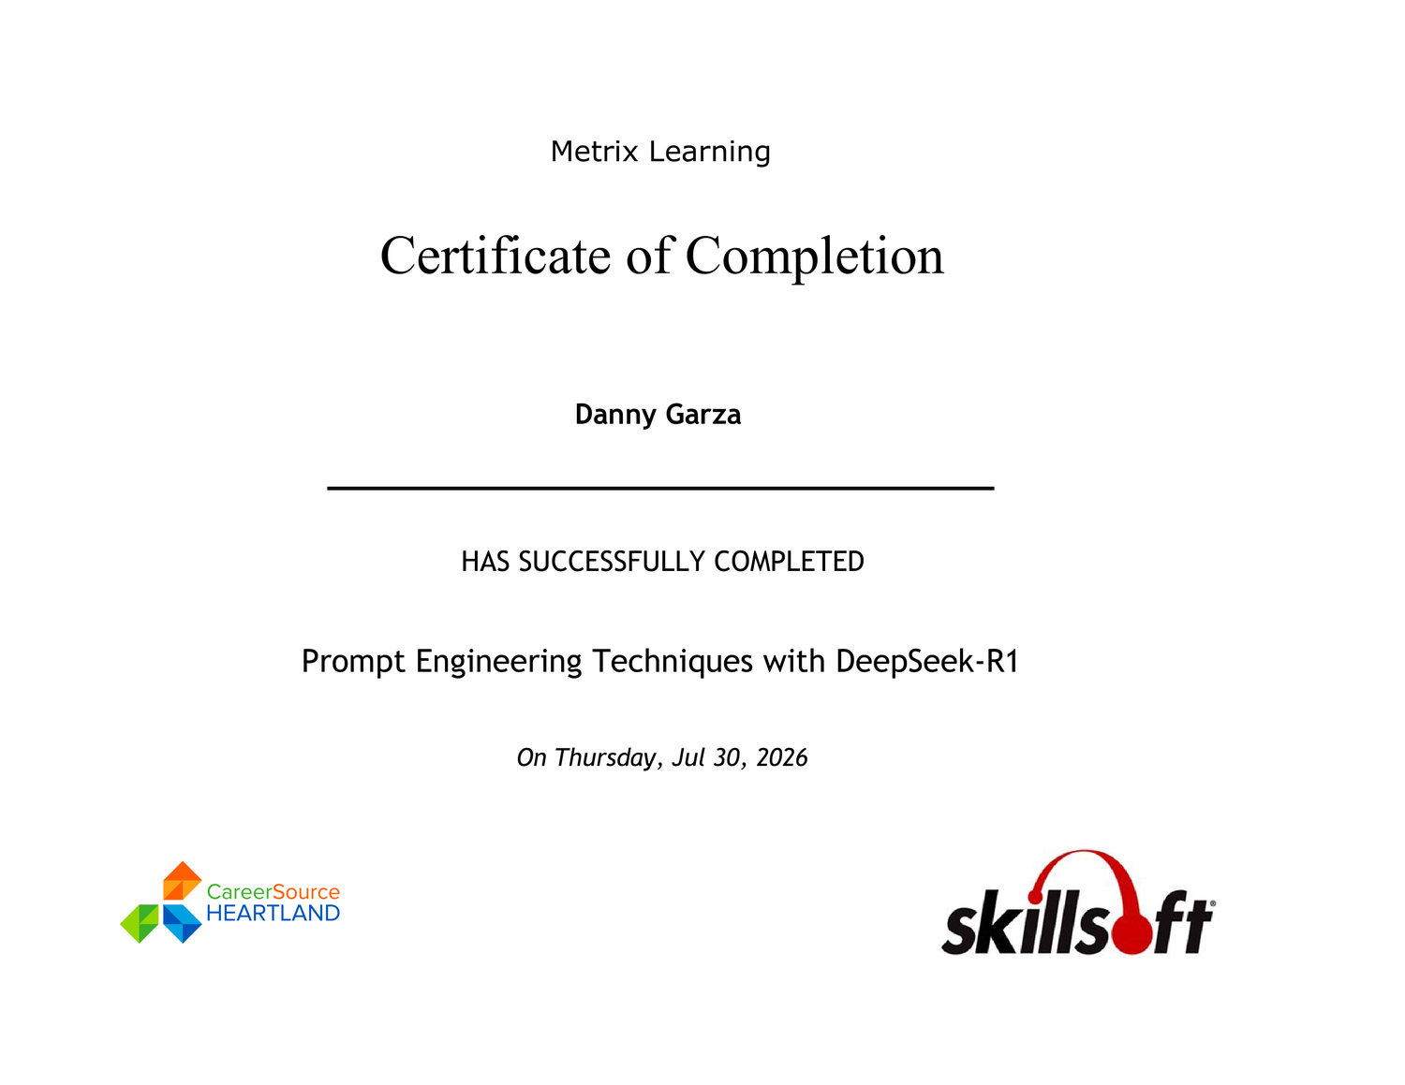

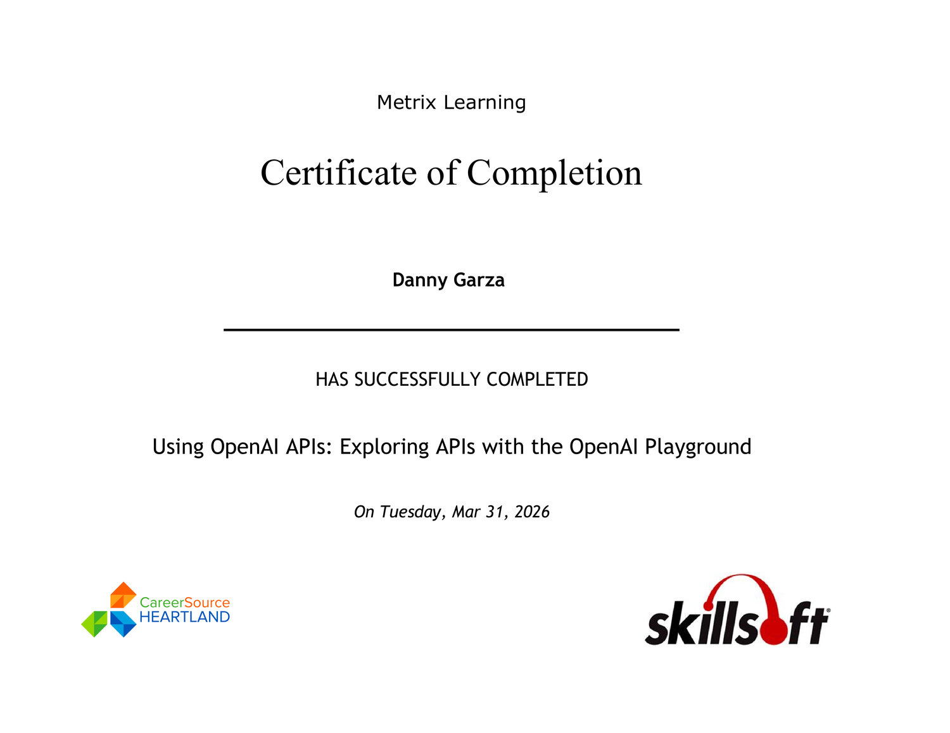

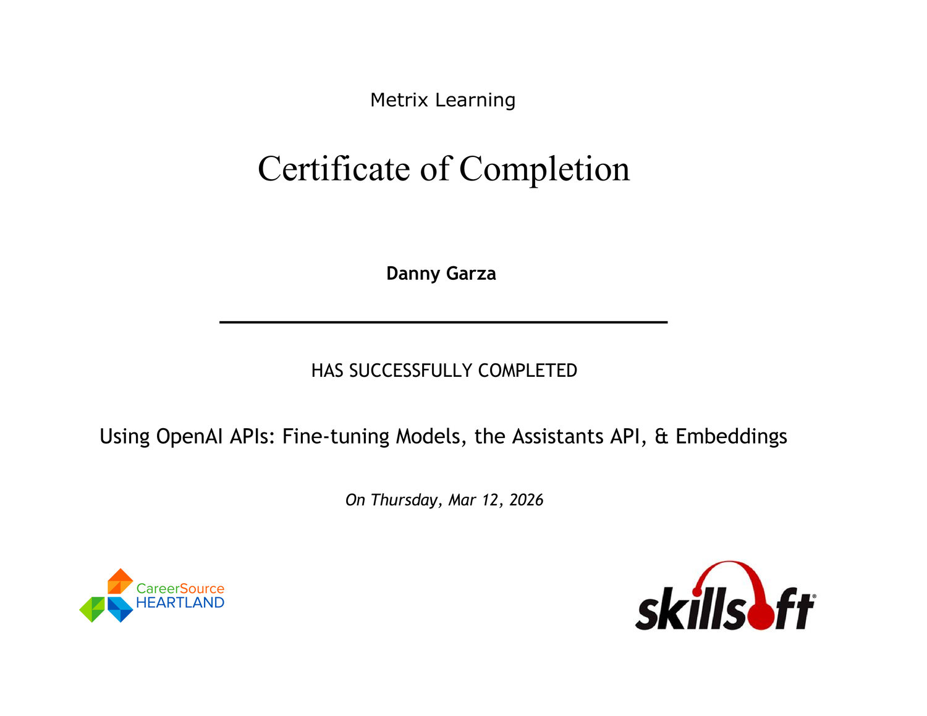

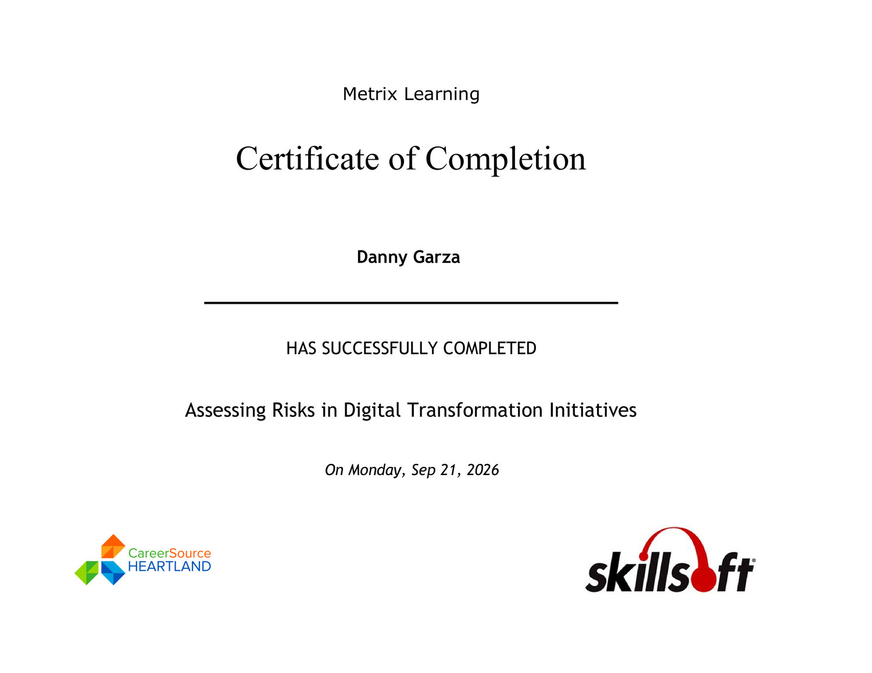

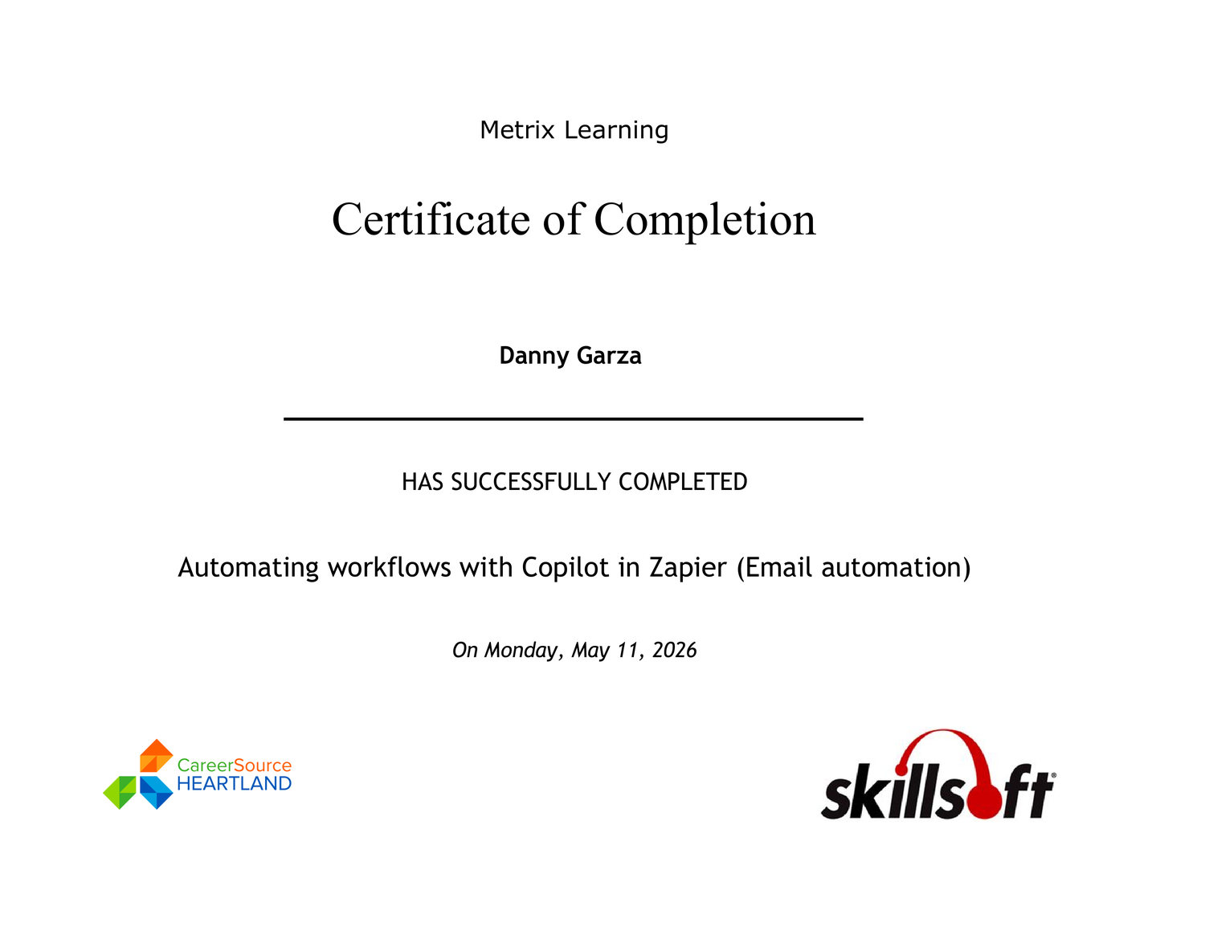

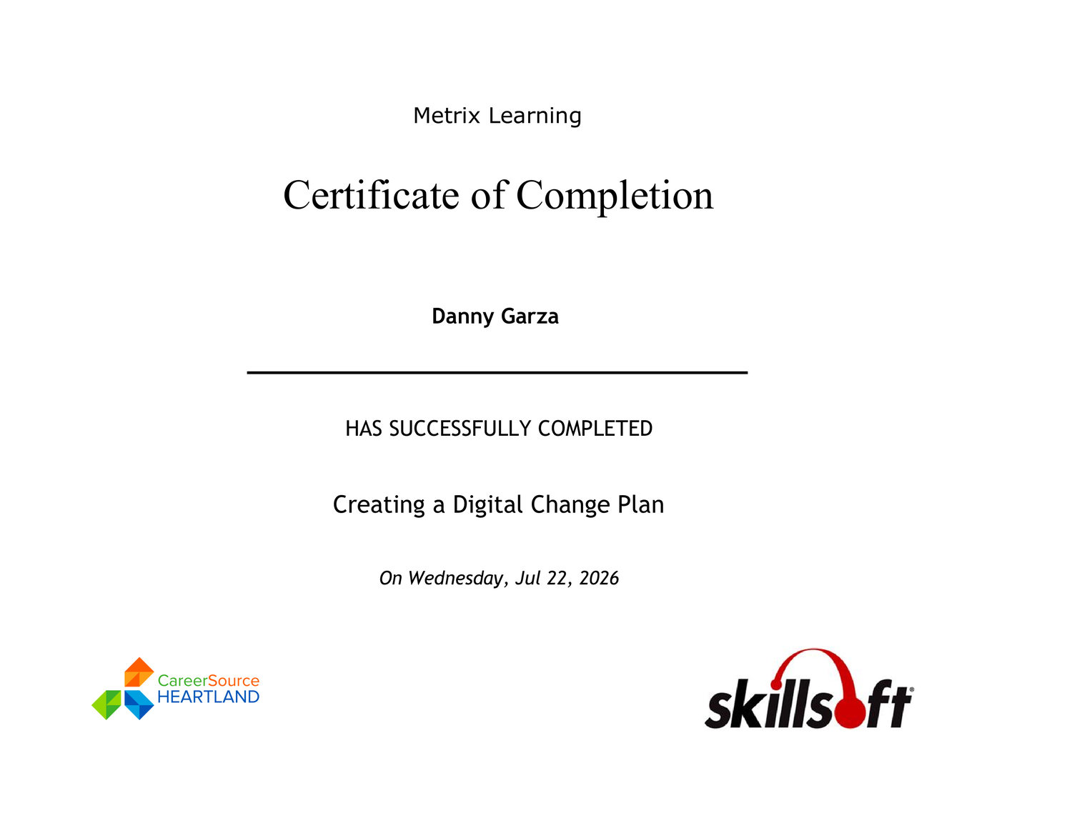

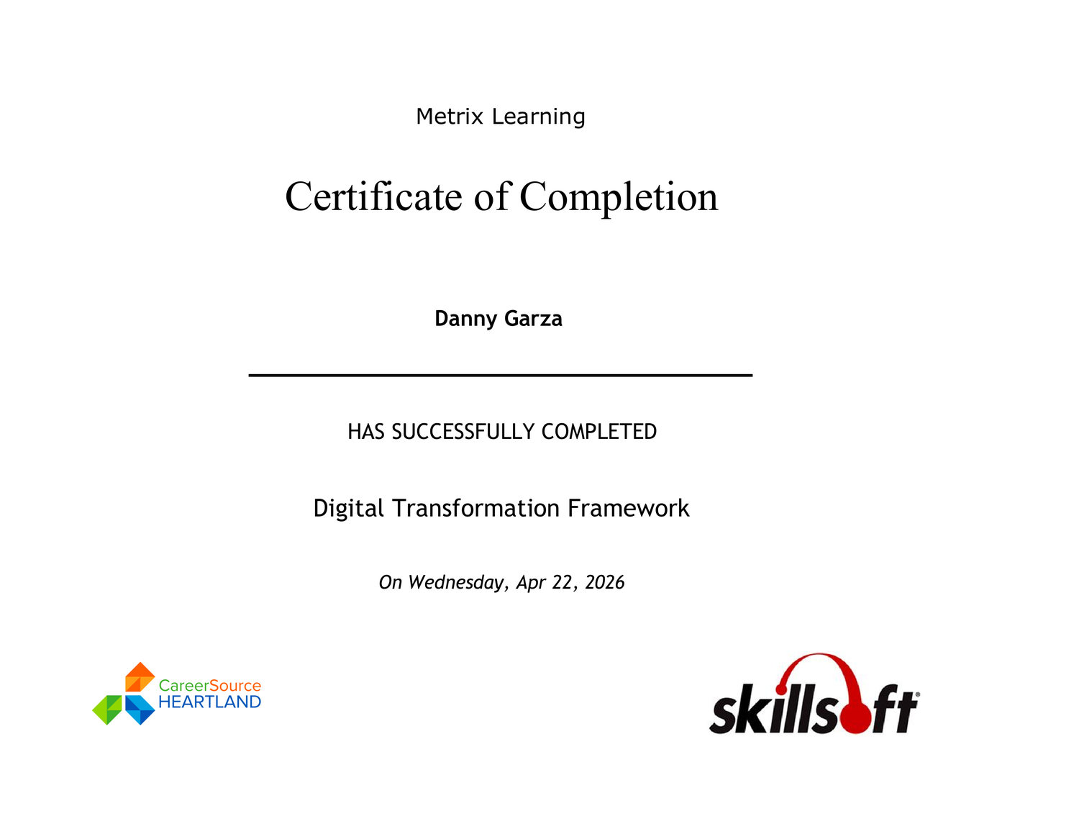

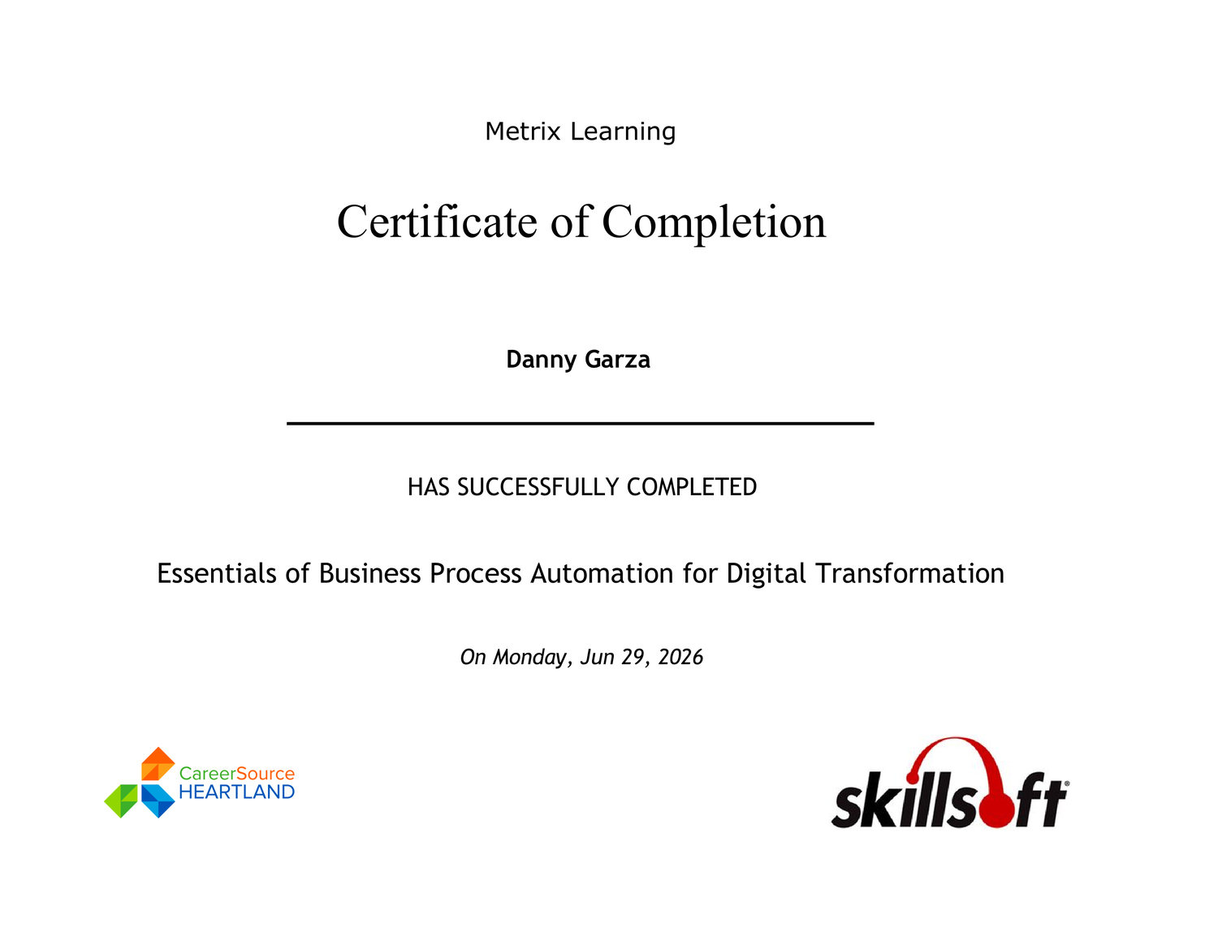

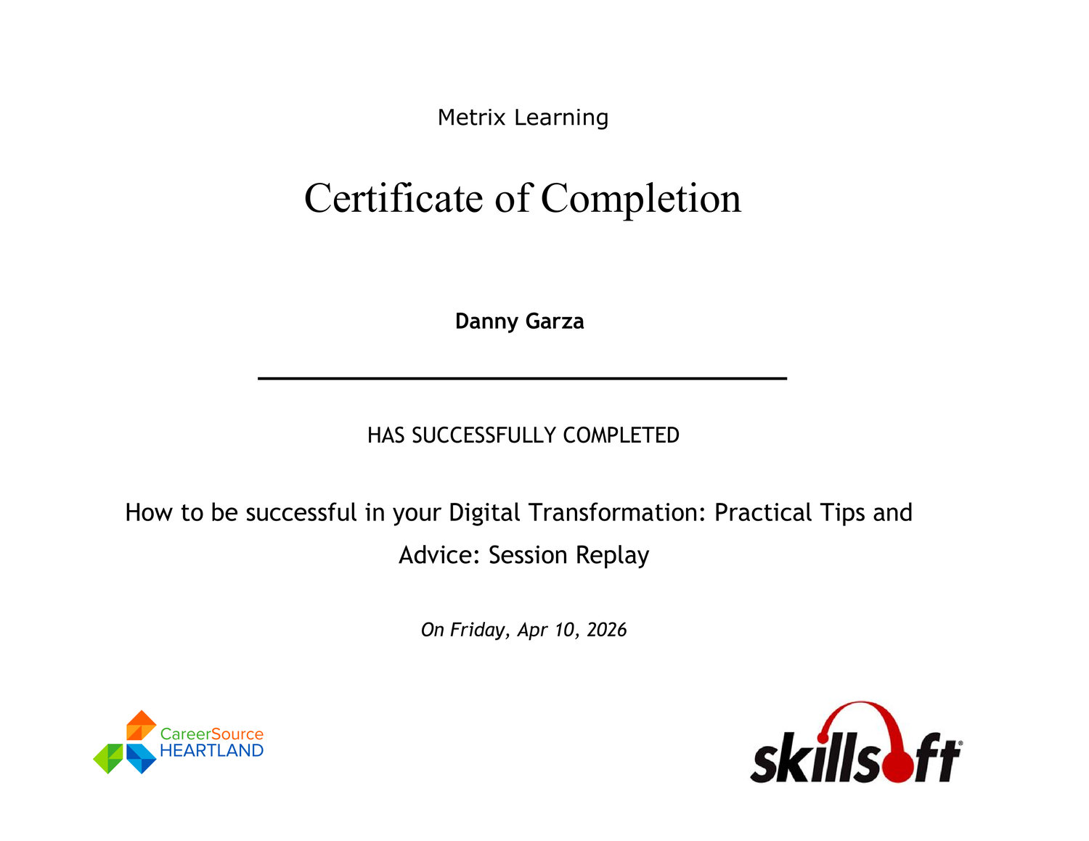

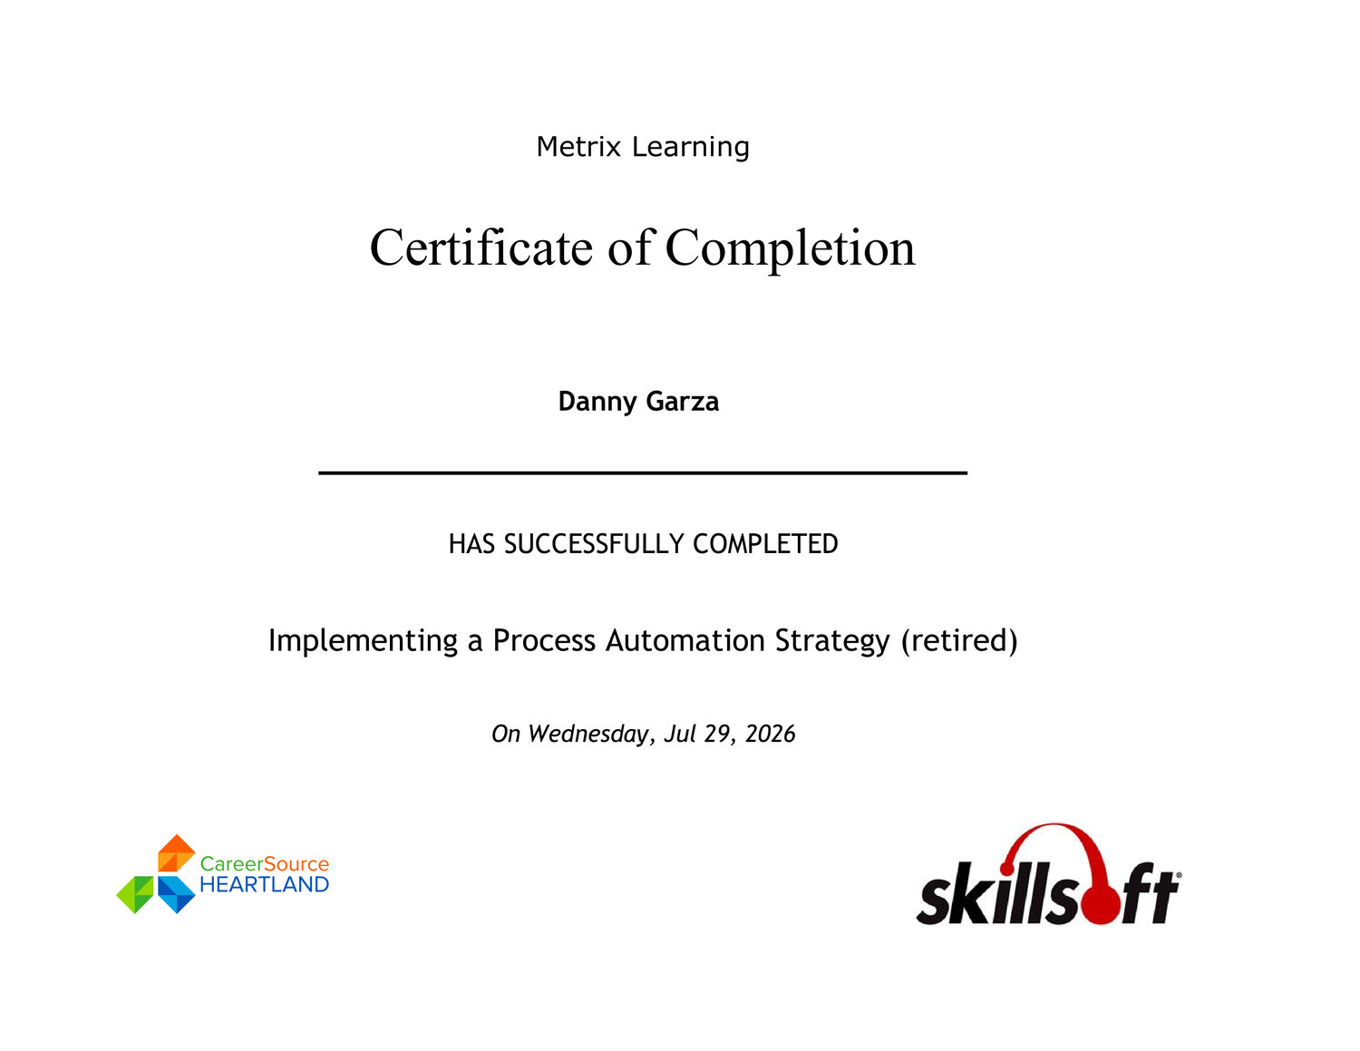

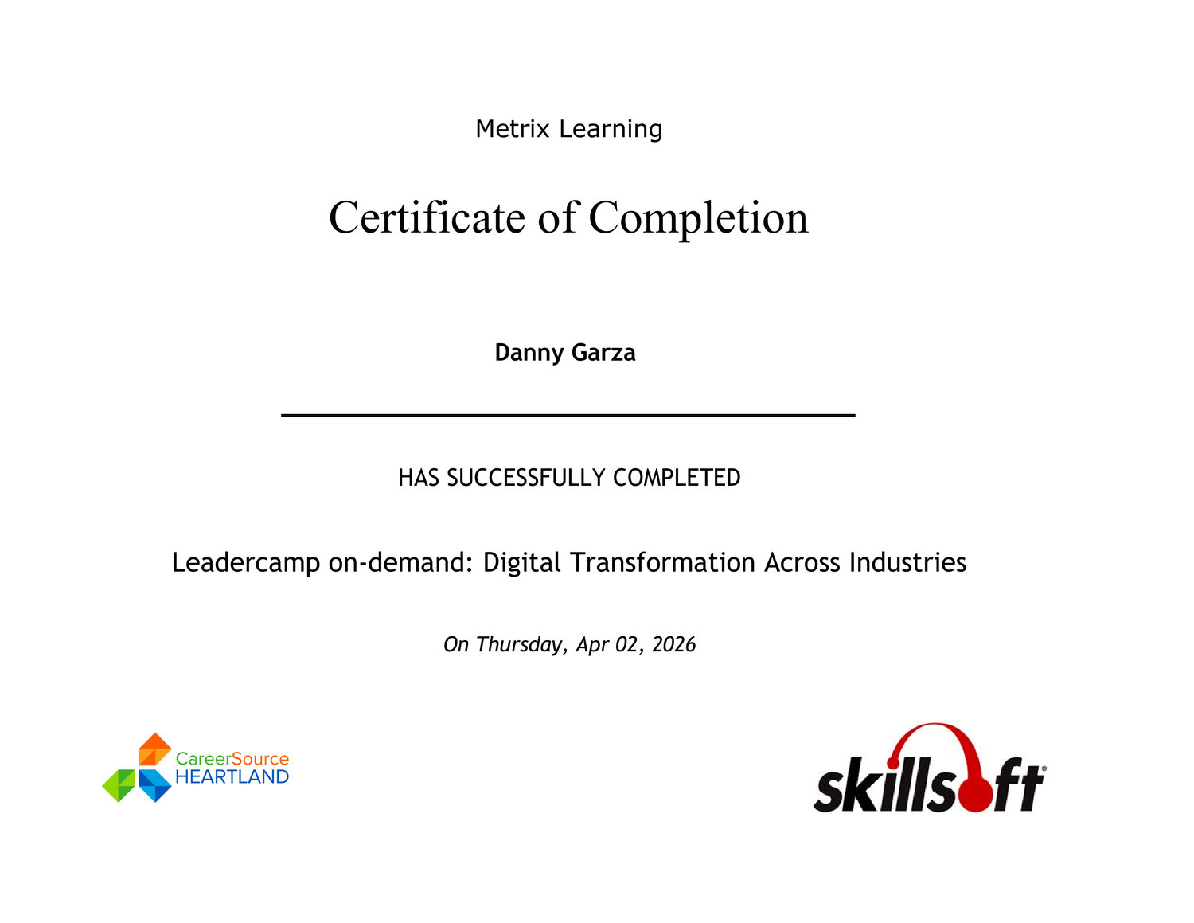

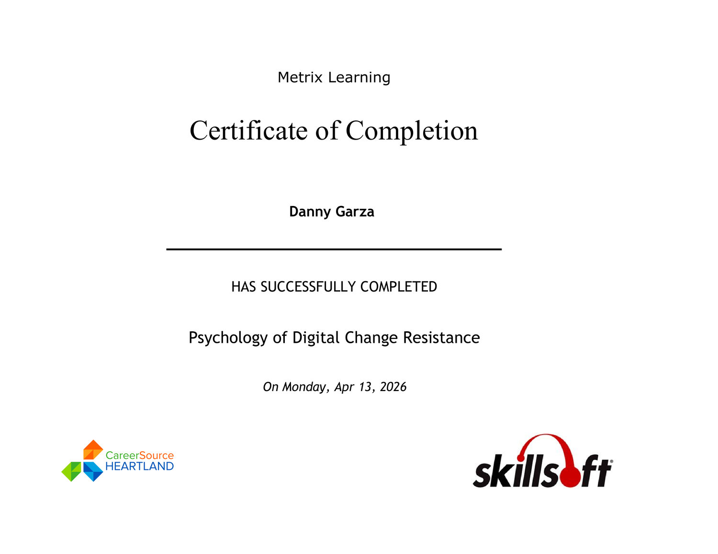

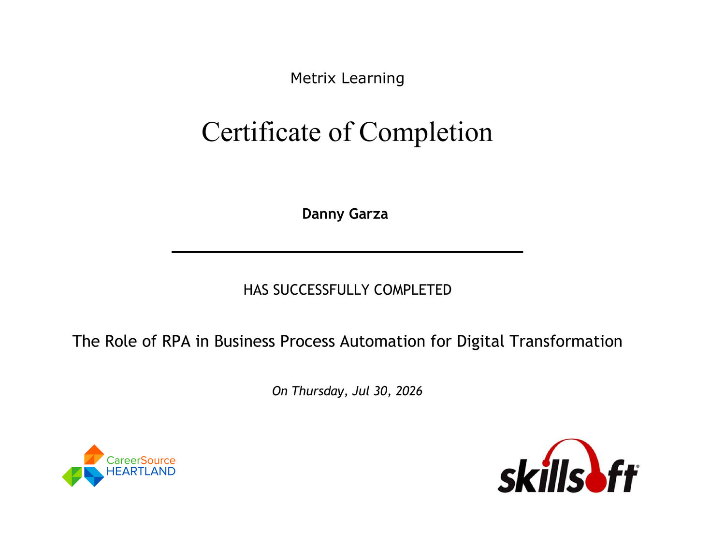

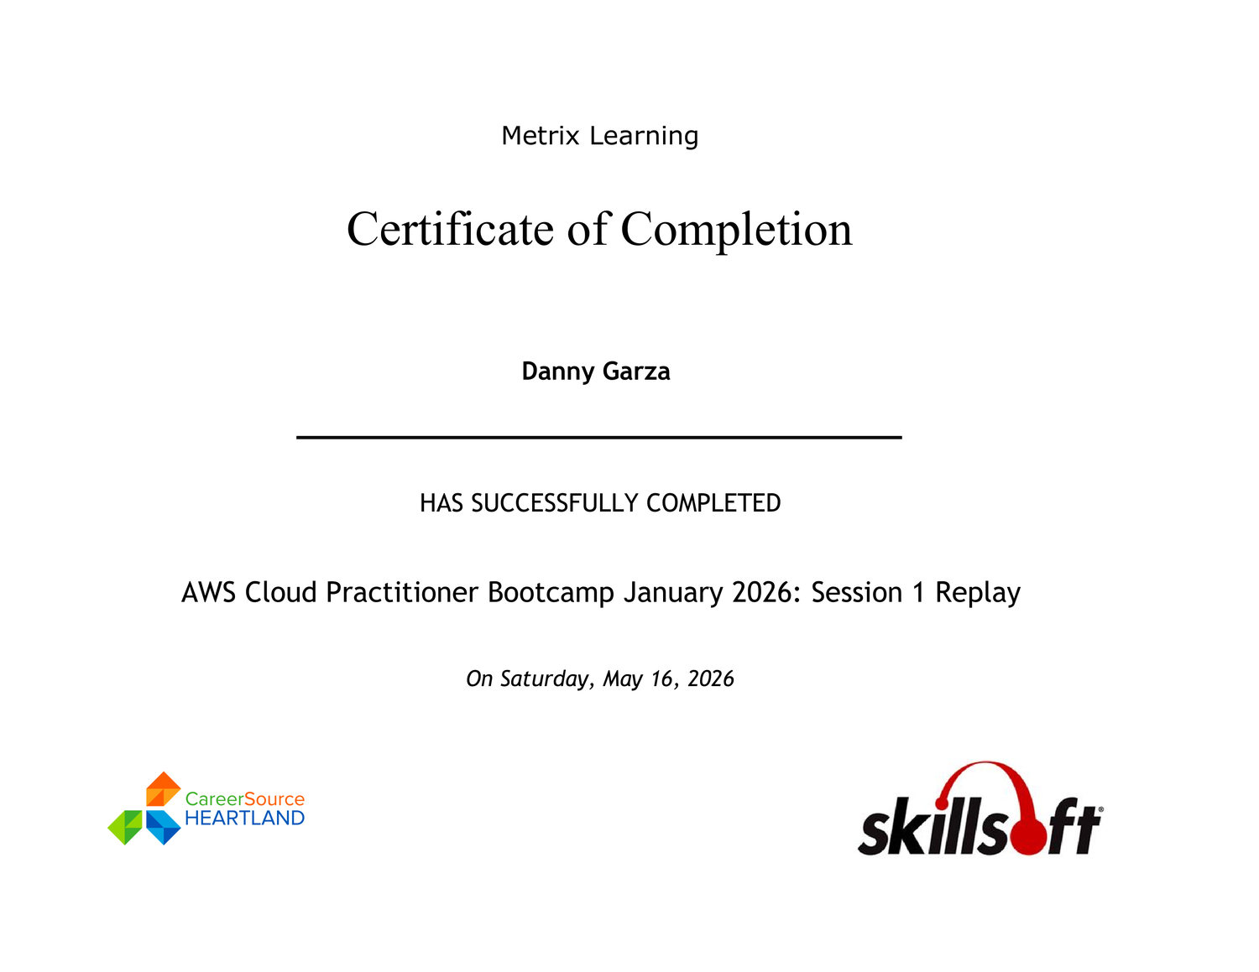

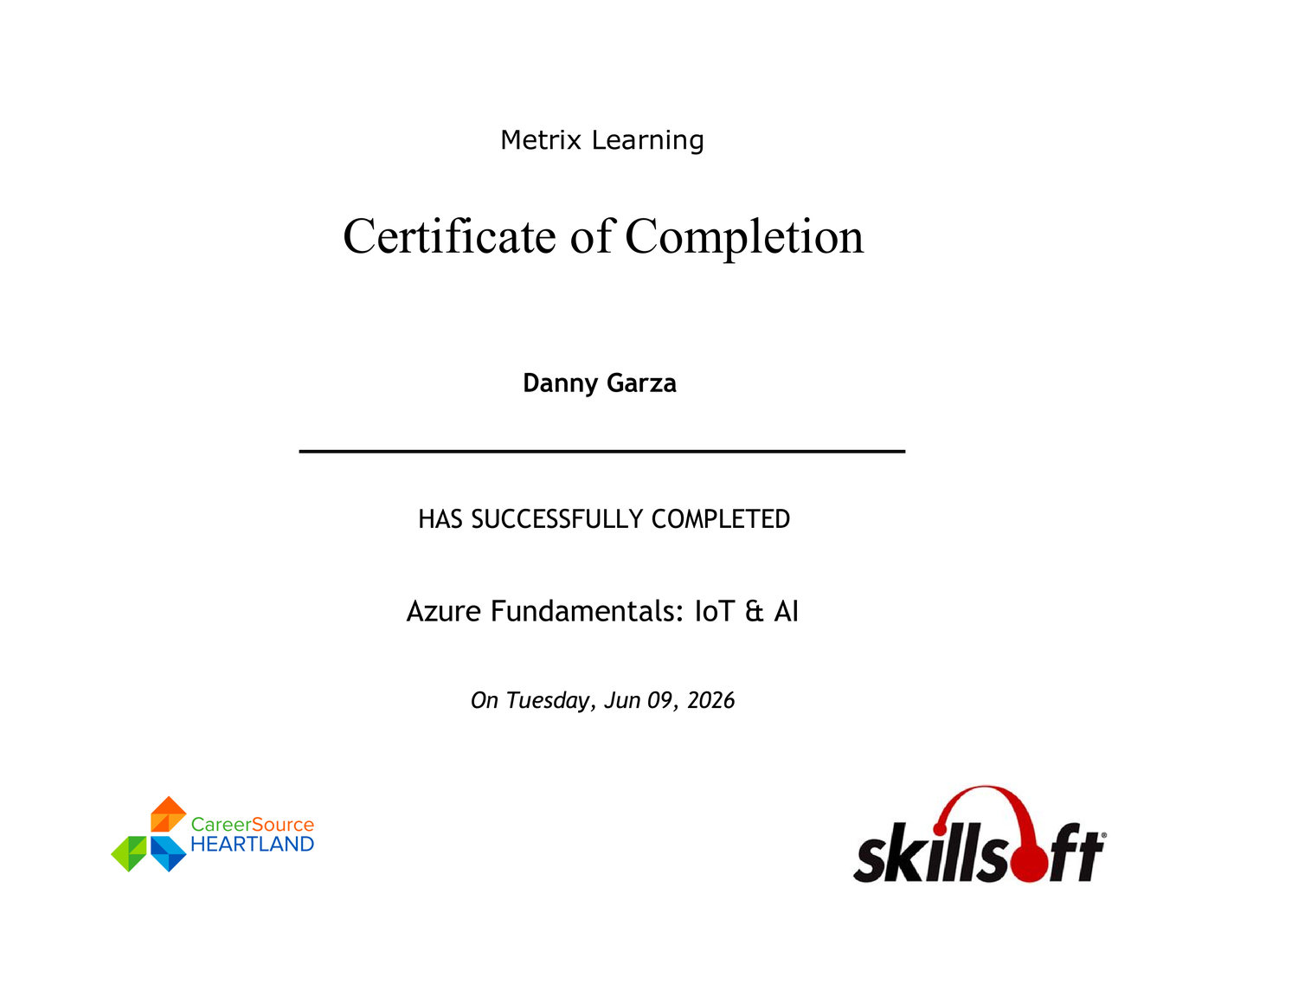

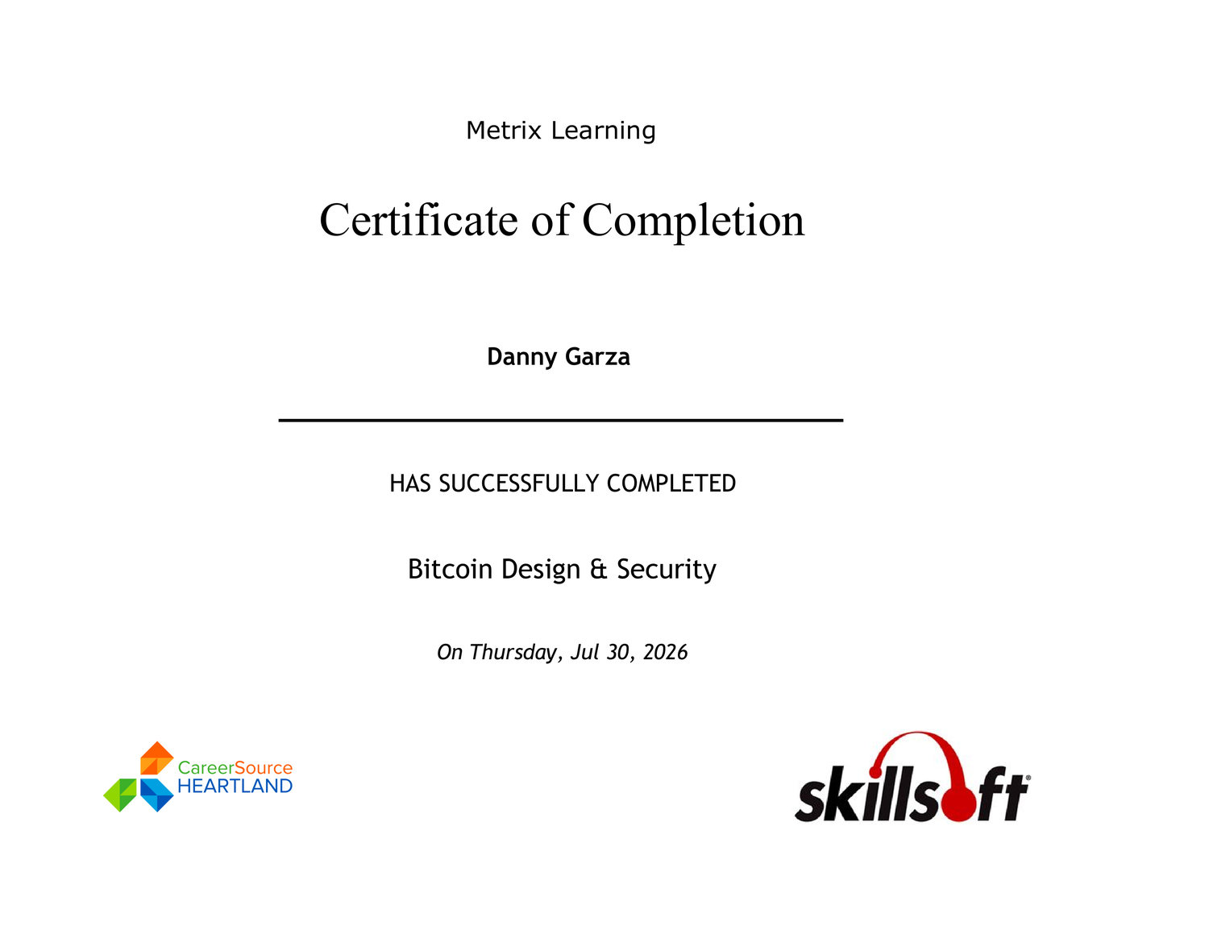

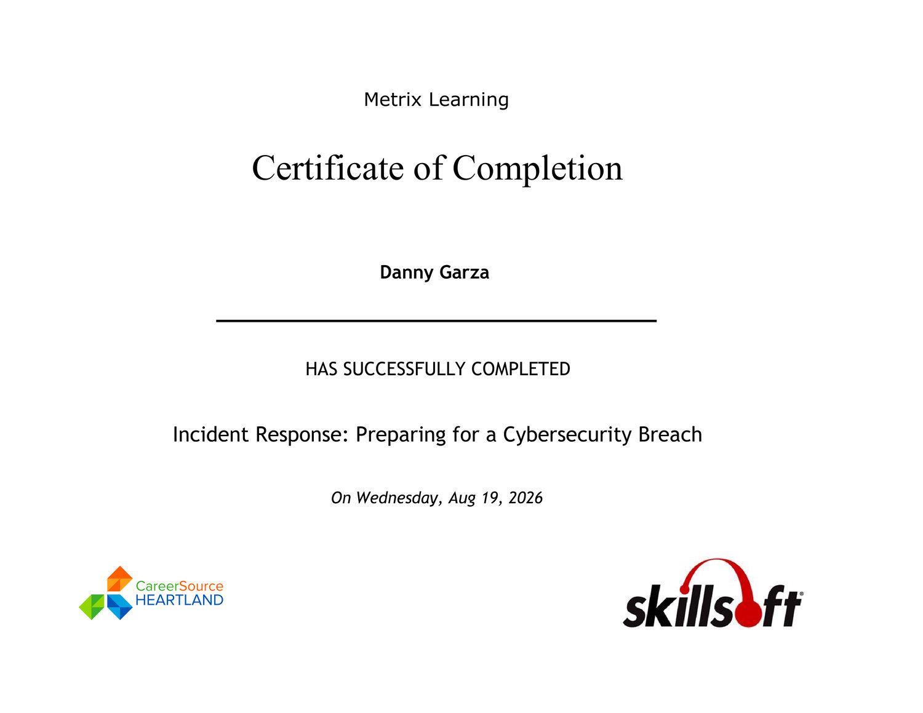

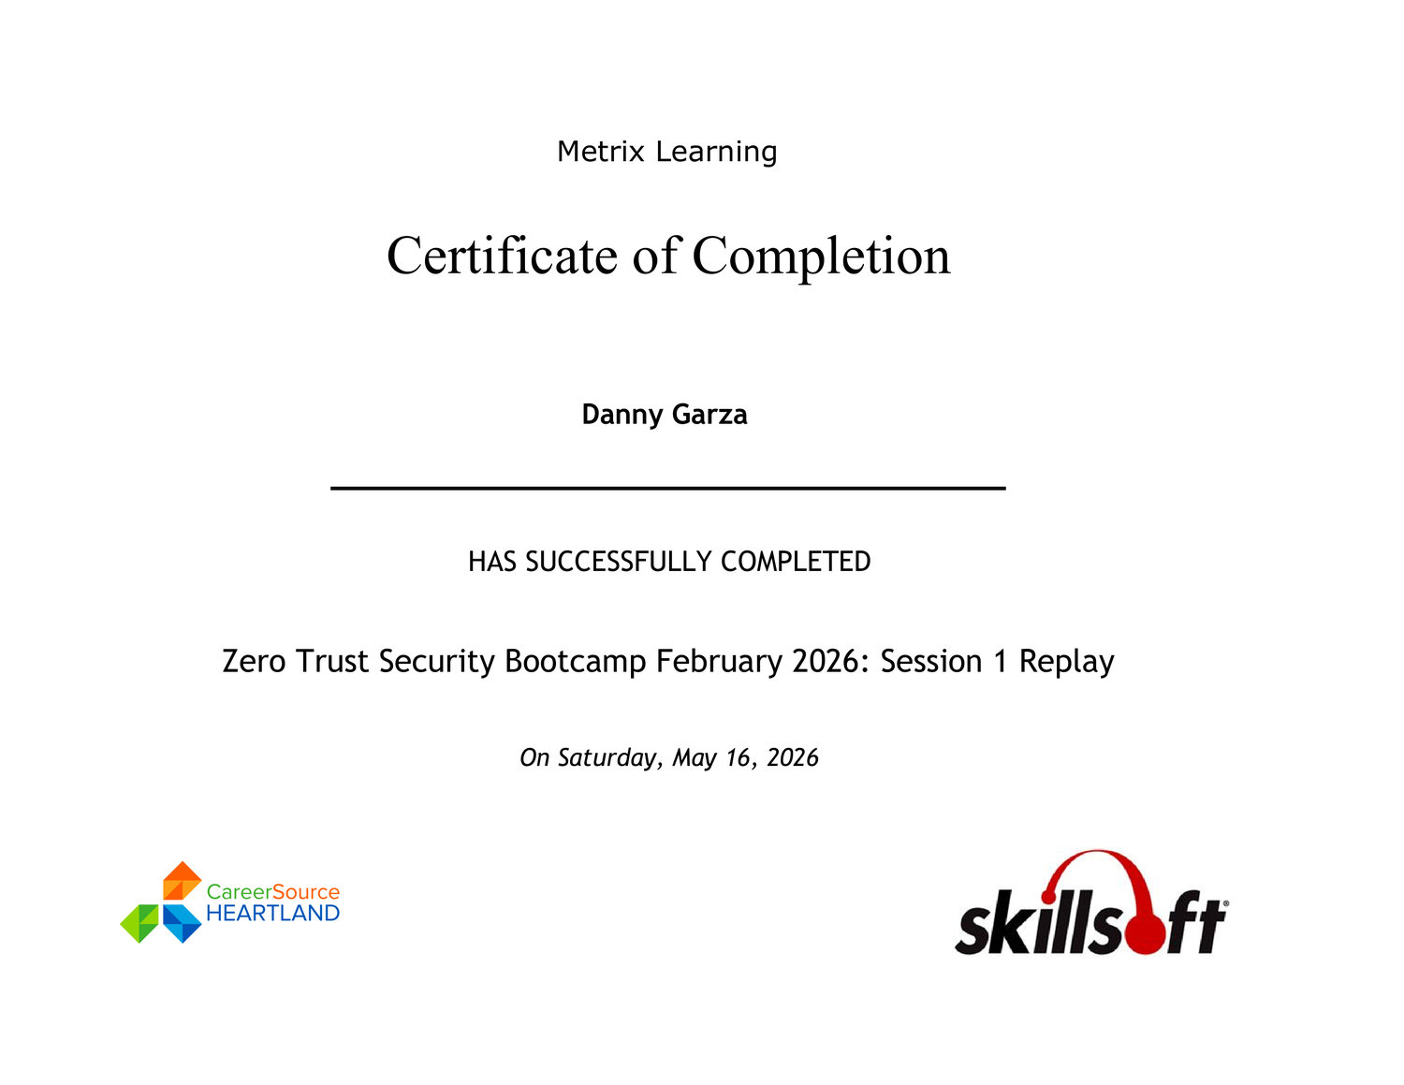

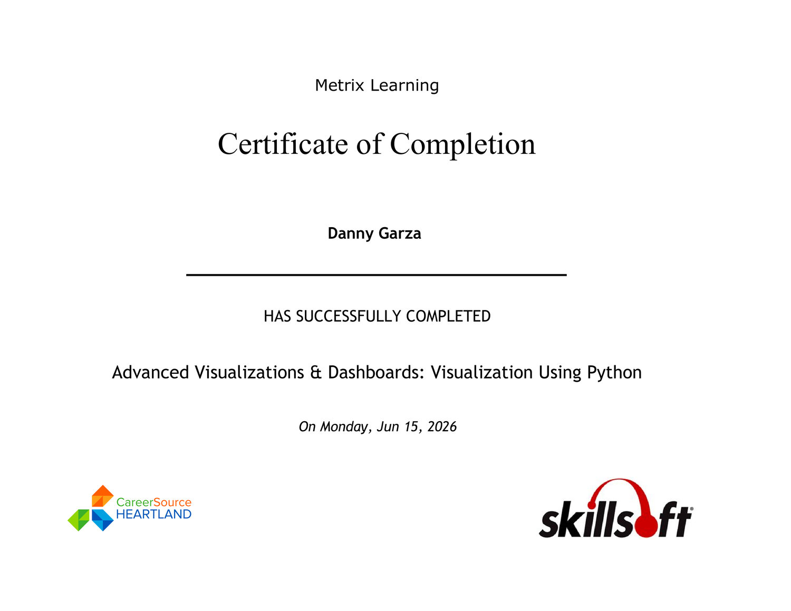

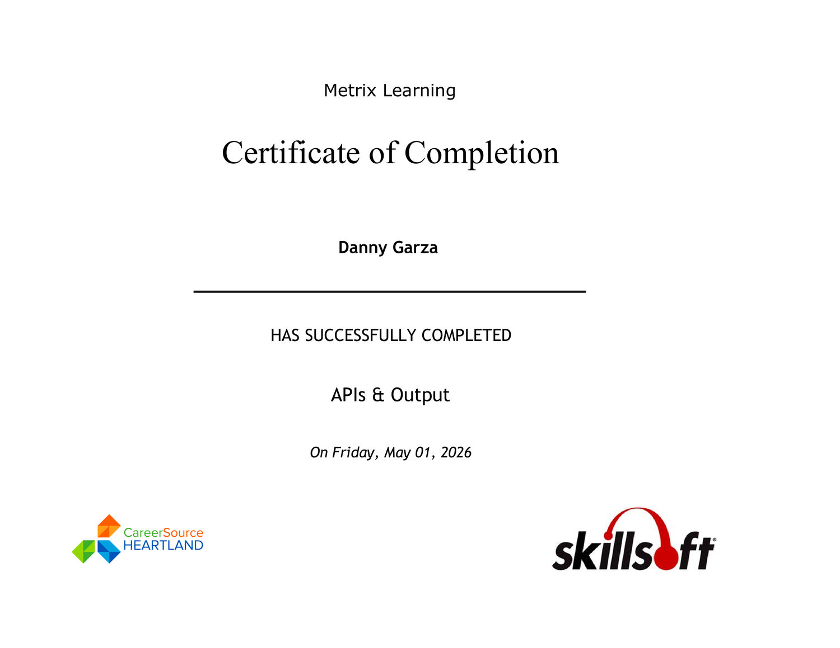

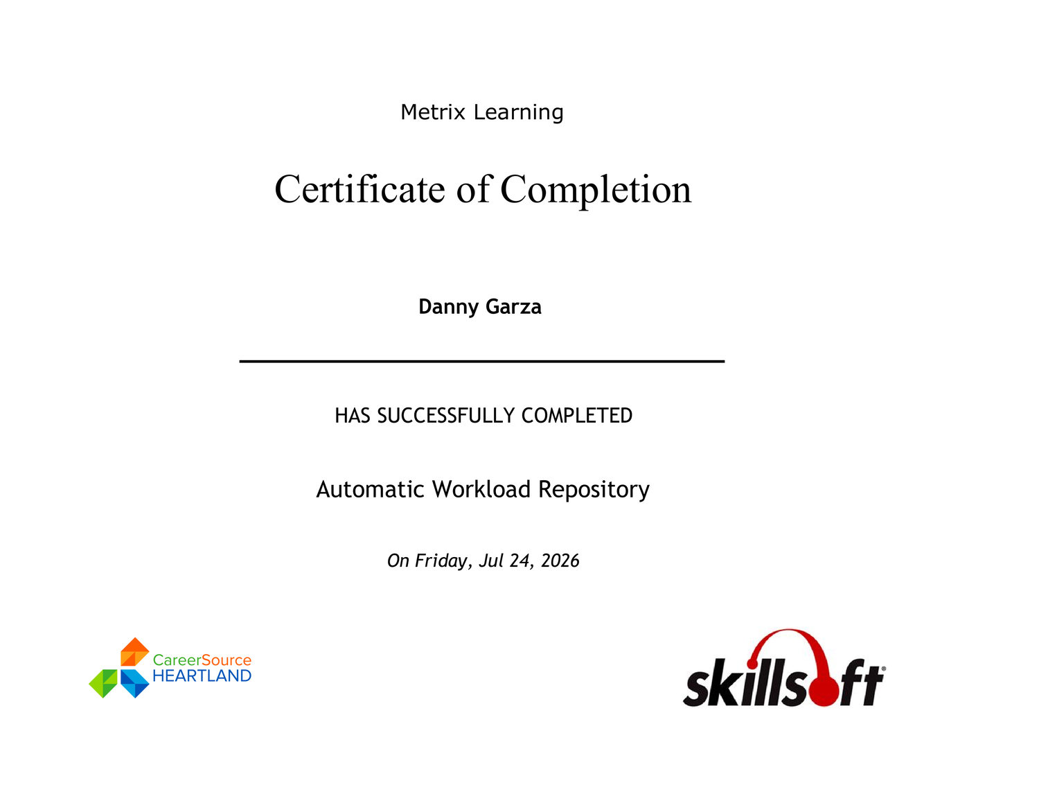

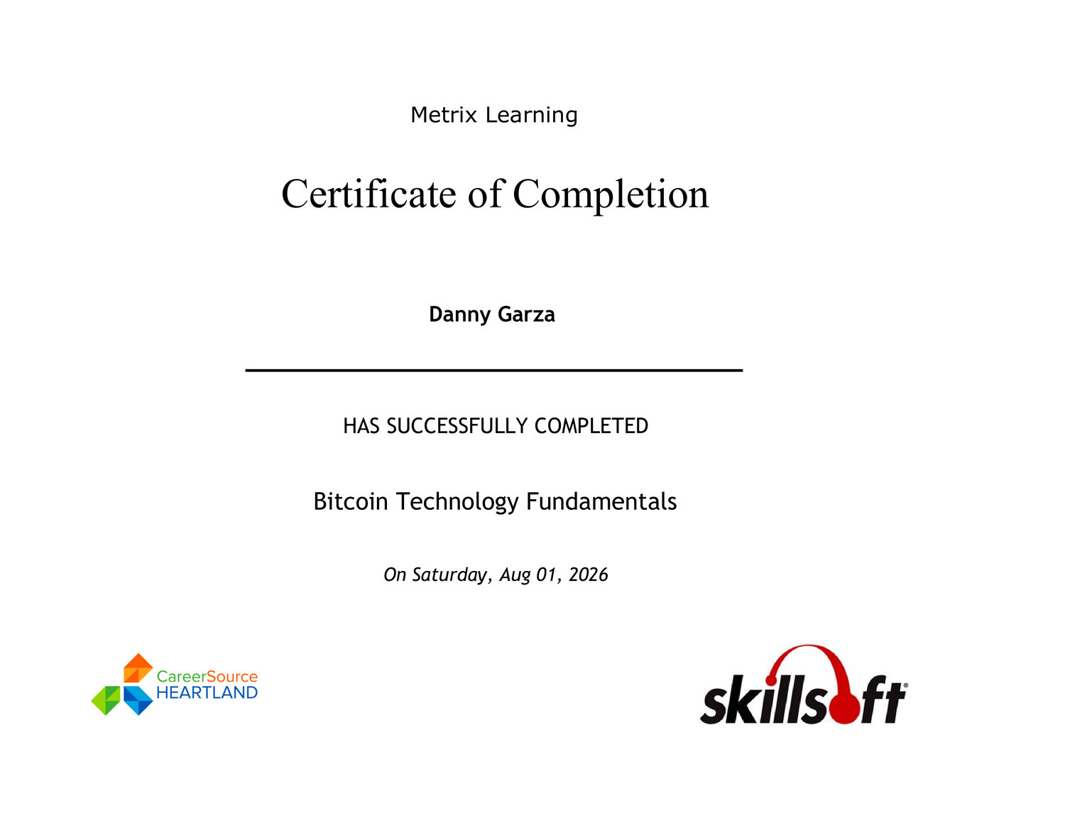

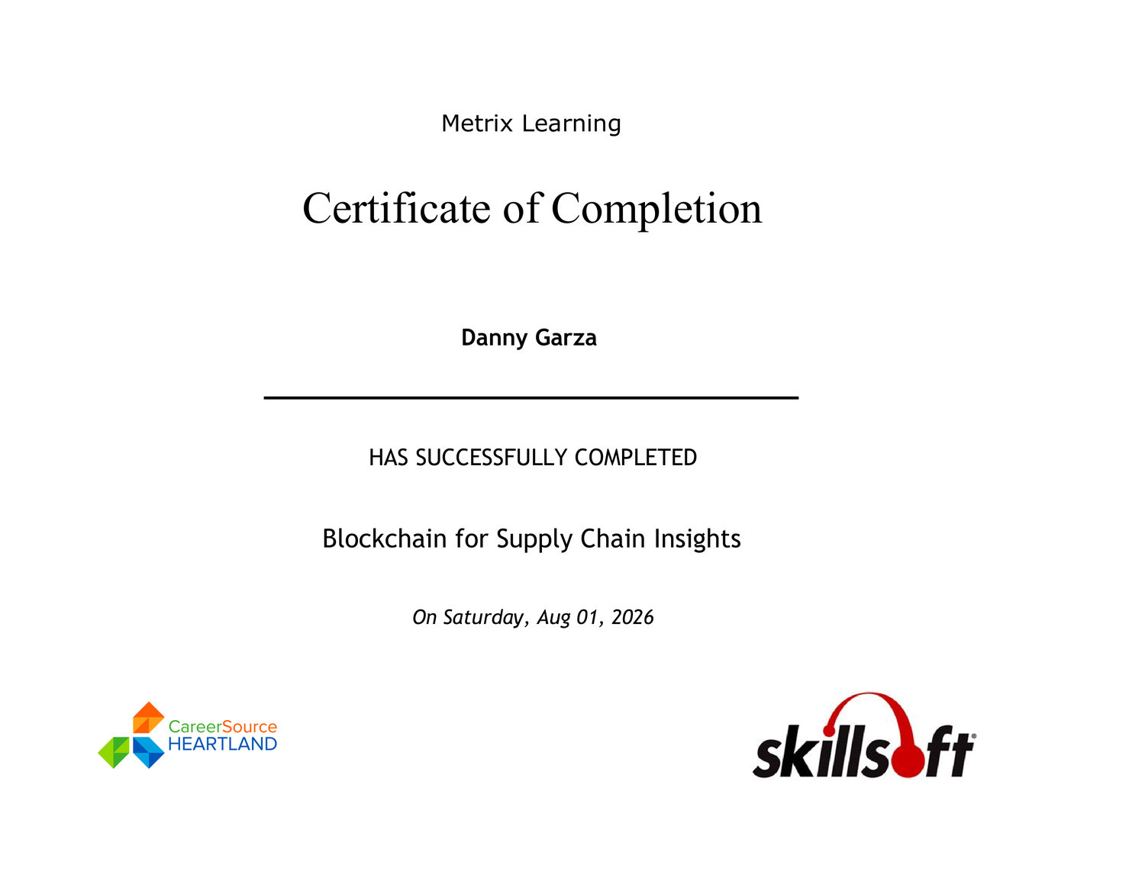

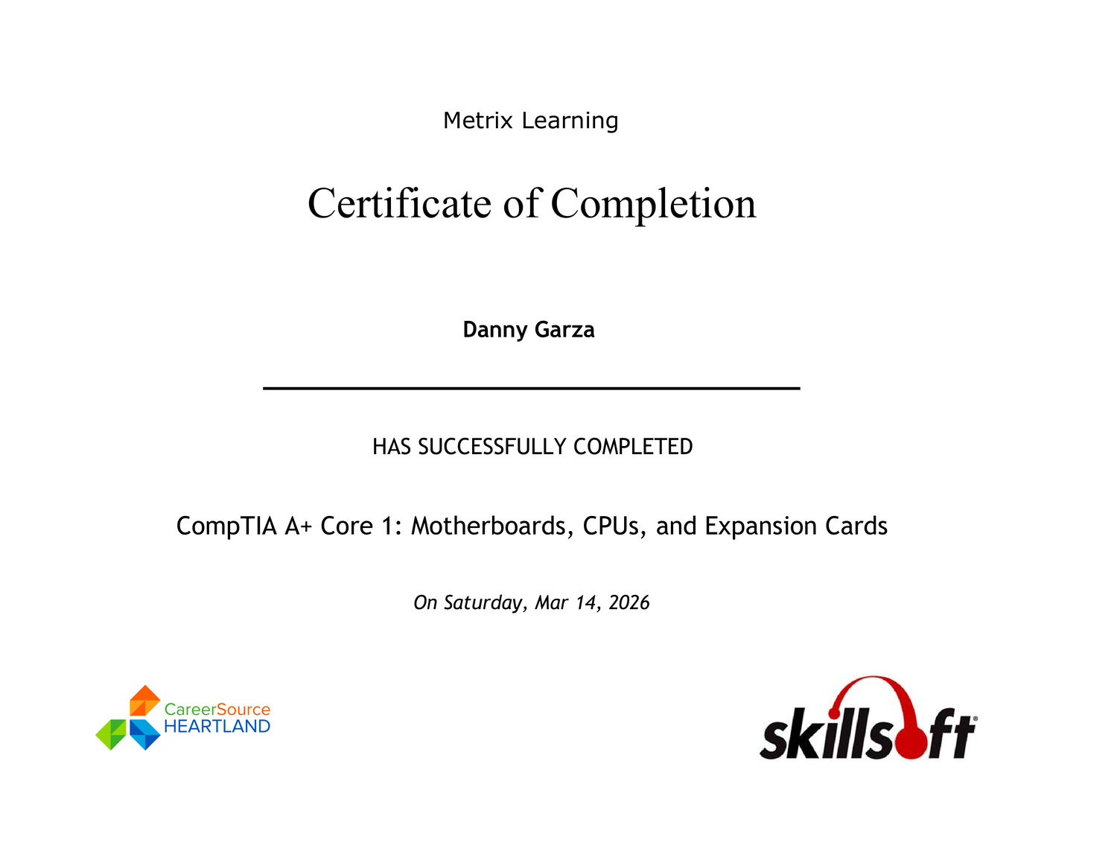

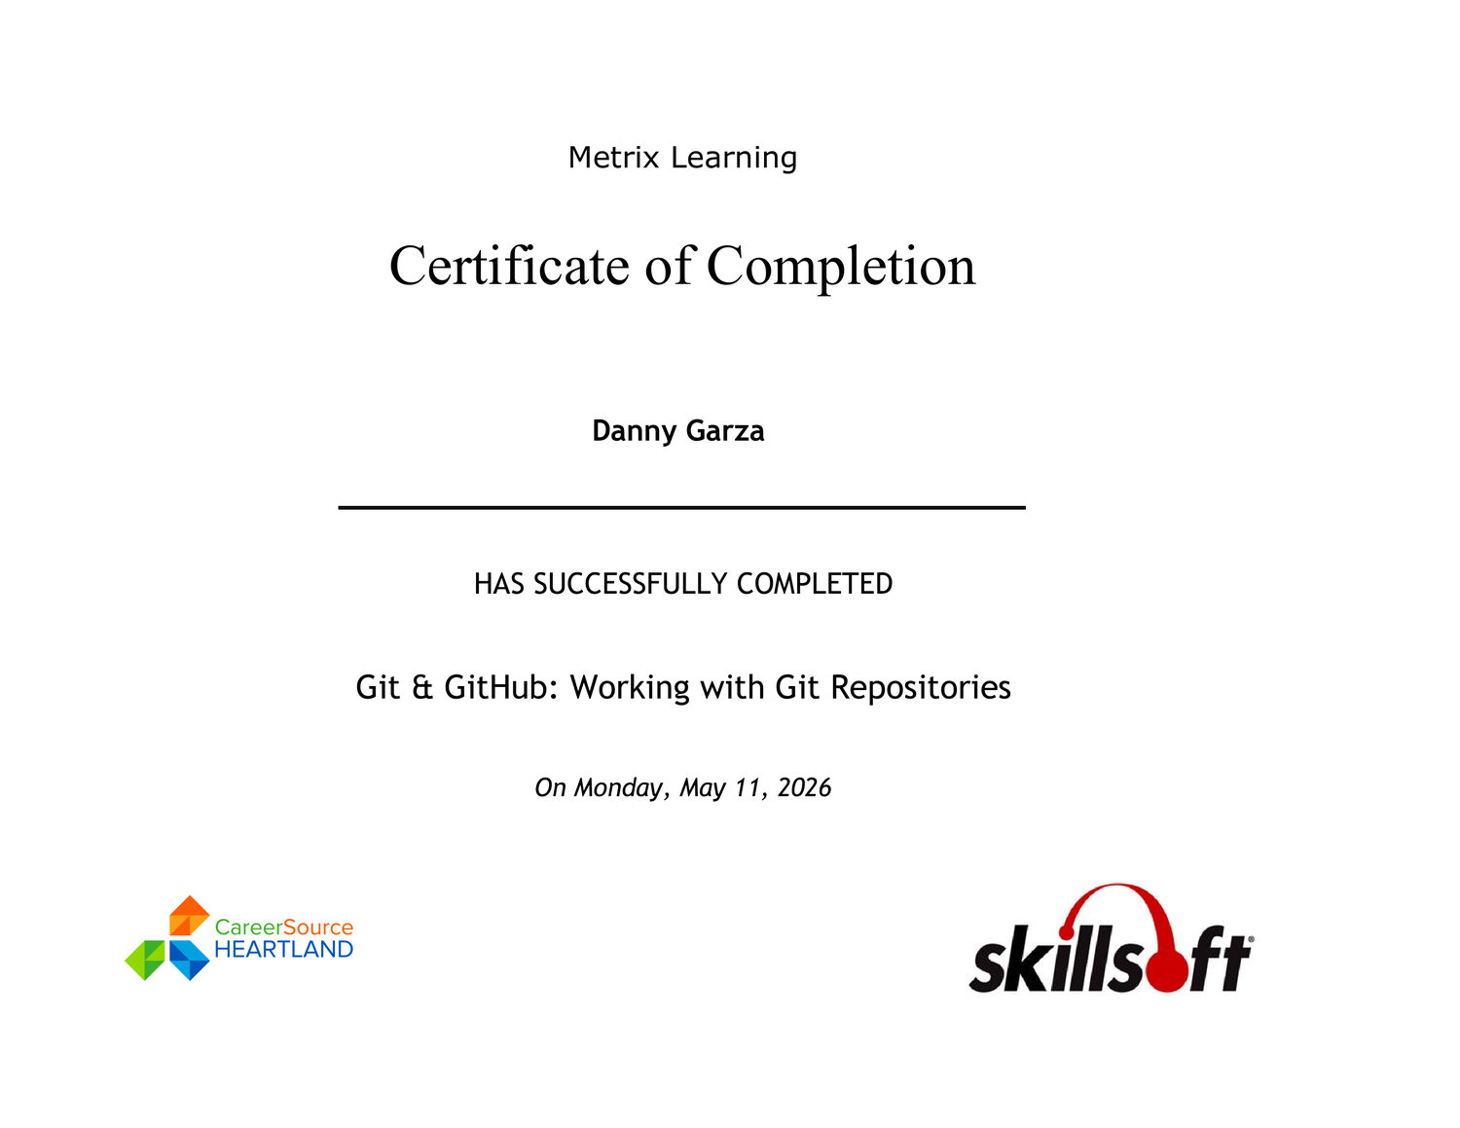

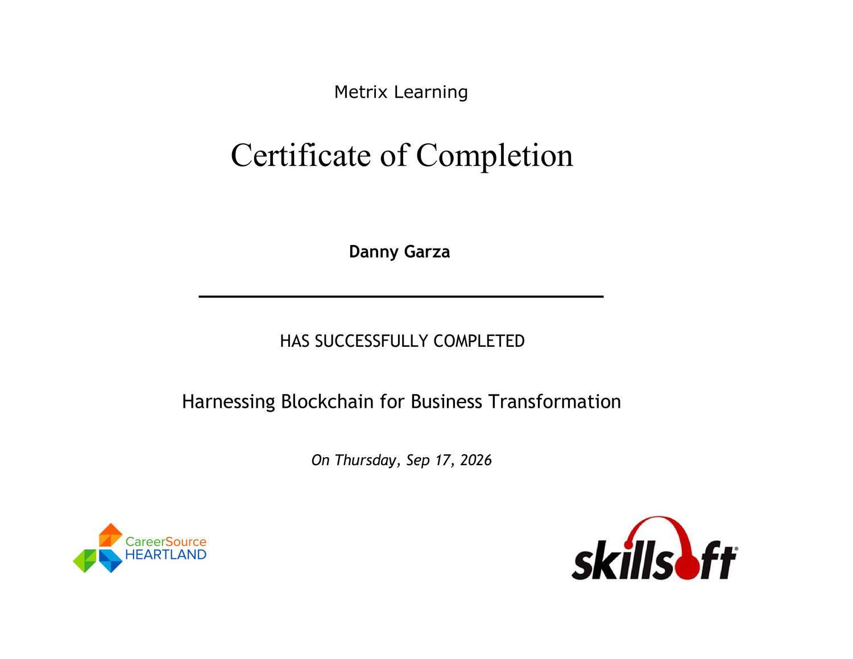

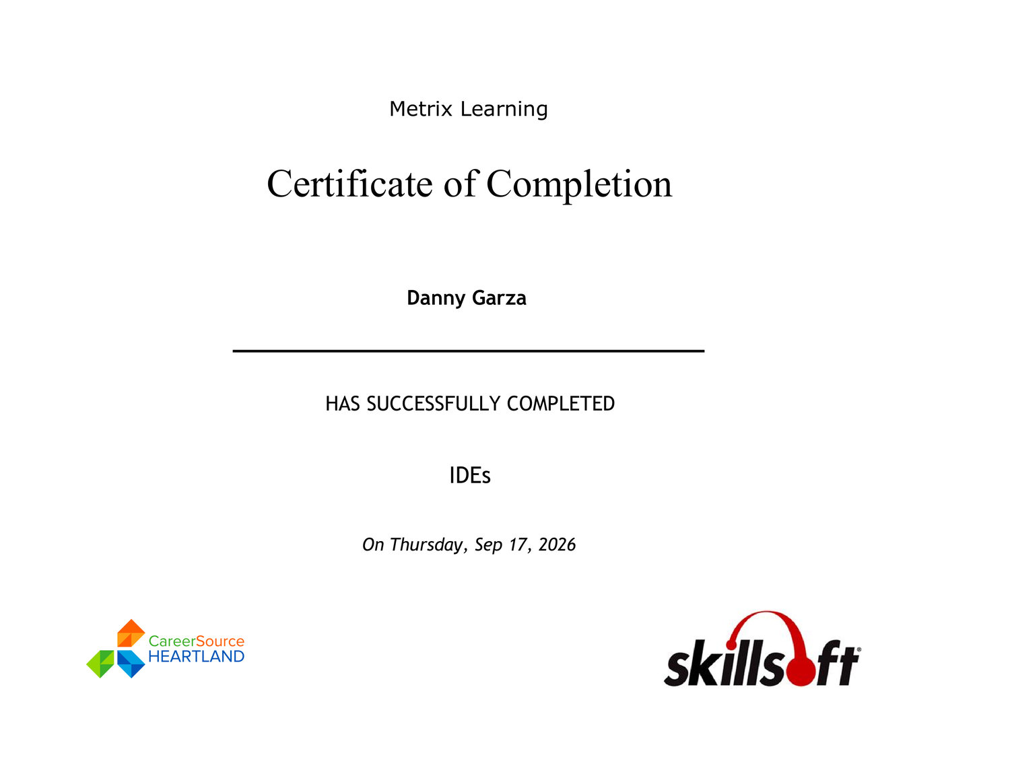

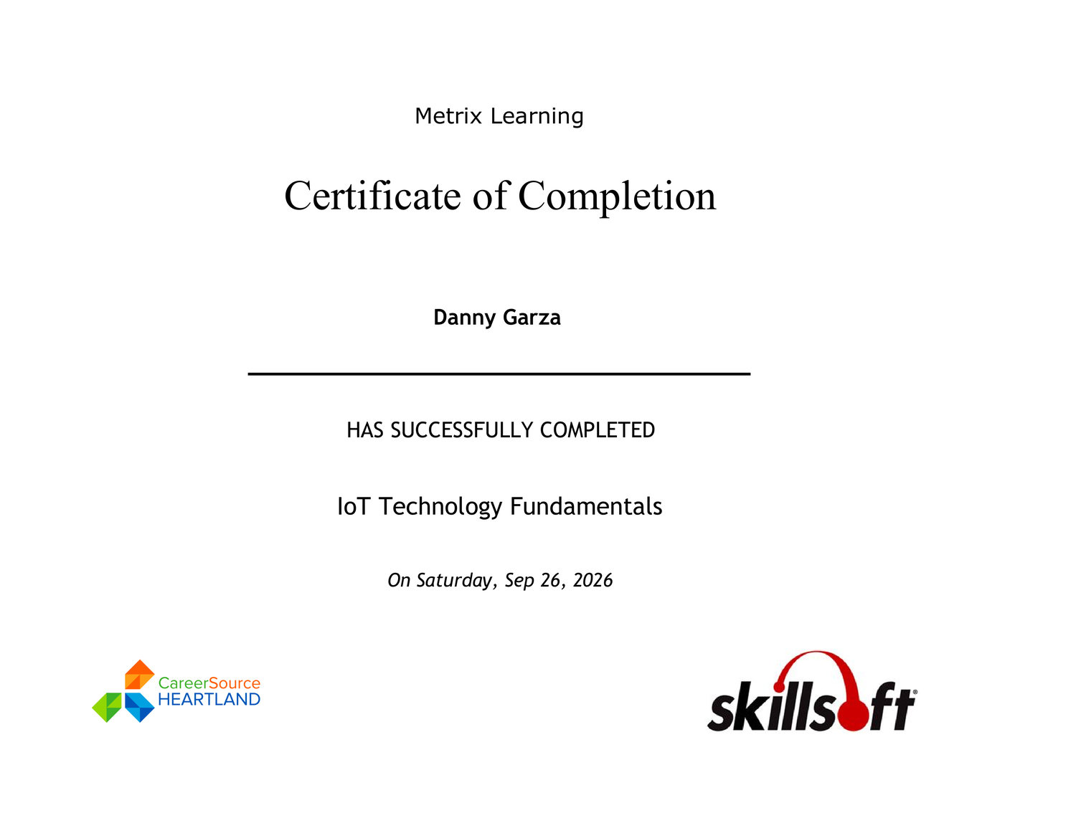

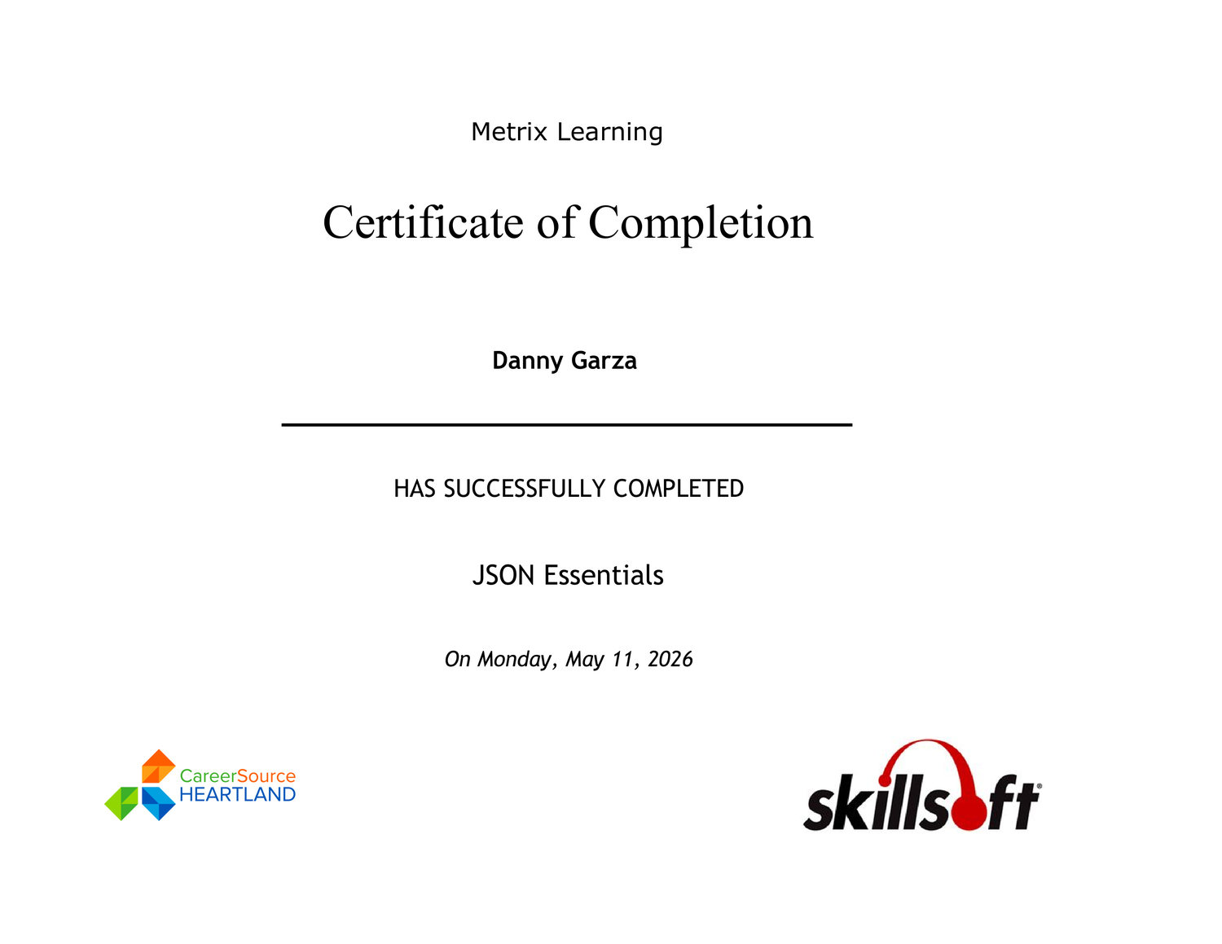

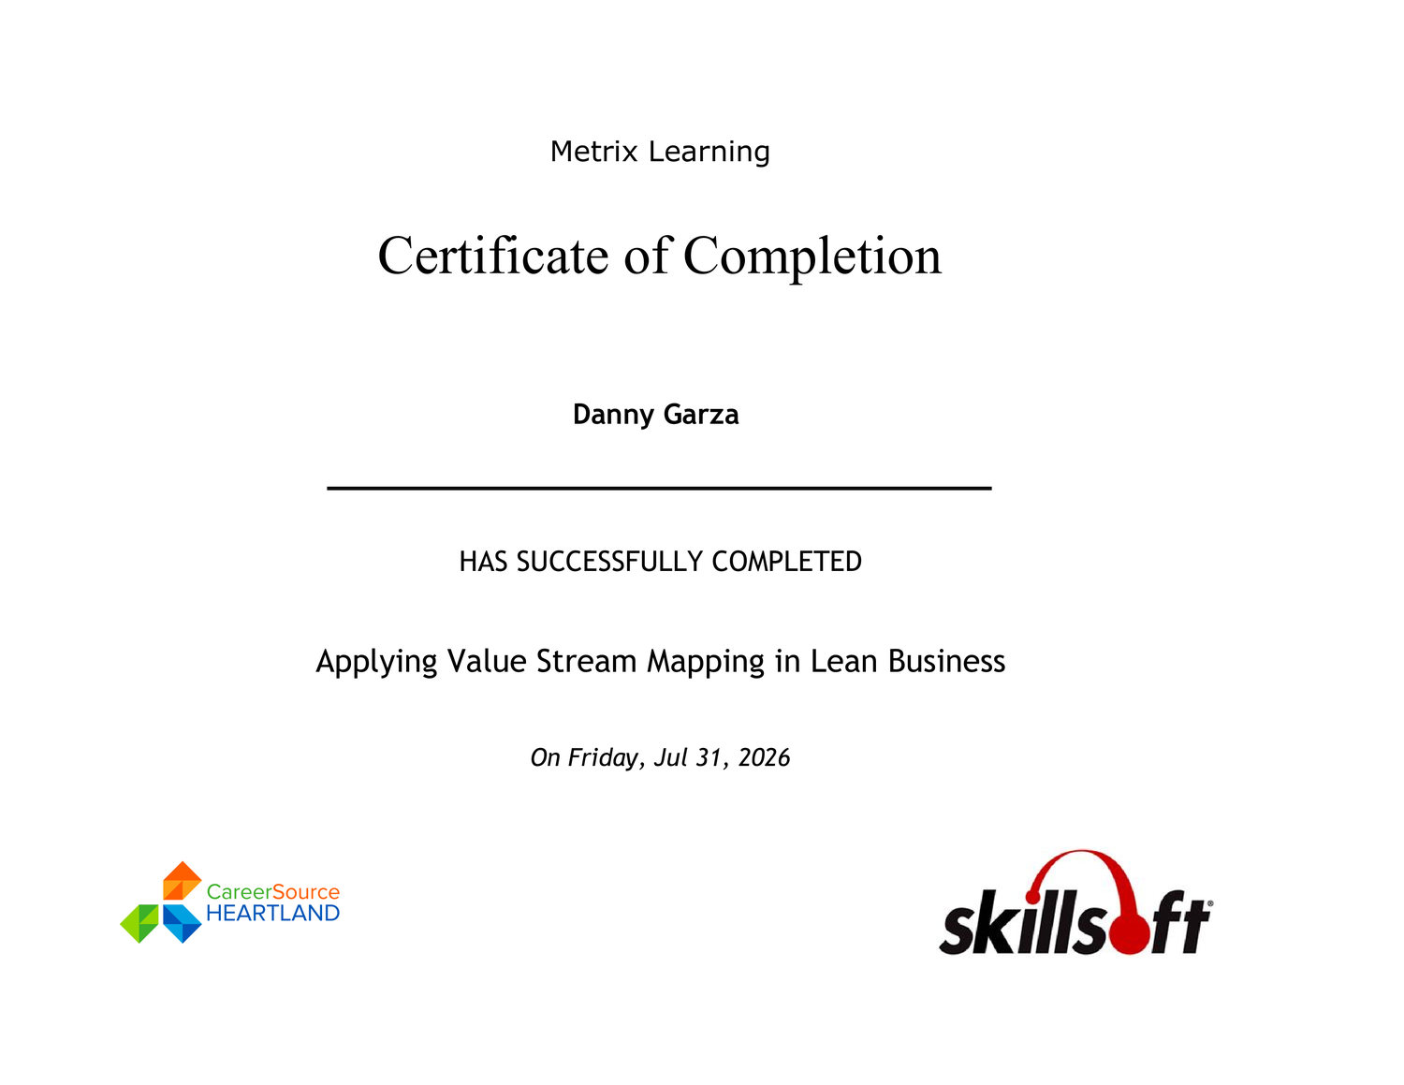

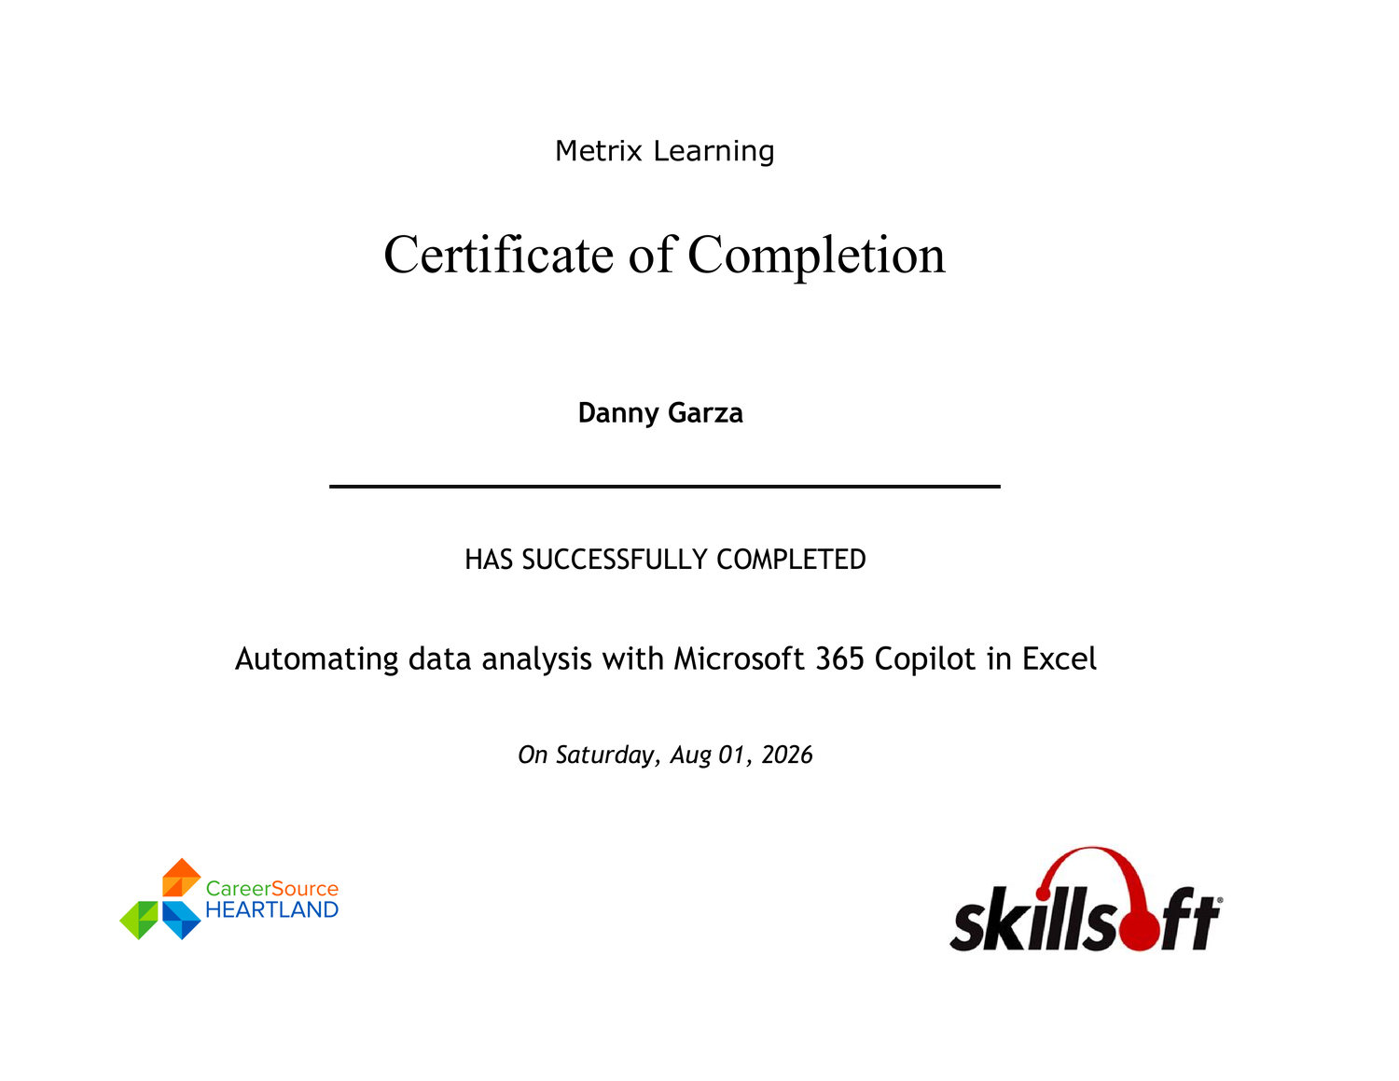

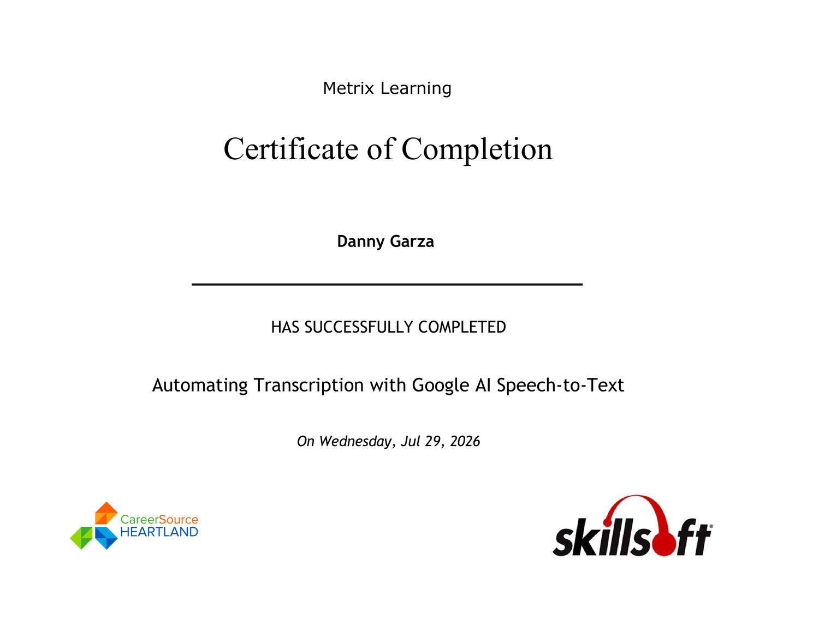

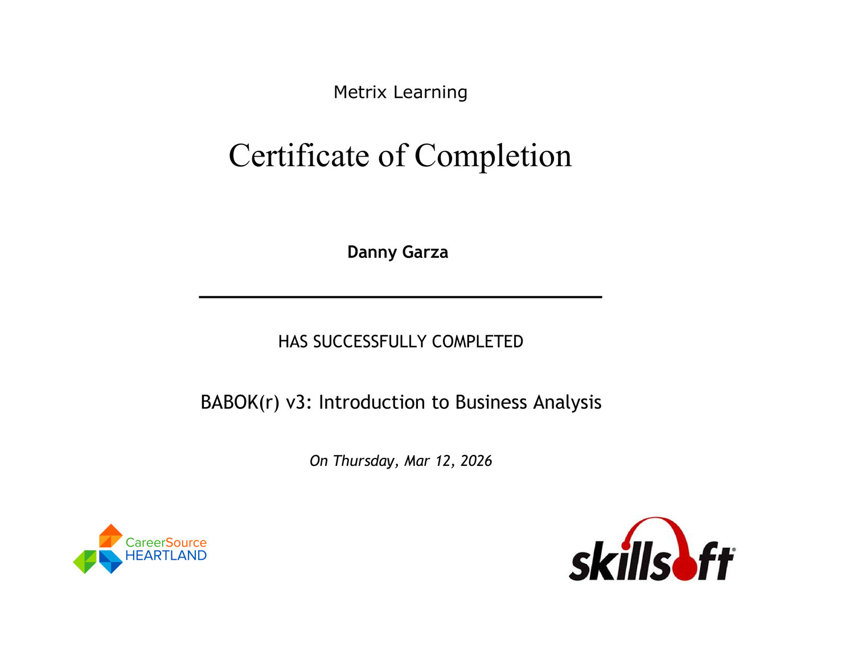

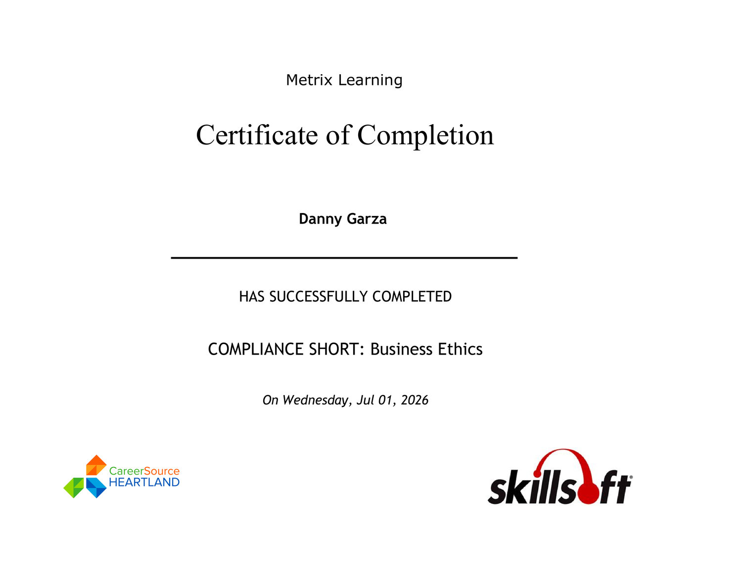

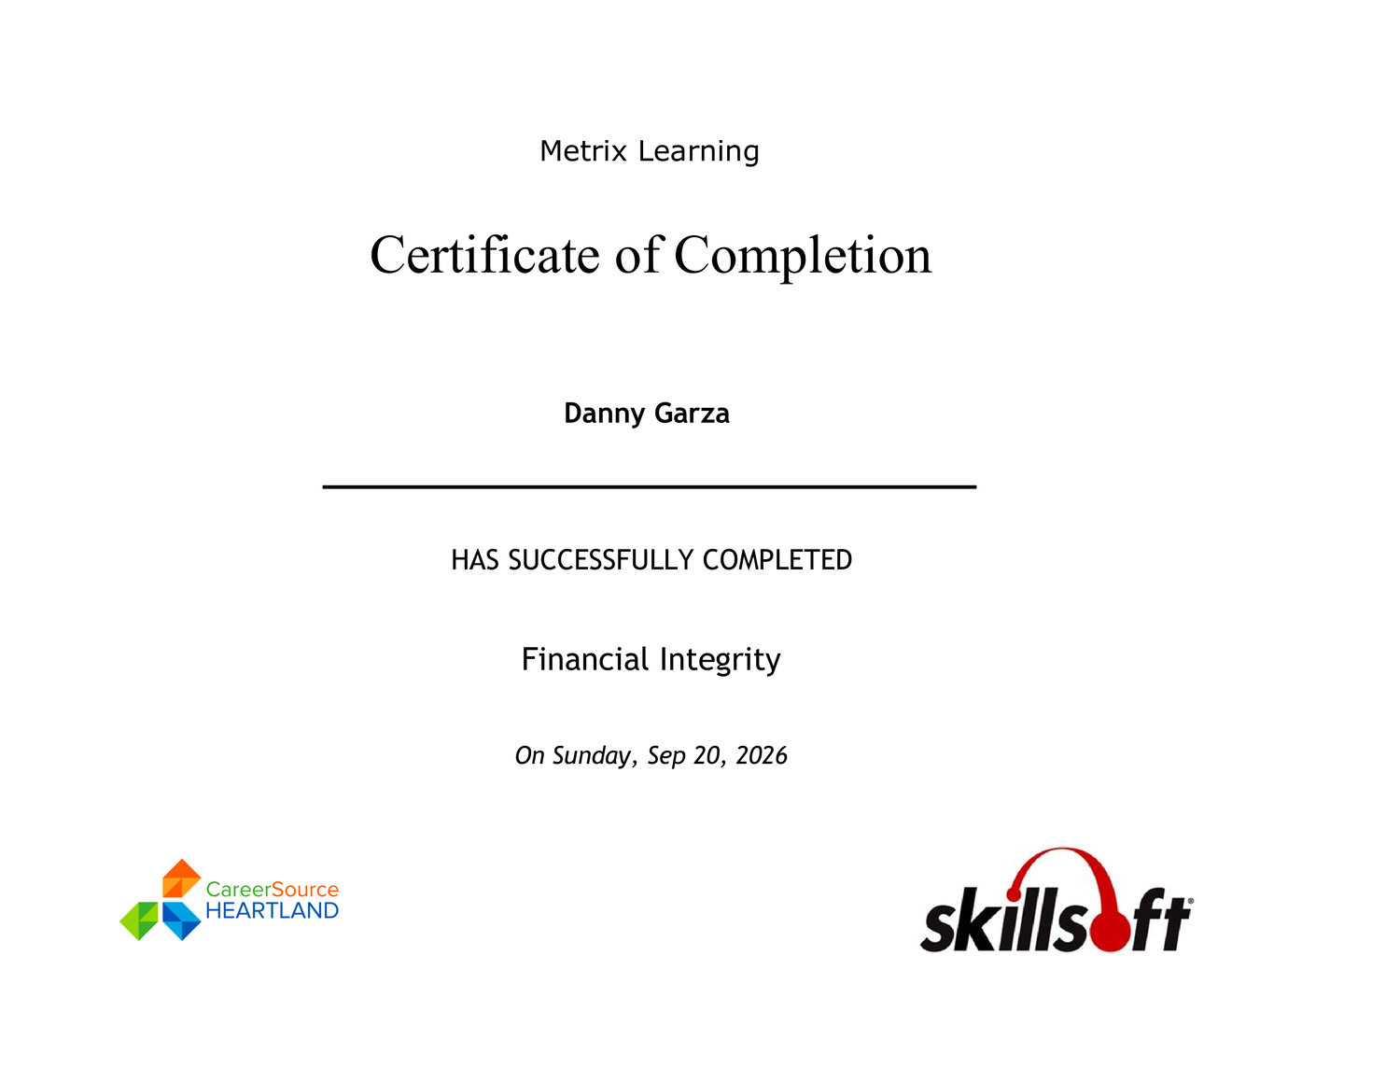

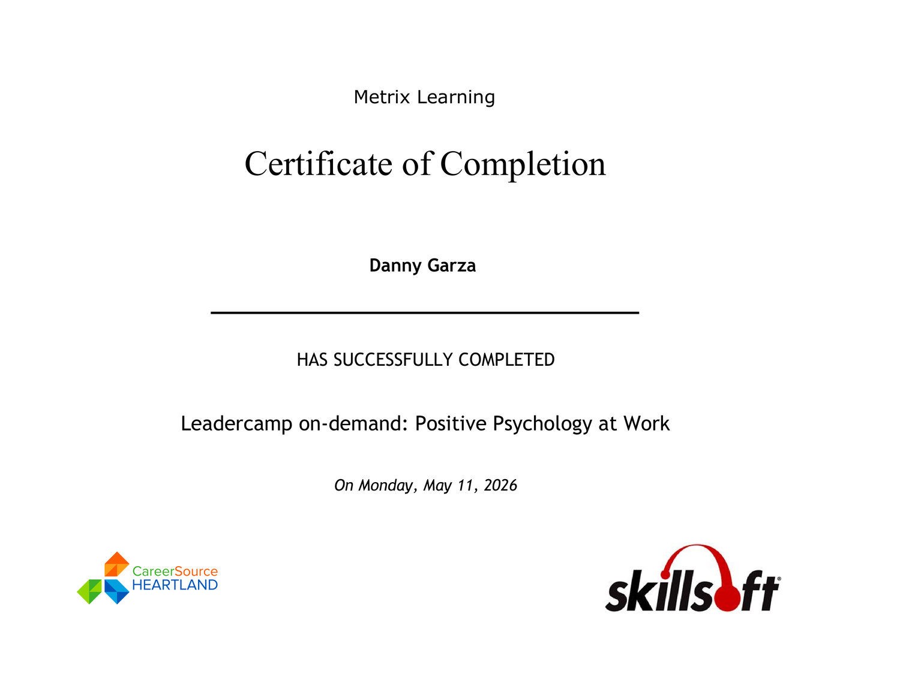

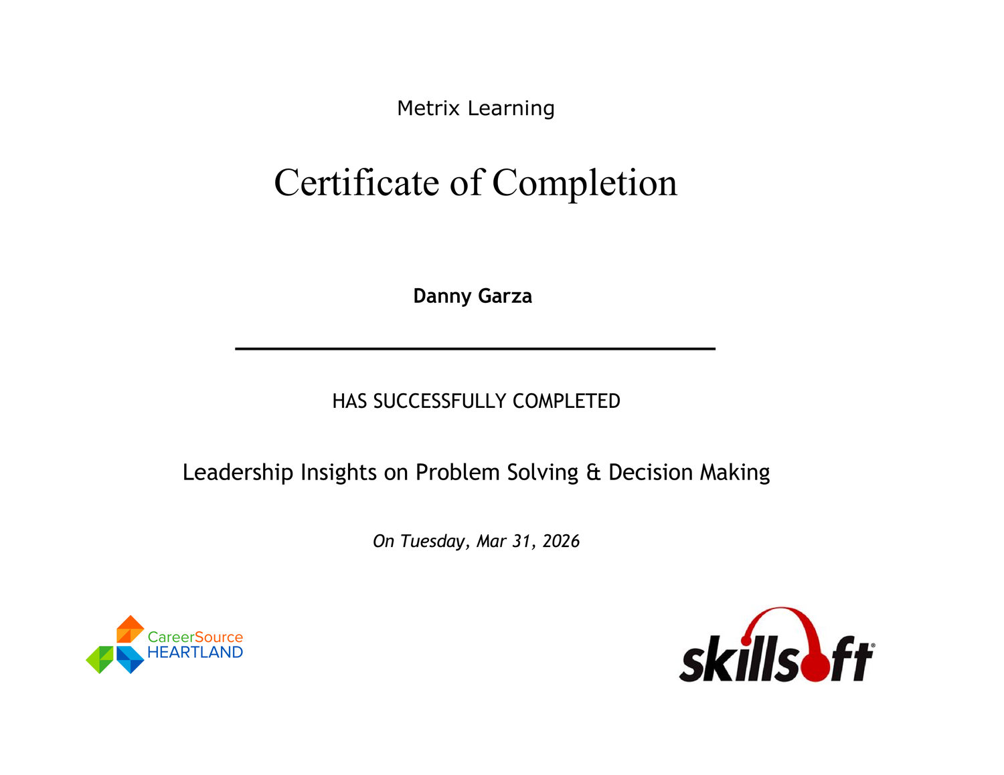

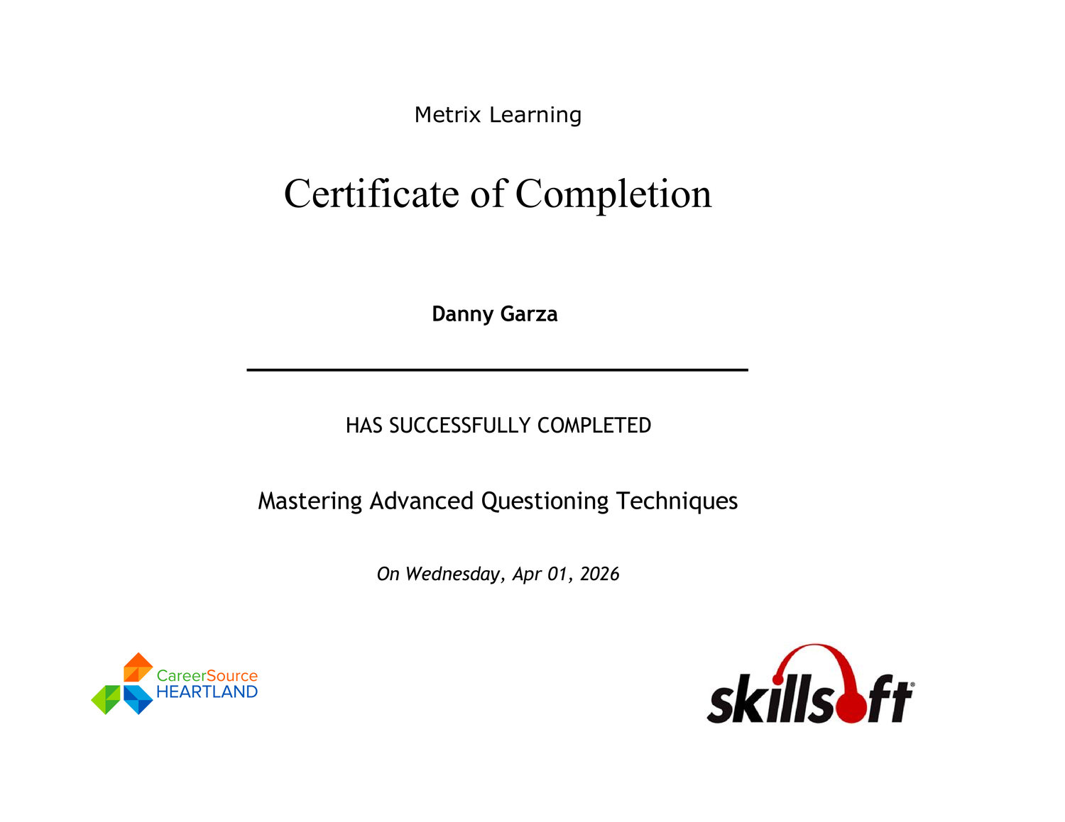

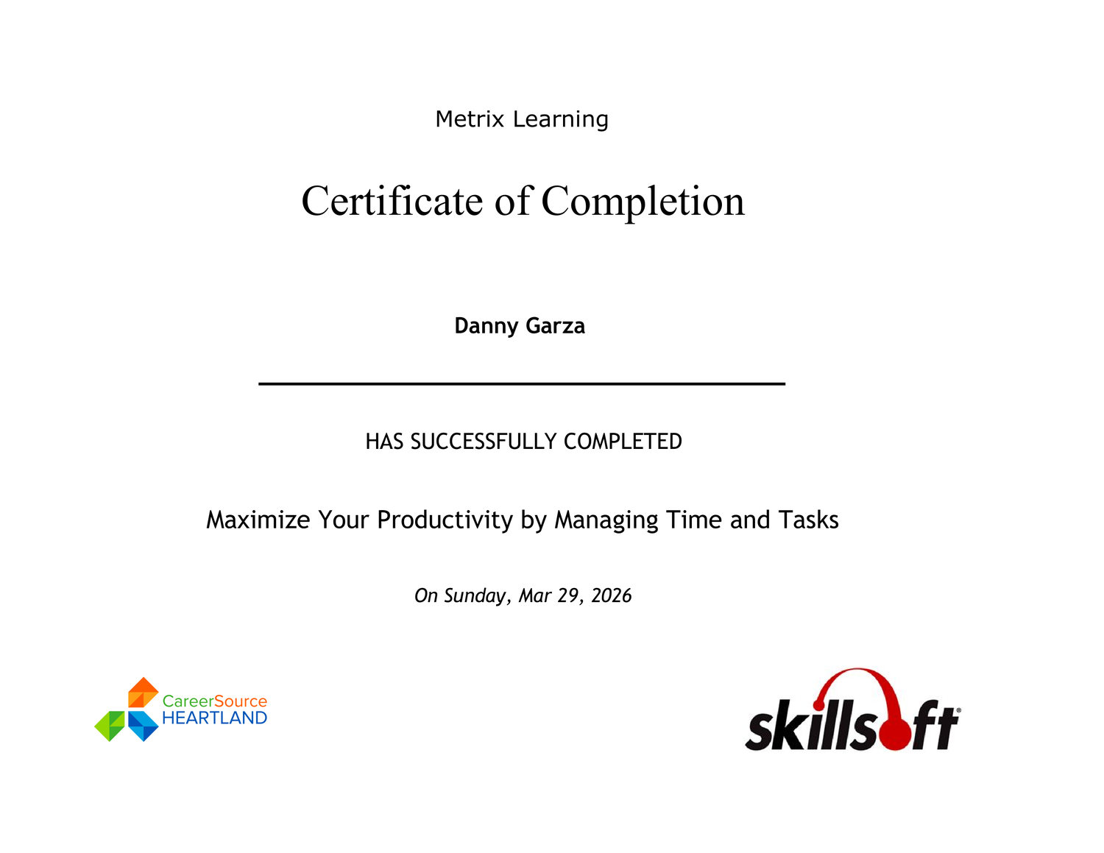

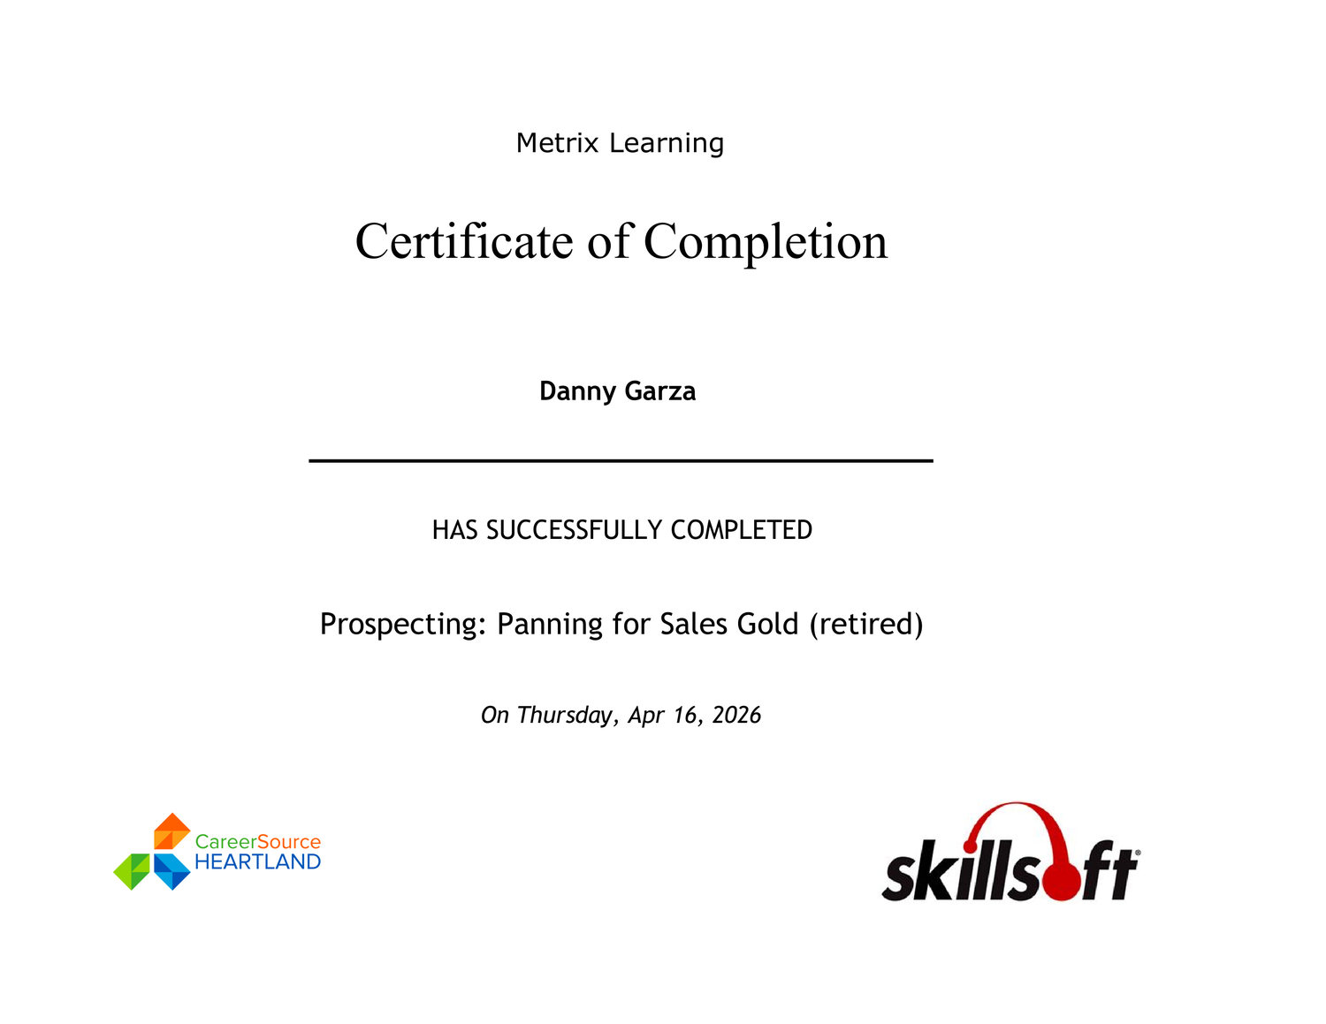

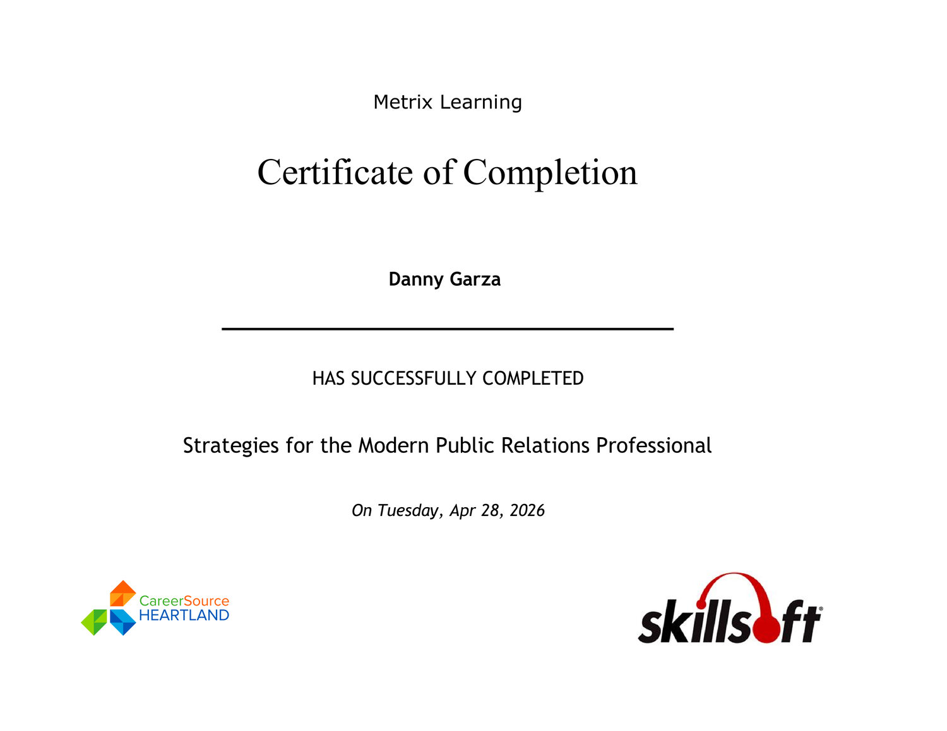

AGENTIC AI • ARCHITECTURE • RELIABILITY
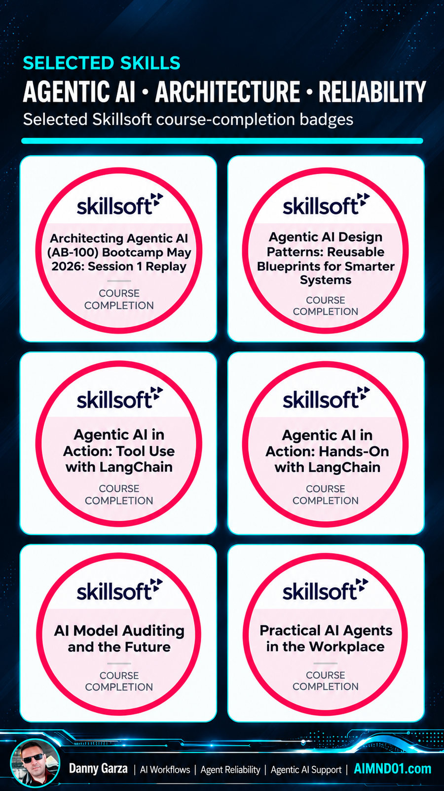
AI AUTOMATION • APIs • WORKFLOWS
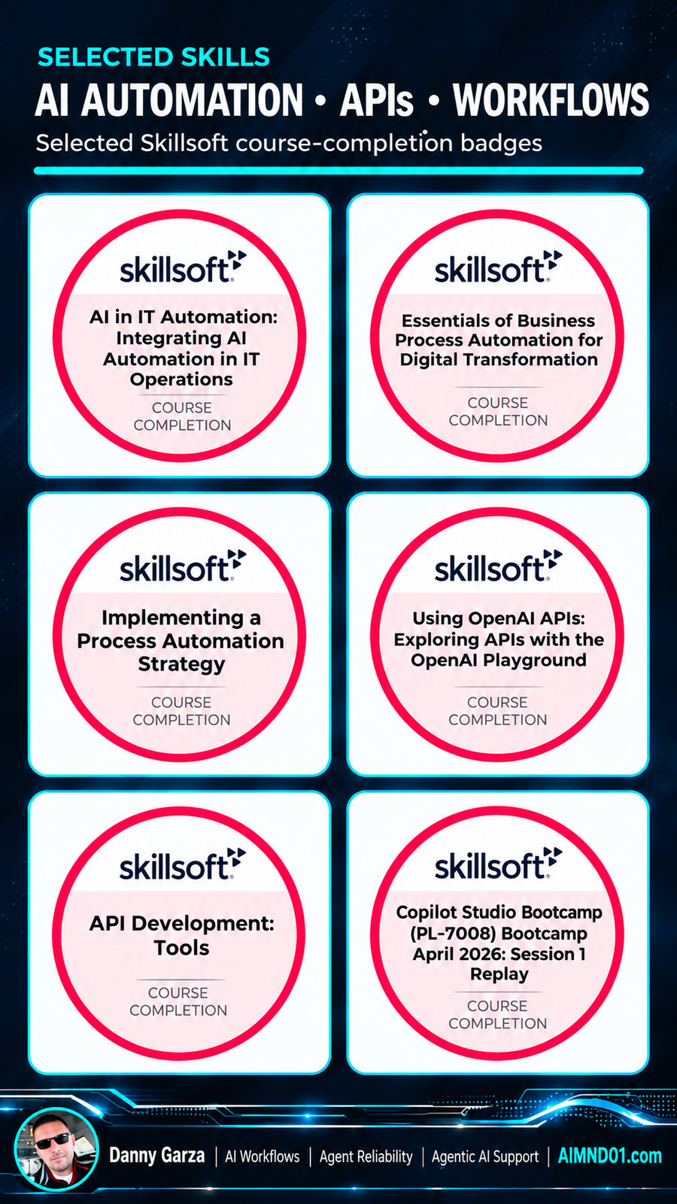
AI SECURITY • GOVERNANCE • TRUST


