# P1- Finding Lane Lines on the Road

1. **Describe your pipeline. As part of the description, explain how you modified the draw_lines() function.**

I defined the line_finder () function to find the pipeline. First, apply grayscale and Gaussian blur to the image to make the image smoothing. After that, it use the Canny algorithm to find the edge, then use Hough transform to find the lane at region_of_interest, where the lane is located. Finally, it apply the line found here to the original image to make a lane detection image.

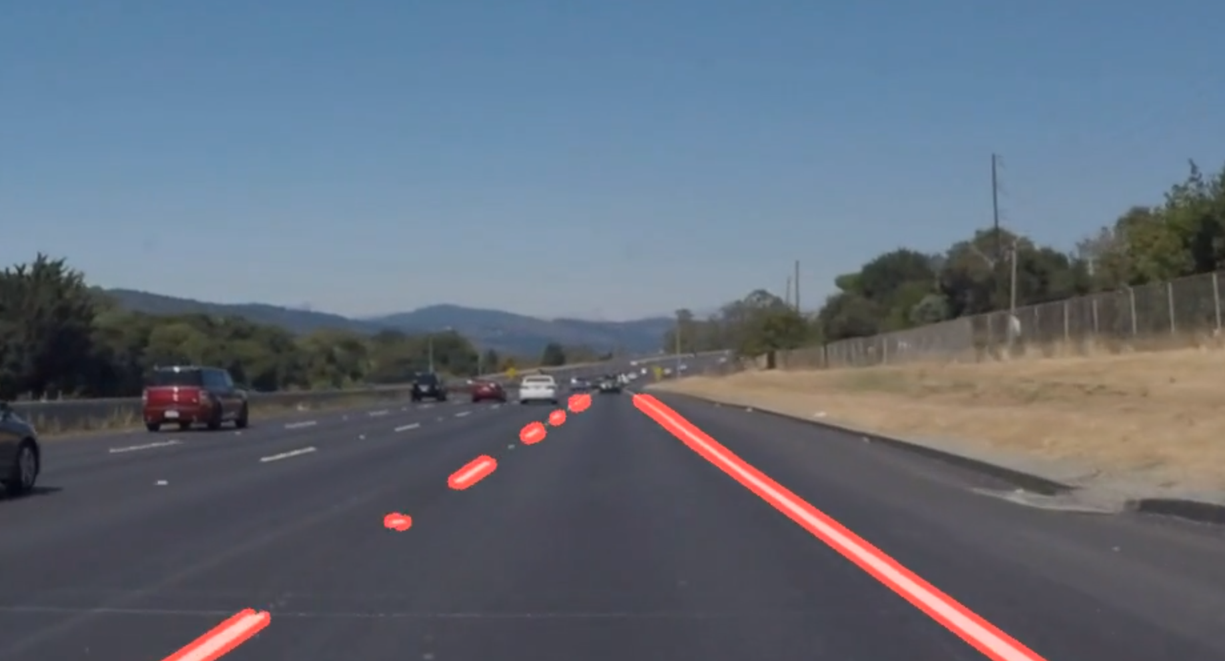

I modified draw_lines to identify the entire range of lanes. This function divides the image in half to recognize the left and right lines separately. I take the x and y coordinates of the recognized lanes of each image and apply scikitlearn to find the best line.

1. **Identify potential shortcomings with your current pipeline**
2. **Insufficient recognition of lane color**In Korea, the color of the lane during driving is used to indicate bus lane or center line. Therefore, if the lane color is not recognized, autonomous driving can’t be performed properly.
3. **Insufficient recognition of dashed line**A solid line is a line that can’t be passed over, and a broken line is a line that can be crossed. Therefore, if it can’t clearly distinguish between the broken line and the solid line, it is difficult to complete the autonomous running.
4. **When there is a long line due to shadows or road repacking, it is also recognized as a lane**  
   In the last video, it detects another line besides the lane. Because of this, the lane is detected as very unstable. It is possible that an accident will happen if you move along the lane due to such a problem.
5. **Suggest possible improvements to your pipeline**
6. **Insufficient recognition of lane color**When a line is recognized, additional information about the line can be acquired to analyze what the line has.
7. **Insufficient recognition of dashed line**In the case of a dashed line, we have two variables in a structure so that we can recognize the dashed line and the solid line to recognize that the vehicle can cross the lane.
8. **When there is a long line due to repainting of shadows or roads, it is also recognized as a lane**  
   Adding more detail such as detecting lane width, lane matching, angle matching, and region_of_interest. Based on this, the lane limit will be clear.