**Government Arts and Science College**

**Kanyakumari – 629 401**

**FACULTY PROFILE**

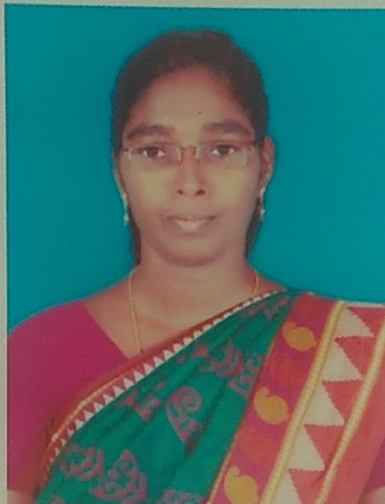

Photo

**Department: Mathematics**

1. **Name : R.SAHAYA SUDHA**
2. **Father’s Name : A.Rayappan**
3. **Designation : Assistant Professor**
4. **Age and Date of Birth : 36 , 17/08/1986**
5. **Gender : Female**
6. **Address for Communication:**

**Phone No : 8270057128**

**Email – id : sahayasudhakan@gmail.com**

1. **Educational Qualification :**

|  |  |  |  |
| --- | --- | --- | --- |
| **S.No.** | **Course** | **University/College** | **Year of Passing** |
| 1 | B.A | Sree Ayyappa College for Women, Chunkankadai, Nagercoil | 2007 |
| 2 | M.A | Sree Ayyappa College for Women, Chunkankadai, Nagercoil | 2009 |
| 3 | M.Phil | Manonmaniam Sundaranar University, Tirunelveli | 2011 |
| 4 | TNSET |  | 2017 |

1. **Area of Specialization:** Indian Writing in English

**9. Experience:**

|  |  |  |  |  |
| --- | --- | --- | --- | --- |
| **S.No.** | **Name of Organisation** | **From** | **To** | **Year of Experience** |
| 1. | Government Arts and Science College, Kanniyakumari | July 2015 | tilldate | 7 Years 9 Months |
| 2. |  |  |  |  |
| 3. |  |  |  |  |
| 4. |  |  |  |  |

**10. Publications:**

|  |  |  |  |  |
| --- | --- | --- | --- | --- |
| **S.No.** | **Title** | **Name of the Journal** | **ISSN / ISBN** | **Year** |
|  |  |  |  |  |
|  |  |  |  |  |
|  |  |  |  |  |

1. **Paper Presented in Conferences/ Seminar :**

|  |  |  |  |
| --- | --- | --- | --- |
|  | **Title** | **Institution** | **Date & Year** |
| 1. | presented a paper entitled  *‘Postcolonial Women in Social Transformation : A Reading of Chinua Achebe’s* ***Anthills of the Savannah’*** | International Conference on ‘Trends in Modern Literature : East and west’, Organized by the Department of English and Foreign Languages, Alagappa University , Karaikudi | 4th & 5th January 2011 |
| 2. | presented a paper entitled  *Social Position and Existing Conflict: Study of Khaled Hossein’s* ***The Kite Runner*** | Two day International Seminar on ‘Multicultural India: Inclusiveness and New Humanities’ at Pondicherry University. | 22ndand 23rd February 2016 |
| 3. | presented a paper entitled  *Double Consciousness in Alice Walker’s* ***Colour Purple*** | ‘Seventh All India Conference of SRF’ held at Scott Christian College (Autonomous) Nagercoil. | March 13,2010 |
| 4. | presented a paper entitled  *Margaret Atwood’s ‘ Surfacing – Alienation of women’* | National Seminar on ‘Canadian Literature’ organized by the Centre for Research and Department of English, Scott Christian College, Nagercoil. | February 26,2010 |
| 5. | presented a paper entitled *The Struggle of Human Race between Displacement and Uncertainty : A Study of Diaspora in Amitav Gosh’s –* ***The Circle of Reason****.* | ‘Sixth All India Conference of KAAS at S.T. Hindu College, Nagercoil . | September 10th &11th ,2010 |
| 6. | presented a paper entitled *Social Impertinence and Discrimination of Manual Scavenger: An Overview* | Two day National Conference on ‘Reservation in Education, Employment and Legislature: Present status and emerging Issues of Marginalized people in India’ at the Department of Education ,Directorate of Distance & Continuing Education, Manonmaniam Sundaranar University , Tirunelveli. | 10th & 11th April 2014. |

1. **Seminar / Conference / workshop / Attended:**

|  |  |  |
| --- | --- | --- |
| **S.No.** | **Institution** | **Date & Year** |
| 1. | Participated in the One day Seminar on Youth Empowerment: Strategies and Approaches at Manonmaniam Sundaranar University , Tirunelveli. | 09/12/2009 |
| 2. | Attended the UGC Sponsored Two-day National Conference on Disability Studies,Organized by the Department of English at Manonmaniam Sundaranar University , Tirunelveli. | 08 and 09 January 2010 |
| 3. | Participated in the National Seminar on Trends in Canadian Literature, Organized by the Department of English at Women’s Christian College, Nagercoil. | 23/09/2010 |
| 4. | Participated in the One day National Workshop on ‘English Language Teaching: Some Innovative Strategies’ held at M.D.T. Hindu College, Tirunelveli. | 10th December 2010 |
| 5. | Participated in the Second International Conference of KAAS -2013, jointly organised by the Kanniyakumari Academy of Arts & Sciences(KAAS) and Sree Ayyappa College for Women, Chunkankadai, Kanniyakumari District, Tamilnadu | 20-21,2013 |
| 6. | Participated in the two days National Workshop on ‘Experiment in Practical Psychology : Training and Orientation’ organized by Immanuel Arasar College of Education , Nattalam and Psychotronics Bangalore. | 18th &19th January 2014. |
| 7. | Participated in the One day Workshop on Writing Scholarly Articles’ held at St. Ignatius College of Education , Tirunelveli . | 23.05.2014 |
| 8. | Attended the five day National Workshop on ‘Indological Research - Traditions and Innovations’ held at Kerala University. | 24 to 28 of June ,2014 |
| 9. | Participated in V’LitS -22. A National Seminar on “A Synoptic View on Literary Theory & Shakespeare at St. Jude's College Thoothoor. | 22 September 2022 |

1. **Details of Research Projects :**

|  |  |  |  |
| --- | --- | --- | --- |
| Title | Sponsoring Agency | Amount | Responsibility |
|  |  |  |  |
|  |  |  |  |

### Ph.D Guidance/Supervisorship

|  |  |  |  |
| --- | --- | --- | --- |
| Name of scholar | Course | Area of research | Status |
|  |  |  |  |
|  |  |  |  |

### Seminar/ Conference/ Workshop Organised:

|  |  |  |  |
| --- | --- | --- | --- |
| **S. No.** | **Topic** | **Institution** | **Date** |
|  |  |  |  |
|  |  |  |  |

### Resource Person:

|  |  |  |  |
| --- | --- | --- | --- |
| Sl.No. | Topic | Delivered at | Period |
|  |  |  |  |
|  |  |  |  |

1. **Members in Organization’s :**

### Other Achievements :

### (Signature)