**Appendix X. ComX Distributions of Landed Catch for Select Species, 1978-1990**

As described in the text, ComX generates predictive distributions of species compositions, by stratum (market category, year, quarter, gear group, and port complex). When multiplied by the total weight of fish landed in a stratum, we obtain the predictive distribution of landed weight by species (i.e. the “expanded” landings estimates by species) for that stratum. This approach allows us to summarize the predictive distributions using percentiles (10th, 25th, 50th, 75th, and 90th) as well as the mean, and to report coefficients of variation (CV). This appendix describes distributions of landed catch at two levels of aggregation, as currently stored in the “COMX_DB” database at the NMFS SWFSC Fisheries Ecology Division. First, we present landings distributions by species, year and gear group, aggregating across all market categories, port complexes, and quarters. This level of aggregation is commonly used in “data-rich” stock assessments that partition annual catch by fishing fleet. Second, we present results by species and year, aggregating across all market categories, port complexes, quarters, and gear groups. This higher level of aggregation is commonly used in “data-moderate” (e.g. surplus production) and “data-poor” (e.g. catch-based) assessment methods.

Given that there are 90+ species in the PFMC’s Groundfish Fishery Management Plan, each landed by multiple gear types, we present results for a subset of species that account for the vast majority of landings, as well as a selection of ‘minor’ stocks that were landed in smaller quantities. Specifically, we ranked species in order of landed weight using the CALCOM database, and identified 9 species that account for 90% of the landed rockfish in California over the period 1978-1990 (Table 1). We also included a selection of minor stocks (in terms of total landings in California) to evaluate performance of the current model in “data-limited” and “data-poor” situations.

Table 1. Rockfish species in descending order of landed catch in California. Source: CALCOM 2018.

|  |  |
| --- | --- |
| **Rockfish Species** | **1978-90 Expanded Landings (1000s of mt)** |
| **Top 90% of Rockfish Landings** | |
| Widow | 47.1 |
| Bocaccio | 44.9 |
| Chilipepper | 32.1 |
| Bank | 14.5 |
| Yellowtail | 10.2 |
| Blackgill | 8.1 |
| Darkblotched | 7.2 |
| Canary | 6.5 |
| Splitnose | 5.4 |
| **Select Minor Stocks** | |
| Cowcod | 2.1 |
| Pacific Ocean Perch | 0.9 |
| Bronzespotted | 0.6 |
| Chameleon | 0.1 |
| Mexican | 0.04 |

In order to generate meaningful comparisons of the ComX distributions and estimates from CALCOM, we ensured that both sets of estimates were based on the same subset of expanded strata. As noted in the main text, ComX does not fit a model to strata in which the minimum number of model parameters is less than the number of available samples. Strata meeting this criterion were excluded from the comparisons in this appendix. For example, the expanded ComX estimates in this appendix exclude landings prior to 1984 in Southern California (insufficient data), market categories 245, 253, and 956 prior to 1983, and market category 265 in both time periods. Market category 245 was excluded because it was only sampled once prior to 1983, and therefore ComX did not fit a model for 245 in this time period. Market categories 253 and 956, prior to 1983, were excluded from the comparison due to issues associated with a reclassification of landing receipts during that time period (details can be found in Pearson et al. 2008). Pearson et al. also described a re-definition of market category 265 that led to its exclusion. To ensure an accurate comparison, expanded landings estimates from CALCOM were queried from the COM_LANDS table based on the same strata that were used to generate the ComX distributions.

Since some market categories are named after a particular species, an uninformed user may mistakenly query landings based on a market category description, assuming they represent total landings for that species (e.g. market category 253, the nominal “bocaccio” category). Using the same subset of strata outlined above, we compare ComX estimates to the landings in the nominal category for each species and gear to illustrate how nominal landings estimates differ from expanded estimates.

**Expanded Landings Aggregated by Species, Year, and Gear Group**

Since deviations between estimates from CALCOM and ComX can occur for a number of reasons, we provide a brief summary of our comparisons to date. Members of the technical team are currently researching specific cases and will be prepared to present further details during the methodological review. We first present species making up 90% of commercial landings, in rank order of landings and beginning with Widow Rockfish (*Sebastes entomelas*), followed by a selection of minor stocks, beginning with Cowcod (*S. levis*).

Widow Rockfish (*Sebastes entomelas*)

Expanded landings of widow rockfish were dominated by the trawl gear group, with relatively minor contributions from line and net gears (Figure X1). Since 1983, regulations require sorting of widows into market category 269, and this species represents one of the most “data-rich” examples, as indicated by the small CVs, particularly for trawl gear estimates. Landings of widow continue to occur in market categories other than 269, which accounts for the slight negative bias between the “nominal” landings and the expanded landings from both ComX and CALCOM. The largest deviations between ComX and CALCOM occur prior to the sort requirement (1979-1981), but the 1982 estimates from all three methods are very similar. Line gear estimates are the least precise among gear groups, but this would have little effect on assessment results due to their minor contribution to total removals.

Bocaccio (*S. paucispinis*)

Expanded landings for Bocaccio (Figure X2) are consistently precise across gears and years for the areas examined in this comparison. ComX distributions at the species/year/gear level have CVs less than 0.4 for all years in the trawl and line gears, as well as for net gear types after 1983. Point estimates for trawl landings from CALCOM generally fall between the 10th and 90th percentiles of the ComX distributions, with the exception of 1980, 1983, and 1984. Use of the nominal “Bocaccio” market category (253) produces very poor estimates of landed catch, reflecting the fact that Bocaccio was landed in large quantities in other market categories, and other species were landed in market category 253.

Chilipepper Rockfish (*S. goodei*)

Chilipepper and Bocaccio are frequently caught together, resulting in similar trends in landings by gear for the two species. Chilipepper landings distributions are also precise relative to other species in the comparison set, having CVs less than 0.4 in most years and gears after 1982 (Figure X3). Expanded point estimates from CALCOM are mostly consistent with ComX distributions, with the exception of trawl landings after 1983, where the CALCOM expansion procedure estimates consistently greater landings, especially after 1987. Chilipepper were almost never landed in their nominal market category (254), by comparison.

Bank Rockfish (*S. rufus*)

Estimates of Bank Rockfish prior to 1983 are consistently imprecise at this level of aggregation, with CVs > 1 for all gears and years (Figure X4). Bank rockfish are common in Southern California and, as noted above, this comparison excludes landings in Southern California prior to 1984 due to limited sampling. Potential approaches to estimate landings for this species in Southern California could include prediction (hindcasting) of species compositions based on data collected from Southern California after 1983. The general trends in expanded trawl landings are roughly consistent, with deviations in 1984 and 1986, although one would expect some deviations by random chance. ComX estimates are consistently higher than CALCOM for line gears, with the opposite pattern in net gears. As with Chilipepper, only a small fraction of Bank Rockfish were landed in their nominal market category (663).

Yellowtail Rockfish (*S. flavidus*)

ComX distributions of expanded catch for Yellowtail Rockfish were less precise, with CVs greater than 0.4 in all years and gear groups (Figure X5). Trawl landings estimates from CALCOM showed no clear trend and were highly variable. Means of the ComX distributions showed an initial increase, followed by a decline from 1980 to 1986, after which landings stabilized around 200 mt per year. Deviations between the mean and median estimates from ComX reflect skewness of the predictive distributions. For both line and net gear types, CALCOM produces expanded estimates that are consistently larger, and with more inter-annual variability, than ComX. Yellowtail landed by trawl gears are rarely landed in their nominal category (259), but total weight of fish in the nominal “yellowtail” category are of similar scale to the ComX expanded estimates for both line and net gear groups.

Blackgill Rockfish (*S. melanostomus*)

Expanded landings of Blackgill Rockfish are highly imprecise prior to 1983 in all gears, with CVs from ComX consistently greater than 1 (Figure X6). CVs of trawl and net gears remain above 0.4 for the remainder of the expanded time periods, while the precision of line gears increases after 1984. Mean and median landings by trawl gears increase in ComX in 1983, and then remain stable. CALCOM estimates after 1983 are highly variable, but lower (on average) than ComX. Both expansion methods show increases in landings by line gears, with a slower rate of increase in the ComX estimates, relative to the CALCOM expansion protocol. The largest deviation between the two expansion methods for net fisheries occurs in 1988, which is the most precisely estimated year for that gear group in ComX (CV = 0.36). Landings in the nominal “blackgill” category (667) are a poor representation of trawl catch. Nominal landings in the line and net gear groups show a similar trend to expanded estimates, but are biased low.

Darkblotched Rockfish (*S. crameri*)

Expanded trawl landings for Darkblotched Rockfish show slight increasing trends based on either CALCOM or ComX estimates. The CALCOM estimates show more interannual variability and estimate trawl landings in 1987 as being more than twice the estimate from ComX (Figure X7). Estimates for line gears, although a minor component of total removals, are higher for ComX prior to 1986, but consistent with CALCOM from 1987-1990. While CALCOM shows negligible landings of Darkblotched by net gears, ComX estimates about 100-200 mt annually. CVs for ComX landings of Darkblotched are high for early years (pre-1984) and net gears in all years (minimum net CV = 0.65). After 1983, CVs for trawl gears range from 0.34 to 0.49. Landings in the “darkblotched” market category (257) are a poor representation of actual landings for trawl and line gears. Landings in the net gear group are consistent with CALCOM, but lower than ComX.

Canary Rockfish (*S. pinniger*)

Over the modeled time period, trawl gears dominated the catch of Canary Rockfish, with only minor contributions by line and net gears (Figure X8). Point estimates of expanded trawl catch fall consistently between the 10th and 90th percentiles of ComX distributions, but show a slightly different trend prior to 1982. ComX CVs for Canary rockfish are greater than 0.4 for all year/gear combinations, with line gears having the highest precision (consistently less than 0.6) after 1984. Canary is another species with landings that are not well-represented by landings in the nominal “canary” market category (247). Nominal landings in category 247 were negligible in all years for all three gear groups.

Splitnose Rockfish (*S. diploproa*)

Expanded landings estimates from both CALCOM and ComX show an increase in Splitnose Rockfish trawl catch after 1982, followed by a decline that is more pronounced in the CALCOM estimates, particularly after 1986 (Figure X9). CALCOM point estimates before 1987 fall between the 10th and 90th percentiles of the ComX distributions. Expanded estimates from net gears are similar in both CALCOM and ComX (slightly higher in ComX), but line gears in CALCOM are attributed negligible landings in CALCOM, compared to a minor, but steadily increasing amount based on ComX. CVs of the ComX distributions for Splitnose are less than 0.4 for trawl gears after 1983, and around 0.5 for line and net gears after 1985. Estimates prior to 1983 are generally poor for line and net gears, with CVs greater than one in all years. With the exception of the first two years in the trawl time series, nominal landings in the “splitnose” market category (270) are negligible, and not a reliable estimate of Splitnose Rockfish landings.

Cowcod (*S. levis*)

Cowcod is the first ‘minor’ species (in terms of total landings) that we chose to examine. Despite its modest contribution to overall rockfish landings, Cowcod is currently managed with the intent to rebuild the stock from a previously declared “overfished” status. As noted in the last assessment (Dick and MacCall, 2014), uncertainty in catch for cowcod leads to considerable uncertainty in estimates of historical spawning stock biomass. As noted above, the nominal market category for Cowcod (245) was excluded from this comparison for years prior to 1983 due to insufficient sample size. This exclusion contributes to the large CVs of the ComX distributions in the early time period (Figure X10). However, the general imprecision also reflects the fact that many species are landed in category 245, including Bronzespotted, Bocaccio, and Chilipepper (Butler et al. 1999). The smallest CVs were estimated for line gears after 1984 (often less than 0.5), with trawl gears having the highest CVs on average. As noted above, landings in market category 245 (“cowcod”) actually consist of several species, and cowcod were often landed in market categories other than 245, so the use of market category 245 to approximate landings of Cowcod is not recommended. ComX estimates of trawl landings are considerably higher than estimates from CALCOM. Estimates of expanded landings by line gears show similar trends, but again show higher inter-annual variability in CALCOM. Both estimators show a similar pattern in the net fishery over time, but CALCOM estimates are higher than ComX for the years 1984-1986.

Pacific Ocean Perch (*S. alutus*)

Pacific Ocean Perch (aka “POP”) has a center of distribution to the north of California, but some POP were landed in the state, mainly by trawl gears (Figure X11). Most year/gear landings distributions from ComX have CVs greater than 1 for this species. A higher level of aggregation (e.g. across gears) for California landings during this time period may be warranted in an assessment context, particularly given the minor contributions from line and net gears. CALCOM estimates for trawl gears are highly variable across years, and smaller (on average) than ComX means. Landings in the nominal “POP” category (271) do not track expanded landings in either CALCOM or ComX.

Bronzespotted Rockfish (*S. gilli*)

Trends in Bronzespotted Rockfish landings from ComX (Figure X12) are very similar to Cowcod (Figure X10), but at a slightly smaller scale. Both species occupy similar habitat, are caught by similar gears, and are landed in similar market categories. Similar to Cowcod, ComX estimates are generally imprecise, and larger than estimates from CALCOM, particularly for trawl gears. Estimates from CALCOM are very similar to ComX means for net gears, but CALCOM estimates do not show a steady increasing trend as suggested by ComX. Nominal landings in the “bronzespotted” market category (662) are negligible for all gear groups. CVs for line gears approach reasonable levels in later years, but most year/gear combinations for Bronzespotted have CVs greater than 1.

Chameleon Rockfish (*S. phillipsi*)

ComX distributions for Chameleon Rockfish are highly skewed and imprecise for Chameleon Rockfish, with CVs greater than 1 for all year and gear combinations and means sometimes exceeding the 75th percentile (Figure X13). As Pearson et al. (2008) noted, Chameleon Rockfish are “…uncommon in commercial landings, particularly in northern and central California. They can be confused with both splitnose and aurora rockfish. The strata in which they occur are not well sampled.” Despite being highly imprecise, point estimates from ComX are considerably higher than those produced by CALCOM, particularly in the trawl fishery. The behavior of ComX in data-poor scenarios is worth further investigation, particularly if estimation of landed catch for minor stocks like Chameleon becomes a priority to management.

Mexican Rockfish (*S. macdonaldi*)

Perhaps the most “data-poor” example in our comparison, CVs for landings distributions of Mexican Rockfish exceed 2 for almost every year/gear combination (Figure X14). Prior to 1983, the distributions are so skewed that the ComX mean exceeds the 90th percentile of the distribution, and medians are near zero. Mexican Rockfish are primarily caught in Southern California, and years prior to 1984 in that region were excluded for purposes of this comparison due to insufficient sampling. The unreliability of Mexican Rockfish landings was previously noted by Pearson et al. (2008).

**Expanded Landings Aggregated by Species and Year**

Using the same set of species as in our comparisons among ComX, CALCOM, and nominal categories, we generated ComX predictive distributions by species and year, i.e. now aggregating across gear types. This format for catch data is commonly used in assessments of “data-limited” and “data-poor” stocks. We present percentiles means and medians as Figures XX – YY [these are in the folder “sp-yr”; see end of document for caption example], to illustrate the flexibility of the database structure in COMX_DB, and how it can produce distributions of landings (and associated summary statistics) at any desired level of aggregation. CVs of landings distributions are reduced, as expected, with higher levels of aggregation (cite table “CVs_by_species_and_year.png” here; see end of doc for caption), but general patterns among species and years are generally consistent with the previous species/year/gear comparison (e.g. minor stocks having generally higher CVs than stocks making up the top 90% of landings).

References

Dick, E. and A. MacCall. 2014. Status and Productivity of Cowcod, *Sebastes levis*, in the Southern California Bight, 2013. Pacific Fishery Management Council, Portland, OR. Available from <http://www.pcouncil.org/groundfish/stock-assessments/>

Butler, J., L. Jacobson, J. Barnes, H. Moser, and R. Collins. 1999. Stock Assessment of Cowcod. Pacific Fishery Management Council, Portland, OR. Available from <http://www.pcouncil.org/groundfish/stock-assessments/>

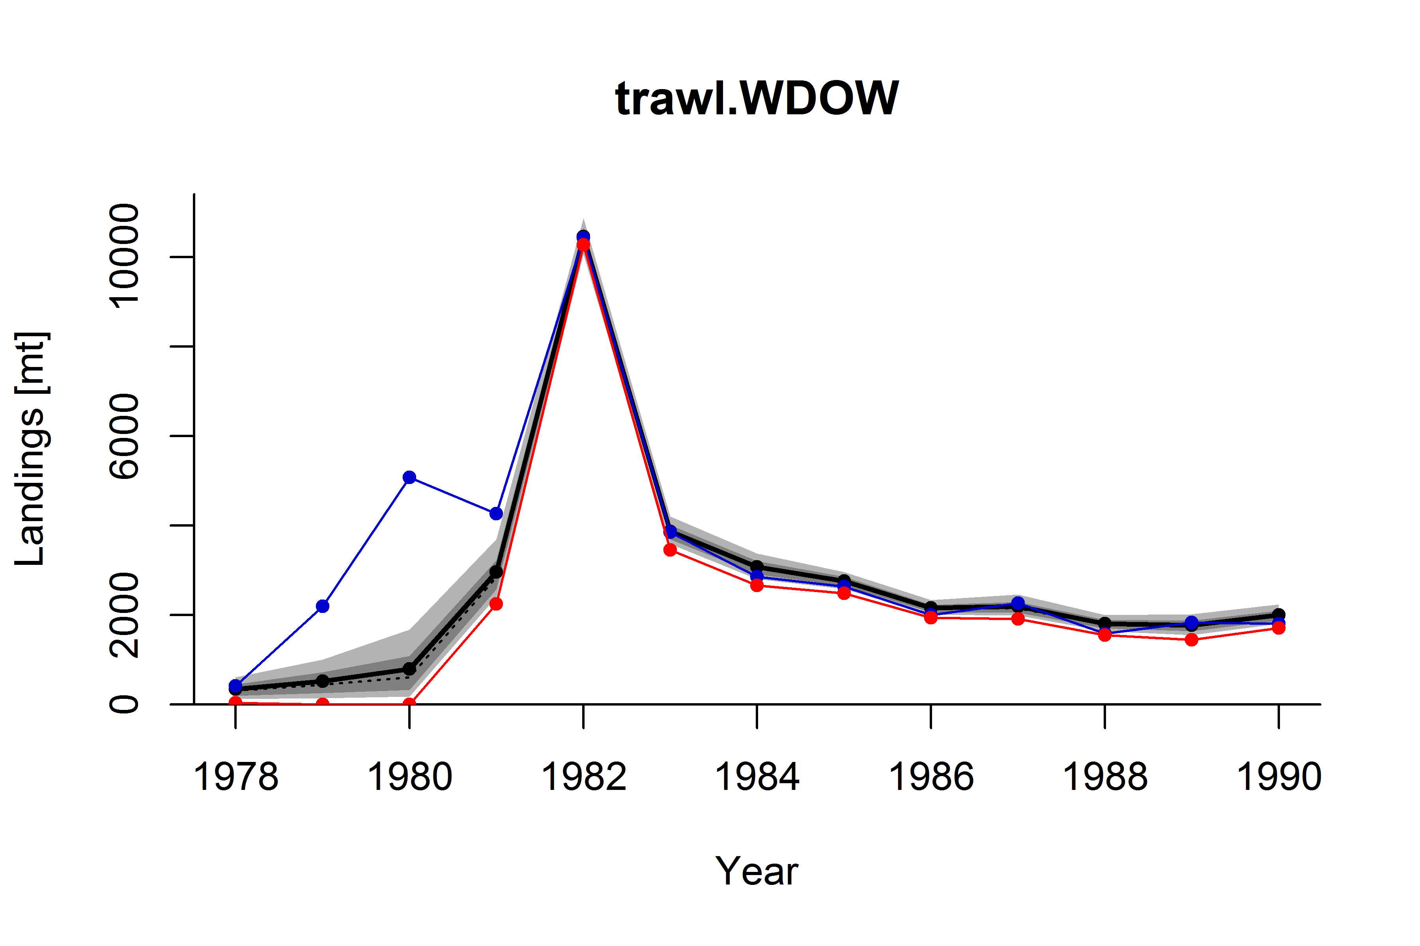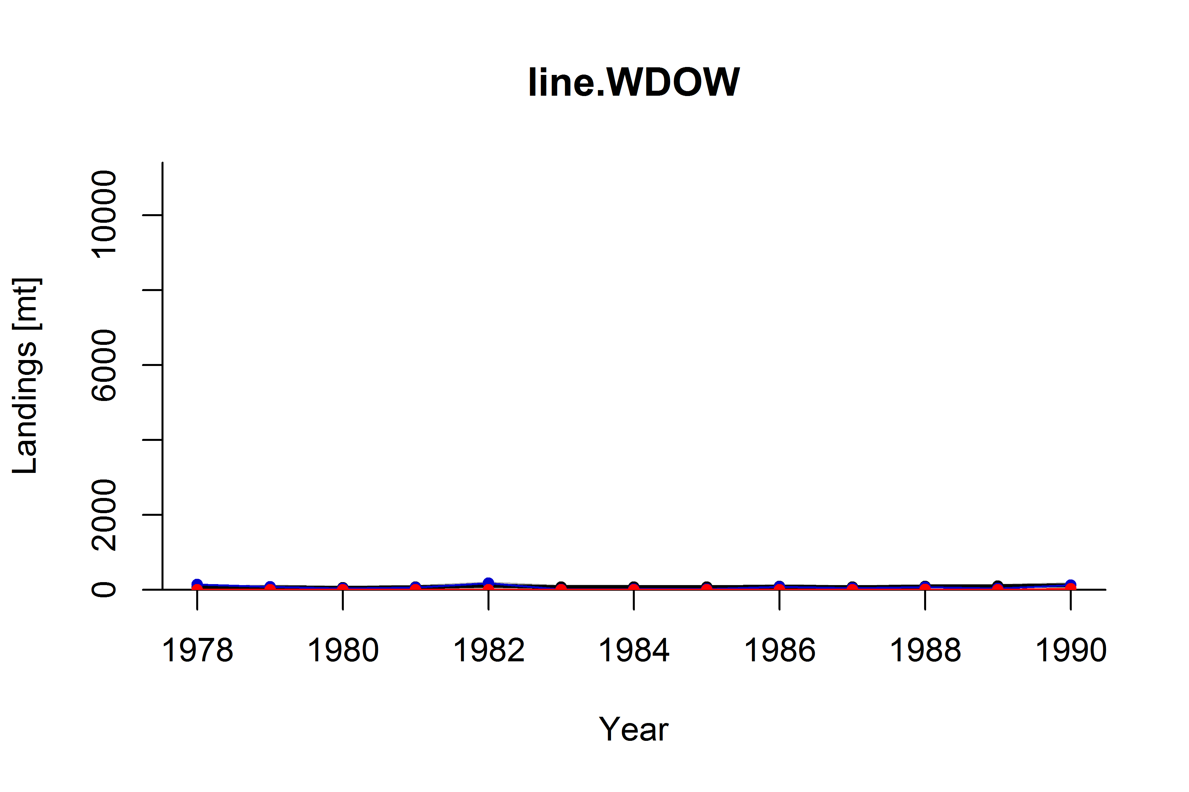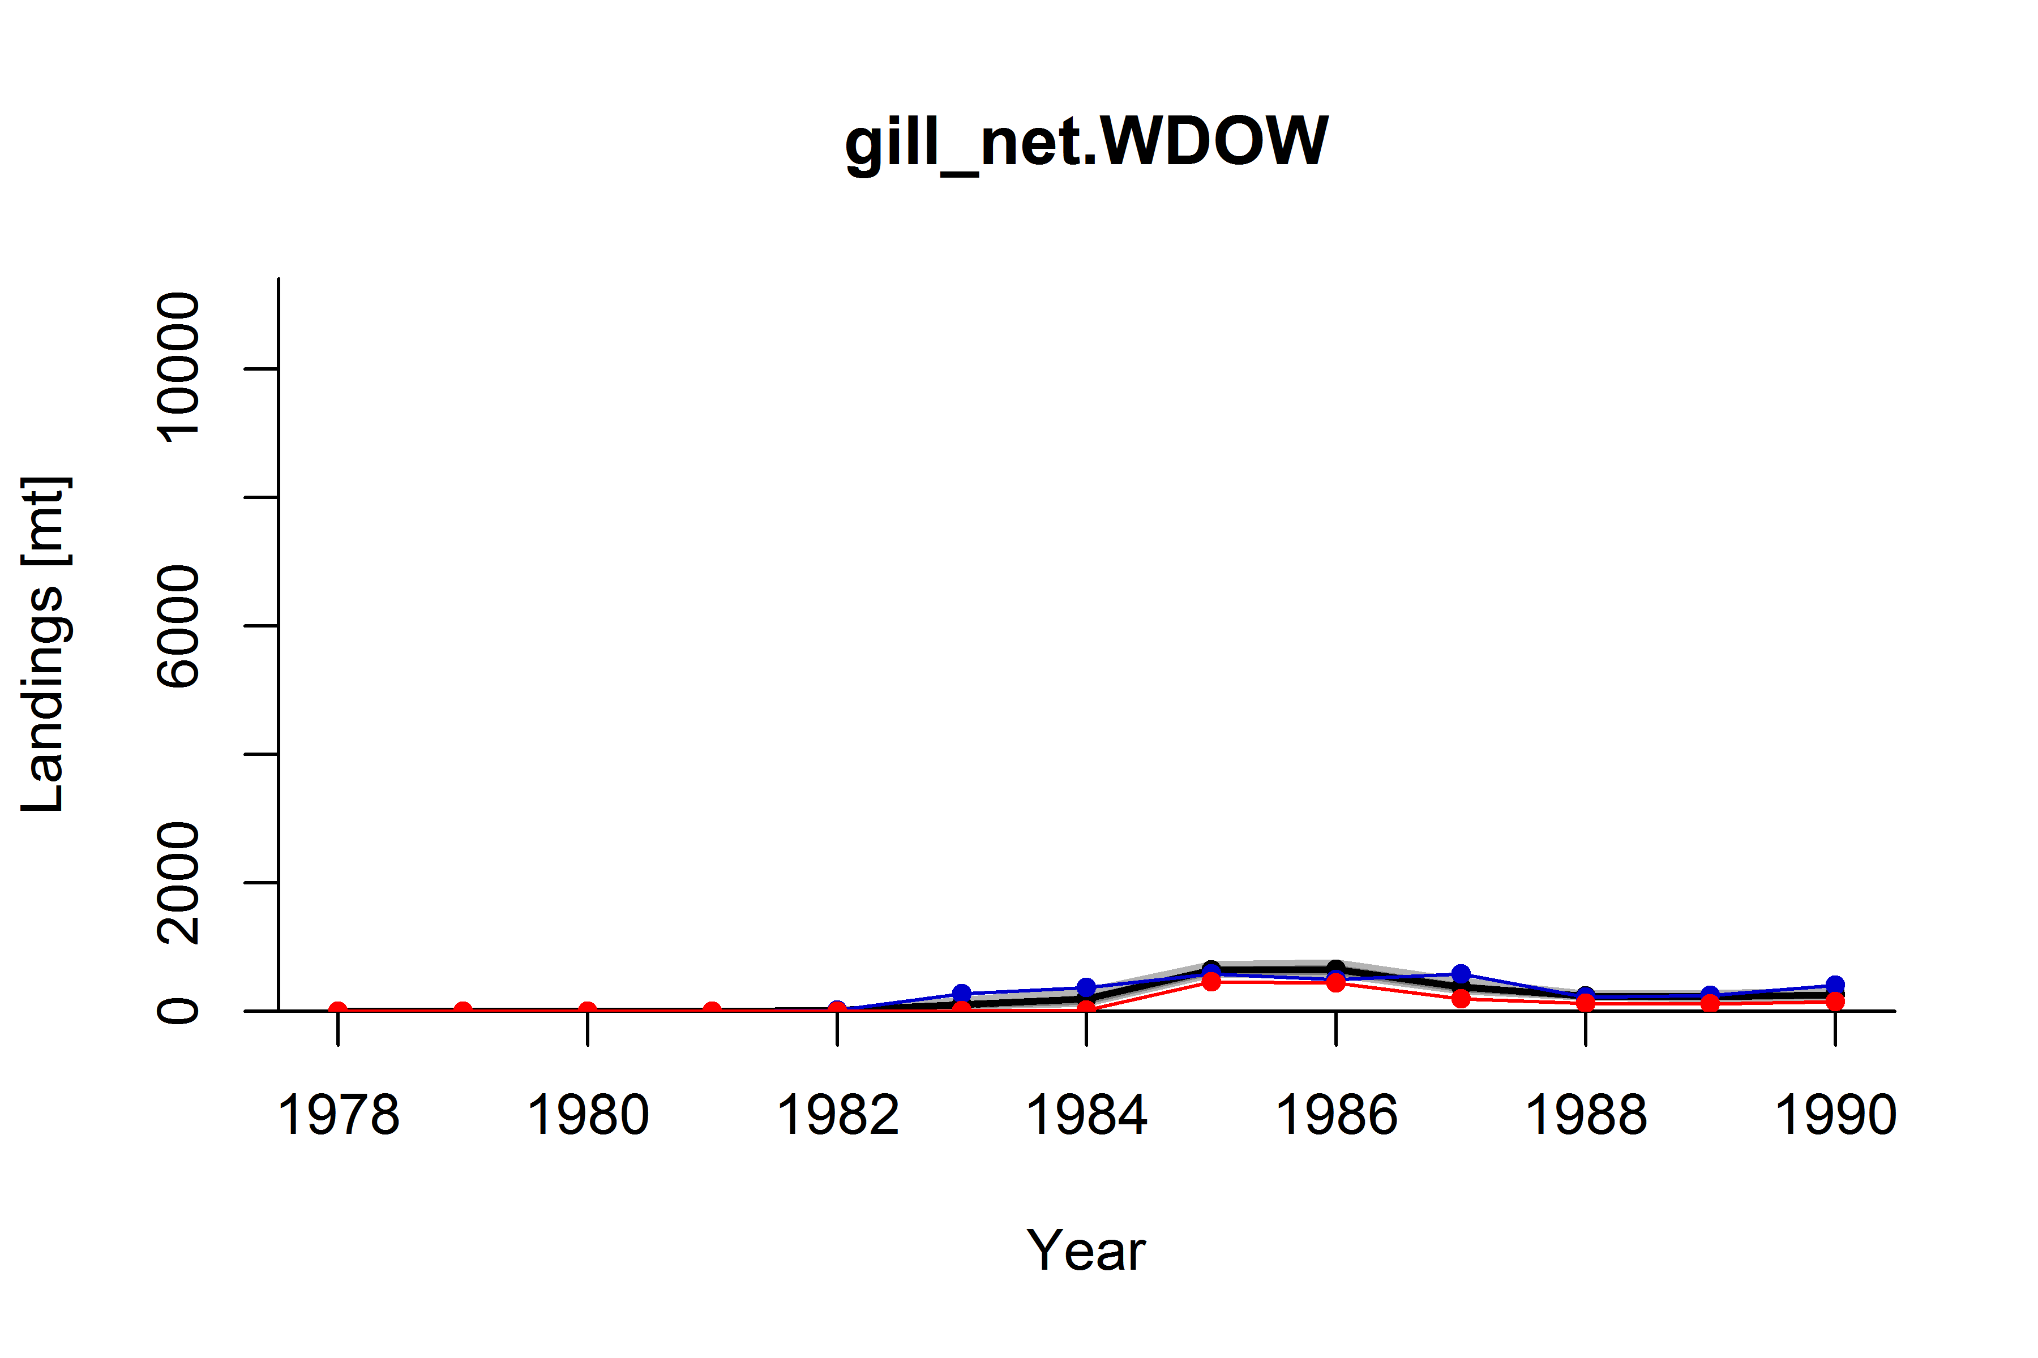

Figure X1. ComX distributions of expanded landings for Widow Rockfish (*S. entomelas*) by year and gear group. Distribution percentiles shown in grey (light grey = 10th to 90th, dark grey = 25th to 50th), along with the mean (solid black line), and median (dashed black line). Point estimates of expanded landings from CALCOM (blue line) and the nominal landings in market category 269 (“widow rockfish”; red line) shown for comparison. CVs by year and gear group are color coded as follows: CV < 0.4 (green), 0.4 ≤ CV ≤ 1.0 (yellow), CV > 1.0 (red).

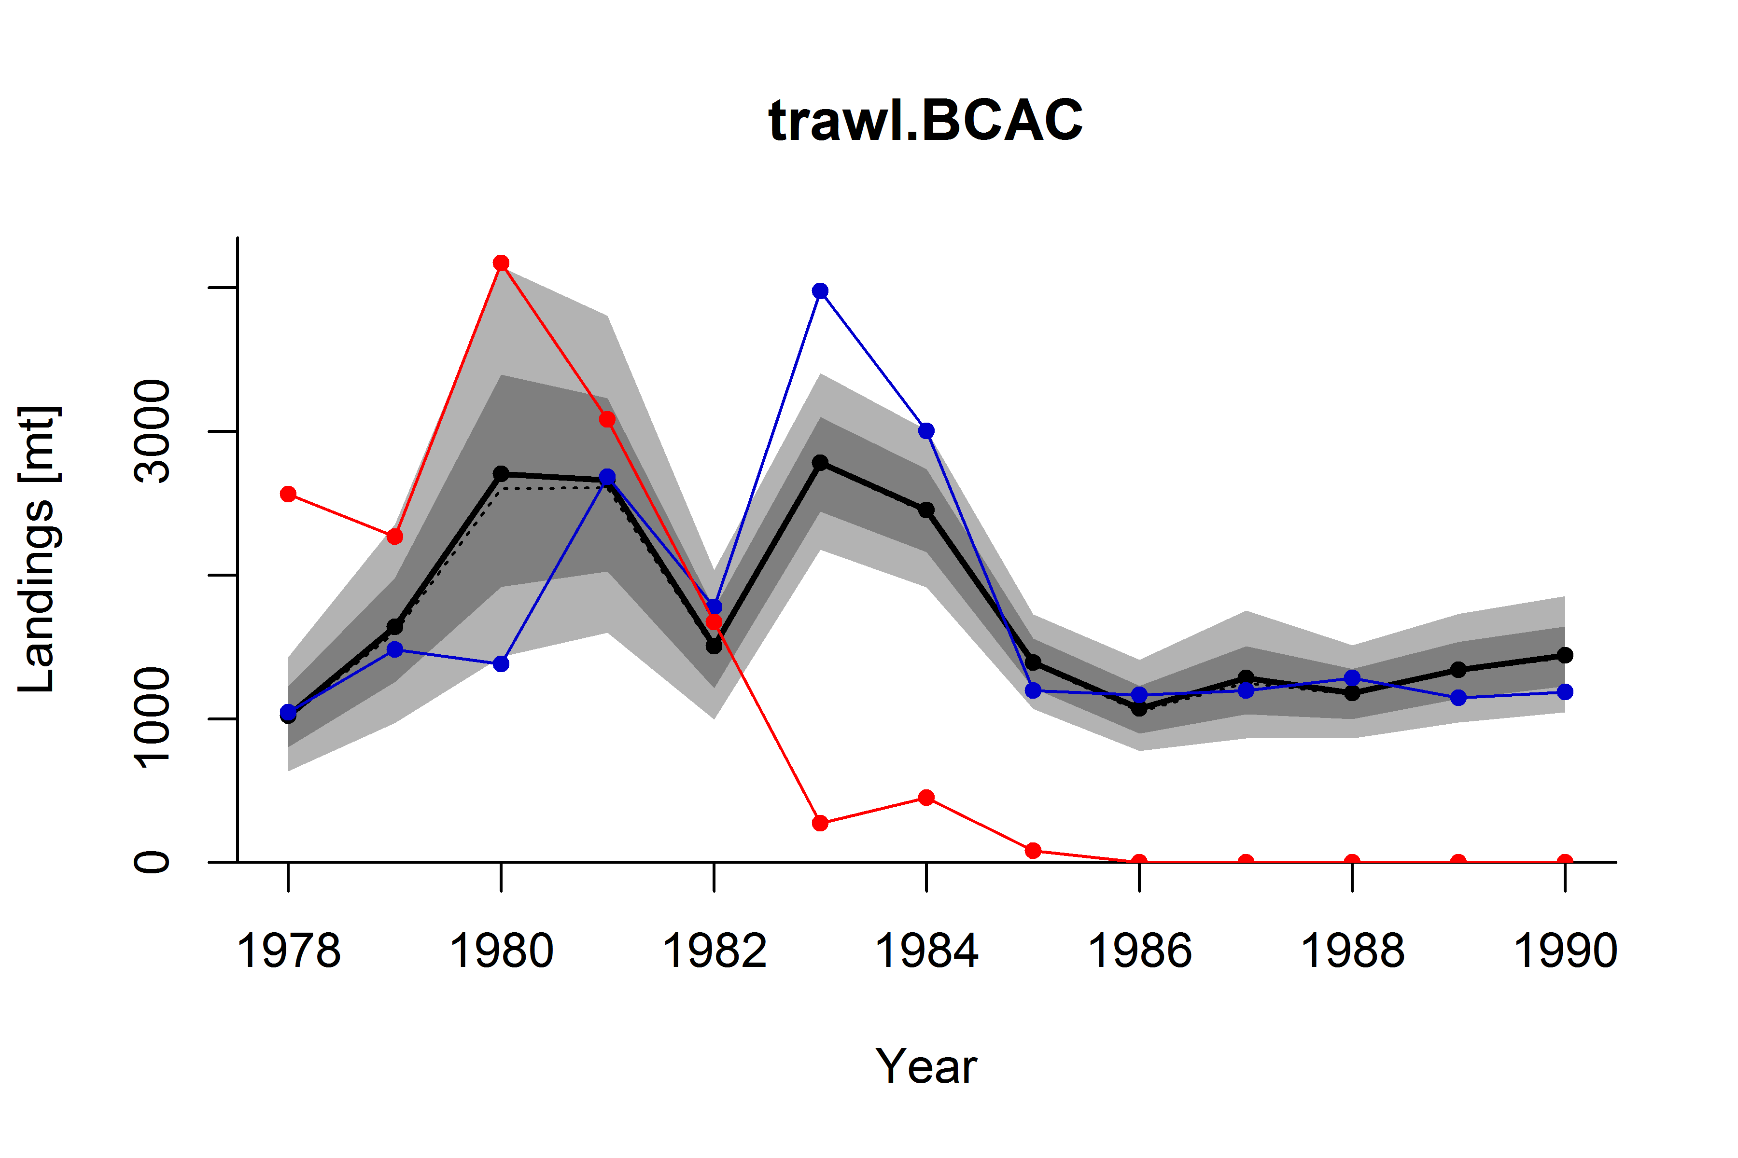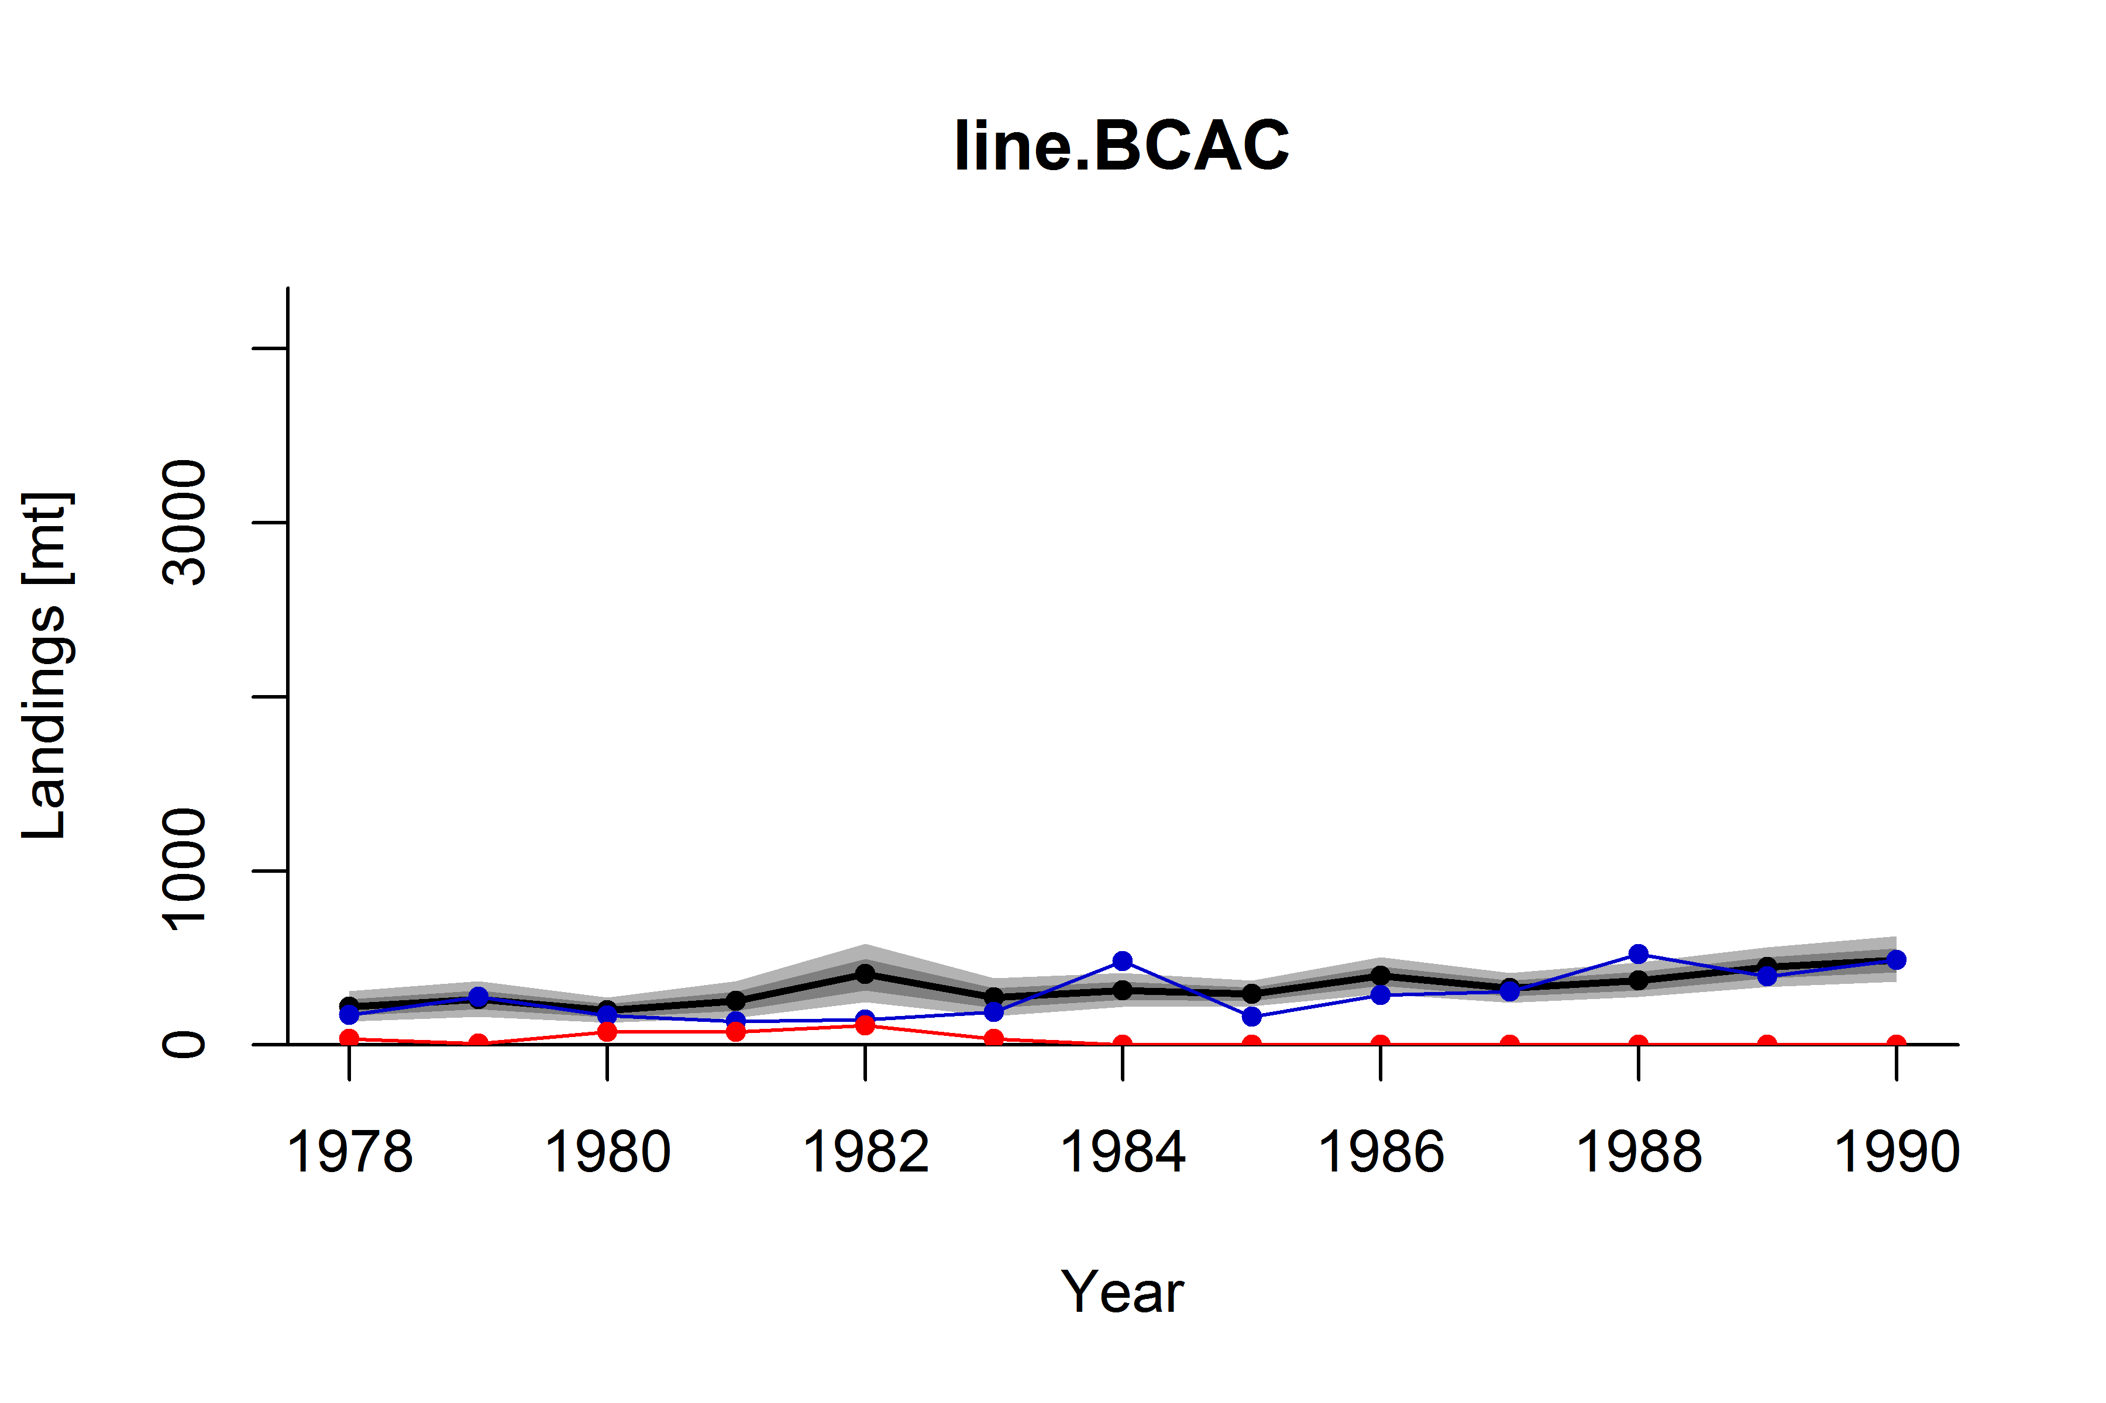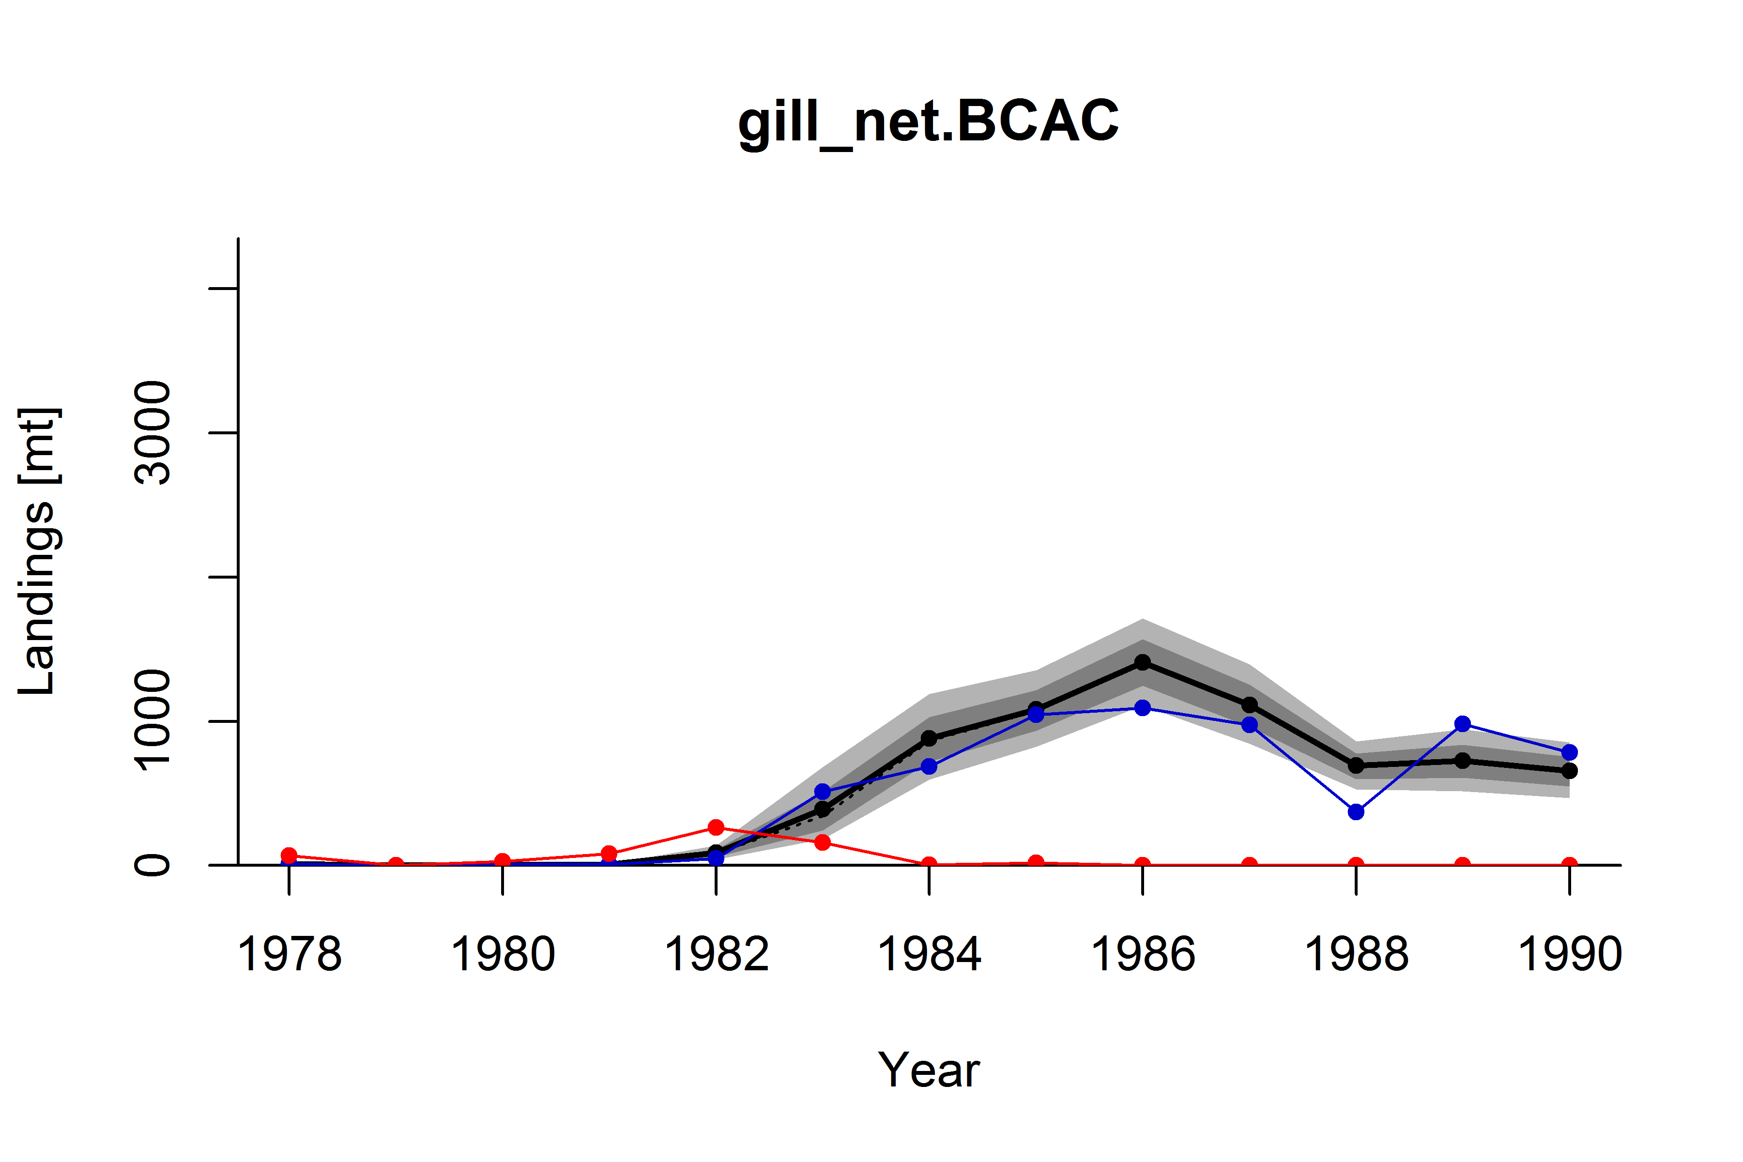

Figure X2. ComX distributions of expanded landings for Bocaccio (*S. paucispinis*) by year and gear group. Distribution percentiles shown in grey (light grey = 10th to 90th, dark grey = 25th to 50th), along with the mean (solid black line), and median (dashed black line). Point estimates of expanded landings from CALCOM (blue line) and the nominal landings in market category 253 (“bocaccio”; red line) shown for comparison. CVs by year and gear group are color coded as follows: CV < 0.4 (green), 0.4 ≤ CV ≤ 1.0 (yellow), CV > 1.0 (red).

Example caption for landings by species and year (aggregated by species):

Figure X. ComX distributions of expanded annual landings for Bocaccio (*S. paucispinis*), all gears combined. Distribution percentiles shown in grey (light grey = 10th to 90th, dark grey = 25th to 50th), along with the mean (solid black line), and median (dashed black line). Point estimates of expanded landings from CALCOM (blue line) shown for comparison.

Caption for table “CVs_by_species_and_year.png”

Table X. Coefficients of Variation (CVs) of ComX distributions for expanded annual landings by species and year, 1978-1990. Species within the black border comprise 90% of cumulative commercial landings, 1978-1990. CVs are color coded as follows: CV < 0.4 (green), 0.4 ≤ CV ≤ 1.0 (yellow), CV > 1.0 (red). See text for species codes.