Improving Catch Estimation Methods in Sparsely Sampled Mixed-Stock Fisheries.

Nick Grunloh, E.J. Dick, Don Pearson, John Field, Marc Mangel

# Abstract

Effective management of exploited fish populations requires accurate estimates of commercial fisheries catches to inform monitoring and assessment efforts. In California, the high degree of heterogeneity in the species composition of many groundfish fisheries, particularly those targeting rockfish (genus ), leads to challenges in sampling all potential strata, or species, adequately. Limited resources and increasingly complex stratification of the sampling system inevitably leads to gaps in sample data. In the presence of sampling gaps, ad-hoc species composition point estimation is currently obtained according to historically derived "data borrowing" (imputation) protocols which do not allow for uncertainty estimation or forecasting. In order to move from the current ad-hoc "data-borrowing" point estimators, we have constructed Bayesian hierarchical models to estimate species compositions, complete with accurate measures of uncertainty, as well as theoretically sound out-of-sample predictions. Furthermore, we introduce a Bayesian model averaging approach for inferring spatial pooling strategies across the over-stratified port sampling system. Our modeling approach, along with a computationally robust system of inference and model exploration, allows us to 1) quantify uncertainty in historical landings, and 2) understand the effect of the highly stratified, and sparse, sampling system on the kinds of inference possible, while simultaneously making the most from the available data.

# Introduction

Estimates of landed catch are a key component of many fishery management systems. Stock assessment models (referred to here as assessments) are often conditioned on time series of annual catch, usually under the assumption that catches are known without error. While some assessment models are able to incorporate uncertainty in catch (e.g. Stock Synthesis; Methot and Wetzel, 2013), reliable estimates of catch uncertainty are often unavailable. Without this information, assessment authors often rely on ad-hoc sensitivity analyses which may or may not be incorporated into management advice and/or fail to propagate catch uncertainty into quantities of interest to managers.

Over the past decade, the estimation of catch and associated uncertainty has become a focus for recreational fisheries in the United States (NAS, 2017). Commercial fisheries, on the other hand, are often assumed to have precise estimates of catch by species. This is due in part to the availability of landing receipts (aka fish tickets) which serve as a record of the weight of fish landed into various market categories (sort groups). As noted by Pearson et al. (2008), it is important to recognize that species and market categories are not synonymous. On the U.S. West Coast, for example, it is common for multiple species to be landed within a single market category (CALCOM 2017, PacFIN 2017). This is expected for categories that are clearly designated as mixed-species categories (e.g. ``nearshore rockfish'', or species within a particular genus or family). However, in some states, categories that are named after a single species still contain several species, to varying degrees, even after regulations require sorting into a particular category (Pearson et al., 2008). As a result, estimation of landings for a single species based on landing receipt data alone may produce biased estimates of total catch.

Fisherman, dealers, or processors typically decide how to sort species into market categories on a landing receipt. Trained port samplers intercept vessels offloading catch or during subsequent processing in order to determine the species composition of catch landed in a given market category (Sen 1984, Crone 1995, Tsou et al. 2015). These species composition data are used to partition, or distribute, the weight of landed catch in a market category across species, a process commonly referred to as catch expansion (Pearson and Almany, 1995). To estimate total landings for a single species, the expanded catch is summed across all relevant market categories. Assuming that landing receipt data are a census of the landed catch, uncertainty in total catch for a given species reflects variability in the species composition among port samples. If information is available to estimate sources of bias in the landing receipt data, e.g. underreporting, then it is possible to also incorporate uncertainty in the bias correction factors as well (Bousquet et al. 2010). In this study, we quantify sampling uncertainty for estimates of landed catch, although the modeling framework could be extended to include uncertainty or bias in landing receipt data.

Within market categories, particularly those used historically for groupings of highly speciose fockfish (Sebastes spp), the species composition of landed catch can vary spatially, temporally, by fishing gear, and catch disposition (e.g. fish sold alive or dead). These differences are attributable to many factors, including market preference, fishing behavior, regulatory constraints , and biological/ecological characteristics (e.g. spatial distribution) of the landed species. As a result, estimates of species composition for a given market category are often stratified over time (e.g. quarterly) and across other relevant strata (e.g. ports, gears, catch disposition ). Sampling programs often have limited funds, and attempts to reduce bias in species composition estimates through the introduction of additional strata comes at a cost, namely reduced precision (Cochran, 1977; Tomlinson, 1971).

On the U.S. West Coast, port sampling programs for rockfish and other groundfish allocate effort both spatially and temporally, but many domains of interest (e.g. market category, gear type, catch disposition) remain unsampled or sparsely sampled due to a proliferation of categories over time, logistical constraints, and limited resources (Sen 1986; Crone 1995; Pearson et al. 2008; Tsou et al. 2015). In California, for example, commercial port sampling effort has changed over time and space (Pearson and Almany 1995). For example, regular sampling of California ports north of Point Conception (roughly 27' N. latitude) began as early as 1978, but the more southern ports were rarely sampled prior to 1983. This allocation of effort was largely based on the statewide distribution of landings, diffuse spatial distribution of southern commercial ports, and limitations in funding for port samplers.

When no port samples are collected for landed strata and domains, species composition estimates are borrowed from other strata using deterministic algorithms based on expert opinion. These algorithms have unknown bias and precision. In contrast, model-based estimators are increasingly used to estimate quantities of interest for domains with small sample sizes and/or unsampled strata (sometimes referred to as small area estimation; Rao 2003). As a pilot study, Shelton et al. (2012) developed a Bayesian hierarchical statistical framework for estimating species compositions in rockfish market categories from trawl fisheries from a single port in California in two separate years. Their model has the ability to partially pool information among sparsely sampled strata, predicts species compositions for unsampled strata, and can be combined with landing receipts to estimate total landings by species, across market categories and other strata, along with associated estimates of uncertainty. However, their model considered hierarchical pooling only among quarters within a single year, and the authors underscored the need to better understand performance of alternative models, and to overcome issues with computation time, particularly since commercial port sampling data sets often include hundreds of landed strata spanning decades, multiple ports, gear types, and other domains of interest.

Among the U.S. West Coast states, the challenge of estimating landings for sparsely-sampled mixed stock rockfish fisheries is perhaps greatest for California. Although overall landings have historically been greater for rockfish off of Oregon and Washington, California has a greater number of commercial ports, market categories, and landed species (Pearson and Irwin 1997), with greater species diversity among ports due to the geographical range of the coast and the observation that species diversity for this genus is greatest in the Southern California Bight (Love et al. 2002 ). California also includes two major biogeographic features, Point Conception and Cape Mendocino, that are associated with different physical oceanographic conditions and biological community assemblages (Hickey 1979, Checkley and Barth 2009, Gottscho 2016), and these features are also frequently used as spatial boundaries for stock assessments and management measures. Of particular consequence to the estimation of species compositions is the proliferation of landed market categories over time, particularly during the 1990s (Figure (Sparse Data)). Sampling effort also leveled off in the mid-1990s, with a reduction in effort in the early 2000s, associated with substantial declines in total catches as well as reductions in sampling resources. The net result of increased stratification and flat (or reduced) sampling effort over time is a decline in mean sample size per stratum (Figure 1). In this situation , it is critical to understand how efforts to reduce bias (e.g. increasing the number of landed market categories) affect precision of the expanded catch estimates.

Models that take catch uncertainty into account are not new (c.f. Doubleday 1976), but most assessments on the U.S. West Coast assume catch is known without error (PFMC 2018). As a result, catch uncertainty is not propagated into management reference points. However, the implications of catch uncertainty are not limited to stock assessment efforts. In a management context, catch estimates with large (but unknown) uncertainty may cause managers to react to large, high-frequency deviations in estimated catch, and either impose unnecessary restrictions on a fishery, or mistakenly support excessive harvest. This is particularly an issue for prohibited and/or "choke" species, for which information is limited and may be based solely on estimates of discarded catch.

In this study, we evaluate the model-based framework proposed by Shelton et al. (2012) using commercial port sampling data collected in California, U.S.A. We describe species composition data collected by the California Cooperative Groundfish Survey (CCGS, 2017) over the period 1978-1990. We then extend the Shelton et al. framework to address limitations of their approach. Specifically, we evaluate alternative likelihoods to address overdispersion, compare multiple hierarchical structures for pooling information through time, and integrate model predictions across uncertainties in the spatial model structure. Finally, we estimate landed catch by species for both sampled and unsampled strata, and summarize a general framework for quantifying uncertainty including an efficient database design for dissemination of results at any level of aggregation.

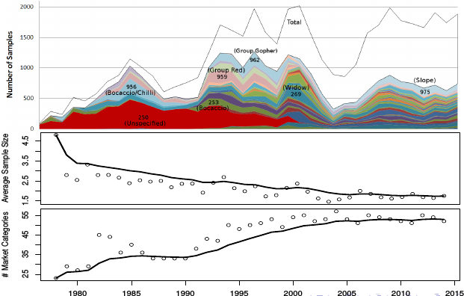

Sparce Data: Number of commercial port samples per market category in California, 1978-2014 (upper panel), average sample size per stratum (middle panel), and number of market categories recorded on landing receipts (lower panel). On the lower panels, points indicate observed values, while the black lines represent 9 year moving averages

# Methods

## Data

As outlined in Sen (1984, 1986) the data collection protocol for the species composition port sampling data, held within the CALCOM database, are the result of a design based cluster sampling procedure across the many strata of California's commercial fisheries. Each sample is intended to be composed of two fifty pound clusters selected at random from a stratum. Although port samplers do their best to follow protocol, in reality the port sampling environment does not always allow Sen's original protocol to be followed. Variations in the sampling protocol may result in only a single cluster being taken, or the size of clusters taken to vary from stratum to stratum based on the particular challenges of sampling each stratum.

Samples are recorded, by port samplers, as integer pounds for each observed species, across the landed market categories, gear groups, and port complexes in time (quarters within year). Presently there are X rockfish market categories, although not all market categories are always used by fisherman. The number of used market categories has gone from less than 25 in 1978 to about 55 in . Landings are grouped into major fishing gear groups (trawl, hook and line, gillnet, fish pot, or other minor categories) and ten major port complexes spanning the California coast.

The model based methodology proposed here does not rely strongly upon the cluster sampling structure, but rather simply views each sample as independent and identically distributed () draws from a data generating model, conditional on a parameterization of the stratification system. So long as the parameterization and data generating model are sufficiently robust for handling the behavior of these data, a conditionally model of these data will be practically useful for producing predictions about the data generating system.

That said, for the purpose of modeling these data, it is enough to know which clusters were collected as part of which samples, and how big each cluster actually ended up being. This information is readily available from CALCOM, a database maintained by the California Cooperative Groundfish Survey (CALCOM 2018). Specifically, we aggregate all observed clusters across a unique sample so that the total weight sampled is the sum of all pounds in each unique sample. Similarly the observed weight for a particular species in each unique sample is the sum of all of the observed weights, for that species, across each cluster of each unique sample.

Although model based data analysis has the potential to add significant structure to data, a judicious application of these methods must always confront the model with enough empirical information to adequately learn about the system. In this setting some market categories and time periods may not be well enough sampled to learn the parameters of the models presented here. For this reason, we refrain from modeling any period where the minimum possible number of effective parameters exceeds the number of samples for the modeled period. Rather than apply models inappropriately, these landings are speciated as the nominal species for their market category. We later demonstrate that due to prioritization in sampling heavily landed, or otherwise commercially relevant categories, this sample size heuristic leaves relatively few landings to be speciated in a statistically uninformed way (i.e. ``nominal'' speciation). Thus nominal speciation represents a negligible component of the overall expanded landings for most species.

* something about chuncking time at regulation time periods?
  + introduce idea of modeled period (mcat/time chunk)
  + a section got added later on by EJ

## Data Generating Model

For the purposes of accurately modeling not only species composition means, but also higher moments of the data, such as species composition variances, it is necessary to recognize model limitations with respect to over-dispersed data. Among the simplest models for count data are the Poisson and binomial models. Both models are typically specified with a single parameter for modeling all of the moments of the data, and thus they rely heavily on their respective data generating processes to accurately represent higher moments in the data. McCullagh and Nelder (1989, pg. 124) commiserate about the prevalence of over-dispersed data in cluster sampling, and explain ways in which cluster sampling itself may result in over-dispersion.

Extending the Poisson and binomial models to deal with over-dispersion, typically involves adding additional parameters for the purpose of modeling higher moments of the data. The negative binomial (NB) distribution is often used as an over-dispersed extension of the Poisson model, since it can be expressly written as an infinite mixture of Poisson distributions. The beta-binomial model is used as an over-dispersed extension of the binomial model.

The Poisson and binomial models attempt to model both the mean and residual variance of the data, with a single parameter for each species. By definition these models do not have additional parameters to model the variance, but rather, residual variances in these models are simply transformations their mean parameters. Only estimating the mean parameters in these cases may not be sufficient to produce models which predict well.

In contrast, the negative binomial and beta-binomial models estimate an additional parameter which can be used to disentangle the mean and residual variance estimates. Thus the negative binomial and beta-binomial models may produce more accurate estimates of the residual variance, while producing more accurate measures of center. We develop an example for a subset of data to demonstrate considerably greater statitiscal support for the beta-binomial model (Appendix B), which we have subsequently used for the purposes of applying at an operational scale.

### Full-Scale Beta-Binomial Model

For a particular market category, is the sample of the species' weight, in the port, caught with the gear, in the quarter, of year . As supported by the results in Appendix B, the are modeled as observations from a beta-binomial distribution conditional on parameters and ,

Above, is the stratum level mean weight, and is the stratum level residual variance. is related to a linear predictor, , via the mean function,

Here is the observed aggregate cluster size for each sample. Additionally, is related to and the overdispersion parameter, , via the following equation,

is the within-cluster correlation. The situation where represents identical information content among replicates within a cluster, with maximal overdispersion relative to the binomial distribution. The situation where represents totally independent information content among replicates within a cluster, and the beta-binomial model approaches the binomial model. explicitly models average overdispersion across all strata within a market category, while gives the model flexibility at the stratum level through the linear predictors,

Firstly, includes a reference level intercept (). Secondly, is factored among the many strata by additive offsets from for each of the species (), port-complexes (), and gear-groups (). Finally year and quarter parameters are indicated generally here inside the term. Several forms for are explored each implying a different prior and partial pooling strategies as described in the following section().

## Priors

To complete the Bayesian formulation of this model, priors are expressed in a largely diffuse manner.

Since the reference level is chosen arbitrarily, with no conception of which values it may take, no restrictions are placed on the value of the intercept. The species (), port-complex (), and gear-group () offsets are assigned diffuse normal priors. The large fixed values of the prior variance hyperparameters produce behavior similar to classical fixed effect models for species, port-complex, and gear- group parameters.

In returning to the time parameter model, , it is useful to consider how overparameterized models may cause overfitting and weaken model performance through the bias-variance dilemma (Ramasubramanian, K., & Singh, A., 2016). Simply put, the bias-variance dilemma means that model formulation is not simply a bias reduction task, but rather the goal is to formulate models which reduce bias, while jointly minimizing uncertainty. Janyes (2003, pg. 511) describes how the inclusion of estimation bias via the Bayesian methodology may produce better performing estimates, more quickly, than unbiased counterparts. Among the simplest ways to see the principle is in the structure of the MSE performance metric, and how it can be explicitly written to value both estimator bias and variance, as follows.

Furthermore a model can minimize bias, without regard for estimation uncertainty, by including one model parameter to be fit to each observation. These parameter estimates are totally unbiased, however such a model is also predictively useless since each estimated parameter is specifically bound to a  
particular observation, and thus such a model does not generalize.

For modeling we consider a spectrum of models which span a wide range of partially pooled models with several different predictive structures as seen below.

### (M1)

(M1) represents a fixed effects model for additive year and quarter parameters. Here each year and quarter are assigned totally independent and diffuse priors.

### (M2)

(M2) estimates two hierarchical variance parameters, and . has the effect of partially pooling information among year parameters, while partially pools information among quarter parameters (i.e. treats both year and quarter as ``random effects''). The actual degree of pooling among each of the years and quarters is determined by the data.  
Depending on the posterior distributions of and , the and may be shrunk back toward the common mean (for small ) or allowed to take largely distinct values (in the case of large estimates of the ).

### (M3)

(M3) functions similarly as (M2), in that it has hierarchical partial pooling among both the and parameters, except that it introduces a two-way interaction term between year and quarter. This interaction term allows estimates for particular quarters to differ from year to year, as opposed to the previous models in which quarters within a year are assumed to be identical from year to year.

Furthermore the are also modeled hierarchically to introduce a single variance parameter, , shared among all of the time chunks. Although this interaction term adds many parameters to the model, the shared parameter functions to shrink extraneous estimates back toward the common stratum mean.

### (M4)

(M4) simplifies (M3) by excluding year and quarter main effects. This leaves all temporal information in the data to be modeled solely by the quarterly interaction terms. This model represents more opportunity for partial pooling through time than (M3), as fewer time parameters are introduced. Furthermore all of the are hierarchically pooled back toward a single common stratum mean via the single shared variance parameter, .

### (M5)

(M5) is largely the same as (M4), but it represents slightly less potential partial pooling through its hierarchical prior variances, , on . Here interaction terms are allowed to partially pool interactions across years, within a common quarter, but since each quarter is assigned a separate variance parameter no pooling is possible between quarters.

### (M6)

(M6) follows the same idea as (M5), however here interaction terms are allowed to partially pool interactions within a common year, across the quarters of that year, but not between years. (M6) often involves fitting slightly more parameters than (M5) because, at least in this setting, it is typical to model more than four years of data at once.

Historically, regulations have been enacted with the aim of isolating catch in a market category to a single species (sort requirements). This clearly affects the composition of the target market category, but these regulations also affect the species composition of other market categories in which the target species previously occurred. We incorporate this information into the model structure by treating time periods with relatively stable regulatory conditions as independent models. In other words, information is only shared among years in which regulations were similar. For example, a sort requirement for widow rockfish (S. entomelas) was initiated in 1983, which not only affected the composition of the widow rockfish market category (xxx), but also the composition of other categories, including the unspecified rockfish market category (250). We model the first five years of available data (1978-1982) independently from the years 1983-1990. In 1991, a sort requirement for bocaccio rockfish (S. paucispinis) was enacted, which is known to have affected the composition of other categories, including the Chilipepper rockfish market category (xxx) and the Chilipepper/Bocaccio market category (xxx).

Hierarchical variance parameters are estimated from the data. As the above models learn the posteriors of the hierarchical variance parameters, it affects the degree of shrinkage as well as the effective number of parameters held within the respective hierarchies (Gelman, 2014). To achieve this, each variance parameter must itself be assigned a prior to be estimated. For all of the hierarchical variance parameters included in the above models is assigned a diffuse inverse gamma (IG) prior .

Finally the overdispersion parameter, , is assigned a diffuse normal prior on the logit scale, . The prior is indeed a symmetric, and far reaching, prior when back transformed to the unit interval. To notice this, it is helpful to realize that the central 95% interval for a (i.e. ), includes almost the entirety of the back transformed unit interval (i.e. ).

Each of models M1-M6 are fit to data from 1978-1982 in market category 250, with Table() guiding the use of model (M4) for the duration of the study.

## Species Composition Prediction

Bayesian inference of the above models gives access to the full posterior distribution of all of the parameters of the model given the data. It is useful to emphasize that in the Bayesian setting, these parameters have full distributions, and they are typically handled as a large number of samples from the joint posterior distribution of the parameters. Once the posterior sampling is complete, this simplifies parameter mean and variance estimation; required moments are simply obtained by computing the desired moments from the posterior samples. Additionally, the fact that the parameters are full distributions means that any functions of those parameters are themselves random variables with the function representing a transformation of those parameters.

To obtain predicted species compositions from this model, first consider the posterior predictive distribution of sampled weight for a particular stratum.

Here BB is the data generating beta-binomial distribution for a predictive observation and is the posterior distribution of the parameters given the observed data. Integration of the parameters, and , is done by Monte Carlo integration to obtain samples from the predictive distribution, , for sampled weights in the stratum.

Obtaining predictive species compositions from predictive weights amounts to computing the following transformation,

For a particular market category, is predicted proportion of species in the port, caught with the gear, in the quarter, of year .

## Expansion

For a particular market category, speciated landings simply amounts to the multiplication of the known total landings (), reported on landing receipts in the stratum, with the posterior predictive , as follows

is then the posterior predictive landings for species in the stratum of a particular market category. Recall that since is a random variable, then so is . Computing the variance of simply amounts to computing the variance of random draws from the distribution. Furthermore, any level of aggregation of is easily obtained by summing draws across the desired indices. For example to obtain the distributions of yearly catch of Bocaccio in a particular market category, one simply sets , and computes the following transformation of ,

.

Distribution summaries such as quantiles, means, or variances may be computed by computing those metrics from the random draws of the resulting distribution.

## Model Exploration & Averaging

Presently, strata with diminishingly small sample sizes are managed by an ad-hoc "data borrowing" protocol, as outlined in Pearson and Erwin (1997). The protocol for "data borrowing" calls for pooling only when forced to fill holes brought about by unsampled strata. Naturally, such a pooling protocol introduces bias to fill in unsampled strata, however due to the mathematically unstructured way in which this bias is introduced, it is hard to quantitatively justify these "data borrowing" rules.

Model (M4) avoids temporal ad-hoc "borrowing" protocols described in Pearson and Erwin (1997) by making use of its hierarchical structure to fill temporal holes with a posterior predictive distribution for unseen time periods within the modeled period. This hierarchical structure uses the data to estimate the degree of pooling through time, rather than ad-hoc "data borrowing".

Despite the benefits of modeling these data as Bayesian hierarchical models, port sampling data still remains sparse. Given the degree of sparsity in these data it is certainly possible that models which consider an additional degree of data pooling between port complexes may offer predictive benefits. In exploring strategies for pooling data across space it is necessary to formalize the port complex pooling scheme in a way which provides a mathematically understandable and scalable structure to build upon.

Given the spatial structure, and complex behavior of, port complex parameters, the typical zero mean hierarchical regularization priors are not appropriate among port complexes. Pooling across spatial categorical parameters in this setting requires the ability to pool port complex parameters back toward an unknown number () of mean levels. Rather than hierarchically regularize port complex, we frame port complex pooling as a model uncertainty problem, in which we consider some degree of full pooling among port complex, but the exact degree of pooling, and the particular partitioning of the pooled port complexes are not known.

Port complex pooling is achieved by repeatedly fitting model (M4) with different partitionings of the port complex variables within a particular market category and modeling time period. This model exploration exercise explores the possible ways to produce groupings of the existing port complexes so as to discover predictively useful partitionings of the port complexes. Insisting that the port complex groupings be partitions of the available port complexes provides a well-defined mathematical structure for exploring the space of pooled port complexes.

The size of the space of possible pooled models is in the setting is well defined in terms of the size of the set of items to be partitioned, , as given by the Bell numbers (),

In the case of California the set of items to be partitioned is the set of port complexes in California, of which there are , implying a grand total of ways of partitioning the port complexes in California in each market category and modeled time period. The brute force model selection strategy of computing all 115975 of these partitionings strategies is computationally infeasible. However, not all pooling schemes represent biologically relevant models. For example, it is likely reasonable to pool only among adjacent ports (i.e. no discontinuities between port complex pooling in space) due to species distributions and the presence of biogeographical provinces, and it may be similarly reasonable to assert that similar regions can only extend across a small number of ports.

Here only adjacent port poolings are considered, such that the maximum size of a port complex grouping is three port complexes. These are the only two constraints that are enforced on port complex partitions here, although many other constraints may, in theory, be chosen. These constraints were chosen so as to mirror the currently accepted protocols in Pearson and Erwin (1997) within the context of this framework. When these two simple constraints are applied, the number of models to explore in each modeled period is reduced to a much more manageable 274 models.

An exhaustive search of the models in the constrained subspace of , allows for a concrete comparison of the relative predictive accuracy of each partitioning. Additionally the partitioned models provide a set of candidate models for use in Bayesian Model Averaging (BMA) (Hoeting et al., 1999). BMA, as applied here, allows the model exploration strategy to average models across all potentially relevant partitions of the port complexes, so as to add robustness to final species composition estimates.

For the model in a set of candidate models , then the BMA weight for follows directly from Bayes Theorem as,

Where is the posterior probability that model is the true data generating model of the data, conditional on the subspace of candidate models and the observed data. is then straightforwardly used to average posteriors across all of the models, as

# Results

## Characteristics of the Landings Data

In the two time periods examined here, Figures (bar78) and (bar83) show how commercial port sampling effort tracks both total landed weight as well as the number of species in each market category. Comparable figures for the periods 1991-1999 and 2000-2015 are provided in Appendix (bars), although we have not yet completed modeling for these time periods. It is important to notice that since port sampling effort prioritizes heavily landed market categories, and our model is only fit to market categories with more data than parameters, then market categories left with too few samples to fit our model tend to be less landed. Thus our model is applied to a relatively large proportion of the landings and nominal speciation occurs for a relatively negligible proportion of total landings. Applying the sample size heuristic to determine which market categories are expended by our model results in 96.8% of landed weight being expanded via our model in the 1978-1982 time and 98.3% of landed weight expanded by our model in 1983-1990.

The lower panels of Figures (bar78) and (bar83) demonstrate just how many different species are landed into commercially relevant market categories. Although market categories often carry names that label them with a nominal species, Figure (bar78) makes it abundantly clear that these names can mislead our thinking about the purity, and consistency, of these categories through time. To drive this point, consider the sampled species in market category 267 in 1978-1982. The nominal label for market category 267 is Brown Rockfish, while Brown Rockfish only amounts to a small fraction of that category in 1978-1982. In fact, only 6.3% of the sampled weight in 1978-1982 consisted of Brown Rockfish. In 1978-1982 market category 267 might be better named Widow Rockfish as Widow amounts to 92.6% of sampled weight in this time period, however market category 267 is composed of 99.6% Brown and 0% Widow in recent time periods (see Appendix X Figure (bars)).

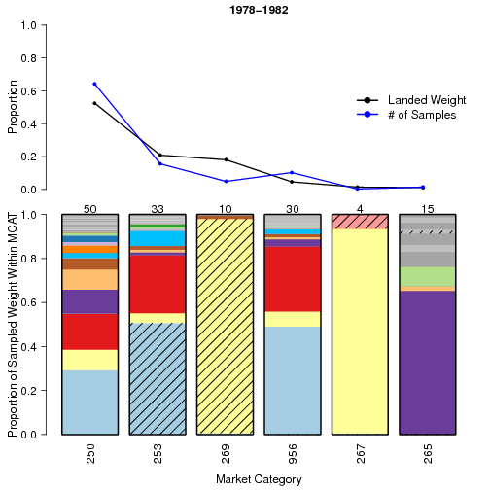 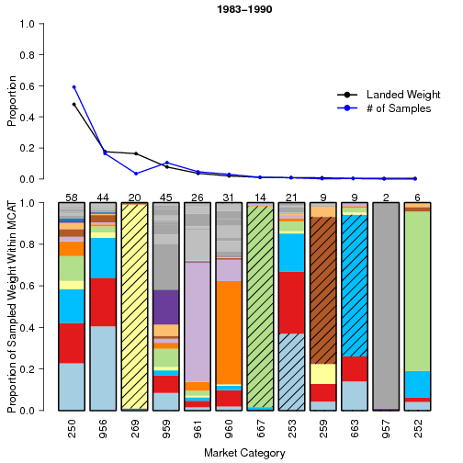 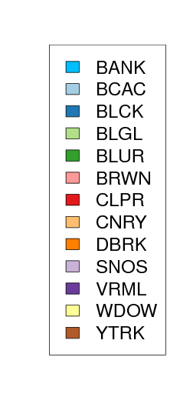

## Predictor and Prior Selection

|  |  |  |  |  |  |  |
| --- | --- | --- | --- | --- | --- | --- |
|  | M1 | M2 | M3 | M4 | M5 | M6 |
| MSE | 0.127245 | 0.127042 | 0.126801 | 0.122373 | 0.127236 | 0.126573 |
| DIC | 2558.56 | 2259.94 | 2013.21 | 0 | 2175.32 | 2174.71 |
| WAIC | 2562.65 | 2263.58 | 2009.32 | 0 | 2171.18 | 2170.56 |
|  |  |  |  |  |  |  |

Table displays the result of fitting models M1-M6 to data from 1978-1982 in market category 250. Recall models M1-M6 differ in the structure of the time parameters. Table shows the relative support for those model structures. From M1 to M4 the models represent a spectrum of models with an increasing potential of shrinkage among time parameters. Models M5 and M6 represent models which build in complexity, from M4, via the inclusion of multiple hierarchical variance parameters among the interaction terms.

Across all of the time models, model M4 displays consistent support over all other candidate models considered here. It is worth mentioning that among all of the models considered here, (M4) offers the largest potential for hierarchical partial pooling among the time parameters. Model M4 represents a model with maximal potential for pooling through time, while still maintain the ability to model differences in seasonality from year to year.

## Model Exploration & Averaging

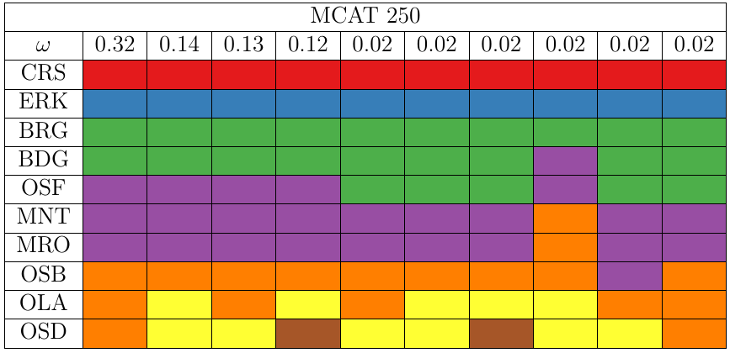

model selection: 1978 to 1982

Figure shows the results of port complex model selection for the modeled period from 1978 to 1982 in market category 250. Along the top, BMA weights for the top 10 models are displayed (each column is a distinct model). The following ten rows indicate the ten port complexes in California, and the colored cells indicate how port complexes are partitioned in each model.

Considering Figure, the best partitioned model (first column, ) gives distinct parameters to CRS and ERK, while pooling BRG/BDG, OSF/MNT/MRO, and OSB/OLA/OSD. This model uses five parameters to model the ten ports complexes in California. Given the set of candidate models explained above, the BMA procedure weights this model at approximately 32% of the truth. Notice that the only difference among the top four models is in how the port complexes south of Point Conception are handled. In fact, the seven northerly port complexes are identically partitioned in the top four models, which also represent all of the possible partitionings of the southern three port complexes.

In this modeled period it is known that no species composition sampling was done south of Point Conception, thus it is not surprising that these models perform similarly. When no data is present, parameters simply represent place holders for out of sample prediction. Since the port complexes south of point conception are not informed by data, the predictions are identical in these categories. Since the first model makes identical predictions to the following three, and does so using the fewest parameters, it is correctly identified as the most parsimonious explanation among these data.

Considering how the top four model configurations share identical structure in the seven northerly port complexes, while exhaustively spanning the candidate partitions south of Point Conception, it is simple to see that BMA assign's approximately 71% marginal probability to the northerly model structure.

The results shown here only represent a single market category across the time period 1978-1982. Similar results for other market categories and time periods are provided in the appendix Figure.

## Prediction

Repeatedly fitting model (M4) across port complex configurations and applying the BMA procedure, ultimately provides access to posterior predictive distributions of the species compositions () within a market category and time interval modeled period. A straight forward way to evaluate the performance of the model in each modeled period is to compare the predictions of the model in each modeled period with the actual observations of species compositions from port samplers.

We evaluate species composition posterior predictive distributions via HDI at three levels containing 68%, 95%, and 99% of posterior predictive probability. Table shows the proportion of observed species compositions which existed within the HDI across all strata, of each prediction level, in each modeled period. For example, observed species compositions for market category 250 in the 1978-1982 time period fell within the 68% HDI of the posterior predictive distribution 67.1% of the time (Table X).

### 78-82

|  |  |  |  |
| --- | --- | --- | --- |
|  | 68% | 95% | 99% |
| 250 | 67.1% | 96.1% | 98.7% |
| 253 | 67.3% | 96.3% | 98.9% |
| 262 | 67.4% | 93.8% | 95.3% |
| 265 | 69.6% | 96.0% | 97.8% |
| 269 | 68.2% | 88.8% | 90.2% |
| 270 | 68.6% | 93.6% | 96.7% |
| 956 | 68.3% | 96.7% | 99.2% |
| 959 | 68.5% | 96.3% | 98.1% |
| 961 | 69.3% | 93.2% | 95.3% |
| AVG | 68.3% | 94.5% | 96.7% |

### 83-90

|  |  |  |  |
| --- | --- | --- | --- |
|  | 68% | 95% | 99% |
| 245 | 60.8% | 94.9% | 97.7% |
| 250 | 68.1% | 96.0% | 99.0% |
| 253 | 69.3% | 97.1% | 98.9% |
| 259 | 83.8% | 91.9% | 92.9% |
| 262 | 68.5% | 95.1% | 95.9% |
| 269 | 68.6% | 94.2% | 94.7% |
| 270 | 67.9% | 94.2% | 96.7% |
| 663 | 68.1% | 94.1% | 96.3% |
| 667 | 69.4% | 92.5% | 93.5% |
| 956 | 67.5% | 96.2% | 99.0% |
| 959 | 67.4% | 96.4% | 99.0% |
| 960 | 68.0% | 96.1% | 98.6% |
| 961 | 68.6% | 94.6% | 97.8% |
| AVG | 68.9% | 94.9% | 96.9% |

Table largely shows that the observed proportion of predicted samples aligns appropriately with the predictions made by the model. Considering the average performance across market categories at each prediction level, it appears that prediction is mostly appropriate with the possible exception of the 99% prediction level. The 99% prediction level appears to slightly under-predict on average, indicating that predictive distributions are slightly lighter in the far tails than the data.

## Nuisance Parameters

### 78-82

#### 

#### 

### 83-90

#### 

* high in 259 and over prediction in 259?
* lower rho might predict more appropriately?

#### 

* Degree of smoothing (hierarchical parameters, rho)
* Report mean/variance of example
* Add and tables across all runs

# Discussion

## Modeling

Models that can incorporate catch uncertainty are not new (c.f. Doubleday 1976), but estimates of uncertainty in commercial landings are rarely made available, at least on the U.S. West Coast. Previous research has focused on discarded and biased (under- or over-reported) catch. Bousquet et al. (2010) developed a model-based framework for estimation of catch and associated uncertainty when underreporting is an issue. Their results included a reduction in precision of management quantities.

The model based statistical framework allows tremendous flexibility in accounting for a dynamic port sampling program. Market forces, regulation changes, and fisherman behavior are a few factors, among the many, which complicate the task of spaciating commercial catch. Unlike a purely sample-based statistical framework, model based statistics allows analysts to quickly explore a wide range of hypotheses for estimating species compositions. The models entertained here manage to achieve generally well behaved predictive accuracy (Tables pred78 and pred 83), however these models are by no means perfect. The models presented here simply offer a few fundamental improvements toward estimating species compositions.

Among the largest structural changes improving from the Bayesian methodology in Shelton et. al. (2012) is the recognition of overdispersion in port sampling data. In the absence of highly predictive covariariates, modeling overdispersion in port sampling data remains an important modeling consideration. Moving forward, modeling decisions will require a careful consideration of predictive accuracy and bias/variance trade-off, so as to tease better and better performance out of further models. The models presented here offer a great operational starting point and provide a basic framework for further model exploration.

The Bayesian models presented here provide easy access to estimates of uncertainty in commercial catch, at any aggregation of the stratification system. Making posterior predictive draws from these models widely available, allows scientists the flexibility to easily compute whichever derived distributions or distributional summaries that follow from this general modeling approach.

## Data

Due to observed trends in the sampling of more heavily landed, or specious, market categories, the vast majority of commercial landings from 1978-1990 are able to be expanded by our model. Moving into the modern era, regulation changes including the start of the live fish fishery, and the proliferation in the number of market categories, due to mandatory sort requirements, may challenge species composition estimation. However, due to the increased number of strata that these changes introduce, uncertainty estimation for these time periods will prove to be critical. Without a matched increase in sampling effort, alongside increased stratification, the number of samples per stratum falls dramatically and species composition estimation may well become very uncertain.

Given a data sparse setting, model-based strategies of catch estimation provide the best chance of a full statistical treatment of available data. However, a more informed path forward involves either increasing sampling effort, or a simplification of the stratification system. Either of these changes provide models with more data to better infer parameters. Model flexibility and justifiable stratum pooling strategies, will become vital for modeling data-sparse time periods. Although estimates are likely estimable in these sparse time periods, as pooling strategies become more extreme, model fit will suffer as both bias and variance estimates increase.

## Future Effort

Future effort in developing models should include an exploration of the effect of preferential sampling toward heavily landed stratum. The model-based approach makes testing this hypothesis straight-forward, as the hypothesis may amount to the inclusion of a single slope parameter, in the linear predictor, regressing on landing size. Given the current model's agreement with existing data, ?as well as comlands estimates?, it is unlikely that landing size has an important predictive effect on estimates, however without testing the hypothesis, we can not say whether the effect will prove to be explainitory.

In an attempt to add further flexibility to the models presented here, exploring the posibilty of gear-species interactions, as random effects, may prove fruitful. Furthermore the inclusion of random vessel effects may also find support.

Finally, further large changes to the methods proposed here might include a true multivariate handling of the likelihood. The Beta-Binomial univariate model, used here, suggests that the multivariate Dirichelette-Multinomial extension might be a good model for these data. We have yet to get these models to practically compute, although they would likely impose much needed, and appropriate, structure across the many species of this system.

The BMA procedure presented here adds significant robustness and pooling potential to our species composition estimates, however it does so at a substantial computational cost. We have found ways (through parallel computation and constraining the model search) to make the computation tractable, however the solution is far from elegant. By using Dirichelette process Bayesian nonparameteric models, among the port parameters, a far more elegant, exhaustive, and potentially computationally cheaper model search may be possible.

## ?? Misc. Other ideas ??

* Sen (1986)
  + Recommended a minimum of 4 samples in each category (MC, gear, live) within a port-month stratum, roughly 52 samples per year. Redirect sampling to infrequently landed categories until 4 samples are obtained.
  + An increased number of categories increases the chance that a category will be missed by samplers.
  + Boats are first stage samples within a stratum, with clusters used to avoid sampling bias due to non-random sampling
* Sort requirements do not eliminate the need for port sampling.
* The proliferation of market categories over time in the sampled catch has not been matched with an increase in sampling effort, effectively reducing the average number of samples per category over time (Figure X). This reduces precision of catch estimates, increases uncertainty in stock assessment outputs , and impedes efforts to monitor removals relative to catch targets.
* Fishermen and Dealers determine Market Categories for landed catch; issue with sampling can't get all categories; describe problem; sort requirements used to increase proportion of a particular species in a given market category, but other species are still landed in these categories (e.g. bocaccio in Figure X); can improve precision of important targets, but is not practical for large numbers of species; even for major targets, DOESN'T ELIMINATE THE NEED FOR SAMPLING; cite example of Dover sole rex sole is small fraction, but of a HUGE landing; decline in sampling effort; need for model-based approach to impute missing strata; current approach is ad-hoc.
* Statistical framework; focus of estimation is the total landed catch, in weight, of a single species; extend Shelton et al. (20xx); model-based allows for imputation, small-area estimation (Fey and Harriott); model selection based on predictive criteria; model averaging to account for model uncertainty; quantifies uncertainty.
* Model-based approach is best course of action given sparse data, but best solution is to increase sampling or reduce the number of strata.
* Recommend cost/benefit analysis to help identify optimal number of market categories given management goals.

# Appendix

## Appendix A

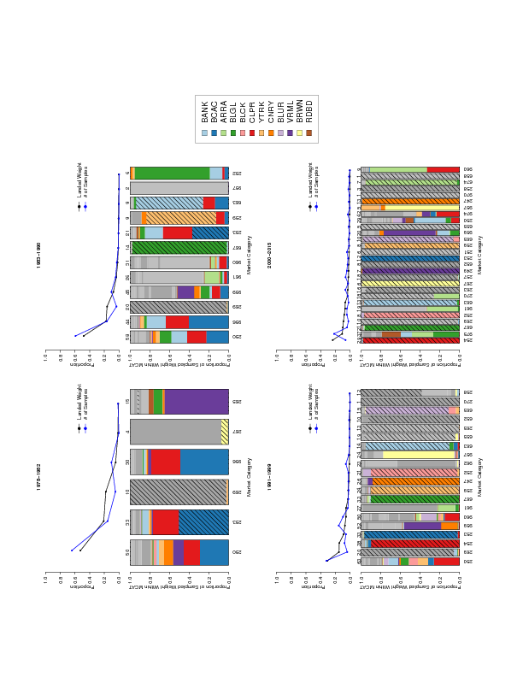

## Appendix B: Subset Motivating Example

To discern between these discrete modeling options we considered Poisson, binomial, negative binomial, and beta-binomial models fit to a subset of the  
data from market category 250, in the Monterey port complex trawl fishery for the second quarter of 1982. This stratum was selected as a relatively data rich setting, although other stratum produce similar results. This stratum was visited 32 times by port samplers, collecting a total of 59 cluster samples across 55 unique species. For brevity, in this example, we only consider the six most prevalent species (BCAC, CLPR, WDOW, YTRK, BANK, STRK).

Simplified models under each of the discrete likelihoods, metioned above, are fit to the subset data.

Here takes the form of each of the considered Poisson, binomial, negative binomial, and beta-binomial models, represents the fixed species parameters, and is included to generally represent the nuisance parameters for modeling overdispersion in the negative binomial, and beta-binomial models.

|  |  |  |  |  |
| --- | --- | --- | --- | --- |
|  | Poisson | Binomial | NB | BB |
| MSE | 0.06412 | 0.06264 | 0.05171 | 0.04479 |
| DIC | 1001.41 | 1230.60 | 5.03 | 0 |
| WAIC | 1079.95 | 1323.75 | 3.43 | 0 |
|  |  |  |  |  |

Table(likelihood) shows Mean Squared Error (MSE; computed on the species composition scale), delta deviance information criterion ( DIC), delta widely applicable information criterion ( WAIC), and marginal Bayesian model probabilities () across the likelihood models fit. These measures span a wide range of model selection philosophies and yet here they all consistently agree in ranking the likelihood models.

Table() show a clear preference for the overdispersed models (NB and BB), with the most overall support for the beta-binomial model and the Poisson model showing the least support. This initial result guides the use of the beta-binomial data generating model for the purposes of building a model to apply at an operational scale.

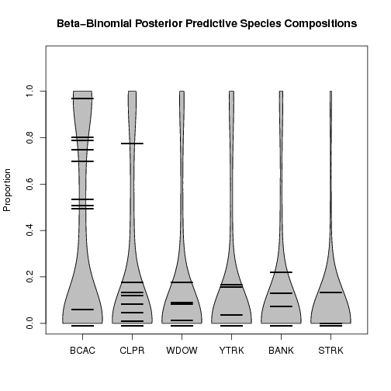

Violin Plot

Figure(violin) shows the beta-binomial predictive distributions as a violin plot, with the observed species compositions, from port sampling, plotted atop each density. Figure(violin) demonstrates how the beta-binomial model distributes predictive density over the unit interval. Species composition is bounded on [0, 1], thus in the presence of large variability, predictive density may aggregate around the bounds.

Figure(Interval Plot) visualizes the predictive species composition distributions as 95% Highest Density Intervals (HDI) (colored vertical lines), plotted on top of the predictive means for each model and the observed species compositions (black horizontal lines) from the data in Figure().

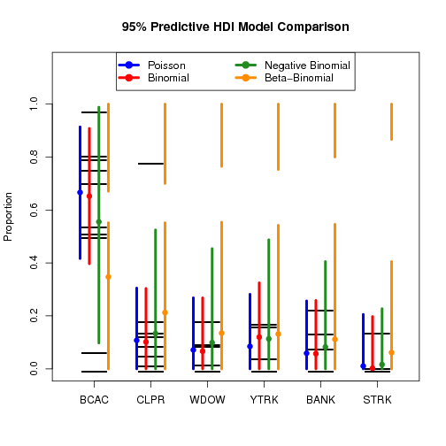

Interval Plot: The predictive species composition distributions as 95% Highest Density Intervals (HDI) (colored vertical lines), plotted on top of the predictive means for each model and the observed species compositions (black horizontal lines) from the data

The large spread of the observed species compositions seen in Figure(Interval Plot) visually demonstrate the degree of overdispersion present in port sampling data. The Poisson and binomial models disregard this overdispersion to prioritize fitting the data mean. The NB and BB models explicitly model overdispersion in the data, and as such they predict a larger subset of the data. Notably, only the intervals produced by the BB model include the low observed proportions of bocaccio (BCAC) and the high observed proportion of chilipepper rockfish (CLPR) in this example.

The split beta-binomial intervals seen in Figure(Interval plot) reflect a large amount of residual variability confined on the unit interval. The beta-binomial is the only model considered here, that estimates such a large degree of variability and thus it is the only model that produces predictive species composition distributions that effectively cover the range of observed species compositions. The predictive intervals in Figure(likelihoods) are the smallest possible regions on each of the densities visualizes in Figure (Violin) so that each intervals contain 95% probability. For the example of STRK, notice that although the predictive HDI in Figure (Interval) is split, the vast majority of density (seen in Figure (Violin)) lies directly atop the data.

## Appendix C

As a final check of the model structure and the implied prior information the prior predictive is considered. The prior predictive distribution summarizes the information that is intrinsic to the model structure itself, in the absence of data. The prior predictive of modeled weight is considered over a 100 pound cluster size, which is consistent with aggregating the two nominal 50 pound cluster samples described by Sen (1984) in the original sampling protocol.

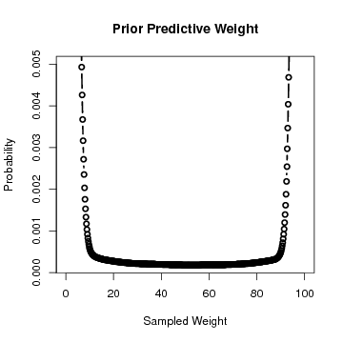

Prior Prediction

As seen in Figure the prior predictive of (M4) is both symmetric and quite diffuse over the 100 pound domain. The U shape of the distribution is a side effect of the diffusion of the selected prior. As data are added to the model, the indecisive U shape collapses toward the data in the posterior.

## Appendix D

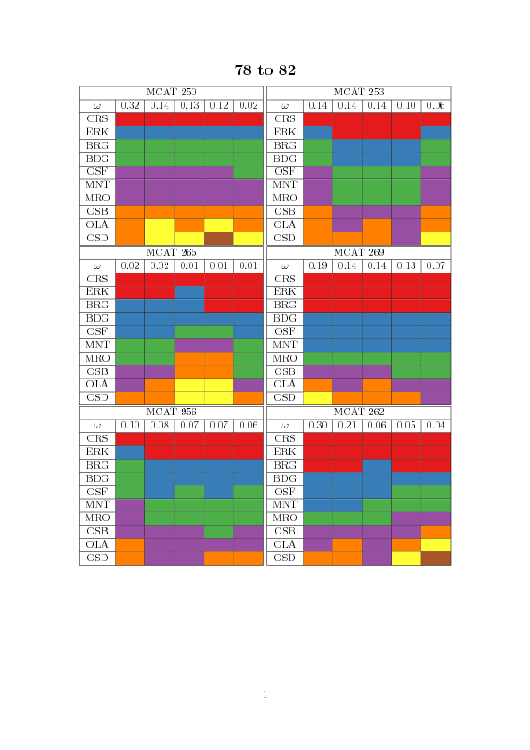 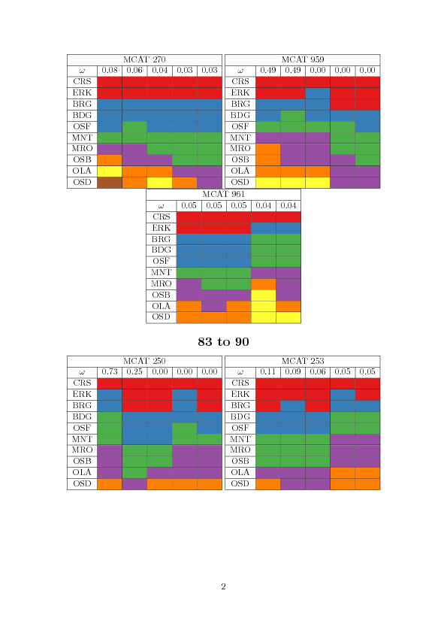 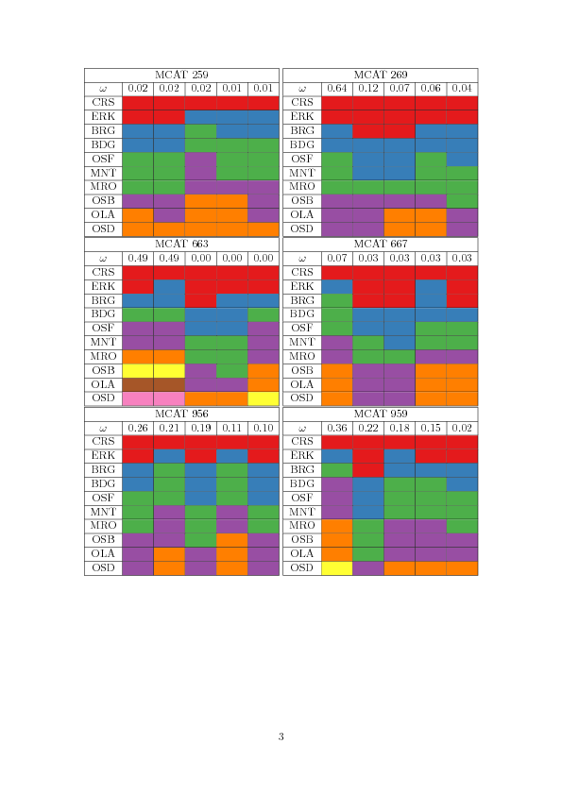 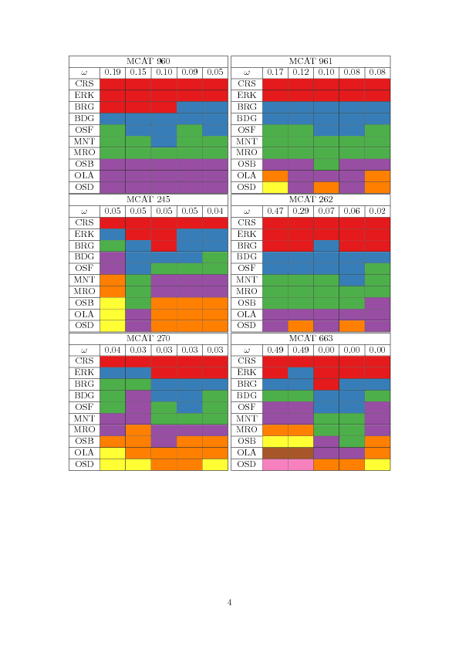

WAIC 1079.95 1323.75 3.43 0 -->