CS 229 Machine Learning, spring 2019

Homework 4:

Discriminative Learning, Bayes Nets and k-NN

Due Monday March 11, 11:59pm

Submit by the **blackboard system**

**Question1: (10 points) Fisher’s criterion (Exercise 4.5 of Bishop’s book)**

The goal of this homework is to become familiar with Fisher’s linear discriminant.

By making use of (4.20), (4.23), and (4.24), show that the Fisher criterion (4.25) can be written in the form (4.26).

**Question2: (10 points) Bayes Net - Proofs**

Given this Bayes net

Prove that C is conditionally independent of A, given B. You should use the definition of joint probabilities for a Bayes net.

**Question3: (60 points) Bayesian Network**

We are going to take the perspective of an instructor who wants to determine whether a student has understood the material, based on the exam score. Figure 2 gives a Bayes net for this. As you can see, whether the student scores high on the exam is influenced both by whether she is a good test taker, and whether she understood the material. Both of those, in turn, are influenced by whether she is intelligent; whether she understood the material is also influenced by whether she is a hard worker.

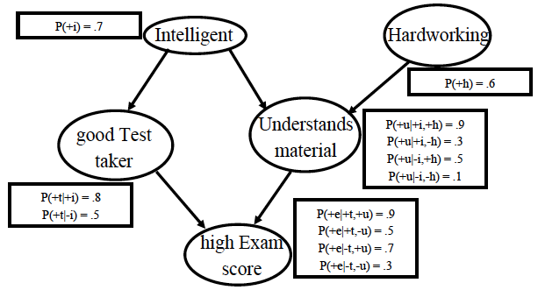

Figure 2 A Bayesian network representing what influences an exam score

1. (**20 points**) Using variable elimination (by hand!), compute the probability that a student who did well on the test actually understood the material, that is, compute P(+u| + e).
2. (**40 points**) For the above Bayesian network, label the following statements about conditional independence as true or false. For this question, you should consider only the structure of the Bayesian network, not the specific probabilities. **Explain each of your answers**.
3. T and U are independent.
4. T and U are conditionally independent given I, E, and H.
5. T and U are conditionally independent given I and H.
6. E and H are conditionally independent given U.
7. E and H are conditionally independent given U, I, and T.
8. I and H are conditionally independent given E.
9. I and H are conditionally independent given T.
10. T and H are independent.
11. T and H are conditionally independent given E.
12. T and H are conditionally independent given E and U.

**Question4: (20 points) k-nearest neighbor**

Write your k-nn code to classify

1. Students in data set in test_data_binary.txt by training data in logreg_data_binary.txt
2. Students in data set in test_data_3class.txt by training data in logreg_data_3class.txt

Report how many student labels in test data are correctly predicted.

NOTE: choose an appropriate *k* to reach the best prediction.