**Virtual and Remote Guidance Counselling System Free Bootstrap and PHP Script**

**Login Form with captcha**

**Admin Dashboard**

* Number of Appointments
* Number of Completed
* Number of Courses
* Number of Students
* Number of Reasons for referral

**Reasons for referral - crud**

* Reason – bullying, depression, stressed, lying
* Description

**Course Management - crud**

* Course Code
* Course Complete Name

**Student Management Information** – crud with import csv button

* Last name
* First name
* Middle name
* Course
* Age
* Gender
* Username
* Password

**Appointment Schedule - crud**

* Date
* Number of Slots Available

**Appointment Reservation List – table only**

* Student name
* Reasons for referral
* State Reason/Concern
* Date
* Time
* Meeting Link – Google Meet, Zoom
* Status – pending, cancelled, approved, completed

**Counselling Information - crud**

* Student name
* Message from Guidance Counsellor
* Strategies students will use
* Video Recording Link
* Remarks
* Date and Time

**Number of Appointment Report with print and export button**

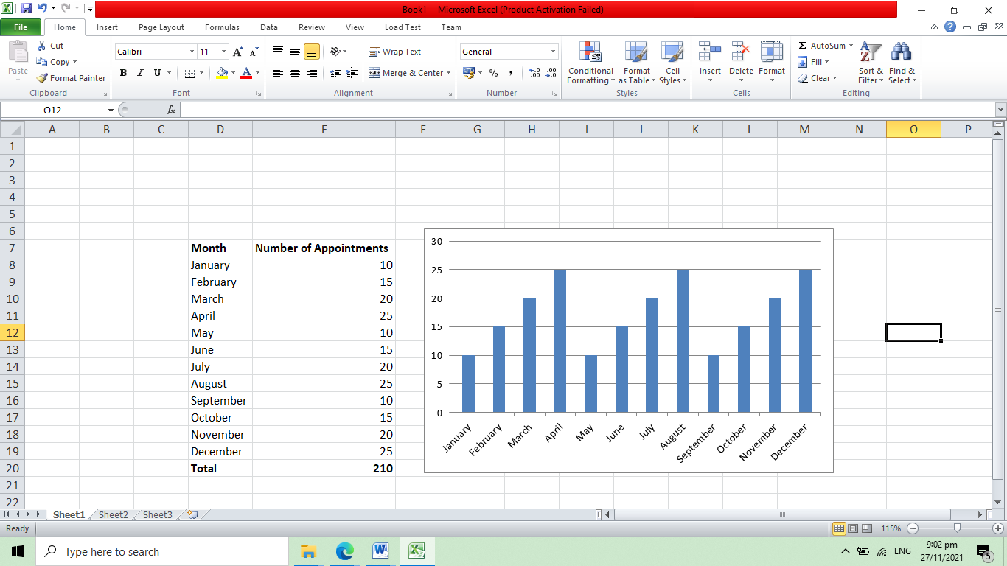

**Appointment by Reason for Referral with print and export button**

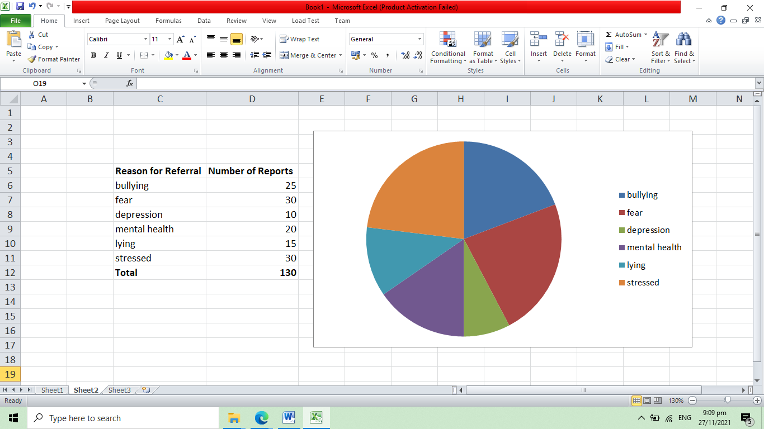

**Student Account**

**Appointment List – table only**

* Reasons for referral
* State Reason/Concern
* Date
* Time
* Meeting Link – Google Meet, Zoom
* Status – pending, cancelled, approved, completed

**New Appointment – form only**

* Student name
* Reasons for referral
* State Reason/Concern
* Select Date

**Counselling Information – table only**

* Message from Guidance Counsellor
* Strategies students will use
* Video Recording Link
* Remarks
* Date and Time