LEVERAGING LARGE LANGUAGE MODELS IN RISK CLASSIFICATION OF INCIDENT REPORTS
Robin Dillon-Merrill, PhD¹; Brian Holland²; Gabriel Soto²
¹McDonough School of Business, Georgetown University
²McCourt School of Public Policy, Georgetown University
Abstract
This project explores the efficacy of large language models (LLMs) in classifying coal mining incidents using narrative descriptions. Accurate risk classification is critical in industries that manage safety hazards, as it supports the development of improved mitigation mechanisms. Our study compares the performance of LLMs against human judgment when analyzing incident reports to determine whether an event is a minor incident or a near miss. By examining both automated and human classification under the same conditions, we assess the potential of LLMs to enhance decision-making processes in risk-sensitive industries, especially as automation increases both in depth and breadth.
Data Selection and Preparation
Dataset Source and Filtering
- Initial dataset consisted of approximately 200,000 incident records from the Mine Safety and Health Administration (MSHA)
- Applied filtering to exclude obviously noteworthy incidents (where days of work were missed)
- Remaining ~60,000 records potentially reflected either minor events or near misses
- Selected 2,000 records for manual classification by up to five human reviewers
Classification Schema
Two primary categories were established for classification:
- Minor events: Incidents where at worst minor first aid is required, but the event could not have been worse
- Near misses: Minor events where, if not for good luck, the incident could have been significantly worse
Example Classification Cases
Minor Event Example:
AN EMPLOYEE WAS PULLING AN INVOICE FROM AN ENVELOPE, WHILE PULLING HIS POINTER FINGER MADE CONTACT WITH THE BANDING MATERIAL AND SLICED A KNUCKLE.
Near Miss Example:
THE EMPLOYEES LEFT INDEX FINGER WAS PINCHED BETWEEN A PALLET OF MATERIAL AND A LIVE ROLLER AS THE PALLET WAS BEING MOVED FROM THE HOODER SYSTEM. THE TIP OF THE LEFT INDEX FINGER AND PART OF THE FINGERNAIL WAS LACERATED DURING INCIDENT.
Analytical Methods
LLM Implementation
- Model Selection: Utilized OpenAI's GPT-3.5-Turbo for the primary analysis, with exploratory testing of other models including Gemma
- API Integration: Implemented Python-based API calls using the OpenAI library
- Tokenization Analysis: Employed tiktoken library to analyze token usage and optimize prompt design
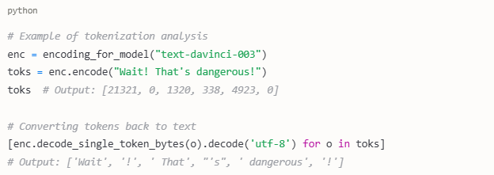
Prompt Engineering
A comprehensive preamble was developed to provide the LLM with:
- Clear definitions of what constitutes a minor event versus a near miss
- Multiple examples of each category
- Domain context about coal mining incidents
- Guidelines for making classification decisions
python
risk_preamble = """Studying small incidents in coal mines is important because it can lead to important safety improvements and thus reduce the risk for workers. However, not all incidents have the same importance: some are minor events and some are near misses.
Minor events are incidents where at worst minor first aid is required, but the event could not have been worse.
Near misses are minor events where at worst minor first aid is required, but if not for some good luck, the incident could have been worse.
The element that distinguishes a near miss, is the presence of a much worse consequence that was prevented only by good luck.
# [Additional examples and guidelines...]
"""
Response Format Control
We implemented multiple approaches to controlling response format:
- Initial open-ended classification
- Direct binary classification (True/False)
- Structured response format with justification
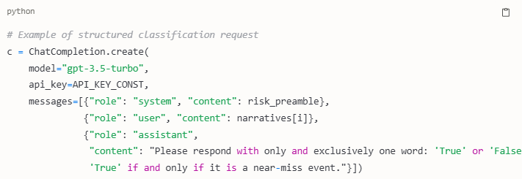
Temperature Experimentation
We conducted experiments varying the temperature parameter:
- Default temperature setting
- Low temperature setting (0.01) for more deterministic responses
- Comparative analysis of response consistency across temperature settings
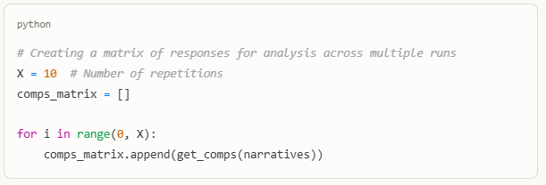Model Comparison Framework
Additional experimentation with alternative models was conducted:
- Explored local deployment of models including Llama-2 and StableBeluga
- Implemented retrieval-augmented generation with Wikipedia context
- Tested embedding models for semantic similarity analysis
Results and Findings
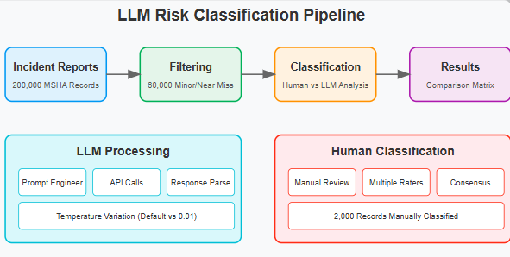
Human vs. LLM Classification Comparison
A comprehensive comparison matrix revealed significant differences between human and LLM classifications:
LLM Classification | Human: Near Miss | Human: Minor
Near Miss | 534 | 103
Minor | 316 | 142
Key Findings
- Classification Divergence: LLMs with identical instruction prompts cannot consistently replicate human-like judgment in risk assessment
- Temperature Effects: The temperature parameter influences classification results, with lower temperature settings providing more consistent responses but not necessarily improving alignment with human assessments
- Response Variability: Multiple runs of the same prompt generate varying responses, highlighting the non-deterministic nature of LLM outputs
- Processing Efficiency: While human classification required weeks to complete, LLM processing could analyze thousands of incidents in minutes
Consistency Analysis
Our multi-run experiments demonstrated:
- Varying degrees of classification stability across different incident narratives
- Certain incidents consistently classified the same way, while others showed high variability
- Response format constraints improved consistency but sometimes at the expense of nuanced assessment
Conclusions and Next Steps
Primary Conclusions
- Current LLMs are not yet suitable as direct replacements for human risk assessment in safety-critical domains
- The speed and scalability advantages of LLMs suggest potential utility as preliminary screening tools
- Response variability presents challenges for consistent risk assessment applications
Future Directions
- Fine-tuning Approaches: Developing specialized models trained on domain-specific incident data may improve classification accuracy
- Hybrid Systems: Implementing human-in-the-loop systems where LLMs provide initial screening followed by human review of borderline cases
- Prompt Optimization: Further refinement of prompting strategies to better capture human risk assessment heuristics
- Model Scaling: Testing whether larger, more capable models demonstrate improved alignment with human judgment
Ethical Considerations
- Potential for bias in the LLMs used to classify risk
- Implications for workplace roles if automated systems replace human judgment
- Privacy concerns related to incident reporting and analysis
- Responsibility and accountability for safety decisions informed by automated systems
References
- Mine Safety and Health Administration. https://www.msha.gov/
- OpenAI Documentation. https://platform.openai.com/docs/guides/text-generation/how-should-i-set-the-temperature-parameter

