PREDICTING INJURY SEVERITY FROM AUTOMATED DRIVING SYSTEMS (ADS) INCIDENTS
Robin Dillon-Merrill, PhD¹; Gabriel Soto²
¹McDonough School of Business, Georgetown University
²McCourt School of Public Policy, Georgetown University
Abstract
This study develops a random forest model to predict injury severity levels (Minor, Moderate, Severe) in Automated Driving Systems (ADS) incidents based on data from 1,489 NHTSA reports. The analysis incorporates both structured data (weather conditions, speed, vehicular motion) and unstructured text data (crash narratives) to identify key predictive factors for each incident type. By addressing significant class imbalance and implementing sophisticated feature engineering, our model achieves strong predictive performance while maintaining interpretability. This research provides valuable insights into the factors that contribute to different levels of injury severity in ADS incidents, with implications for improving autonomous vehicle safety standards and regulatory frameworks. Introduction
Autonomous vehicle technology is rapidly evolving, bringing with it new safety considerations and regulatory challenges. The National Highway Traffic Safety Administration (NHTSA) has implemented compulsory crash reporting requirements for ADS-equipped vehicles, creating a valuable but complex dataset for analysis. This research leverages this data to develop predictive models for injury severity following ADS incidents, with the goal of identifying key risk factors.
Key research challenges addressed in this study include:
- Significant class imbalance in injury severity categories (90.4% Minor, 2.8% Moderate, 5.8% High severity)
- Integration of structured vehicle and environmental data with unstructured narrative text
- Identifying meaningful interaction effects between features that may amplify risk
- Extracting interpretable insights from complex machine learning models
Through topic modeling with Latent Dirichlet Allocation (LDA), we explore the probability distributions of topics within each accident type, identifying distinctive linguistic patterns associated with different severity levels. This mixed-methods approach combines the statistical power of machine learning with the nuanced insights of natural language processing.
Data Selection and Preparation
Dataset Source and Characteristics
The analysis uses data collected through NHTSA's standing general order on crash reporting for vehicles equipped with SAE Level 2 advanced driver assistance systems (ADAS) or SAE Levels 3-5 automated driving systems. The dataset includes:
- 1,489 incidents after initial filtering
- Comprehensive structured data on vehicle behavior, road conditions, and crash dynamics
- Narrative descriptions of each incident
- Injury severity outcomes ranging from no injuries to fatalities
Initial feature selection focused on the following categories:
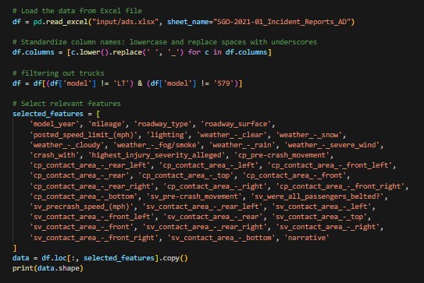
Data Preprocessing
Several preprocessing steps were implemented to prepare the data for analysis:
- Filtering: Removal of truck data (models 'LT' and '579') to focus on passenger vehicle ADS
- Type conversion: Standardizing string columns and converting binary indicators to numeric values
- Missing value handling: Using comprehensive checks to identify and address various types of missing values
- Weather and road condition engineering: Simplifying multiple weather indicators and standardizing road condition representations
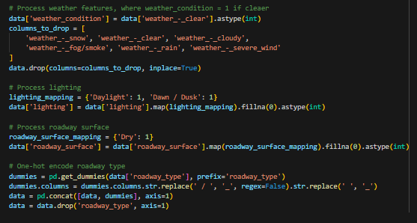
Feature Engineering
Sophisticated feature engineering was performed to extract maximum value from the available data:
- Contact Area Aggregation: Consolidating detailed impact areas into meaningful regions
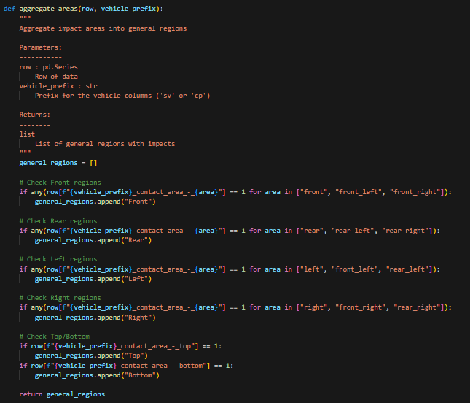
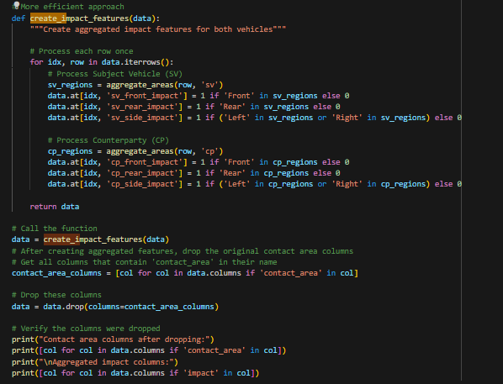
- Categorical Variable Encoding: One-hot encoding for roadway types, crash objects, and pre-crash movements
- Interaction Features: Creating meaningful interaction variables between speed, impact location, and other factors
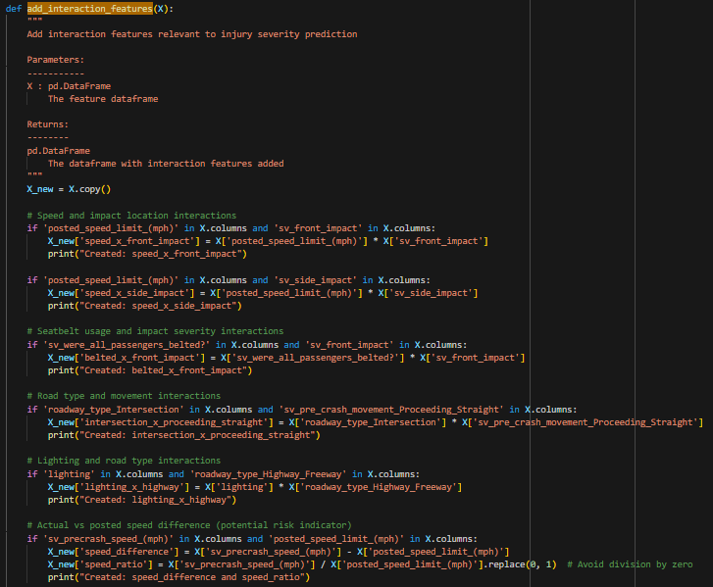
- Multicollinearity Reduction: Systematic identification and removal of highly correlated features
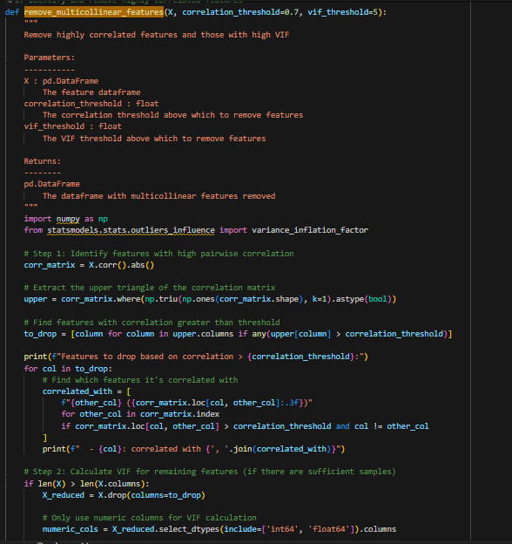
Target Variable Encoding
The injury severity levels were encoded into three distinct categories:
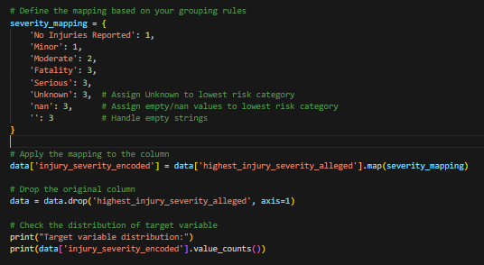
This resulted in the following class distribution:
- Class 1 (No/Minor Injury): 90.4%
- Class 2 (Moderate Injury): 2.8%
- Class 3 (Severe Injury/Fatality): 5.8%
Analytical Methods
Addressing Class Imbalance
The severe class imbalance in the dataset presented a significant challenge for model training. We implemented Synthetic Minority Over-sampling Technique (SMOTE) to address this issue:
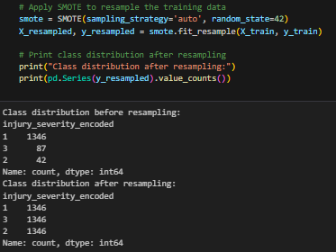
This technique creates synthetic examples of the minority classes based on nearest neighbors, resulting in a more balanced dataset that prevents the model from simply predicting the majority class in all cases.
Random Forest Implementation
We selected Random Forest as our primary modeling approach due to its robustness to overfitting, ability to handle mixed data types, and inherent feature importance metrics. The initial model was configured as follows:
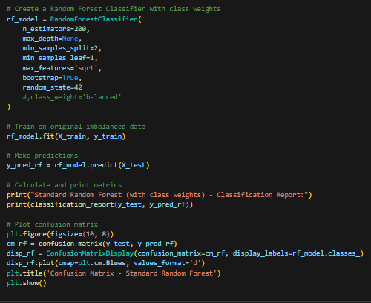
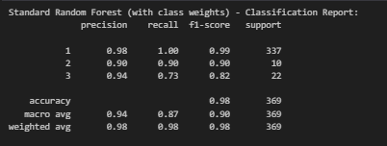
Preventing Overfitting
To address potential overfitting, we implemented several strategies:
- Cross-validation: Using K-fold cross-validation to ensure model stability
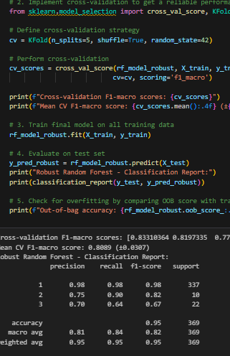
- Hyperparameter tuning: Adjusting model parameters to prevent memorization
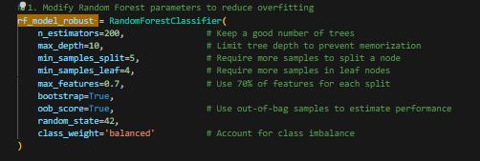
Text Analysis with Topic Modeling
To extract insights from the narrative text, we implemented a sophisticated text preprocessing and topic modeling pipeline:
- Text preprocessing: Comprehensive cleaning and normalization
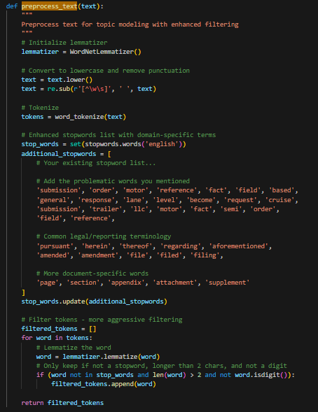
- TF-IDF based filtering: Using term frequency-inverse document frequency to identify and remove non-informative terms
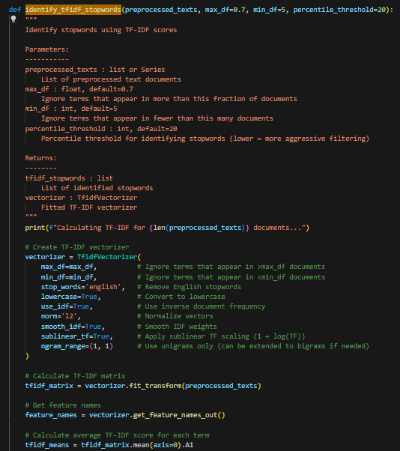
- LDA Topic Modeling: Identifying key topics within narrative text
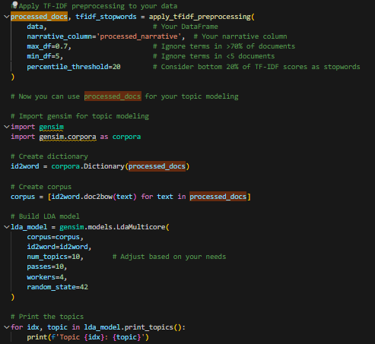
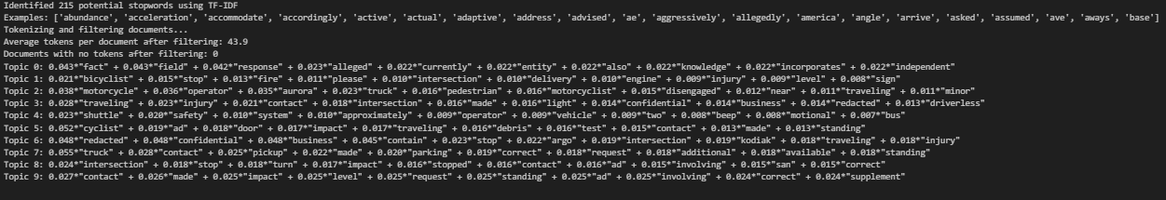
Model Evaluation and Results
Performance Metrics
Our optimized random forest model achieved impressive performance metrics:
- Overall accuracy: 93%
- Class-specific accuracy:
  - Minor injuries: 96%
  - Moderate injuries: 69%
  - Severe injuries/fatalities: 50%
These results represent a strong classification performance considering the complexity of predicting injury severity and the significant class imbalance in the original dataset.
Feature Importance Analysis
SHAP (SHapley Additive exPlanations) values were utilized to understand feature contributions to model predictions:
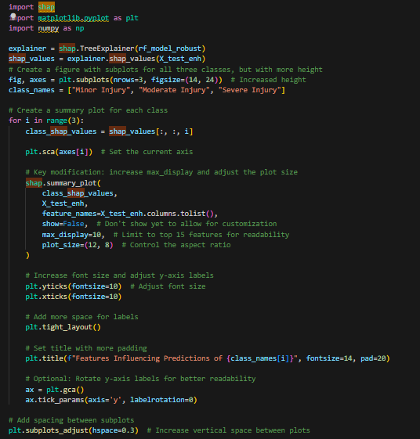
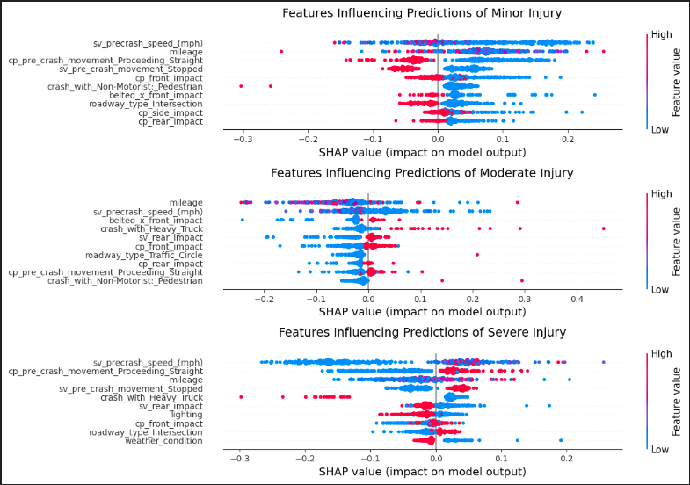

Key findings from the feature importance analysis:
- For Severe Injuries:
  - Front impact location emerged as a dominant predictor
  - Heavy truck involvement significantly increased severity prediction
  - Lack of seatbelt usage was a critical factor
- For Moderate Injuries:
  - Pre-crash speed was the most influential predictor
  - Side impacts showed stronger association than with other severity levels
  - Specific pre-crash movements (particularly turning movements) were important
- For Minor Injuries:
  - Seatbelt usage was strongly predictive of minor outcomes
  - Dry road conditions and daylight showed positive associations
  - Lower speed differentials between posted and actual speeds were predictive
Decision Tree Visualization
To provide more interpretable insights, we visualized individual decision trees from the random forest:
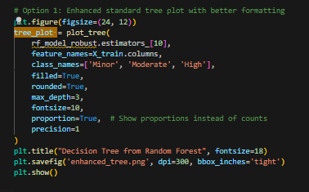
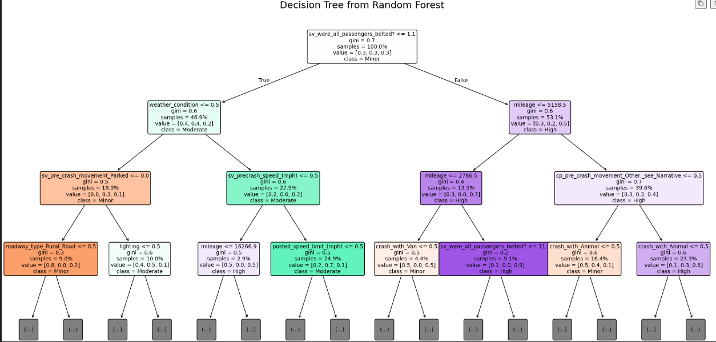
The tree visualization revealed several important decision pathways:
- Seatbelt usage as an initial split point in many trees
- Speed thresholds creating meaningful decision boundaries
- Impact location (particularly side impacts) as critical decision nodes
Topic Modeling Results
The LDA topic modeling of narrative text revealed distinct linguistic patterns associated with different severity levels:
Key narrative elements associated with severity levels:
- Severe Injury Narratives:
  - Higher frequency of terms related to high-speed impacts
  - More mentions of heavy vehicles and object collisions
  - Language describing loss of control scenarios
- Moderate Injury Narratives:
  - Greater prevalence of terms related to intersection scenarios
  - More frequent mentions of turning movements and unexpected obstacles
  - Higher representation of weather and visibility factors
- Minor Injury Narratives:
  - More mentions of low-speed maneuvering
  - Higher frequency of terms related to parking and backing
  - Greater representation of fender-bender and minor contact scenarios
Limitations and Future Work
Several limitations of the current study should be acknowledged:
- Class Imbalance: Despite SMOTE application, the severe class imbalance in the original dataset presents ongoing challenges for model development.
- Redacted Data: Manufacturer-specific redactions in the dataset limit the depth of analysis possible for certain vehicle types and systems.
- Causality Interpretation: While the model identifies predictive factors, establishing causal relationships requires further investigation and domain expertise.
- Temporal Factors: The dataset represents a specific time period and may not fully capture the rapid evolution of ADS technology.
Future research directions include:
- Enhanced Qualitative Analysis: Deeper investigation of narrative text using more sophisticated NLP techniques.
- Expanded Topic Modeling: Further refinement of topic models to better understand the interaction between features (e.g., how speed relates to injury outcomes in different scenarios).
- Cross-validation with Other Datasets: Comparing findings with other sources of ADS incident data to validate and extend insights.
- Manufacturer-specific Analysis: Where data permits, investigating differences in safety outcomes across different ADS implementations.
Ethical Considerations
This research highlights several ethical considerations related to ADS safety and data transparency:
- Complete Disclosure: The importance of comprehensive and standardized incident reporting to enable thorough safety analysis.
- Data Transparency: Balancing manufacturer confidentiality concerns with the public interest in safety information.
- Algorithmic Fairness: Ensuring that predictive models do not inadvertently introduce or amplify biases in safety analysis.
- Interpretability: Maintaining model transparency and interpretability to support evidence-based policy and regulatory decisions.
Conclusion
This research demonstrates the value of combining structured data analysis with text mining techniques to understand factors influencing injury severity in ADS incidents. Our findings underscore the importance of fundamental safety measures like seatbelt usage while also highlighting the specific risk factors associated with autonomous vehicle technology.
The predictive models developed in this study can serve multiple purposes:
- Informing regulatory frameworks for ADS safety requirements
- Supporting manufacturer safety testing and design priorities
- Enhancing public understanding of ADS risk factors
As ADS technology continues to evolve, ongoing analysis of safety data will be essential to realize the potential benefits of autonomous vehicles while minimizing risks. This requires both sophisticated analytical approaches and a commitment to transparency in data sharing and reporting.
References
- National Highway Traffic Safety Administration. General Order on Crash Reporting. https://www.nhtsa.gov/laws-regulations/standing-general-order-crash-reporting
- Alambeigi et al. (2020). Crash themes in Automated Vehicles. Available online: https://arxiv.org/abs/2001.11087

