
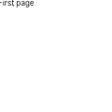
Floating image paragraph.
Following paragraph.

