Echolabel: Image-based echogram annotation tool for marine ecology
Gaspard Ringuenet
Gildas Roudaut
Alejandro Ariza
Arnaud Bertrand
2026-10-13
Abstract
Active acoustic systems are essential for studying aquatic ecosystems, delivering high-resolution information over large spatial scales. Yet processing these data still relies heavily on manual annotation, and no open-source annotation tool currently integrates with Echostack, the emerging Python toolkit for echosounder data. We present Echolabel, an open-source, cross-platform tool for fast echogram visualization and annotation, which produces CSV outputs directly compatible with Echoregions, the Echostack package for handling annotation. Echolabel is deliberately minimal and task-specific, and is not intended to replace general-purpose acoustic processing software. The tool is available as a command-line interface and as a Python application programming interface. It builds on the LabelMe graphical user interface to annotate cached echogram images and transparently converts between images and physical (time, depth) coordinates. Visualization options include RGB-composite echograms, which combine several acoustic frequencies and enable annotations informed by the frequency response of the imaged targets. We demonstrate the practical utility of Echolabel, combined with Echoregions, on routine annotation tasks and a brief ecological analysis. Echolabel is particularly well suited to delineating irregular, fuzzy objects such as sound-scattering layers, and thus facilitates the sonar-based investigation of aquatic ecosystems.

Metadata
Nr | Code metadata description | Metadata
C1 | Current code version | V1.0.0
C2 | Permanent link to code/repository used for this code version | https://github.com/gaspardringuenet/echolabel
C3 | Permanent link to reproducible capsule
C4 | Legal code license
C5 | Code versioning system used | Git
C6 | Software code languages, tools and services used | Python
C7 | Compilation requirements, operating environments and dependencies
C8 | If available, link to developer documentation/manual | https://echolabel.readthedocs.io/
C9 | Support email for questions | gaspard.ringuenet@umontpellier.fr

1 Motivation and Significance
Aquatic ecosystems, from lakes and rivers to coastal waters and the open ocean, are largely hidden from direct observation. Many of their organisms live in the water column, which direct sampling with nets or traps covers only sparsely, at high cost and often invasively. In this context, active acoustic systems (sonars) provide crucial information: by sounding the water column at high resolution, they are the only technology capable of providing continuous observations of organism distribution and behavior at the spatial and temporal scales at which physical and ecological processes occur [1].
Although the tool presented here applies to echograms from any aquatic environment, the examples in this paper come from the pelagic ocean. The pelagic zone designates the water column away from the seabed. This vast three-dimensional habitat represents more than 90 % of the available living volume on the planet. Lacking hard physical structures in comparison to the benthic zone (i.e., the seabed) or land, it can be divided into depth layers based on light penetration. The mesopelagic, where less than 1 % of light reaches, typically spans from 200 to 1000 m. Its significance is evident from its large biomass and diversity [2–4], its crucial role in ocean functioning [5,6], and its interdependence with human societies [7,8]. Despite this, the “twilight zone” remains understudied, primarily due to technical limitations in investigating deep waters. Active acoustics is particularly valuable here, as echosounders can sample the water column up to ~1000 m with high resolution.
However, extracting ecological information from acoustic data remains a major challenge. Manual delineation of features in echograms has long been a common practice in marine acoustics. Targeted biological features are most often aggregations such as fish schools or krill swarms, but may also include sound-scattering layers, which comprise a wide variety of organisms, from invertebrates to fish, distributed horizontally in the water column.
Annotating these features is part of the daily routine in ecosystem acoustic surveys, whether for subsequent analyses of distribution and biomass or to populate libraries used to train machine learning models for species identification. Several software solutions are currently available for this purpose: commercial options such as Echoview [9]; free but closed-source Windows-based software such as LSSS [11] and Movies3D [12]; or open-source software requiring a proprietary MATLAB license, such as ESP3 and Matecho [13,14].
In recent years, there has been significant development of free, open-source, cross-platform software for ecosystem acoustics. The most notable example, both in terms of development and engagement from the scientific community, is Echostack, a suite of Python packages for performing various routine tasks with scientific echosounder data [15,16]. Echostack includes the Echoregions package, designed to parse acoustic annotations and interface them with the gridded acoustic data. The package contains functions to create masks for machine learning models training or for routine processing tasks such as biomass estimation. However, no open-source solution is available for such annotations yet, despite this being one of the areas most in demand by the scientific community in ecosystem acoustics.
To bridge this gap, we propose Echolabel, a minimalist Python app for echogram annotation, built to be interoperable with Echostack / Echoregions. Its scope is narrower than that of most GUI-based acoustic software, which provide suites of analysis-ready computation tools. Echolabel focuses on the annotation task only, leveraging the power of LabelMe [17], a widely used open-source Python application for image annotation, by converting acoustic data into a set of echogram images. The output is an Echoregions-compatible CSV file, ensuring integration into the Python acoustic data processing environment. Echolabel is free, open-source, cross-platform, and free of proprietary dependencies. It requires little computing power, and offers an easy-to-use GUI for annotation

2 Software description

2.1 Software architecture
The software is written in Python, with separate modules responsible for app configuration, command-line inputs, cached data management, and parsing annotation files.
It is minimalist, comprising 13 Python source files, totalling < 1000 lines of code, and avoids re-implementing existing functionalities as much as possible. The annotation interface is entirely provided by LabelMe v6.0.0, and Echolabel focuses on parsing annotations between LabelMe and Echoregions. The annotation parsing module is called regions2d_extension and mimics Echoregions’ code to parse Echoview annotation data, with the aim of providing clear insight into the application’s purpose.
Echolabel has been developed to be primarily used from the command-line interface (CLI; see Listing 1). The main process command triggers conversion of the acoustic data into images before automatically running LabelMe. It features a number of optional parameters, allowing the user to modify the echogram. Passed CLI parameters are used to override a default configuration file, which can be directly edited for improved control and reproducibility. If necessary, a programmatic interface remains available with the EcholabelApp and Config classes at the top level.
A series of unit tests ensure that core features are preserved across future updates. Tested functionalities include configuration, data loading, image-dataset management, and annotation parsing. Git is used for version control.

2.2 Software functionalities
Echolabel wraps LabelMe. It loads acoustic data, chunks it into a dataset of echogram images, and runs LabelMe. When the user exits the LabelMe GUI, the image-based annotations are converted to physical (time, depth) coordinates and saved in a format that can be read using Echoregions.
Echolabel works with processed, gridded volume backscattering strength data (Sv, dB) [18], i.e., the widely used acoustic measure for characterizing the distribution of organisms in the water column, after the data have been cleaned of artifacts and regridded onto a consistent grid across frequency, depth, and time–distance dimensions. By default, Echolabel supports two widely used conventions for distributing data with this structure and level of processing: the IMOS SOOP-BA NetCDF convention [19] and the coordinate/variable names adopted by Echostack. For full flexibility, it can support any variable names, provided that the user manually identifies Sv, depth, and time–distance variables in the configuration file. Both NetCDF files and Zarr stores are accepted as input formats. Several files in the same directory may be loaded as a single dataset as long as their coordinates are compatible.
Common echogram visualization options are provided. The user can select the visualized frequency and specify value bounds as well as the colormap. A wide range of matplotlib colormaps can be selected using their names. In addition to single-frequency echograms, Echolabel offers a triple-frequency RGB echogram mode in which three channels are mapped to each of the red, green, and blue channels (with equal bounds). This visualization method is very effective for assessing the distribution of frequency responses across the echogram (for examples see [20,21]). The background (defined as where no channel is active) colour can also be specified in the configuration (as a matplotlib-compatible string or tuple).
Running the app triggers data loading and the building and caching of an echogram image dataset using visualization options. Echogram images are the representation of acoustic data once colour mapping has been applied. Each pixel represents a sampled volume. Each image’s physical (time and depth) coordinates are saved in cache. The image dataset building step is the only step involving significant computation. While lazy-loading of the acoustic dataset prevents memory overload, this step may take up to a few minutes for large-scale surveys with high resolution data. To avoid rebuilding the images at each session, Echolabel enables reuse of the cached images, allowing the GUI to launch almost instantaneously.
A prominent feature of Echolabel is the LabelMe graphical user interface (GUI; Figure 1), which is used to create annotations. This relies on the prior conversion of the acoustic data into images. Within the open window, the user can loop through the images in the “File List” panel. They can also visualize and edit existing annotations using the “Annotation List” panel and point clicks. Most importantly, they can use the “CreateShapeTools” to add new shapes. All changes are automatically saved in cache as LabelMe JSON annotations during the GUI editing session. The GUI is customizable, and the user has the option to edit the LabelMe configuration file on their system. Since Echolabel runs LabelMe as a subprocess and only operates on annotation files, modifying the LabelMe configuration should not create conflicts.
When closing the GUI, shape annotations are parsed and saved as a CSV file compatible with the echoregions.Regions2D class. This conversion uses the saved image coordinates to convert pixel-wise annotations into (time, depth) points. Regions2D objects can represent polygons only. For this reason, the polygon and rectangle LabelMe tools are the only ones whose shapes can be converted (output from other tools is ignored). Once the annotation-format conversion is done, the CSV file is created or updated. It is ready to be loaded into Echoregions in a single line.
Additional features include a demo command that downloads and processes demonstration data. It is also worth noting that LabelMe provides an AI polygon creation tool. The tool installs an image segmentation model (Meta’s Segment Anything Model 2 as of LabelMe v6.0.0) locally to provide assistance by automatically delineating objects. While such models are efficient on natural images, they appear much less useful on echograms. However, since the tool produces polygons, annotations are correctly parsed by Echolabel.

3 Illustrative examples

3.1 Polygon annotation on RGB echogram
The ABRAÇOS II survey was conducted off the north-eastern coast of Brazil during the Austral fall of 2017 (April 9th – May 7th). Research vessel Antea of the French oceanographic fleet operated a hull-mounted EK60 echosounder at four frequencies (38, 70, 120, and 200 kHz) with a pulse length of 512 μs [22,23]. Two configurations were used: a ping rate of 0.45 s for seabed depth less than 150 m, and a ping rate of 2.4 seconds for deeper areas, recording to depth up to 750 m. The echosounder was calibrated mid-survey in Fernando de Noronha using standard protocols [24]. Acoustic data processing was conducted using the Matecho software. Noise and artifact removal was performed using a combination of automated and manual cleaning tools. Volume backscattering strength was echo-integrated with a minimum threshold of -90 dB in 3-pings by 1-m cells. A conversion from the MATLAB format used by Matecho to a Zarr store was applied to the echo-integrated product. The demonstration data used thereafter are a 10-hour subset of the ABRAÇOS II survey, spanning both open ocean and a ~50 m deep seamount.
Several objects of interest are selected from the demonstration dataset using Echolabel. The GUI is launched from the terminal using a simple command, rendering an RGB composite echogram showing 38, 70, and 120 kHz channels simultaneously (Listing 1). Selected features are delineated using the “Create Polygons” and “Create Rectangles” tools and assigned text labels (Figure 1): a sound-scattering layer (“Layer”), a probable fish aggregation (“School”), a v-shaped anomaly probably caused by a lowered instrument (“Artifact”), and rectangle areas of varying hue (“Unknown”). The eight annotated regions are saved as a CSV file when closing the graphical interface.
Listing 1: Example bash command to build an RGB echogram and run the ROI demonstration.
echolabel process \
-s data/demo.zarr \ # acoustic data store
-o data/demo_regions.csv \ # annotation file
-f 38000 -f 70000 -f 120000 \ # mapped frequencies (Hz)
--cmap RGB # RGB composite echogram

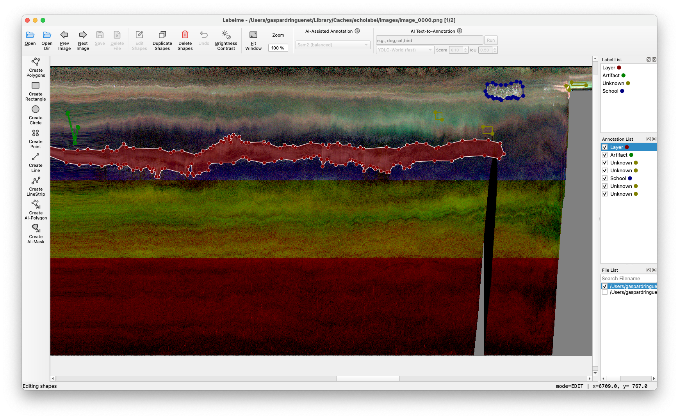
Figure 1: LabelMe graphical user interface showing drawn regions on an RGB composite echogram (R: 38 kHz; G: 70 kHz; B: 120 kHz - as specified in Listing 1) in the image panel (center). The grey shape on the right of the echogram indicates pixels below the ocean floor. Similarly, horizontal colour boundaries show the channels’ range limits. Regions of interest are defined as rectangles visible on top of the echogram. Labels are associated with the rectangle shapes (visible in the “Annotation List” panel, and as a non-duplicated list in the “Label List” panel). The “File List” panel shows all available echogram images.
Echolabel solely focuses on creating the annotations, but the software’s strength lies in its immediate compatibility with the Echoregions package. Hence, the following sections demonstrate first-order use cases for such annotations using Echoregions.

3.2 Use case 1 - Routine tasks
Figure 2 shows regions with the “Unknown”, “Artifact”, and “School” labels (a), along with processing or data analysis steps corresponding to the underlying echogram features (b-g): frequency response investigation, artifact removal, and aggregation mask extraction, respectively. All of those are made possible by the masking functionality of Echoregions (using the regionmask package) package) and each requires no more than a dozen lines of code to compute (omitting figure building).
The most basic task is computing the frequency responses of an echogram region. The influence of the organisms’ anatomy on their back-scattering properties has long been acknowledged, and is the motivation for multifrequency acoustics [1]. Spatio-temporal variations in frequency responses can then be attributed to variations in the species (or age) composition in the sampled volumes. While the RGB echogram successfully renders part of this contrast, a quantitative comparison of back-scattering between regions of interest provides a more exhaustive and objective insight. Figure 2 b,c compares two reddish (38 kHz strong) and two greenish (70 kHz) regions, in different oceanographic setups (pelagic or on seamount edge), depths (150 m or 50 m) and intensity (seemingly stronger near the seamount) by computing the frequency response relative to the 38 kHz channel ($R(f)=Δ{\text{MVBS}}_{f−38\text{kHz}}=S_{v}(f)−S_{v}(38\text{ kHz})$ ; see [18] for notation) for all regions. Green regions contain similar R(f). On the other hand, red regions show great differences, especially at 120 and 200 kHz, suggesting a very different biological composition. Further analysis using this kind of regions of interest may include target strength (TS) modelling, or building a training set for a multifrequency classification algorithm.
In spite of a thorough cleaning of acoustic data, some unwanted signal or noise may remain in the final product. This is accentuated by the context-dependence of unwanted signal. Manual cleaning of the echo-integrated product can easily be conducted with the combination of Echolabel and Echoregions. This is demonstrated in Figure 2 d,e in which the back-scattering of a probable CTD profiler is removed using a polygonal shape.
On the contrary, one may want to extract the mask of a biological aggregation of interest. This is common for fish schools and shoals, and illustrated in Figure 2 f,g. A typical use of such masks is supervised deep learning model training. Computation of acoustic variables, or post processing of the mask (for instance to remove unwanted pixels) may also apply to fish aggregations.
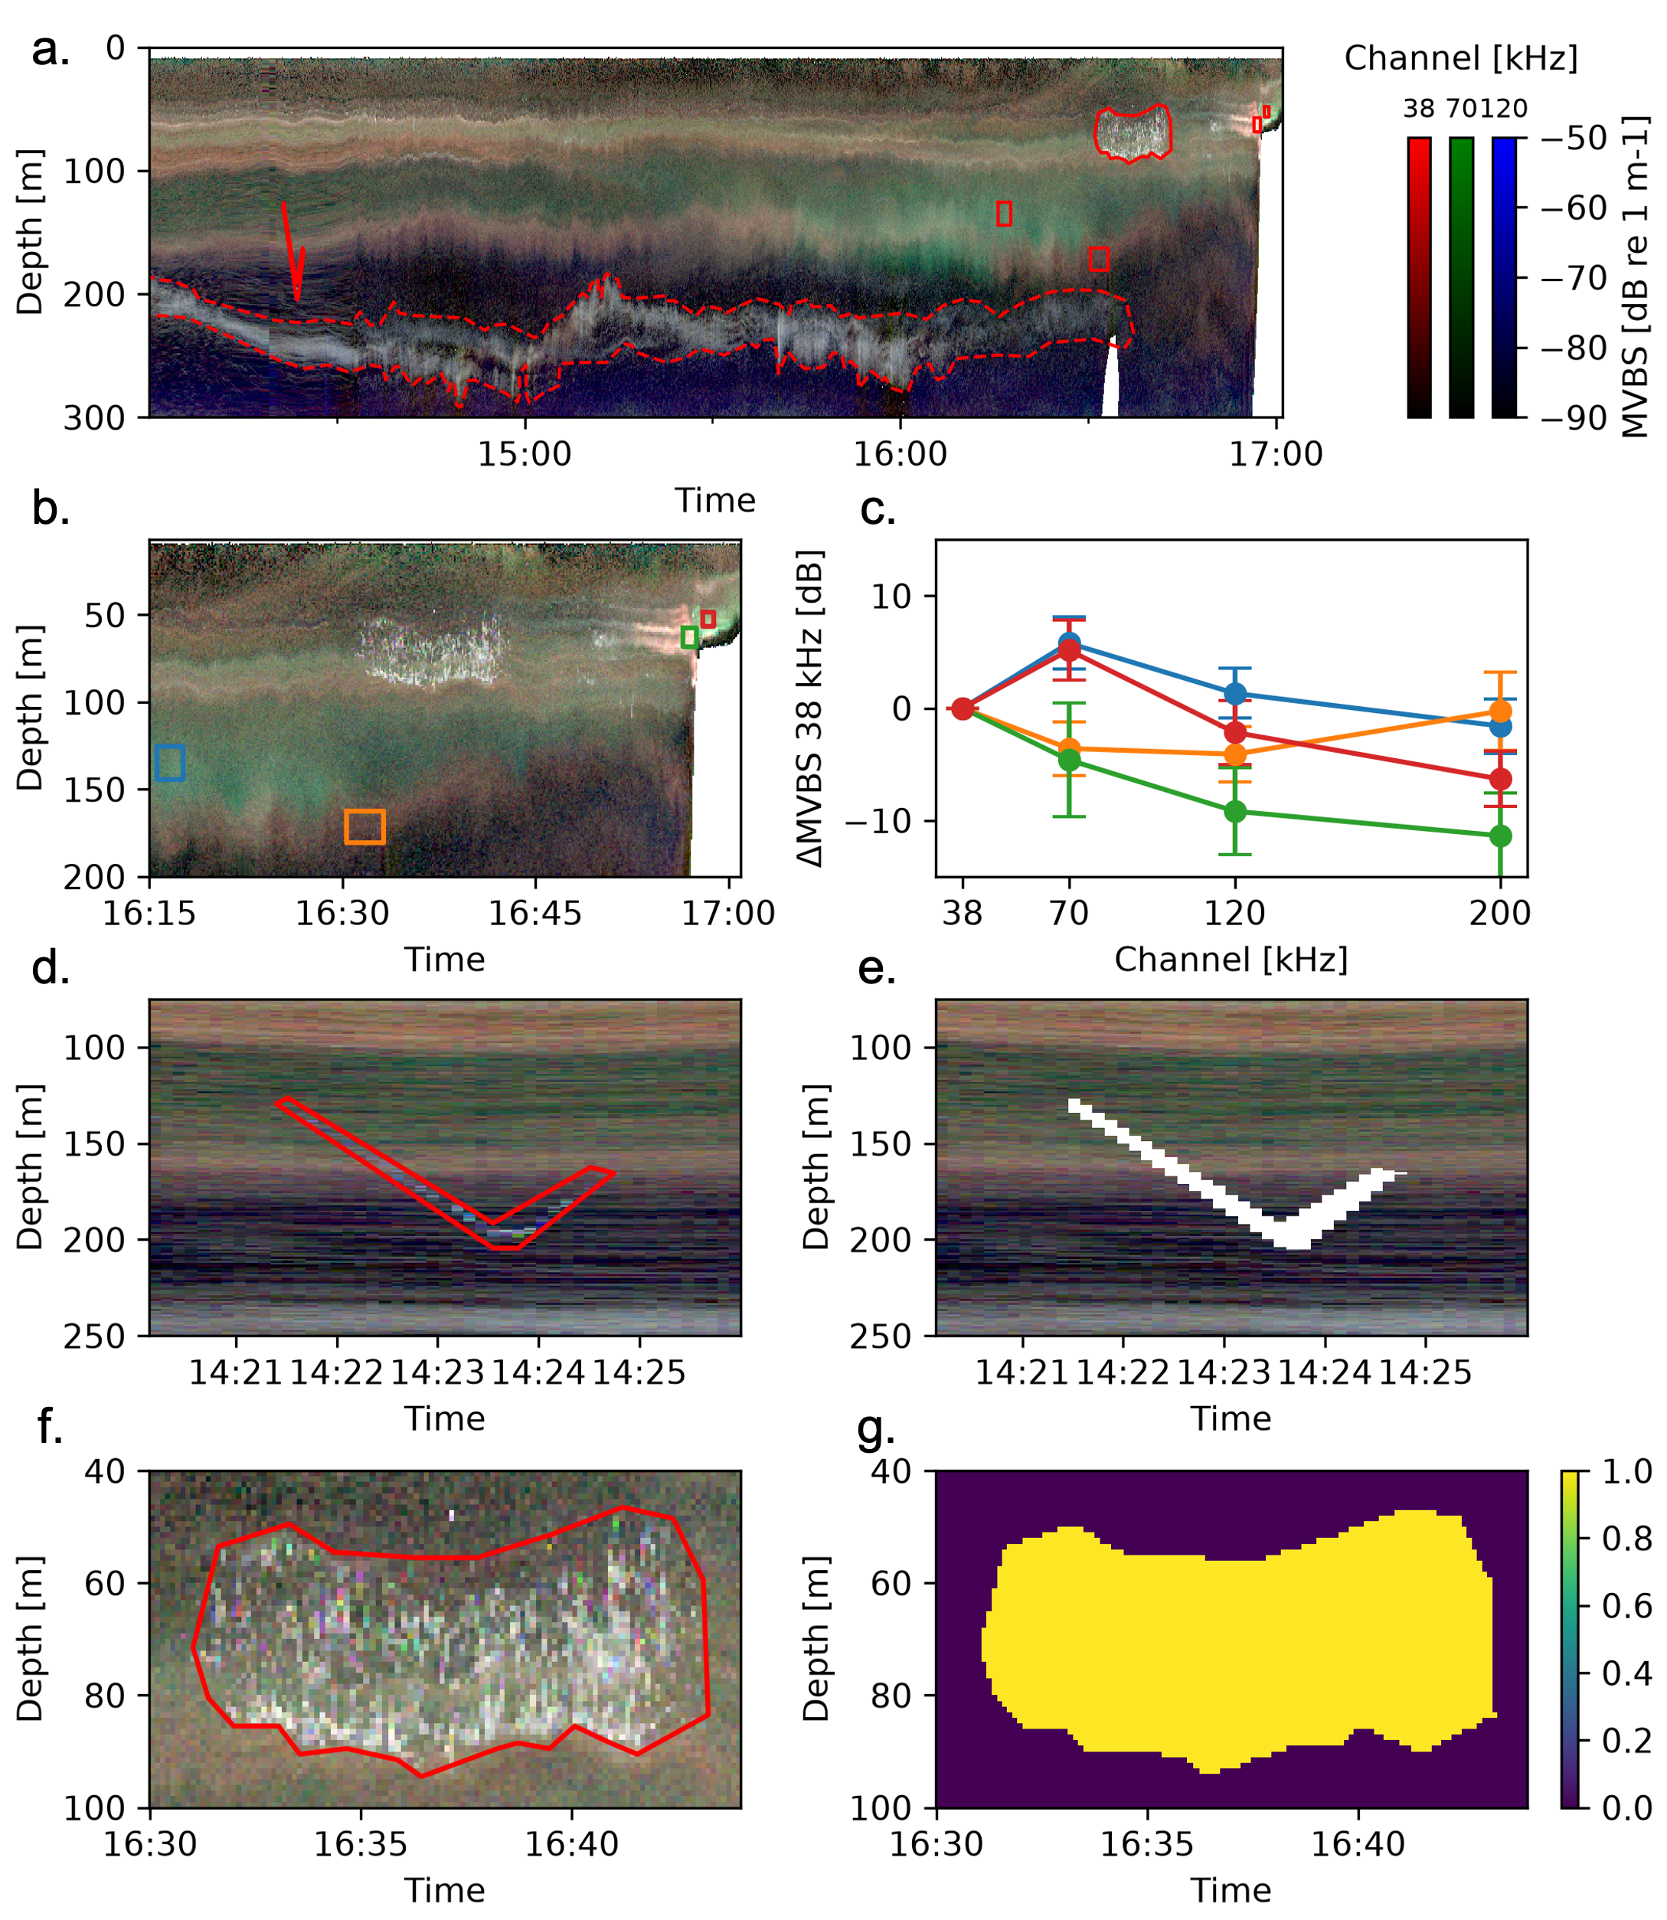
Figure 2: Annotated echogram regions and simple use cases. (a) Annotated polygonal regions displayed on top of an RGB echogram, whith the dashed line representing the “Layer” polygon. (b-g) Use cases: the annotated rectangles (b) can be used to compute the mean and standard deviation of relative frequency responses of data within (c); a v-shaped anomaly, typical of a lowered instrument (d) can be masked out (e); the binary mask (g) of a fish aggregation (f) can be computed.

3.3 Use case 2 - Analysis of a sound-scattering layer
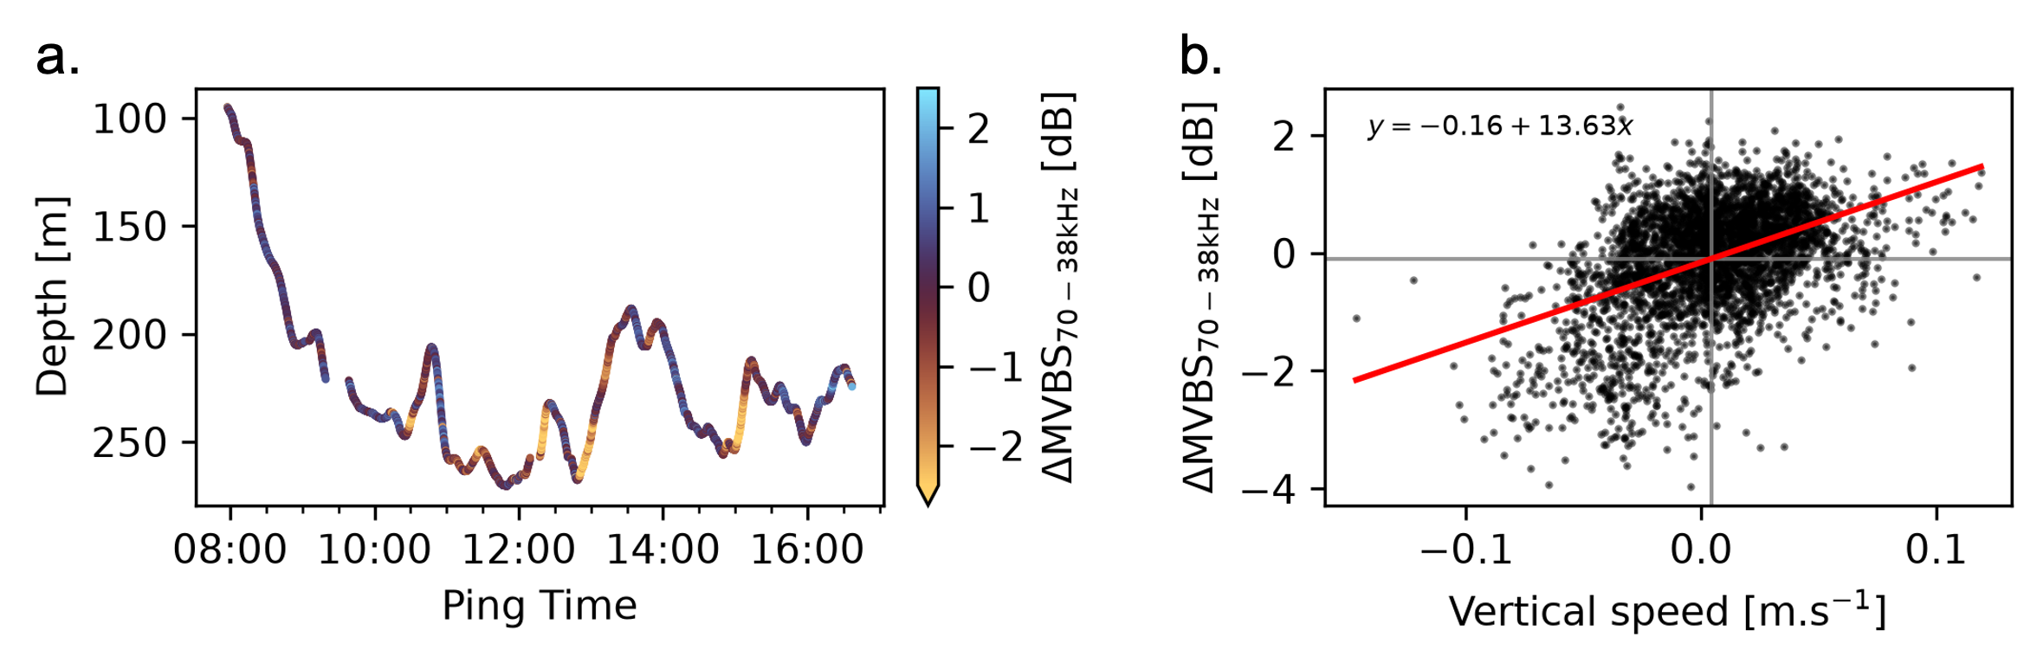
Figure 3: Example first-order analysis of a diffuse sound-scattering layer (selected as the “Layer” polygon in Figure 1). (a) Time series of the depth of the layer’s center of gravity (NASC-weighted mean depth), smoothed with a 50-timestamp rolling mean. The colour indicates the sign and magnitude of the relative frequency response. (b) Scatter plot of $Δ{\text{MVBS}}_{70−38\text{kHz}}$ , against downward vertical speed. The red line shows the linear regression fit, and the fitted equation is given in the top left corner. Grey lines indicate the means of both variables.
A wide variety of data analyses can be conducted using masked echograms. We briefly demonstrate how Echolabel, together with Echoregions, can be used to test a simple hypothesis. A close inspection of the data within the “Layer” polygon on the RGB echogram shows an interesting pattern. The layer varies both in depth, with finer-scale variations superimposed on the diel vertical migration pattern, and in frequency response, with some sections appearing brown while others appear grey (most visible in Figure 2 a). We hypothesize that changes in frequency response are linked to changes in the mean tilt angle of mesopelagic organisms (presumably fish in this case). To test this, we compare $Δ{\text{MVBS}}_{70−38\text{kHz}}$, to the vertical speed of the layer (positive downward), assuming vertical speed is tightly linked to the average tilt angle of the fish.
The layer is delineated manually using Echolabel, as shown in Figure 1, and the corresponding mask is generated with Echoregions. The irregular and fuzzy nature of the extracted object calls for manual extraction, making this an exemplary ecological use case for our software. For each timestamp, the mean depth of the layer is computed, weighted by the nautical area scattering coefficient ($\text{NASC }[{\text{m}}^{2}{\text{ nmi}}^{−2}]$, a linear measure of the back-scattered energy [18]). The computed line is smoothed using a rolling mean spanning 50 timestamps. From this vector, the layer’s downward migration speed is obtained by differentiation with respect to time. The depth-averaged $Δ{\text{MVBS}}_{70−38\text{kHz}}$ is visually compared to both migration depth and speed (Figure 3). A linear regression is used to test the dependence of frequency response on vertical speed.
Figure 3 a supports the visual impression given by the RGB echogram. Marked upward-swimming events correspond to a higher response at 38 kHz than at 70 kHz. Indeed, those events are the only occurrences of extreme (-4 to -2 dB) $Δ{\text{MVBS}}_{70−38\text{kHz}}$, while a large proportion of points have smaller frequency response differences. This is consistent with the scatter plot in Figure 3 b, that most data fall within a small range of $Δ{\text{MVBS}}_{70−38\text{kHz}}$ (-1 to 1 dB) and vertical speed (-5 to 5 cm s⁻¹) values. A minority of points show extreme values of both variables, with concordant signs (both negative or both positive). Even accounting for the mass of near-zero points, the linear model shows a positive dependence of $Δ{\text{MVBS}}_{70−38\text{kHz}}$ on downward speed ($p<{10}^{−3}$), with satisfactory residual distributions.
This exploratory analysis visually identifies a correlation between vertical speed and $Δ{\text{MVBS}}_{70−38\text{kHz}}$ and shows the statistical dependence of the latter on the former. This result is consistent with the tilt-angle hypothesis, i.e., variations in frequency response are here associated with the movements of the fish rather than with changes in species composition, although the latter cannot be ruled out. In addition, the stronger effect during swift upward-swimming events (visible in Figure 3 a, and in the poorer model fit for small values in Figure 3 b) could indicate that these events are more coordinated than downward migrations events, with more animals aligned and swimming in the same direction. We also observe that the organisms eventually return to a depth consistent with a first-order u-shaped diel vertical migration.
Light level is the main driver of diel vertical migration, with organisms seeking refuge in deeper waters during the day to avoid visual predators [25]. Yet, during some observed upward-swimming events, the layer raised more than 50 m above its nominal depth (Figure 3 a). The sudden and coordinated nature of these events could suggest that the layer is reacting to a threat or avoiding a physical barrier. Another explanation could be weather events changing skylight intensity, as animals may also avoid darkening waters. Further analysis and evidence are required to address these questions properly. This analysis nonetheless illustrates the potential of manual acoustic data annotation, and so of Echolabel, to address questions in pelagic behavioural ecology.

4 Impact
Echolabel bridges a gap for aquatic scientists using Python who want to integrate acoustic annotation into Echoregions-dependent pipelines. The flexible acoustic dataset loading framework allows most acoustic NetCDF conventions to be loaded, and the use of Echoregions’ CSV convention for annotated shapes enables subsequent analysis with the package. In addition, relying on cached echogram images makes the annotation process responsive on most machines. Together with the smooth and fast LabelMe GUI, this enables efficient echogram annotation. The RGB composite mode also makes frequency-response-aware labelling possible.
Echolabel is a single-purpose tool, and it is not designed to replace acoustic processing software. This tool was primarily developed for an internal purpose. Its core functionality, i.e., annotating polygonal shapes on echograms, can be achieved using most general-purpose GUI-based acoustic software (although the use of RGB echograms remains relatively uncommon among them). However, the outputs of few such software packages can currently be parsed by Echoregions.
Nevertheless, we believe that a minimalist and fast tool might be of use to the community. It is particularly well-suited to individual researchers wanting to annotate a large number of echogram features that do not require inspecting data/metadata values during annotation (image files do not provide such information; such information can, however, be accessed during subsequent processing with Echoregions).
Future development of open-source acoustic tools might render Echolabel obsolete. Echoregions might extend its supported annotation formats. Other tools might arise for the annotation of dynamic echograms, possibly in Python using datashader-based mechanisms to reduce the computational cost of rendering. A shallow layer over the HoloViews library might be a suitable approach, allowing users to create custom interfaces easily using Panel. Such developments are needed to support a comprehensive Python stack for acoustic data analysis. To our knowledge, Echolabel remains the only open-source echogram annotation software directly compatible with Echoregions.

5 Conclusions
Echolabel provides a simple command-line interface for echogram annotation, producing outputs that integrate into Echostack, specifically the Echoregions package, a Python ecosystem for processing and analysing active acoustic data that is expected to become a standard in the
Our tool leverages a widely used image annotation software package by converting acoustic data into echogram image files and using LabelMe to annotate them. NetCDF and Zarr formats are accepted, and most conventions can be used as input (IMOS SOOP-BA and Echopype conventions are accepted by default). No innovation is claimed with respect to echogram generation: the software provides either basic single-channel mapping or tri-frequency RGB echograms.
Example use cases demonstrate the ease with which various echogram features can be selected, and how the underlying data may be processed or analysed with minimal effort using the masking functionality of Echoregions after annotation with Echolabel. Such manual annotation proves particularly useful for fuzzy objects with unclear boundaries, which are commonplace in active acoustics (e.g. sound-scattering layers). Aside from convenience, Echolabel also enables very fast annotation workflows. However, the manual nature of the annotation task does not allow an objective measurement of performance, which is why no performance example was proposed in this work. Nevertheless, the absence of rendering cost after generating images, together with the widespread use of LabelMe within the computer vision community, supports the practical usability of the approach.
The scope of Echolabel is deliberately limited to echogram images generation and annotation. Strong limitations are inherent to the image-based design: the loss of direct access to data and metadata values, and the division of the dataset into individual frames. LabelMe also renders images using bilinear interpolation, causing pixel-scale blurring that may affect the precision of fine-scale annotations.
While Echolabel has clear limitations, it provides an efficient and convenient solution for tasks requiring the rapid annotation of large numbers of shapes. Future developments in the open-source active acoustics community may eventually provide more comprehensive alternatives, but Echolabel currently offers a lightweight, cross-platform, and Echoregions-compatible solution for this specific use case.

Availability
Echolabel is open-source and available at https://github.com/gaspardringuenet/echolabel. Additional source code, scripts and data used to demonstrate Echolabel are available at this manuscript’s quarto project repository (https://github.com/gaspardringuenet/echolabel-manuscript).

Funding
This research received no specific grant from any funding agency in the public, commercial, or not-for-profit sectors.

Artificial intelligence (AI) use statement
AI-based tools were used to assist with planning, code review, improvement suggestions, and writing tests during software development. All AI-written code has been reviewed. AI tools were used for review only during manuscript preparation, and for clarity improvement in the abstract section.

Declaration of competing interest
The author declares that they have no known competing financial interests or personal relationships that could have appeared to influence the work reported in this paper.

Acknowledgement
We acknowledge the French oceanographic fleet for funding ABRAÇOS II ship-time and the officers and crew of the R/V Antea for their contribution to the success of the operations. This work is a contribution to and was supported by the International Joint Laboratory TAPIOCA (www.tapioca.ird.fr).

References
[1] K.J. Benoit-Bird, G.L. Lawson, Ecological insights from pelagic habitats acquired using active acoustic techniques, Annual Review of Marine Science 8 (2016) 463–490. https://doi.org/10.1146/annurev-marine-122414-034001.
[2] X. Irigoien, T.A. Klevjer, A. Røstad, U. Martinez, G. Boyra, J.L. Acuña, A. Bode, F. Echevarria, J.I. Gonzalez-Gordillo, S. Hernandez-Leon, S. Agusti, D.L. Aksnes, C.M. Duarte, S. Kaartvedt, Large mesopelagic fishes biomass and trophic efficiency in the open ocean, Nature Communications 5 (2014) 3271. https://doi.org/10.1038/ncomms4271.
[3] L.N. Eduardo, M.M. Mincarone, T. Sutton, A. Bertrand, Deep-pelagic fishes are anything but similar: A global synthesis, Ecology Letters 27 (2024) e14510. https://doi.org/10.1111/ele.14510.
[4] S.H.D. Haddock, C.A. Choy, Life in the midwater: The ecology of deep pelagic animals, Annual Review of Marine Science 16 (2024) 383–416. https://doi.org/10.1146/annurev-marine-031623-095435.
[5] C. Robinson, D.K. Steinberg, T.R. Anderson, J. Arístegui, C.A. Carlson, J.R. Frost, J.-F. Ghiglione, S. Hernández-León, G.A. Jackson, R. Koppelmann, B. Quéguiner, O. Ragueneau, F. Rassoulzadegan, B.H. Robison, C. Tamburini, T. Tanaka, K.F. Wishner, J. Zhang, Mesopelagic zone ecology and biogeochemistry a synthesis, Deep Sea Research Part II: Topical Studies in Oceanography 57 (2010) 1504–1518. https://doi.org/10.1016/j.dsr2.2010.02.018.
[6] U. Passow, C.A. Carlson, The biological pump in a high CO_{2 world}, Marine Ecology Progress Series (2012). https://doi.org/10.3354/meps09985.
[7] A. Martin, P. Boyd, K. Buesseler, I. Cetinic, H. Claustre, S. Giering, S. Henson, X. Irigoien, I. Kriest, L. Memery, C. Robinson, G. Saba, R. Sanders, D. Siegel, M. Villa-Alfageme, L. Guidi, The oceans’ twilight zone must be studied now, before it is too late, Nature 580 (2020) 26–28. https://doi.org/10.1038/d41586-020-00915-7.
[8] L.N. Eduardo, A. Bertrand, Deep-pelagic ecosystems should be considered as socialecological systems, Nature Ecology & Evolution 9 (2025) 745–748. https://doi.org/10.1038/s41559-025-02692-w.
[9] Echoview, (n.d.). https://echoview.com/support/release-notes/ (accessed July 31, 2026).
[10] LSSS, (n.d.). https://github.com/marec-open-source/lsss (accessed August 2, 2026).
[11] R.J. Korneliussen, E. Ona, I. Eliassen, Y. Heggelund, R. Patel, O.R. Godø, C. Giertsen, D. Patel, E. Nornes, T. Bekkvik, H.P. Knudsen, G. Lien, The large scale survey system - LSSS, in: 2006. https://www.academia.edu/143858735/The_large_scale_survey_system_LSSS.
[12] V.M. Trenkel, L. Berger, S. Bourguignon, M. Doray, A. Et., Overview of recent progress in fisheries acoustics made by ifremer with examples from the bay of biscay, Aquatic Living Resources (2009). https://doi.org/10.1051/alr/2009027.
[13] Y. Ladroit, P.C. Escobar-Flores, A.C.G. Schimel, R.L. O’Driscoll, ESP3: An open-source software for the quantitative processing of hydro-acoustic data, SoftwareX 12 (2020) 100581. https://doi.org/10.1016/j.softx.2020.100581.
[14] Y. Perrot, P. Brehmer, J. Habasque, G. Roudaut, N. Behagle, A. Sarré, A. Lebourges-Dhaussy, Matecho: An open-source tool for processing fisheries acoustics data, Acoustics Australia 46 (2018) 241–248. https://doi.org/10.1007/s40857-018-0135-x.
[15] W.-J. Lee, V. Staneva, L.“Don”. Setiawan, E. Mayorga, C. Tuguinay, S. Butala, B. Lucca, D. Lei, Echostack: A flexible and scalable open-source software suite for echosounder data processing, Python in Science Conference (2024) 386–397. https://doi.org/10.25080/WXRH8633.
[16] W.-J. Lee, L. Setiawan, C. Tuguinay, E. Mayorga, V. Staneva, Interoperable and scalable echosounder data processing with echopype, ICES Journal of Marine Science 81 (2024) 1941–1951. https://doi.org/10.1093/icesjms/fsae133.
[17] K. Wada, Labelme: Image polygonal annotation with python, (2026). https://doi.org/10.5281/zenodo.5711226.
[18] D.N. Maclennan, P.G. Fernandes, J. Dalen, A consistent approach to definitions and symbols in fisheries acoustics, ICES Journal of Marine Science 59 (2002) 365–369. https://doi.org/10.1006/jmsc.2001.1158.
[19] H. Kunnath, R. Kloser, T. Ryan, IMOS SOOP-BA netCDF conventions. Version 2.2, Commonwealth Scientific; Industrial Research Organisation, Hobart, TAS, 2018.
[20] A. Ariza, A. Lebourges-Dhaussy, D. Nerini, E. Pauthenet, G. Roudaut, R. Assunção, E. Tosetto, A. Bertrand, Acoustic seascape partitioning through functional data analysis, Journal of Biogeography (2022) jbi.14534. https://doi.org/10.1111/jbi.14534.
[21] P. Annasawmy, J.-F. Ternon, P. Cotel, Y. Cherel, E.V. Romanov, G. Roudaut, A. Lebourges-Dhaussy, F. Ménard, F. Marsac, Micronekton distributions and assemblages at two shallow seamounts of the south-western indian ocean: Insights from acoustics and mesopelagic trawl data, Progress in Oceanography 178 (2019) 102161. https://doi.org/10.1016/j.pocean.2019.102161.
[22] A. Bertrand, ABRACOS 2 cruise, RV antea, (2017). https://doi.org/10.17600/17004100.
[23] A. Bertrand, M. Simier, G.V.F. Afonso, G. Alory, A. Ariza, R. Assunção, J.-C. Auguet, F. Baurand, B. Bec, D. Bonnet, L.F. Cabanez, C. Carré, A. Chaigneau, A. de L.M. Cocentino, I.A. Cordeiro, A. Costa da Silva, M. Coubard, M. de Melo Junior, J.-C. Molinero, J. Devesa, G. Domalain, L.N. Eduardo, G. Eldin, G.B. Farias, G. Ferreira, G.G.A.A. Figueiredo, T. Frédou, D.X. Garcia, E. Giachini Tosetto, J.G. Gonzalez, J. Grelet, S. Hillion, A. Justino, M.C. Jales, S.R. Lacerda, F. Le Loc’h, A. Lebourges-Dhaussy, R.S. Lima, N. Lins-Silva, A.S. Lira, S.M. de A. Lira, C. Marcolin da Rocha, J.R. Martins, A. Médieu, C. Melo, P.A.M. de C. Melo, M.M. Mincarone, M. Monnier, J.-M. Munaron, S. Neumann-Leitão, J.M. Nogueira, M. Oliveira, B. Padovani Ferreira, L. Pelage, D. Point, U. Pinheiro, F. Roubaud, G. Roudaut, P. Rousselot, J. de L. Santana, R. Schwamborn, M. da G.G. Silva-Cunha, A. Soares, J.F. Souza Filho, J.-F. Ternon, P. Travassos, G. Vargas, T. Vaske Jr., R.P.S. Campelo, B.T. Villarins, F. Lucena-Frédou, The ABRACOS dataset: A multidisciplinary marine ecosystem baseline for the western tropical atlantic (20152017), Earth System Science Data Discussions (2026) 1–51. https://doi.org/10.5194/essd-2026-512.
[24] D.A. Demer, L. Berger, M. Bernasconi, E. Bethke, K. Boswell, D. Chu, R. Domokos, A. Dunford, S. Fassler, S. Gauthier, L.T. Hufnagle, J.M. Jech, N. Bouffant, A. Lebourges-Dhaussy, X. Lurton, G.J. Macaulay, Y. Perrot, T. Ryan, S. Parker-Stetter, S. Stienessen, T. Weber, N. Williamson, Calibration of acoustic instruments., (2015). https://repository.oceanbestpractices.org/handle/11329/626.
[25] A.S. Brierley, Diel vertical migration, Current Biology 24 (2014) R1074–R1076. https://doi.org/10.1016/j.cub.2014.08.054.

6 Supplementary
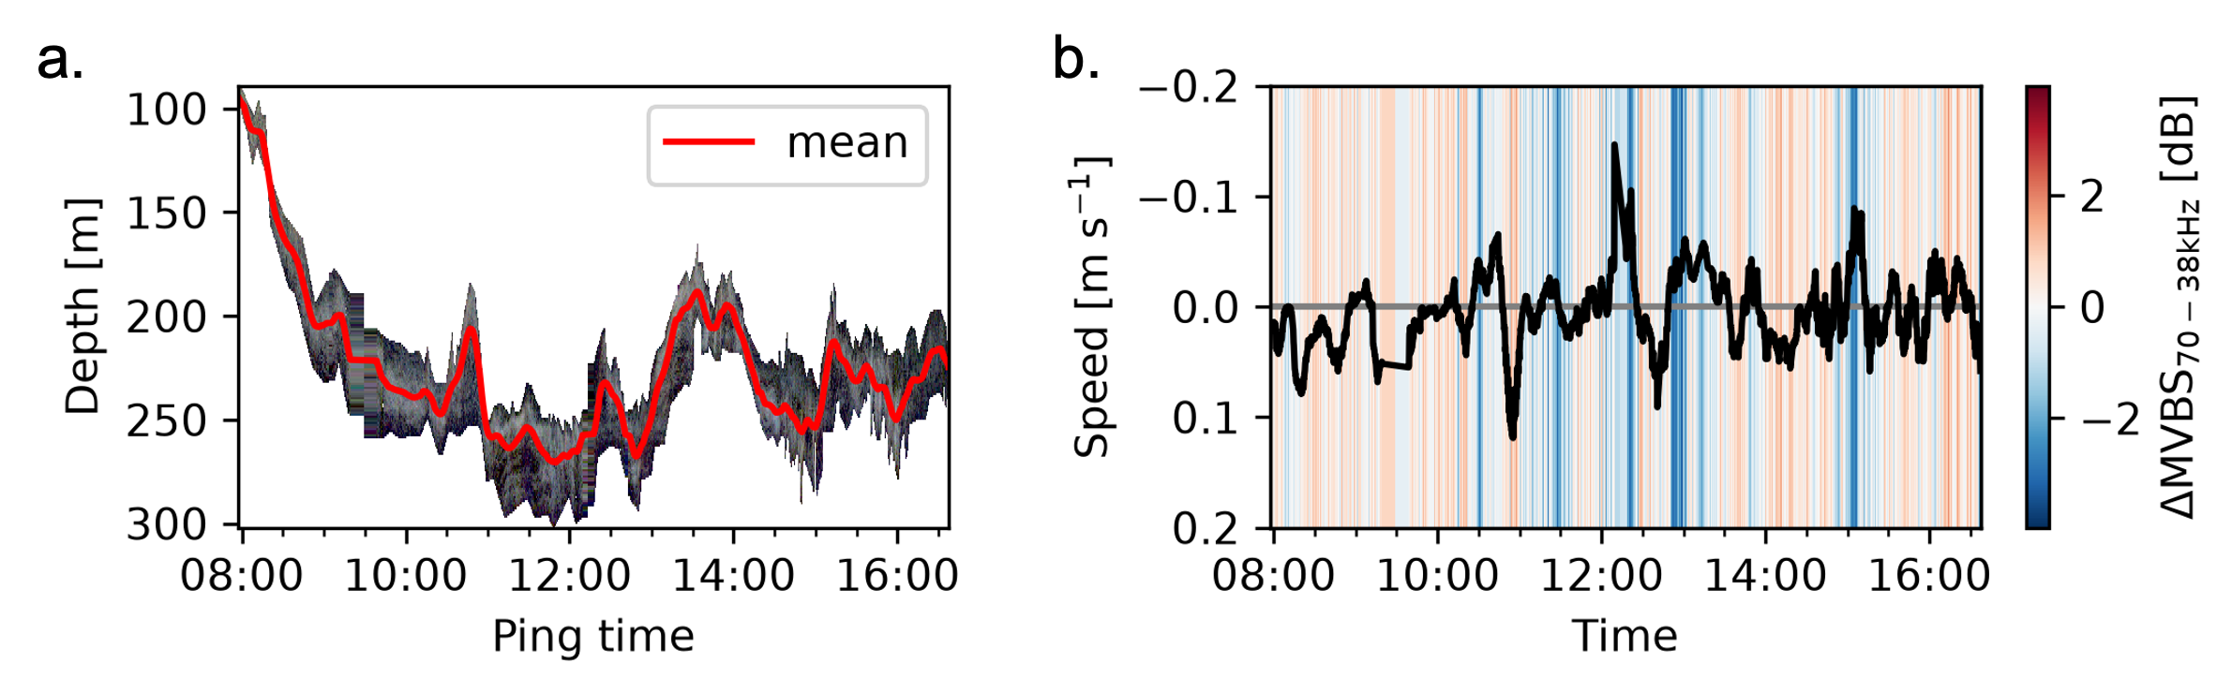
Figure 4: Example first-order analysis of a diffuse sound-scattering layer (selected as the “layer” polygon in Figure 1). (a) RGB echogram of data within the layer mask. See Figure 2 for color bar. The red line indicates the smoothed $s_{A}$-weighted mean depth. (b) Comparison of downward vertical speed (compute from the smoothed mean depth) with $Δ{\text{MVBS}}_{70−38\text{kHz}}\text{[dB]}$.

LSSS now has an open-source version [10], and it is available for linux and macOs (https://marec.no/downloads.htm).

