**Usage example using programatical solution:**

- In your recent created sample plugin project reate new class named Data.java

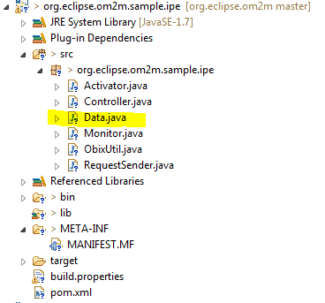

- In this class you have to declare which data will Cep server process. In our demo we will process only double values from the sensor. Modify it for your needs.

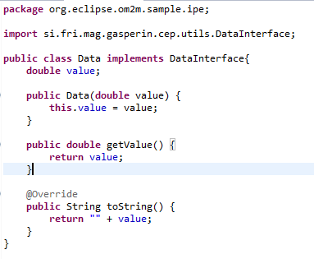

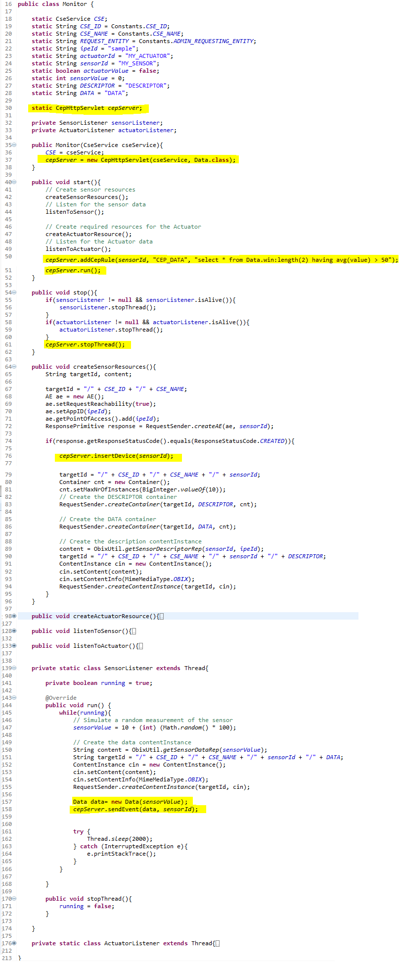- Open Monitor.java file. On top of that class add:

*static CepHttpServlet cepServer;*

- In constructor method of Monitor class add:

*cepServer =*

*new CepHttpServlet(cseService,Data.class);*

- In start() method of class add:

*cepServer.addCepRule(sensorId, "CEP_DATA", "select * from Data.win:length(2) having avg(value) > 50");*

*cepServer.run();*

- In stop() method add:

*cepServer.stopThread();*

- In createSensorResources() method add:

*cepServer.insertDevice(sensorId);*

- In class SensorListener, in method run() add:

*Data data= new Data(sensorValue);*

*cepServer.sendEvent(data, sensorId);*

- Right click on org.eclipse.om2m project -> Run as -> Maven install

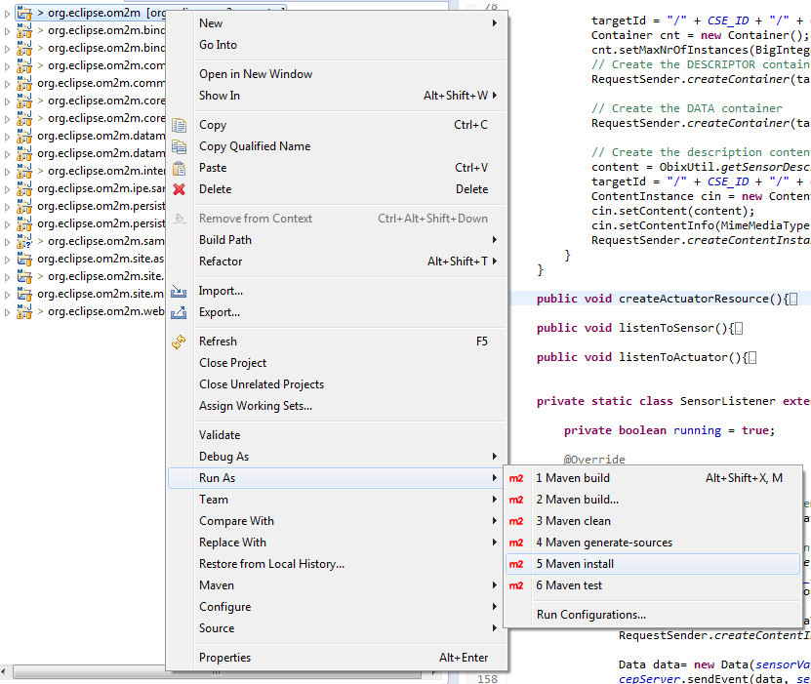

- Open explorer and go to:

org.eclipse.om2m\org.eclipse.om2m.site.in-cse\target\products\in-cse\win32\win32\x86_64

- Double click on start.bat

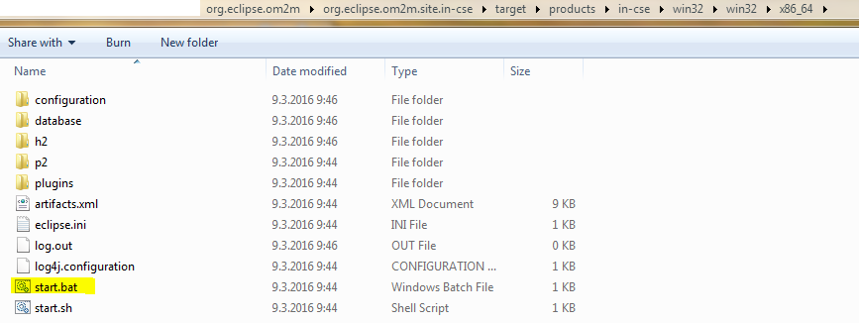

- Type "ss" into comand line and look for id of your recently created plugin (e.g. org.eclipse.om2m.sample.ipe)

- Type "start id" (e.g. "start 32")

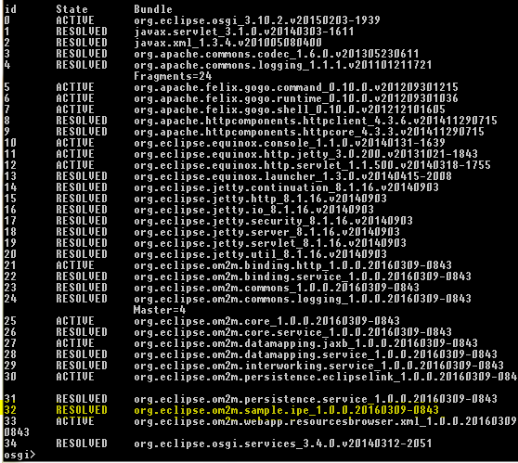

**Check your new cep rule:**

- Open "http://localhost:8081/cep" and login (default values for login are also "admin" : "admin"). Here you can add/delete/update cep rules for specific device.

- You should see already created cep rule in the CEP rules table editor.

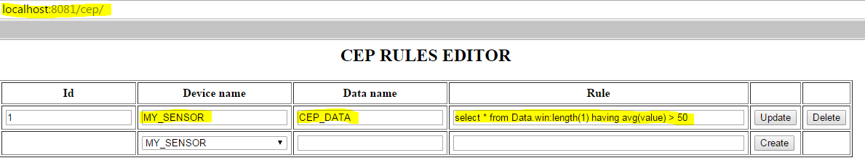

**Check your om2m platform:**

- Open web browser, type into url "http://localhost:8080/webpage" and login (default values for login are "admin" : "admin"). Here you can monitor your data and data catched into predefined cep rules.

- Under MY_SENSOR -> DATA are all sensor measurments sent to OM2M platform

- Under MY_SENSOR -> CEP_DATA are all triggered messages by predefined cep rule

