# Project Report

# DataScience Course/Graded Assessment 1

Prepared by: Georges Assaf

Date: Nov 2024

This document contains 2 Reports:

Report 1: created based on the clarification sent by email

Report 2: covers all task of the assignement and employs Linear Regression and many other classifiers with all the variables of the dataset and contains a description that covers all the steps of the project

Report 1

Report 1 covers only the linear regression as per the clarification mail shared with us

# Introduction

This project involves working with a dataset derived from the 1994 US Census for analyzing income patterns. We will explore data relationships, handle missing values, and perform linear regression and other classifier to uncover insights about working hours per week for male and female The assignment requires submitting a Jupyter Notebook. The section in the notebook that covers this section is called

Machine learning as requested in the clarification email

# Scope

The objective of this project is to perform multiple linear regression fits, each time adding an additional control variable, and observe the trend of weekly working hours between men and woman.

* In the first model, we will fit a linear regression using only the "sex" variable.
* In the second model, we will include an additional control variable, "education-num."
* In the third model, a third control variable, "income," will be incorporated.

## Insights from Original Dataset

as a basic analysis and to have an insight about the trend of working hours , I have plotted the average of working hours per week in the actual/original dataset and group them by sex.

This chart compare the average number of hours worked per week between male and female.

The blue bar representing the average working hours per week for male is significantly higher than the pink bar representing females. The difference is approximately around 6 hours per week.

Figure 1-Avg hours per week in original data

## Statistic Used

In linear regression several statistical metrics are used to evaluate the performance of the model. The most common one used are MSE, RMSE,etc. In this exercise, I will be using the MSE (Mean Squared Error) that measures the average squared difference between the actual and predicted values.

Lower MSE indicates better model performance.

## Linear Regression with Sex

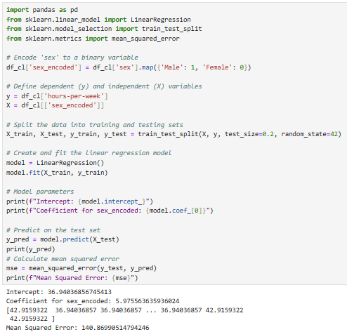Using Sex as independent variable, I ran this model and got the followings:

Intercept: and intercept of 36.9 represent a baseline of 36.9 hours per week

Coefficient: a coefficient for sex of 5.9 represents the difference in weekly working hours between the sex categories.

Mean Squared Error: This is average squared error. MSE= 140 indicates that there is some error in the model’s prediction and it could be potentially improved

Figure 2-Linear Regression [sex]

This bar chart displays the predicted average weekly working hours, segmented by male and female. It is evident that the trend in the predicted data, generated by the model that includes sex as an independent variable, closely aligns with the trend observed in the original data.

Figure 3-Predicted Avg Hours Per Week [sex]

## Linear Regression with Sex and education-num

Coefficient: The coefficient 0.68 for education-num indicates a relation between **education-num** and number of working hours. Individual with higher education levels if education tend to work slightly more hours per week. That verify why we have a slight decrease in MSE.

MSE: Adding a new control variable education-num seems to have an impact on reducing the error.between the average actual and predicted values of weekly working hours. Lower MSE indicates a better model.

Figure 4-Linear Regression [education-num, sex]

After introducing the new control variable, education-num, the trend showing that males work more hours per week remains unchanged. However, there is a slight variation in the number of working hours observed.

Figure 5-Predicted Avg Hours Per Week [education-num, sex]

## Linear Regression with Sex, education-num, and income

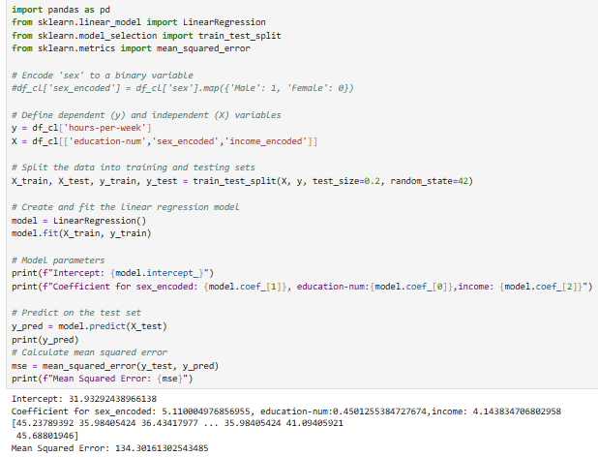

Figure 6-Linear Regression [education-num, sex, income]

MSE: Adding a third control variable seems to have an impact of reducing more the error. This can verified by looking at the coefficient of income (4.14) that means for each one-unit increase in income, the model predict 4.14 hours increase in weekly working hours. This indicates that people with higher income are expected to work more hours per week/

We can conclude that adding more variable is helping the model to capture more patterns and thus reducing the error.

Figure 7-Predicted Avg Hours Per Week [education-num, sex, income]

Adding a third binary variable income to the model, does not have an impact on changing the trend of weekly working hours between male and female. However we noticed a small variation in the number of hours.

# Conclusion:

To improve the model, we should consider the followings:

* Adding more features
* Exploring other types of regression models or regularization techniques.

In the next report, I am analyze the entire dataset with income as the dependent variable, apply various models, and conclude with a comparison of their performance to identify the best model.

Report 2

NB: this report covers all the steps available in the notebook that follows the steps of the assignment that are mainly grouped under 3 main groups:

* Data Exploration
* Correlation
* Linear Regression and other classifier models (XGBoost, Logistic Regression, RandomForest) where income is considered the dependent variable and all remaining variables are used

# Introduction

This project involves working with a dataset derived from the 1994 US Census for analyzing income patterns. We will explore data relationships, handle missing values, and perform linear regression and other classifier to uncover insights about income trends. The assignment requires submitting a Jupyter Notebook with analysis and a brief report summarizing the findings.

# Data Description

## Dataset Overview

The dataset, extracted from the 1994 US Census, includes demographic and employment-related attributes to analyze income patterns and trends.

## Key Features

The dataset, derived from the 1994 US Census, contains a mix of categorical and numerical features representing demographic and employment information. Numerical features include **age**, **fnlwgt** (sampling weight), **education_num** (numerical education level), **capital_gain**, **capital_loss**, and **hours_per_week**. Categorical features capture aspects like **workclass**, **education**, **marital_status**, **occupation**, **relationship**, **race**, **sex**, and **native_country**.

## Target Variable

The target variable, **income**, is categorical and indicates whether an individual's income exceeds $50K annually.

## Challenges

This dataset seems to have challenges, like outliers, missing values and inconstancies in the column values.

# Data exploration

## Column Data Types

After importing the dataset from the library ucimlrepo, I have validated the column types comparing to the dataset column type with the text description sheet. The integer columns are easily comparable since the same type is on both.

However, for the object columns in the imported dataset, I had to run df.nunique() to have a look at the number of distinct values which can give an idea whether the column is categorical or not, all are matching.

For the binary columns in the dataset, I checked the distinct values and noticed that for **sex** has 2 distinct values while income is having 4 distinct values. To dig more, I had to print the distinct values of income and noticed that there is a typos error (>50K. and <=50K.) which will updated later in the project to have a total of 2 distinct values.

## A screenshot of a computer Description automatically generatedA screenshot of a computer Description automatically generatedData Completeness and Validity

Figure 8-Column Type

Figure 9- Count of Unique Values

For data completeness, I checked only the presence of data by identifying **np.nan** values. However, this approach does not address the validity of the values. To ensure validity, I created a new dataframe summarizing the distinct values in each column, allowing for a visual inspection and validation.

After quick validation of the dataset columns, I found out that the columns **workclass, occupation, and native-country** are having invalid values represented by ?

To continue with the project, the values represented by ? are casted with **np.nan** considering the values are missing.

Figure 10-count of Null values

## Data Distribution

To look at the data distribution, I started by generating the histogram for capital-gain and capital-loss

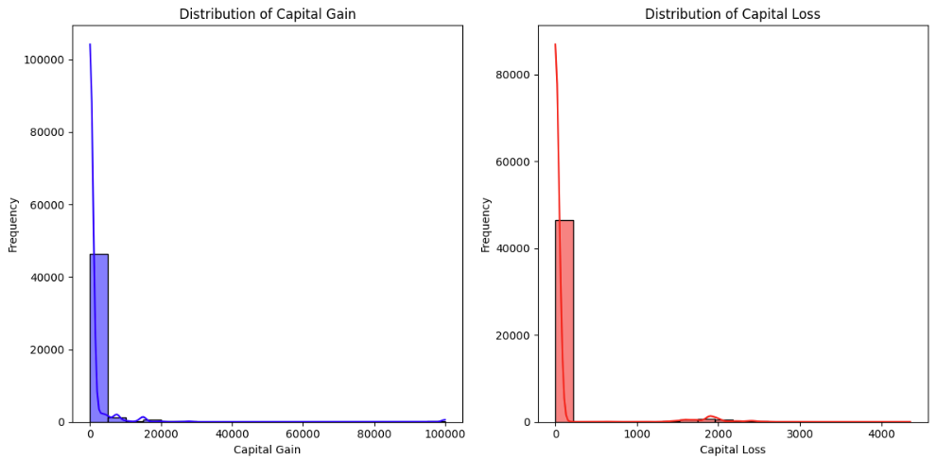

Figure 11-Distribution of capital-gain and capital-loss

Capital-gain: the distribution of capital-gain is likely to be skewed with the majority of people reporting zero or very low capitals gains and a very small percentage having high capital-gain. This is confirmed by the value_counts which shows that 91.7% (44807 rows) are having 0 values and only 8.3% are having values distributed between low and high gain. Based on this observation.  
**I recommend transforming the capital-gain column into two categories: gain and no-gain**

Capital-loss: The value_counts output for the capital_loss column shows that the majority of individuals have zero capital loss, with 46,560 rows showing a value of zero. A few other values, such as 1902, 1977, and 1887, appear more frequently but still have relatively low occurrences.

Figure 12-Value Count for capital-gain

Figure 13-Value Counts for capital-loss

Based on this observation,

**I recommend transforming the capital-loss column into two categories: loss and no-loss.**

In conclusion, both columns will be merged in one column called capital-gain-loss-classification as per below table:

|  |  |  |
| --- | --- | --- |
| Gain | Loss | Capital-gain-loss-classfication |
| >0 |  | Gain |
|  | >0 | Loss |
| 0 | 0 | Break-even |

That conversion lead to the below distribution:

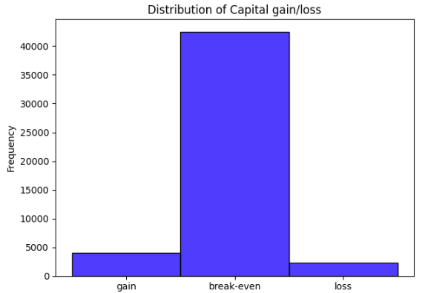

Figure 14-Numerical Distribution of capital-gain-loss-classification

Figure 15-Distribution of capital-gain-loss

Another distribution to look at is for the **fnlwgt** column

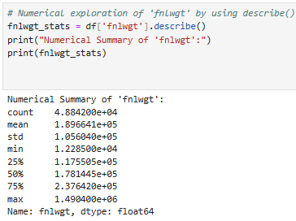by looking at the overall numerical distribution, we can notice that the mean value is around 189664 and the median or 50th percentile is around 178144 which indicates a slight skew in the distribution.

In addition, comparing the min=12285 and the max=1490400 indicates the existence of potential outliers.

Figure 16-Numerical Distribution for fnlwgt

When looking at the histogram, the distributions between men and woman are similar in shape, but there might be slight differences in density at certain ranges.

The **fnlwgt** variable has extreme values that do not represent realistic population weights, these should be excluded (set to NaN). Otherwise, they could disproportionately influence analyses. I will use the interquartile range (IQR) to set the outliers to missing (NaN).

Figure 17-Distribution of fnlwgt

This plot shows the outliers available under the columns fnlwgt. These outlies has been replace with NaN values.

In next plot the outliers has been replaced and its confirmed with df.isnull().sum() how the number of missing values has been increased.

Figure 18-Boxplot-fnlwgt- before replacing outliers

Figure 20-Boxplot-after replacing outliers

Figure 19-null values after replacing outliers

## Correlation

In this section we will examine the correlation between the numerical values such as age, education-num and hours-per-week. Moderate correlation will be statistically tested using p_value. In addition, we we will do statistical test to verify the significance relationship between variables.

Figure 21-Correlation Matrix

age and education-num: the correlation coefficient is 0.03 which is very close to 0. This value indicates a very week positive correlation. In turn, this means there is almost no linear relationship between age and education-num

age and hours-per-week: The correlation coefficient is 0.071558 which is also close to 0. This indicates a very weak positive correlation, meaning there is almost no linear relationship between age and hours-per-week.

education-num and hours-per-week: The correlation coefficient is 0.143689, which is a moderate positive correlation. This suggests a weak to moderate positive linear relationship between education-num and hours-per-week. As education_num increases, hours worked per week tend to increase slightly, though the correlation is still not very strong.

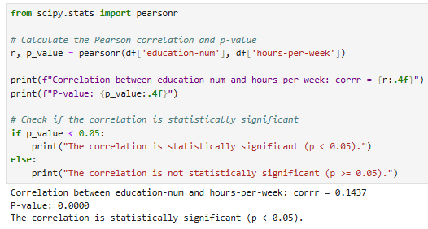Based on the correlation matrix, the only pair with a correlation coefficient greater than |0.1| is education-num and hours-per-week, with a correlation coefficient of 0.143689.

Null Hypothesis (H0): There is no correlation between education-num and hours-per-week (ρ=0)

H1: There is a linear correlation between education-num and hours-per-week. by calculating the p_value, and since we get a value of p_value=0, which is less than 0.05, we can reject the null hypothesis and conclude that there is statistically significant evidence for the relationship (correlation) between the variables education-num and hours-per-week.

Figure 22-Statistical Test

Going deeper, comparing between male and female, I ran the same testing for male dataset and female dataset separately:

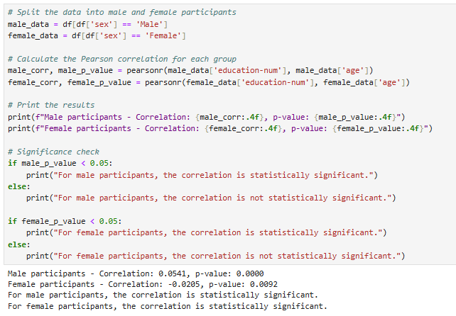I did not expect a negative correlation for females. It appears that educational trends among women may differ from those of men in certain contexts or periods, potentially resulting in a weak inverse correlation between age and education. Younger women seem to attain higher education levels compared to older generations.

Figure 23-p_value Male/Female

Another analysis is the **covariance matrix**:

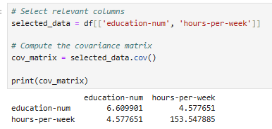education-num: 6.609901. This shows moderate variability in education levels within the dataset. hours-per-week: 153.547885. This indicates significant variability in the number of hours worked per week. The covariance between education-num and hours-per-week is 4.577651. A positive covariance value suggests that as one variable increases, the other tends to increase as well. In this case, people with higher education levels generally tend to work more hours per week

Figure 24-Covariance Matrix

# Machine Learning Part

Since we are classifying income as either more than 50K or less, this is a classification problem. In this section, I have used several models, including Linear Regression with a threshold to convert it into a class, Logistic Regression, XGBoost Classifier, and Random Forest Classifier.

## Data Cleanning

The data cleaning consist of removing outliers and removing or imputing null values. In this exercise I have removed the outliers using the IQR method and removed the rows with null values. Another data cleaning is to remove the typos error available in the values of the income column

## Feature Engineering

At this stage, I have removed the variables (capital-gain, capital-loss ,capital_gain_category, capital_loss_category ) since all these column are now represented by the column capital-gain-loss-classification

Another step I took was encoding all the non-numerical variables. I experimented with two encoding methods: first, I used LabelEncoder(), and then I tried the get_dummies encoding algorithm..

I have tested models using both scaled and unscaled data to assess the impact of feature scaling on model performance. Scaling is important because many machine learning algorithms are very sensitive to the magnitude of input features. Withou scaling, features with larger values can dominate the learning process. I applied standard scaling to bring all features to a similar scale and observed any improvement in prediction accuracy. This comparison helped me to evaluate whether scaling enhances model performance or not.

## Splitting Data

I splitted the dataset into training and testing sets with test_size=0.2 that indicates the proportion of dataset that will be allocated to the test set. In this case, 20% will be allocated for testing and 80% will be allocated for training. Another parameter is random_state=42 that ensure the split is reproducible.

## Training & Prediction

I have done several training and prediction using different models.

For XGBoost and RandomForestClassifier, I have done some hyperparameters fine-tuning using gridseachcv and RandomizedSearchCV to find the best parameters. I summarized the accuracy of each combination of encoder used, model employed, data scaling and Accuracy

|  |  |  |  |  |
| --- | --- | --- | --- | --- |
| # | Encoder | Model | Scaled/not Saled | Accuracy |
| 1 | Label Encoder | Logistic Regression | Not Scaled | 0.78 |
| 2 | Get_dummies | Logisitic Regression | Not Scaled | 0.83 |
| 3 | Label Encoder | Linear Regression(threshold 0.5) | Not Scaled | 0.8 |
| 4 | Get Dummies | Linear Regression (threshold 0.5) | Not Scaled | 0.83 |
| 5 | Get Dummies | RandomForestClassifier(n_esimator=131) | Not Scaled | 83.08 |
| 6 | Get Dummies | XGBoost(n_estimator=100) | Not Scaled | 83.92 |
| 7 | Get Dummies | XGBoost(n_estimator=31) | Not Scaled | 84.12 |
| 8 | Label Encoder | Linear Regresion | Scaled | 0.8 |
| 9 | Label Encoder | Logistic Regression | Scaled | 0.8 |
| 10 | Label Encoder | RandomForestClassifier(n_esimator=141) | Scaled | 82.94 |
| 11 | Label Encoder | XGBoost(n_estimator=41) | Scaled | 84.16 |
| 12 | Get Dummies | Linear Regresion | Scaled | 83 |
| 13 | Get Dummies | Logistic Regression | Scaled | 83.5 |
| 14 | Get Dummies | RandomForestClassifier(n_esimator=111) | Scaled | 82.93 |
| 15 | Get Dummies | XGBoost(n_estimator=31) | Scaled | 84.12 |
| 16 | Get Dummies | RandomForestClassifier()  fine tuned with best param:  {'n_estimators': 600,  'min_samples_split': 2,  'min_samples_leaf': 2,  'max_features': 'sqrt',  'max_depth': 50,  'bootstrap': True} | Scaled | 83.68 |
| 17 | GetDummies | XGBoost  Fine tuned with best param  Best Parameters: {'colsample_bytree': 1.0, 'learning_rate': 0.1, 'max_depth': 5, 'n_estimators': 200, 'subsample': 1.0} | Scaled | 84 |

## General Observations

Looking at rows 1,2,9 and 13 from the table, we can conclude that accuracy with get dummies encoding outperforms label encoder especially with the Logistic Regression for both scaled(80% to 83.5%) and unscaled data (78% to 83%)

Looking at the rows 10, 14, and 16, we can conclude that the RandomForestClassifier shows varying accuracy based on parameter tuning, with the fine-tuned model reaching 83.68% with scaled data and 83.08% unscaled.

We can conclude that Get Dummies encoding is generally more effective than Label Encoder, particularly with XGBoost and Random Forest, both of which benefit more from this encoding. Scaling does not dramatically improve the models' performance but can offer slight improvements in specific cases, such as with XGBoost.