Construction Bidding Simulation using Agent-Based Modeling

Description
A simulation of contractors bidding for projects, using Agent-Based modelling.

How does it work
This is a simulation, using agent-based modeling, of constractors bidding. Each contractor has an error distribution and a markup factor. The error distribution controls the error of the contractor's bid. The markup is the markup for the bid. After each bid, depending on whether the contractor wins or looses, according to the following figure.
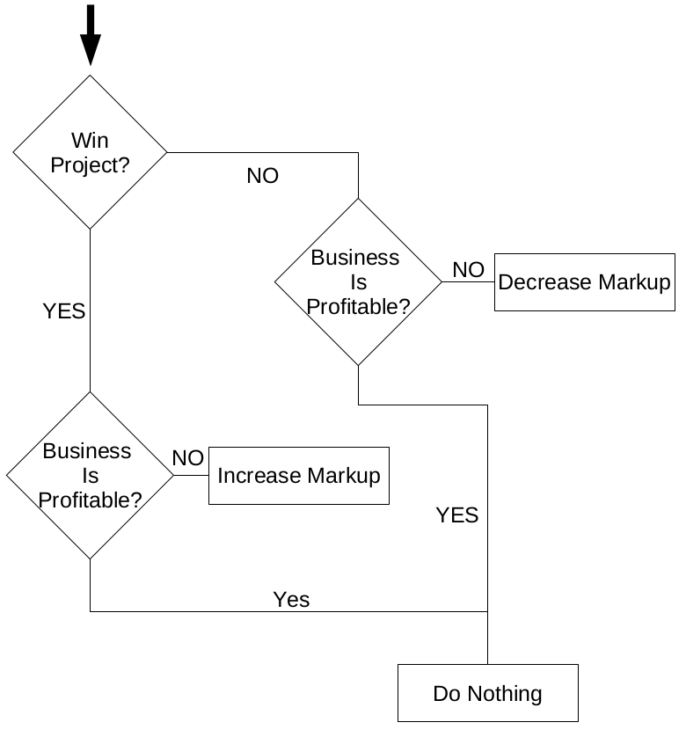

Results and Analysis
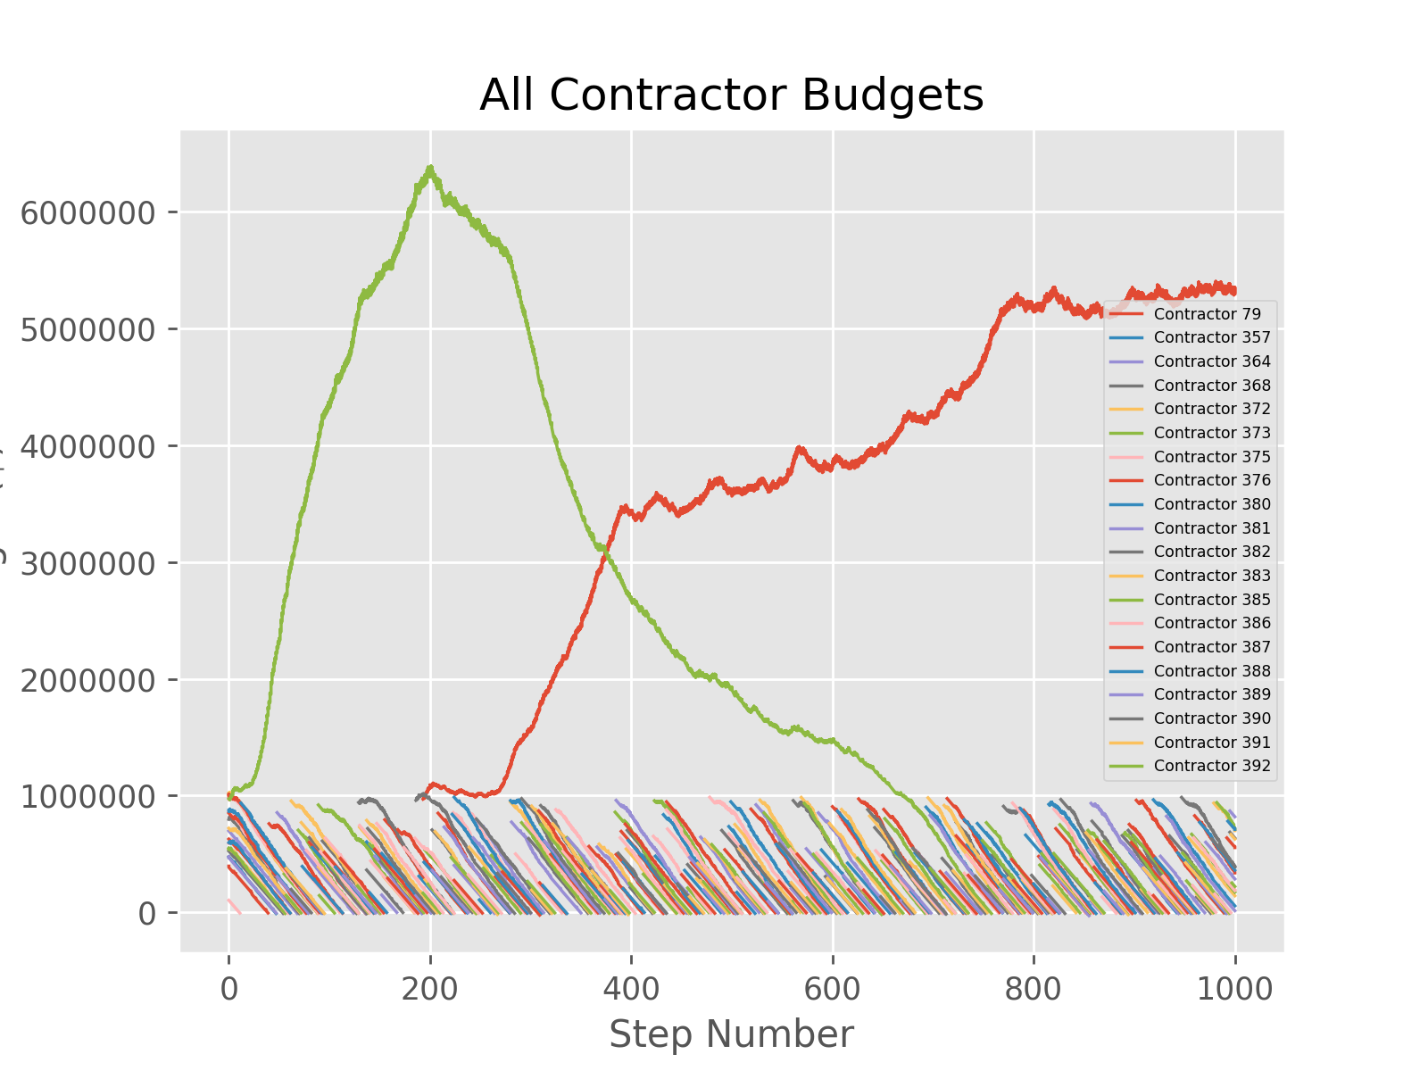
For some - still unresolved - reason, one contractor dominates the market at one time, i.e. the contractor in green, and the contractor in red. Both of those contractor's markups are steady. The other contractors reduce their markup severly, but still do not win bids, and in the end go bankrupt.

Future work
Work is needed to resolve the afforementioned issue. The rules need to be changed to make the market more stable.

