GREETINGS AND FAREWELLS

(gritins and feirwels) – saludos y buenos modales

HELLO!

(jelou) - hola

Color the picture: (colorea la imagen)

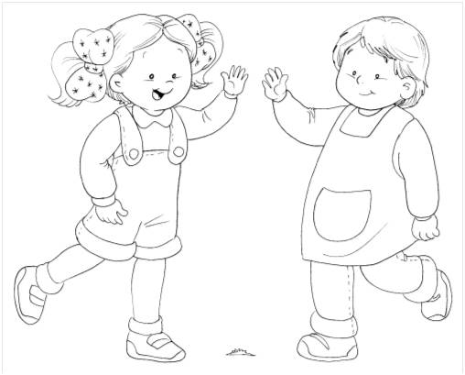

GOOD MORNING!

Gud mornin) – Buenos días

 Spread yellow pastillin inside the sun, then cover it with   
 packing tape. (esparce plastilina amarilla en el sol, luego cúbrelo con cinta de embalaje)

Trace the dots with crayon: (delinea con crayola)

Good Morning!



(gud bai) – adios

Black and White Little Girl Waving Clip Art - Black and ...
 Color and trace the dots with a yellow marker (colorea y delinea con plumón amarillo)

Good bye!