Determinants of County-Level Democratic Swing (2016–2020)
Data Integration, OLS Modelling, and Monte Carlo Simulation
Gastón Sola
MSc Data Science and Public Policy · University College London · gaston.sola.25@ucl.ac.uk
January 2026 · Working Paper
Abstract
This paper investigates the drivers of the Democratic Swing at the U.S. county level between the 2016 and 2020 presidential elections. Integrating four heterogeneous administrative sources — electoral results (MIT Election Lab), county unemployment rates (FRED API), state cost-of-living proxies (MIT Living Wage Project), and demographic denominators (SEER Programme) — the analysis tests the retrospective voting hypothesis: that voters in counties with greater labour market deterioration shifted toward the Democratic candidate. OLS regression on 3,109 counties identifies unemployment change as a positive and highly significant predictor of the Democratic swing (β = 1.42, p < 0.001). A 1,000-iteration parallelised Monte Carlo simulation confirms estimator unbiasedness (bias = 0.010 on the primary regressor). The analysis also surfaces a demographic saturation effect in historically Democratic counties.
Keywords: retrospective voting; electoral swing; county-level analysis; unemployment; OLS regression; Monte Carlo simulation; U.S. elections; political economy; data integration

Part I — Data Acquisition, Web Scraping, and Harmonisation
This study integrates four heterogeneous data sources, requiring archival file parsing (TAB and GZ), API acquisition with local backup, and iterative web scraping.

I.1 The Multi-Source Pipeline
1. Electoral Outcomes (MIT Election Lab)
The foundational dataset contains over 94,000 observations of county-level presidential results. Democratic Swing was computed as the percentage-point change in Democratic vote share (2016 to 2020) after pivoting from long to wide format. FIPS codes were strictly enforced as 5-character zero-padded strings to prevent silent join failures.
2. Economic Stressors (FRED API)
Annual unemployment rates for 3,109 counties were retrieved from FRED. The API's 1,000-series query limit was bypassed by iterating through all states. The unemployment delta is the primary independent variable, grounded in retrospective voting theory. A local backup (.rds) was created to ensure reproducibility without re-downloading.
3. Cost of Living Proxies (MIT Living Wage Project)
State-level living wage data were scraped from livingwage.mit.edu using rvest, iterating through all 51 state codes. While the data reflect 2025 values, relative interstate variation is historically stable, providing an acceptable proxy for structural affordability during 2016–2020.
4. Demographic Denominators (SEER Programme, NCI)
Population, gender, and age data were parsed from large-scale Fixed-Width Format (FWF) files. % Young (< 35) and % Female were calculated as county composition controls. Total population was log-transformed to stabilise variance and reduce the leverage of extreme outliers.

I.2 Harmonisation Challenges and Remedial Strategies
• Identifier Integrity: FIPS codes enforced as 5-character strings to prevent silent join failures across datasets.
• Many-to-Many Join Risks: A unique county lookup table was constructed before merging, ensuring one observation per county.
• Clustering of Regressors: Living Wage is state-level, introducing intra-state clustering; standard errors for this regressor are interpreted with caution.
• Data Attrition: 3,109 of 3,158 counties included in the final regression. Loss of 49 observations (≈ 1.5%) is attributable to missing values in FRED or SEER and does not compromise the analysis.

I.3 Descriptive Visual Analysis

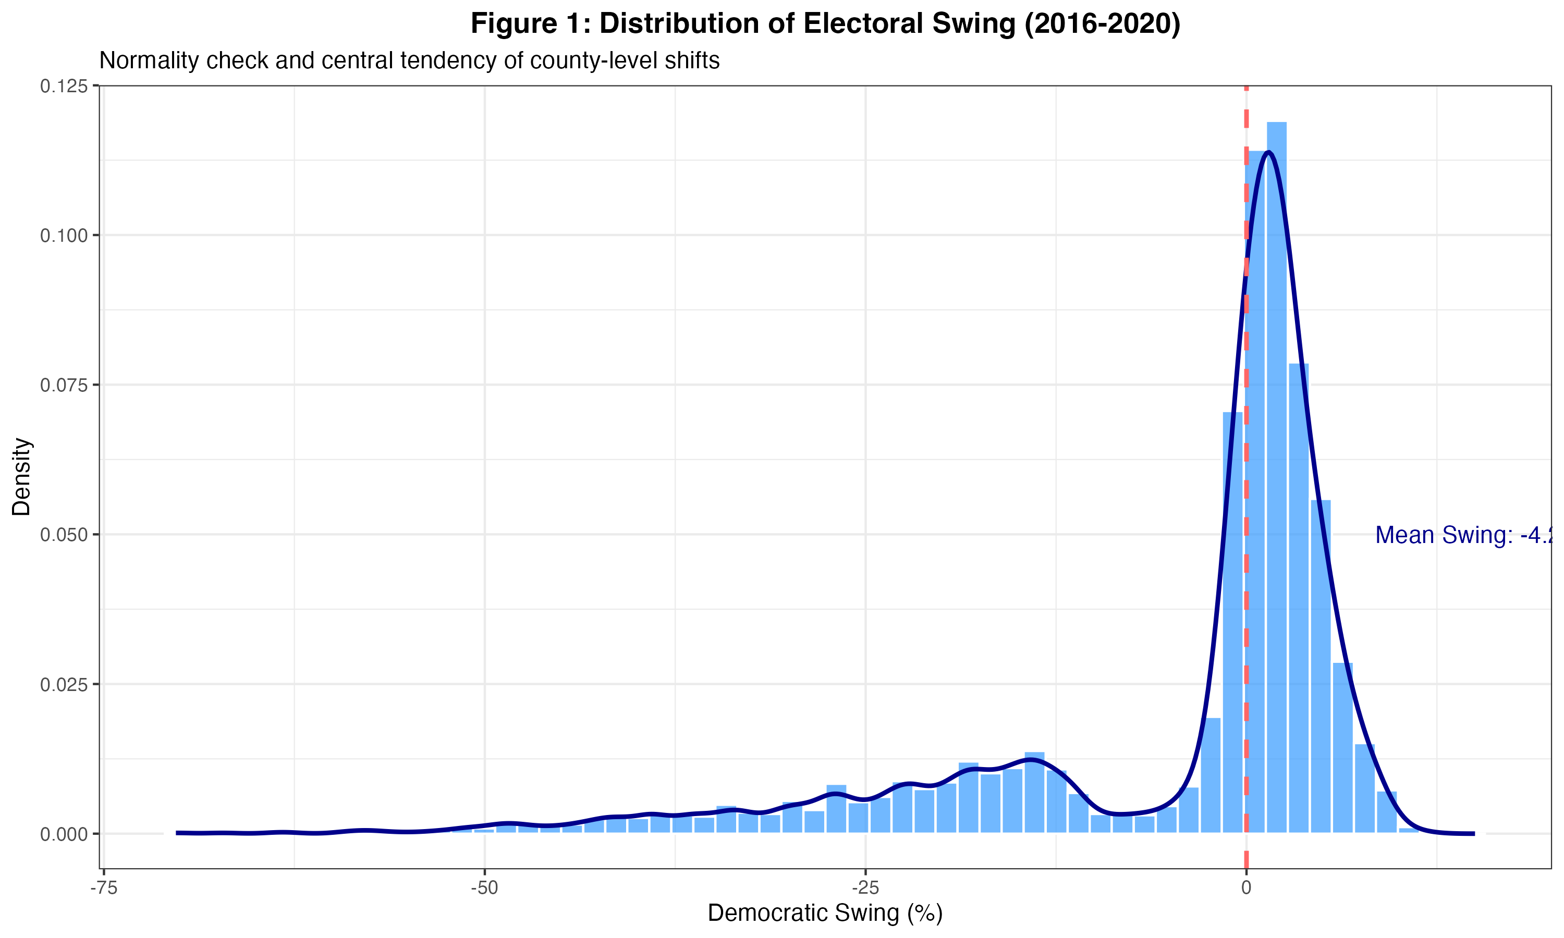
Figure 1 — Distribution of the Democratic Swing (2016–2020)
The swing distribution is heterogeneous and asymmetric, with a dense mass near small positive values and a long negative tail. This motivates the use of pop_log to reduce the leverage of extreme observations in the OLS model.

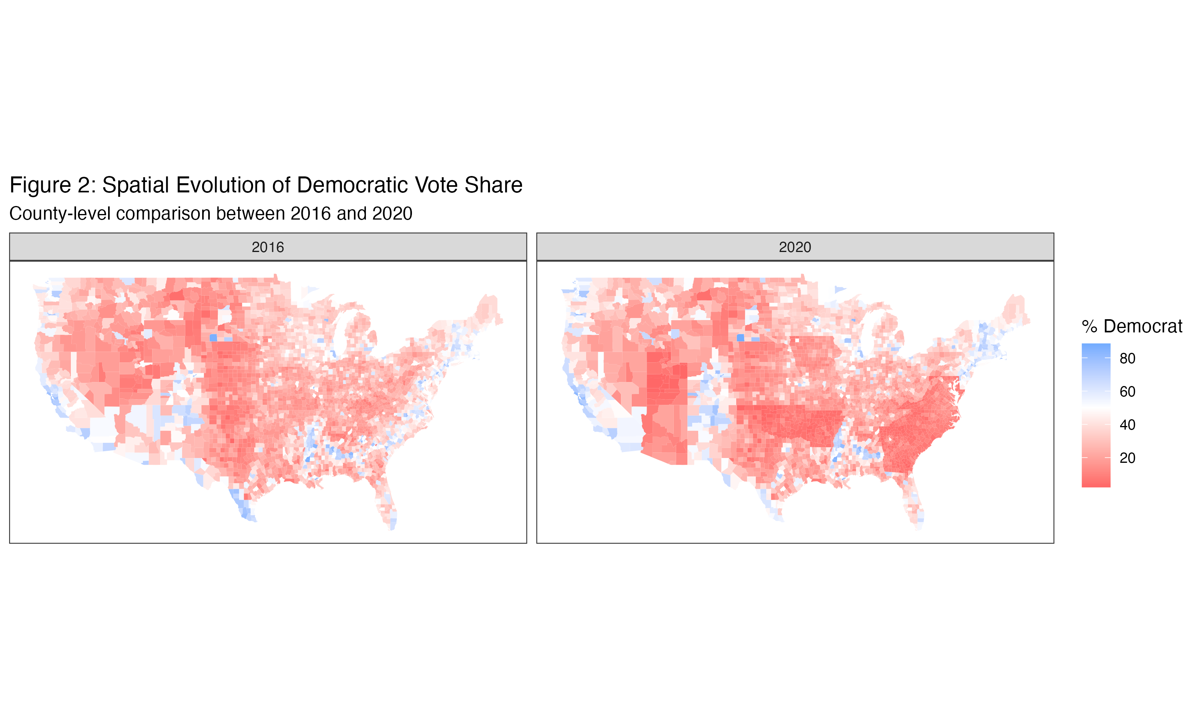
Figure 2 — Spatial comparison: Democratic vote share (2016 vs 2020)
Geographic clustering is evident in both maps, pointing to unobserved regional factors (state institutions, political culture). The visual highlights the urban/suburban versus rural dynamic that characterised the 2016–2020 realignment.

Part II — Modelling Voting Behaviour (2016–2020)

II.1 Research Question and Modelling Approach
Which local economic and demographic conditions are associated with the county-level change in Democratic vote share from 2016 to 2020? Given the continuous outcome, multivariate OLS regression is the appropriate baseline, linking observed county conditions to electoral change with transparent assumptions.

II.2 Model Specification and Hypotheses
• H1 (Retrospective economic voting): Counties with larger unemployment increases will show a larger Democratic swing, as voters punish the incumbent for economic deterioration.
• H2 (Cost-of-living context): Higher state-level costs may correlate with baseline partisan leanings in urbanised high-cost states, limiting marginal swing.
• H3 (Demographic saturation): Negative coefficients for composition variables suggest a saturation effect where already-Democratic counties had limited room for further gains.
• H4 (Urbanisation scale): Population scale proxies urban/suburban structure, central to recent coalition dynamics.

II.3 Regression Results
Table 1 — OLS Regression Results: 2016–2020 Democratic Swing
Variable | Coefficient (Std. Error) | Significance
Unemployment Change | 1.422 (0.161) | ***
Living Wage (State) | −1.057 (0.107) | ***
% Pop < 35 Years | −0.203 (0.042) | ***
% Female | −0.844 (0.100) | ***
Population (Log) | 0.213 (0.194) | (not sig.)
Constant | 65.173 (5.568) | ***
Observations | 3,109
R² | 0.072
Adjusted R² | 0.071
Residual Std. Error | 12.216 (df = 3,103)
F-Statistic | 48.354 (df = 5; 3,103) | ***
*** p < 0.01. Standard errors in parentheses. Dependent variable: percentage-point change in Democratic vote share.
Key findings:
• Unemployment Penalty: Unemployment Change (β = 1.422, p < 0.001) is positive and highly significant. For each 1-point increase in local unemployment, the Democratic swing grew by 1.42 points, confirming retrospective economic voting.
• Demographic Saturation: Negative coefficients for %Young (−0.203) and %Female (−0.844) reflect the limited scope for marginal gains in already-Democratic counties.
• Living Wage Context: The negative coefficient (−1.057) implies that high-cost states — typically Democratic strongholds — had less room for marginal swing.
• Population Scale: Population (Log) (0.213) is not statistically significant (p > 0.1), suggesting size does not independently drive swing once economic and demographic controls are included.

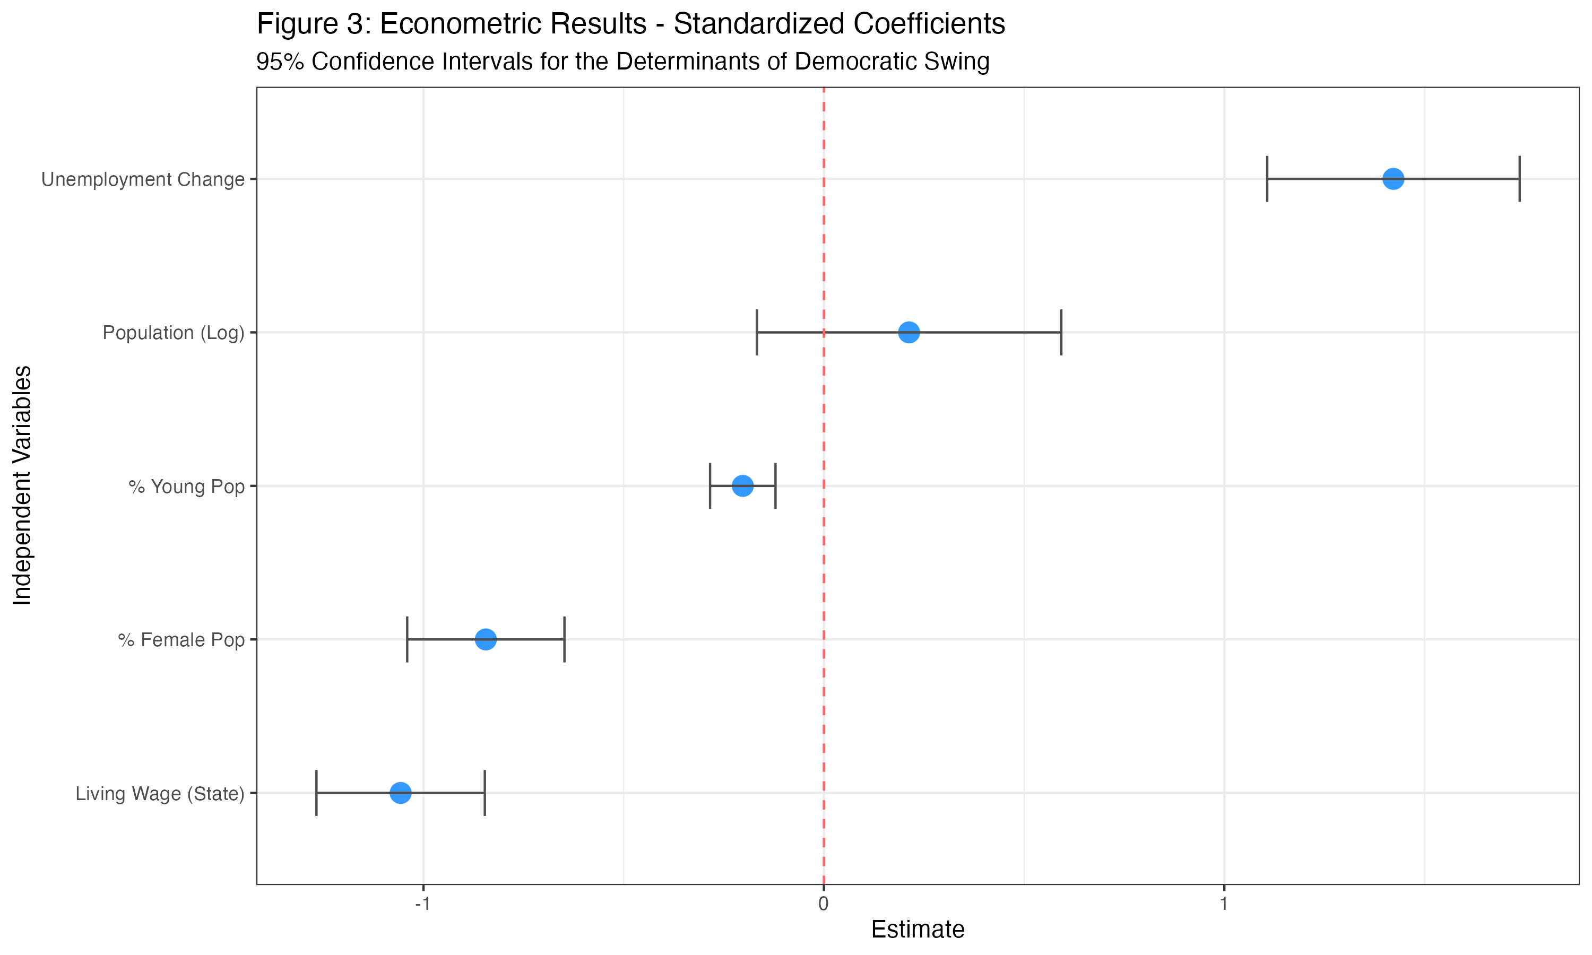
Figure 3 — Coefficient plot with 95% confidence intervals

Part III — Simulation Study (Monte Carlo)

III.1 Simulation Objective
To study the sampling distribution of OLS coefficients under repeated sampling and to demonstrate the performance gains from parallel computing.

III.2 Monte Carlo Design (Fixed X)
1,000 iterations were run with the covariate matrix X fixed at observed values. Stochastic noise was added based on OLS coefficients and the residual standard deviation (12.216). Refitting the regression in each iteration produces the empirical sampling distribution for comparison against theoretical values.

III.3 Sequential vs. Parallel Implementation
The simulation was implemented using foreach and doParallel (4 cores):
• Sequential runtime: ≈0.779 seconds
• Parallel runtime: ≈0.304 seconds
• Speedup: 2.56× — sublinear due to cluster setup and task scheduling overhead, as expected.

III.4 Estimator Consistency and Unbiasedness
Table 2 — Monte Carlo Validation (1,000 Iterations)
Variable | True Beta | Simulated Mean | Bias
Intercept | 65.173 | 65.217 | 0.044
Unemployment Change | 1.422 | 1.432 | 0.010
Living Wage (State) | −1.057 | −1.061 | −0.004
% Pop < 35 Years | −0.203 | −0.202 | 0.001
% Female | −0.844 | −0.846 | −0.002
Population (Log) | 0.213 | 0.219 | 0.006
Bias = Simulated Mean − True Beta. All biases negligible under standard OLS assumptions.

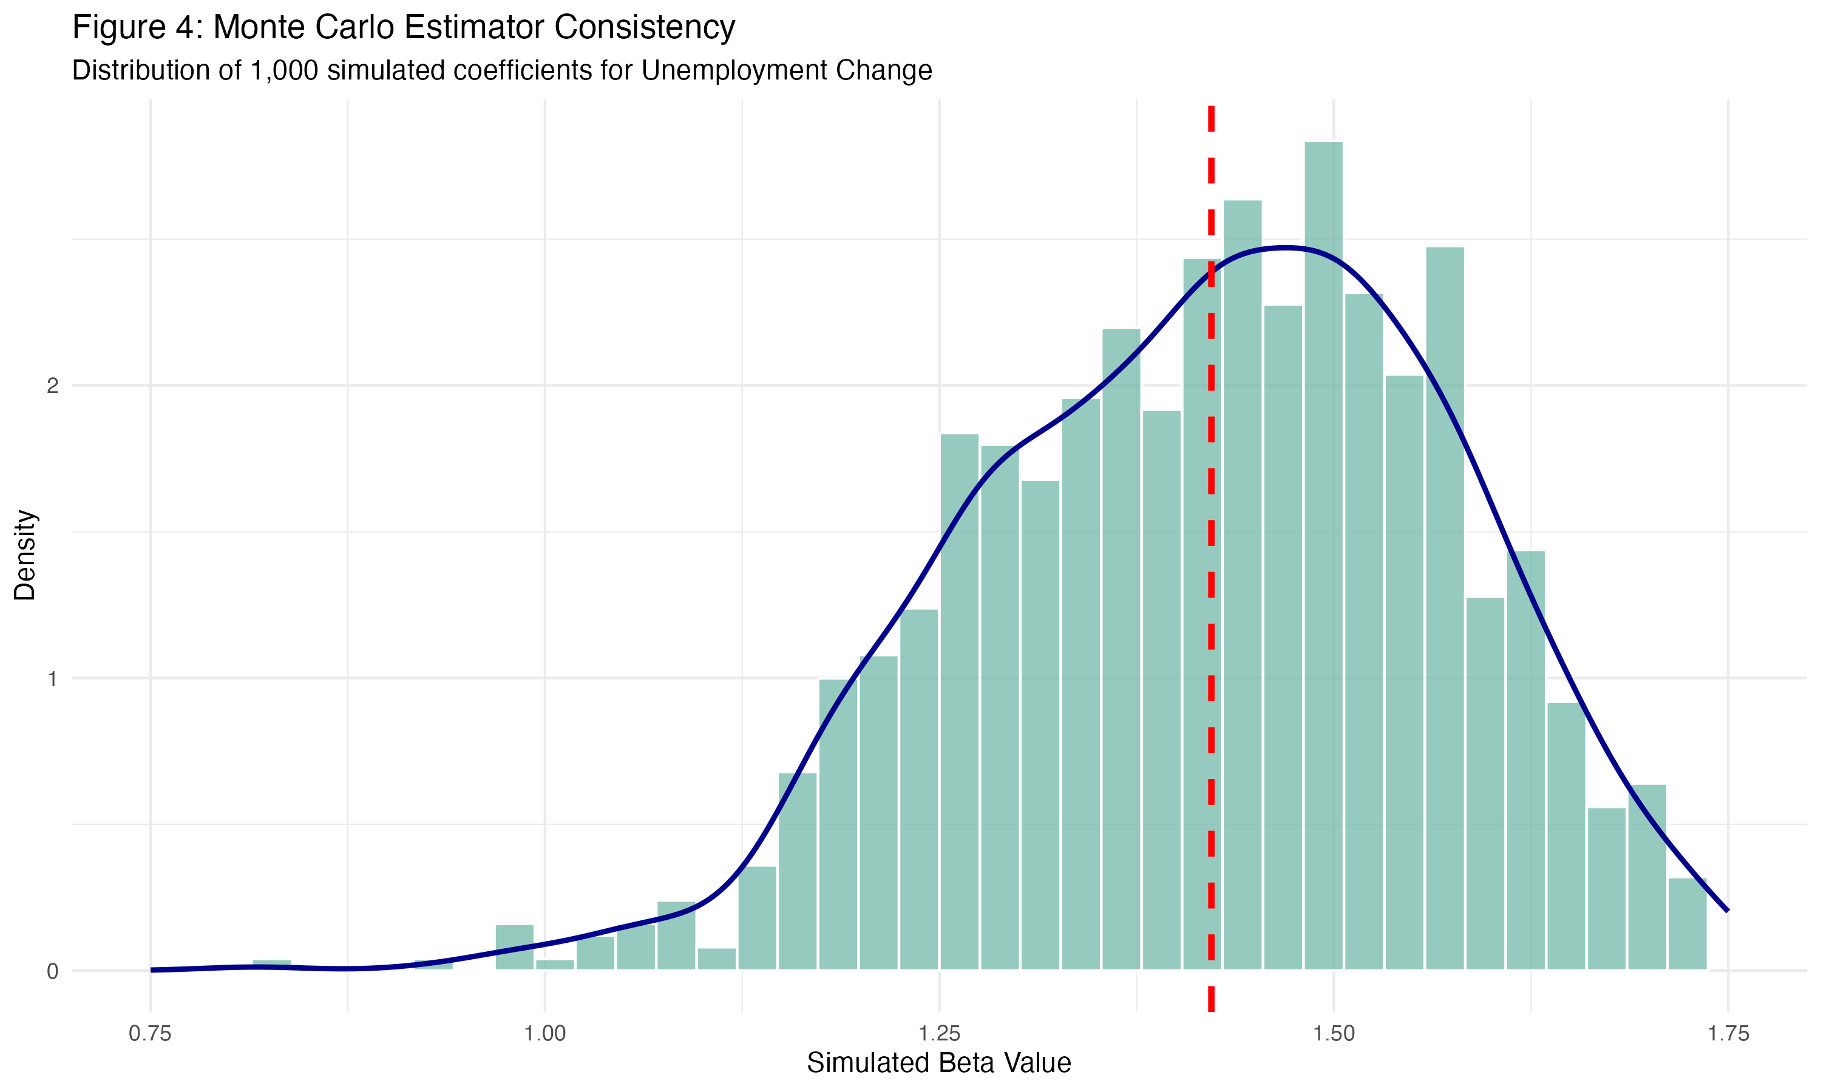
Figure 4 — Sampling distribution of the unemployment coefficient (1,000 iterations)
The density is approximately normal and centred near the true value (bias = 0.010), confirming that OLS inference in Part II is not driven by numerical instability or idiosyncratic sampling.

Conclusion
Even in an era of intense partisan polarisation, local economic stress — captured by county-level unemployment volatility — is strongly associated with shifts in electoral margins. This confirms a retrospective voting mechanism where voters held the incumbent party accountable for crisis-era labour market disruption. Demographic composition shapes baseline political geography, but economic disruption was the critical correlate of marginal change in 2020.
The Monte Carlo study confirms unbiased OLS estimation under standard assumptions, and parallelisation delivers meaningful runtime gains for repeated estimation. The full pipeline is reproducible from publicly available sources; see electoral_swing_analysis.R and README.md for replication instructions.
Note¹ — AI (Gemini 1.5 Pro) was used solely for grammar correction. All research, analysis, modelling, and interpretation are the author’s own.

