# Yoda

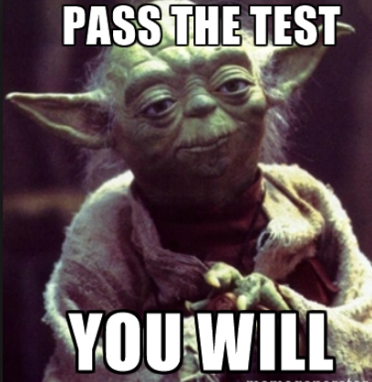From Wikipedia, the free encyclopedia

**Yoda** is a fictional character in the [*Star Wars*](https://en.wikipedia.org/wiki/Star_Wars) [space opera](https://en.wikipedia.org/wiki/Space_opera) franchise created by [George Lucas](https://en.wikipedia.org/wiki/George_Lucas), first appearing in the 1980 film [*The Empire Strikes Back*](https://en.wikipedia.org/wiki/The_Empire_Strikes_Back). In the original films, he trains [Luke Skywalker](https://en.wikipedia.org/wiki/Luke_Skywalker) to fight against the [Galactic Empire](https://en.wikipedia.org/wiki/Galactic_Empire_(Star_Wars)). In the prequel films, he serves as the ***Grand Master of the Jedi Order*** and as a high-ranking general of [Clone Troopers](https://en.wikipedia.org/wiki/Clone_Trooper) in the [Clone Wars](https://en.wikipedia.org/wiki/Clone_Wars_(Star_Wars)).

### Contents

1. [Performance](https://en.wikipedia.org/w/index.php?title=Yoda&printable=yes" \l "Performance)
   * [1.1 Character overview](https://en.wikipedia.org/w/index.php?title=Yoda&printable=yes" \l "Character_overview)
2. [Appearances](https://en.wikipedia.org/w/index.php?title=Yoda&printable=yes" \l "Appearances)
   * [2.1 Feature films](https://en.wikipedia.org/w/index.php?title=Yoda&printable=yes" \l "Feature_films)
     + [2.1.1 Original trilogy](https://en.wikipedia.org/w/index.php?title=Yoda&printable=yes" \l "Original_trilogy)
     + [2.1.2 Prequel trilogy](https://en.wikipedia.org/w/index.php?title=Yoda&printable=yes" \l "Prequel_trilogy)
     + [2.1.3 Sequel trilogy](https://en.wikipedia.org/w/index.php?title=Yoda&printable=yes" \l "Sequel_trilogy)
3. [Merchandising](https://en.wikipedia.org/w/index.php?title=Yoda&printable=yes" \l "Merchandising)

### Performance

[Frank Oz](https://en.wikipedia.org/wiki/Frank_Oz) provided Yoda's voice in each film and used his skills as a [puppeteer](https://en.wikipedia.org/wiki/Puppeteer) in the [original trilogy](https://en.wikipedia.org/wiki/Star_Wars_original_trilogy) and [*Star Wars: Episode I – The Phantom Menace*](https://en.wikipedia.org/wiki/Star_Wars:_Episode_I_–_The_Phantom_Menace). For some walking scenes in Episodes V and I, dwarf actors [Deep Roy](https://en.wikipedia.org/wiki/Deep_Roy) and [Warwick Davis](https://en.wikipedia.org/wiki/Warwick_Davis) appeared in costume as Yoda (though neither was credited). While Frank Oz served as the primary performer, he was assisted by a multitude of other puppeteers, including:[[5]](https://en.wikipedia.org/w/index.php?title=Yoda&printable=yes" \l "cite_note-5) [Kathryn Mullen](https://en.wikipedia.org/wiki/Kathryn_Mullen) (*Ep. V*), [Wendy Froud](https://en.wikipedia.org/wiki/Wendy_Froud) (*Ep. V*), [David Barclay](https://en.wikipedia.org/wiki/David_Barclay_(puppeteer)) (*Ep. V*-*VI*), [Mike Quinn](https://en.wikipedia.org/wiki/Mike_Quinn_(puppeteer)) (*Ep. VI*), [David Greenaway](https://en.wikipedia.org/wiki/David_Greenaway) (*Ep. I* & *VI*), [Don Austen](https://en.wikipedia.org/wiki/Don_Austen) (*Ep. I*), and Kathy Smee (*Ep. I*). For the [radio dramatizations](https://en.wikipedia.org/wiki/Star_Wars_(radio)) of [*The Empire Strikes Back*](https://en.wikipedia.org/wiki/The_Empire_Strikes_Back) and [*Return of the Jedi*](https://en.wikipedia.org/wiki/Return_of_the_Jedi), Yoda was voiced by [John Lithgow](https://en.wikipedia.org/wiki/John_Lithgow), while [Tom Kane](https://en.wikipedia.org/wiki/Tom_Kane) voiced him in the [*Clone Wars* animated series](https://en.wikipedia.org/wiki/Star_Wars:_Clone_Wars_(TV_Series)), several [video games](https://en.wikipedia.org/wiki/Video_game), and the series [*Star Wars: The Clone Wars*](https://en.wikipedia.org/wiki/Star_Wars:_The_Clone_Wars_(2008_TV_series)).

|  |  |  |  |
| --- | --- | --- | --- |
| **Films** | **Television series** | **Games** | **Audio** |
| The Clone Wars (2008–14)  Rebels (2014–present) | IV – A New Hope (1977)  V – The Empire Strikes Back (1980)  VI – Return of the Jedi (1983) | Star Wars Battlefront | Music of Star War |