Yoda
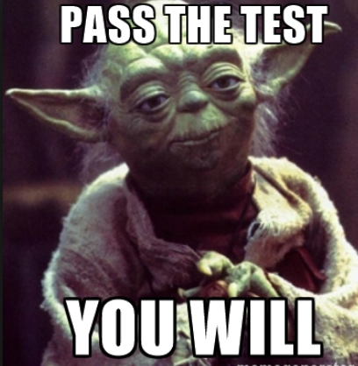
From Wikipedia, the free encyclopedia
Yoda is a fictional character in the Star Wars space opera franchise created by George Lucas, first appearing in the 1980 film The Empire Strikes Back. In the original films, he trains Luke Skywalker to fight against the Galactic Empire. In the prequel films, he serves as the Grand Master of the Jedi Order and as a high-ranking general of Clone Troopers in the Clone Wars.

Contents
- Performance
  - 1.1 Character overview
- Appearances
  - 2.1 Feature films
    - 2.1.1 Original trilogy
    - 2.1.2 Prequel trilogy
    - 2.1.3 Sequel trilogy
- Merchandising

Performance
Frank Oz provided Yoda's voice in each film and used his skills as a puppeteer in the original trilogy and Star Wars: Episode I – The Phantom Menace. For some walking scenes in Episodes V and I, dwarf actors Deep Roy and Warwick Davis appeared in costume as Yoda (though neither was credited). While Frank Oz served as the primary performer, he was assisted by a multitude of other puppeteers, including:^{[5]} Kathryn Mullen (Ep. V), Wendy Froud (Ep. V), David Barclay (Ep. V-VI), Mike Quinn (Ep. VI), David Greenaway (Ep. I & VI), Don Austen (Ep. I), and Kathy Smee (Ep. I). For the radio dramatizations of The Empire Strikes Back and Return of the Jedi, Yoda was voiced by John Lithgow, while Tom Kane voiced him in the Clone Wars animated series, several video games, and the series Star Wars: The Clone Wars.
Films | Television series | Games | Audio
The Clone Wars (2008–14)  Rebels (2014–present) | IV – A New Hope (1977)  V – The Empire Strikes Back (1980)  VI – Return of the Jedi (1983) | Star Wars Battlefront | Music of Star War

