**A simple and accurate method based on a water consumption model for phenotyping soybean genotypes under hydric deficit conditions**

Sebastián Simondi, Esteban Casaretto, Gastón Quero, Sergio Ceretta, Victoria Bonnecarrere and Omar Borsani\*

G. Quero, E. Casaretto and O. Borsani, Departmento de Biología Vegetal, Facultad de Agronomía, Universidad de la República, Garzón 809, Montevideo, Uruguay, V. Bonnecarrere, Instituto Nacional de Investigación Agropecuaria (INIA), Unidad de Biotecnología. Estación Experimental Wilson Ferreira Aldunate, Ruta 48, Km 10, Rincón del Colorado, Canelones 90200, S. Simondi, 4Area de Matemática, Facultad de Ciencias Exactas y Naturales, Universidad Nacional de Cuyo (FCEN-UNCuyo), Padre Contreras 1300, Mendoza. Argentina. S. Ceretta, Instituto Nacional de Investigación Agropecuaria (INIA), Programa de Cultivo de Secano, Estación Experimental INIA La Estanzuela, Ruta 50, Km 11, Colonia, Uruguay,

\*Corresponding author: Omar Borsani [oborsani@fagro.edu.uy](mailto:oborsani@fagro.edu.uy)

**Abstract** (350 palabras)

Kinetic of water consume is an informative and useful trait for high through phenotyping for drought response and GWAS analysis in soybean

**Introduction**

Drought stress is one of the most important environmental factors which limits crop productivity and reduce yield stability. This reduction has occurred despite the continuous yield increasing achieved by breeding and better agricultural practices. Soybean (*Glycine* *max* L.) is not an exception on this scenery; conversely it is especially susceptible considering it is a summer crop (Zhang and Lin, 2016; Zipper et al. 2016). Drought stress affects both, the vegetative and the reproductive stages in soybean, reducing leave area, increasing flower and pod abortion and diminishing pod and seed size (Boyer, 1983). There are several works which relate the response in the vegetative stage with drought tolerance during reproductive stages (Kron et al. 2008; He et al. 2016; Sinclair et al. 2010). According to Kron et al (2008) there is a “developmental window” in V4 stage (Fehr et al. 1971), where plant subjected to water stress improve the subsequent drought stress tolerance in the reproductive stage. Furthermore, Sinclair et al. (2010) using a simulation model determined that water conservation, through early decrease in stomata conductance and reduced transpiration rate, explain the increase in soybean yield during 70 years with drought events.

Soybean breeding programs are mostly focused on increasing total yield and yield stability, which is principally affected by water shortage during the crop cycle. These programs, and particularly public breeding programs, do not use drought response as selection criteria due to the expensiveness of the massive phenotyping equipment currently available. Most of high-throughput phenotyping platforms are based on the diagnostic of changes in the plant physiology, such as leaf conductance, leaf area and root system development, using a complex and expensive system of analysis (Humplík et al. 2011). Hence, including drought tolerance as a selection criterion in breeding programs requires the developing of high-throughput, precise and low-cost phenotyping strategies (Tuberosa, 2012). However, as Valdez et al (2013) indicate strategies could include the quantification of two crucial aspects of the plant water budget: (i) the ability to capture more water; and (ii) the ability to conserve and use captured water more efficiently. (Functional Plant Biology, 2013, 40, 1310–1322 <http://dx.doi.org/10.1071/FP13149>). Nowadays is well documented that water extraction during the key crop stages is greatly informative about crop performance under water restriction scenario (Ratnakumar et al. 2009; Zaman-Allah et al. 2011a; Vadez et al. 2013b). (Functional Plant Biology, 2013, 40, 1310–1322 [htp://dx.doi.org/10.1071/FP13149](http://dx.doi.org/10.1071/FP13149)).

Water balance in a land crop is greatly dependent of evapotranspiration phenomena. This is the combination of two independent processes involved in water losses from the soil. One is the evaporation of the water content in the soil surface and the second is the loos of water contained in the plant tissues by transpiration. In crops, the transpiration is increased as the plants grow due to the increase of leaf area and at the same time this cause a contrary effect on the evaporation that become each more depreciable. Evapotranspiration can be determined by measuring several components of water balance in the soil. Specifically, in a controlled close system wherein no run-off or percolation, the total water content of the system within a certain period of time can be quantified as weight.

At whole plant level and under constant water demand, water uptake or water use depends mainly on root system development, leaf area, transpiration rate and leaf conductance (Vadez et al., 2013). Under conditions with increasing water restriction the role of each parameters mentioned above on water use is different. However, there is a consensus in the scientific community that transpiration changes are a critical component in a context where the available water content in the soil is changing (). Transpiration is determined by the demand and controlled by stomatas, during soil desiccation water extractable by the roots is continuously reduced determining that full transpiration demand cannot supported, in this situation the plants respond with the stomatal closure to avoid shoot desiccation. Also, stomatal opening is quite sensitive to the evaporative demand, and a high vapor pressure deficit (VPD) reduces stomatal aperture to restrict water losses, soil water content and atmospheric demand ultimately determine dynamic of water consume (). On this way, leaf conductance measurements using gravimetric methods have been explored as robust parameters for breeding programs (). Moreover, in soybean variation of stomatal response to VPD and water soil content has been revealed is genotypic dependent (Fletcher et al. 2007; Sadok and Sinclair 2009).

In this study, we developed a simple and informative model supported by biological and mathematical approaches for evaluating, under controlled growth condition, soybean plants response to water restriction through quantification of water consumption in vegetative stage. In order to find a physiological explanation of the variables generated by the model, they were correlated with stomatal conductance dynamic. Also, preliminary testing of the model was performed in a segregating biparental population and in an elite breeding population, independently. Results demonstrate that the approach proposed is a valid option to be included in plant phenotyping protocols with low incorporation of manpower and infrastructure.

**Materials and methods**

**Phenotyping method based on water consumption under environmental controlled conditions**

For the mathematical model develop, an experiment with a soybean genotype (GENESIS 5601) was performed. Plants were grown in a plastic 0.5 L bottle (pot) filled with a mix of sand:vermiculite 1:1. This combination of plant, pot and substrate was defined as Plant Pot Substrate system (PPS). Plants were grown in an environment defined by 30/20 °C day/night cycle and a photoperiod 16/8 light/darkness, humidity was controlled at 35/40 % HR during all growth period. Solucion nutritive Three seeds per pot were sown and after cotyledon was expanded only one seedling was remained. Plants homogeneity was carefully analyzed to avoid any interference related with plant developmental phenotype. During the first 16 days after sowing (developmental stage V2-3), soybean seedlings were grown without water restriction and substrate were kept at field capacity. Since day 17 watering was suspended and water substrate content was measured by gravimetry (water gravimetric content) daily during the next 10 days of water deficit (dwd) (**Figure 1**). PPS weight and stomatal stomata conductance () was measured simultaneously.

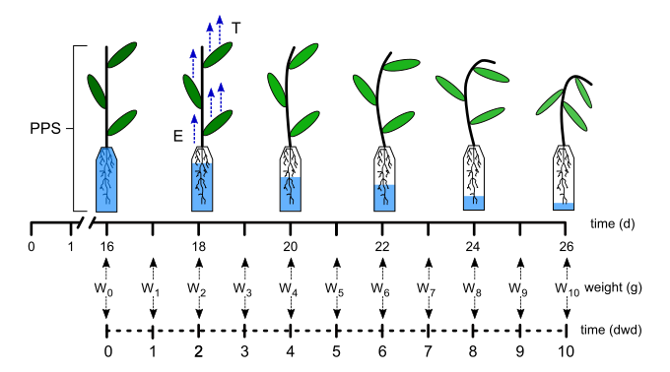

**Figure 1. Schematic illustration of the experiment for water consumption determination.** Plants were maintained in field capacity condition until day 16. Afterwards, water supply is suspended. The Plant Pot Substrate system (PPS) was weighted every day for 10 days ( until  ). Evaporation (), Transpiration (), days of wáter déficit (dwd) .

**Mathematical model description**

In the experiment the PPS system weight ()is defined by the weight of water () plus the rest of components of system (******). ****** is the summatory of substrate, pot and plant weight respectively, this last was considered constant during the assay, because in spite off could vary during the days this is insignificant in comparison of the rest of components of ******. ****** is the summatory the transpirable water (******) plus a percentage of that cannot be evapotranspired by the PPS during the whole assay, this portion of water not evapotranspirable is defined as residual water (). Values of  depend of the matric potential of the substrate and the transpiratory capacity of plants **(Figure 2A).** Quantity of water could be evapotranspired by the PPS is a function dependent of time (*)*, and is named*.*Therefore, 

***Modelling of PPS weight along the time***

If  is function of weight of PPS along the time *t*, so



In order to find an algebraic expression for the function , we assume the following supposition: *“Velocity with which the PPS weight varies is directly proportional to water that can be evapotranspired for the PPS in this fraction of time”*. Supposition can be mathematically expressed through the following differential equation



where $k>0$ is a constant of proportionality. Negative sign of the equation is due the weight of PPS decrease along the time, because the assay was performed withdrawing the watering at .

Like  and ** are constant magnitudes along the time, derivation of the equality getting , thus the equation can be rewritten as



Obtaining the differential equation for the function .

Resolving the equation get us



Combination of (0.1) and (0.4) the following equation is obtained



Graphic representation and the experimental data adjusting of equation (0.5) are showed in **Figure 2A**.

***Modelling of evapotranspiration as function of time***

In order to quantify the evapotranspiration (Figure 2B) () by the PPS from the precise moment of the watering was withdrawal () to time *t*, the differentia between the weight of PPS in both times, that is



Combining the equation and (0.6) we have that,



Therefore,



Graphic representation and the experimental data adjusting of equation are showed in **Figure 2B.**

***Potential evapotranspiration estimated by the model***

At the moment the watering is suspended (), the PPS have the maximum quantity of evapotranspirable water. By definition, this quantity is  as is observed in **Figure 2A**.

On the other hand, because the constant of proportionality  of the equation is positive, we have that



That is, the parameter is the horizontal asymptote of the function , and represent the potential evapotranspiration of PPS, as can be observed in **Figure 2B.**

***Half-life of ET***

Half-life is by definition, the time required for PPS to reduce to half of potential evapotranspiration. Because the potential evapotranspiration is **, we have that the half-life, , satisfice



For calculating , equation is used and we have that



Thus the half-life is inversely proportional to the constant and independent of**. Graphic representation of  is showed in Figure 2B.

***Calculation of parameters of the ET model from the experiment data***

If is the weight of PPS registered in the *j-*th day since the water suspension, is the set of data obtained from de assay (**Figure 2A**).

Para determinar los parámetros de ET en función del tiempo (**Figure 2B**), utilizando dicho conjunto de datos podemos a partir de la ecuación el método de cuadrados mínimos que necesita recursos computacionales o un método analítico. For this last option we took three specific determinations, ,  and , performed in the days *0, n* and *2n* respectively. Replacing this data on the equation we can find directly the parameters, obtaining

 .



Comparison between the results obtained by both methods is showed in Figure 3

***Stomatal conductance as function of time***

By definition, stomatal conductance () is the measurement of velocity CO2 entering to the substomatal chamber, and the water vapor exiting through the stomata pore of the leaf. Since the big part the water loosed by the PPS is from the stomatal transpiration, so is possible suppose that the evaporation is negligible, thus the variation of the weight can be assigned only to the transpiration, that is



Deriving and replacing in we have that,



Graphic representation and the experimental data adjusting of equation are showed in **Figure 4A.**

***Conductance as function of PPS weight***

Combining with get,



Then,



wherein .

Thus, the stomata conductance is a lineal function of weight of PPS as is showed in **Figure 4B**.

**Phenotyping strategy applied to F3 segregating population**

A F3 segregating population of 177 genotypes derived from the crossing of parental lines SO.655 x DM6.8 was phenotyped using the methodology and the mathematical model developed in this study. The phenotyping experiment was laid out in a randomized incomplete block design with three replications in each experiment. Growth conditions were the same described above. The PPS weight and stomatal stomata conductance was measured simultaneously.

**Phenotyping strategy applied to an elite breeding population**

A local elite breeding population was also phenotyped using the methodology and the mathematical model described above. This population was composed of 190 genotypes which belong to maturity group (MG) IV to VII. Five commercial well known varieties (fulana y mengana, etc) were included as checks in all phenotyping experiments. In this case, plants were grown in a PVC tube 2.851 L (11 cm diameter and 30 cm length) with a mix of sand/vermiculite (1/1) under same environmental conditions described previously. Plant grown without any watering restriction for 30 days (developmental stage V4-5) afterward the watering was suspended and the PPS weight registered. The weight of PPS at day 0, 4 and 8 after water supply suspension was registered. The PPS weight and stomatal stomata conductance was measured simultaneously.

**Data analysis**

Correlaciones y regresiones. Analisis de componentes principales.

**Multivariate characterization**

The multivariate characterization of the Soja populations was accomplished by means of some exploratory analysis and visualization tools. First, genotypes were clustered in groups based the PCA of all thegenotypic variables using a hierarchical clustering algorithm (HCPC). Genotypes were grouped based on similarity from the Euclidean distance using the Ward method and the number of groups was determined by the highest relative loss in inertia using the function *HCPC* of the *FactoMineR* (Le et al. 2008) package in R Statistical Software (R Core Team, 2018). Second, a correspondence analysis (CA) was performed from the contingency tables of the HCPC analysis from genotypic and the agrupacion hecha en function de T0.5 y de Gw0.5. The correspondence analysis was performed to visualize the relationship between the two grouping strategies (i.e. based on molecular markers and based on phenotipic variables). The CA was conducted using the *CA* function of the *FactoMineR* (Le et al. 2008) package in R Statistical Software (R Core Team, 2018).

**Statistical model**

**Adjustment of phenotypic means**

Best linear unbiased estimators (BLUEs) for each advanced inbred line were obtained with mixed models to include experimental design components using the following model:

yij = µ+ αi + βj + εij

where yij is the response variable, µ is the overall mean or intercept, αi a random variable associated with the ith assay with αi ~ Ν (0, σ2A), βj is the effect of the jth line, and εij is the residual error with εij ~ Ν (0, σ2ε). The model was adjusted in the R statistical software using the *lme4* package (Bates et al. 2015) in R Statistical Software (R Core Team 2018). The BLUEs were estimated using the *emmeans* package (Russell 2019) in the R statistical software (R Core Team 2018). In all cases, BLUEs were further used as genotypic values for the model, PCA and CA analysis.

**Genotyping by sequencing and SNP calling**

**FALTA poner como se hicieron los marcadores de la población biparental**

Genotyping-by-sequencing (GBS) data were obtained for the elite breeding population. DNA was extracted from young leaf tissue from plants grown in the Biotechnology Unit at Las Brujas, Canelones, Uruguay. The extraction was performed using the Qiagen DNeasy kit (www.qiagen.com). GBS libraries and sequencing were done at Université Laval, Canada, as described in Elshire et al. (2011). SNPs were called from fastq files using the TASSEL5.0 v2 GBS pipeline (Glaubitz et al., 2014). DNA samples were digested with the ApeKI restriction enzyme followed by the ligation of adapters to the ends of the fragment. Adapters consisted of ION-Torrent Proton (Life Technologies, Carlsbad, CA) sequencing primers and a barcode adapter for sample multiplexing. A PCR amplification was performed to create the GBS libraries, which were submitted to ION-Torrent Proton for sequencing. Two sequenced libraries produced on average 100 Mb high-quality reads. The GBS analysis pipeline as implemented in Tassel Version 5.0 v2 was used to call SNPs. Briefly, 1) tag counts were generated from fastq files with the FastqToTagCount plugin (options: −s 300000000, −c 1); 2) tag counts were merged with the MergeMultipleTagCount plugin (options: −c 5); 3) tags were aligned to the reference genome Gmax\_275\_v2.0 (downloaded from Phytozome on July 2016) with BWA version 0.7.5a and then added to GBSdb using the SAMToGBSdb plugin with the position information for each aligned tag. SNPs were called using the DiscoverySNPCaller plugin V2 (options: −mnMAF 0.01, −mnLCov 0.1, −mxSites 1,000,000). The quality scores for all discovered SNPs were calculated with the SNPQuality Profiler plugin. Scaffolds were ignored for SNP calling. To obtain the final SNP matrix, SNPs with over 50% missing data and SNPs with a minor allele frequency under 1% were removed from the analysis. All genotypes with more than 70% of missing markers were removed.

**Results**

In this work, we developed an empirical mathematical model for describing the kinetic of water consumption of a PPS (Figure 2 and 4) using soybean as interest plant. This model was the base for the development of a water deficit response phenotyping methodology of soybean plants in V3 stage under controlled environmental conditions. The methodology was also used for phenotyping two breeding populations. Parameters of model defined by water consumption and its relationship with stomatal conductance () was also analyzed (Figure 4).

**Mathematical model explains the kinetic of water consumption of soybean**

To development an empirical model, the PPS weight measurements () during the whole water deficit period were used to determine the curve fitting according the experimental methods described in Figure 2. As is shown in Figure 1, ten days of water restriction determine a curve of weight loos of the PPS determined by the water transpired by plants. As is indicated in the Figure 2A,  at time t is defined by the parameters  determined by the weight when  is 0 and represent the water that could be evapotranspired,  the water not extractable and  the weight of support and dry substrate.

La evapotranspiración del PPS en función del tiempo desde que se suprimió el suministro de agua queda determinada en la ecuación por dos parámetros y . Recordemos que el parámetro represent the potential evapotranspiration of PPS y half-life () is by definition, the time required for PPS to reduce to half of potential evapotranspiration Figura 2B. These parameters are good indicators of water consumption kinetic of the genotypes and could help to the characterization of soybean genotypes.

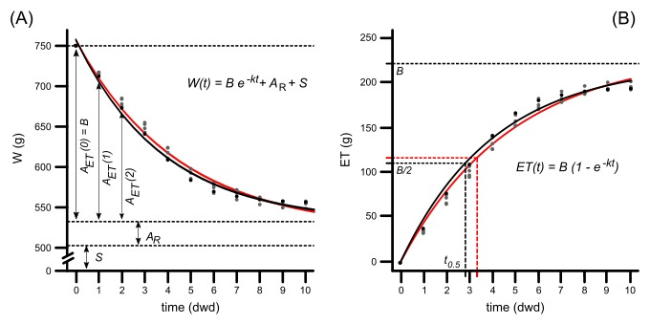

**Figure 2. A)** **Empirical model representing the evapotranspiration over time and empirical model adjustment.** Weight () of the PPS along days water of deficit (dwd). The sum of substrate, pot and plant weight (), residual water (), water evapotranspirable () and potential evapotranspiration () by plants at field capacity conditions. **B)  as function of time**. Mathematical analysis for modeling  as function of time. Parameter  is the time required for PPS to reduce to half of potential evapotranspiration.

**Model minimizes sampling requirements in phenotyping protocols**

To simplify the data collection procedure and increase the high throughput capacity, the model parameters were estimated using the minimum sampling. En la figura 3A se grafican los valores del parámetro k de la ecuación X estimado por el método numérico de Gauss\_Newton versus los valores del parámetro k estimado por un método analítico con un muestro de 2 días del peso del PPS. Como se ve en la Figura 3A el ajuste optimo se obtiene cuando se los valores del peso del PPS son el día 4 y 8, los parámetros estimados con el peso de estos dos días se acercan más a la línea de …………. . Lo mismo sucede para el parámetro B de la ecuación X. Both parameters of the model are critical to evaluate the water consumption curve of a specific genotype. Hence, the weight of PPS in days 4 and 8 appear to be enough to describe the kinetic of water consumption for along water restriction period. En la Figura 3C se observa que el ajuste de la curva de la ecuación X con los parámetros B y k es el mismo que el ajuste de la ecuación X con los parámetros estimados por el método de Gaus\_Newton usando todos los datos de peso del PPS.

On the other hand, as was mentioned before in response to water availability explained by the model can also contribute to phenotyping. In this case the minimum sampling data of Gw should be taken is three because the relation between both variables. By sampling the Gw in the days 2, 4 and 8 is enough to register the values of a and b predicted by the model with 0.96 and 0.95 of correlation coefficient respectively (Figure 4B).

**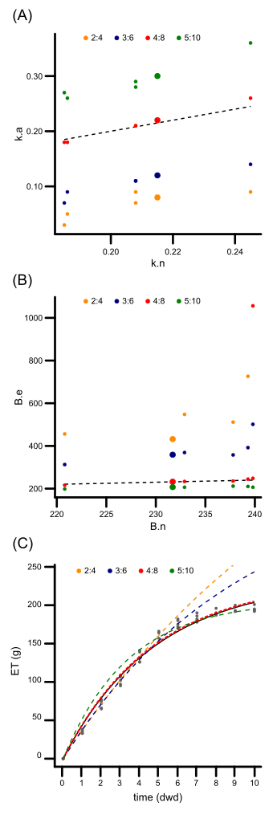**

Figure 3. A) Regresión entre el parámetro k de la ecuación X estimados por el método numérico (k.n ) vs método analítico (k.a). B) Regresión entre el parámetro B de la ecuación X estimados por el método numérico (B.n) vs método analítico (B.a). C) ET en función del tiempo. La curva continua es la grafica de la ecuación X que se ajusta a los datos con los parámetros estimados por el método numérico. Las líneas punteas muestran el ajuste de la ecuación X con los parámetros estimados según el método analítico. La línea punteada representa ……………..

**Modeling of** s**tomatal conductance in response to water availability**

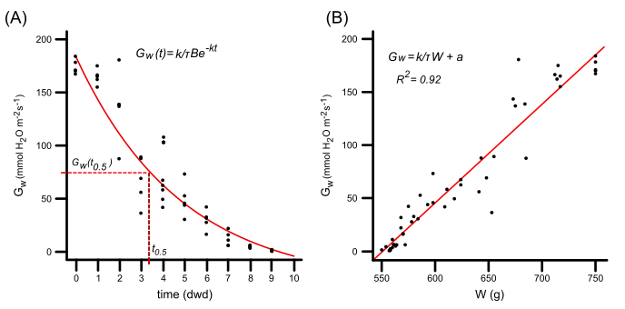

**Figure 4. A) Empirical model representing the conductance over time and empirical model adjustment. B) Regresión lineal entre la conductancia y el peso del sustrato.** Gw conductancia estomática, W peso del sustrato

A partir de las ecuaciones 1.5 y 1.13 (ver sección) determinamos una igualdad que modela la conductancia estomática en función del tiempo (Gw(t)). En la Figura 4A vemos como el modelo obtenido de manera teórica se ajusta a datos experimentales. A partir de la función 1.14 podemos estimar half-life para Gw(t) (t0.5), desde la suspensión del riego. Dicho parámetro toma relevancia al momento de identificar respuestas contrastantes al déficit hídrico entre distintos genotipos de soja.

En la figura 4B se observa la relación lineal teórica, obtenida a partir de la ecuación 1.15, entre la Gw y peso del PPS. Esta r

La relación lineal teórica, obtenida a partir de la ecuación 1.15, entre la Gw y peso del PPS se observa junto con datos experimentales en la figura 4B. El coeficiente de Pearson para esta relación es de 0.92. hay que poner que significa -a/b

**Application of the phenotyping methodology to two breeding populations and distinct plant developmental stages**

**Usando vida media y conductance**

Analysis of water consumption kinetic in response to a progressive water deficit was performed in a biparental population. Two parameters, t 0.5 and Gw (t 0.5), were selected to characterize de variability of the recombinants genotypes (**Figure 5A**). Values of t 0.5 ranked between 2 and 6 days showing a high variability in the kinetic of water consumption. However, most of the genotypes have t0.5 lower than 5 days, normal distribution observed confirms the values of parameters have a biological behavior inside the population. On the other hand, distribution of Gw t0.5 ranked between 101.8 and 202.8 (poner unidades) show normal distribution than accomplish the behavior of water consumption response (Fig5).

When the phenotyping protocol was evaluated in V5 plants of an elite breeding population (wider genotypic background) similar range of t0.5 values were obtained compared with obtained in the biparental population evaluated in V3 plants (Fig 5C and Fig 5A). However, when Gw t0.5 was analyzed a wider range of values was obtained (6-300) showing this parameter is more affected by the developmental stage (Fig 5D and Fig 5 B) This confirms the idea that parameters identified by the model are biologically relevant and at least in soybean could help the analysis of plant response to water deficit.

ACA HAY QUE PONER PARA QUE SIRVE ESTA CLASIFICACION O QUE SIGNIFICA For both variables in both populations three groups was generated considering the values of t0.5 and Gw (t0.5) of each genotypes. Group 1 and 3 include the genotypes with values in the percentile 10 % (Fig. 4 and 5) and 90% respectively, group 2 include genotypes with values between both previous Groups.

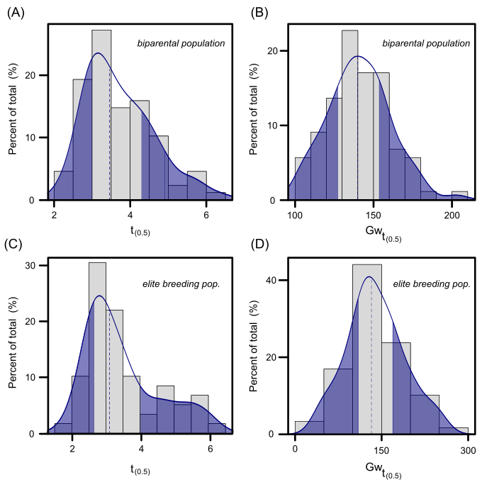

Gw(1/2) es la mitad de Gw0. No es que la medimo a t0 y la dividimos por 2. La estimamos para el t0.5. ese es el verso que tenemos que armar

**Fig5 Distribution de los valores de los parametros de t0.5 y Gwt05 en dos población de soja.**

**Estructura genética de las poblaciones y análisis de correspondencia**

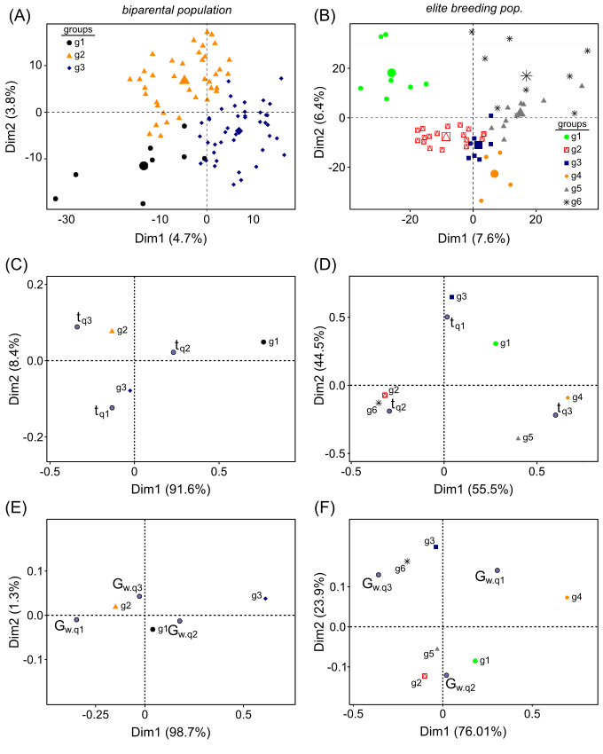

Fig6 Genetic structure in soja populations. A and B) Population structure calculated from all genotypic variables (molecular markers) , The groups were obtained by hierarchical clustering on principal component (HCPC) A biparental population, g1, g2, g3,groups were obtained by HCPC. B elite breeding population g1, g2, g3, g4, g5 and g6, groups were obtained by HCPC. C and D) Correspondence analysis of the contingency table between groups based on agrupamiento por t0.5 and groups based on genotype cluster. C) A biparental population D) elite breeding population.

E and F) Correspondence analysis of the contingency table between groups based on agrupamiento por Gwt0.5 and groups based on genotype cluster. E) A biparental population F) elite breeding population.

**Discussion (poner mas citas)**

In the current climate change scenario, it is imperative that soybean breeders use effective strategies for developing varieties with better ability to cope with period of water shortage. The complexity of drought tolerance trait has prevented the development of successful and reachable phenotyping strategy for selection in small-scale breeding programs. This situation gave rise this work in order to develop an enforceable phenotyping strategy. Simplification of strategies for phenotyping s become necessary with a high number of plants should be evaluated at the same time. In this line, big efforts have been done to reach this objective (ZZ). In our case we fixed the focus in the development of a model able to characterize and predict the water consumption curve with low sampling requirements. Because the plant growth system despise the water losses by evaporation, water consumption curve could related with transpiration curve and also include the stomatal response as parameters of the model. As was demonstrated in several studies water consumption using gravimetric methods correlate with measurement of the transpiration rate under specific conditions of VPD so fairly high throughput analysis could be applied. (e.g. Kholová et al. 2012).

Model confirms the relation between the kinetic of water consumption and stomatal conductance, this means that water transpired by the PPS defined in the study is regulated by stomatal conductance and this last variable is regulated by the water availability in the pot. Moreover, model can predict the value of water when the conductance is 0 and define the limit of water extraction. This trait has been identified as an important factor because genotypes with high values of water thresholds begin to partially close their stomata at relatively high water content and hereafter save water of soil (Valdez et al. 2013). A study using data from different region and years from USA country has shown through simulation tools that this trait would lead to a significant soybean yield increase, especially in crop season classified as dry (Sinclair et al. 2010). An early and accurate screening of genotypes with specific response in water consumption curve under water deficit appears as interesting advantageous in a plant breeding program.

How drought episodes are establishing at field conditions is variable depend of agro climatic regions, rain regimens, soil characteristic and atmospheric demand. Under alternating drought conditions, in which there is frequent the period alleviation of stress genotypes with high evapotranspiration capacity and water extraction (higher B and lower AR) could be more interesting that those with contrary response (lower B and high AR). However, in a drought situation with low probability of soil water recovery the selection of genotypes with low B and high AR could be main objective for breeding.

The gravimetric measurements of transpiration curves trait under different VPD lead the increase of adaptations of several crops genotype to different environments, using a simple and affordable method with high potential of scale up possibility. Phenotyping protocols have been reached different ways to classified genotypes in response to drought (). Here we proposed that some parameters of the model could be assigned as a specific trait of genotypes so this parameters should be not discarded to be usedin a phenotyping methods. Moreover, associations among the variables of the model increase the possibility to identify other parameters more informative about plant drought tolerance. For example, model demonstrated conductance could be included as explicative variable of plant response to progressive water deficit. In this context, ‘Gw appears as an effective measurement for explaining responsiveness of genotypes to changes in water availability.

The PCA analysis show that most of the 65% of variance explain water consumption is explained by the model parameters. Moreover phenotype of soybean plant in response to hydric defict from two breeding population could be characterized by the model proposed. El fenotipo de cada genotipo esta determinado por el genoma (citar), dos variables del modelo t0.5 y B fueron utilizados en un analisis de qtls en la población biparental permitio encontrar varios qtls asociados a estas varibles. Esto confirma la asociación genética de estos parámetros con un fenotipo de respuesta a defict hídrico determinado.

Validation of water deficit response at field conditions of a set of genotypes previously characterized by the model is presented as the next challenge. This point is critical in order to propose the phenotyping methodology as a tool to be included in a crop breeding program, especially in those programs with low income support.

**Author Contributions**

SS performed the mathematical theoretical model. OB, VB, EC GQ and SC were involved in the planning of the work. GQ conducted all data analysis of the experiments. EC and GQ performed the phenotypic evaluation. SC generated the breeding populations. All authors corrected the manuscript OB and VB wrote the manuscript.

**Funding**

The work was supported by the projects: CSIC-UdelaR Grupo 418 Estrés abiótico en plantas, Innovagro FSA\_1\_2013\_1\_12924 funded by the Agencia Nacional de Investigación e Innovación and Red Nacional de Biotecnología Agrícola RTS\_1\_2014\_1 funded by the Agencia Nacional de Investigación e Innovación, Instituto Nacional de Investigación Agropecuaria, Barraca Erro S.A., Lebu SRL, Fadisol SA, CALMER and COPAGRAN..

**Conflict of Interest Statement**

The authors declare that the research was conducted in the absence of any commercial or financial relationships that could be construed as a potential conflict of interest.

**Acknowledgments**

E.C wants to thank Comisión Academica de Posgrado Universidad de la República for a Doctoral fellowship.

**Supplementary Material**

**References**

Begum, H., J.E. Spindel, A. [Lalusin](https://www.ncbi.nlm.nih.gov/pubmed/?term=Lalusin%20A%5BAuthor%5D&cauthor=true&cauthor_uid=25785447), T. [Borromeo](https://www.ncbi.nlm.nih.gov/pubmed/?term=Borromeo%20T%5BAuthor%5D&cauthor=true&cauthor_uid=25785447), G. Gregorio, J. Hernandez, P. [Virk](https://www.ncbi.nlm.nih.gov/pubmed/?term=Virk%20P%5BAuthor%5D&cauthor=true&cauthor_uid=25785447) ,B. Collard and S.R. McCouch. (2015). Genome-Wide Association Mapping for yield and other agronomic traits in an elite breeding population of tropical rice (Oryza sativa). PLoS ONE. 10(3):e0119873.

Brachi, B., G.P. Morris and J. Borevitz. (2011). Genome-wide association studies in plants: the missing heritability is in the field. Genome Biol. 12, 232.

Contreras-Soto RI, Mora F, de Oliveira MAR, Higashi W, Scapim CA, Schuster I. (2017). A Genome-Wide Association Study for Agronomic Traits in Soybean Using SNP Markers and SNP-Based Haplotype Analysis. PLoS ONE 12(2):e0171105. doi:10.1371/journal.pone.0171105

Corey Lesk, C., Pedram, R., and Ramankutty, N. (2016). Influence of extreme weather disasters on global crop production. Nature 529, 84-87.

Dhanapal, A.P., Ray, J.D., Singh, S.K., Hoyos‑Villegas, V., Smith, J.R., Purcell, L.C. ·King, C., Cregan, P.B., Song, Q. and Fritschi, F.B. (2014). Genome‑wide association study (GWAS) of carbon isotope ratio (δ13C) in diverse soybean [*Glycine* *max* (L.) Merr.] genotypes. *Theor. Appl. Genet.* DOI 10.1007/s00122-014-2413-9

[Dissanayaka](https://www.ncbi.nlm.nih.gov/pubmed/?term=Dissanayaka%20A%5BAuthor%5D&cauthor=true&cauthor_uid=27436951),A., Rodriguez, T.O.,  [Shaokang Di](https://www.ncbi.nlm.nih.gov/pubmed/?term=Di%20S%5BAuthor%5D&cauthor=true&cauthor_uid=27436951), S., [Fan Yan](https://www.ncbi.nlm.nih.gov/pubmed/?term=Yan%20F%5BAuthor%5D&cauthor=true&cauthor_uid=27436951), F., [Stephen M. Githiri](https://www.ncbi.nlm.nih.gov/pubmed/?term=Githiri%20SM%5BAuthor%5D&cauthor=true&cauthor_uid=27436951), S.M., Rojas-Rodas, F., Jun Abe, J., Takahashi, R. (2016). Quantitative trait locus mapping of soybean maturity gene E5. [Breed Sci](https://www.ncbi.nlm.nih.gov/pmc/articles/PMC4902463/). 66, 407–415. doi:  [10.1270/jsbbs.15160](https://dx.doi.org/10.1270%2Fjsbbs.15160" \t "pmc_ext)

Fehr, W.R., Caviness, C.F., Burmood, D.T., Pennington, J.S., 1971. Stage of development descriptions for soybeans, Glycine max (L.) Merrill. Crop Sci. 11, 929-931.

Gutierrez, L., G.Quero, S. Fernandez and S. Brandariz. lmem.gwaser: Linear Mixed Effects Models for Genome-Wide Association. Studies. R package version 0.1.0. [https://CRAN.R-project.org/package=lmem.gwaser](https://cran.r-project.org/package=lmem.gwaser" \t "_blank) (accessed 17 January 2017).

* Humplík, J.F., Lazár, D.,Husičková, A.,Spíchal, L. (2015). [mailto:lukas.spichal@upol.cz](mailto:lukas.spichal@upol.cz" \o "Email author)Automated phenotyping of plant shoots using imaging methods for analysis of plant stress responses – a review. Plant Methods 11:29 <https://doi.org/10.1186/s13007-015-0072-8>

Jannink, J.L., M. Bink and R. Jansen. (2001). Using complex plant pedigrees to map valuable genes. *Trends Plant Sci*. 6, 337-342.

Langewisch, T., Lenis, J., Jiang, G.L., Wang, D., Pantalone, V.,  Bilyeu, K. (2017). The development and use of a molecular model for soybean maturity groups. BMC Plant Biology. [https://doi.org/10.1186/s12870-017-1040-4](https://doi.org/10.1186/s12870-017-1040-4" \t "_blank).

Li, X., Fang, C., Xu, M., Zhang, F., Lu, S., Nan, H., Su, T., Li, S., Zhao, X., Kong, L., Yuan, X., Liu, B., Abe, J., Cober, E.R., and Kong, F. (2017). Quantitative Trait Locus Mapping of Soybean Maturity Gene E6. Crop Science . 57,

Lu, S.J., Li, Y., Wang, J.L., Nan, H.Y., Cao, D. Li, X.M., Shi, D.N., Fan, C., Shi, G.X. Yuan, X.H., Abe, J., Liu, B.H., Kong, F.H. (2016). Identification of additional QTLs for flowering time by removing the effect of the maturity gene E1 in soybean. [J. Int. Agriculture](http://www.sciencedirect.com/science/journal/20953119" \o "Go to Journal of Integrative Agriculture on ScienceDirect). 15, 42-49.

[Malosetti, M](http://www.ncbi.nlm.nih.gov/pubmed/?term=Malosetti%20M%5BAuthor%5D&cauthor=true&cauthor_uid=17151263)., C. Van der Linden, B. [Vosman](http://www.ncbi.nlm.nih.gov/pubmed/?term=Vosman%20B%5BAuthor%5D&cauthor=true&cauthor_uid=17151263) and F.A. Van Eeuwijk. 2007.A mixed-model approach to association mapping using pedigree information with an illustration of resistance to Phytophthora infestans in potato. Genetics. 175:879-889. doi:[10.1534/genetics.105.054932](https://dx.doi.org/10.1534/genetics.105.054932)

Parisseaux, B. and R. Bernardo. 2004. Insilico mapping of quantitative trait loci in maize. Theor. Appl. Genet. 109:508-514. doi:10.1007/s00122-004-1666-0.

Price, A.L., N.J. Patterson, R.M. Plenge, M.E. Weinblatt, N.A. Shadick and D. Reich. 2006. Principal components analysis corrects for stratification in genome-wide association studies. Nat. Genet. 38:904-909. doi:10.1038/ng1847

Quero, G, Gutiérrez, L., Monteverde, E., Blanco,P., Pérez de Vida, F., Rosas, J., Fernández, S., Garaycochea, S., McCouch, S., Berberian, N., Simondi, S., Bonnecarrère, V. (2017). Genome-wide association study using historical breeding population discovers genomic regions involved in high-quality rice. The Plant Genome

Schweder, T. and E. Spjotvoll. 1982. Plots of P-Values to Evaluate Many Tests Simultaneously. Biometrika. 69:493-502. doi:10.1093/biomet/69.3.493

Scott W, Aldrich S. Modern soybean production. Champaign: S & A Publications; 1970.

Tasma, I.M., Lorenzen, L.L,  Green, D.E., Shoemaker, R.C. (2001). Mapping genetic loci for flowering time, maturity, and photoperiod insensitivity in soybean. Mol. Breeding. 8, 24-35.

Tuberosa, R. (2012). Phenotyping for drought tolerance of crops in the genomics era. [Front Physiol](https://www.ncbi.nlm.nih.gov/pmc/articles/PMC3446691/). 2012; 3: 347. doi:  [10.3389/fphys.2012.00347](https://dx.doi.org/10.3389%2Ffphys.2012.00347" \t "pmc_ext).

Watanabe, S., T. Tadjuddin, N. Yamanaka, M. Hayashi and K. Harada, (2004). Analysis of QTLs for reproductive development and seed quality traits in soybean using recombinant inbred lines. Breed. Sci. 54: 399–407.

Wilson RF. Soybean: market driven research needs, vol. 2. New York: Springer Science Press; 2008.

Samuel C Zipper, S.C., Qiu, J., Kucharik, C.J. (2016). Drought effects on US maize and soybean production: spatiotemporal patterns and historical changes. [Environ. Res. Lett.](http://iopscience.iop.org/journal/1748-9326) 11:094021. doi:10.1088/1748-9326/11/9/094021

Spetch 1999

[Xia, Z](https://www.ncbi.nlm.nih.gov/pubmed/?term=Xia%20Z%5BAuthor%5D&cauthor=true&cauthor_uid=22619331)., [Watanabe, S](https://www.ncbi.nlm.nih.gov/pubmed/?term=Watanabe%20S%5BAuthor%5D&cauthor=true&cauthor_uid=22619331)., [Yamada, T](https://www.ncbi.nlm.nih.gov/pubmed/?term=Yamada%20T%5BAuthor%5D&cauthor=true&cauthor_uid=22619331)., [Tsubokura, Y](https://www.ncbi.nlm.nih.gov/pubmed/?term=Tsubokura%20Y%5BAuthor%5D&cauthor=true&cauthor_uid=22619331)., [Nakashima, H](https://www.ncbi.nlm.nih.gov/pubmed/?term=Nakashima%20H%5BAuthor%5D&cauthor=true&cauthor_uid=22619331)., [Zhai, H](https://www.ncbi.nlm.nih.gov/pubmed/?term=Zhai%20H%5BAuthor%5D&cauthor=true&cauthor_uid=22619331)., [Anai, T](https://www.ncbi.nlm.nih.gov/pubmed/?term=Anai%20T%5BAuthor%5D&cauthor=true&cauthor_uid=22619331)., [Sato, S](https://www.ncbi.nlm.nih.gov/pubmed/?term=Sato%20S%5BAuthor%5D&cauthor=true&cauthor_uid=22619331)., [Yamazaki, T](https://www.ncbi.nlm.nih.gov/pubmed/?term=Yamazaki%20T%5BAuthor%5D&cauthor=true&cauthor_uid=22619331)., [Lü, S](https://www.ncbi.nlm.nih.gov/pubmed/?term=L%C3%BC%20S%5BAuthor%5D&cauthor=true&cauthor_uid=22619331)., [Wu, H](https://www.ncbi.nlm.nih.gov/pubmed/?term=Wu%20H%5BAuthor%5D&cauthor=true&cauthor_uid=22619331)., [Tabata, S](https://www.ncbi.nlm.nih.gov/pubmed/?term=Tabata%20S%5BAuthor%5D&cauthor=true&cauthor_uid=22619331)., [Harada, K](https://www.ncbi.nlm.nih.gov/pubmed/?term=Harada%20K%5BAuthor%5D&cauthor=true&cauthor_uid=22619331). (2012). Positional cloning and characterization reveal the molecular basis for soybean maturity locus E1 that regulates photoperiodic flowering. [Proc. Natl. Acad. Sci. U S A.](https://www.ncbi.nlm.nih.gov/pubmed/22619331" \o "Proceedings of the National Academy of Sciences of the United States of America.) 7;109 (32):E2155-64. doi: 10.1073/pnas.1117982109.

Yamanaka, N., Ninomiya, S., Hoshi, M., Tsubokura, Y., Yano, M., Nagamura, Y., Sasaki, T., Harada, K. (2001). An Informative Linkage Map of Soybean Reveals QTLs for Flowering Time, Leaflet Morphology and Regions of Segregation Distortion. DNA Research. 8, 61–72.

[Yu, J](https://www.ncbi.nlm.nih.gov/pubmed/?term=Yu%20J%5BAuthor%5D&cauthor=true&cauthor_uid=16380716)., G. Pressoir, W.H. Briggs, B.I. VrohI M., Yamasaki, J.F. Doebley, M.D. McMullen, B.S. [Gaut](https://www.ncbi.nlm.nih.gov/pubmed/?term=Gaut%20BS%5BAuthor%5D&cauthor=true&cauthor_uid=16380716), D.M. [Nielsen](https://www.ncbi.nlm.nih.gov/pubmed/?term=Nielsen%20DM%5BAuthor%5D&cauthor=true&cauthor_uid=16380716), J.B. [Holland](https://www.ncbi.nlm.nih.gov/pubmed/?term=Holland%20JB%5BAuthor%5D&cauthor=true&cauthor_uid=16380716), S. [Kresovich](https://www.ncbi.nlm.nih.gov/pubmed/?term=Kresovich%20S%5BAuthor%5D&cauthor=true&cauthor_uid=16380716) and E.S. [Buckler.](https://www.ncbi.nlm.nih.gov/pubmed/?term=Buckler%20ES%5BAuthor%5D&cauthor=true&cauthor_uid=16380716) 2006. A unified mixed-model method for association mapping that accounts for multiple levels of relatedness. Genetics. 38:203-208. doi:10.1038/ng1702

Zeng, A., Chen, P., Korth, K., Hancock, F., Pereira, A., Brye, K., C. Wu, C. and Shi, A. (2017). Genome-wide association study (GWAS) of salt tolerance in worldwide soybean germplasm lines. Mol Breeding (2017) 37:30.

Zhang L, Kyei-Boagen S, Zhang J, Zhang M, Freeland T, Watson C Jr. (2007). Modifications of optimum adaptation zones for soybean maturity groups in the USA. Crop Manag. 6.

Zhang, J., Song, Cregan, Q.P., Nelson, R.L., Wang, X., Wu, J. and Jiang, G.L. (2015). Genome-wide association study for flowering time, maturity dates and plant height in early maturing soybean (*Glycine max*) germplasm. BMC Genomics 16:217. DOI 10.1186/s12864-015-1441-4

Zipper, S.C., J. Qiu, and C.J. Kucharik. 2016. Drought effects

on US maize and soybean production: Spatiotemporal patterns

and historical changes. Environ. Res. Lett. 11:094021.

doi:10.1088/1748-9326/11/9/094021

Bernard RL. (1971). Two major genes for time of flowering and maturity in soybeans. Crop Sci.11:242–4.

Buzzell RI. (1971). Inheritance of a soybean flowering response to fluorescent day length conditions. Can J Genet Cytol.13:703–7.

Buzzell RI, Voldeng HD. (1980). Inheritance of insensitivity to long day length. Soybean Genet Newslett.7:26–9.

McBlain BA, Bernard RL. (1987). A new gene affecting time of flowering and matuirty in soybeans. J Hered.78(3):160–2.

Bonato ER, Vello NA. (1999). E6, a dominant gene conditioning early flowering and maturity in soybeans. Genet Mol Biol. 22(2):229–32.

Cober ER, Voldeng HD.(2001). A new soybean maturity and photoperiod-sensitivity locus linked to E1 and T. Crop Sci. 41:698–701.

Cober ER, Molnar SJ, Charette M, Voldeng HD. (2010). A new locus for early maturity in soybean. Crop Sci. 50:524–7.

Kong F, Nan H, Cao D, Li Y, Wu F, Wang J, et al. (2014). A new dominant gene E9 conditions early flowering and maturity in soybean. Crop Sci. 54:2529–35.

Boyer JS (1983) Environmental stress and crop yields. In: Crop reactions to water and temperature stresses in humid, temperate climates, Raper, CD Jr., Kramer PJ (eds.). Westview Press, Boulder, CO, 3-7.

Specht, J. E., D. J. Hume, and S. V. Kumudini. 1999. Soybean Yield Potential—A Genetic and Physiological Perspective Joint contribution of 12-194 of the Nebraska Agric. Res. Div. (Journal Paper No. J-12497), Lincoln, NE 68583-0915 and the Dep. of Plant Agriculture, Univ. of Guelph. . Crop Sci. 39:1560-1570. doi:10.2135/cropsci1999.3961560x

Babu Valliyodan1, Heng Ye1, Li Song1, MacKensie Murphy1, J. Grover Shannon2, Henry T. Nguyen1,\* 2016. Genetic diversity and genomic strategies for improving

drought and waterlogging tolerance in soybeans Journal of Experimental Botany

doi:10.1093/jxb/erw433 Volume 68, Issue 8, 1 April 2017, Pages 1835–1849

Zhang, T. and Lin, x. 2016. Assessing future drought impacts on yields based on historical irrigation reaction to drought for four major crops in Kansas. [Science of The Total Environment](https://www.sciencedirect.com/science/journal/00489697" \o "Go to Science of The Total Environment on ScienceDirect). 550, 851-860. [https://doi.org/10.1016/j.scitotenv.2016.01.181](https://doi.org/10.1016/j.scitotenv.2016.01.181" \t "_blank" \o "Persistent link using digital object identifier)

Gustavo M. Souza, Tiago A. Catuchi, Suzana C. Bertolli and Rogerio P. Soratto (January 2nd 2013). Soybean Under Water Deficit: Physiological and Yield Responses, A Comprehensive Survey of International Soybean Research James Board, IntechOpen, DOI: 10.5772/54269. Available from: <https://www.intechopen.com/books/a-comprehensive-survey-of-international-soybean-research-genetics-physiology-agronomy-and-nitrogen-relationships/soybean-under-water-deficit-physiological-and-yield-responses>

Zaman-Allah *et al*. (2011*b*) and Belko *et al*. (2012), the leaf canopy conductance was calculated as the ratio of gravimetric transpiration measurements at the wholeplant level divided by the leaf area and the time that plants were allowed to transpire (either an entire day or one-hour time periods across an entire day). Thus, it was ensured that the leaf area index of the plants was <1, such that there was a lack of (or limited) mutual shading of leaves. Leaf conductance measurements using gravimetric methods have a throughput that makes them suitable for breeding programs. These measurements were robust, and they were preferred over porometric measurements, which have several drawbacks (Turner 1991), including sampling (choice of leaf or choice of leaf section), time of sampling (possible changes in light or VPD conditions), and throughput. Porometric

measurements would also not be able to cope with the possibility of stomatal patchiness (Buckley and Mott 2000). Using these methods, chickpea genotypes that were tolerant to terminal water stress were found to have a lower leaf canopy conductance at the vegetative stage and under fully irrigated conditions (Zaman-Allah *et al*. 2011*b*).

t0.5

Figure 3. The equation is depicted within the plot.Using experimental data, the curve was fitted. The model fit the experimental data with an R-square of 0.986. D) Relation between K estimated by Gauss Newton and predicted K generated with two sampling E) Relation between B estimated by Gauss Newton and predicted B with two sampling.

