(1) Overview

Title
Open Educational ECG Acquisition and Data-Logging Platform Using AD8232 and ESP32-C3

Authors
1. Ambati, Shreyas; lead author
2. Dias, Gaston Ravin; corresponding author
3. Ahmad, Mohd Yazed bin; author
1. Independent student researcher; email: shreyasmabati64@gmail.com
2. Healthcare Engineering (Pvt) Ltd, Colombo, Sri Lanka; email: sam.gastondias@gmail.com; ORCID: 0009-0006-6596-788X
3. Universiti Malaya, Malaysia; email: myaz@um.edu.my
Corresponding author: Gaston Ravin Dias, sam.gastondias@gmail.com

Abstract
This Educational Hardware article documents a modular single-lead ECG acquisition and data-logging platform developed for supervised biomedical-engineering teaching. The original breadboard prototype combined an AD8232 analogue front end, ESP32-C3 controller, OLED display, DS3231 real-time clock, microSD pathway, INA219 power monitoring, buck-boost regulation, rechargeable power support and a small solar-assisted extension. Retained evidence comprises prototype photographs, OLED outputs and serial-plotter waveform visualisations. These materials demonstrate physical integration and qualitative signal streaming but do not establish calibrated amplitude, diagnostic accuracy, timing precision, dropped-sample rate, storage reliability, battery runtime or solar-charging performance. The open release therefore focuses on transparent educational reuse. It provides an editable wiring diagram, pin map, bill of materials, assembly and safety guidance, a reference firmware configured for raw 12-bit ADC logging at a nominal 250 samples/s, a qualitative evidence matrix, and a reproducible test protocol. The firmware records lead-off and storage status but performs no heart-rate diagnosis, arrhythmia classification or trained AI inference. The design is intended only for supervised education and non-clinical bench prototyping.

Metadata Overview
Item | Description
Main design files | Versioned repository: https://github.com/gastonravindias/open-educational-ecg-data-logger; release: v1.0.0. The package contains editable design files, reference firmware, BOM, assembly guidance, test protocol, safety records and media.
Target group | Biomedical engineering students and educators, supervised STEM learners, embedded-systems students and open-hardware developers.
Skills required | Breadboard wiring - intermediate; ESP32/Arduino programming - intermediate; I²C/SPI interfacing - intermediate; low-voltage bench testing - intermediate.
Replication | One original breadboard prototype was assembled and demonstrated. Independent replication was not completed and is not claimed.

Keywords
educational hardware; electrocardiography; AD8232; ESP32-C3; data logging

Introduction
Low-cost ECG platforms are useful for teaching the pathway from electrode interface and analogue conditioning to embedded acquisition, display and storage [1-5]. Their limitations must also be explicit: electrode contact, movement, baseline drift, wiring layout and power noise can alter a displayed waveform, and a single-lead maker prototype cannot replace a certified clinical ECG system [6-8].
The present contribution is therefore educational rather than clinical. It documents the architecture, available functional evidence, reconstructed reference firmware, build logic, safety boundaries and open files needed for students to study or extend an ECG data logger. The optional solar subsystem is retained as an energy-design exercise, but no self-powered or runtime claim is made [9,10]. Open design sources and explicit reuse conditions support the reproducibility principles of open hardware [11,12].

Overall Implementation and design

Architecture and signal chain
Electrodes provide a single-lead input to the AD8232 analogue front end. Its conditioned output is connected to the ESP32-C3 ADC. A shared I²C bus connects the SSD1306 OLED, DS3231 RTC and INA219; the microSD module uses SPI. The released firmware writes raw ADC counts, elapsed time, RTC time, lead-off status, system state and cached power telemetry to CSV. It contains deterministic status logic only.
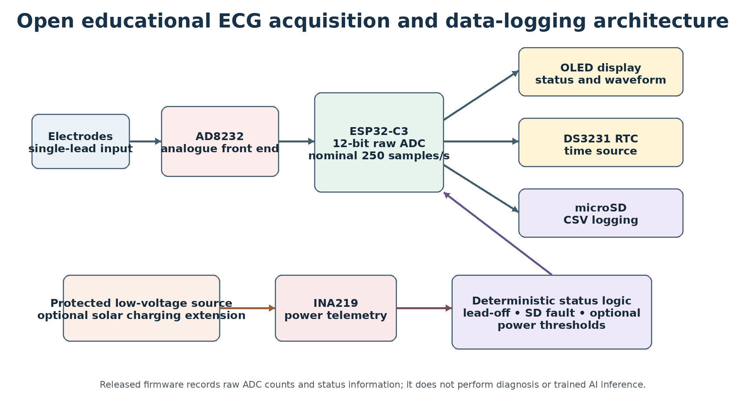
Figure 1: Educational ECG acquisition and data-logging architecture. The nominal firmware configuration is not a measured performance claim.
The original hardware was assembled from modular breakout boards on breadboards. This makes the signal and power pathways visible to learners and permits subsystem replacement, but it also creates loose-wire, noise and mechanical stability limitations. Figure 2 shows the assembled prototype and main modules.
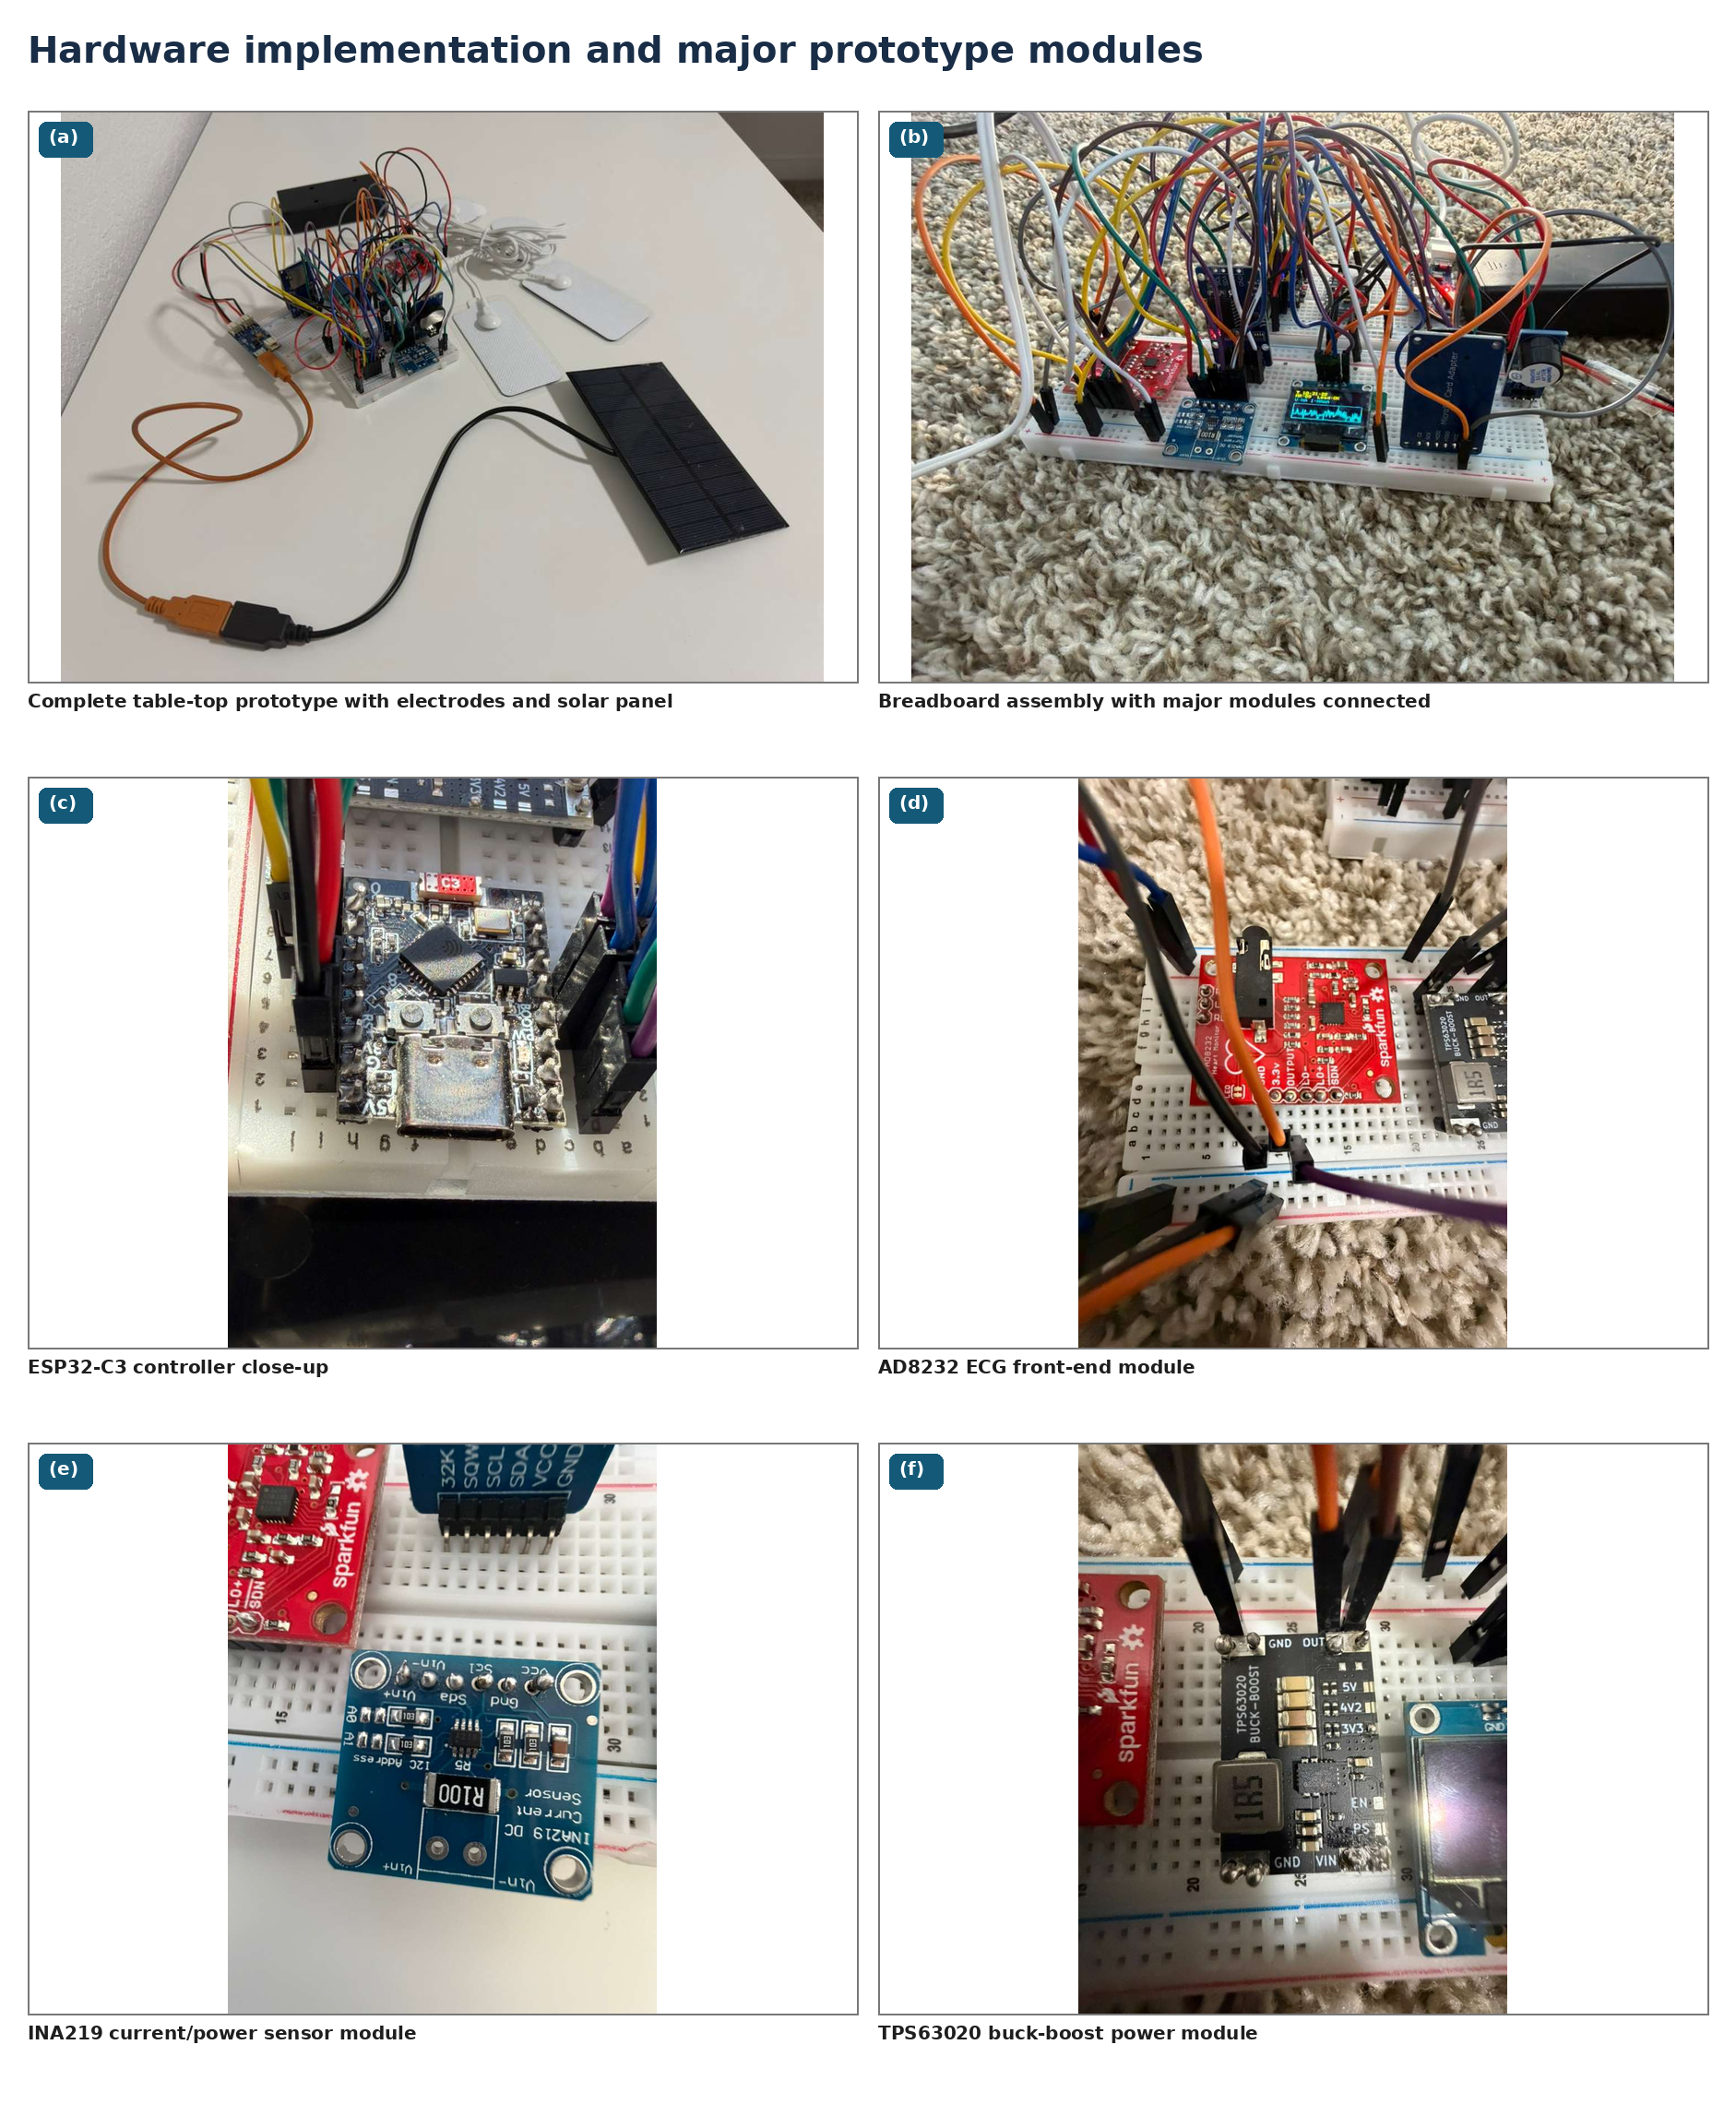
Figure 2: Original breadboard prototype and main modules, including the ESP32-C3, AD8232, INA219 and TPS63020.

Connections and reference firmware
The documented pin map is normalised in Table 1 and is implemented in the released reference firmware. The firmware uses a code-defined 4000 microsecond schedule, corresponding to a nominal 250 samples/s, and explicitly sets 12-bit ADC resolution. These values describe the software configuration; retained measurements were insufficient to claim timing accuracy or calibrated voltage.
Module signal | ESP32-C3 pin | Purpose
I²C SDA / SCL | GPIO20 / GPIO21 | OLED, DS3231 and INA219
microSD SCK / MISO / MOSI / CS | GPIO4 / GPIO5 / GPIO6 / GPIO7 | CSV storage
AD8232 OUT | GPIO0 / ADC | Raw analogue input
AD8232 LO+ / LO- | GPIO1 / GPIO3 | Lead-off status
AD8232 SDN | GPIO10 | Run/shutdown control
Buzzer input | GPIO2 | Active-low warning

Table 1: Normalised connection map used by the reference firmware.
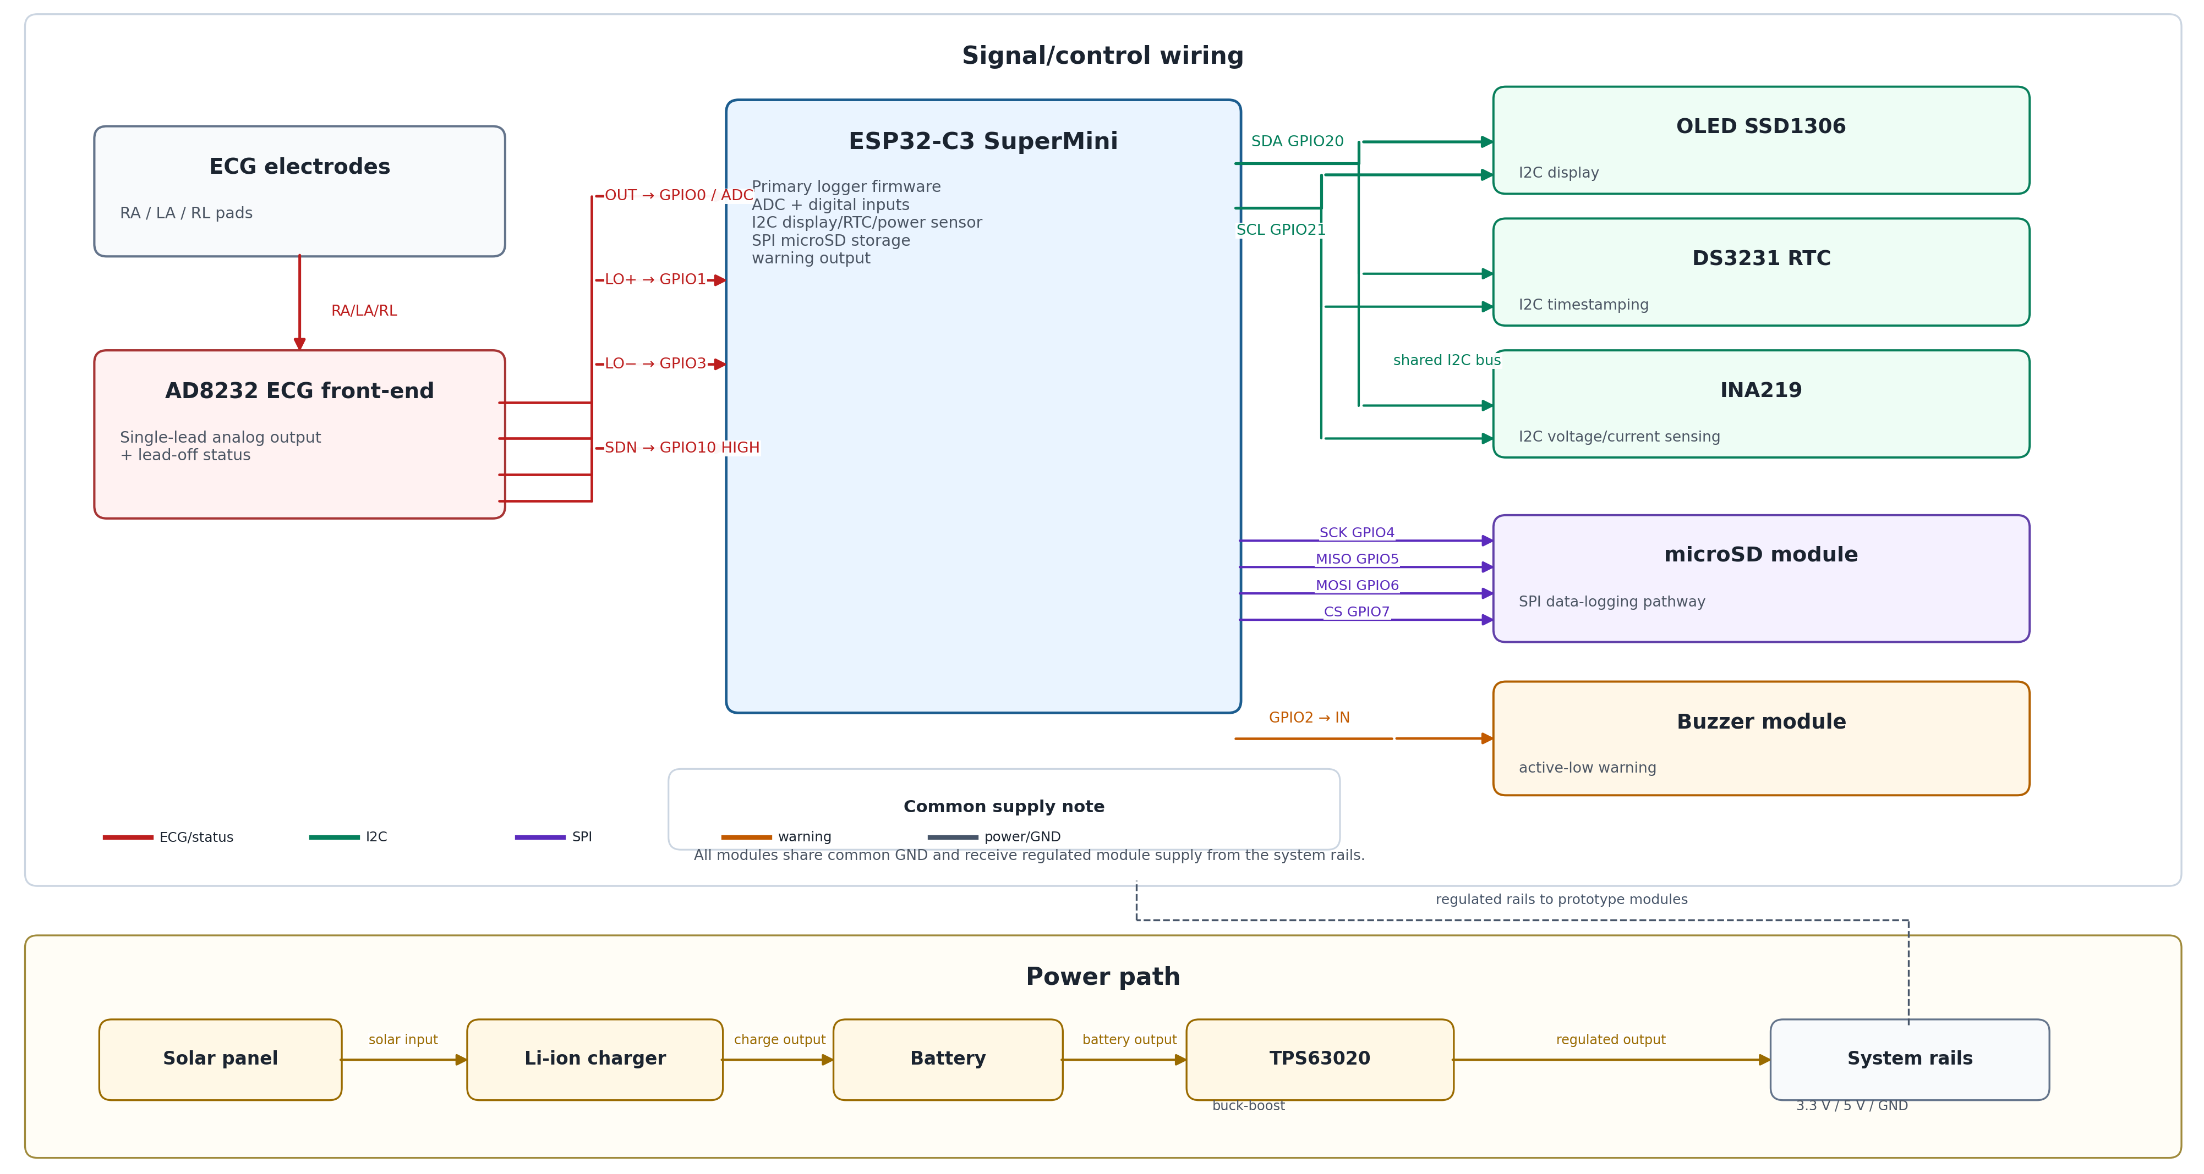
Figure 3: Reconstructed subsystem wiring and power-path diagram. The editable SVG source is included in the repository.

Optional solar extension
The photographs show a small panel, battery holder, regulator and INA219, but the panel label, cell capacity and charger purchase records were not retained. No claim is therefore made that the photographed panel sustained the system. For replication, the repository provides a conservative design calculation using a 0.60 W assumed core load, 8 h/day operation, 0.80 regulator efficiency, four equivalent peak-sun-hours, 0.70 charging efficiency and a 1.30 safety factor. The calculated minimum is 2.79 W; a 5 V panel rated at least 3 W is recommended only when paired with a compatible protected charger. This is a design recommendation, not an experimental result.

(2) Quality control

Safety
The prototype is not a medical device and has not been evaluated for IEC 60601-1 or IEC 60601-2-47 compliance [13,14]. ISO 14971 is cited only as a risk-management reference; compliance is not claimed [15]. The valid use context is supervised bench education.
The release requires battery-only operation whenever electrodes are connected; physical disconnection of USB, charging and externally powered instruments before electrode connection; disconnection of electrodes before programming; and avoidance of human-connected use of the open breadboard. Quantitative tests should use an ECG simulator or calibrated source. Protected batteries and charger-compatible power components are required.

Calibration
No diagnostic or amplitude calibration is claimed. The retained screenshots do not provide traceable voltage or reference-ECG comparison. The released firmware therefore logs raw 12-bit ADC counts. The repository test protocol explains how a replicator can apply known safe voltages or an ECG simulator, derive count-to-voltage scaling, characterise timing and preserve raw data.

General testing
Available quality control is limited to functional evidence retained from the project. Table 2 separates supported observations from unavailable measurements so that qualitative demonstration is not confused with validation.
Function | Evidence available | Conclusion
Physical integration | Prototype and module photographs | One breadboard proof-of-concept was assembled.
OLED output | Time, status and waveform photographs | Local display operation demonstrated qualitatively.
Serial output | Serial-plotter screenshots | Analogue signal streaming demonstrated qualitatively.
Lead status | Displayed status and documented LO pins | Interface present; response time not quantified.
RTC | Time field and DS3231 module | Timestamp pathway present; timing accuracy not measured.
microSD | Module, wiring and reference firmware | Long-duration reliability and write-success rate not retained.
Power/solar | Hardware photographs | Integration shown; runtime and charging performance not evaluated.
Clinical accuracy | No reference ECG comparison | Not claimed.

Table 2: Evidence boundary for the original educational prototype.
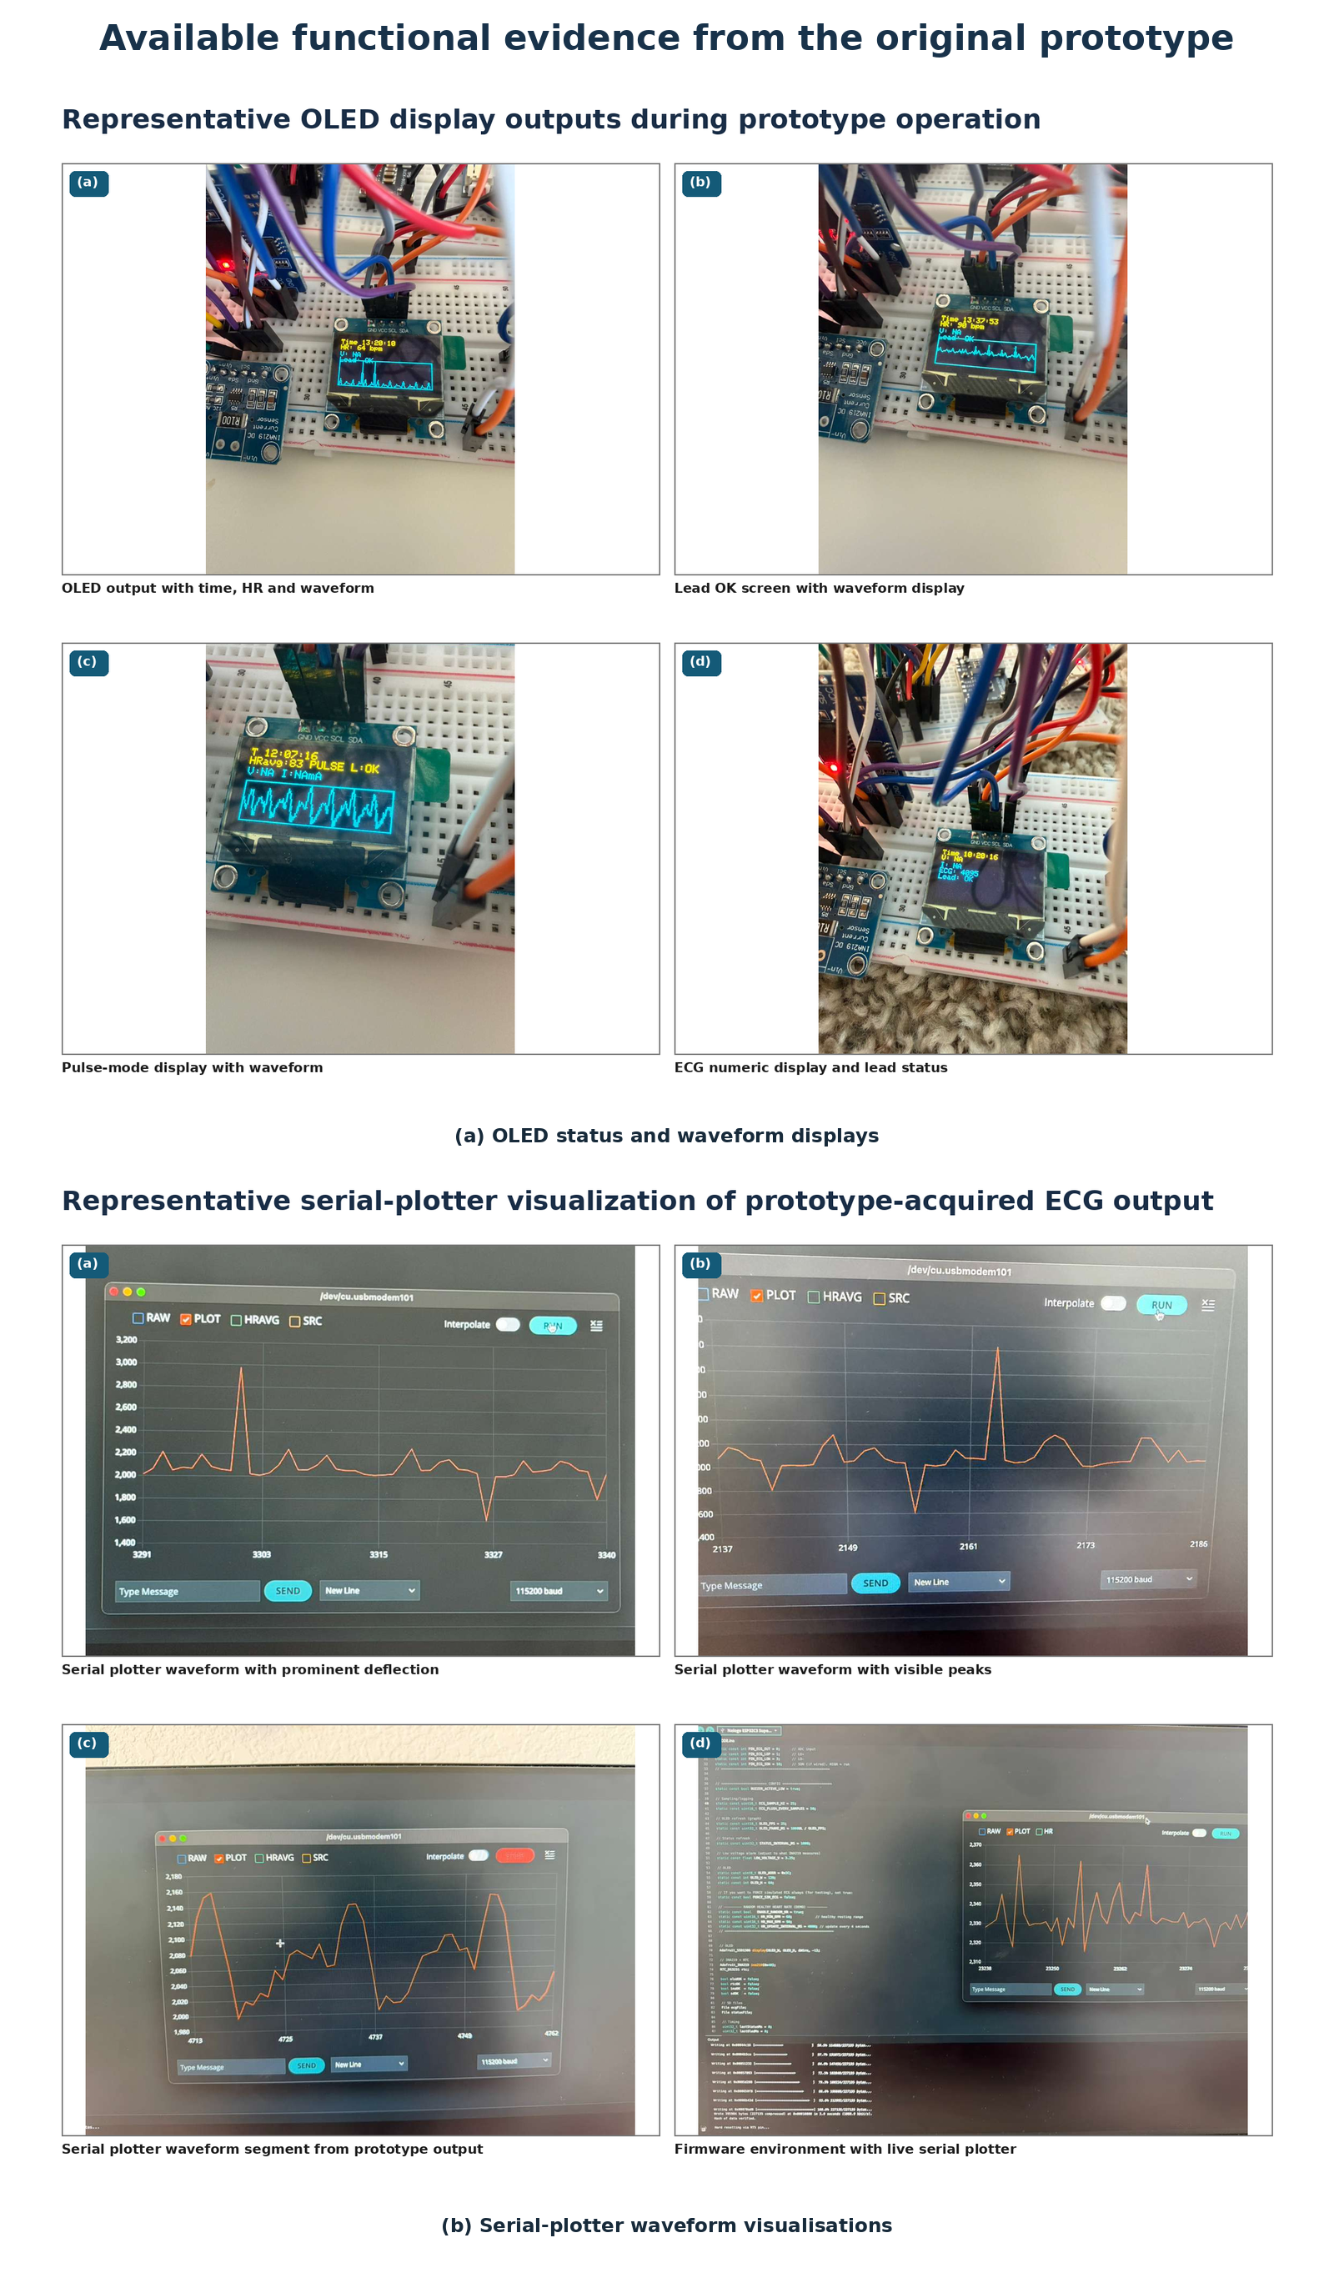
Figure 4: Retained OLED and serial-plotter evidence. These images support functional demonstration only; no diagnostic interpretation is made.

Reproducibility
One original build was completed by the student project developer. No independent build was documented. Rather than claiming replication, the release provides the materials needed for a future independent build: editable wiring, pin map, reference firmware, BOM, assembly guide, known limitations, safety controls and test protocol. Known failure points include transposed GPIO connections, missing common ground, incompatible microSD voltage levels, loose breadboard contacts, lead-off noise and file interruption during power loss.

(3) Application

Use case(s)

Biomedical instrumentation teaching
A supervised laboratory session can use the platform to identify the ECG signal chain, verify I²C and SPI buses, observe lead-off status, inspect raw ADC values, examine the CSV structure, distinguish software configuration from measured performance, and discuss the responsibilities attached to electrode-connected hardware.

Embedded systems and open-hardware teaching
Students can modify display refresh, storage buffering and status logic, compare qualitative outputs with simulator settings, calculate an energy budget, and practise version control, licensing and reproducible documentation. Clinical diagnosis, treatment, patient monitoring and unsupervised human use are outside the intended application.

(4) Build Details

Availability of materials and methods
The core build uses commercially available development modules and requires no specialist manufacturing. The repository BOM separates components observed in the original prototype from the safety-oriented recommendation for a protected low-voltage power source. Exact original supplier and purchase-price records were unavailable and are not invented.
Component | Quantity | Role
ESP32-C3 development board | 1 | Controller and ADC
AD8232 module | 1 | Single-lead analogue front end
SSD1306 OLED | 1 | Local status and waveform display
DS3231 RTC | 1 | Time source
microSD module and card | 1 | CSV storage
INA219 | 1 | Power telemetry pathway
TPS63020 module | 1 | Buck-boost regulation
Buzzer | 1 | Status warning
Electrode cable and pads | 1 set | Single-lead interface
Breadboards and jumpers | as required | Educational assembly
Protected low-voltage source | 1 | Core power
Optional 5 V panel ≥3 W | 1 | Solar-design exercise with compatible charger

Table 3: Component-level bill of materials. Detailed fields are supplied in the repository.

Ease of build / Design decision
Breakout modules were chosen to minimise fabrication and expose subsystem boundaries. The trade-off is inferior mechanical stability and potentially greater noise compared with a secured PCB. The optional solar extension is not required for the core ECG lesson and should be omitted when the charger, panel or battery compatibility cannot be verified.

Operating software and peripherals
The reference firmware is written for the Arduino ESP32 environment and uses Wire, SPI, SD, Adafruit_GFX, Adafruit_SSD1306, Adafruit_INA219 and RTClib. It writes raw data and status fields and intentionally omits heart-rate estimation, arrhythmia classification and AI inference. The exact library versions used by each replicator should be recorded in the repository release notes.

Dependencies
Hardware dependencies are the modules in Table 3. Software dependencies are listed in the firmware directory. No proprietary software is required for the reference build, although individual commercial modules may contain vendor-specific circuitry and must be used according to their own documentation.

Hardware documentation / build instructions / files location:

Archive for hardware documentation and build files (required)
Name: open-educational-ecg-data-logger
Review repository: https://github.com/gastonravindias/open-educational-ecg-data-logger
Version: v1.0.0
Persistent archive: not assigned at initial submission; the accepted release can be preserved through the journal's archival workflow.
Publisher/depositor: Gaston Ravin Dias
Release date: recorded in the public repository release metadata.

Modifiable design files
Name: hardware/editable_source/wiring_diagram.svg
Identifier: https://github.com/gastonravindias/open-educational-ecg-data-logger/tree/main/hardware/editable_source

Software code repository (required)
Name: solar_ecg_educational_logger_v1_0.ino
Identifier: https://github.com/gastonravindias/open-educational-ecg-data-logger/tree/main/firmware

(5) Discussion

Conclusions
The documented prototype integrates ECG analogue conditioning, ESP32-C3 acquisition, display, timestamping, storage and power-related modules in a transparent educational architecture. Its publication value lies in the open teaching package and explicit evidence boundary, not in clinical performance. The retained project material supports a functional proof-of-concept; the repository converts that material into a structured resource for supervised study and later independent replication.

Future Work
Priority work is independent replication, simulator-based ADC and timing characterisation, SD reliability testing, measured power logging, protected enclosure/PCB development and validation of any solar charger and battery pair. Human-participant or clinical research would require separate ethics review, electrical-safety engineering and a prospective validation protocol.

Ethics and consent
No identifiable personal data are included. The retained images are used only as non-diagnostic functional demonstrations. The article makes no participant-level physiological claim. Any future human-connected study must obtain appropriate consent and institutional ethics determination before data collection.

Paper author contributions (CRediT)
Role | Contribution
Conceptualization and prototype development | Shreyas Ambati
Hardware assembly and original functional demonstration | Shreyas Ambati
Repository reconstruction and documentation | Shreyas Ambati; Gaston Ravin Dias
Supervision | Gaston Ravin Dias; Mohd Yazed bin Ahmad
Writing - original draft | Shreyas Ambati; Gaston Ravin Dias
Writing - review and editing | All authors
Project administration and correspondence | Gaston Ravin Dias

Acknowledgments
The authors acknowledge the educational supervision and review that supported the prototype project and manuscript preparation.

Funding statement
No specific external funding was received for this work.

Competing interests
The authors declare that they have no competing interests.

References
[1] Serhani MA, El Kassabi HT, Ismail H, Nujum Navaz A. ECG monitoring systems: review, architecture, processes, and key challenges. Sensors. 2020;20(6):1796. DOI: 10.3390/s20061796.
[2] Bravo-Zanoguera M, Cuevas-González D, Reyna MA, García-Vázquez JP, Avitia RL. Fabricating a portable ECG device using AD823X analog front-end microchips and open-source development validation. Sensors. 2020;20(20):5962. DOI: 10.3390/s20205962.
[3] Mendes Junior JJA, Campos DP, Biassio LCAVD, Passos PC, Júnior PB, Lazzaretti AE, Krueger E. AD8232 to biopotentials sensors: open source project and benchmark. Electronics. 2023;12(4):833. DOI: 10.3390/electronics12040833.
[4] Heaney J, Buick J, Hadi MU, Soin N. Internet of Things-based ECG and vitals healthcare monitoring system. Micromachines. 2022;13(12):2153. DOI: 10.3390/mi13122153.
[5] Solano J, Calderón AJ, Paguada S, Hernández Ó, Reyes Marín EV, Sandoval H, et al. Handy EKG: a low-cost electrocardiograph for primary care. Cureus. 2023;15(11):e48563. DOI: 10.7759/cureus.48563.
[6] Campero Jurado I, Lorato I, Morales J, Fruytier L, Stuart S, Panditha P, et al. Signal quality analysis for long-term ECG monitoring using a health patch in cardiac patients. Sensors. 2023;23(4):2130. DOI: 10.3390/s23042130.
[7] Rahman S, Karmakar C, Natgunanathan I, Yearwood J, Palaniswami M. Robustness of electrocardiogram signal quality indices. J R Soc Interface. 2022;19(189):20220012. DOI: 10.1098/rsif.2022.0012.
[8] An X, Liu Y, Zhao Y, Lu S, Stylios GK, Liu Q. Adaptive motion artifact reduction in wearable ECG measurements using impedance pneumography signal. Sensors. 2022;22(15):5493. DOI: 10.3390/s22155493.
[9] Páez-Montoro A, García-Valderas M, Olías-Ruiz E, López-Ongil C. Solar energy harvesting to improve capabilities of wearable devices. Sensors. 2022;22(10):3950. DOI: 10.3390/s22103950.
[10] Khan AS, Khan FU. A wearable solar energy harvesting based jacket with maximum power point tracking for vital health monitoring systems. IEEE Access. 2022;10:119475-119495. DOI: 10.1109/ACCESS.2022.3220900.
[11] Bonvoisin J, Molloy J, Häuer M, Wenzel T. Standardisation of practices in open source hardware. J Open Hardw. 2020;4(1):2. DOI: 10.5334/joh.22.
[12] Open Source Hardware Association. Open Source Hardware Definition 1.0. Available from: https://oshwa.org/resources/open-source-hardware-definition/.
[13] International Electrotechnical Commission. IEC 60601-1:2005+A1:2012+A2:2020. Medical electrical equipment - Part 1: General requirements for basic safety and essential performance. Geneva: IEC; 2020.
[14] International Electrotechnical Commission. IEC 60601-2-47:2012. Medical electrical equipment - Part 2-47: Particular requirements for the basic safety and essential performance of ambulatory electrocardiographic systems. Geneva: IEC; 2012.
[15] International Organization for Standardization. ISO 14971:2019. Medical devices - Application of risk management to medical devices. Geneva: ISO; 2019.

(6) Licenses
Article: Creative Commons Attribution 4.0 International (CC BY 4.0).
Hardware design files: CERN Open Hardware Licence Version 2 - Permissive (CERN-OHL-P-2.0).
Reference firmware: MIT License.
Documentation and original repository figures: CC BY 4.0. Third-party module materials retain their original terms.

