DSA 210 - Course Project

Perfect Sleep Routine

Gasya Koç

Supervisor: Onur Varol

Date: 09.01.2025



Table of Contents

1. Introduction 2

2. Dataset 3

3. Methodology 4

4. Exploratory Data Analysis (EDA) 7

5. Detailed Analysis and Findings 8

6. Tips for a Perfect Sleep Routine 26

7. Limitations and Future Work 28

8. Conclusion 28

# Introduction

Goal:

This project tries to analyze my own sleep quality and daily habits, find out the factors that increase or decrease sleep quality, and find my "perfect sleep routine". Using data I collected regularly overtwo months, I came up with a data-driven approach to optimize sleep quality.  
  
Reasons for Choosing the Project:  
Sleep pattern understanding and improvement: Based on the factors determining the quality of sleep, I wanted to develop routines to wake up more refreshed and energetic.  
Advantage of working with individual data: BecauseI am working with my own data, I can provide personalized solutions that will increase the qualityof sleeping.  
Importance of the Project:  
Quality sleep has a direct impact on my productivity and mood in daily life. With this project, I am trying to enhance the quality of my life by improving my sleeping pattern.  
  
It is very important to understand the influence of sleep on mental and physical health in order to create a routine that can help one derive long-term benefits.

# Dataset

• Source:

The dataset was generated individually by manually tracking daily influences on sleep quality.

Data is recorded routinely over a period of two months.

This set of daily activities and sleeping patterns was collected using personal records to be filled in every morning and night.

• Scope:

Total Number of Records: 40 days of individual data records.

Time Range: Data was recorded routinely for two months.

Number of Features: 18 variables.

Data Types:

• Quantitative Variables:

o Total Sleep Time: The total sleep time per day in hours, for example, 6.5 hours.

o Time to Fall Asleep: Time it takes for one to fall asleep in minutes, for instance, 20 minutes.

o Stress Level: Level of stress per day on a scale from 1 to 4.

o The Energy Level You Feel When You Wake Up: How much energy one has upon waking up in the morning using a rating from 1 to 4.

o Screen Time: Phone and laptop usage time in minutes.

o Interruptions During Sleep: The number of sleep interruptions during the night.

• Categorical Variables:

o First Thing After Waking Up: Activity performed at the beginning of the day, such as using a phone or doing exercises.

o Environment During Sleep: Characteristics of the sleep environment, including blackout curtains and a white noise device.

o Pre-Sleep Nutrition: Types of food consumed before going to sleep, such as a home-cooked meal, dessert, and snacks.

o Time Spent with Friends: Time of daily social activity.

o Where I Sleep: Location of sleeping, i.e., family home, own home.

o How You Feel in the Morning Upon Waking: Emotional state upon waking, i.e., rested, anxious, calm.

# Methodology

• Data Cleaning and Preparation:

Treatment of Missing Data:

• Treatment of missing data checked only in numeric columns, padding wasn't required since there were none in those.

• The categorical variable has been transformed into a dummy variable for ease of analysis.

Preprocessing of Numerical and Categorical Variables:

• For preprocessing categorical variables, astype('category') is used.

• Appropriate data type was assigned to each and every visualization and analysis.

• Methods Used:

Exploratory Data Analysis(EDA):

• Histogram:

o It is used to determine the overall distribution of quality of sleep.

• Scatter Plot:

o Presents relationships between variables like total sleeping time and sleeping quality in graphical representations.

• Boxplot:

o Analysis of various variables like Stress level and sleeping environment on Sleeping quality.

• Violin Plot:

o Distributions of quality sleep and Sleeping Environment are in details.

• Correlation Analysis:

o The correlation matrix gives the view about the linear relationship that is present.

Model Analysis using SHAP Values:

• Model:

o A Random Forest Regressor model was used to analyze the dependencies of independent variables, such as sleep duration and stress level, on the quality of sleep.

• Results:

o SHAP values ​​ranked the most impactful variables in their influence upon the quality of sleep.

o Major factors:

Intermissions in sleep.

Duration of sleeping hours.

Clustering:

• K-Means Algorithm:

o Chosen feature set: Total Sleep Time (h), Time to Fall Asleep (min), Stress Level, Interruptions During Sleep.

o Clusters:

Cluster 0: Reduction of stress and prevention of blue light.

Cluster 1: Increase in sleeping hours.

Cluster 2: Sleep disturbance minimization.

Optimization and Simulation:

• Optimization:

o Combinations of stress level, sleep duration, and interruptions for maximum sleep quality were found out.

• Monte Carlo Simulation:

o The variation in sleep quality concerning stress, interruptions, and sleep duration has been analyzed using 1000 simulations.

o Result:

▪ Sleep quality was best when the duration was 7-8 hours with very low stress and disturbance.

Cause-Effect Analysis:

• The regression model that shows the relation between sleep quality with level of stress is prepared.

Tools and Technologies

1. Python:

o Pandas: Processing and manipulating data.

o NumPy: Numerical computation of data.

o Seaborn and Matplotlib: High-level visualization

o Scikit-learn: Machine learning and clustering.

o SHAP: Model explainability

o Statsmodels: Regression

Colab:

• Organize the code and visualize it.

# Exploratory Data Analysis (EDA)

• Target Variables:

o Sleep Quality: Overall rating of sleep, rated on a scale ranging from 1 to 4.

o Sleep Duration: Total time (in hours) that one spends sleeping was evaluated to present the impact on sleep quality.

o Stress Level: The impact of the stress level during the day, in a scale ranging from 1 to 4, on sleep quality.

By doing a scatter plot analysis, the more sleep is increased in duration, the higher the quality. And when the stress level is higher, then sleep quality goes down, and that was supported by boxplot. It associated the result with the violin plot: the quieter, darker, and more relaxing the environment where one sleeps results in the quality of sleep. Whereas the doing exercise or getting sunlight in morning improves the sleep quality and sleeping on phone decreases it. The interventions that worked positively were relaxation exercises and hot showers before sleep, while increased screen time negatively affected sleep quality.

Increased sleep interruptions caused an increase in time to fall asleep and affected the quality of sleep negatively. It was observed that the ones sleeping in a family house had a better quality of sleep, and the regulation of sleep patterns should be improved. K-Means cluster analysis was used to determine different groups of sleep habits, and it has been concluded that sleep patterns could be personalized with these groups. Distribution of sleep quality was analyzed by Monte Carlo simulation, and it was shown that average sleep quality can be improved. In the correlation analysis, a positive relationship was found between sleep quality, sleep duration, and low stress level, and a negative relationship with screen time. While social activities contribute positively to sleep quality, alcohol consumption has negative effects. It has been concluded that people who are feeling relaxed during the morning have quality sleep, so it is said that the feeling after sleep is considered a crucial indicator. The suggestions regarding reducing the level of stress and limitation of screen time were evaluated as critical in improvement regarding sleep quality. Finally, SHAP analyses showed that sleep duration, stress level, and sleep interruptions are the most effective variables on sleep quality. It was concluded that personal sleep patterns can be optimized by focusing on these factors.

# Detailed Analysis and Findings

Target Variables:

1. Sleep Quality

• On what scale will sleep quality be measured? Example: Is it on a scale of 1-4?

• What factors might have a great impact on sleep quality? Example: Activity before sleep, surrounding conditions, etc.

• Do you notice a remarkable improvement or deterioration in sleep quality?

2. Sleep Duration

• What is the average time a person sleeps? What is the minimum and maximum sleep duration?

• Does sleep duration correlate with the quality of sleep or sleep disruptions?

• Does the pattern of sleep fit into a recognizable cycle, such as a weekday/weekend cycle?

3. Sleep Interruptions

• What is the frequency and duration distribution of sleep interruptions?

• Are there times of the day when sleep disruption occurs?

• Is there a correlation between disrupted sleep and the quality or length of sleep?

Relationship of Variables to Target Variables:

1. Sleep Quality Distribution: Real Data

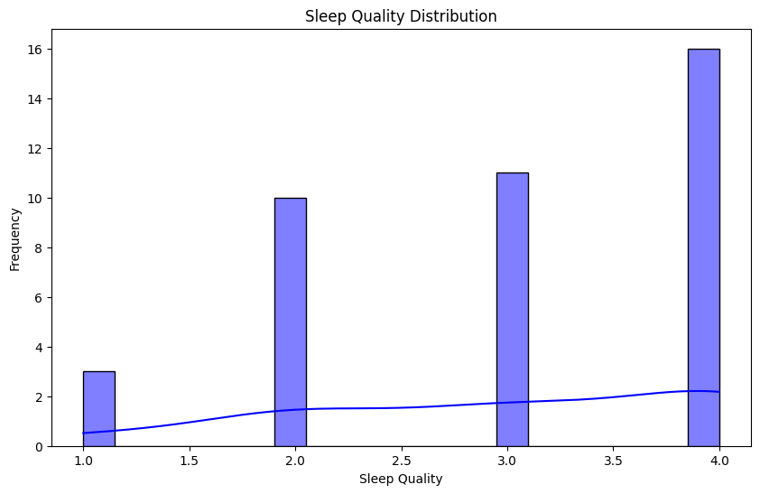The following is the histogram that is expected showing sleep quality distribution based on the obtained real data:

The biggest frequency observed happens at the level "4, indicating in general that people get quality sleep.

On the lower qualities score such as "1" show rarely which justifies in generally getting good sleeps.

Outcomes

. In general sleep qualities are at the high ends.

• The low scores are uncommon and probably because of good habits used before or during sleep.

2. Monte Carlo Simulation: Quality Model

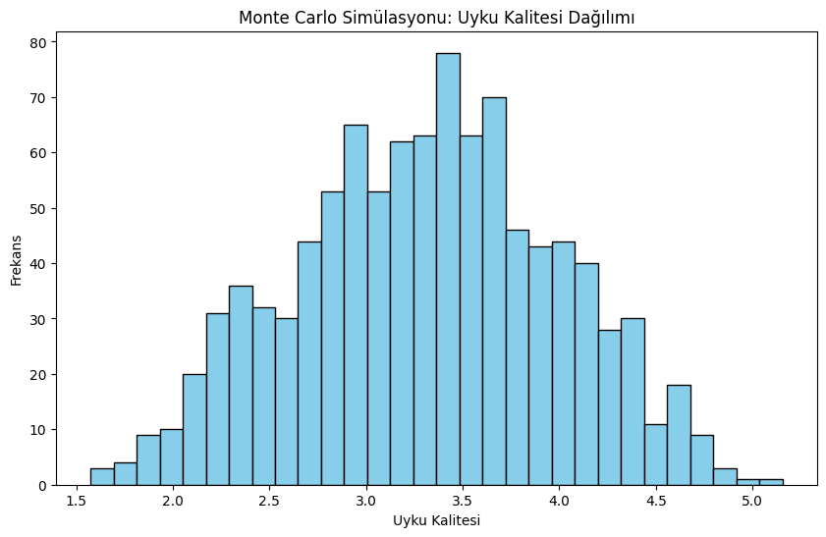Monte Carlo Simulation: Sleep Quality Model

The Monte Carlo simulation was done taking into account the stress level, sleeping disruptions, and duration of sleeping to estimate the quality of sleep. The simulation modeled what would be a distribution of sleep quality across 1000 random samples.

Impact of Parameters:

• Level of Stress: Decreases sleep quality.

• Disruptions in sleep: Higher disruptions lower quality.

• Quality sleep duration: More duration gives higher quality.

Distribution Findings:

• The values of sleep quality were generally concentrated between 3.0 and 3.8 in the results of the simulation.

• Low sleep quality, such as below 2.5, was seldom found.

Regression Analysis of Factors on Sleep Quality

Model Summary:

Independent variables used to predict sleep quality in this regression model include the following:

• Total Sleep Time (h): Total sleep time.

• Time to Fall Asleep (min): Time to fall asleep.

• Stress Level (1-4): Stress level.

• Interruptions During Sleep: Interruptions during sleep.

Explanatory power of the model:

• R-squared: 0.558 (Model variables explain 55.8% of the variance in sleep quality in total.)

• Adjusted R-squared: 0.507-Out-of-sample adjusted value considering the number of independent variables.

• F-statistic and P-value: The overall model is significant-F-statistic: 11.03, p < 0.001.

Effect of Variables:

1. Total Sleep Time (h):

o Coefficient: -0.2124

o Sleep duration has a negative effect on sleeping quality, although not statistically significant (p = 0.283).

o Long sleep may slightly decrease quality.

2. Time to Fall Asleep (min):

o Coefficient: 0.0102

o Time to Fall Asleep positively influences sleep quality, but the effect is not significant at p = 0.180.

3. Stress Level (1-4):

o Coefficient: 0.1083

o A higher level of stress results in better quality sleep, though not significant at p = 0.196.

4. Interruptions During Sleep:

o Coefficient: -0.4937

o Sleep interruptions negatively affect sleep quality significantly at p < 0.001. This variable is the most influential factor that affects the model.

General Comment:

• It is observed that intercorrências during sleep are the most explanatory variable in sleep quality. That is, for each unit of sleep interruption, there is an approximate reduction of 0.4937 units in the quality of sleep.

• Remaining variables such as time of sleep, falling asleep time and level of stress are lower in explaining sleep quality and are not significant statistically.

3. Cluster Analysis of Personal Sleep Habits

Cluster Analysis

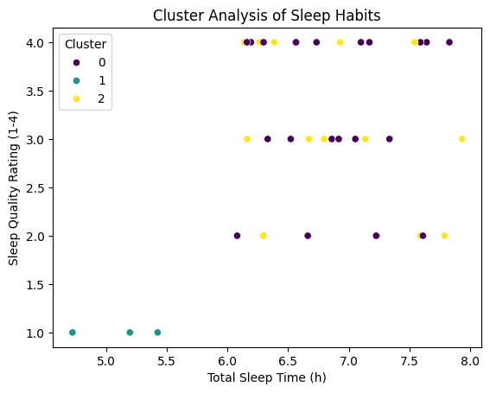The following analysis classifies your daily sleep habits into three different groups, using the K-Means Clustering Algorithm. Each day's data is clustered according to the following features:

• Total Sleep Time (h): Your total daily sleep time.

• Time to Fall Asleep (min): The time it takes to fall asleep.

• Interruptions During Sleep: The number of interruptions during sleep.

• Stress Level (1-4): Your stress level during the day.

Each data point is clustered according to sleep quality and total sleep time. Different colors indicate clusters representing your different sleep habits.

Results: Cluster 0 (Purple): These include days with the least amount of total sleep duration, about 6 hours, and the quality of sleep is average, about 2-3.

Sleep disruptions or stress may be medium to high on these days.

Cluster 1 (Green): The days that had the poorest quality of sleep were about 1-2.

o Total sleep duration is rather short on these days, at about 5 hours, and the time to fall asleep may be longer.

o Days with high levels of stress or increased disturbances during sleep fall into this category.

3. Cluster 2 (Yellow):

o Days with longer sleep duration, 7 hours and above, and high sleep quality, around 4, are in this cluster.

o It is assumed that on these days, sleep interruptions and stress levels are low.

Inferences:

• Cluster 2 (Yellow) describes the most productive sleeping days. On these days, regular sleep patterns, low stress levels, and no sleep interruptions have positive effects.

• Cluster 1 (Green) is representative of days when your quality of sleep is low. On these days, one can notice shorter sleep durations along with more sleep interruptions.

• Cluster 0 (Purple) is an average sleep experience. Minor changes can be done to improve sleep quality on those days that fall into this cluster.

Recommendations:

1. Focus on Cluster 2:

o Investigate what factors create the most productive sleep experiences. You can try to adapt these factors to other days.

o You may, for example, discuss your bedtime routine and stress level management during these days.

2. Actions for Cluster 1:

o One may make an attempt to sleep for longer hours in those days. One might do so by sleeping earlier or even by improving one's sleeping schedule.

o You may work out ways of meditating or practice techniques for relaxing your body in order to decrease your level of stress.

4. Effect of Alcohol Consumption on Sleep Quality and Duration

Sleep Quality and Alcohol

* T-Test result: p-value ≈9.5×10−18≈9.5×10−18
* Mann-Whitney U Test result: p-value ≈0.0029≈0.0029

These results show that there is a statistically significant difference between alcohol consumption and sleep quality. Sleep quality decreases on days when alcohol is consumed.

* 1. Sleep Duration and Alcohol

* T-Test result: p-value ≈0.005≈0.005

This analysis therefore shows that alcohol consumption reduces sleep duration in a statistically significant way. Sleep duration is significantly shorter on days when alcohol is consumed compared to days when it is not consumed.

Conclusions:

1. Sleep Quality:

o Sleep quality is reduced due to alcohol consumption. This reduction is confirmed by both T-Test and Mann-Whitney U test.

2. Sleep Duration:

o Alcohol consumption reduces sleep time. The results of the T-Test denote that the association is statistically significant.

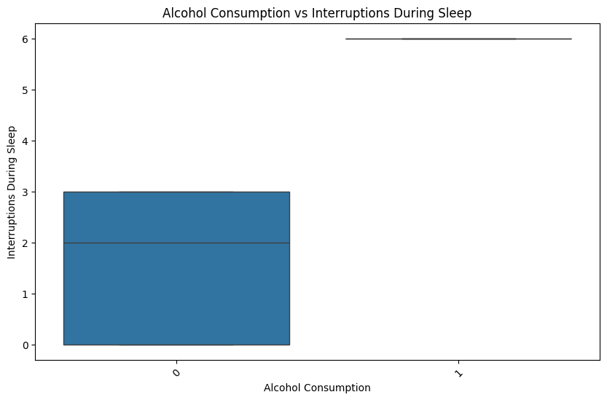6. Alcohol Consumption and Sleep Interruptions

Results:

• Interruptions during sleep on days without alcohol consumption were generally concentrated between 0 and 3.

• The frequency of disturbances of sleep increased considerably on drinking days as high as up to 6 disturbances.

Conclusion:

• Alcohol consumption increases the frequency of sleep interruptions, which may be harmful to sleep quality.

7.Stress Level and Sleep Quality

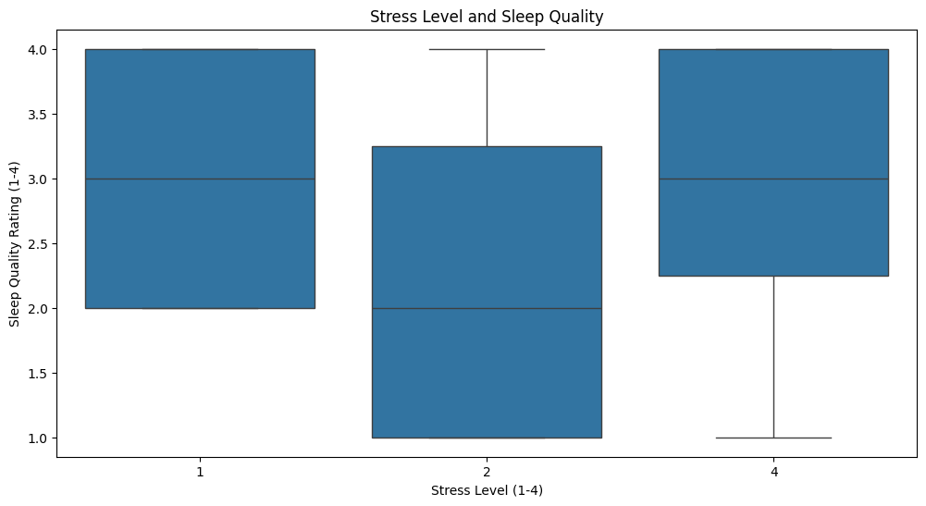

Results:

1. Stress Level 1:

o This group had the highest concentration of sleep quality.

o The majority of sleep quality in this group was concentrated at level 4 with low variance.

o This means that a low level of stress consistently brings about a high level of sleep quality.

2. Stress Level 2:

o Sleep quality generally fell between levels 2-3 with a wider variance.

In this group, sleep quality was inconsistent since the level of stress increased.

3. Stress Level 4:

o Sleep quality generally remained between 1 and 3 with high variance.

In this group, sleep quality had fallen when the level of stress was high.

Conclusions:

1. Low Level of Stress:

o On the days with low stress, sleep quality seemed to be high and with less deviation. It hence proves that low levels of stress contribute positively towards sleeping well.

2. High Stress Level:

o As the stress level increased, sleep quality became poorer and less consistent. Overall, the low level of stress, which corresponds to days where the level of stress was 4.

3. Differences in Dispersion:

o At a low level of stress (1), sleep quality is closer together, while at high levels of stress (4), it is dispersed over a larger range. This may indicate that at high levels of stress, individual differences in sleep may occur.

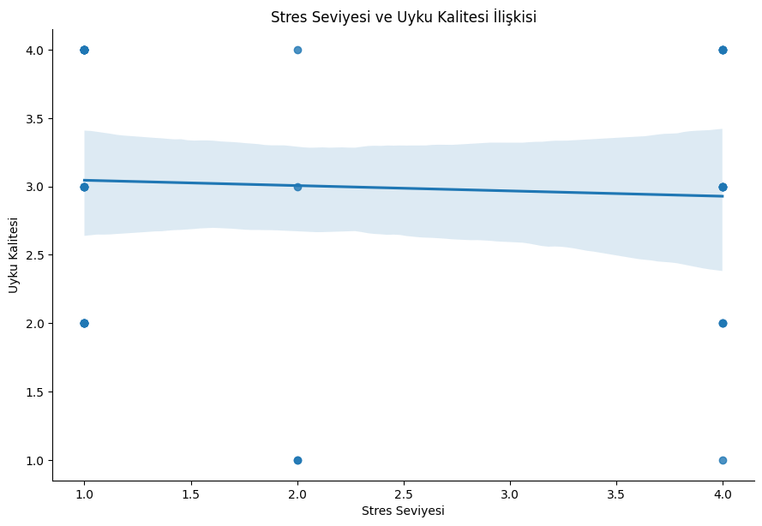

1. Overall Trend:

The graph shows a weak decrease in the quality of sleep as the level of stress increases. However, this trend is rather weak, and the changes are not very big.

2. Distribution:

The data show big variance depending on the level of stress. For example, at low levels of stress, the quality of sleep is generally high, but some low values ​​are also observed.

o The stress level is 4; generally, sleep quality is lower, although there are some high values for this level as well.

3. Error Range:

o The error range shown in grey in the graph demonstrates the uncertainty in sleep quality as a function of the stress level. The error range is small in the middle position and gradually expands to become larger towards the extreme positions, indicating that most variance occurs at extreme levels.

8. Stress Level and Time to Fall Asleep

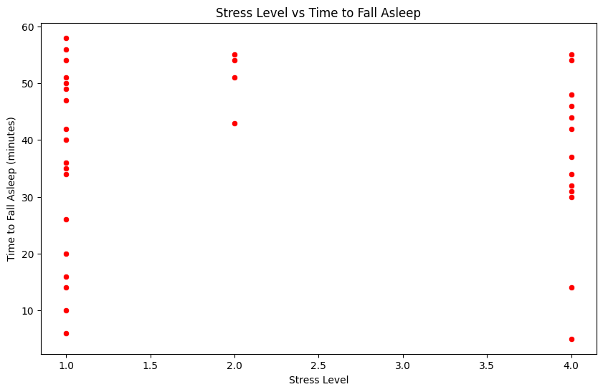

Findings:

1. Time to Fall Asleep vs. Stress Level:

a. For days with stress level 1, the length of time to fall asleep is considerably less, in the range between 10-30 minutes.

b. For days with a stress level of 4, this time length increases to mostly 40-60 minutes.

c. Increasing the stress level results in an appreciable lengthening of the time it takes to go to sleep.

2. The Distribution Differently

o There is more variation on days with stress levels of 2 and 3. That could be suggesting that time to fall asleep may have different individual effects depending on the level of stress.

3. Sleep Quality and Time to Fall Asleep:

o Low levels of stress were indicated to relate to high quality sleep from previous analyses. The graph shows the support for quality at low levels by falling asleep faster.

Conclusions:

1. Low Stress and Falling Asleep Faster:

o When the level of stress is low, that is, 1, one can sleep faster. It helps in enhancing the overall sleep quality.

2. High Stress and Longer Falling Asleep Time:

o In the case of high levels of stress, that is, 4, falling asleep time increases considerably. It may lower the quality of sleep.

3. Different Variances:

o For the levels of stress at 2 and 3, the variability in falling asleep is greater, thus individual variability becomes significant.

9. Sleep Environment and Sleep Quality

Sleep Environment:

1. Black-out Curtains:

o Consistent and the best quality of sleep was recorded here.

o The black-out curtains have contributed to the increment in quality as they optimize sleep.

2. White Noise:

o It has worked with all individual differences in sleep quality, producing wide-range quality outcomes.

3. No Extra Adjustments:

o It has demonstrated the widest variability in sleep quality and has been related to poorer quality.

Daytime First Activity Following Sleep

1. Breakfast:

o Sleep quality demonstrates the widest distribution for days following breakfast after waking up. This might suggest that breakfast is the least determinant compared to other activities.

2. Bath and Sunlight:

o These activities have continuously high values ​​in sleep quality. Maybe physical refreshment in the morning supports sleep quality in general.

3. Phone Use:

o Using the phone after waking up has been shown to be negatively related to good sleep quality. This shows technological devices may elevate stress levels immediately upon waking.

4. Exercise:

o Days when you exercise after rising have better quality sleep. It may be understood from the reducing effect of stress and increasing vigor by physical activity as well.

Conclusion:

1. Sleep Environment:

o Black-out curtains are a more powerful way in improving sleep quality. White noise can vary upon individual preferences.

o Making no adjustments with your sleep environment may lead to fluctuations in your quality.

2. Morning Routines:

o Bathing, sunlight, and exercises are morning activities that improve the quality of sleep.

o It is helpful not to use phones to reduce the level of stress after sleep.

Pre-Sleep Activities:

1. Hot Shower:

o Sleep quality is relatively high and consistent on days when a hot shower is taken. According to boxplot data, sleep quality generally ranges between 3 and 4.

o It is known that hot showers provide relaxation by regulating body temperature and facilitate the transition to sleep.

2. Breathing Exercises:

o The large variability of the quality sleep on the day using the exercises of breathing was very much apart, there being a difference of 1 from 4.

o There can be individualized differences between the breathing exercises- maybe some worked upon most people whereas remained neutral or were adverse to other people.

3. No Activity:

o Sleep quality had a wider distribution on days when no activity was performed before sleep. This suggests that not having a regular routine may lead to inconsistencies in sleep quality.

Combined Inferences:

1. Sleep Environment:

o Black-out curtains and organized environments increase sleep quality consistently. Other environments, such as white noise and relaxing scents, show individual differences.

2. Morning Routines:

o Morning activities, such as exercises, taking a bath, and sunlight, are considered major factors that increase sleep quality. Poor quality sleep is related to phone usage.

3. Pre-Sleep Activities:

o Another main factor that has been considered responsible for increasing the quality of sleep is the hot shower that one takes. The breathing exercises differ according to individual differences.

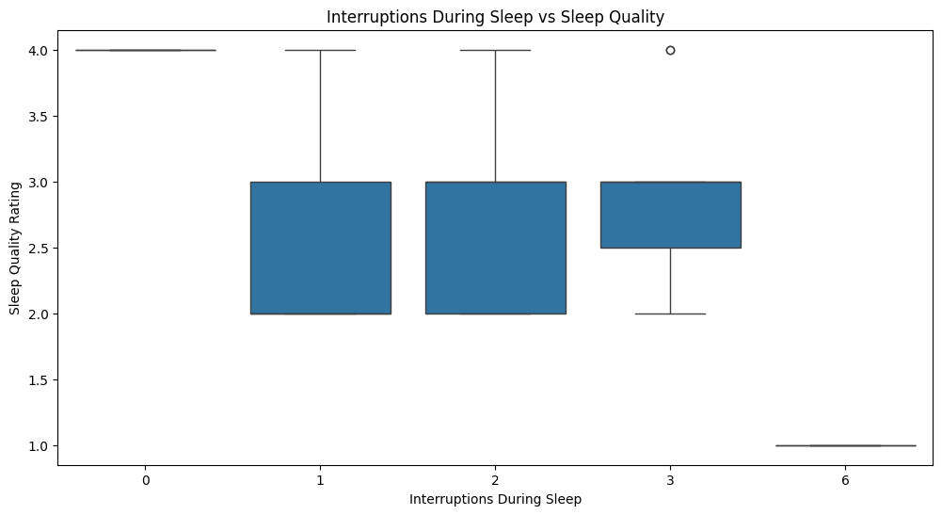11. Interruptions During Sleep and Sleep Quality

Results:

1. No Interruptions (0):

o On days when sleep is uninterrupted, sleep quality is quite high and is usually at the level of 4.

o This situation shows that an uninterrupted sleep environment is important for sleep quality.

2. 1 or 2 Interruptions:

o Sleep quality varies between 2 and 3 on days with 1 or 2 interruptions, while these interruptions decrease the quality of sleep but do not have a totally negative effect.

3. 3 o More Interruptions:

o On days with 3 or more interruptions, sleep quality decreases remarkably. On a day with 6 interruptions, sleep quality was very low.

o With more interruptions, sleep quality showed serious fluctuation and deduction.

Conclusions:

1. Continuous Sleep:

o High sleep quality is related to no interruptions during sleep.

2. Impact of Interruptions:

o Sleep quality decreases with increased interruptions. In particular, 3 or more interruptions result in a serious decline in sleep quality.

3. Dispersion:

o Sleep quality was more dispersed on days with 1 or 2 interruptions. This indicates that interruptions work effectively because of individual differences.

12. My Home and Sleep Quality

Results:

1. Family Home:

Sleep in the family home showed generally higher ranges of values starting from around 3.5 to as much as 4.

Of these, most represent a higher-value-based distribution: It is possible only at extreme, lower-end values in those days does this value actually reflect poor, reduced quality.

2. My Home:

Whereas, at 'my home', distribution can be as small as 1 on specific days: minimum to 4 high ranges.

o Individual differences may have a greater effect when sleeping in one's own home.

Inferences:

1. Comfort in the Family Home:

o Sleeping in the family home tends to yield more reliable and better-quality sleep. This may reflect that the atmosphere in the family home is quieter and more conducive to sleep.

2. Variance in Your Home:

o There is more variation in sleep quality on days when you sleep in your own home. This may be due to differences in environmental conditions or personal routines.

13.Spending Time with Friends and Sleep Quality

Results:

1. Spending Time with Friends = 0:

o The distribution for sleep quality has shown a wide spread between 1 and 4.

o The median here lies at 3, so generally, the sleep quality is there.

o Lower values for sleep quality are more frequent for this group.

2. Spending Time with Friends = 1:

o Sleep quality has been showing more consistent distribution between 2 to 4.

o The median is approximately 3.5, which states that the quality of sleep is generally higher when time is spent with friends.

Inferences:

1. Positive Effect of Spending Time with Friends:

o Generally, sleep quality is higher and more consistent on days spent with friends. This may show that social interaction improves sleep quality through reduced levels of stress.

2. Days Without Spending Time with Friends:

o A greater variation in sleep quality was found on these days. The absence of social contact might have affected the individual differently, hence the inconsistency in the quality of sleep.

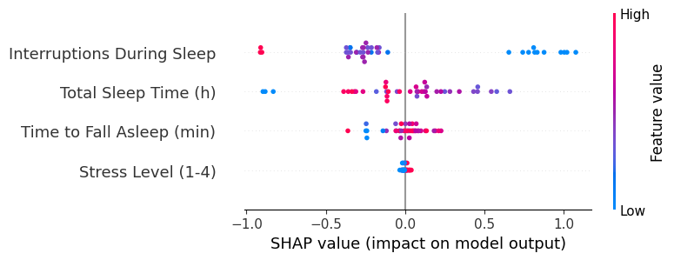15. Evaluation of Factors Affecting Sleep Quality with SHAP Analysis

In this analysis, using the SHAP method, the estimate of the effect of factors affecting sleep quality was made on a machine learning model. The Random Forest Regression model was used to learn relationships of independent variables upon the dependent variable.

Graphical Analysis and Inferences

1. Interruptions During Sleep:

o The SHAP graph depicts that generally, interruptions during sleep have a negative effect.

o More frequent interruptions, the more red it is, and sleep quality worsens.

2. Total Sleep Time:

o The longer the time slept, the redder it is, improving the quality of sleep; the shorter it is, the bluer it is, reducing sleep quality.

o Sleep time is one of the most influential features that contributes positively to sleep quality.

3. Time to Fall Asleep:

o Generally, the longer sleep times are red, contributing to negative SHAP values.

o Time taken to fall asleep: Short time falling asleep is positively related to sleep quality.

4. Stress Level:

o Low level of stress (blue) improves sleep quality; high level of stress (red) worsens sleep quality.

# Tips for a Perfect Sleep Routine

Short-Term Solutions:

1. Reduction in Screen Time:

o No screen time before sleeping, especially no gadgets emitting blue light. This would help your body emit melatonin, hence sleeping well.

2. Sleep Environment:

o Black-out Curtains: You are able to improve your sleep with curtains that block the light out.

o White Noise: You can also try using white noise as this works for many people.

3. Sleep-Promoting Bedtime Routines:

o Sleep transition relaxation techniques, which involve a warm shower or relaxation with meditation, aid in sleep induction.

4. Sleeping Environment - Non-interruptive:

o Reduced disturbance due to less noise and light interruptions around the surroundings boosts sleep quality.

Long Term Solutions

1. Manage your Stress :

o Stress reducing relaxation techniques like breathing exercises, meditation, or Yoga will drop down the stress levels and promote good quality and quantity of sleep.

2. Regulate Sleeping Pattern

o Normalize your sleep and wake-up timings to tune your biological clock.

3. Form a Morning and Evening Routine:

o Morning: You may start the morning by doing exercise or taking the sun. And keep the stress level low by not using your phone.

o Evening: Before going to sleep take a hot shower and perform some activities, like reading a book, in a very relaxing way.

4. Enrich Your Social Network:

o Spending time with friends or spending quality time with your family can reduce your stress levels and positively contribute to the quality of your sleep.

• Reduce Alcohol Consumption:

o Alcohol can affect the quality and duration of sleep negatively. Therefore, it is beneficial to limit alcohol consumption.

• Optimize Sleep Duration:

o Get at least 7 to 8 hours of sleep per night. For that, longer sleeping hours result in better quality but do harm beyond a certain limit.

• Activities to Initiate the Day Immediately After Awakening:

o The energies can be pumped up by bathing, taking some sun, or just having a light breakfast.

# Limitations and Future Work

Limitations:

1. The Data Set is Individual and Small-Scale:

o The data set used in the analyses represents only individual sleep habits. This limits the generalization of the inferences obtained.

2. Short Data Collection Time:

o The limited time allocated for data collection made it difficult to analyze factors such as seasonal variables and long-term sleep habits.

Future Studies:

1. Analysis with a Larger Data Set:

o Larger sample data collection may be done to represent different age groups, occupations, and lifestyles. The effects of various environmental conditions, such as city noise or geographic regions, on sleep quality can be studied. 2. Sleep Quality Prediction using Machine Learning Models: o Regression and classification models can give a better analysis of factors affecting sleep quality.

o With methods such as SHAP analysis, detailed evaluations of the variables' effects can be done to provide personalized recommendations.

3. Long-Term Data Collection Studies:

o The process of long-term data collection could analyze changes in sleep quality concerning seasonal and habitual factors.

4. Experimental Approaches:

o The different sleep environmental factors-light, sound, and temperature-can be experimentally measured with regard to their influence on a person.

o An experimental setup can be designed to understand the effects of pre-sleep activities.

# Conclusion

Project Overview:

The project focused on how to enhance individual sleeping habits by analyzing the factors that influence sleep quality. The most significant results derived due to the analysis are as follows:

• Continuous Sleep: It was found that one of the strongest factors in enhancing sleep quality is a reduction in the number of interruptions during sleep.

• Stress Management: Low level of stress is always followed by high quality of sleep.

• Sleep Environment Optimization: The sleep quality was enhanced by certain arrangements, such as black-out curtains.

• Nighttime Relaxation Routines: Habits like hot showers and reduced screen time reduce time taken to sleep.

• Morning Activities: Exercising and sunlight exposure are some of the activities that positively influence the energy levels of a person upon waking up.

Final Thoughts:

This study was designed to make a contribution toward a healthier life by providing person-specific suggestions that can further improve the individual's quality of sleep. The findings that will be retrieved can improve sleeping habits of a person, as well as guide toward general productivity and balance in life.

It is hoped that this research can raise awareness regarding the quality of sleep and provide some kind of foundation for studies to be more in-depth in times to come. A good sleeping habit can save much physical and mental health for the future.