Dhatupatha nach MW (unvollständig!)

I. bhuuv-aaday-a.h

I.A. udaattaa.h
2, 4: bAdh
2, 5: nAdh
2, 6: nAth
2, 10: vand
2, 12: mand
2, 13: spand
2, 15: mud
2, 20: kUrd
2, 25: hrAd
2, 26: hlAd
2, 28: pard
2, 32: vith
2, 35: grath
2, 36: katth
3, 4: zcut
3, 13: khad
3, 16: rad
3, 17: nad
3, 19: nard
3, 30: nand
3, 31: cand
4, 12: zaGk
4, 18: vRk
4, 19: cak
4, 41: zlAgh
5, 1: phakk
5, 2: tak
5, 28: IGkh
5, 33: riGkh
5, 33: rikh
5, 35: valg
5, 36: raGg
5, 46: iGg
5, 47: riGg
6, 2: sac
6, 16: Rj
6, 20: ej
6, 22: bhrAj
6, 23: rej
6, 24: Ij
7, 7: vaJc
7, 13: mruc
7, 35: yuch
7, 38: dhraj
7, 50: sarj
7, 54: mluc
7, 56: tej
7, 61: sphUrj
8, 2: veST
8, 4: goSTha
8, 13: heTh
8, 20: bhaND
9, 4: mreD
9, 6: caT
9, 10: raT
9, 20: bhaT
9, 21: taT
9, 27: luD
9, 27: lul
9, 29: viT
9, 30: viD
9, 30: biT
9, 36: maND
9, 38: puT
9, 45: paTh
10, 6: vip
10, 8: lap
10, 13: kamp
10, 14: ramb
10, 15: lamb
10, 22: ribh
10, 24: rambh
10, 27: skambh
10, 31: valbh
10, 34: stubh
11, 6: sap
11, 7: rap
11, 19: raph
11, 42: zubh
12, 6: paN
12, 8: bhAm
12, 10: kam
13, 4: bhaN
13, 17: kan
13, 18: stan
13, 21: san
13, 23: dram
14, 3: pay
14, 8: say
14, 13: pUy
14, 14: knUy
14, 16: sphAy
14, 18: tAy
14, 24: bhal
14, 26: kal
14, 30: sev
15, : jUrv
15, 5: hay
15, 7: hary
15, 10: mIl
15, 18: kUl
15, 19: ci
15, 24: phull
15, 24: phulla
15, 32: kSvel
15, 33: vell
15, 39: gal
15, 40: sal
15, 52: SThiv
15, 56: mIv
15, 59: kSiv
15, 64: dhUrv
15, 70: carv
15, 71: bharv
15, 79: pinv
15, 82: hi
15, 87: raNv
16, 1: dhukS
16, 4: zikS
16, 5: bhikS
16, 7: dakS
16, 8: dIkS
16, 11: bhAS
16, 17: eS
16, 18: hreS
16, 18: preS
16, 20: heS
16, 23: bhAs
16, 25: rAs
16, 26: nas
16, 27: bhyas
16, 32: baMh
16, 44: vAh
16, 49: glah
17, 6: rakS
17, 7: nikS
17, 11: vakS
17, 12: makS
17, 13: takS
17, 16: rAdh
17, 22: cUS
17, 25: mUS
17, 34: kaS
17, 43: riS
17, 44: bhaS
17, 48: miS
17, 51: zriS
17, 53: pruS
17, 61: hras
17, 65: ghas
17, 69: pis
17, 77: zaz
17, 78: zas
17, 79: zaMs
17, 81: mah
17, 82: rah
17, 84: dRMh
18, 2: zvit
18, 4: kSviD
18, 4: svid
18, 5: ruc
18, 15: sraMs
18, 16: dhvaMs
18, 17: bhraMz
18, 22: lubh
18, 22: syand

I.A.19. ghatA=aaday-a.h M-IT-a.h
19, 52 : chad
19, 2: bhid
19, 2: vyath
19, 16: heD
19, 16: heD
19, 28: sthag
19, 36: zraN
19, 37: znath
19, 40: klath
19, 44: hval
19, 47: dRR
19, 58: val
19, 59: skhal
19, 62: svan
19, 68: vam
19, 68: van
19, 73: phaN
19, 74: rAj
19, 82: sam

I.A.21. jvalA=aaday-a.h (3.1.140)
20, : kSal
20, 3: dhAnya
20, 4: Tal
20, 9: phal
20, 15: pat
20, 17: path
20, 18: math
20, 20: bhram
20, 23: ram
20, 24: sad
20, 25: zad

I.A.22. svartita=IT-a.h
21, 3: yAc
21, 5: cat
21, 7: mith
21, 8: ned
21, 9: zRdh
21, 10: mRdh
21, 11: budh
21, 13: ven
21, 18: dAz
21, 19: bheS
21, 20: bhreS
21, 27: bhakS
21, 28: dAs
21, 31: zri

I.B. anudaatta.h

I.B.1. aC=antaa.h
22, 1: bhR
22, 2: hR
22, 3: dhR
22, 5: nI
22, 8: mlai
22, 10: drai
22, 14: styai
22, 21: zrA
22, 24: vai
22, 27: pA
22, 30: sthA
22, 31: mnA
22, 35: smR
22, 39: gR
22, 41: dhvR
22, 42: sru
22, 44: zru
22, 47: dru
22, 49: jri
22, 54: kU
22, 60: jU
22, 61: pru
22, 62: plu
22, 63: ru
22, 67: zyai
22, 68: pyai

I.B.2. haL=antaa.h
23, 3: man
23, 5: rabh
23, 6: labh
23, 7: svaj
23, 10: skand
23, 11: yabh
23, 12: nam
23, 14: sRp
23, 15: yam
23, 18: saJj
23, 23: mih
23, 24: cit
23, 25: dAn
23, 27: pac
23, 30: raJj
23, 31: zap
23, 33: yaj
23, 34: vap
23, 35: vah
23, 38: vye
23, 39: hve
23, 40: vad
23, 41: zvi

II. Ad=aaday=a.h

II.A. anudattaa.h
24, 2: han
24, 2: vadh
24, 5: dih
24, 6: lih
24, 7: vRj

II.B. udattaa.h
24, 14: kas
24, 15: niMs
24, 17: ziJj
24, 20: pRc
24, 21: sU
24, 22: zI
24, 28: kSNu
24, 29: snu

II.C. anudattaa.h parasmaipad-on-a.h
24, 31: dyu
24, 34: stu
24, 35: brU
24, 39: vI
24, 41: yA
24, 42: vA
24, 43: bhA
24, 44: snA
24, 47: psA
24, 49: rA
24, 50: lA
24, 52: khyA
24, 53: prA
24, 54: mA
24, 59: rud
24, 60: svap
24, 61: zvas
24, 67: zAs
24, 68: AdhI
24, 70: sas
24, 71: vaz
24, 73: hnu

III. Ju-ho-ti-aaday-a.h

III.A. anudaatta.h
25, 1: hu
25, 3: hrI
25, 8: hA
25, 11: nij
25, 12: vic

III.B. chaandasaa.h parasmai-pad-in-a.h
25, 14: ghR
25, 18: bhas
25, 23: dhan
25, 24: jan
25, 25: gA

IV. Div-aaday-a.h

IV.A. udaattaa.h udaatta=IT-a.h
26, 2: siv
26, 7: vyuS
26, 9: nRt
26, 11: kuth
26, 17: stim
26, 18: vrID
26, 20: sah

IV.B. su=aaday-a.h (oT=IT-a.h) aatmane-pad-on-a.h
26, 25: dI
26, 32: pI
26, 36: zo
26, 37: dhI

IV.D. udaattaa.h
26, 47: jur
26, 49: cUr
26, 50: tap
26, 53: kAz
26, 54: vAz
26, 56: zuc

IV.E. anudaattaa.h
26, 57: nah
26, 64: yudh
26, 69: sRj
26, 70: liz
26, 71: sAdh
26, 72: vyadh

IV.F. pu.sA=aaday-a.h (3.1.55) udaatta=IT-a.h
26, 74: zuS
26, 78: zak
26, 82: zudh
26, 83: sidh
26, 84: radh
26, 85: naz
26, 89: muh
26, 92: zam
26, 93: tam
26, 101: yas
26, 116: vRz
26, 116: vRz
26, 117: kRz
26, 119: hRS
26, 123: gup
26, 124: yup
26, 125: rup
26, 126: lup
26, 130: nabh

V. Su=aaday=a.h

V.A. anudaattaa.h
27, 1: su
27, 2: si
27, 3: zi
27, 4: mi
27, 6: stR
27, 9: dhU
27, 10: du
27, 12: pR
27, 13: spR
27, 15: sUrkS

V.B. udaattaa.h
27, 18: stigh
27, 20: sagh
27, 26: dagh
27, 27: cam
27, 33: drU

VI. Tuda=aaday-a.h
28, 2: nud
28, 7: RS
28, 11: vrazc
28, 12: vyac
28, 15: Rch
28, 19: Rc
28, 20: ubj
28, 23: rih
28, 23: riph
28, 32: ubh
28, 38: mRD
28, 53: mur
28, 56: pur
28, 58: stRh
28, 65: il
28, 69: hil
28, 71: mil
28, 72: likh
28, 75: kuc
28, 79: chur
28, 87: luTh
28, 88: kUD
28, 95: sphur
28, 103: gur
28, 106: gu
28, 111: rI
28, 112: pi
28, 113: dhi
28, 118: dR
28, 120: prach
28, 122: majj
28, 126: riz
28, 128: spRz
28, 130: viz
28, 131: mRz
28, 139: lip
28, 140: sic
28, 143: piz

VII. Rudh=aaday-a.h
29, 1: rudh
29, 8: chRd
29, 10: kRt
29, 13: vid
29, 15: piS
29, 16: bhaJj
29, 17: bhuj
29, 20: ud
29, 23: vij

VIII. Tan-aaday-a.h
30, 6: vRN

IX.Krii=aday-a.h
31, 2: prI
31, 3: zrI
31, 6: sku
31, 7: stambh
31, 9: yu
31, 12: pU
31, 13: lU
31, 18: zRR
31, 21: hvR
31, 22: sRR
31, 22: mRR
31, 24: jRR
31, 29: jyA
31, 31: lI
31, 32: vlI
31, 34: bhrI
31, 35: kSI
31, 54: viS
31, 56: pluS
31, 57: puS
31, 58: muS
31, 59: khac

X. Cur-aaday-a.h

X.A. parasmai-pad-in-a.h
32, : jas
32, 2: cint
32, 5: lakS
32, 8: mid
32, 11: pID
32, 12: naT
32, 14: bandh
32, 19: prath
32, 23: kuTT
32, 36: snih
32, 37: smi
32, 38: zliS
32, 46: guNTh
32, 50: bhand
32, 68: cal
32, 69: pAl
32, 74: mArg
32, 74: vaj
32, 74: vraj
32, 90: sphiT
32, 91: cumb
32, 95: vyay
32, 107: sR
32, 109: tij
32, 119: mrakS
32, 124: gRdh
32, 131: ruS
32, 132: Damb
32, 132: dabh

X.B. aatmane-pad-in-a.h
33, 7: spaz
33, 11: gandh
33, 12: hikk
33, 15: kUN
33, 18: zal
33, 19: yakS
33, 29: bhaj
33, 30: vRS
33, 31: mad
33, 33: gRR
33, 33: kRR
33, 36: yuj
33, 43: sUd
33, 45: paz
33, 48: sphuT
33, 49: ghaT
33, 51: div
33, 55: las
33, 56: bhUS
33, 56: taMs
33, 62: yat
33, 63: lag
33, 63: rag
33, 66: muc
33, 70: vas
33, 71: car
33, 72: cyu
33, 76: gras
33, 79: paT
33, 82: tuj
33, 87: laGgh
33, 91: daMz
33, 95: bRh
33, 97: valh
33, 102: puth
33, 104: loc
33, 106: kup
33, 108: vRt
33, 109: vRdh
33, 120: raGgh
33, 123: raMh
33, 124: maMh
33, 126: taD
33, 126: pRR
33, 129: ruj
33, 130: svad

X.C. parasmai-pad-in-a.h
34, 10: ric
34, 11: ziS
34, 14: cRt
34, 14: dRp
34, 15: bhI
34, 16: dRbh
34, 18: mI
34, 19: krath
34, 23: hiMs
34, 28: juS
34, 31: zrath
34, 35: vac
34, 37: bhU
34, 43: dhRS

X.D. aT=ant-aa.h
35, 2: vR
35, 8: gad
35, 11: svar
35, 12: rac
35, 16: zAr
35, 17: kRp
35, 19: spRh
35, 24: gomaya
35, 32: vAs
35, 40: zram
35, 44: pad
35, 45: gRhaya
35, 48: zUr
35, 77: ras
35, 83: varN
35, 84: kSap
35, 84: rUS

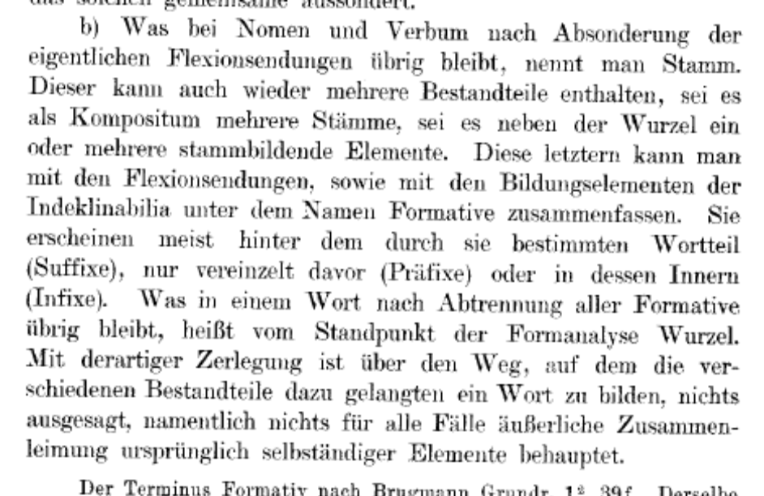
Wackernagel, Jacob (1905). Altindische Grammatik, II.1. Einleitung zur Wortlehre. Nominalkomposition. Göttingen. 12 of 172
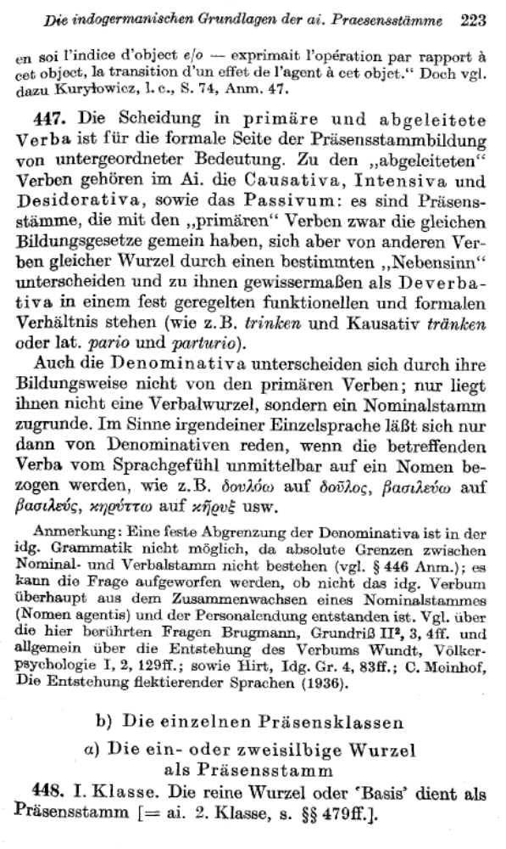
117 of 252

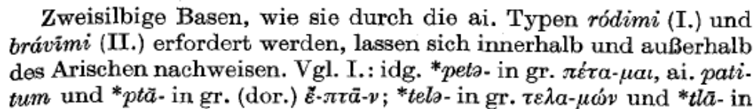
118 of 252

