॥ श्रीः॥ ॥śrīḥ॥
ādikaviśrīvālmīkimahāmunipraṇītaṃ
rāmāyaṇam
tilakākhyayā vyākhyayā sametam।
sundarakāṇḍam।

triṃśaḥ sargaḥ || 30

Source in Sanskrit (devanāgarī) (file Ramayana 2.pdf)
Page | Verse | Comment
116 | 1-5 | 1-5 (beg.)
117 | 6-22 | 5-22 (beg.)
118 | 23-41 | 22-41 (beg.)
119 | 42-44 | 41-44

devanāgarī.

Page 116. Verse (1-5)
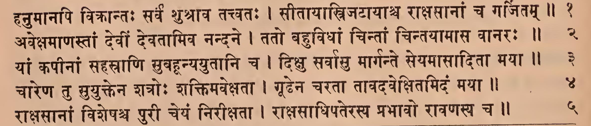

Page 116. Comment (1-5 beg.)

Page 117. Verse (5-22)
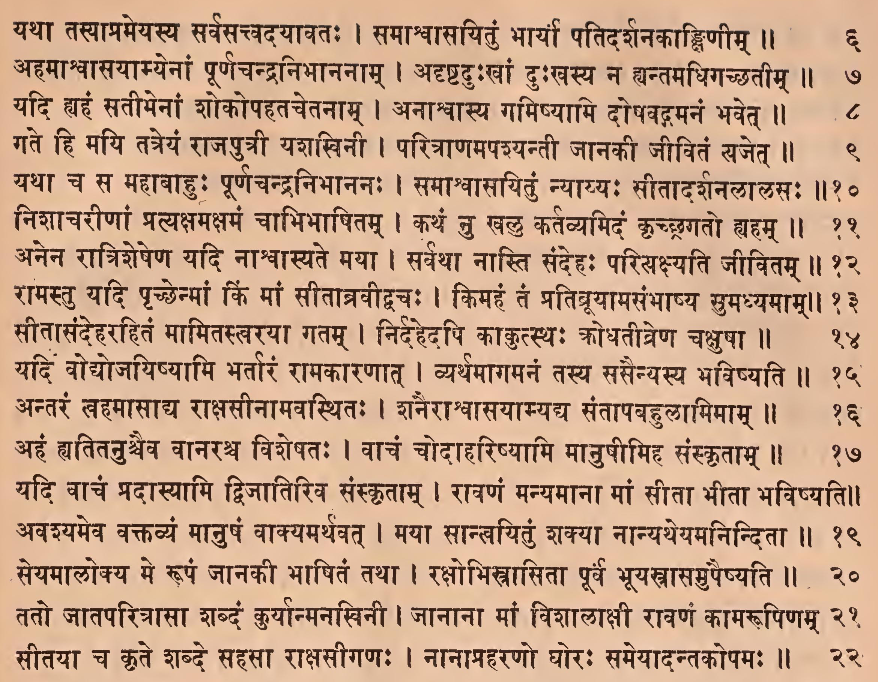

Page 117. Comment (5-22 beg.)
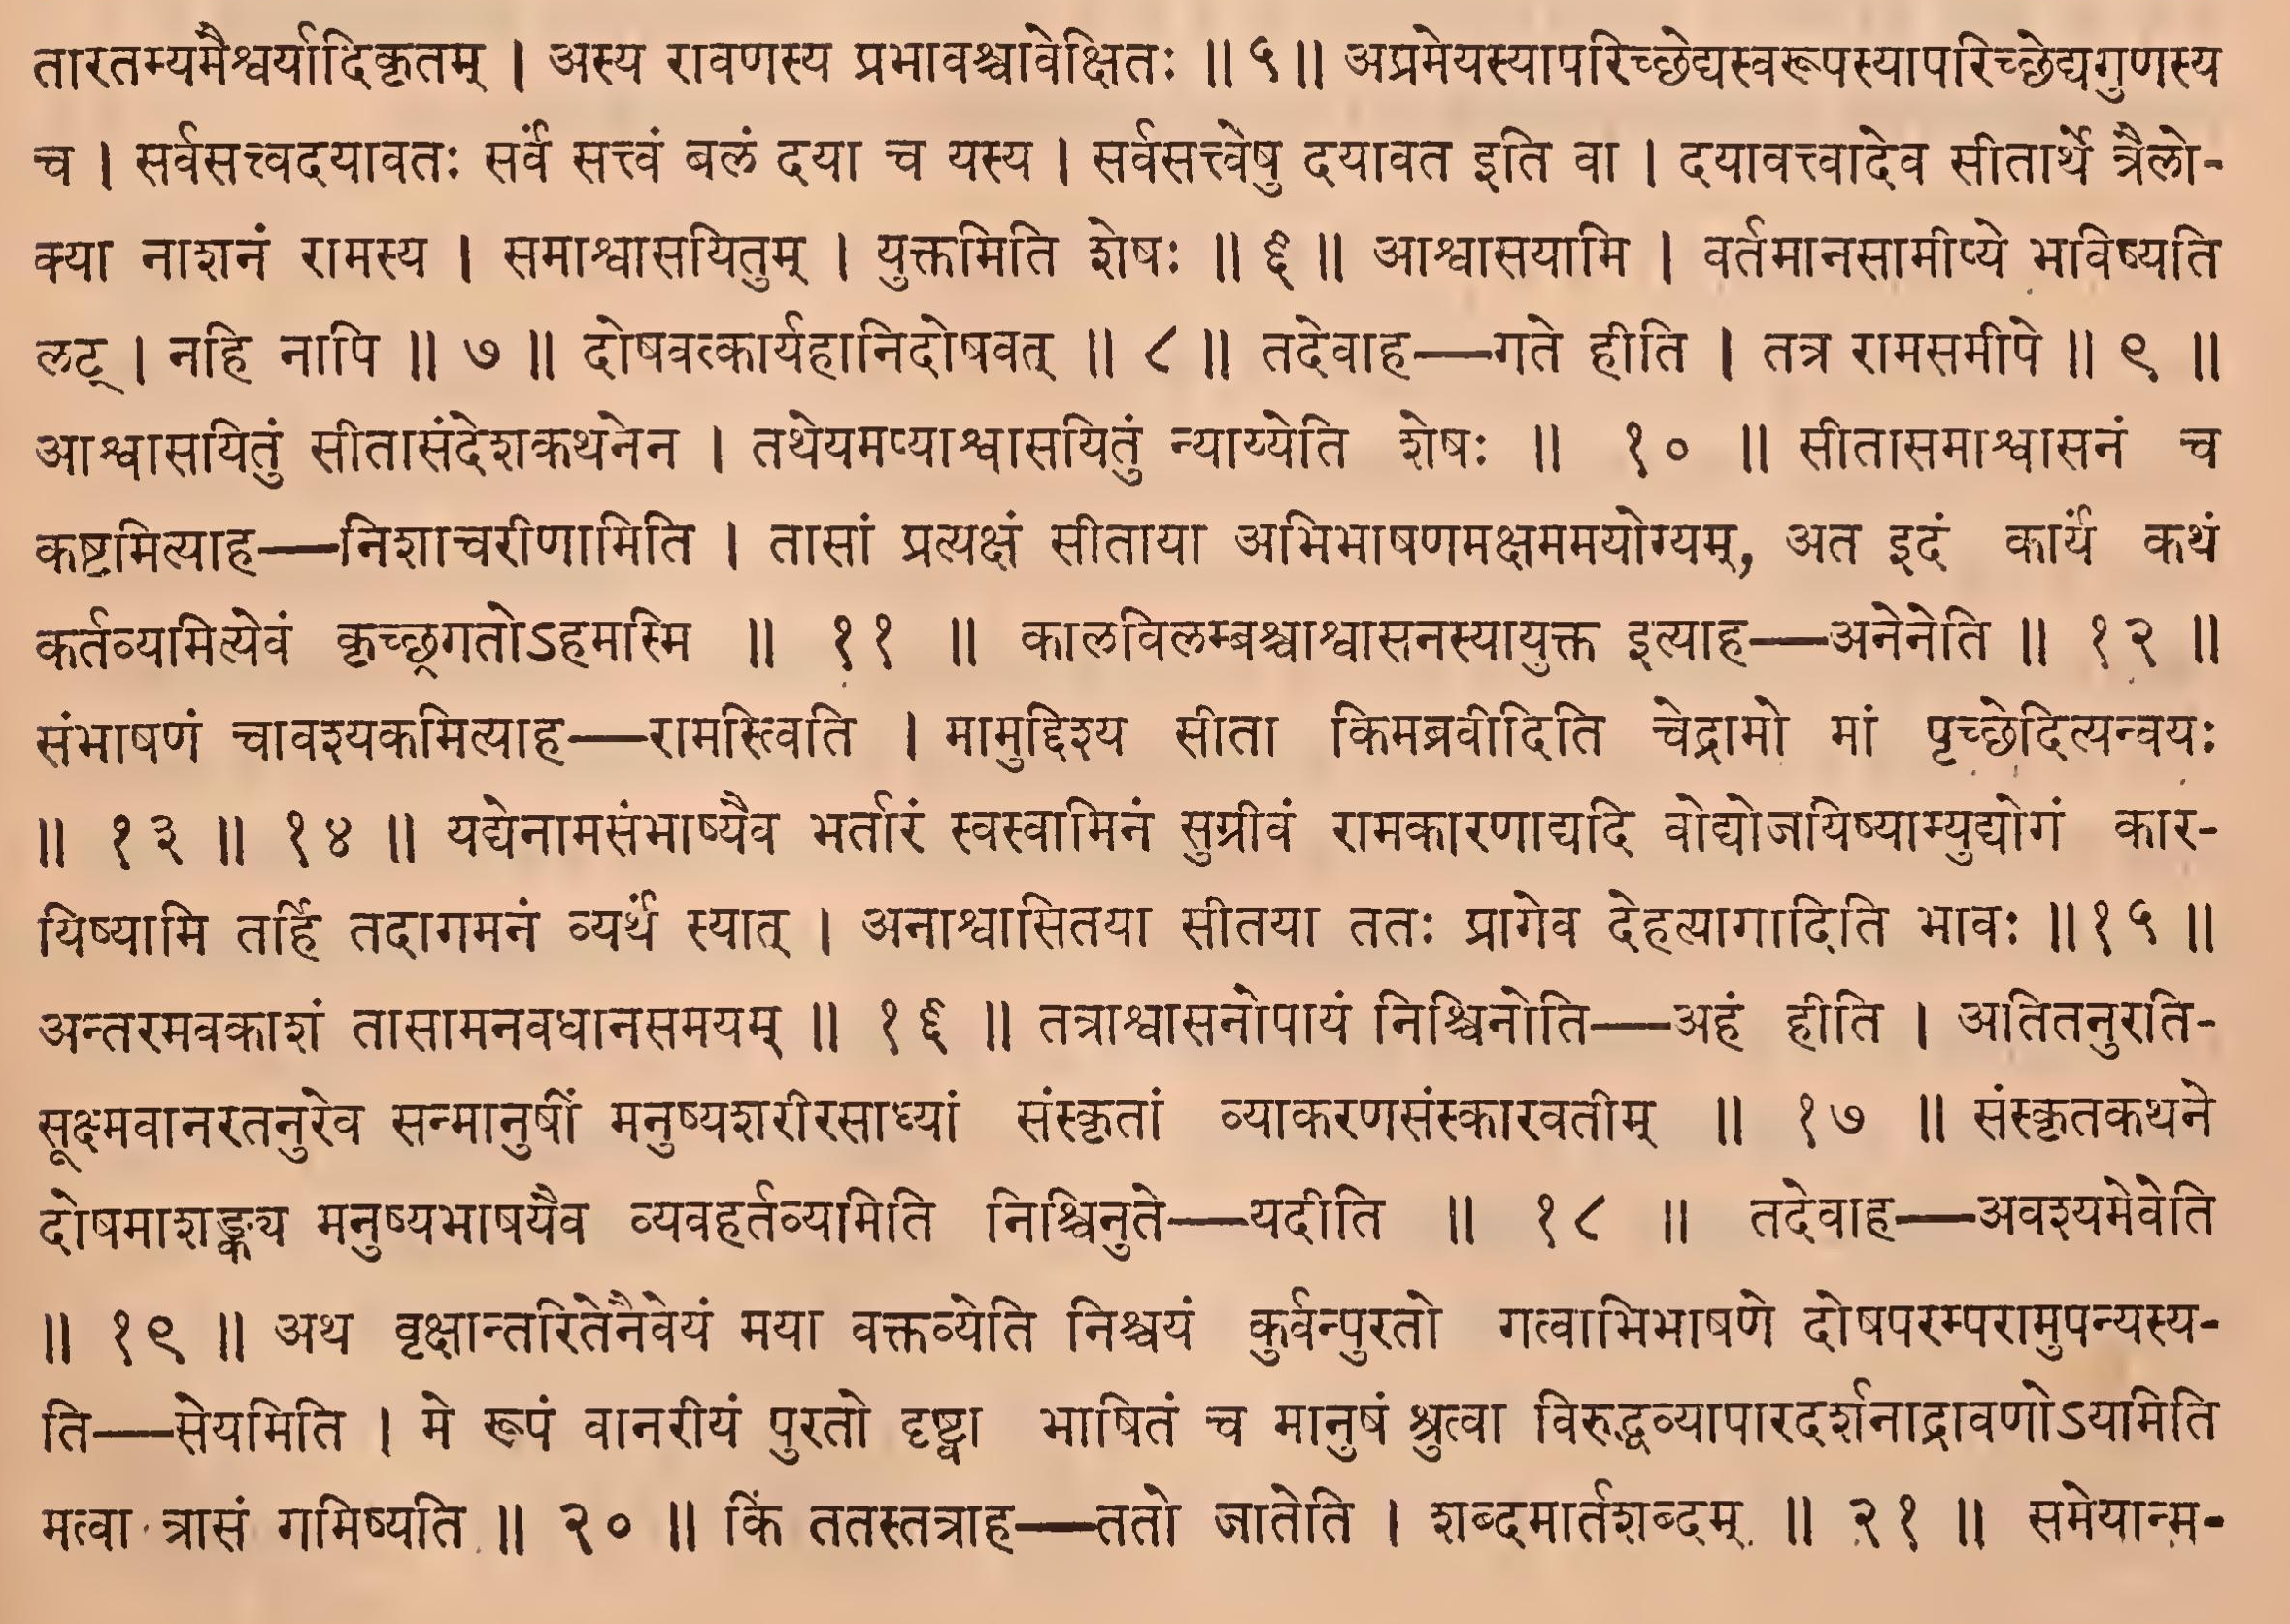

Page 118. Verse (23-41)
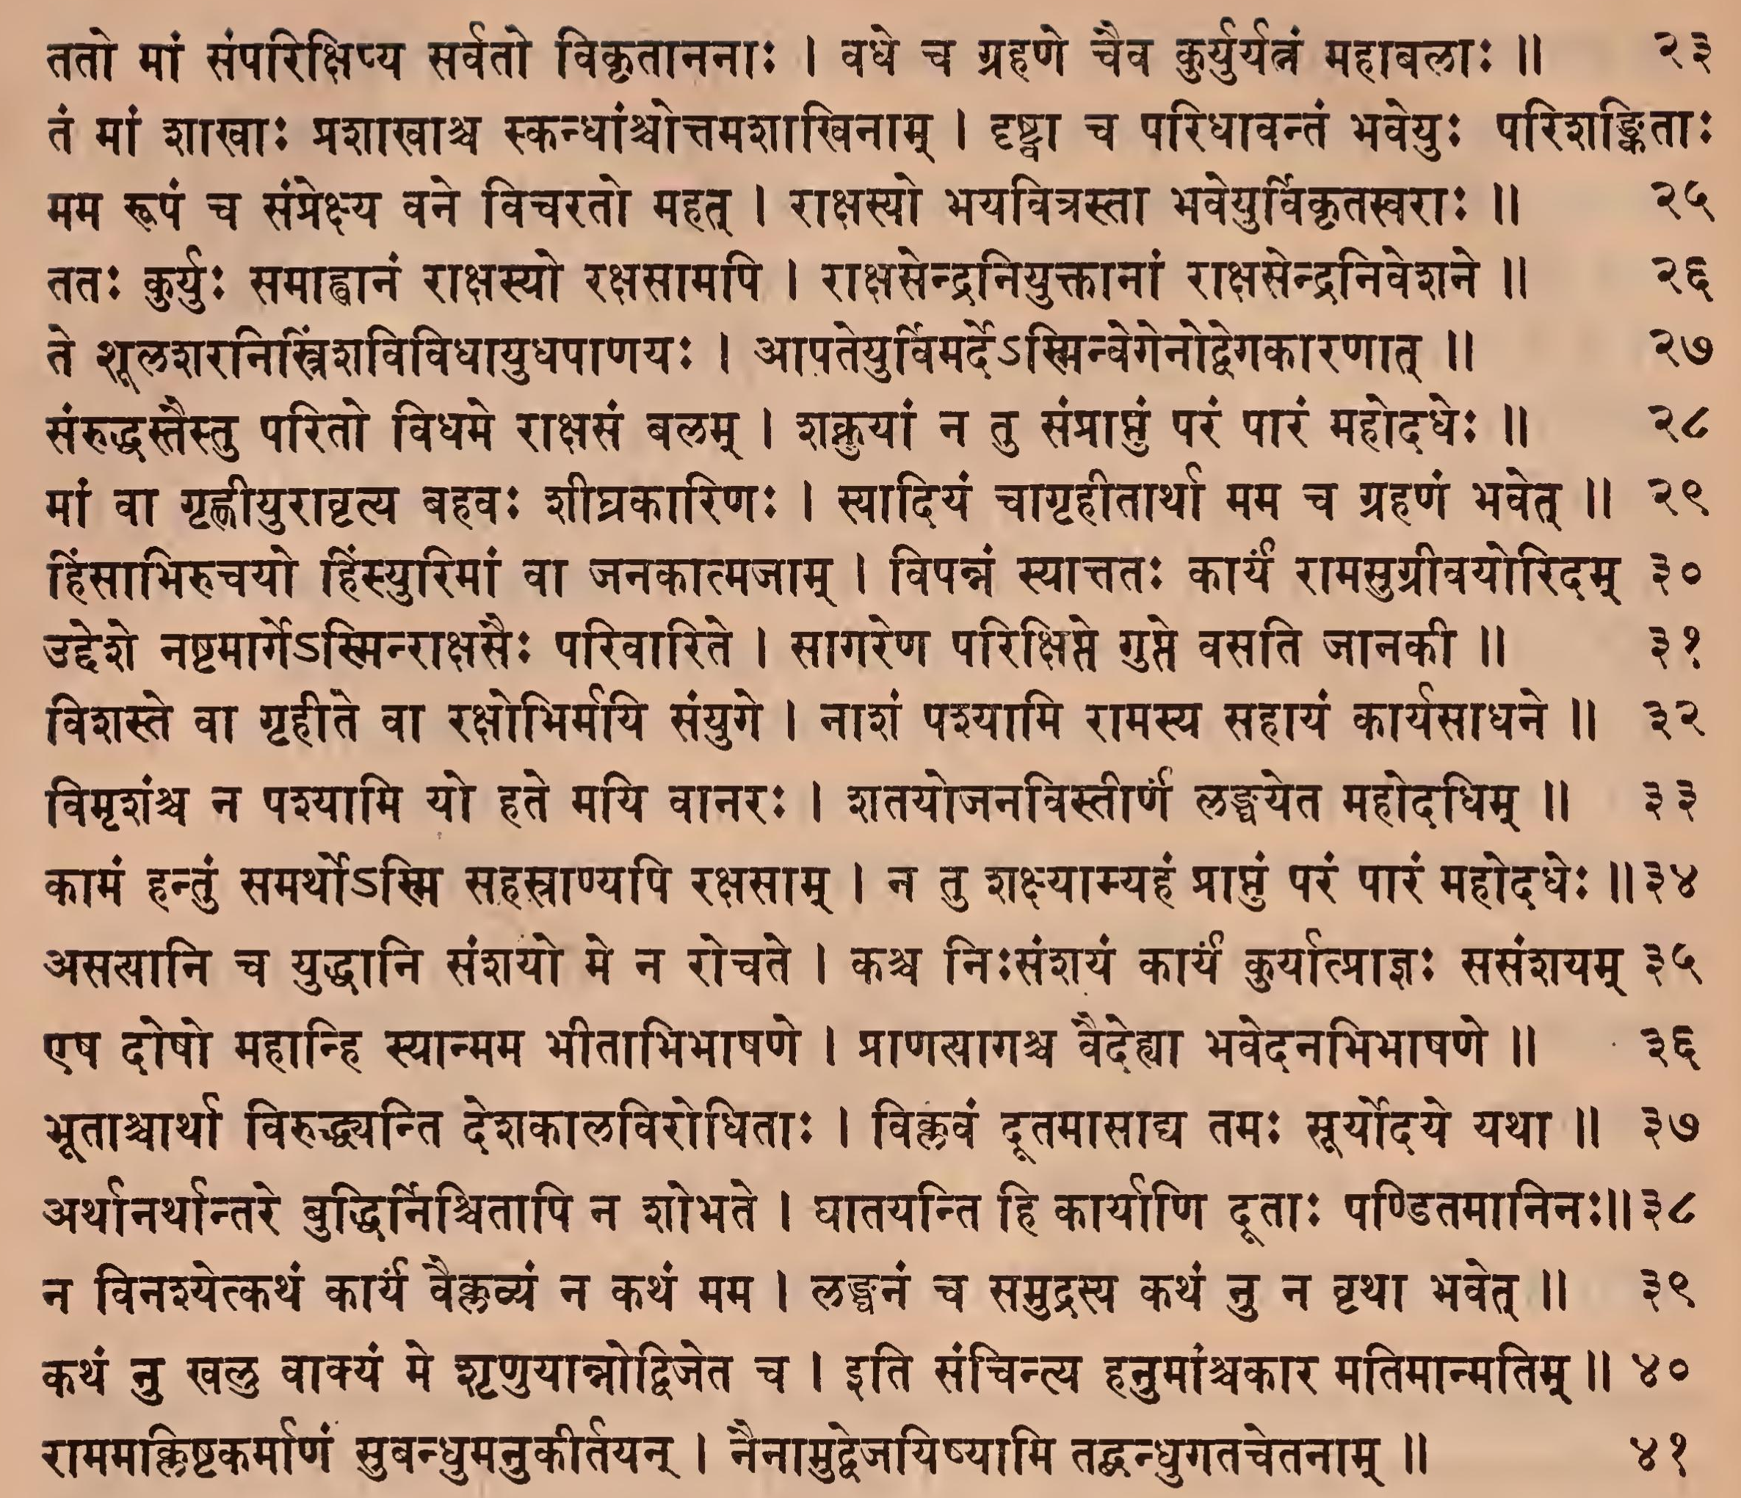

Page 118. Comment (23-41 beg.)
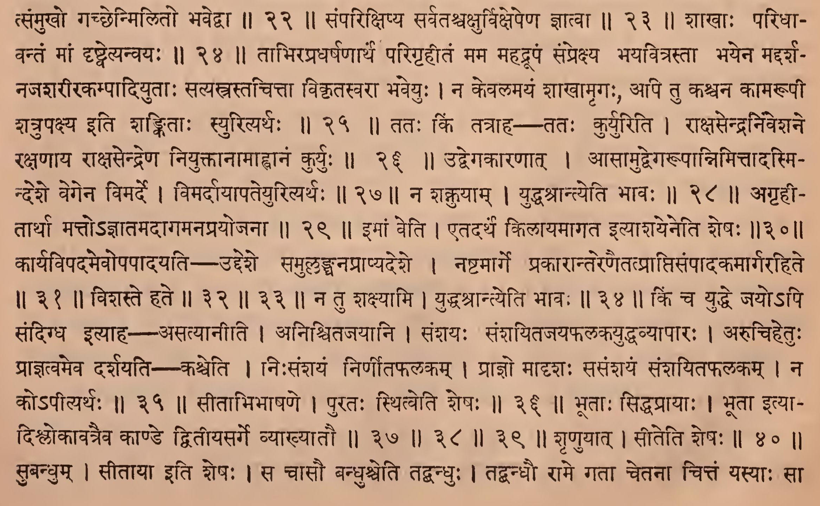

Page 119. Verse (42-44)
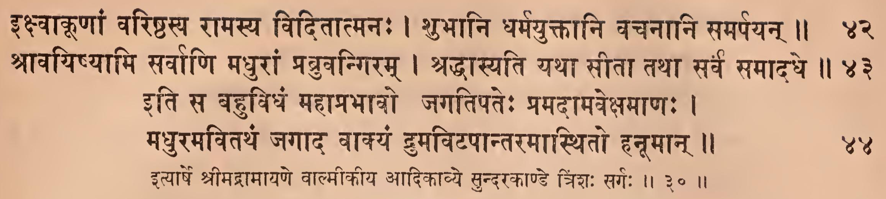

Page 119. Comment (41-44)
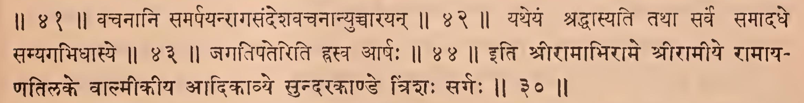

IAST - International Alphabet of Sanskrit Transliteration
hanumānapi vikrāntaḥ sarva śuśrāva tattvataḥ |
sītāyāstrijaṭāyāśca rākṣasānāṃ ca garjitam || 1
vikrāntaḥ śūraḥ | sītāyātrijaṭāyāḥ [ca] | svapnakathanamiti śeṣaḥ || 1 ||
avekṣamāṇastāṃ devīṃ devatāmiva nandane |
tato bahuvidhāṃ cintāṃ cintayāmāsa vānaraḥ || 2
yāṃ kapīnāṃ sahasrāṇi suvahanyayutāni ca |
dikṣu sarvāsu mārgante seyamāsāditā mayā || 3
cintāṃ cintayāmāsa | cintāṃ cakāretyarthaḥ || 2 || 3 ||
cāreṇa tu suyuktena śatroḥ śaktimavekṣatā |
gūḍhena caratā tāvadavekṣitamidaṃ mayā || 4
cāreṇa cārātmanā pravartamānena | idaṃ vakṣyamāṇam || 4 ||
rākṣasānāṃ viśeṣaśca purī ceyaṃ nirīkṣatā |
rākṣasādhipaterasya prabhāvo rāvaṇasya ca || 5
rākṣasānāṃ viśeṣaḥ, tāratamyamaiśvaryādikṛtam | asya rāvaṇasya prabhāvaścāvekṣitaḥ || 5 ||
yathā tasyāprameyasya sarvasattvadayāvataḥ |
samāśvāsayituṃ bhāryā patidarśanakāṅkṣiṇīm || 6
aprameyasyāparicchedyasvarūpasyāparicchedyaguṇasya ca | sarvasacvadayāvataḥ sarve sattvaṃ balaṃ dayā ca yasya | sarvasattveṣu dayāvata iti vā | dayāvattvādeva sītārthe trailokyā nāśanaṃ rāmasya | samāśvāsayitum | yuktamiti śeṣaḥ || 6 ||
ahamāśvāsayāmyenāṃ pūrṇacandranibhānanām |
adṛṣṭaduḥkhāṃ duḥkhasya na hyantamadhigacchatīm || 7
āśvāsayāmi | vartamānasāmīpye bhaviṣyati laṭ | nahi nāpi || 7 ||
yadi hyahaṃ satīnāṃ śokopahatacetanām |
anāśvāsya gamiṣyāmi doṣavagamanaṃ bhavet || 8
doṣavatkāryahānidoṣavat || 8 ||
gate hi mayi tatreyaṃ rājaputrī yaśakhinī |
paritrāṇamapaśyantī jānakī jīvitaṃ yajet || 9
tadevāha – gate hīti | tatra rāmasamīpe || 9 ||
yathā ca sa mahābāhuḥ pūrṇacandranibhānanaḥ |
samāśvāsayituṃ nyāyyaḥ sītādarśanalālasaḥ || 10
āśvāsayituṃ sītāsandeśakathanena | tatheyamapyāśvāsayituṃ nyāyyeti śeṣaḥ || 10 ||
niśācarīṇāṃ pratyakṣamakṣamaṃ cābhibhāṣitam |
kathaṃ nu khalu kartavyamidaṃ kṛcchragato hyaham || 11
sītāsamāśvāsanaṃ ca kaṣṭamityāha---niśācarīṇāmiti | tāsāṃ pratyakṣaṃ sītāyā abhibhāṣaṇamakṣamamayogyam, ata idaṃ kārya kathaṃ kartavyamityevaṃ kṛcchragato'hamasmi || 11 ||
anena rātriśeṣeṇa yadi nāśvāsyate mayā |
sarvathā nāsti sandehaḥ pariyakṣyati jīvitam || 12
kālavilambaśvāśvāsanasyāyukta ityāhaaneneti || 12 ||
rāmastu yadi pṛcchenmāṃ kiṃ māṃ sītābravīdvacaḥ |
kimahaṃ taṃ pratibrūyāmasaṃbhāṣya sumadhyamām || 13
sītāsandeharahitaṃ māmitastvarayā gatam |
nirdahedapi kākutsthaḥ krodhatītreṇa cakṣuṣā || 14
saṃbhāṣaṇaṃ cāvaśyakamityāha - rāmastviti | māmuddiśya sītā kimabravīditi cedrāmo māṃ pṛcchedityanvayaḥ || 13 || 14 ||
yadi vodyojayiṣyāmi bhartāraṃ rāmakāraṇāta |
vyarthamāgamanaṃ tasya sasainyasya bhaviṣyati || 15
yadyenāmasaṃbhāṣyaiva bhartāraṃ svasvāminaṃ sugrīvaṃ rāmakāraṇādyadi vodyojayiṣyāmyudyogaṃ kārayiṣyāmi tarhi tadāgamanaṃ vyartha syāt | anāśvāsitayā sītayā tataḥ prāgeva dehatyāgāditi bhāvaḥ || 15 ||
antaraṃ tvahamāsādya rākṣasīnāmavasthitaḥ |
śanairāśvāsayāmyadya santāpabahulāmimām || 16
antaramavakāśaṃ tāsāmanavadhānasamayam || 16 ||
ahaṃ hyatitanuścaiva vānaraśca viśeṣataḥ |
vācaṃ codāhariṣyāmi mānuṣīmiha saṃskṛtām || 17
tatrāśvāsanopāyaṃ niścinoti — ahaṃ hīti | atitanuratisūkṣmavānaratanureva sanmānuṣīṃ manuṣyaśarīrasādhyāṃ saṃskṛtāṃ vyākaraṇasaṃskāravatīm || 17 ||
yadi vācaṃ pradāsyāmi dvijātiriva saṃskṛtām |
rāvaṇaṃ manyamānā māṃ sītā bhītā bhaviṣyati || 18
saṃskṛtakathane doṣamāśaṅkaya manuṣyabhāṣayaiva vyavahartavyamiti niścinute - yadīti || 18 ||
avaśyameva vaktavyaṃ mānuṣaṃ vākyamarthavat |
mayā sānvayituṃ śakyā nānyatheyamaninditā || 19
tadevāha —– avaśyameveti || 19 ||
seyamālokya me rūpaṃ jānakī bhāṣitaṃ tathā |
rakṣobhistrāsitā pūrva bhūyastrāsamupaiṣyati || 20
atha vṛkṣāntaritenaiveyaṃ mayā vaktavyeti niścayaṃ kurvanpurato gatvābhibhāṣaṇe doṣaparamparāmupanyasyati — seyamiti | me rūpaṃ vānarīyaṃ purato dṛṣṭvā bhāṣitaṃ ca mānuṣaṃ śrutvā viruddhavyāpāradarśanādrāvaṇo'yamiti matvā trāsaṃ gamiṣyati || 20 ||
tato jātaparitrāsā śabdaṃ kuryānmanakhinī |
jānānā māṃ viśālākṣī rāvaṇaṃ kāmarūpiṇam || 21
kiṃ tatastatrāha - tato jāteti | śabdamārtaśabdam || 21 ||
sītayā ca kṛte śabde sahasā rākṣasīgaṇaḥ |
nānāpraharaṇo ghoraḥ sameyādantakopamaḥ || 22
sameyānmatsaṃmukho gacchenmilito bhavedvā || 22 ||
tato māṃ saṃparikṣipya sarvato vikṛtānanāḥ |
vadhe ca grahaṇe caiva kuryuryatnaṃ mahābalāḥ || 23
saṃparikṣipya sarvataścakṣurvikṣepeṇa jñātvā || 23 ||
taṃ māṃ śākhāḥ praśākhāśca skandhāṃścottamaśākhinām |
dṛṣṭvā ca paridhāvantaṃ bhaveyuḥ pariśaṅkitāḥ || 24
śākhāḥ paridhāvantaṃ māṃ dṛṣṭvetyanvayaḥ || 24 ||
mama rūpaṃ ca saṃprekṣya vane vicarato mahat |
rākṣasyo bhayavitrastā bhaveyurvikṛtasvarāḥ || 25
tābhirapradharṣaṇārthaṃ parigṛhītaṃ mama mahadrūpaṃ saṃprekṣya bhayavitrastā bhayena maddarśanajaśarīrakampādiyutāḥ satyastrastacittā vikṛtasvarā bhaveyuḥ | na kevalamayaṃ śākhāmṛgaḥ, api tu kaścana kāmarūpī śatrupakṣya iti śaṅkitāḥ syurityarthaḥ || 25 ||
tataḥ kuryuḥ samāhvānaṃ rākṣasyo rakṣasāmapi |
rākṣasendraniyuktānāṃ rākṣasendraniveśane || 26
tataḥ kiṃ tatrāha — tataḥ kuryuriti | rākṣasendraniveśane rakṣaṇāya rākṣasendreṇa niyuktānāmāhvānaṃ kuryuḥ || 26 ||
te śūlaśaranistriṃśavividhāyudhapāṇayaḥ |
āpateyurvimarde'sminvegenodvegakāraṇāt || 27
udvegakāraṇāt | āsāmudvegarūpānnimittādasmindeśe vegena vimarde | vimardāyāpateyurityarthaḥ || 27 ||
saṃruddhastaistu parito vidhame rākṣasaṃ balam |
śaknuyāṃ na tu saṃprāptuṃ paraṃ pāraṃ mahodadheḥ || 28
na śaknuyām | yuddhaśrāntyeti bhāvaḥ || 28 ||
māṃ vā gṛhṇīyurānṛtya bahavaḥ śīghrakāriṇaḥ |
syādiyaṃ cāgṛhītārthā mama ca grahaṇaṃ bhavet || 29
agṛhītārthā matto'jñātamadāgamanaprayojanā || 29 ||
hiṃsābhirucayo hiṃsyurimāṃ vā janakātmajām |
vipannaṃ syāttataḥ kāryaṃ rāmasugrīvayoridam || 30
imāṃ veti | etadarthaṃ kilāyamāgata ityāśayeneti śeṣaḥ || 30 ||
uddeśe naṣṭamārge'sminrākṣasaiḥ parivārite |
sāgareṇa parikṣipte gupte vasati jānakī || 31
kāryavipadamevopapādayati — uddeśe samullaṅghanaprāpyadeśe | naṣṭamārge prakārāntareṇaitatprāptisaṃpādaka mārgarahite || 31 ||
viśaste vā gṛhīte vā rakṣobhirmayi saṃyuge |
nāśaṃ paśyāmi rāmasya sahāyaṃ kāryasādhane || 32
vimṛśaṃśca na paśyāmi yo hate mayi vānaraḥ |
śatayojanavistīrṇa laṅghayeta mahodadhim || 33
viśaste hate || 32 || 33 ||
kāmaṃ hantuṃ samartho'smi sahasrāṇyapi rakṣasām |
na tu śakṣyāmyahaṃ prāptuṃ paraṃ pāraṃ mahodadheḥ || 34
na tu śakṣyāmi | yuddhaśrāntyeti bhāvaḥ || 34 ||
asasāni ca yuddhāni saṃśayo me na rocate |
kaśca niḥsaṃśayaṃ kāryaṃ kuryātprājñaḥ sasaṃśayam || 35
kiṃ ca yuddhe jayo'pi sandigdha ityāha — asatyānīti | aniścitajayāni | saṃśayaḥ saṃśayitajayaphalakayuddhavyāpāraḥ | arucihetuḥ prājñatvameva darśayati—kaśceti | niḥsaṃśayaṃ nirṇītaphalakam | prājño mādṛśaḥ sasaṃśayaṃ saṃśayitaphalakam | na ko'pītyarthaḥ || 35 ||
eṣa doṣo mahānhi syānmama bhītābhibhāṣaṇe |
prāṇasāgaśca vaidehyā bhavedanabhibhāṣaṇe || 36
sītābhibhāṣaṇe | purataḥ sthitveti śeṣaḥ || 36 ||
bhūtācārthā viruddhyanti deśakālavirodhitāḥ |
viklavaṃ dūtamāsādya tamaḥ sūryodaye yathā || 37
arthānarthāntare buddhirniścitāpi na śobhate |
ghātayanti hi kāryāṇi dūtāḥ paṇḍitamāninaḥ || 38
na vinaśyetkathaṃ kārya vaiklavyaṃ na kathaṃ mama |
laṅghanaṃ ca samudrasya kathaṃ nu na vṛthā bhavet || 39
bhūtāḥ siddhaprāyāḥ | bhūtā ityādiślokāvatraiva kāṇḍe dvitīyasarge vyākhyātau || 37 || 38 || 39 ||
kathaṃ nu khalu vākyaṃ me śṛṇuyānnodvijeta ca |
iti sañcintya hanumāṃścakāra matimānmatim || 40
śṛṇuyāt | sīteti śeṣaḥ || 40 ||
rāmamakliṣṭakarmāṇaṃ subandhumanukīrtayan |
naināmudvejayiṣyāmi tadbandhugatacetanām || 41
subandhum | sītāyā iti śeṣaḥ | sa cāsau bandhuśceti tadbandhuḥ | tadbandhau rāme gatā cetanā cittaṃ yasyāḥ sā || 41 ||
ikṣvākūṇāṃ variṣṭhasya rāmasya viditātmanaḥ |
śubhāni dharmayuktāni vacanāni samarpayan || 42
vacanāni samarpayanrāgasandeśavacanānyuccārayan || 42 ||
śrāvayiṣyāmi sarvāṇi madhurāṃ prabruvangiram |
śraddhāsyati yathā sītā tathā sarva samādadhe || 43
yatheyaṃ śraddhāsyati tathā sarva samādadhe samyagabhidhāsye || 43 ||
iti sa bahuvidhaṃ mahāprabhāvo jagatipateḥ pramadāmavekṣamāṇaḥ |
madhuramavitathaṃ jagāda vākyaṃ drumaviṭapāntaramāsthito hanūmān || 44
jagatipateriti hrasva ārṣaḥ || 44 ||
ityārṣe śrīmadrāmāyaṇe vālmīkīya ādikāvye sundarakāṇḍe triṃśaḥ sargaḥ || 30
iti śrīrāmābhirāme śrīrāmīye rāmāyatilake vālmīkīya ādikāvye sundarakāṇḍe triśaḥ sargaḥ || 30 ||

