॥ श्रीः॥ ॥śrīḥ॥
ādikaviśrīvālmīkimahāmunipraṇītaṃ
rāmāyaṇam
tilakākhyayā vyākhyayā sametam।
sundarakāṇḍam।

ekonatriṃśaḥ sargaḥ || 29

Source in Sanskrit (devanāgarī) (file Ramayana 2.pdf)
Page | Verse | Comment
116 | 1-8 | 1-8

devanāgarī.

Page 116. Verse (1-8)
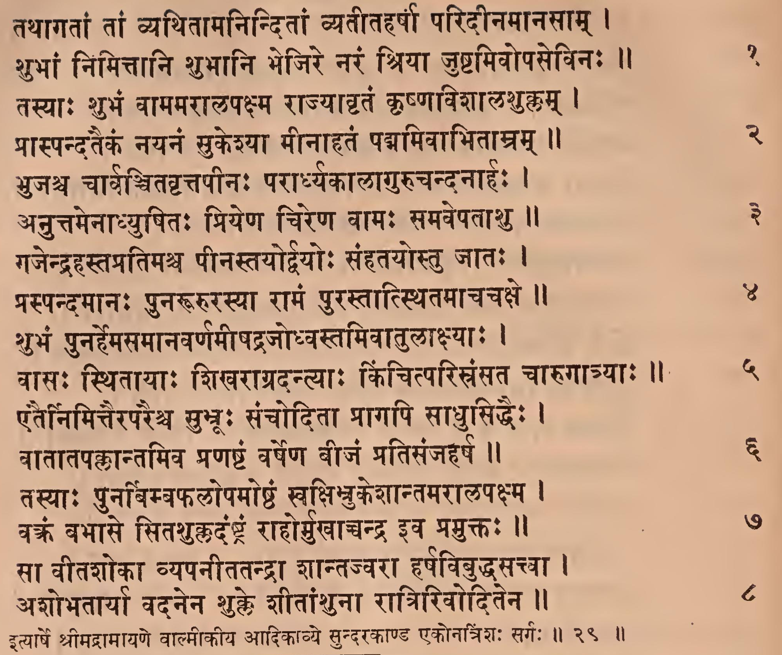

Page 116. Comment (1-8)

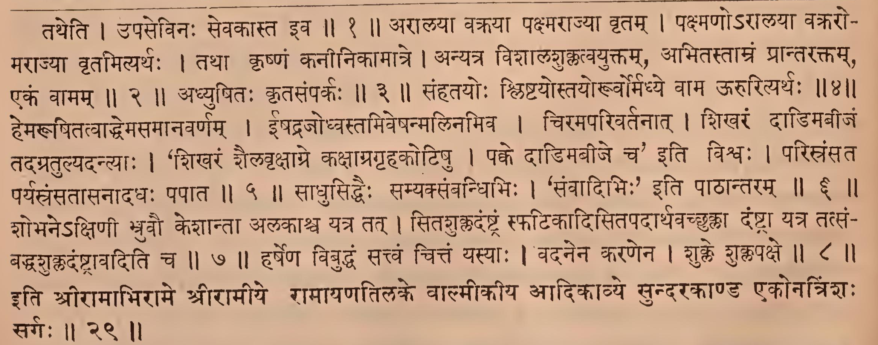

IAST - International Alphabet of Sanskrit Transliteration
tathāgatāṃ tāṃ vyathitāmaninditāṃ vyatītaharṣā paridīnamānasām |
śubhāṃ nimittāni śubhāni bhejire naraṃ śriyā juṣṭamivopasevinaḥ || 1
tatheti | upasevinaḥ sevakāsta iva || 1 ||
tasyāḥ śubhaṃ vāmamarālapakṣma rājyāhṛtaṃ kṛṣṇaviśālaśuklam |
prāspandataikaṃ nayanaṃ sukeśyā mīnāhataṃ padmamivābhitāmram || 2
arālayā vakrayā pakṣmarājyā vṛtam | pakṣmaṇo'rālayā vakraro- marājyā vṛtamityarthaḥ | tathā kṛṣṇaṃ kanīnikāmātre | anyatra viśālaśuklatvayuktam, abhitastāmraṃ prāntaraktam, ekaṃ vāmam || 2 ||
bhujaśca cārvañcitavṛttapīnaḥ parārdhyakālāgurucandanāhaḥ |
anuttamenādhyuṣitaḥ priyeṇa cireṇa vāmaḥ samavepatāśu || 3
adhyuṣitaḥ kṛtasaṃparkaḥ || 3 ||
gajendra hastapratimaśca pīnastayordvayoḥ saṃhatayostu jātaḥ |
praspandamānaḥ punarūrurasyā rāmaṃ purastātsthitamācacakṣe || 4
saṃhatayoḥ śliṣṭayostayoruvormadhye vāma ūrurityarthaḥ || 4 ||
śubhaṃ punarhemasamānavarṇamīṣadrajodhvastamivātulākṣyāḥ |
vāsaḥ sthitāyāḥ śikharāgradantyāḥ kiñcitparisraṃsata cārugātryāḥ || 5
hemarūpitatvāddhemasamānavarṇam | īṣadrajodhvastamiveṣanmalinamiva | ciramaparivartanāt | śikharaṃ dāḍimabījaṃ tadagratulyadantyāḥ | ‘śikharaṃ śailavṛkṣāgre kakṣāpragṛhakoṭiṣu | pakke dāḍimabīje ca' iti viśvaḥ | parisraṃsata paryasraṃsatāsanādadhaḥ papāta || 5 ||
etairnimittairaparaiśca subhrūḥ sañcoditā prāgapi sādhusiddhaiḥ |
vātātapakkāntamiva praṇaṣṭaṃ varṣeṇa vījaṃ pratisañjaharṣa || 6
sādhusiddhaiḥ samyaksaṃvandhibhiḥ | ' saṃvādibhiḥ' iti pāṭhāntaram || 6 ||
tasyāḥ punarvimbaphalopamoṣṭhaṃ svakṣinukeśāntamarālapakṣma |
vakraṃ babhāse sitaśukkadaṃṣṭraṃ rāhormukhāccandra iva pramuktaḥ || 7
śobhane'kṣiṇī bhruvau keśāntā alakāśca yatra tat | sitaśukkadaṃṣṭraṃ sphaṭikādisitapadārthavacchukkā daṃṣṭrā yatra tatsaṃ- baddhaśukladaṃṣṭrāvaditi ca ||7||
sā vītaśokā vyapanītatandrā śāntajvarā harṣavibuddhasattvā |
aśobhatāryā vadanena śukle śītāṃśunā rātririvoditena || 8
harṣeṇa vibuddhaṃ sattvaṃ cittaṃ yasyāḥ | vadanena karaṇena | śukle śuklapakṣe || 8 ||
ityārṣe śrīmadrāmāyaṇe vālmīkīya ādikāvye sundarakāṇḍa ekonatriṃśaḥ sargaḥ || 29 ||
iti śrīrāmābhirāme śrīrāmīye rāmāyaṇatilake vālmīkīya ādikāvye sundarakāṇḍa ekonatriṃśaḥ sargaḥ || 29 ||

