॥ श्रीः॥ ॥śrīḥ॥
ādikaviśrīvālmīkimahāmunipraṇītaṃ
rāmāyaṇam
tilakākhyayā vyākhyayā sametam।
sundarakāṇḍam।

aṣṭaviṃśaḥ sargaḥ || 28

Source in Sanskrit (devanāgarī) (file Ramayana 2.pdf)
Page | Verse | Comment
113 | 1-2 | 1-2 (beginning)
114 | 3-10 | 2 (ending)- 10 (beginning)
115 | 11-19 | 10 (ending) – 19

devanāgarī.

Page 113. Verse (1-2)
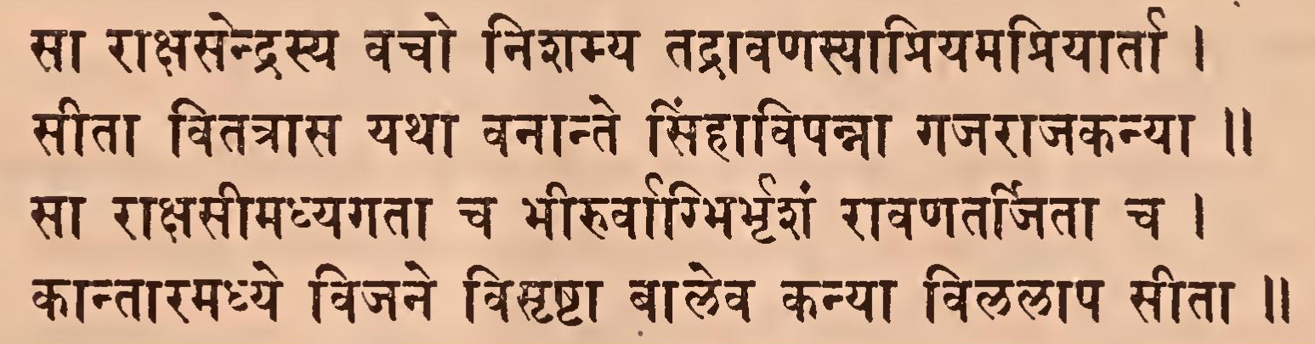

Page 113. Comment (1-2)
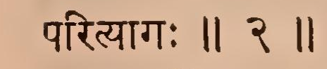

Page 114. Verse (3-10)
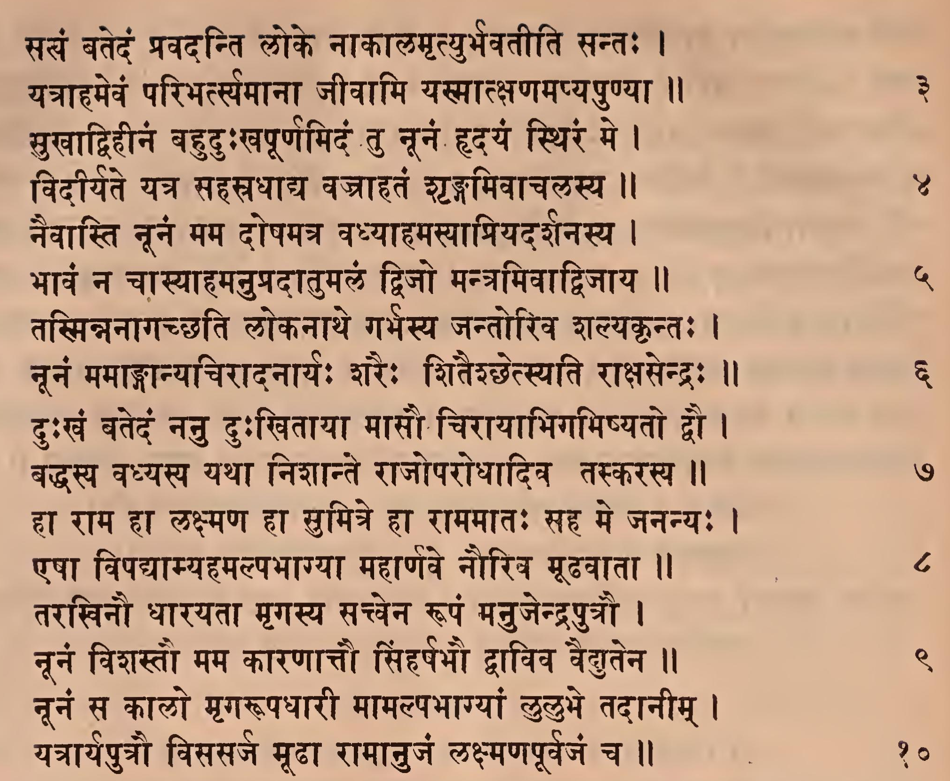

Page 114. Comment (3-10)
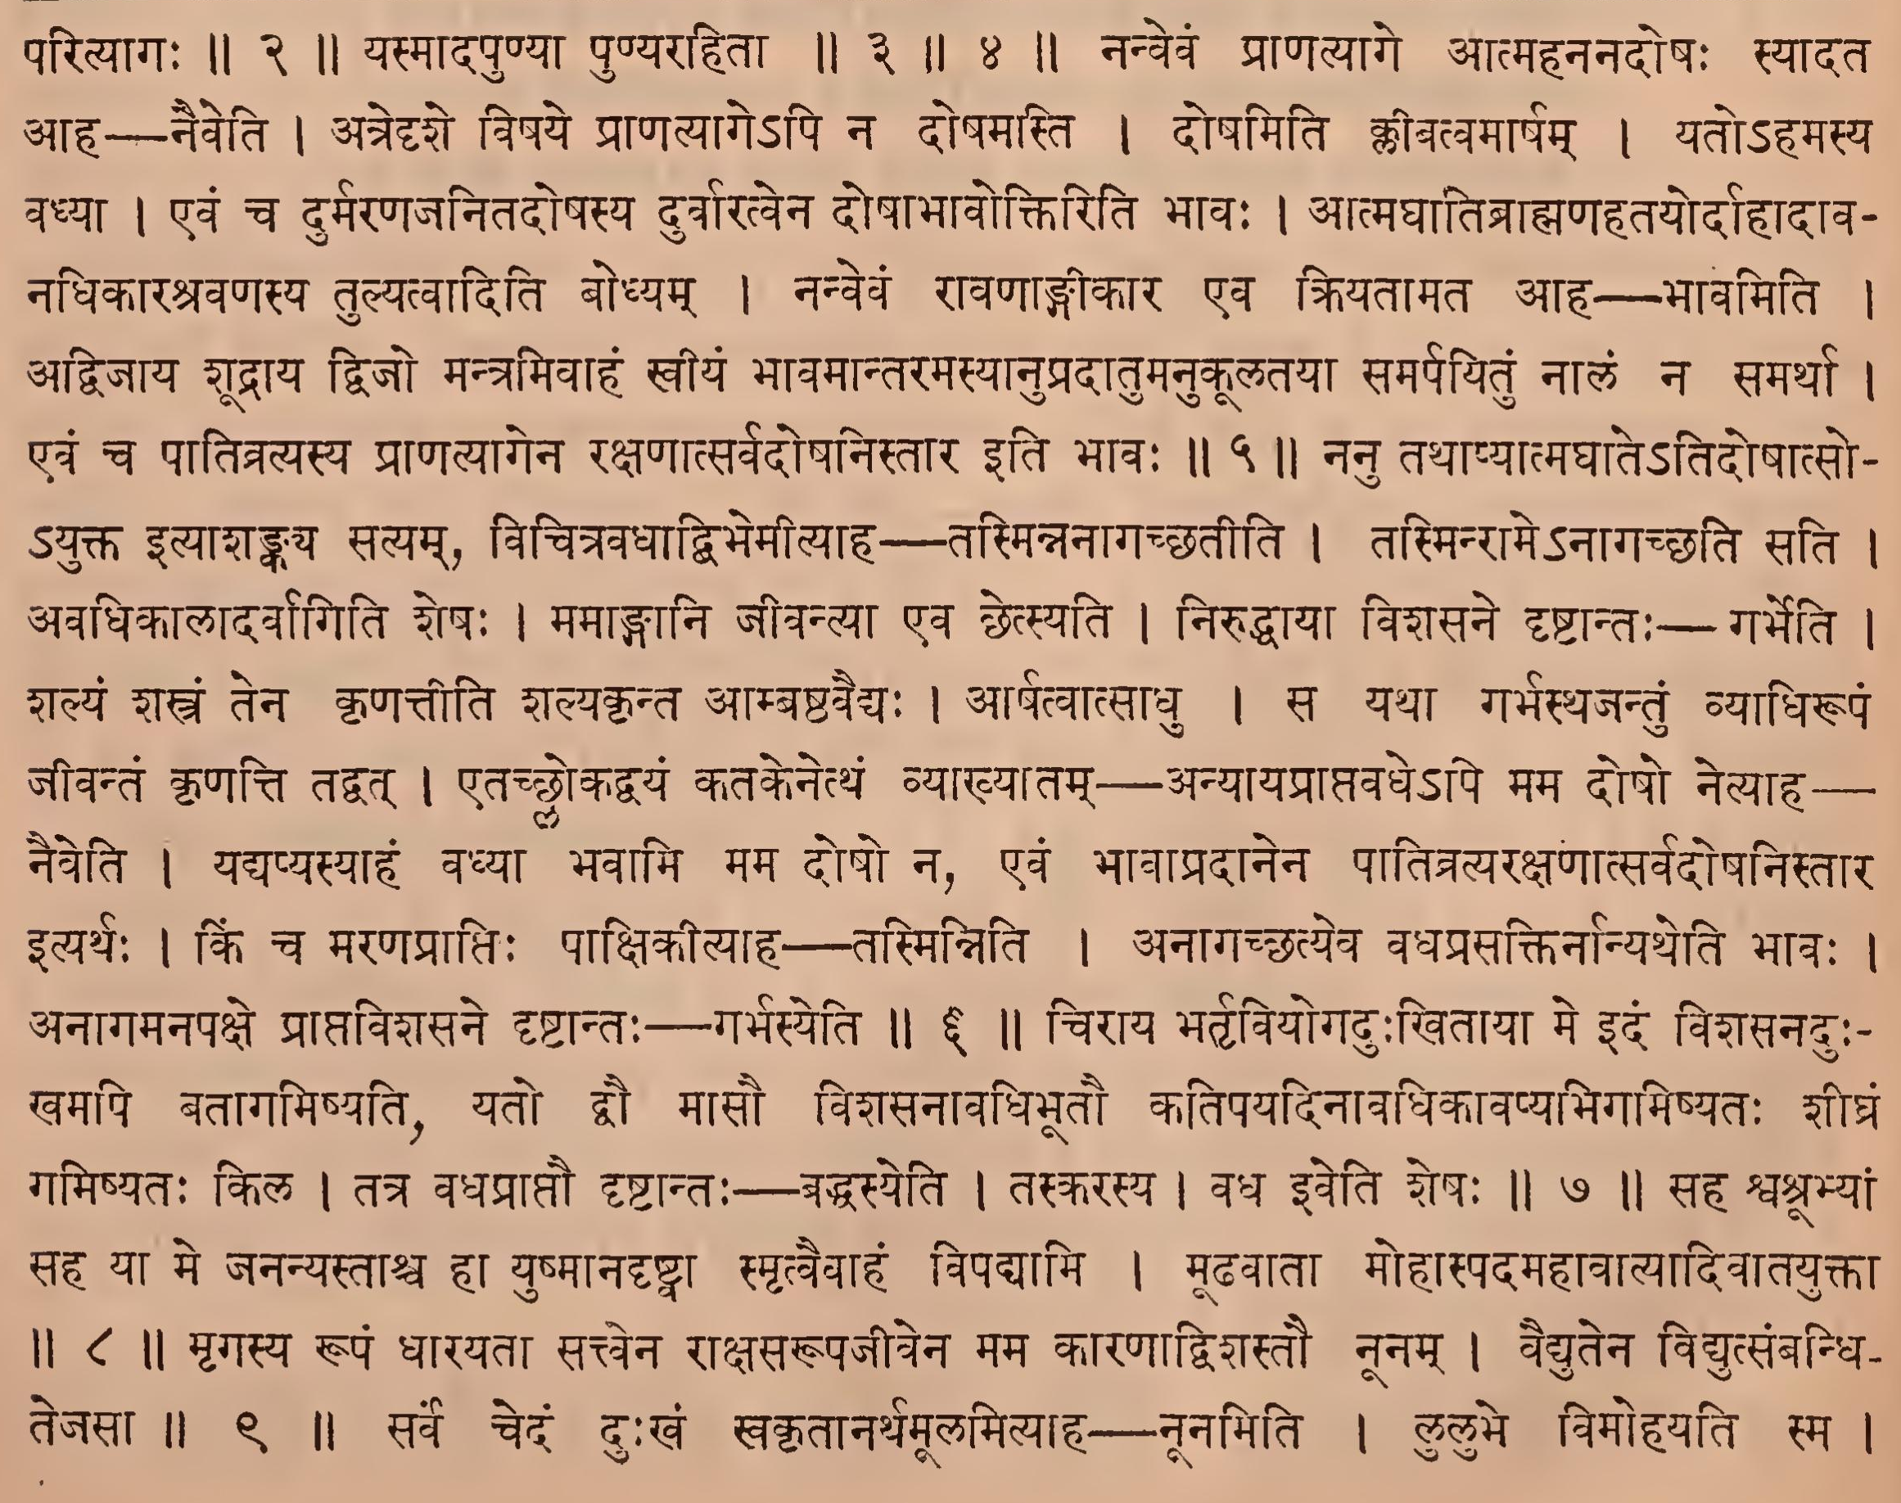

Page 115. Verse (11-19)
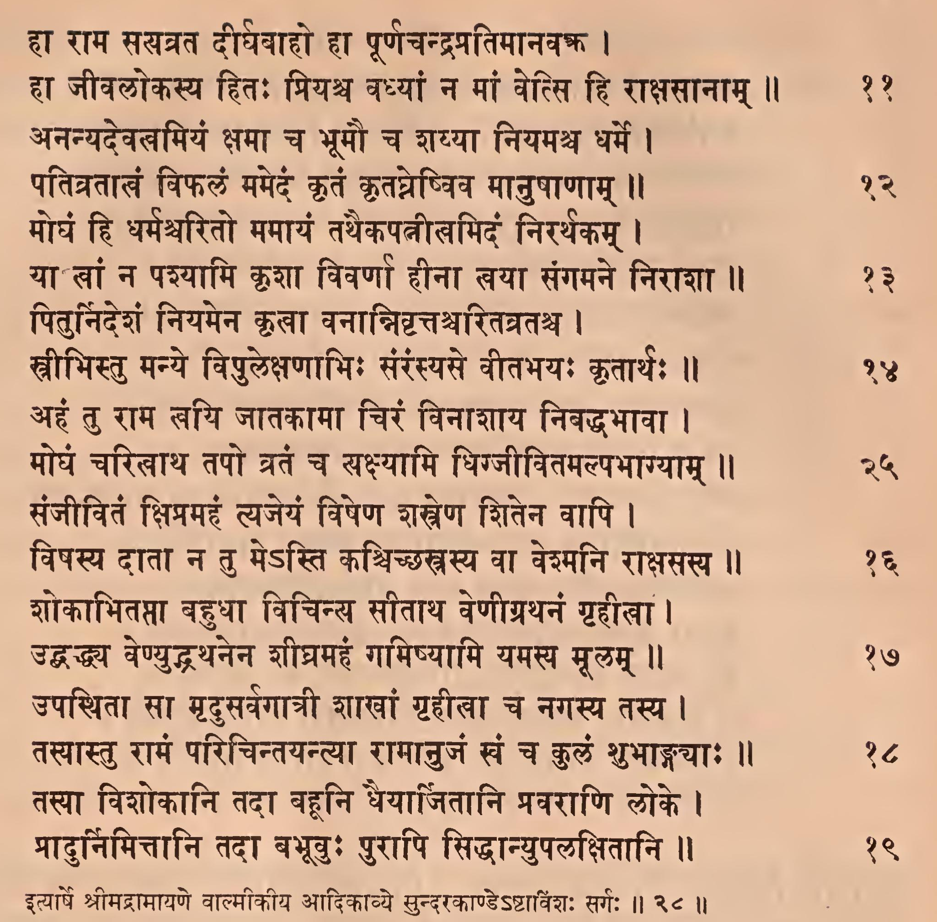

Page 115. Comment (11-19)
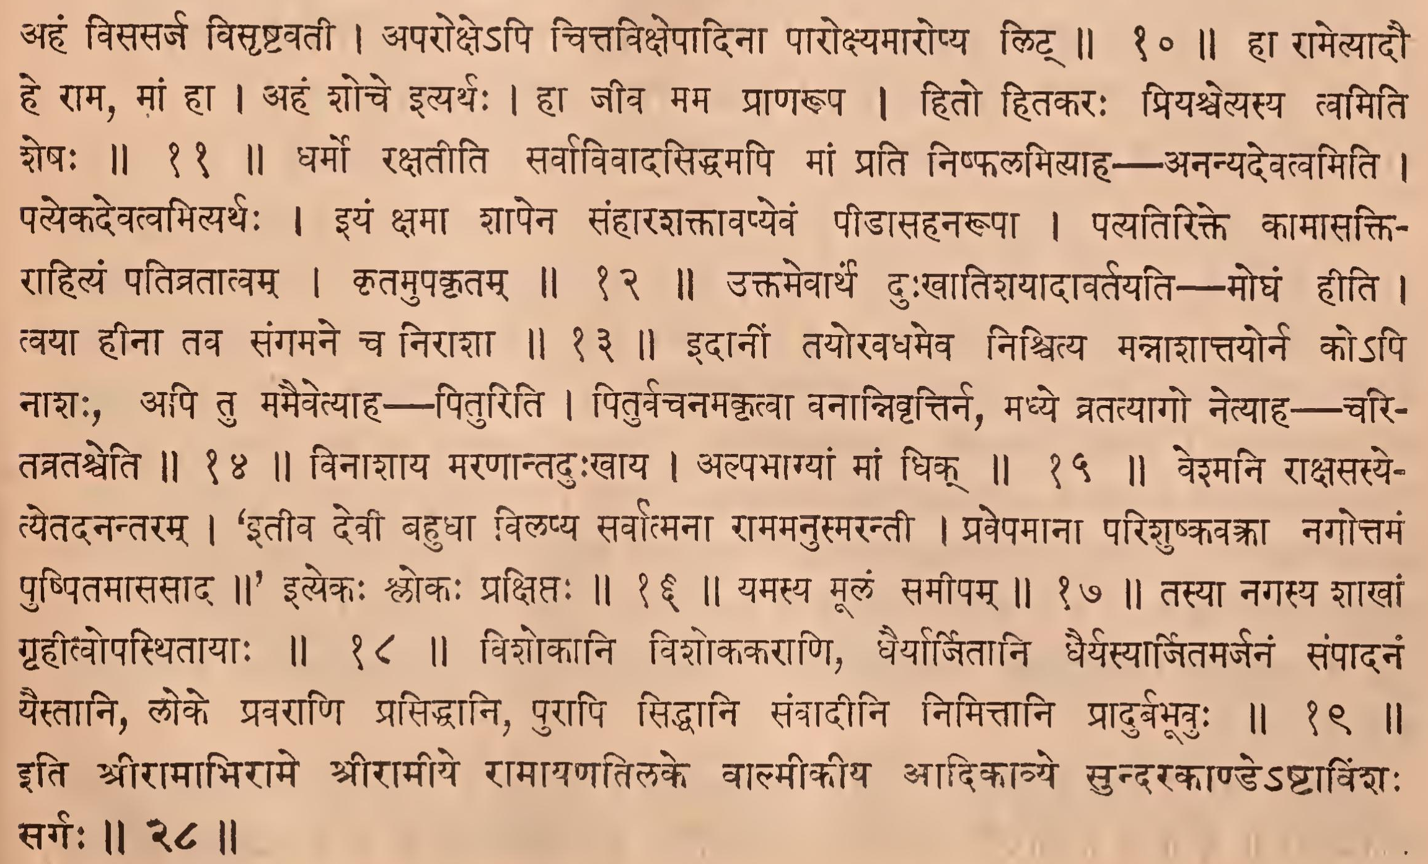

IAST - International Alphabet of Sanskrit Transliteration
sā rākṣasendrasya vaco niśamya tadrāvaṇasyāpriyamapriyārtā |
sītā vitatrāsa yathā vanānte siṃhāvipannā gajarājakanyā || 1
punarduḥkhapāramadṛṣṭveva sītāpralāpaḥ - seti || 1 ||
sā rākṣasīmadhyagatā ca bhīruvagbhirbhṛśaṃ rāvaṇatarjitā ca |
kāntāramadhye vijane visṛṣṭā vāleva kanyā vilalāpa sītā || 2
visṛṣṭā bālā kanyeva mahādurbhikṣobhavaśādvālakanyāyāḥ parityāgaḥ || 2 ||
satyaṃ vatedaṃ pravadanti loke nākālamṛtyurbhavatīti santaḥ |
yatrāhamevaṃ paribhartyamānā jīvāmi yasmātkṣaṇamapyapuṇyā || 3
mukhādvihīnaṃ bahuduḥkhapūrṇamidaṃ tu nūnaṃ hṛdayaṃ sthiraṃ me |
vidīryate yatra sahasradhādya vajrāhataṃ śṛṅgamivācalasya || 4
yasmādapuṇyā puṇyarahitā || 3 || 4 ||
naivāsti nūnaṃ mama doṣamatra vadhyāhamasyāpriyadarśanasya |
bhāvaṃ na cāsyāhamanupradātumalaṃ dvijo mantramivādvijāya || 5
nanvevaṃ prāṇatyāge ātmahananadoṣaḥ syādata āha— naiveti | atredṛśe viṣaye prāṇatyāge'pi na doṣamasti | doṣamiti klīvatvamārṣam | yato'hamasya vadhyā | evaṃ ca durmaraṇajanitadoṣasya durvāratvena doṣābhāvoktiriti bhāvaḥ | ātmaghātibrāhmaṇahatayordāhādāva- nadhikāraśravaṇasya tulyatvāditi bodhyam | nanvevaṃ rāvaṇāṅgīkāra evaṃ kriyatāmata āha— bhāvamiti | advijāya śūdrāya dvijo mantramivāhaṃ svīyaṃ bhāvamāntaramasyānupradātumanukūlatayā samarpayituṃ nālaṃ na samarthā | evaṃ ca pātivratyasya prāṇatyāgena rakṣaṇātsarvadoṣanistāra iti bhāvaḥ || 5 ||
tasminnanāgacchati lokanāthe garbhasya jantoriva śalyakṛntaḥ |
nūnaṃ mamāṅgānyacirādanāryaḥ śaraiḥ śitaiśchetsyati rākṣasendraḥ || 6
nanu tathāpyātmaghāte'tidoṣātso- 'yukta ityāśaṅkaya satyam, vicitravadhādvibhemītyāha - tasminnanāgacchatīti | tasminrāme'nāgacchati sati | avadhikālādarvāgiti śeṣaḥ | mamāṅgāni jīvantyā eva chetsyati | niruddhāyā viśasane dṛṣṭāntaḥ - garbheti | śalyaṃ śastraṃ tena kṛṇattīti śalyakṛnta āmbaṣṭavaidyaḥ | ārpatvātsādhu | sa yathā garbhasthajantuṃ vyādhirūpaṃ jīvantaṃ kṛṇatti tadvat | etacchlokadvayaṃ katakenetthaṃ vyākhyātam — anyāyaprāptavadhe'pi mama doṣo netyāha— | naiveti | yadyapyasyāhaṃ vavyā bhavāmi mama doṣo na, evaṃ bhāvāpradānena pātitratyarakṣaṇātsarvadoṣanistāra ityarthaḥ | kiṃ ca maraṇaprāptiḥ pākṣikītyāha —tasminniti | anāgacchatyeva vadhaprasaktirnānyatheti bhāvaḥ | anāgamanapakṣe prāptaviśasane dṛṣṭāntaḥ - garbhasyeti || 6 ||

duḥkhaṃ vatedaṃ nanu duḥkhitāyā māsau cirāyābhigamiṣyato dvau |
baddhasya vadhyasya yathā niśānte rājoparodhādiva taskarasya || 7
cirāya bhartṛviyogaduḥkhitāyā meṃ idaṃ viśasanaduḥ- khamapi batāgamiṣyati, yato dvau māsau viśasanāvadhibhūtau katipayadināvadhikāvapyabhigamiṣyataḥ śīghraṃ gamiṣyataḥ kila | tatra vadhaprāptau dṛṣṭāntaḥ - baddhasyeti | taskarasya | vadha iveti śeṣaḥ || 7 ||
hā rāma hā lakṣmaṇa hā sumitre hā rāmamātaḥ saha me jananyaḥ |
eṣā vipadyāmyahamalpabhāgyā mahārṇave nauriva mūḍhavātā || 8
saha śvaśrabhyāṃ saha yā me jananyastāśca hā yuṣmānadṛṣṭvā smṛtvaivāhaṃ vipadyāmi | mūḍhavātā mohāspada mahāvātyādivātayuktā || 8 ||
tarakhinau dhārayatā mṛgasya sattvena rūpaṃ manujendraputrau |
nūnaṃ viśastau mama kāraṇāttau siṃharṣabhau dvāviva vaidyutena || 9
mṛgasya rūpaṃ dhārayatā sattvena rākṣasarūpajīvena mama kāraṇādviśastau nūnam | vaidyutena vidyutsaṃbandhi- tejasā || 9 ||
nūnaṃ sa kālo mṛgarūpadhārī māmalpabhāgyāṃ lulubhe tadānīm |
yatrāryaputrau visasarja mūḍhā rāmānujaṃ lakṣmaṇapūrvajaṃ ca || 10
sarve cedaṃ duḥkhaṃ svakṛtānarthamūlamityāha — nūnamiti | lulubhe vimohayati sma | ahaṃ visasarja visṛṣṭavatī | aparokṣe'pi cittavikṣepādinā pārokṣyamāropya liṭ || 10 ||
hā rāma satyavrata dīrghavāho hā pūrṇacandrapratimānava |
hā jīvalokasya hitaḥ priyaśca vadhyāṃ na māṃ vetsi hi rākṣasānām || 11
hā rāmetyādau he rāma, māṃ hā | ahaṃ śoce ityarthaḥ | hā jīva mama prāṇarūpa | hito hitakaraḥ priyaścetyasya tvamiti śeṣaḥ || 11 ||
ananyadevatvamiyaṃ kṣamā ca bhūmau ca śayyā niyamaśca dharme |
pativratālaṃ viphalaṃ mamedaṃ kṛtaṃ kṛtaghneṣviva mānuṣāṇām || 12
dharmo rakṣatīti sarvāvivādasiddhamapi māṃ prati niṣphalamityāha — ananyadevatvamiti | patyeka devatvamityarthaḥ | iyaṃ kṣamā śāpena saṃhāraśaktāvapyevaṃ pīḍāsahanarūpā | patyatirikte kāmāsakti- rāhityaṃ pativratātvam | kṛtamupakṛtam || 12 ||
moghaṃ hi dharmaśvarito mamāyaṃ tathaikapatnītvamidaṃ nirarthakam |
yā khāṃ na paśyāmi kṛśā vivarṇā hīnā khayā saṅgamane nirāśā || 13
uktamevārthaṃ duḥkhātiśayādāvartayati — moghaṃ hīti | tvayā hīnā tava saṅgamane ca nirāśā || 13 ||
piturnideśaṃ niyamena kṛtvā vanānnivṛttaścaritavrataśca |
strībhistu manye vipulekṣaṇābhiḥ saṃraṃsyase vītabhayaḥ kṛtārthaḥ || 14
idānīṃ tayoravadhameva niścitya mannāśāttayorna ko'pi nāśaḥ, api tu mamaivetyāha--— pituriti | piturvacanamakṛtvā vanānnivṛttirna, madhye vratatyāgo netyāha – cari- tatrataśceti || 14 ||
ahaṃ tu rāma tvayi jātakāmā ciraṃ vināśāya nibaddhabhāvā |
moghaṃ caritvātha tapo vrataṃ ca sakṣyāmi dhigjīvitamalpabhāgyām || 15
vināśāya maraṇāntaduḥkhāya | alpabhāgyāṃ māṃ dhik || 15 ||
sañjīvitaṃ kṣimamahaṃ tyajeyaṃ viṣeṇa śastreṇa śitena vāpi |
viṣasya dātā na tu me'sti kaścicchastrasya vā veśmani rākṣasasya || 16
veśmani rākṣasasye- tyetadanantaram | ‘itīva devī bahudhā vilapya sarvātmanā rāmamanusmarantī | pravepamānā pariśuṣkavakrā nagottamaṃ puṣpitamāsasāda ||' ityekaḥ ślokaḥ prakṣiptaḥ || 16 ||
śokābhitaptā bahudhā vicinya sītātha veṇīgrathanaṃ gṛhīlā |
uddhaddhaya veṇyuddhathanena śīghramahaṃ gamiṣyāmi yamasya mūlam || 17
yamasya mūlaṃ samīpam || 17 ||
upasthitā sā mṛdusarvagātrī śākhāṃ gṛhīlā ca nagasya tasya |
tasyāstu rāmaṃ paricintayantyā rāmānujaṃ khaṃ ca kulaṃ śubhāṅgayāḥ || 18
tasyā nagasya śākhāṃ gṛhītvopasthitāyāḥ || 18 ||
tasyā viśokāni tadā bahūni dhaiyārjitāni pravarāṇi loke |
prādurnimittāni tadā babhūvuḥ purāpi siddhānyupalakṣitāni || 19
viśokāni viśokakarāṇi, dhairyārjitāni dhairyasyārjitamarjanaṃ saṃpādanaṃ yestāni, loke pravarāṇi prasiddhāni purāpi siddhāni saṃvādīni nimittāni prādurbabhūvuḥ || 19 ||
ityārṣe śrīmadrāmāyaṇe vālmīkīya ādikāvye sundarakāṇḍe'ṣṭāviṃśaḥ sargaḥ || 28 ||
iti śrīrāmābhirāme śrīrāmīye rāmāyaṇatilake vālmīkīya ādikāvye sundarakāṇḍe'ṣṭāviṃśaḥ sargaḥ || 28 ||

