॥ श्रीः॥ ॥śrīḥ॥
ādikaviśrīvālmīkimahāmunipraṇītaṃ
rāmāyaṇam
tilakākhyayā vyākhyayā sametam।
sundarakāṇḍam।

dvātriṃśaḥ sargaḥ || 32

Source in Sanskrit (devanāgarī) (file Ramayana 2.pdf)
Page | Verse | Comment
120 | 1-9 | 1-10 (beg.)
121 | 10-14 | 10-14

devanāgarī.

Page 120. Verse (1-9)
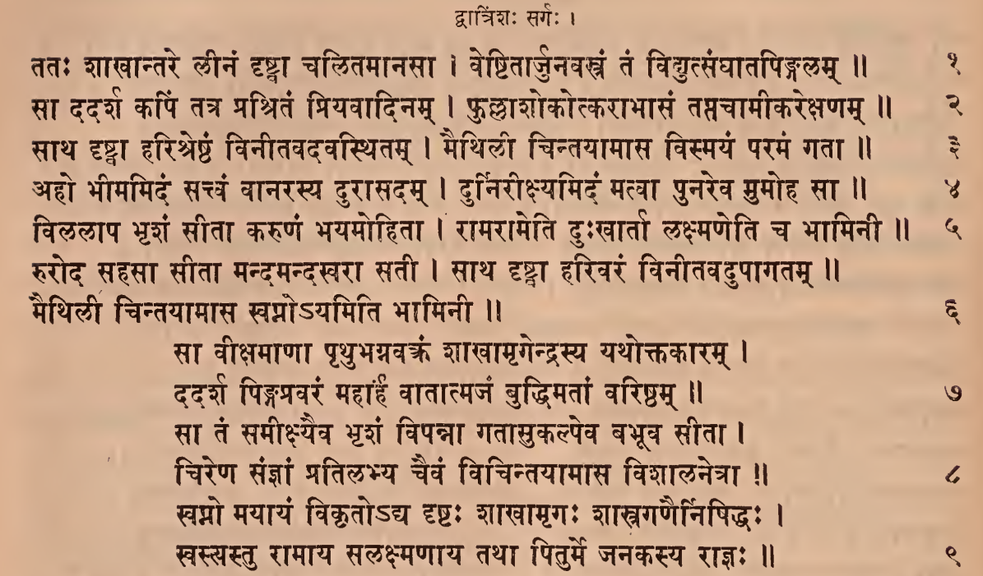

Page 120. Comment (1-10 beg.)
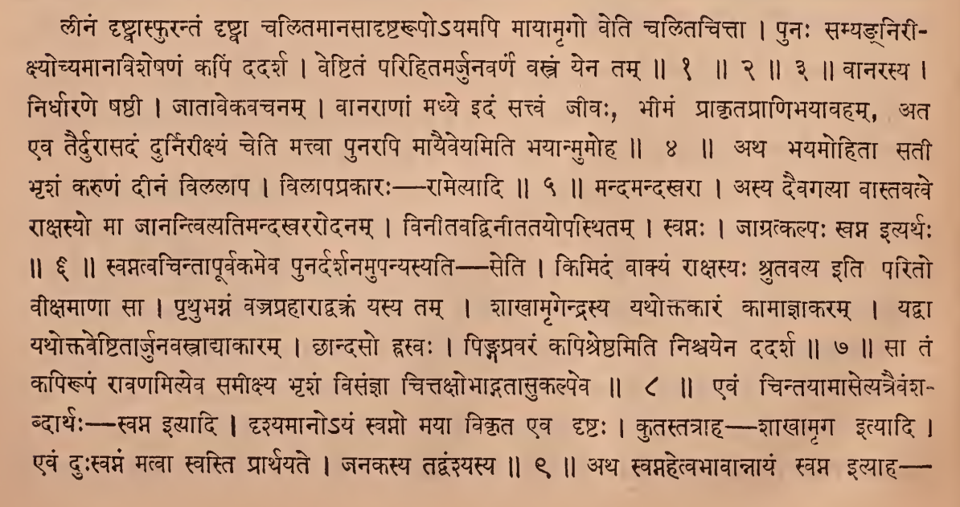

Page 121. Verse (10-14)
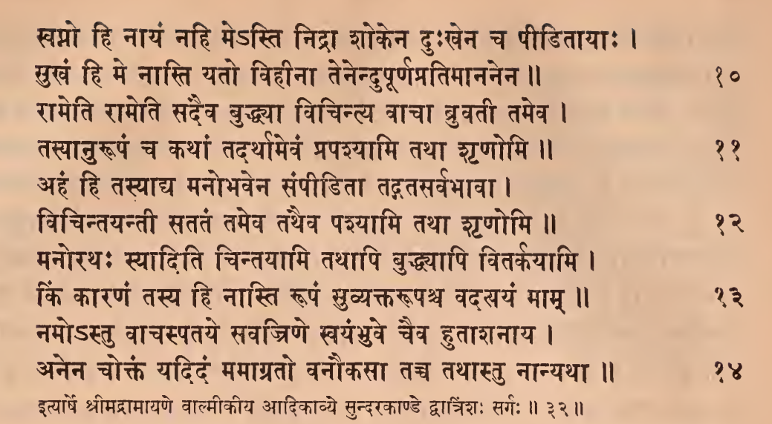

Page 121. Comment (10-14)
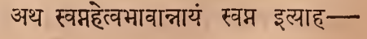
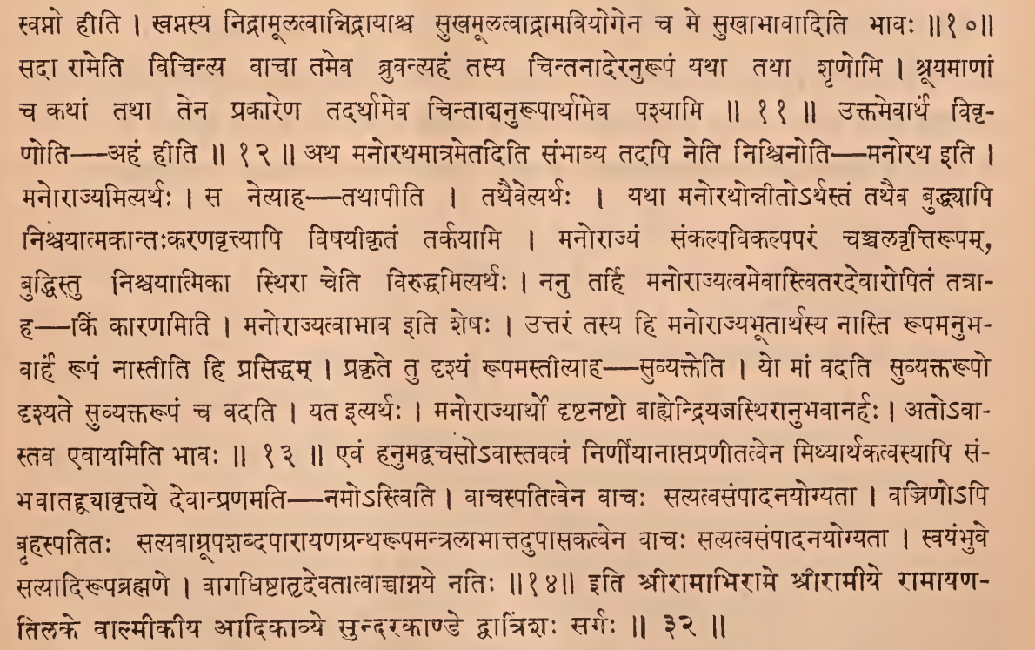

IAST - International Alphabet of Sanskrit Transliteration
dvātriṃśaḥ sargaḥ |
tataḥ śākhāntare līnaṃ dṛṣṭvā calitamānasā |
veṣṭitārjunavastraṃ taṃ vidyutsaṅghātapiṅgalam || 1
sā dadarśa kapiṃ tatra praśritaṃ priyavādinam |
phullāśokotkarābhāsaṃ taptacāmīkarekṣaṇam || 2
sātha dṛṣṭvā hariśreṣṭhaṃ vinītavadavasthitam |
maithilī cintayāmāsa vismayaṃ paramaṃ gatā || 3
līnaṃ dṛṣṭvāsphurantaṃ dṛṣṭvā calitamānasādṛṣṭarūpo'yamapi māyāmṛgo veti calitacittā |
punaḥ samyagnirīkṣyocyamānaviśeṣaṇaṃ kapiṃ dadarśa |
veṣṭitaṃ parihitamarjunavarṇaṃ vastraṃ yena tam || 1 || 2 || 3 ||
aho bhīmamidaṃ sattvaṃ vānarasya durāsadam |
durnirīkṣyamidaṃ matvā punareva mumoha sā || 4
vānarasya |
nirdhāraṇe ṣaṣṭhī |
jātāvekavacanam |
vānarāṇāṃ madhye idaṃ sattvaṃ jīvaḥ, bhīmaṃ prākṛtaprāṇibhayāvaham ata eva tairdurāsadaṃ durnirīkṣyaṃ ceti mattvā punarapi māyaiveyamiti bhayānmumoha || 4 || vilalāpa bhṛśaṃ sītā karuṇaṃ bhayamohitā |
rāmarāmeti duḥkhārtā lakṣmaṇeti ca bhāminī || 5
atha bhayamohitā satī bhṛśaṃ karuṇaṃ dīnaṃ vilalāpa |
vilāpaprakāraḥ – rāmetyādi || 5 ||
ruroda sahasā sītā mandamandasvarā satī |
sātha dṛṣṭvā harivaraṃ vinītavadupāgatam ||
maithilī cintayāmāsa svapno'yamiti bhāminī || 6
mandamandasvarā |
asya daivagatyā vāstavatve rākṣasyo mā jānantvityatimandakhararodanam |
vinītavadvinītatayopasthitam |
svapnaḥ |
jāgratkalpaḥ svapna ityarthaḥ || 6 ||
sā vīkṣamāṇā pṛthubhagnavaktraṃ śākhāmṛgendrasya yathoktakāram |
dadarśa piṅgapravaraṃ mahārhaṃ vātātmajaṃ buddhimatāṃ variṣṭham || 7
svatvacintāpūrvakameva punardarśanamupanyasyati — seti |
kimidaṃ vākyaṃ rākṣasyaḥ śrutavalyaḥ iti parito vīkṣamāṇā sā |
pṛthubhagnaṃ vajraprahārādvakraṃ yasya tam |
śākhāmṛgendrasya yathoktakāraṃ kāmājñākaram |
yadvā yathoktaveṣṭitārjunavastrādyākāram |
chāndaso hrasvaḥ |
piṅgapravaraṃ kapiśreṣṭhamiti niścayena dadarśa || 7 ||
sā taṃ samīkṣyaiva bhṛśaṃ vipannā gatāsukalpeva babhūva sītā |
cireṇa sañjñāṃ pratilabhya caivaṃ vicintayāmāsa viśālanetrā || 8
sā taṃ kapirūpaṃ rāvaṇamityeva samīkṣya bhṛśaṃ visañjñā
cittakṣobhādgatāsukalpeva || 8 ||
svapno mayāyaṃ vikṛto'dya dṛṣṭaḥ śākhāmṛgaḥ śāstragaṇairniṣiddhaḥ |
svastyastu rāmāya salakṣmaṇāya tathā piturme janakasya rājñaḥ || 9
evaṃ cintayāmāsetyatraivaṃśabdārthaḥ—svapna ityādi |
dṛśyamāno'yaṃ svapno mayā vikṛta eva dṛṣṭaḥ |
kutastatrāha — śākhāmṛga ityādi |
evaṃ duḥsvapnaṃ matvā svasti prārthayate |
janakasya tadvaṃśyasya || 9 ||
svapno hi nāyaṃ nahi me'sti nidrā śokena duḥkhena ca pīḍitāyāḥ |
sukhaṃ hi me nāsti yato vihīnā tenendupūrṇapratimānanena || 10
atha svapnahetvabhāvānnāyaṃ svapna ityāha - svapno hīti |
svapnasya nidrāmūlatvānnidrāyāśca sukhamūlatvādrāmaviyogena ca me sukhābhāvāditi bhāvaḥ ||10||
rāmeti rāmeti sadaiva buddhyā vicintya vācā bruvatī tameva |
tasyānurūpaṃ ca kathāṃ tadarthāmevaṃ prapaśyāmi tathā śṛṇomi || 11
sadā rāmeti vicintya vācā tameva bruvantyahaṃ tasya cintanāderanurūpaṃ yathā tathā śṛṇomi |
śrūyamāṇāṃ ca kathāṃ tathā tena prakāreṇa tadarthāmeva cintādyanurūpārthameva paśyāmi || 11 ||
ahaṃ hi tasyādya manobhavena saṃpīḍitā tadgatasarvabhāvā |
vicintayantī satataṃ tameva tathaiva paśyāmi tathā śṛṇomi || 12
uktamevārthaṃ vivṛṇoti - ahaṃ hīti || 12 ||
manorathaḥ syāditi cintayāmi tathāpi buddhyāpi vitarkayāmi |
kiṃ kāraṇaṃ tasya hi nāsti rūpaṃ suvyaktarūpaśca vadatyayaṃ mām || 13
atha manorathamātrametaditi saṃbhāvya tadapi neti niścinoti - manoratha iti |
manorājyamityarthaḥ |
sa netyāha – tathāpīti |
tathaivetyarthaḥ |
yathā manorathonnīto'rthastaṃ tathaiva buddhyāpi niścayātmakāntaḥkaraṇavṛttyāpi viṣayīkṛtaṃ tarkayāmi |
manorājyaṃ saṅkalpavikalpaparaṃ cañcalavṛttirūpam, buddhistu niścayātmikā sthirā ceti viruddhamityarthaḥ |
nanu tarhi manorājyatvamevāstvitaradevāropitaṃ tatrāha—kiṃ kāraṇamiti |
manorājyatvābhāva iti śeṣaḥ |
uttaraṃ tasya hi manorājyabhūtārthasya nāsti rūpamanubhavārhaṃ rūpaṃ nāstīti hi prasiddham |
prakṛte tu dṛśyaṃ rūpamastītyāha – suvyakteti |
yo māṃ vadati suvyaktarūpo dṛśyate suvyaktarūpaṃ ca vadati |
yata ityarthaḥ |
manorājyārtho dṛṣṭanaṣṭo bāhyendriyajasthirānubhavānarhaḥ |
ato'vāstava evāyamiti bhāvaḥ || 13 ||
namo ’stu vācaspataye savajriṇe svayaṃbhuve caiva hutāśanāya |
anena coktaṃ yadidaṃ mamāgrato vanaukasā tacca tathāstu nānyathā || 14
evaṃ hanumadvacaso'vāstavatvaṃ nirṇīyānāptapraṇītatvena mithyārthakatvasyāpi saṃbhavātaddvyāvṛttaye devānpraṇamati namo'stviti |
vācaspatitvena vācaḥ satyatvasaṃpādanayogyatā |
vajriṇo'pi bṛhaspatitaḥ satyavāgrūpaśabdapārāyaṇagrantharūpamantralābhāttadupāsakatvena vācaḥ satyatvasaṃpādanayogyatā |
svayaṃbhuve satyādirūpabrahmaṇe |
vāgadhiṣṭhātṛdevatātvāccāgnaye natiḥ || 14 ||
ityārṣe śrīmadrāmāyaṇe vālmīkīya ādikāvye sundarakāṇḍe dvātriṃśaḥ sargaḥ ||32||
iti śrīrāmābhirāme śrīrāmīye rāmāyaṇatilake vālmīkīya ādikāvye sundarakāṇḍe dvātriṃśaḥ sargaḥ || 32 ||

