* In most networks, multiple nodes share a communication medium for transmitting their data packets!
* The medium access control (MAC) protocol is primarily responsible for regulating access to the shared medium!
  + The choice of MAC protocol has a direct bearing on the reliability and efﬁciency of network transmissions!
  + due to errors and interferences in wireless communications and to other challenges!
  + Energy efﬁciency also affects the design of the MAC protocol!
  + trade energy efﬁciency for increased latency or a reduction in throughput or fairness!
* Responsibilities of MAC layer include:
  + decide when a node accesses a shared medium
  + resolve any potential conﬂicts between competing nodes
  + correct communication errors occurring at the physical layer
  + perform other activities such as framing, addressing, and ﬂow control.
* Second layer of the OSI reference model (data link layer) or the IEEE 802 reference model (which divides data link layer into logical link control and medium access control layer.

[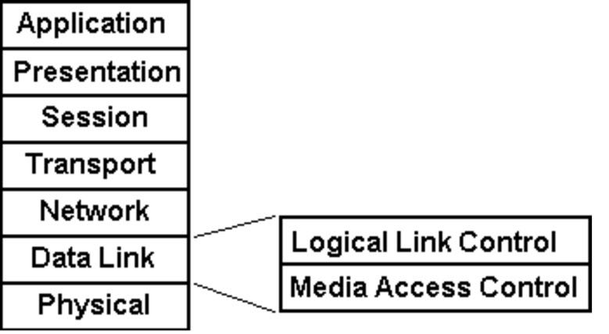](https://www.google.co.in/url?sa=i&rct=j&q=&esrc=s&source=images&cd=&cad=rja&uact=8&ved=2ahUKEwiB9OHfntLhAhUYfX0KHRbLDZ8QjRx6BAgBEAU&url=https%3A%2F%2Ffossbytes.com%2Fllc-logical-link-control-layer-osi-model%2F&psig=AOvVaw1aOyIbBxD91000OnnKmp9o&ust=1555422563608571)

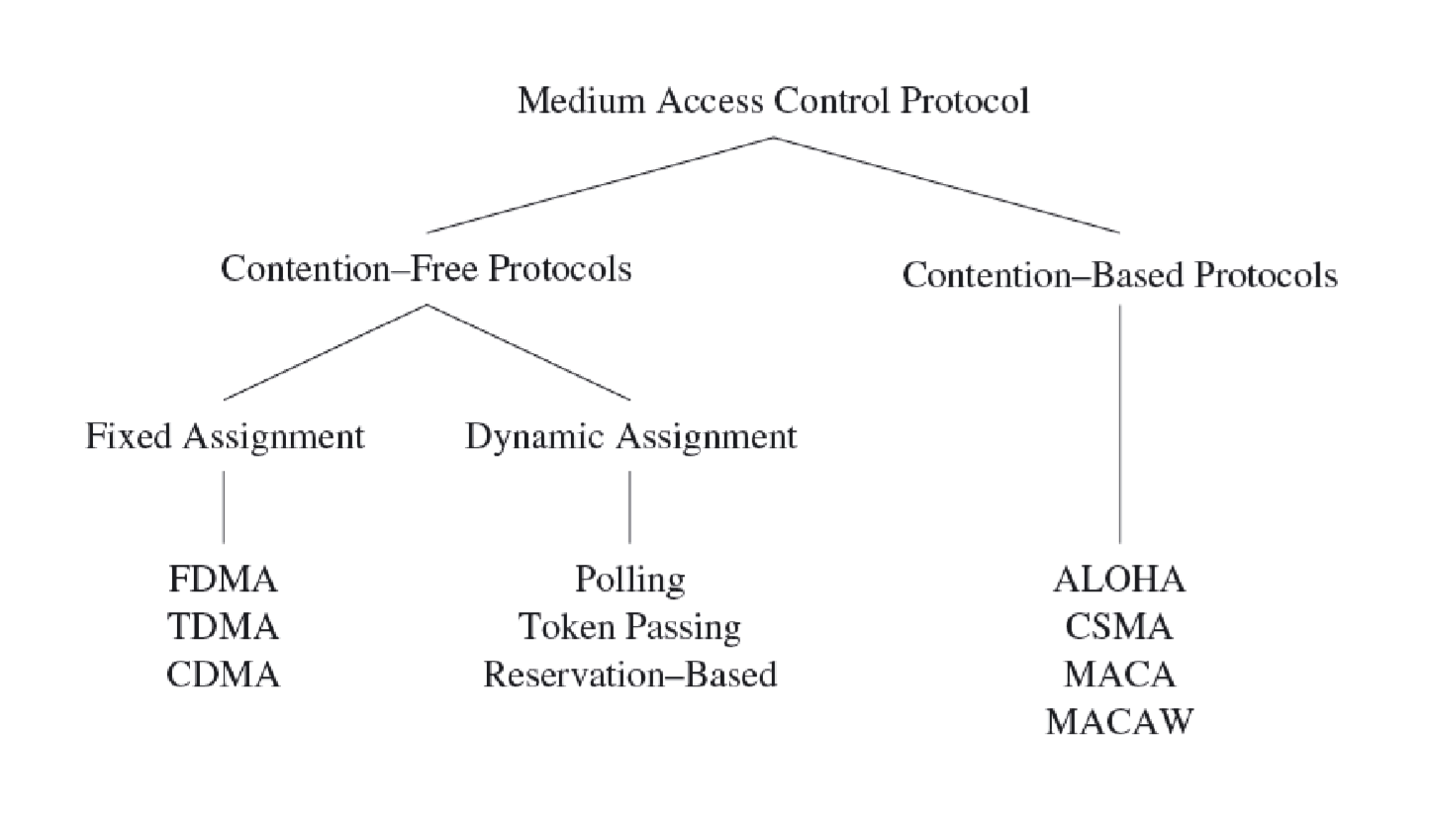

* Collisions can be avoided by ensuring that each node can use its allocated resources exclusively!

Examples of ﬁxed assignment strategies:

* FDMA: Frequency Division Multiple Access

1. the frequency band is divided into several smaller frequency bands
2. the data transfer between a pair of nodes uses one frequency band
3. all other nodes use a different frequency band

* TDMA: Time Division Multiple Access

1. multiple devices to use the same frequency band
2. relies on periodic time windows (frames)
3. frames consist of a ﬁxed number of transmission slots to separate the medium accesses of different devices
4. a time schedule indicates which node may transmit data during a certain slot

* CDMA: Code Division Multiple Access

1. simultaneous accesses of the wireless medium are supported using different codes
2. if these codes are orthogonal, it is possible for multiple communications to share the same frequency band
3. forward error correction (FEC) at the receiver is used to recover from interferences among these simultaneous communications

* Fixed assignment strategies are inefﬁcient!

1. it is impossible to reallocate slots belonging to one device to other devices if not needed in every frame
2. generating schedules for an entire network can be a taunting task
3. these schedules may require modiﬁcations every time the network topology or trafﬁc characteristics in the network change

* Dynamic assignment strategies: allow nodes to access the medium on demand

1. polling-based protocols
2. a controller device issues small polling frames in a round-robin fashion, asking each station if it has data to send
3. if no data to be sent, the controller polls the next station!
4. token passing
5. stations pass a polling request to each other (round-robin fashion) using a special frame called a token
6. a station is allowed to transmit data only when it holds the token
7. reservation-based protocols
8. static time slots used to reserve future access to the medium

e.g., a node can indicate its desire to transmit data by toggling a reservation bit in a ﬁxed location

1. these often very complex protocols then ensure that other potentially conﬂicting nodes take note of such a reservation to avoid collisions

**Contention-Based Medium Access**

* Nodes may initiate transmissions at the same time
* requires mechanisms to reduce the number of collisions and to recover from collisions!   Example

1. ALOHA protocol
2. uses acknowledgments to conﬁrm the success of a broadcast data transmission.
3. allows nodes to access the medium immediately.
4. addresses collisions with approaches such as exponential back-off to increase the likelihood of successful transmissions.
5. slotted-ALOHA protocol
6. requires that a station may commence transmission only at predeﬁned points in time (the beginning of a time slot).
7. increases the efﬁciency of ALOHA.
8. introduces the need for synchronization among nodes.
9. Carrier Sense Multiple Access (CSMA)
10. CSMA with Collision Detection (CSMA/CD)

* sender ﬁrst senses the medium to determine whether it is idle or busy.
* if it is found busy, the sender refrains from transmitting packets.
* if the medium is idle, the sender can initiate data transmission.

1. CSMA with Collision Avoidance (CSMA/CA)

* CSMA/CD requires that sender aware of collisions.
* instead, CSMA/CA attempts to avoid collisions in the ﬁrst place.

**MAC Protocols for WSN**

There are two main categories of MAC protocols for WSNs, according to how the MAC manages when certain nodes can communicate on the channel:

1. **Time-division multiple access (TDMA) based:**

These protocols assign different time slots to nodes. Nodes can send messages only in their time slot, thus eliminating contention. Examples of these kind of MAC protocols include LMAC, TRAMA, etc.

* **LMAC**

LMAC (short for lightweight MAC) is a TDMA-based MAC protocol. There are data transfer timeframes, which are divided into time slots. The number of time slots in a timeframe is configurable according to the number of nodes in the network. Each node has its own time slot, in which only that particular node can transmit. This saves power, as there are no collisions or retransmissions. A transmission consist of a control message and a data unit. The control message contains the destination of the data, the length of the data unit, and information about which time slots are occupied. All nodes wake up at the beginning of each time slot. If there is no transmission, the time slot is assumed to be empty (not owned by any nodes), and the nodes go back to sleep. If there is a transmission, after receiving the control message, nodes that are not the recipient go back to sleep. The recipient node and the sender node goes back to sleep after receiving/sending the transmission. Only one message can be sent in each time slot. In the first five timeframes, the network is set up and no data packets are sent. The network is set up by nodes claiming a time slot. They send a control message in the time slot they want to reserve. If there are no collisions, nodes note that the time slot is claimed. If there are multiple nodes trying to claim the same time slot, and there is a collision, they randomly choose another unclaimed time slot.

* **TRAMA**

Traffic adaptive medium access (TRAMA) protocol which aims to achieve the energy efficiency by avoiding the collisions of data packets while receiving and by employing a low power mode for node which are not scheduled in transmission and reception. The usage of low power mode is dynamically determined and adapted according to traffic pattern. TRAMA applies a traffic adaptive distribution election scheme that selects the receivers based on the schedules announced by transmitters. Nodes using TRAMA, exchange their two hop information and the transmission schedules fixing which nodes are the intended receivers of their traffic in chronological order. TRAMA consists of three components which are neighbour protocol(NP), schedule exchange protocol (SEP) which allows to exchange two-hop neighbour information and schedules and adaptive election algorithm (AEA) uses the information of NP,SEP and it selects transmitters and receivers for current time slot and leaving the other nodes in network to switch to the low power mode.

1. **Carrier-sense multiple access (CSMA) based:**

These protocols use carrier sensing and backoffs to avoid collisions, similarly to IEEE 802.11. Examples include B-MAC, SMAC, TMAC, X-MAC.

* **B-MAC**

B-MAC (short for Berkeley MAC) is a widely used WSN MAC protocol, it is part of TinyOS. It employs low-power listening (LPL) to minimize power consumption due to idle listening. Nodes have a sleep period, after which they wake up and sense the medium for preambles (clear channel assessment - CCA.) If none is detected, the nodes go back to sleep. If there is a preamle, the nodes stay awake and receive the data packet after the preamle. If a node wants to send a message, it first sends a preamle for at least the sleep period in order for all nodes to detect it. After the preable, it sends the data packet. There are optional acknowledgements as well. After the data packet (or data packet + ACK) exchange, the nodes go back to sleep. Note that the preamble doesn’t contain addressing information. Since the recipient’s address is contained in the data packet, all nodes receive the preamble and the data packet in the sender’s communication range (not just the intended recipient of the data packet.)

* **X-MAC**

X-MAC is a development on B-MAC and aims to improve on some of B-MAC’s shortcomings. In B-MAC, the entire preamle is transmitted, regardless of whether the destination node awoke at the beginning of the preamle or at the end. Furthermore, with B-MAC, all nodes receive both the preamble and the data packet. X-MAC employs a strobed preamble, i.e. sending the same lenght preamle as B-MAC, but as shorter bursts, with pauses in between. The pauses are long enough that the destination node can send an acknowledgement if it is already awake. When the sender receives the acknowledgement, it stops sending preambles and sends the data packet. This can save time because potentially, the sender doesn’t have to send the whole length preamble. Also, the preamle contains the address of the destination node. Nodes can wake up, receive the preamble, and go back to sleep if the packet is not addressed to them. These features improve B-MAC’s power efficiency by decreasing nodes’ time spent in idle listening.

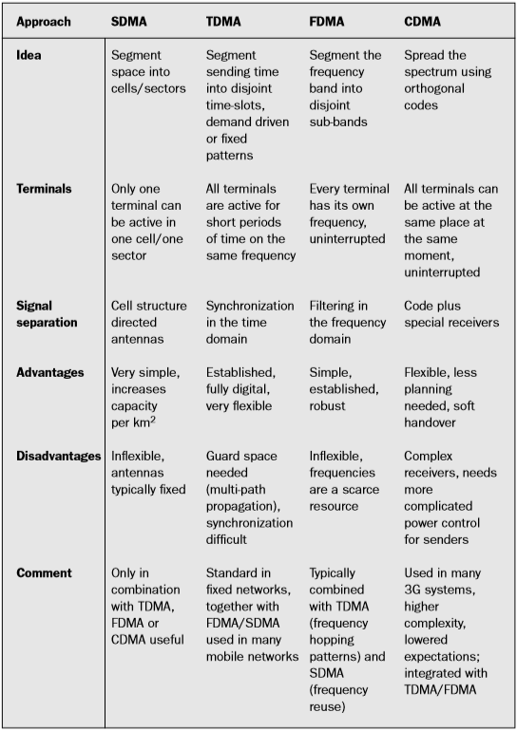

**Routing Protocols**

Routing protocols for wireless sensor networks can be classified as data-centric, hierarchical or location-based. In these three categories, source, shortest path, and hierarchical-geographical strategies play an important role to develop all of the routing protocols

**Data-centric protocols**

In data-centric protocols, the sensor nodes broadcast an advertisement for the available data and wait for a request from an interested sink. Flooding is a simple technique that can be used to broadcast information in wireless sensor networks, however it requires significant resources because each node receiving a message must rebroadcast it, unless a maximum number of hops for the packet are reached, or the destination of the packet is the node itself. Flooding is a reactive technique that does not require costly topology maintenance or complex route discovery algorithms. However, it does have several additional deficiencies such as: implosion, overlap and resource blindness [8]. A derivation of flooding is gossiping, in which nodes do not broadcast. Instead, they send the incoming packets to a randomly selected neighbour. Sensor protocols for information via negotiation (SPIN) address the deficiencies of classic flooding by providing negotiation and resource adaptation [9]. However, SPIN data advertisement mechanism cannot, by itself, guarantee data delivery [10]. SPIN employs a shortest path strategy based on three types of messages to communicate:

ADV- new data advertisement. When a SPIN node has data to share, it can advertise this fact by transmitting an ADV message containing meta-data. REQ - request for data. A SPIN node sends an REQ message when it wishes to receive some actual data. DATA - data message. DATA messages contain actual sensor data with a meta-data header.

Unlike traditional networks, a sensor node does not necessarily require an identity (e.g. an address). Instead, applications focus on the different data generated by the sensors. Because data is identified by its attributes, applications request data by matching certain attribute values. One of the most popular algorithms for data-centric protocols is direct diffusion and it bases its routing strategy on shortest path. A sensor network based on direct diffusion exhibits the following properties: each sensor node names data that it generates with one or more attributes, other nodes may express interests based on these attributes, and network nodes propagate interests. Interests establish gradients that direct the diffusion of data. In its simple form, a gradient is a scalar quantity. Negative gradients inhibit the distribution of data along a particular path, and positive gradients encourage the transmission of data along the path. The Energy-Aware Routing protocol is a destination-initiated reactive protocol that increases the network lifetime using only one path at all times, it seems very similar to source routing. Rumor routing is a variation of direct diffusion that is mainly intended for applications where geographic routing is not feasible. Gradient based routing is another variant of direct diffusion [14]. The key idea of gradient based routing is to memorize the number of hops when the interest is diffused throughout the network. Constraint Anisotropic Diffusion Routing (CADR) is a general form of direct diffusion [15] and lastly, Active Query Forwarding in Sensor Networks (ACQUIRE) [16] views the network as a distributed database, where complex queries can be further divided into several sub queries.

**Hierarchical protocols**

Hierarchical protocols are based on clusters because clusters can contribute to more scalable behaviour as the number of nodes increases, provide improved robustness, and facilitate more efficient resource utilization for many distributed sensor coordination tasks. Low-Energy Adaptive Clustering Hierarchy (LEACH) is a cluster-based protocol that minimizes energy dissipation in sensor networks by randomly selecting sensor nodes as cluster-heads [17]. Power-Efficient Gathering in Sensor Information System (PEGASIS) [18] is a near optimal chain-based protocol. The basic idea of the protocol is to extend network lifetime by allowing nodes to communicate exclusively with their closest neighbours, employing a turn-taking strategy to communicate with the Base Station (BS). Threshold-sensitive Energy Efficient protocol (TEEN) [19] and Adaptive Periodic TEEN (APTEEN) [20] have also been proposed for time-critical applications. In TEEN, sensor nodes continuously sense the medium, but data transmission is done less frequently. APTEEN, on the other hand, is a hybrid protocol that changes the periodicity or threshold values used in the TEEN protocol, according to user needs and the application type.

**Location-based protocols**

In location-based routing, the forwarding decision by a node is primarily based on the position of a packet's destination and the position of the node's immediate onehop neighbour. The position of the destination is contained in the header of the packet. If a node has a more accurate position of the destination, it may choose to update the position in the packet before forwarding it. The position of the neighbours is typically learned through a one-hop broadcast beacon. These beacons are sent periodically by all nodes and contain the position of the sending node. We can distinguish three main packet-forwarding strategies for position-based routing: greedy forwarding, restricted directional flooding, and hierarchical approaches. For the first two, a node forwards a given packet to one (greedy forwarding) or more (restricted directional flooding) one-hop neighbours that are located closer to the destination than the forwarding node itself. The selection of the neighbour in the greedy case depends on the optimization criteria of the algorithm. The third forwarding strategy is to form a hierarchy in order to scale to a large number of mobile nodes. Minimum Energy Communication Network (MECN) [21] establishes and maintains a minimum energy network for wireless networks by utilizing low-power geographic positioning system (GPS). The main idea of MECN is to find the sub-network with the smallest number of nodes that requires the least transmission power between any two particular nodes (shortest path). The Small Minimum Energy Communication Network (SMECN) [22] is an extension of MECN. The major drawback with MECN is that it assumes every node can transmit to every other node, which is not always possible. One advantage of SMECN is that it considers obstacles between pairs of nodes. Geographic Adaptive Fidelity (GAF) [23] is an energy-aware location-based

Routing Strategies for Wireless Sensor Networks 195

routing algorithm primarily designed for ad-hoc networks that can also be applied to sensor networks. GAF conserves energy by turning off unnecessary nodes in the network without affecting the level of routing fidelity. Finally, Geographic and Energy Aware Routing [24] uses energy-awareness and geographically informed neighbour selection heuristics to route a packet toward the destination region.

**ZigBee Protocol**

The IEEE 802.15.4-2003 standard defines the lower two layers: the physical (PHY) layer and the medium access control (MAC) sub-layer. The ZigBee alliance builds on this foundation by providing the network (NWK) layer and the framework for the application layer, which includes the application support sub-layer (APS), the ZigBee device objects (ZDO) and the manufacturer-defined application objects. IEEE 802.15.4-2003 has two PHY layers that operate in two separate frequency ranges: 868/915 MHz and 2.4 GHz. The 2.4 GHz mode specifies a Spread Spectrum modulation technique with processing gain equal to 32. It handles a data rate of 250 kbps, with Offset-QPSK modulation, and a chip rate of 2 Mcps. The 868/915 MHz mode specifies a DSSS modulation technique with data rates of 20/40 kbps and chip rates of 300/600 kcps. The digital modulation is BPSK and the processing gain is equal to 15. On the other hand, the MAC sub-layer controls access to the radio channel using a CSMA-CA mechanism. Its responsibilities may also include transmitting beacon frames, synchronizing transmissions and providing a reliable transmission mechanism. The responsibilities of the ZigBee NWK layer includes mechanisms used to join and exit a network, in order to apply security to frames and to route frames to their intended destinations based on shortest path strategy. In addition, the discovery and maintenance of routes between devices transfer to the NWK layer. Also, the discovery of one-hop neighbors and the storing of pertinent neighbor information are done at the NWK layer. The NWK layer of a ZigBee coordinator is responsible for starting a new network, when appropriate, and assigning addresses to newly associated devices. The responsibilities of the APS sub-layer include maintaining tables for binding, which is the ability to match two devices together based by their services and their needs, and forwarding messages between bound devices. The responsibilities of the ZDO include defining the role of the device within the network, initiating and/or responding to binding requests and establishing a secure relationship between network devices. The ZDO is also responsible for discovering devices on the network and determining which application services they provide.

* **Data Dissemation**

A data dissemination is a process by which data and queries for data are routed in the sensor network. In a scope of data dissemination, a source is the node that generates the data and an event is the information to be reported . A node that is interested in data is called sink and the interest is a descriptor for some event that node is interested in. Thus, after source receives an interest from the sink, the event is transferred from the source to the sink. As a result, data dissemination is a two-step process. First, the node that is interested in some events, like temperature or air humidity, broadcasts its interests to its neighbours periodically. Interests are then propagated through the whole sensor network. In the second step, nodes that have requested data, send back data after receiving the request. Intermediate nodes in the sensor network also keep a cache of received interests and data. There exist several different data dissemination methods. In this paper flooding, gossiping, SPIN [2], and cost-field approach [3] are covered in

1. **Flooding**

In flooding method each sensor node that receives a packet broadcasts it to its neighbours assuming that node itself is not the destination of the packet and the maximum hop count is not reached. This ensures that the data and queries for data are sent all over the network. Flooding is a very simple method, but is has several disadvantages. In flooding duplicate messages can be sent to the same node which is called implosion. This occurs when a node receives the same message for several neighbours. In addition, the same event may be sensed by several nodes, and thus when using flooding, neighbours will receive duplicate reports of the same event, this situation is called overlap. Finally, many redundant transmissions occur when using flooding and flooding does not take into account available energy at sensor nodes. This wastes a lot of network's resources and decreases the lifetime of the network significantly.

1. **Gossiping**

Gossiping method is based on flooding, but node that receives the packet forwards it only to a single randomly selected neighbour instead of sending it to all neighbours. The advantage of gossiping is that it avoids the problem of implosion and it does not waste as much network resources as flooding. The biggest disadvantage of gossiping is that since the neighbour is selected randomly, some nodes in the large network may not receive the message at all. Thus, gossiping is not a reliable method for data dissemination.

1. **SPIN**

Sensor Protocols for Information via Negotiation (SPIN) use negotiation and resource adaption to address the disadvantages of basic flooding. SPIN uses data-centric routing, nodes are advertising their data and they will send the data after receiving a reply from interested nodes. SPIN uses three types of messages: ADV, REQ, and DATA. The sensor node that has collected some data sends an ADV message containing meta-data describing the actual data. If some of node's neighbors is interested in the data, the neighbor sends a REQ message back. After receiving the REQ message, the sensor node sends the actual DATA. The neighbor also sends ADV message forward to its neighbors, thus data is disseminated through the network

1. **Cost-field approach**

The aim of the cost-field approach is to solve problem of setting paths to the sink. The cost-field approach is a two-phase process, first the cost field is set up in all sensor nodes, based on some metric like a delay. In the second phase, data is disseminated using the costs. The cost at each node is the minimum cost from the node to the sink, which occurs on the optimal path. With the cost-field approach explicit path information does not need to be maintained.

* **Data Gathering**

The aim of data gathering is to transmit data that has been collected by the sensor nodes to the base station. Data gathering algorithms aim to maximize the amount of rounds of communication between nodes and the base station, one round means that the base station has collected data from all sensor nodes. Thus, data gathering algorithms try to minimize power consumption and delay of the gathering process. Data gathering may seem similar to data dissemination, but there are some differences. In data dissemination, also other nodes beside the base station can request the data while in data gathering all data is transmitted to the base station. In addition, in data gathering data can be transmitted periodically, while in data dissemination data is always transmitted on demand. Various data gathering approaches like direct transmission, PEGASIS [4], and binary scheme [5] will be covered here in more detail.

1. Direct transmission In direct transmission method all sensor nodes send their data directly to the base station. While direct transmission is a simple method, it is also very ineffective. Some sensor nodes may be very far away from the base station, thus amount of energy consumed can be extremely high. In addition, sensor nodes must take turns when transmitting data to the base station to avoid collision. Thus, the delay is also very high. Overall, direct transmission method performs very poorly since the aim of data gathering approaches is to minimize both the energy consumption and the delay.
2. PEGASIS Power-Efficient Gathering for Sensor Information Systems (PEGASIS) is a data gathering protocol that assumes that all sensor nodes know the topology of the whole network. PEGASIS aims to minimize the transmission distances over the whole sensor network, minimize the broadcast overhead, minimize the amount of messages that are sent to the base station, and to distribute the energy consumption equally between all nodes.
3. Binary scheme is also a chain-based scheme like PEGASIS. It classifies nodes into different levels. All nodes that receive message at one level rise to the next level where the amount of nodes is halved. Transmission on a one level occur simultaneously to reduce delay. An example of the binary scheme is shown in Figure 4 below. Nodes s1, s3, s5 and s7 receive messages on the first level and thus they rise to the next level. On the second level nodes s3 and s7 receive messages and finally node s7 forwards all data to the base station.

**ROUTING CHALLENGES & DESIGN ISSUES IN WSN**

* High energy efficiency, in order to increase the node autonomy.
* Low cost, as a network that covers a large area can consist of hundreds or thousands of nodes. An estimation of the number of the nodes that are required to cover a given area is presented in.
* Distributed Sensing, in order to cover a large area despite the obstacles in the environment.
* Wireless communication, as it is the only choice for nodes deployed in remote areas or where no cabling infrastructure is available.
* Multi-hop networking. Depending on the radio parameters, it can be more efficient to reach a distant node or a base station using two or more wireless hops than a single large distance hop.
* Local data processing in the node, like zero suppression, data compression and parameter extraction can reduce the transmitted payload, and, thus, the power consumption.

The design of routing protocols in WSNs is influenced by many challenging factors. These factors must be overcome before efficient communication can be achieved. Following some of the routing challenges and design issues that affect routing process in WSNs, are summarized.

1. **Node Deployment**

Node deployment in WSNs is application dependent and affects the performance of the routing protocol. The deployment can be either deterministic or randomized. In deterministic deployment, the sensors are manually placed and data is routed through predetermined paths. However, in random node deployment, the sensor nodes are scattered randomly creating an infrastructure in an ad hoc manner. If the resultant distribution of nodes is not uniform, optimal clustering becomes necessary to allow connectivity and enable energy efficient network operation. Inter-sensor communication is normally within short transmission ranges due to energy and bandwidth limitations. Therefore, it is most likely that a route will consist of multiple wireless hops.

1. **Energy Consumption without Losing Accuracy**

The sensor nodes can use up their limited supply of energy performing computations and transmitting information in a wireless environment. As such, energy conserving forms of communication and computation are essential. Sensor node lifetime shows a strong dependence on the battery lifetime. In a multihop WSN, each node plays a dual role as data sender and data router. The malfunctioning of some sensor nodes due to power failure can cause significant topological changes and might require rerouting of packets and reorganization of the network.

1. **Data Reporting**

Model Data sensing and reporting in WSNs is dependent on the application and the time criticality of the data reporting. Data reporting can be categorized as either time- driven (continuous), event-driven, querydriven, and hybrid. The time-driven delivery model is suitable for applications that require periodic data monitoring. As such, sensor nodes will periodically switch on their sensors and transmitters, sense the environment and transmit the data of interest at constant periodic time intervals.

1. **Fault-Tolerance**

Some sensor nodes may fail or be blocked due to lack of power, physical damage, or environmental interference. The failure of sensor nodes should not affect the overall task of the sensor network. If many nodes fail, MAC and routing protocols must accommodate formation of new links and routes to the data collection base stations[5]. This may require actively adjusting transmit powers and signaling rates on the existing links to reduce energy consumption, or rerouting packets through regions of the network where more energy is available. Therefore, multiple levels of redundancy may be needed in a fault tolerant sensor network.

1. **Scalability**

The number of sensor nodes deployed in the sensing area may be in the order of hundreds or thousands, or more. Any routing scheme must be able to work with this huge number of sensor nodes. In addition, sensor net-work routing protocols should be scalable enough to respond to events in the environment. Until an event occurs, most of the sensors can remain in the sleep state, with data from the few remaining sensors providing a coarse quality.

1. **Network Dynamics**

Most of the network architectures assume that sensor nodes are stationary. However, mobility of both BSs and sensor nodes is sometimes necessary in many applications [8]. Routing messages from or to moving nodes is more challenging since route stability becomes an important issue, in addition to energy, bandwidth etc.

**Basic Stratergies**

In source routing, each packet header carries the complete ordered list of nodes through which the packet must pass. The key advantage of source routing is that intermediate nodes do not need to maintain up-to-date routing information in order to route the packets they forward, since the packets themselves already contain all the routing information. This fact, coupled with the on-demand nature of the protocol, eliminates the need for the periodic route advertisement and neighbour detection packets present in other protocols such as the Energy Aware Routing. In the shortest path strategy, when a node S needs a route to destination D, it broadcasts a route request message to its neighbours, including the last known sequence number for that destination. The route request is flooded in a controlled manner through the network until it reaches a node that has a route to the destination.

Each node that forwards the route request creates a reverse route for itself back to node S. Examples are SPIN, Direct Diffusion, MECN, and the ZigBee standard. When the route request reaches a node with a route to D, that node generates a route reply containing the number of hops necessary to reach D and the sequence number for D most recently seen by the node generating the reply. Importantly, each node that forwards this reply back toward the originator of the route request (node S) creates a forward route to D. The state created in each node remembers only the next hop and not the entire route, as would be done in source routing. Hierarchical-geographical strategy improves the traditional routing strategies based on non-positional routing by making use of location information provided by GPS as it minimizes flooding of its Location Request (LREQ) packets. Flooding, therefore, is directive for traffic control by using only the selected nodes, called gateway nodes to diffuse LREQ messages. The purpose of gateway nodes is to minimize the flooding of broadcast messages in the network by reducing duplicate retransmissions in the same region. Member nodes are converted into gateways when they receive messages from more than one cluster-head. All the members of the cluster read and process the packet, but do not retransmit the broadcast message. This technique significantly reduces the number of retransmissions in a flooding or broadcast procedure in dense networks. Therefore, only the gateway nodes retransmit packets between clusters (hierarchical organization). Moreover, gateways only retransmit a packet from one gateway to another in order to minimize unnecessary retransmissions, and only if the gateway belongs to a different cluster-head. We decided to evaluate source, shortest path and hierarchical-geographical routing strategies since they represent the foundation of all of the above mentioned routing protocols. The simulator for evaluating the three routing strategies for our wireless sensor network is implemented in OPNET 11.5, and the simulation models a network of 225 MICAz sensor nodes [2]. This configuration represents a typical scenario where nodes are uniformly placed within an area of 1.5 km2. We used a 2405- 2480 MHz frequency range and a 250 kbps data rate for our simulation, with a MICAz sensor node separation of 75 m. This scenario represents a typical wireless sensor network with one sink node acting as a gateway to communicate the WSN with a separate network (Internet). In our scenario one sensor node communicates with the sink, and the sensor node sends a packet every second (constant bit rate).

**Transport control protocol**

The architecture of computer and communication networks is often structured in layers: physical, data link, network (or internetworking), transport, and other higher layers, including session, presentation, and application. Each lower layer acts as a service provider to its immediate upper layer, which is a service user. Interactions between neighbouring layers occur through service access points (SAPs). For example, the data link layer provides link services to the network layer, which is immediately above the link layer. The network layer provides addressing and routing services to the transport layer above it, which in turn provides message transportation service to the layers above it. In this model, the lower three layers exist almost exclusively in all nodes. But the transport and layers above it exist only at the endpoints or hosts, and perform as part of end-to-end protocol functions.

The transport layer provides end-to-end segment transportation, where messages are segmented into a chain of segments at the source and are reassembled back into the original message at the destination nodes. The transport layer does not concern itself with the underlying protocol structures for delivery and/or with the mechanisms used to deliver the segments to the destination nodes. Examples of transport protocols are the transport control protocol (TCP) [7.7], the user datagram protocol (UDP) [7.8], the sequenced packet exchange protocol (SPX), and NWLink (Microsoft’s approach to implementing IPX/SPX). TCP and UDP are commonly deployed

in the Internet.

TCP can be classified as either connection-oriented and connectionless. The connection-oriented protocol operation consists of the following three phases:

1. **Connection establishment.** The sender issues a request message to establish a connection between itself and the destination. If the destination node is available and there is a path between source and the destination, a connection will be established. This connection is a logical link connecting the sender and the receiver.
2. **Data transmission.** After a connection has been established, data transmission commences between the sender and the receiver. During the information exchange, the rate at which either side is transmitting may be adjusted. This adjustment depends on the possible congestion (or lack thereof) in the network. Since data may be lost in the process of transmission, the transport protocol may support packet loss detection and loss recovery mechanisms.
3. **Disconnect**. After completion of data exchange between the source and the destination, the connection is torn down. In some cases, unexpected events such as the receiver becoming unavailable in the midst of data exchange may also lead to connection breakdown.

**Problems with Transport Control Protocols**

The major functions of transport protocols for wireless sensors networks that should be considered carefully in the design of these protocols are congestion control reliability guarantee, and energy conservation. Most of the existing protocols reviewed here and reflected in the literature provide either congestion or reliability in either upstream or downstream (not both). Certain applications in wireless sensor networks require it in both directions: for example, re-tasking and critical time sensitive monitoring and surveillance operations. Another problem with the existing transport protocols for wireless sensor networks is that they only control congestion either end-to-end or hop-by-hop. Although in CODA there are both end-to-end and hop-by-hop mechanisms for congestion control, it uses them simultaneously rather than adaptively. An adaptive congestion control that integrates end-to-end and hop-by-hop mechanis ms may be more helpful for wireless sensor networks with diverse applications, and useful due to energy conservation and simplification of sensor node operation.

Transport protocols studied so far provide either packet- or application-level reliability (if reliability is provided at all). If a sensor network supports two applications, one that requires packet-level reliability and the other application-level reliability, the existing transport control protocols will face difficulty. Therefore, an adaptive recovery mechanism is required to support packet- and applicationlevel reliability as well as for energy efficiency. None of the existing transport protocols implement cross-layer optimization. As discussed earlier, lower layers, such as the network and MAC layers, can provide useful information to the transport layer.

**EXAMPLES OF EXISTING TRANSPORT CONTROL PROTOCOLS**

Examples of several transport protocols designed for WSNs are shown in Table 7.1. Most examples can be grouped in one of the four groups: upstream congestion control, downstream congestion control, upstream reliability guarantee, and downstream reliability guarantee.

**CODA (Congestion Detection and Avoidance)**

CODA [7.1] is an upstream congestion control technique that consists of three elements: congestion detection, open-loop hop-by-hop backpressure, and closed-loop end-to-end multisource regulation. CODA attempts to detect congestion by monitoring current buffer occupancy and wireless channel load. If buffer occupancy or wireless channel load exceeds a threshold, it implies that congestion has occurred. The node that has detected congestion will then notify its upstream neighbor to reduce its rate, using an open-loop hop-by-hop backpressure. The upstream neighbor nodes trigger reduction of their output rate using methods such as AIMD. Finally, CODA regulates a multisource rate through a closed-loop end-to-end approach, as follows: (1) When a sensor node exceeds its theoretical rate, it sets a ‘‘regulation’’ bit in the ‘‘event’’ packet; (2) If the event packet received by the sink has a ‘‘regulation’’ bit set, the sink sends an ACK message to the sensor nodes and informs them to reduce their rate; and (3) if the congestion is cleared, the sink will send an immediate ACK control message to the sensor nodes, informing them that they can increase their rate. CODA’s disadvantages are its unidirectional control, only from the sensors to the sink; there is no reliability consideration; and the response time of its closed-loop multisource control increases under heavy congestion since the ACK issued from the sink will probably be lost.

**ESRT (Event-to-Sink Reliable Transport)**

ESRT [7.2], which provides reliability and congestion control, belongs to the upstream reliability guarantee group. It periodically computes a reliability figure ðrÞ, representing the rate of packets received successfully in a given time interval. ESRT then deduces the required sensor reporting frequency (f) from the reliability figure (r) using an expression such as f ¼ GðrÞ. Finally, ESRT informs all sensors of the values of ( f) through an assumed channel with high power. ESRT uses an end-to-end approach to guarantee a desired reliability figure through adjusting the sensors’ reporting frequency. It provides overall reliability for the application. The additional benefit of ESRT is energy conservation through control of reporting frequency. Disadvantages of ESRT are that it advertises the same reporting frequency to all sensors (since different nodes may have contributed differently to congestion, applying different frequencies would be more appropriate) and considers mainly reliability and energy conservation as performance measures.

**RMST (Reliable Multisegment Transport)**

RMST [7.3] guarantees successful transmission of packets in the upstream direction. Intermediate nodes cache each packet to enable hop-by-hop recovery, or they operate in noncache mode, where only end hosts cache the transmitted packets for end-to-end recovery. RMST supports both cache and noncache modes. Furthermore, RMST uses selective NACK and timer-driven mechanisms for loss detection and notification. In the cache mode, lost packets are recovered hop by hop through the intermediate sensor nodes. If an intermediate node fails to locate the lost packet, or if the intermediate node works in noncache mode, it will forward the NACK upstream toward the source node. RMTS is designed to run above directed diffusion [7.12], which is a routing protocol, in order to provide guaranteed reliability for applications. Problems with RMST are lack of congestion control, energy efficiency, and application-level reliability.

**PSFQ (Pump Slowly, Fetch Quickly)**

PSFQ [7.4] distributes data from sink to sensors by pacing data at a relatively slow speed but allowing sensor nodes that experience data loss to recover any missing segments from immediate neighbors. This approach belongs to the group downstream reliability guarantee. The motivation is to achieve loose delay bounds while minimizing loss recovery by localizing data recovery among immediate neighbors. PSFQ consists of three operations: pump, fetch, and report. This is how PSFQ works: Sink broadcasts a packet to its neighbors every T time units until all the data fragments have been sent out. Once a sequence number gap is detected, the sensor node goes into fetch mode and issues a NACK in the reverse path to recover the missing fragment. The NACK is not relayed by the neighbor nodes unless the number of times that the NACK is sent exceeds a predefined threshold [7.4]. Finally, the sink can ask sensors to provide it with the data delivery status information through a simple and scalable hop-by-hop report mechanism. PSFQ has the following disadvantages: It cannot detect packet loss for single packet transmission; it uses a slow pump, which results in a large delay; and hop-by-hop recovery with cache necessitates larger buffer sizes.

**GARUDA**

GARUDA [7.5] is in the downstream reliability group. It is based on a two-tier node architecture; nodes with 3i hops from the sink are selected as core sensor nodes (I is an integer). The remaining nodes (noncore) are called second-tier nodes. Each noncore sensor node chooses a nearby core node as its core node. Noncore nodes use core nodes for lost packet recovery. GARUDA uses a NACK message for loss detection and notification. Loss recovery is performed in two categories: loss recovery among core sensor nodes [7.5], and loss recovery between noncore sensor nodes and their core node. Therefore, retransmission to recover lost packets looks like a hybrid scheme between pure hop by hop and end to end. GARUDA designs a repeated wait for first packet (WFP) pulse transmission to guarantee the success of single or first packet delivery. Furthermore, pulse transmission is used to compute the hop number and to select core sensor nodes in order to establish a two-tier node architecture. Disadvantages of GARUDA include lack of reliability in the upstream direction and lack of congestion control. Published results on GARUDA at the time of this writing did not include reports of any results on reliability or a performance comparison with other algorithms, such as PSFQ.

**ATP (Ad Hoc Transport Protocol)**

ATP [7.6] works based on a receiver-and network-assisted end-to-end feedback control algorithm. It uses selective ACKs (SACKs) for packet loss recovery. In ATP, intermediate network nodes compute the sum of exponentially distributed packet queuing and transmission delay, called D. The required end-to-end rate is set as the inverse of D. The values of D are computed over all packets that traverse a given sensor node, and if it exceeds the value that is piggybacked in each outgoing packet, it updates the field before forwarding the packet. The receiver calculates the required end-to-end rate (inverse of D) and feeds it back to the sender. Thus, the sender can intelligently adjust its sending rate according to the value received from the receiver. To guarantee reliability, ATP uses selective ACKs (SACKs) as an end-to-end mechanism for loss detection. ATP decouples congestion control from reliability and as a result, achieves better fairness and higher throughput than TCP. However, energy issues are not considered for this design, which raises the question of optimality of ATP for an end-to-end control scheme.