Software Design Document

For

DATS CareHub
An AI-Integrated Digital Care Management System

Team 2

Winter 2026
Version 1.0

Team Members:
Devi Madhusudanan (000489919)
Samuel Molla (000499865)
Tanvi Tanvi (000489679)
Alice Yu (000488835)

Contents
1 Introduction 3
1.1 Project Overview 3
2 Structural Design 3
2.1 Overall Architecture 3
2.2 How MVVM Works in Our Desktop App 4
2.3 How React Works for the Web App 4
2.3.1 How the Mobile App Works (React Native) 5
2.4 Class Diagrams 5
2.5 Database Tables 6
2.6 API Endpoints 6
2.7 AI Service Architecture 7
3 Behavioral Design 7
3.1 Login Flow 7
3.2 MAR Workflow 7
3.3 Offline Sync Flow (Desktop Only) 8
3.4 AI Summary Workflow (Planned) 8
4 UI Design 9
4.1 Navigation Layout 9
4.2 Screen Wireframes 9
4.3 AI Features (Planned) 10
Revision History 10

1 Introduction

1.1 Project Overview
This document explains how we designed and built DATS CareHub. It covers the overall structure of the app, how the different parts connect to each other, the main workflows, and what the screens look like.
Our app has three front-ends that all connect to the same backend:
- A .NET MAUI desktop app for Windows (the main app with offline support).
- A React web UI that staff can open in any browser - this gives access to the same features as the desktop app without needing to install anything.
- A React Native mobile app for Android phones and tablets, so staff can check things while walking around the facility.
On the backend, we have an ASP.NET Core API that talks to a PostgreSQL database. All three front-ends call the same API, so the data is always in sync.

2 Structural Design

2.1 Overall Architecture
Here is a simple diagram showing how all the pieces connect:
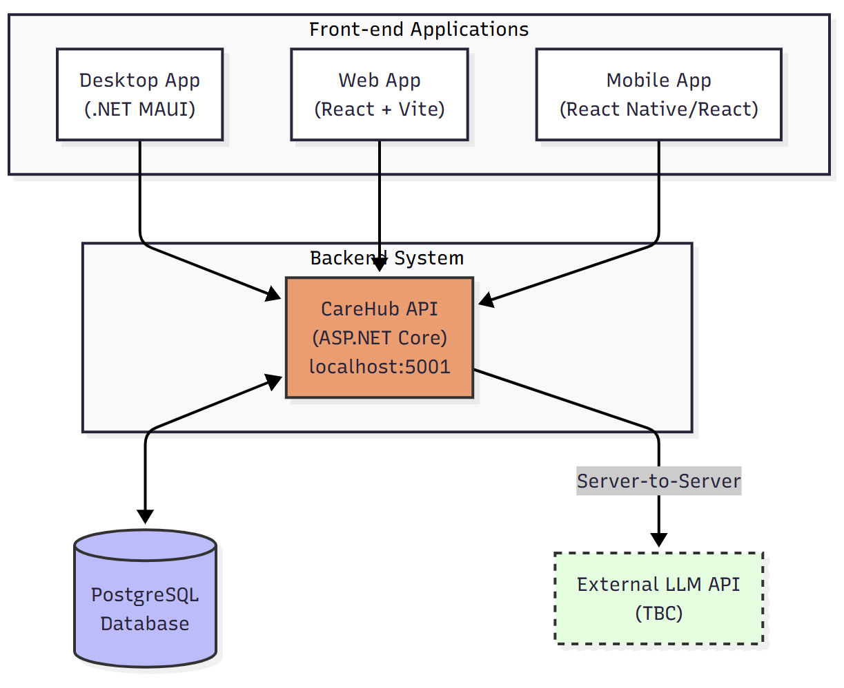
Desktop App (.NET MAUI): This is the Windows app with the most features. It has XAML pages for the UI, ViewModels for the logic, and services that talk to the API. If the API goes down, it falls back to reading/writing local JSON files so staff can keep working.
Web UI (React): A browser-based version of the app. Staff can open it on any device with a web browser. It talks directly to the API, so it needs an internet connection. This is great for computers that cannot install the desktop app or for quick access.
Mobile App (React Native): A mobile-friendly version built with React Native, targeting Android. It connects to the same backend API as the desktop and web apps and shares the same data structures.
Backend (ASP.NET Core): The API server that handles all requests from all three front-ends. It uses Entity Framework Core to talk to the PostgreSQL database.
Database (PostgreSQL 16): Runs inside a Docker container. Stores all the data - residents, medications, observations, and MAR records.
External LLM API (TBC): A planned server-to-server connection where the CareHub API sends requests to an external LLM for tasks like summarizing observations or flagging medication interactions. All LLM calls go through the backend to keep API keys secure.

2.2 How MVVM Works in Our Desktop App
The desktop app uses the MVVM pattern (Model-View-ViewModel) to keep things organized. Here is what each part does:
Part | What It Does | Examples in Our App
Model | The data objects - what a resident or medication looks like in code. | Resident.cs, Medication.cs, Observation.cs, MarEntry.cs
View | The XAML pages - the actual screens the user sees and clicks on. | ResidentsPage.xaml, MarPage.xaml, LoginPage.xaml
ViewModel | The middleman - gets data from services, formats it, and passes it to the View. | ResidentsPageViewModel.cs, MarPageViewModel.cs
Services | Handle talking to the API or reading local files. We use interfaces so we can swap between online and offline. | IResidentService, ResidentApiService, ResidentJsonService

2.3 How React Works for the Web App
The web UI is built with React. It calls the same API as the desktop app and displays the same data in a browser-friendly layout.
Here is how the React side is organized:
- Components: Reusable UI pieces like forms, tables, buttons, and cards.
- Pages/Screens: The main views like Residents List, MAR Page, Login, etc.
- Services/API calls: Functions that call our ASP.NET Core backend using fetch or axios.
- State Management: Keeps track of the logged-in user, current resident, etc.
The web app runs in any modern browser (Chrome, Edge, Firefox, Safari) and needs an internet connection to work.

2.3.1 How the Mobile App Works (React Native)
The mobile app is a separate React Native project (CareHub.Mobile) that targets Android. It shares the same data structures as the other apps (Resident.cs, Medication.cs) so the data structures are consistent. Currently, the mobile app is connected to the backend API. Here is what it has:
ResidentsPage – Shows a list of all residents in a card-based layout. Tapping a resident opens their detail page.
ResidentDetailPage – Shows the selected resident’s info and their medications (name, dosage, schedule).
The mobile app currently loads data from the backend API (Resources/Raw/Residents.json and Medications.json). It does not connect to the API yet. There is a login screen and role-based access – it enforces the SRD access matrix.
It supports the Observer (Resident) role so residents can view their own data on their phone. Navigation uses React Navigation with a simple list-to-detail flow. Note: The Dev Reference document lists the mobile app as React Native, which is the confirmed technology for the mobile app.

2.4 Class Diagrams
Here are the main data classes (entities) used across the app:
Class | Important Fields | Connected To
Resident | Name, DOB, Gender, Address, Emergency Contacts, Doctor Info, Allergies, Room Number | Has many Medications, Observations, and MAR Entries
Medication | Name, Dosage, Stock Quantity, Reorder Level, Expiry Date, Weekly Schedule | Belongs to a Resident
Observation | Type (Vitals), Temperature, Blood Pressure, Pulse, SpO2, Notes, Recorded By | Belongs to a Resident
MarEntry | Status (Given/Refused/Held/Missed), Dose, Scheduled Time, Administered Time, Notes, Can Be Voided | Belongs to a Resident and a Medication
On the desktop side, each data type has the same service pattern: an interface, an API version, and a local JSON version for offline use:
Interface | API Version | Offline Version
IResidentService | ResidentApiService | ResidentJsonService
IMedicationService | MedicationApiService | MedicationJsonService
IObservationService | ObservationApiService | ObservationJsonService
IMarService | MarApiService | MarJsonService
The React web app does not have an offline version - it always calls the API directly.

2.5 Database Tables
Here are the tables in our PostgreSQL database and how they relate to each other:
Table | What It Stores | Linked To
Residents | All resident info (name, DOB, allergies, room, etc.) | Everything links back to this
Medications | Medication details, stock levels, and schedules | Linked to Residents
Observations | Vitals and notes (stored as JSON text) | Linked to Residents
MarEntries | Records of when meds were given/refused/etc. | Linked to Residents and Medications
MedicationInventoryLedgers | A log of every stock change (like an audit trail) | Linked to Medications and MarEntries
When a resident is deleted, all their medications, observations, and MAR entries are automatically deleted too (cascade delete).

2.6 API Endpoints
Here are the main API routes. All three front-ends (desktop, web, mobile) call these same endpoints:
Method | URL | What It Does
GET | /api/residents | Get a list of all residents
POST | /api/residents | Add a new resident
PUT | /api/residents/{id} | Update a resident
DELETE | /api/residents/{id} | Delete a resident
GET | /api/medications | Get all medications
GET | /api/medications/lowstock | Get meds that are running low
POST | /api/medications | Add a new medication
PUT | /api/medications/{id} | Update a medication
DELETE | /api/medications/{id} | Delete a medication
POST | /api/medications/{id}/adjustStock | Manually change stock count
GET | /api/observations | Get all observations
POST | /api/observations | Add a new observation
GET | /api/mar | Get MAR entries (with date filters)
POST | /api/mar | Record a new MAR entry
POST | /api/mar/{id}/void | Void (undo) a MAR entry
GET | /health | Simple health check

2.7 AI Service Architecture
The AI features in CareHub are powered by an external large language model (LLM) API. The AI layer sits between the existing backend API and the external AI provider. It is designed so that:
- The AI provider can be swapped out without changing the rest of the app (e.g., switching from OpenAI to Claude or a local model).
- All AI calls go through our own backend API, never directly from the front-end apps. This keeps the API key safe on the server.
- If the AI service is unavailable, the rest of the app works normally.
The front-end apps never talk to the AI provider directly. They call our CareHub API endpoints (like /api/ai/shift-summary), and our backend handles the AI call. This keeps things secure and lets us control what data is sent to the AI.We plan to add a few AI endpoints to the API. These are not built yet, but here is what we are thinking:
Method | URL | What It Does
POST | /api/ai/shift-summary | Generate a plain-language summary of a resident’s recent care activity.
POST | /api/ai/medication-explain | Get a simple explanation of what a medication does and its side effects.
POST | /api/ai/detect-trends | Look for patterns in a resident’s data over time (e.g., declining vitals).
These endpoints will only be available to Nurse and Admin roles. The AI will not store any responses in the database – it just generates text on the fly. We will also be careful not to send sensitive info like SIN numbers or full addresses to the AI.

3 Behavioral Design
This section shows how the app behaves during key workflows. We used simple flowcharts to illustrate each one.

3.1 Login Flow
This flow is the same on desktop, web, and mobile: 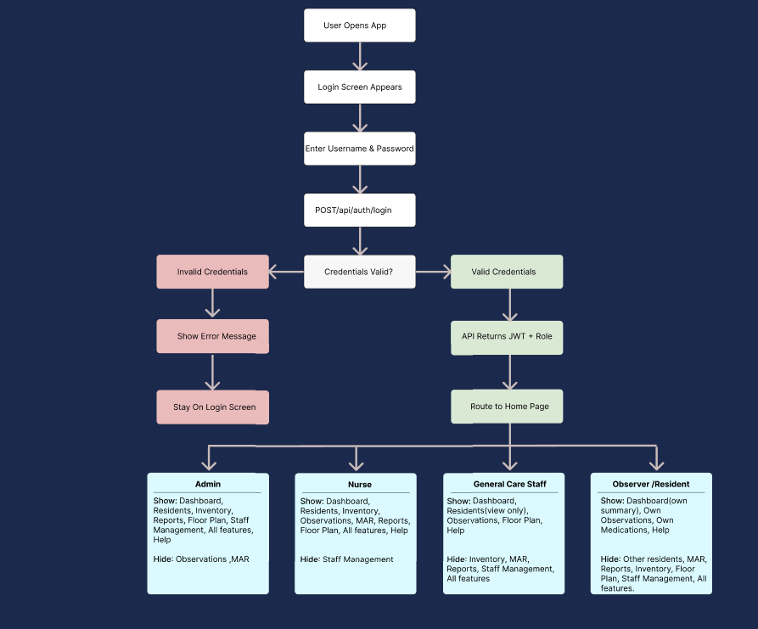

3.2 MAR Workflow
This is the main clinical workflow - recording when a medication is given: 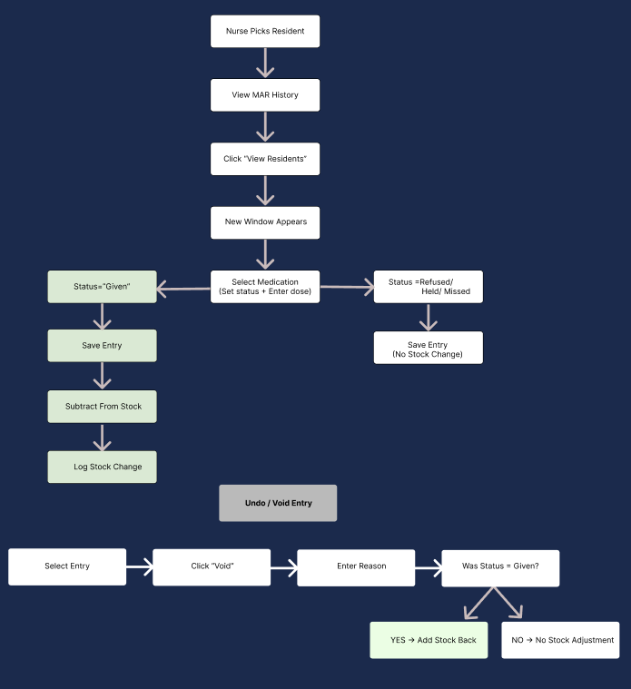

3.3 Offline Sync Flow (Desktop Only)
This only applies to the desktop app. The web and mobile apps need an internet connection to work.
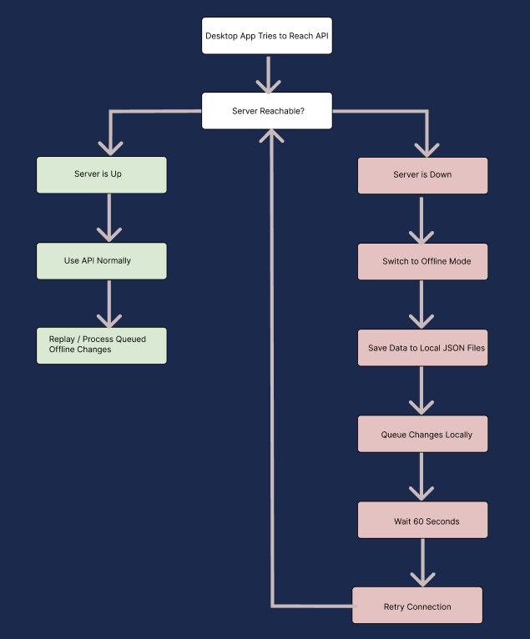

3.4 AI-Assisted Workflows (Planned)
The AI features share a common backend flow: the front-end calls a CareHub API endpoint, the backend gathers relevant data, sends it to an external AI service, and returns the result. Below are the specific workflows for each AI feature. All AI output is labeled so staff know it was generated by AI.
- Shift Summary (POST /api/ai/shift-summary): A Nurse or Admin opens a resident’s profile and clicks “Generate AI Summary.” The app sends the request to the CareHub API, which gathers the resident’s recent observations, medications, and MAR entries, sends them to the external AI service with a prompt, and returns a plain-language summary. The front-end displays the result with an “AI-Generated” label.
- Medication Explain (POST /api/ai/medication-explain): On the medications list, a Nurse or Admin clicks the “Explain” button next to a medication. The app sends the medication name and dosage to the CareHub API, which forwards it to the AI service. The AI returns a simple description of what the medication does and its common side effects. The result is shown in a popup with a disclaimer.
- Detect Trends (POST /api/ai/detect-trends): A Nurse or Admin views a resident’s profile and clicks “Detect Trends.” The app sends the request to the CareHub API, which gathers the resident’s observation history over time. The AI analyzes the data for patterns (e.g., declining vitals, frequent medication refusals) and returns a summary of any flagged trends. The result is displayed with an “AI-Generated” label.
If the AI service is down or slow, the app shows an error message and everything else keeps working. The AI features are completely optional and do not affect the core clinical workflows. Only Nurse and Admin roles can access these features.

4 UI Design

4.1 Navigation Layout
On the desktop and web apps, we use a tab bar at the top for navigation. On mobile, we use a side menu or bottom navigation since the screen is smaller. Which pages you see depends on your role. There is also a Resident role that is mobile-only and can only view observations and medications.
Page | Admin | Nurse | CareStaff | Observer
Home | Yes | Yes | Yes | Own only
Residents | Yes | Yes | Yes | Own only
Inventory / Medications | Yes | Yes | No | Own meds
MAR | No | Yes | No | No
Observations | No | Yes | Record + View | View own
Reports | Yes | Yes | No | No
Floor Plan | Yes | Yes | Yes | No
Staff Management | Yes | No | No | No
Help | Yes | Yes | Yes | Yes
AI Features | Yes | Yes | No | No
The Observer (Resident) role is only available on the web and mobile apps. Observers can only see their own data – their own observations, their own medications, and a simple dashboard. They cannot see other residents or edit anything. On mobile, the Observer would see a simplified version of the app with just their personal health info. For the Residents page, Observers see only their own profile (demographics and basic info). They do not have access to other residents’ profiles.

4.2 Screen Wireframes
Here are rough wireframes for the mobile version. The layout is similar across desktop, web, and mobile.
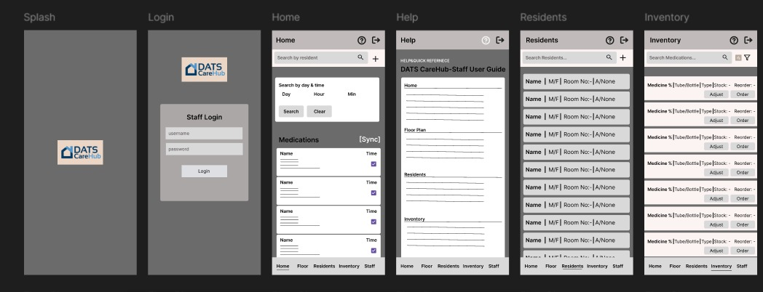

4.3 AI Features (Planned)
We have not finalized the AI screens yet, but the general idea is:
AI Summary – There will be an “AI” tab or button on the resident’s profile page. Clicking it shows a plain-language summary of the resident’s recent activity, with a clear label that it was generated by AI.
Medication Explain – On the medications list, there will be an “Explain” button next to each medication. Clicking it opens a popup with a simple description of what the medication does.
Detect Trends – On a resident’s profile, there will be a “Detect Trends” button. Clicking it analyzes the resident’s observation history and displays any flagged patterns (e.g., declining vitals or frequent medication refusals) in a summary view.
All AI screens will include a disclaimer like: “AI-Generated – For Informational Purposes Only.”

Revision History
Version | Date | Name | Description
1.0 | March 2026 | Team 2 | Initial document.

