Software Requirements Document
For
DATS CareHub
An AI-Integrated Digital Care Management System

Team 2

Winter 2026
Version 1.0

Team Members:
Devi Madhusudanan (000489919)
Samuel Molla (000499865)
Tanvi Tanvi (000489679)
Alice Yu (000488835)

Contents
1 Introduction 3
1.1 Project Overview 3
1.2 Goals and Objectives 3
2 General Design Constraints 3
2.1 Software Environment 3
2.2 Hardware Environment 4
2.3 Other Constraints 4
3 Nonfunctional Requirements 4
3.1 Operational Requirements 4
3.2 Performance Requirements 4
3.3 Security Requirements 4
3.4 Other Requirements 5
4 Functional Requirements 5
4.1 Use Case 1: General CareStaff 5
4.2 Use Case 2: Nurse (Full Clinical) 6
4.3 Use Case 3: Admin 6
4.4 Use Case 4: Observer / Resident (Web + Mobile) 7
4.5 Use Case 5: AI-Assisted Features 7
Revision History 8

1 Introduction

1.1 Project Overview
DATS CareHub is a care management app that we built for places like nursing homes and assisted living facilities. The idea is to replace the messy mix of paper forms, spreadsheets, and sticky notes that care staff deal with every day.
Our app has three ways to access it. The main desktop app is built with .NET MAUI and runs on Windows. We also have a web-based UI so staff can access the same features from any browser without installing anything. On top of that, we built a mobile app using .NET MAUI for Android so staff can use their phones or tablets while walking around the facility.
All three front-ends connect to the same ASP.NET Core backend API with a PostgreSQL database, so everyone is always looking at the same up-to-date information.

1.2 Goals and Objectives
Here is what we want our app to do:
- Keep all resident info (demographics, meds, notes) in one place instead of scattered files.
- Make it easy for nurses to record when they give medications (MAR workflow).
- Let staff record vitals like blood pressure, temperature, and pulse quickly.
- Generate simple reports that can be used during shift handovers.
- Work offline if the server goes down (desktop app), and sync back up when it reconnects.
- Have different access levels so admins, nurses, general care staff, and observers see different things.
- Be accessible from desktop, web browser, and mobile devices.

2 General Design Constraints

2.1 Software Environment
Here are the main tools and technologies we used:
What | Technology We Used
Desktop App | .NET MAUI (targets Windows)
Web UI | React (browser-based, accesses the same backend)
Mobile App | React (targets Android)
Backend / API | ASP.NET Core Web API
Database | PostgreSQL 16 (runs in Docker)
Desktop Language | C# with XAML
Web Language | JavaScript with React

2.2 Hardware Environment
For the desktop version, you need a Windows 10 or newer PC. The web UI works on any modern browser (Chrome, Edge, Firefox, Safari) on any device. The mobile app runs on Android phones and tablets.
All three front-ends need some kind of internet connection to talk to the API. The desktop app can also work offline using local storage and syncs when it reconnects.
The server side just needs a machine that can run Docker and .NET 8. We used Docker Compose to spin up the PostgreSQL database, so setup is simple.

2.3 Other Constraints
- Since we are dealing with healthcare data, we need to be careful about privacy.
- The AI features we planned are meant to help staff, not make decisions for them.
- The desktop app should still work if the internet drops out (offline mode).
- The web and mobile apps require a network connection since they talk directly to the API.

3 Nonfunctional Requirements
These are things the app should do that are not about specific features, but about how well it works overall.

3.1 Operational Requirements
ID | What It Means
NFR-01 | Multiple staff should be able to use the app at the same time through the API.
NFR-02 | The desktop app should switch to offline mode automatically if the server goes down.
NFR-03 | When the server comes back, any changes made offline should sync up on their own.
NFR-04 | The web UI and mobile app should show a clear message if the server is not reachable.

3.2 Performance Requirements
ID | What It Means
NFR-05 | Pages should load quickly - the API should respond in under a second.
NFR-06 | If the server does not respond within 2 seconds, the desktop app should switch to offline mode.
NFR-07 | Generating a resident report should take no more than a few seconds.

3.3 Security Requirements
ID | What It Means
NFR-08 | Users must log in with a username and password. The system uses JWT (token-based) authentication.
NFR-09 | There are 4 roles: Admin, Nurse, General CareStaff, and Observer (Resident). Each role sees different pages. Observer is Web + Mobile only.
NFR-10 | Only Admins can access the Staff Management page.

3.4 Other Requirements
The app includes AI-powered features that help staff understand resident data more easily. The AI is assistive only – it does not make decisions, change records, or replace clinical judgment.
ID | What It Means
NFR-11 | The web and mobile UIs should be responsive and work on different screen sizes.
NFR-12 | AI output should always be labeled so staff know it came from AI, not from a real person.
NFR-13 | The AI should only read data and generate text. It should never add, edit, or delete any records on its own.
NFR-14 | If the AI service is not available, the app should still work normally without it.

4 Functional Requirements

4.1 Use Case 1: General CareStaff
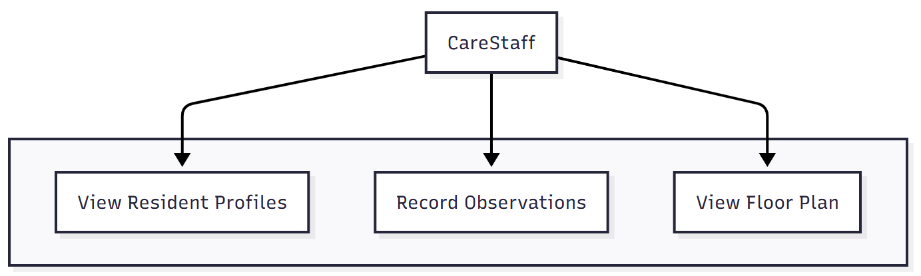
General CareStaff are front-line care workers who can view resident information and record observations. They cannot manage residents, medications, inventory, or MAR.
Pages accessible:
- Home – Dashboard overview.
- Residents – View profiles (read-only).
- Observations – Record and view vitals.
- Floor Plan – Facility layout and room assignments.
- Help – Help and guidance.
Field | Description
Use Case ID | UC-01
Name | General CareStaff Daily Tasks
Actor | General CareStaff
What It Does | Lets general care staff view resident info (read-only), record observations and vitals, and use the floor plan. Available on Desktop, Web, and Mobile.

4.2 Use Case 2: Nurse (Full Clinical)
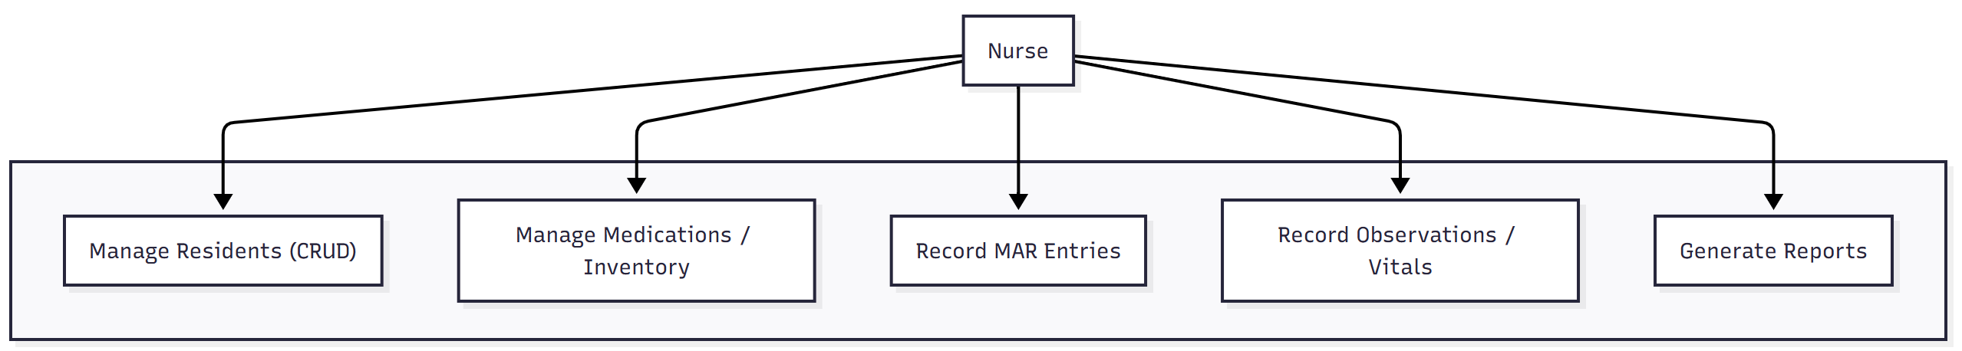Nurses handle the full clinical side. They can do everything a CareStaff can, plus manage residents, medications, MAR records, and generate reports.
Additional pages (on top of CareStaff):
- Medications – Manage inventory, stock levels, and low-stock alerts.
- MAR – Record medication administration (Given, Refused, Held, Missed) and void entries.
- Reports – Generate resident summary reports.
- AI Features – Access AI-assisted summaries, medication explanations, and trend detection.
Key behaviors:
Administering a medication with status "Given" automatically subtracts from stock. Voiding a "Given" entry adds the stock back. Cascade delete: removing a resident also removes their medications, observations, and MAR records.
Field | Description
Use Case ID | UC-02
Name | Nurse Clinical Tasks
Actor | Nurse
What It Does | Everything General CareStaff can do, plus: manage residents, manage medications, record MAR entries, record observations and vitals, handle inventory, and generate reports.

4.3 Use Case 3: Admin
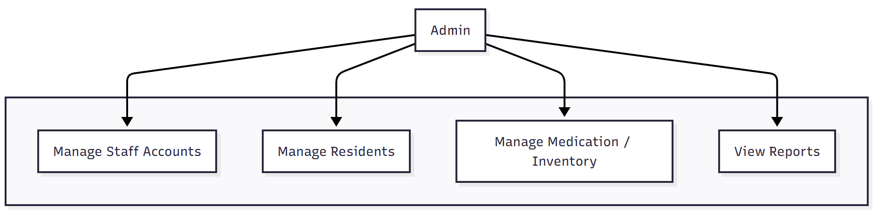Admins manage the system. They can do most of what a Nurse can (manage residents, medications, reports) but cannot record observations or MAR since those are clinical tasks. Their unique capability is staff account management.
Additional page (on top of Nurse, excluding Observations and MAR):
Staff Management – Add, edit, delete staff accounts and assign roles (Admin, Nurse, CareStaff).
Available on Desktop and Web only.
Field | Description
Use Case ID | UC-03
Name | Admin System Management
Actor | Admin
What It Does | Manages staff accounts, residents, medications, inventory, and reports. Cannot record observations or MAR (clinical tasks only). Available on Desktop and Web.

4.4 Use Case 4: Observer / Resident (Web + Mobile)
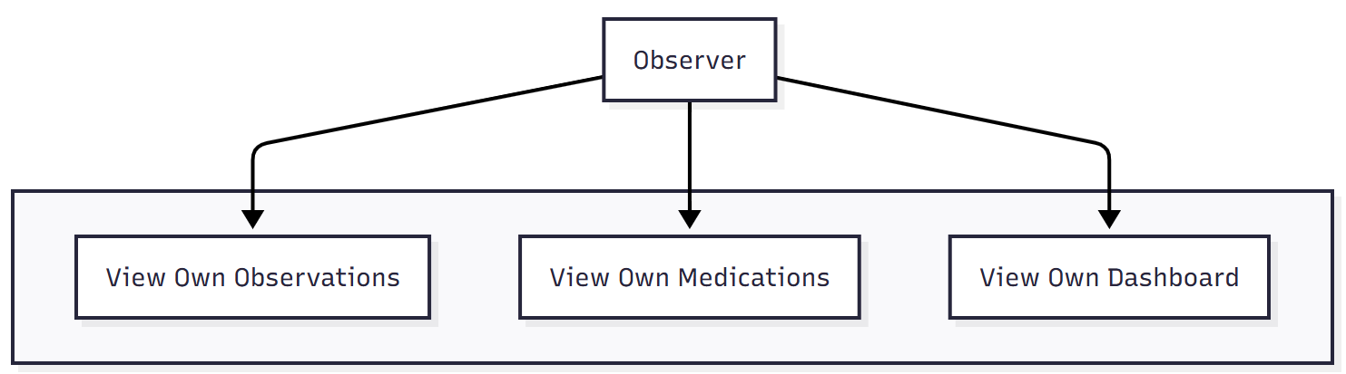Observers are the residents themselves. They can log into the web or mobile app to view their own health information. Strictly read-only – they cannot see other residents or edit anything.
Field | Description
Use Case ID | UC-04
Name | Observer / Resident (Web + Mobile)
Actor | Observer (Resident)
What It Does | Lets residents view their own observations and medications. Read-only, no editing allowed. Available on Web and Mobile only..

4.5 Use Case 5: AI-Assisted Features
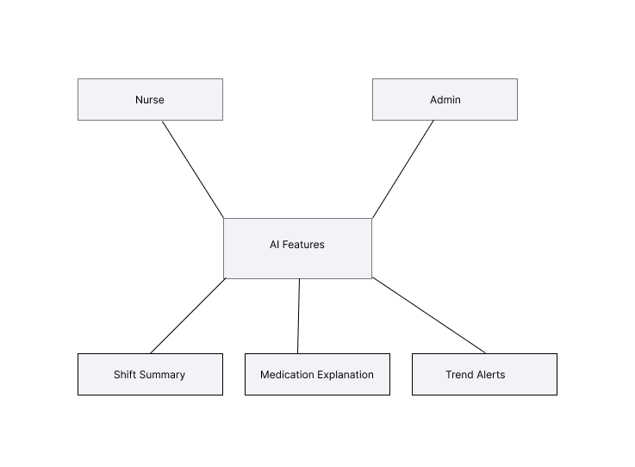
AI features help Nurses and Admins understand resident data more quickly. These are planned and not yet finalized. The AI is assistive only – it never changes data or makes clinical decisions. All output is clearly labeled as AI-generated.
Planned features:
- Shift Summary – Plain-language summary of a resident’s recent care activity.
- Medication Explanation – Simple description of what a medication does and its side effects.
- Trend Alerts – Flags patterns in a resident’s data over time (e.g., declining vitals, frequent refusals).
Field | Description
Use Case ID | UC-05
Name | AI-Assisted Care Features
Actors | Nurse, Admin
Available On | Desktop, Web, Mobile
Page | CareStaff | Nurse | Admin | Observer
Home | Yes | Yes | Yes | Own only
Residents (view) | Yes | Yes | Yes | Own only
Residents (add/edit/delete) | No | Yes | Yes | No
Observations | Record + View | Yes | No | View own
Floor Plan | Yes | Yes | Yes | No
Help | Yes | Yes | Yes | Yes
Medications | No | Yes | Yes | Own meds
MAR | No | Yes | No | No
Reports | No | Yes | Yes | No
Staff Management | No | No | Yes | No
AI Features | No | Yes | Yes | No
Summary of role access:

Revision History
Version | Date | Name | Description
1.0 | 02-Mar-2026 | Team 2 | Initial document.

