Algae Count Estimator
Samuel Dunlap, Matt Ralphs, Andrew Young, Josh Minor
Software Design Document
Issue 1.2
TABLE OF CONTENTS

1 Introduction 1
1.1 Purpose 1
1.2 Scope 2
1.3 Definitions, Acronyms and Abbreviations 2
2 System Overview 3
2.1 System Characteristics 3
2.2 System Architecture 3
3 System Design 4
3.1 Interface Design 4
3.2 Component Design 4
3.3 Naming conventions 6
3.4 Programming Standards 6
4.1 usage and reflection 7

Revision History

Name | Revision | Description | Date
Samuel Dunlap | 1.0 | Initial Document | 05/28/2014
Samuel Dunlap | 1.1 | Finished Initial Doc | 06/04/2014
Andrew Young | 1.2 | Added references | 06/07/2014

Introduction
For scientists who require the assistance in the counting of blue-green algae, specifically Aphanocapsa and Aphanothece, the Algae Count Estimator (ACE) is a tool that graphically generates algae colonies with known counts. The software will be implemented using PyQt as an engine to assist with the generation of the graphical interface. All GUI examples provided in this document are screen shots generated in this way. We will be using PyQt version 4.0 alongside Python 2.7 in the interest of stability. The program pyuic4 assists in generating the necessary code to implement the PyQt’s “.ui” file in Python, where the additional code shall be added. It remains unclear which specific rendering engine we will use to assist in the creation of “algae slides”. Options include SFML, PyGames, OpenGL, and the built-in Qt graphical engine. Two components are associated with this program.
The first of which, is a tool that will be used to train users in the process of counting algae. This is done by presenting the user with computer generated images of algae colonies that have known counts and requiring them to make educated guesses on the quantity pictured. This training tool will accumulate statistics on each given user (average relative error for each training session, as well as overall, and as a graph through time). Users will be able to view their personal statistics on a separate stats page. The simulated images include qualities that you would typically find when viewed through a microscope. The virtual microscope will have controls that allow a user to zoom, pan, adjust focus, and change lighting (polarized or not). The user will select the number of slides they wish to be tested on. The slides can be generated by our program, or if the user likes, they may use a previously generated slide set.
The second component of this project will create an imagine tool that will give the user a way to generate an image of algae containing either, or both of the aforementioned taxa. The user chooses which algae to generate, and selects a tool (this includes “draw a colony shape”, “add density”, “delete density”, and a tool where the user can simply add algae around the mouse on-click, where the amount added will be a function of the time the mouse button is held down). This component will regularly refresh the number of cells in the current picture. It is the intent of this program to use this component to facilitate a more accurate estimate of a real sample by allowing the user to closely match what they actual observe under their microscope. The diagrams and text provided in the following sections of this document are intended to provide the reader with a more solid understanding of the user’s flow through the system, and the implementation of each component.

Purpose

This document is intended to assist any desiring stakeholder of the ACE project in understanding the overall design and architecture of the project as a whole, and how it is intended to be implemented. This is a technical document that will be used by the team to assist in documenting and implementing the project. We, as the ACE team encourage any questions on this document if something remains unclear.

Scope

The scope is fully outlined in the separate Vision and Scope Document. Because of the nature of this project, design may be changed at any point throughout implementation. Any changes deemed by all members to be an acceptable addition or change will be implemented. The customer will be notified of initial design decisions and be given a chance to comment and request changes at this time. All subsequent changes to this materiel must be filed to the ACE team properly as a change request in writing, and it is at the digression of the team whether to implement said changes. We will use the criteria of if we deem them reasonable to finish in the requested time, and are of need for the success of the project.

Definitions, Acronyms and Abbreviations
Class Diagram | Describes the structure of a system
Context Diagram | Shows a rough overview of the system as a whole
Sequence Diagram | Shows one or several sequences of messages sent among a set of objects
GUI | Graphical User Interface
ACE | Algae Count Estimator

References

PyQt Coding Style Guidelines
http://bitesofcode.blogspot.com/2011/10/pyqt-coding-style-guidelines.html
Provided tips and tricks recommending good practices to limit overriding built-in Qt functions and class variables.

Google Python Style Guild
http://google-styleguide.googlecode.com/svn/trunk/pyguide.html
Good standards for python

PyQt4 tutorial
http://zetcode.com/gui/pyqt4/
Simple tutorials to start PyQt4 applications

Rapid GUI Programming with Python and Qt by Mark Summerfield
http://www.qtrac.eu/pyqtbook.html
Books provides sample code for common Qt applications.

C++ GUI Programming with Qt 4 by Mark Summerfield
http://www.informit.com/store/c-plus-plus-gui-programming-with-qt4-9780132354165
Books information about the Qt Widget classes.

Setting Up IDE and Creating A Cross Platform Qt Python GUI Application
http://popdevelop.com/2010/04/setting-up-ide-and-creating-a-cross-platform-qt-python-gui-application/

System Overview

System Characteristics
- Images and cell counts will be updated in real time.
- Allow one user to be logged in at a time per process. Processes shall not interact with each other. However, each process may submit stats for the logged in user to the server at any time. Students must be able to also pull their most recent stats, and a teacher will be able to pull the stats for her/himself and any students that are contained in a class they are teaching.
- To be scalable and easily maintainable in the future.

System Architecture
Because the project is to be implemented in Python, we will follow an object oriented architecture. PyQt further enforces this decision. The project will be divided into four UI windows. These include main menu, trainer, editor, and stats. The names are indicative of which feature listed in the introduction is to be implemented on each.

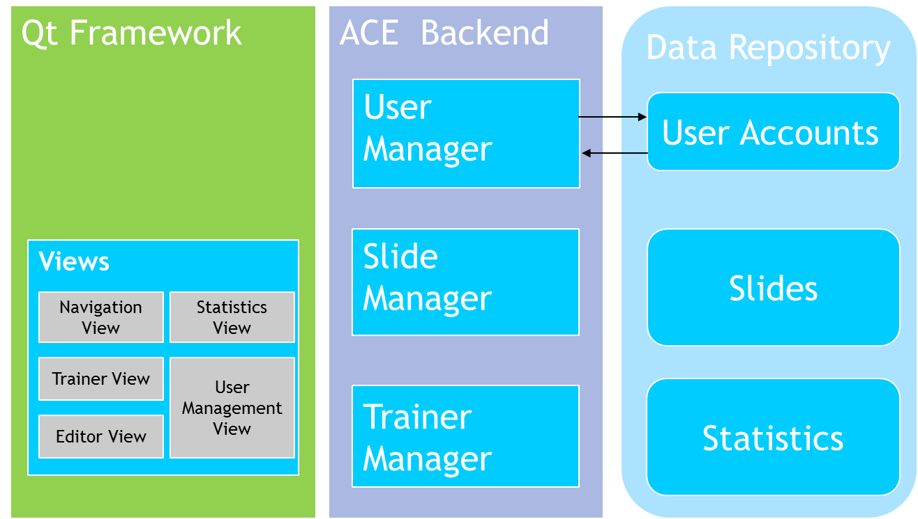

System Design

Interface Design

Main Menu:

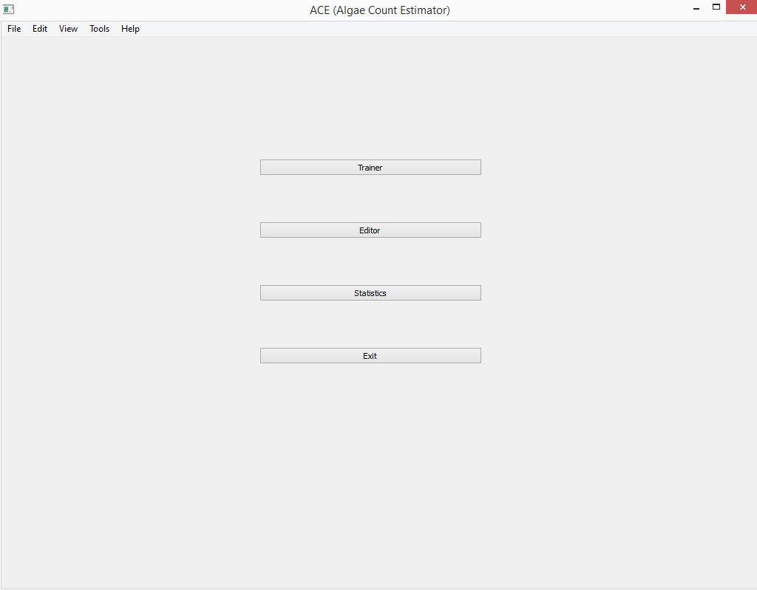

Trainer:

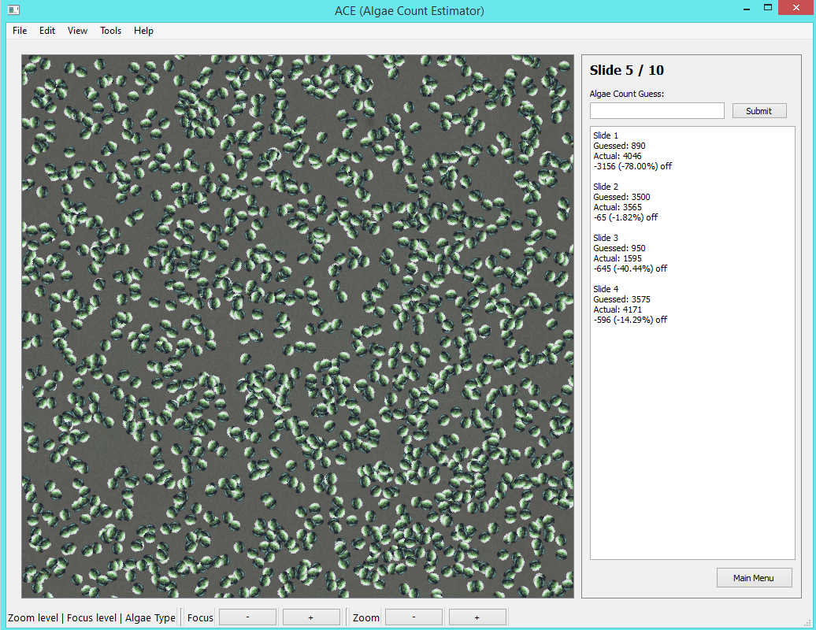

Editor:
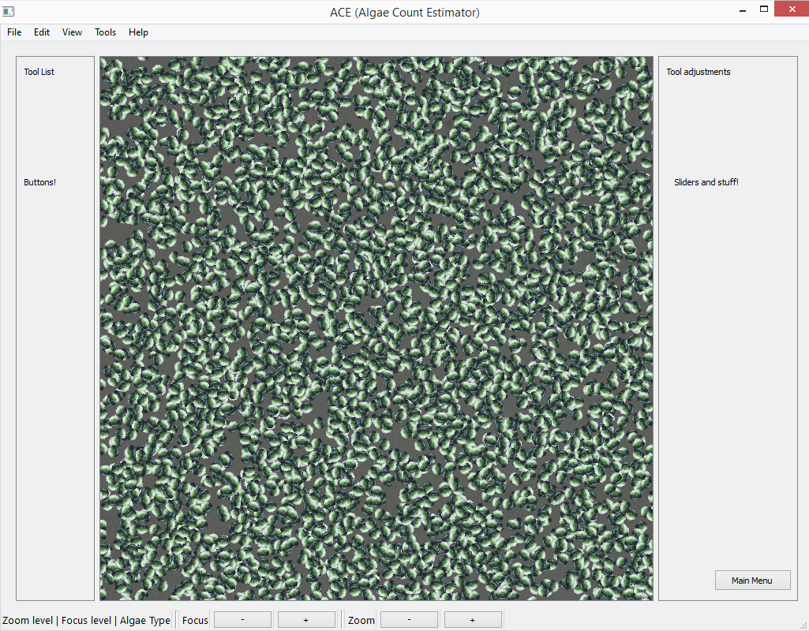
Stats:
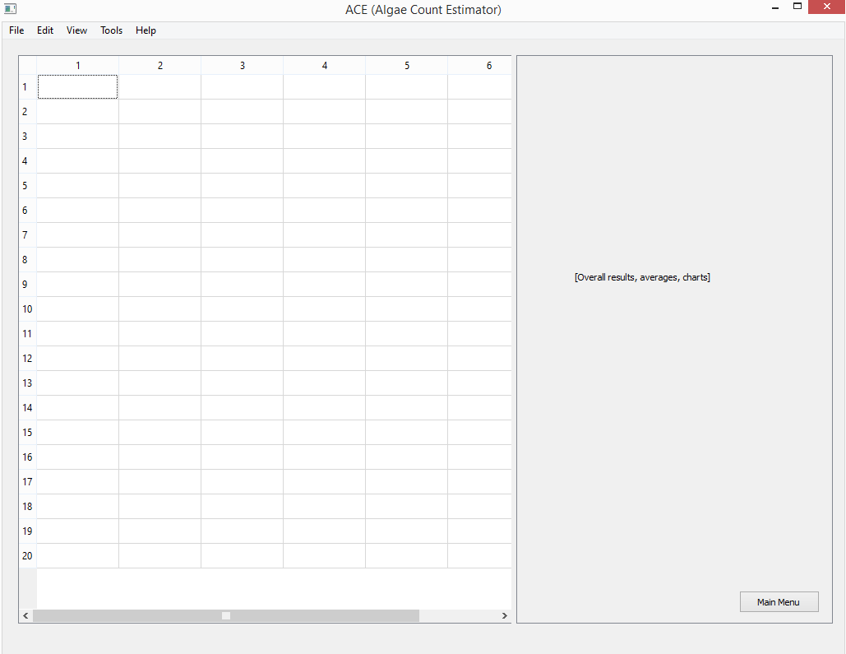

Component Design
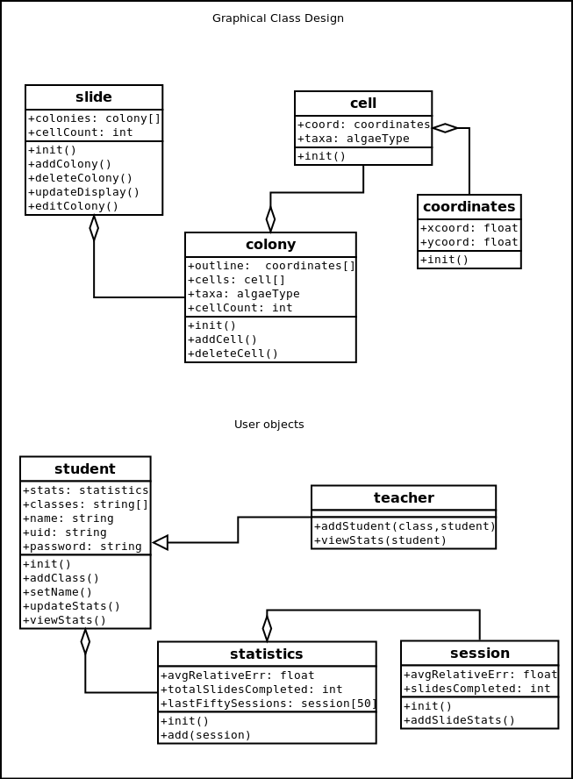

Naming conventions
Any widget or variable that pertains to a specific window of the program should be labelled as such. The labels mm, t,e,s are for main menu, trainer, editor, and stats respectively (e.g. if a pushbutton is part of the editor window, the name should be pushbuttonx_e). Any underscores except this last one are discouraged. Capitalization of all except the first word shall be used to denote multiple word names. Names should be descriptive about the particular object.

Programming Standards
The programming language used is Python 2.7. The tool used for implementing UI and graphics is PyQt.
The following are standards for coding style:
[File Header] At the top of each file you must have a comment that identifies the programmer, when the file was started, and the overall purpose of the given file.
[Indentation] An indentation of 4 characters per block.
[Variable Names] Follow the above mentioned naming conventions.
[Functions] All functions should include a header describing the purpose of the function, and the expected output for a given input. Others reading this should be able to use the function without delving into the code that implements it.
[Comments] Comments embedded within a function are to be added with caution, and with the purpose of providing additional legibility. Avoid over-commenting.

